**Database Setup for Air3550**

**By Andrew Fox, Andrew Le, Amogh Kulkarni**

**Tools required:**

* SQL Server 2019 Express (v15.0.2): <https://go.microsoft.com/fwlink/?linkid=866658>
* Visual Studio 2019: <https://visualstudio.microsoft.com/downloads/>
* SQL Server Management Studio: <https://docs.microsoft.com/en-us/sql/ssms/download-sql-server-management-studio-ssms?view=sql-server-ver15>
* CovidAirlines_Demo.bak – Found in the 7zip archive

**Procedure:**

For our project, we are utilizing SQL Server Express as the database and SQL Server Management Studio (SSMS) to connect and interact with our SQL Server.

Once these tools are installed, we can begin our database setup with the following steps:

**Restore Backup**

1. Open SSMS, connect to our instance of SQL Server Express.

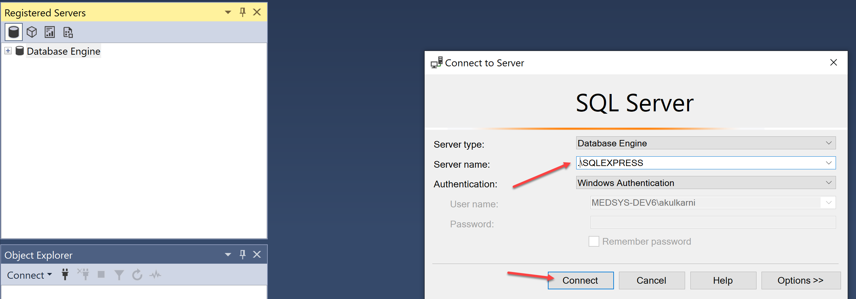

1. Once we are connected, we want to restore our backup (.bak file).   
   Right click “Databases” and select “Restore Database”  
   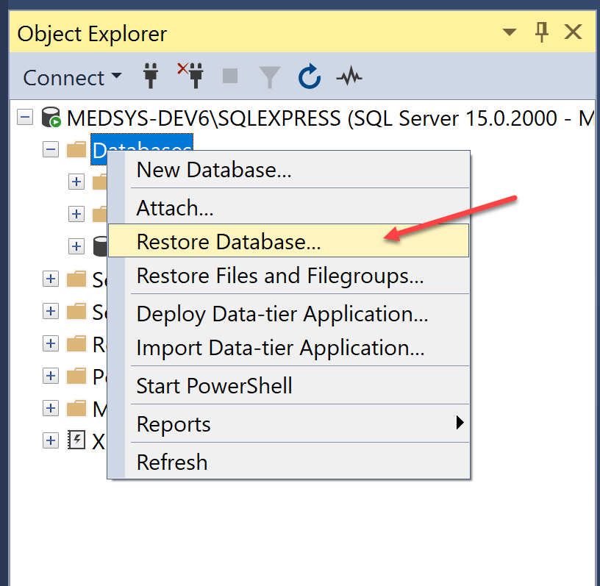
2. Select “Device” and click the three-dot button to open the file selection dialog. 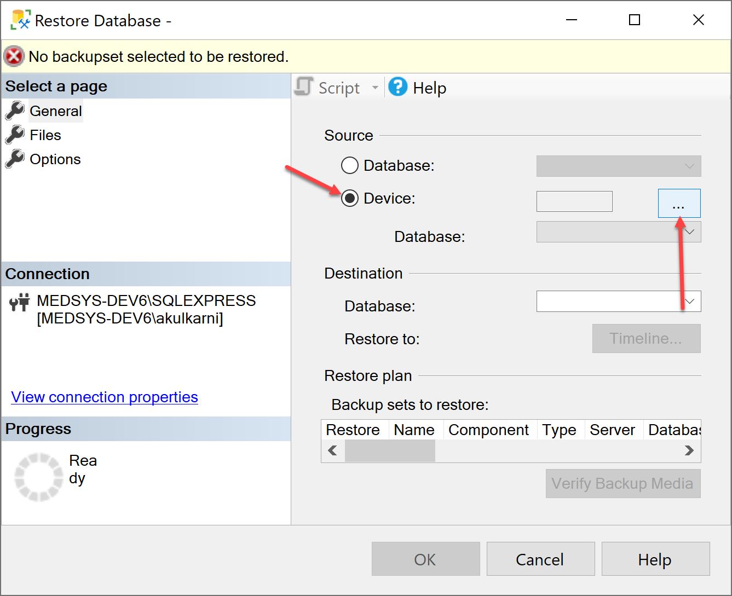
3. From there, locate and select the backup file on the machine by clicking the “Add” button and then click “OK”.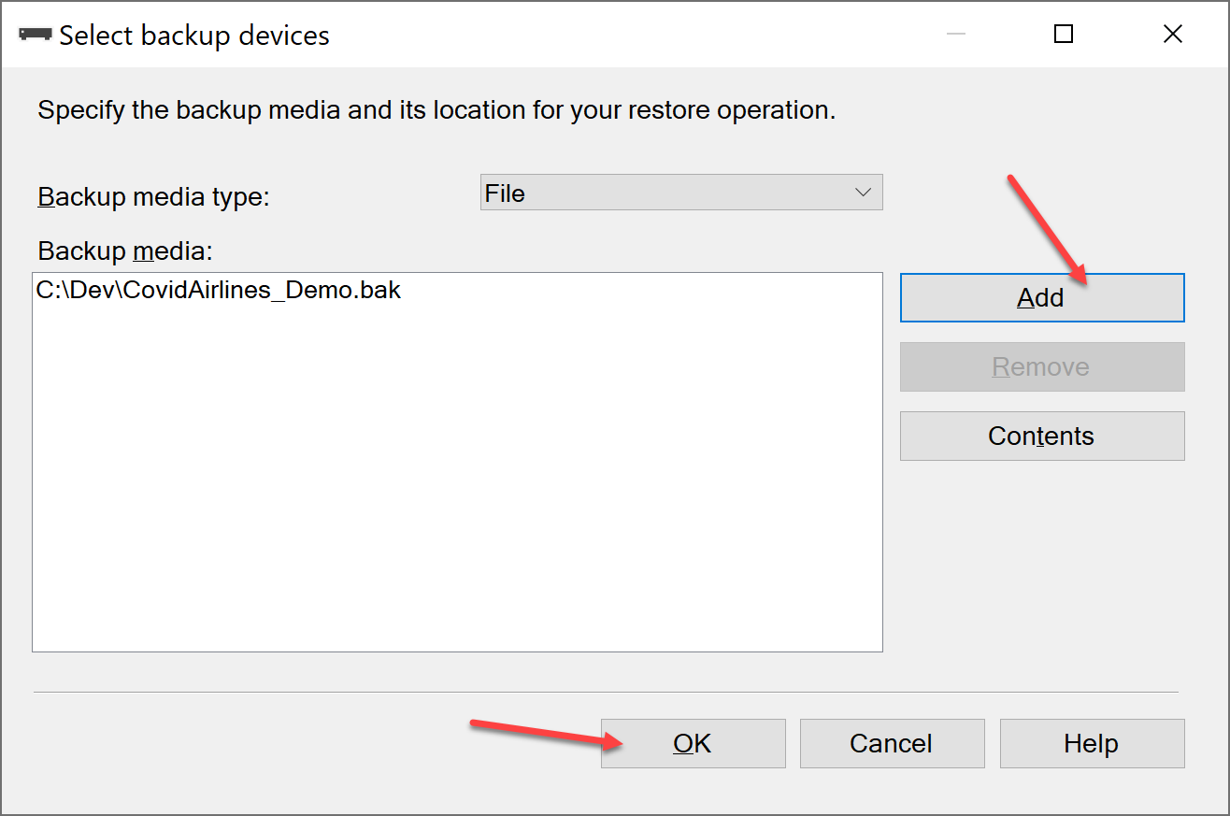

**Load Project**

1. Once the database is restored, fire up Visual Studio and open the CovidAirlines.sln file.  
   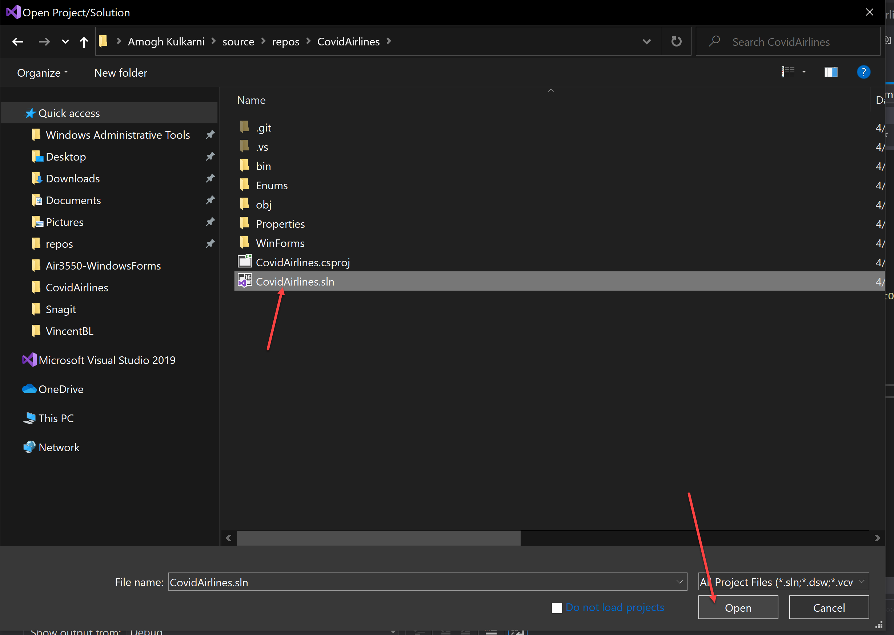

**Connect Visual Studio to SQL Server**

1. Once the project loads, we need to connect it to our instance of SQL Server Express. Head on over to the View tab and open “Server Explorer”  
   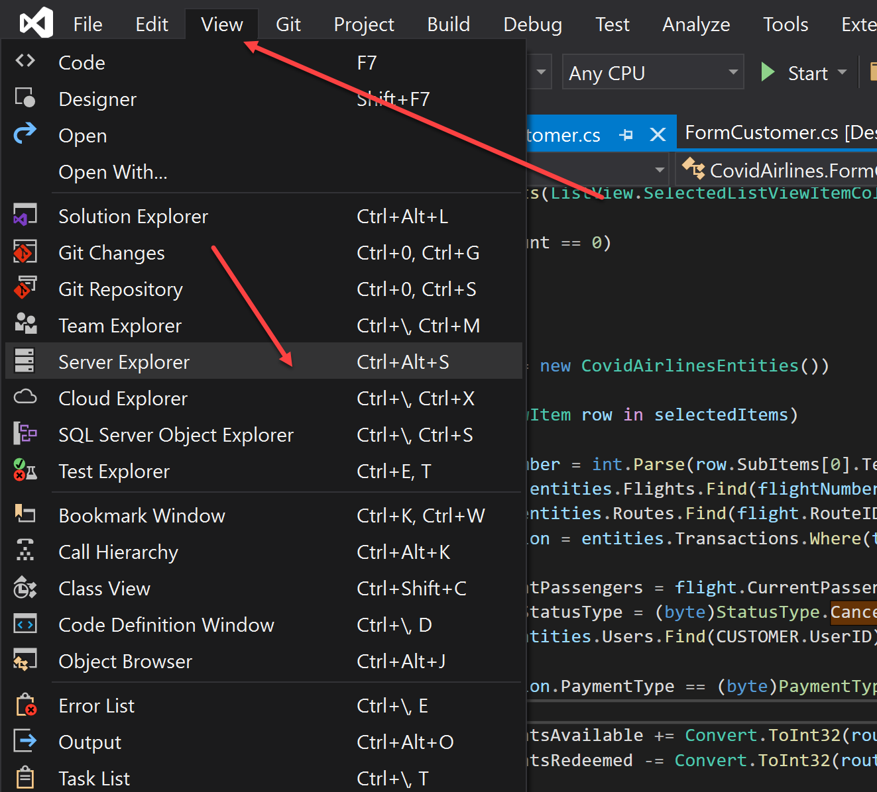
2. From there, click on the following button “Connect to Database”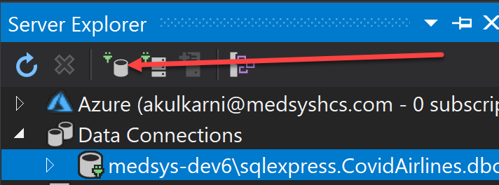
3. We are now presented with a wizard. Select “Microsoft SQL Server” as the datasource and “.NET Framework Data Provider for SQL” as the data provider. Click on “Continue”.  
   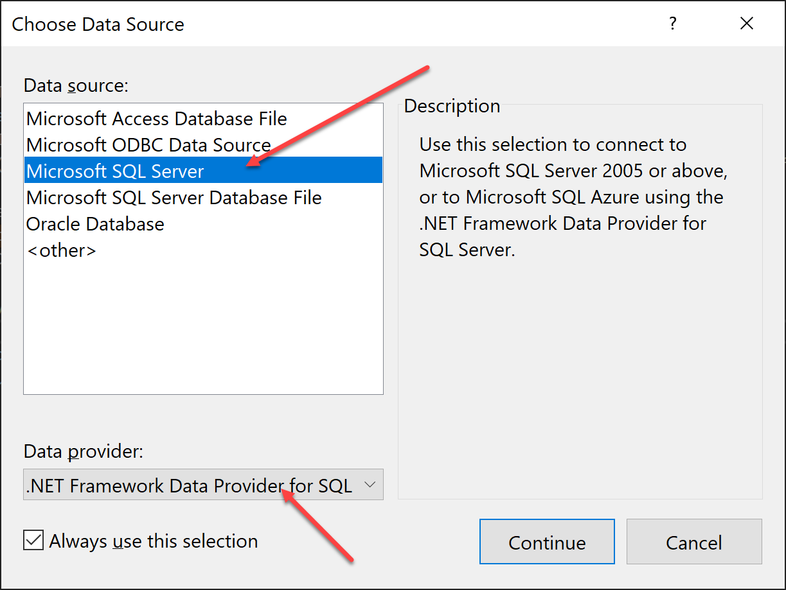
4. In this final step, type in “.\SQLEXPRESS” as the server name, Select “CovidAirlines” as the database name. Click OK