**RODO Smilekey® Instructions for Use**

Please carefully read the following Instructions for Use (IFU) before using the RODO Smilekey**®**. (Please refer to the separate IFU for the RODO® Abutments and Components, IFU 0001)

**Caution**

**U.S. Federal law restricts this device to sale by or on the order of a licensed dentist or physician.**

**Compatibility Information**

The RODO Smilekey**®** is only compatible with a prosthesis that is designed for use with the RODO Abutments and Components. The RODO Smilekey**®** is intended to remove prostheses secured by RODO Smileloc**®** Sleeves.

**Precaution**

The RODO Smilekey**®** must be used only with a compatible prosthesis. Failure to do so may harm the patient and/or result in damage to the implant, abutment, components, or instruments.

**Warning: The RODO Smilekey® is intended only for use in dental implant abutment systems and should never be used on natural teeth. Use on natural teeth may lead to pulpal death and possible loss of the tooth.**

**Indications**

RODO Smilekey**®** is intended to be used with the RODO Abutment System for removing prostheses compatible with Smileloc**®** Sleeve by using induction heating.

**Device Description**

The RODO Smilekey**®** is used in conjunction with a compatible prosthesis as an instrument to remove the prosthesis from the abutment. RODO Smilekey**®** is provided in non-sterile condition. The Smilekey**®** Handle contains a rechargeable lithium battery. The Smilekey**®** Handle and Tip should be disposed according to local laws. The Smilekey**®** has no user-serviceable parts.

The RODO Smilekey**®** is used to unlock the Smileloc**®** Sleeve by delivering energy (heat) to the Smileloc**®** Sleeve for a preset time (8 seconds), causing the Smileloc**®** Sleeve to reach its activation temperature of 60°C. It consists of three parts:

* A reusable RODO Smilekey**®** Handle with LED and sound indicators to inform the user when:
  + Unit is turned on and ready to activate (solid BLUE LED)
  + Energy is being applied to the Smileloc**®** Sleeve (blinking BLUE LED, beeping during activation and two beeps in quick succession at the end of the activation)
  + Battery charge level is low (solid BLUE and AMBER LED)
  + Battery is charging (blinking AMBER LED)
  + Smilekey**®** has reached maximum number of consecutive activations and needs to cool down before next activation (solid GREEN LED)
  + Tip is not properly attached to the handle or other error (blinking BLUE, GREEN, and AMBER LEDs)
* A reusable RODO Smilekey**®** Tip that fits around the prosthesis and delivers energy to the Smileloc**®** Sleeve.
* A charger

Indicators LED’s

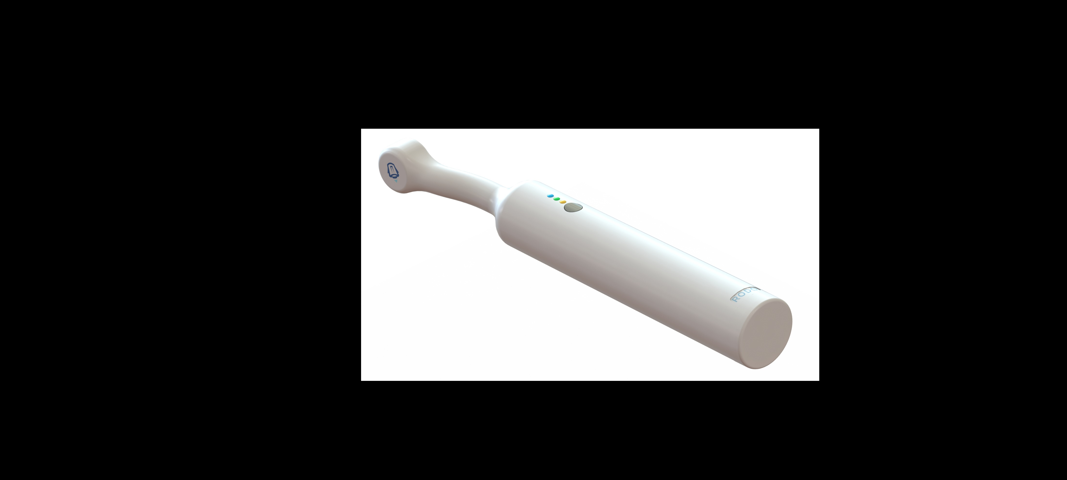

Charging Port

(No Visible)

Power and Activation Button

Smilekey

Tip

Smilekey**®** safety features:

• LEDs to indicate when battery charge level is low (solid AMBER LED).

• LED and audio indicator to inform the user when energy is being applied to the Smileloc**®** Sleeve (blinking BLUE LED and beeping) and when the energy delivery is complete (BLUE LED is back to solid state and audio is no longer emitted). Energy delivery duration is limited to 8 seconds.

• Internal timer that regulates the amount of energy delivered to the Smileloc**®** Sleeve. Once the preset time (8 seconds) is reached, the Smilekey**®** automatically shuts off.

Smilekey**®** must be cleaned and disinfected promptly after each use per instructions below. User must visually inspect Smilekey**®** after cleaning and disinfection to ensure there is no deterioration such as corrosion, cracks or discoloration. If such deterioration is found, please dispose of the device according to local laws.

**Cleaning**

1. Transport the Smilekey**®** device from the patient use setting to area where cleaning and disinfection will be performed.
2. While wearing disposable gloves, remove and discard the FDA-cleared dental barrier sleeve and gloves into appropriate biohazardous waste containers.
3. Disassemble Smilekey**®** Tip from Handle and cover connectors to ensure they are protected during cleaning procedure.
4. Wipe Smilekey**®** Handle and Tip (with connectors facing downwards) using lint-free cloth dampened with lukewarm tap water until all visible soil is removed.
5. Prepare Valsure**®** Enzymatic Detergent per manufacturer’s recommendation and spray Smilekey**®** Handle and Tip (with connectors facing downwards) with the prepared Valsure**®** Enzymatic, reapplying as needed to remain visibly wet for 2 minutes. Do not directly spray connectors.
6. Wipe Smilekey**®** Handle and Tip (with connectors facing downwards) using lint-free cloth dampened with lukewarm tap water and dry.
7. Repeat steps 3-4 using Valsure**®** Neutral.

**Disinfection**

1. Disassemble Smilekey**®** Tip from Handle and cover connectors to ensure they are protected during disinfection procedure.
2. Spray Smilekey**®** Handle and Tip (with connectors facing downwards) with CaviCide**®** spray, ensuring all surfaces are wet, then wipe with sterile, lint-free cloth.
3. Spray Smilekey**®** Handle and Tip (with connectors facing downwards) with CaviCide**®** spray, reapplying as needed to remain visibly wet for 5 minutes. Wipe with a sterile, lint-free cloth dampened with purified water.
4. Spray purified water on Handle and Tip (with connectors facing downwards) and dry with sterile lint-free cloth to remove residuals and dry.

Do not autoclave or immerse the device, as this may cause damage. Prevent liquids from entering openings on unit.

**Recharging**

The RODO Smilekey**®** should only be recharged using the RODO supplied Smilekey USB-C charger. The use of other chargers may cause malfunction or damage to the Smilekey device.

**Contraindications**

Use on patients with heat hypersensitivity.

**Warnings and Precautions**

**Carefully read all the instructions for use prior to use of RODO Smilekey®. The Smilekey® should be used only be licensed professionals familiar with RODO Medical Devices and trained in the restoration of dental implants.**

**The use of metal instruments (i.e. metal mirror) near the device may interfere with Smilekey® activation. Do not place metal instruments near the device during activation.**

Operator should not touch the accessible contacts of the Handle or Tip and the patient simultaneously, which could cause shock or burns to operator and/or patient.

No modification of the RODO Smilekey**®** is allowed. The RODO Smilekey**®** should only be used with compatible accessories provided by RODO Medical.

Failure to follow the procedures outlined in these instructions including the reuse of single-use components may lead to any or all of the following complications:

* Inability to remove prosthesis
* Damage to patient tissues
* Infection
* Damage to the implant, abutment, or other accessories
* Loosening of the abutment and other accessories
* Improper final restoration or malfunction of the prosthesis
* Impairment of the patient’s chewing function
* Failure of the implant
* Removal of the implant

**Safety and Liability**

This product is to be used only with original components and instruments specified in the compatibility section and elsewhere in this IFU. The use of components or instruments other than those specified in these instructions for use will render any warranties null and void. The proper use and handling of this product is the sole responsibility of the user. RODO Medical accepts no liability for any damage resulting from the improper use of its products.

**Disposal**

The RODO Smilekey**®** Handle and Tip should be disposed according to local laws. The RODO Smilekey**®** has no user-serviceable parts.

**Restoration Retrieval**

1. Take periapical X-ray to identify Smileloc**®** Sleeve retained crown.
2. Turn Smilekey**®** on by pressing the Activation button and check to ensure that battery is sufficiently charged (solid BLUE LED on, AMBER LED off). Charge if necessary (AMBER LED on) before proceeding to next step.
3. Connect Tip to Handle.
4. Place FDA-cleared dental barrier sleeve (minimum size 3” x 12”) over entire Handle and Tip.
5. Place Tip around identified Smileloc**®** Sleeve retained crown. Align the center of Tip over Smileloc**®** Sleeve inside restoration as shown below. The Smileloc**®** icon marks the active side of the tip.

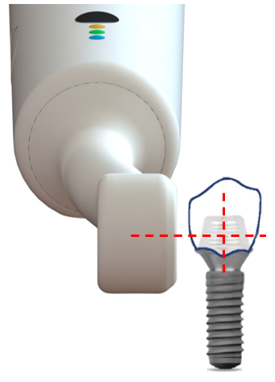

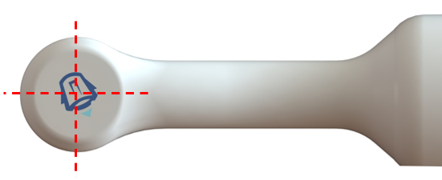

1. Press Smilekey**®** Handle button once and release the button. The BLUE LED will start blinking and the unit will start beeping, indicating that the Smilekey**®** is working. Ensure that the Tip remains positioned and centered over Smileloc**®** Sleeve during activation.
2. When the BLUE LED stops blinking (8 seconds) and beeping stops, remove the Tip from crown and use an air syringe to dry the crown.

**Warning: Do not immediately re-activate the Smilekey® on the same crown. Allow a minimum of 2 minutes for the crown to cool before attempting to re-activate the same crown using the Smilekey®. If second activation after 2 minutes cooling does not unlock crown, allow a minimum of 7 minutes for the crown to cool before attempting another activation. Failure to allow cooling or exceeding recommended energy delivery times in these Instructions for Use may result in over-heating, damage to tissues, or risk of burn to the patient.**

1. Remove crown. Locate the Smileloc**®** Sleeve (either on the abutment or inside the crown) and dispose of properly. If using Smilekey**®** on a multi-unit restoration, repeat steps 5-7 for each Smileloc**®** Sleeve until all Smileloc**®** Sleeves have been unlocked.

If the crown remains locked after repeated attempts using the Smilekey**®**, please follow the following solutions as listed in the table below:

| **Issue** | **Solution** |
| --- | --- |
| Smilekey**®** Handle is not charged | Recharge Handle |
| Smilekey**®** Handle and Tip are not property connected by the clinician | Disassemble and securely re-assemble the Smilekey**®** Handle and Tip |
| Smilekey**®** Tip did not remain in place centered over Smileloc**®** Sleeve | Ensure that the Tip remains positioned and centered over Smileloc**®** Sleeve during activation |

Troubleshooting: If crown remains locked after repeated attempts using the Smilekey**®** the crown can be removed using a dental bur implementing the same procedure as used for removal of a cement-retained crown.

NOTES:

* If user desires to stop activation prior to full completion of activation procedure, simply remove Smilekey from crown and disconnect Smilekey**®** Tip from Handle.

**RODO SMILEKEY® SPECIFICATIONS**

|  |  |
| --- | --- |
| **RODO Smilekey® Environmental Specifications** | |
| Temperature | Operating: 59°-86° F (15°-30° C)  Transportation & Storage: 32°-122° F (0°-50° C) |
| Humidity | Operating: 10% to 80%  Transportation & Storage: 10% to 90% non-condensing |
| Altitude | Operating: max. 6,561 ft (2,000 m)  Transportation & Storage: max. 12,000 ft (3,658 m) |
| Pressure | Operating: 70-106 kPa  Transportation: 50-106 kPa |

The RODO Smilekey**®** is internally powered and requires special precautions regarding EMC and must be installed and put into service according to the EMC information provided below. Portable and mobile RF communications equipment can affect the RODO Smilekey**®** (see Recommended Separation Distances). Failure to follow these instructions could result in decreased electromagnetic immunity, which could lead to malfunction of the Smilekey**®**, insufficient or excessive heating, damage to the Smilekey**®**, prosthesis, abutment, or implant. Smilekey**®** has no essential performance requirements.

|  |  |  |
| --- | --- | --- |
| **Guidance and manufacturer’s declaration – electromagnetic emissions** | | |
| The RODO Smilekey**®** is intended for use in the electromagnetic environment specified below. The customer or the user of the RODO Smilekey**®** should assure that it is used in such an environment. | | |
| **Emissions test** | **Compliance** | **Electromagnetic environment – guidance** |
| RF emissions  CISPR 11 | Group 1 | The RODO Smilekey**®** uses RF energy only for its internal function. Therefore, its RF emissions are very low and are not likely to cause any interference in nearby electronic equipment. |
| RF emissions  CISPR 11 | Class A | The RODO Smilekey**®** is suitable for use in all establishments other than domestic (household) and those directly connected to the public low-voltage power supply network that supplies buildings used for domestic purposes. |
| Harmonic emissions  IEC 61000-3-2 | Not Applicable |
| Voltage fluctuations/flicker emissions  IEC 61000-3-3 | Not Applicable |

| **Guidance and manufacturer’s declaration – electromagnetic emissions** | | | |
| --- | --- | --- | --- |
| The RODO Smilekey**®** is intended for use in the electromagnetic environment specified below. The customer or the user of the RODO Smilekey**®** should assure that it is used in such an environment. | | | |
| **Immunity Test** | **IEC 60601 test level** | **Compliance level** | **Electromagnetic environment – guidance** |
| Electrostatic discharge (ESD)  IEC 61000-4-2 | ± 8 kV contact  ± 15 kV air | ± 8 kV contact  ± 15 kV air | Floors should be wood, concrete or ceramic tile. If floors are covered with synthetic material, the relative humidity should be at least 30%. |
| Power frequency (50/60 Hz) magnetic field  IEC 61000-4-8 | 30 A/m | 30 A/m | Power frequency magnetic fields should be at levels characteristic of a typical location in a typical commercial or hospital environment. |
| NOTE *U*T is the a.c. mains voltage prior to application of test level. | | | |

| **Guidance and manufacturer’s declaration – electromagnetic immunity** | | | |
| --- | --- | --- | --- |
| The RODO Smilekey**®** is intended for use in the electromagnetic environment specified below. The customer or the user of the RODO Smilekey**®** should assure that it is used in such an environment. | | | |
| **Immunity test** | **IEC 60601 test level** | **Compliance level** | **Electromagnetic environment** – **guidance** |
| Conducted RF  IEC 61000-4-6  Radiated RF  IEC 61000-4-3 | 3 Vrms  150 kHz to 80 MHz  6 Vrms in specific ISM bands  3 V/m  80 MHz to 2,7 GHz | 10 V/m  10 V/m  3 V/m | Portable and mobile RF communications equipment should be used no closer to any part of the RODO Smilekey**®**, including cables, than the recommended separation distance calculated from the equation applicable to the frequency of the transmitter.  **Recommended separation distance**  Not Applicable  *d =* 1,2 √*P* 80 MHz to 800 MHz  *d =* 2,3 √*P* 800 MHz to 2,5 GHz  where *P* is the maximum output power rating of the transmitter in watts (W) according to the transmitter manufacturer and *d* is the recommended separation distance in meters (m).  Field strengths from fixed RF transmitters, as determined by an electromagnetic site survey,a should be less than the compliance level in each frequency range.b  Interference may occur in the vicinity of equipment marked with the following symbol: |
| NOTE 1 At 80 MHz and 800 MHz, the higher frequency range applies.  NOTE 2 These guidelines may not apply in all situations. Electromagnetic propagation is affected by absorption and reflection from structures, objects, and people. | | | |
| a Field strength from fixed transmitters, such as base stations for radio (cellular/cordless) telephones and land mobile radios, amateur radio, AM and FM radio broadcast and TV broadcast cannot be predicted theoretically with accuracy. To assess the electromagnetic environment due to fixed RF transmitters, an electromagnetic site survey should be considered. If the measured field strength in the location in which the RODO Smilekey**®** is used exceeds the applicable RF compliance level above, the RODO Smilekey**®** should be observed to verify normal operation. If abnormal performance is observed, additional measures may be necessary, such as re-orienting or relocating the RODO Smilekey**®**.  b Over the frequency range 150 kHz to 80 MHz, the compliance level is not applicable. | | | |

|  |  |  |  |
| --- | --- | --- | --- |
| **Recommended separation distances between  portable and mobile RF communications equipment and the RODO Smilekey®** | | | |
| The RODO Smilekey**®** is intended for use in an electromagnetic environment in which radiated RF disturbances are controlled. The customer or the user of the RODO Smilekey**®** can help prevent electromagnetic interference by maintaining a minimum distance between portable and mobile RF communications equipment (transmitters) and the RODO Smilekey**®** as recommended below, according to the maximum output power of the communications equipment. | | | |
| **Rated maximum output power of transmitter**  **W** | **Separation distance according to frequency of transmitter**  **m** | | |
| **150 kHz to 80 MHz**  *Not applicable* | **80 MHz to 800 MHz**  *d =* 1.17 √*P* | **800 MHz to 2,5 GHz**  *d =* 2.33 √*P* |
| 0.01 | Not applicable | 0.12 | 0.23 |
| 0.1 | Not applicable | 0.37 | 0.74 |
| 1 | Not applicable | 1.17 | 2.33 |
| 10 | Not applicable | 3.69 | 7.38 |
| 100 | Not applicable | 11.67 | 23.33 |
| For transmitters rated at a maximum output power not listed above, the recommended separation distance *d* in meters (m) can be estimated using the equation applicable to the frequency of the transmitter, where *P* is the maximum output power rating of the transmitter in watts (W) according to the transmitter manufacturer.  NOTE 1 At 80 MHz and 800 MHz, the separation distance for the higher frequency range applies.  NOTE 2 These guidelines may not apply in all situations. Electromagnetic propagation is affected by absorption and reflection from structures, objects and people. | | | |

**EXPLANATION OF SYMBOLS**

Important Information – Read and Keep

**All symbols are not applicable to all products**

|  |  |
| --- | --- |
|  | RODO Products with the CE mark fulfill the requirements of the Medical Device 93/42 EEC |
|  | Non-sterile |
|  | Consult Instructions for Use |
|  | Use before expiry date |
|  | Do not re-use |
|  | Temperature limit |
|  | Humidity limitation |
|  | Atmospheric pressure limitation |
|  | Keep dry |
|  | Fragile, handle with care |
|  | Type BF applied part |
|  | Article number |
|  | Lot/batch number |
|  | U.S. Federal law restricts this device to sale by or on the order of a licensed dentist or physician. |
|  | Manufacturer  RODO Medical, Inc.  6399 San Ignacio Ave., Suite 100  San Jose, CA 95119, USA  Phone: (408) 245-7636  Fax: (408) 338-6940  Email Address: [info@rodomedical.com](mailto:info@rodomedical.com) |

**© RODO Medical, Inc., 2021. All rights reserved. RODO Medical, RODO, Smileloc®, Smilekey® and other trademarks are the property of RODO Medical, Inc.**

**EMC Labeling per IEC 60601-1-2**