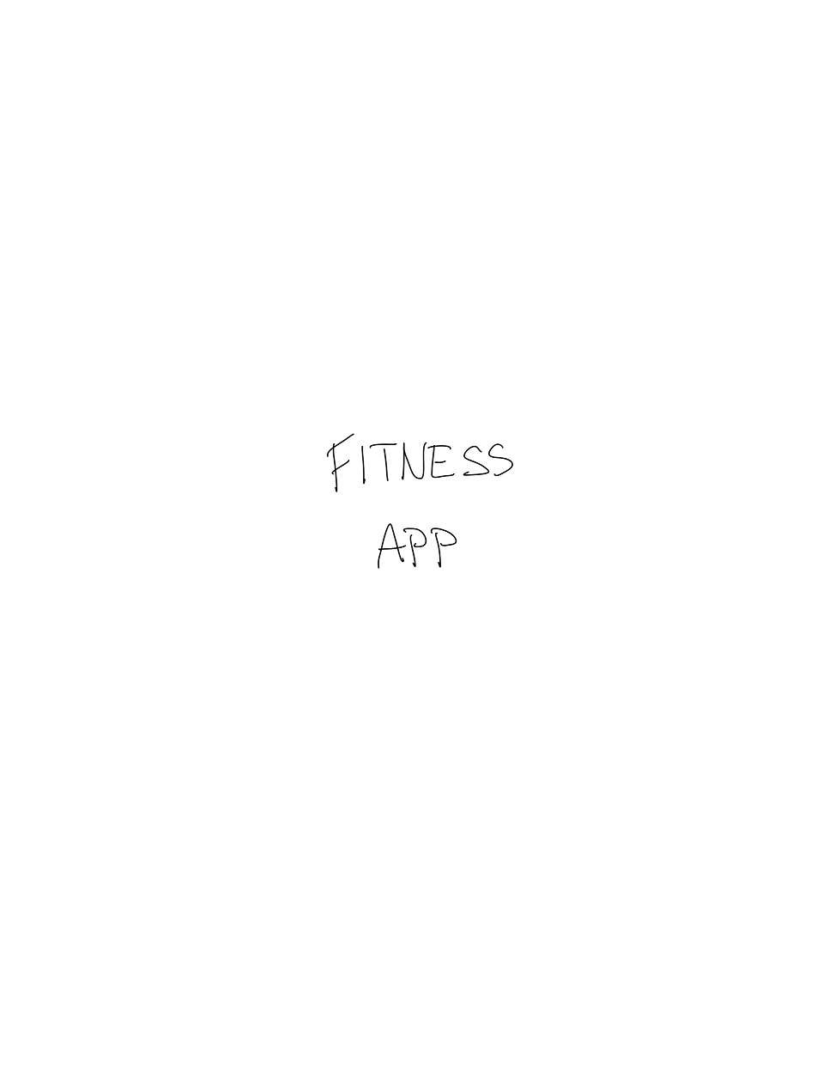

# What is done:

-Introductory (splash) screen

-A screen visible (only?) when the app is starting

# Todo:

-We need to discuss the app/project name – Workout Buddy came to my mind as a temporary “Working title”

- Žiada si to tu nejako logo – (Veľa sa dá nájsť/vygenerovať na nete, prípadne, keď to bude vážne, počerpáme Jana nech nám niečo profi nakreslí)

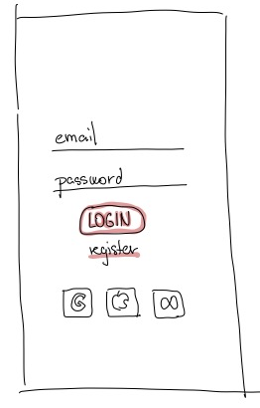

What is done:

-Simple login screen

-OAuth 2.0 authentication/authorization option (a must today)

TODO:

-Subtle “forgotten password” button/text

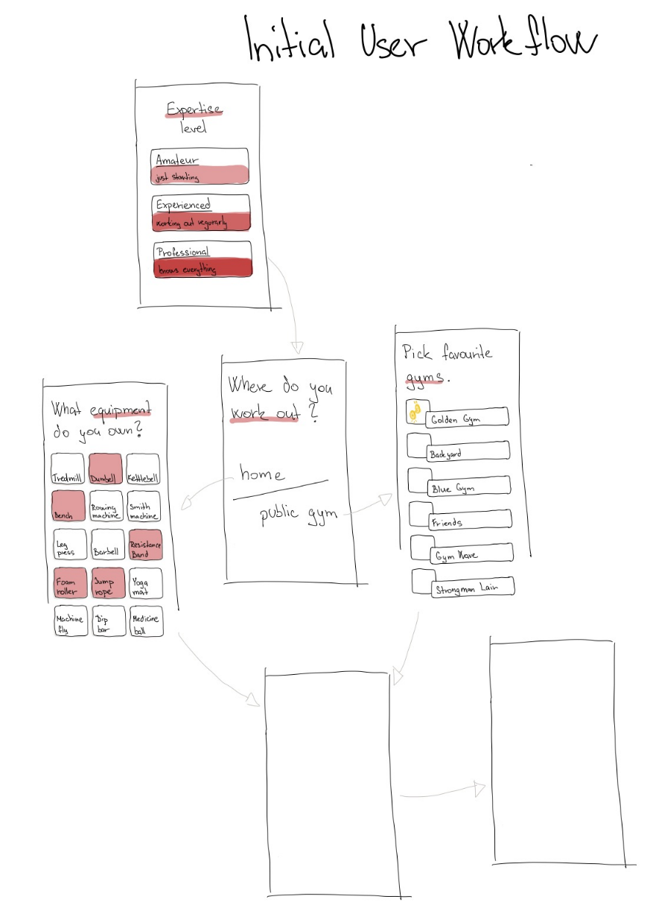

What is done:

* Initial setup/configuration screen
* Expertise level choice screen
* Workout “place” choice screen
* Home equipment choice screen
* Gym picker

TODO:

* Personal parameters / measures / statistics input screen (probably optional, with skip button)
  + Weight, Height, Age, Sex, … Ideally strength and endurance somehow (How much you can lift / run)
* Goals choice screen (personally, I think, maybe the most important one)
  + Just Lose Weight
  + Increase strength
  + Gain Muscle
  + General fitness improvement (Combination) – preferred if you don’t have a certain goal set yet

Ideas:

* I would add one additional experience level – Absolute Beginner
* I would shift Amateur to: “I have worked out several times before and I feel like I have some basic sport/fitness knowledge”
* Experienced: “I have some serious experience and already made some visible progress on my body. I am working out for at least six+ months straight now.”
* Professional: “I am here just to track my progress and workouts. Some inspiration to freshen my routine would be nice too.”

Notes:

* Expertise by som asi nahradil za experience
* Super nápad s tým home workoutom a equipmentom
* Tým gym pickrom si nie som istý … nepríde mi to nejako praktické či užitočné -> Viem si ale predstaviť po kliknutí na public gym nejaký dialóg type -> „Need help finding a gym near you?“ -> Kde by reálne mohlo vyhľadať gymy napr. v okolí 10km, ... -> Bojím sa ale či by sme to implementačne zvládli, plus by to chcelo nejaké kvalitné dáta alebo dobré API -> Ak by sa nám toto ale podarilo funkčne implementovať, viem si predstaviť že by to bol kurva dobrý sale-argument a veľmi originálna a helpful funkcionalita, vďaka, ktorej by z toho reálne mohla byť relevantná fitness appka

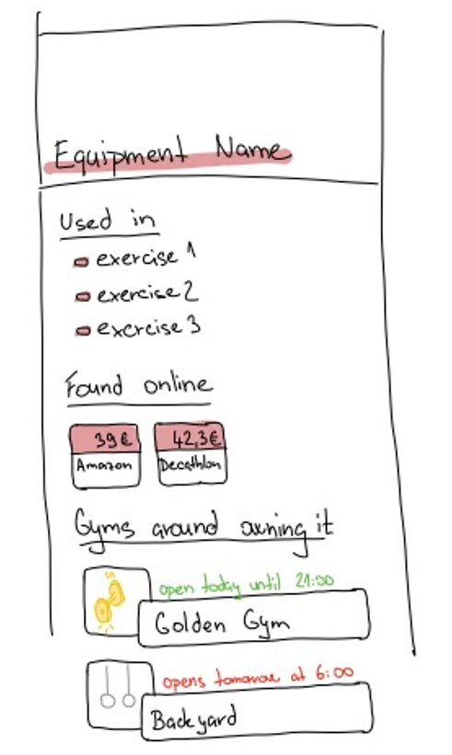

What is done:

* Equipment detail screen
* Linkage to exercises where it is used
* Links to buy
* Gyms around with this equipment

TODO:

* Description / Notes field I find necessary
* Picture of the equipment included

Notes:

* Ehmm no neviem no, to found online a gyms around to mi pride ako niečo celkom out of scope, plus tie gyms by sme asi ani nemali ako implementovať. Nechal by si som ako optional/nice to have ale rozhodne low priority

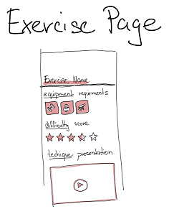

What is done:

* Exercise detail page
* Equipment requirements
* Difficulty
* Technique / howto

TODO:

* Description / notes

Ideas:

* I am not sure how difficult it would be to find and include the videos, especially if we would like to cover most of the exercises, therefore maybe illustrative pictures such as <https://www.google.com/url?sa=i&url=https%3A%2F%2Fwww.strengthlog.com%2Fbench-press%2F&psig=AOvVaw3EM4TfI__cnMWITN_NLEk_&ust=1638653281213000&source=images&cd=vfe&ved=0CAsQjRxqFwoTCODp8bLJyPQCFQAAAAAdAAAAABAD> would suffice. Combination is also possible – videos for most important exercises, pictures for the rest …

Notes:

* Fakt pekne nakreslená a vymyslená obrazovka, ja som mal fakt pravdu miro, že ty si 10 krát lepší kreslič než tá cigoška čo nás v glumovi hodinu kreslila :D
* Chce to začínať slová veľkými písmenami (ako inde) asi + preklep v technique

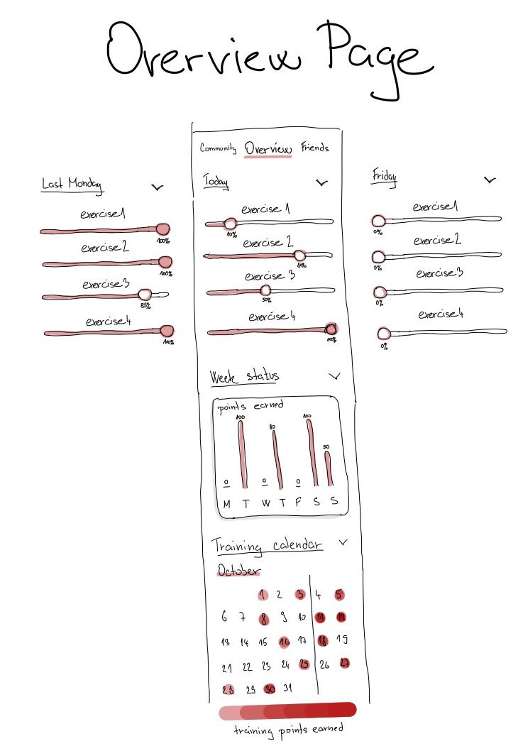

What is done:

* Progress overview screen
* Workout schedule planner?

TODO:

* Navigation (Left and Right Arrows) between workout sessions

Ideas:

* I think calendar should be accessible via a calendar icon/button in either top left or right corner
* I would rename this screen to “Personal Progress” and put it as first among the tabs on the top and Friends as second (First make some progress -> Then compete with your friends -> Become the best one out there (problémom je dôveryhodnosť inputnutých dát))

Notes:

* I am not sure about the “percentage” type of work recording, but I am not confident enough about other Ideas I have so far either
* This input style would require at least some tutorial/instructions for the user

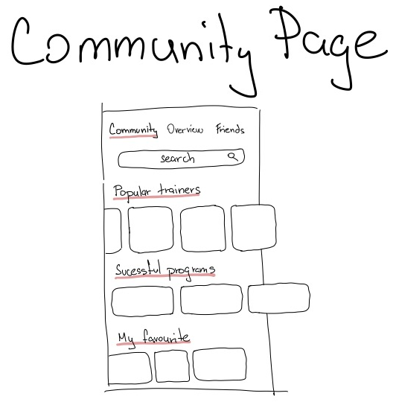

What is done:

* Community screen
* Possibility to find/contact a personal trainer
* Workout routines (for example of famous people) recommendations

TODO:

* “These people near you are looking for a workout buddy!” type of content
* “Let the community know you are looking for a workout buddy / personal trainer”

Ideas:

* Celebrity / famous bodybuilders / athletes workout plans

Notes:

* Will search find people to add as friends too? Or will it only be for “public” stuff and recommendations?
* I prefer friends and “personal community” separate
* I am not sure about the point/role of “My favourite” here
* Successful – Dve c aj s

TODO (Design):

1. We are missing some main navigation (Menu)
   1. I think some left side bar “Hamburger” menu would be nice and sufficient (see Greenpass, Sygic, Kalorické Tabulky, …)
   2. I can imagine a grid style menu (e.g. 3x3, maybe scrollable). Something like this, but fancier (floating round-square icons with shadows, …):

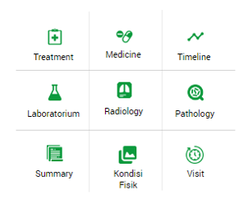

I would include at least these in the menu: Progress, Friends, Community, Plan your workouts, Browse Exercises, Statistics, Settings … a lot of more ideas possible but too far ahead at the roadmap

1. Friends screen
   1. Comparison of progress between you and your friends -> I imagine a graph consisting of N curves (each for each friend, different colors, …) and you can see you are better because your curve is currently above your friends, etc… Curves connect points in time which represent individual workout sessions
   2. Some list of your friends (with profile pictures? By default just random avatars/colors would do fine)
   3. Add friend button
   4. Possibility to inspect friend’s workout schedule and exercise routine
   5. Group/personal chat? – Cool to have, not important
2. Workout / exercise routine planner
   1. Screen for the tool allowing you to actually plan what exercises you are going to do, which muscle areas you want to workout when
   2. Possibility to build your training by yourself -> choose between Full-body (recommended for beginners), Semi-Full-body (Amateurs which don’t have much time for training), Different types of Split (Chest + Biceps is most common, but lot of people do chest+triceps or biceps+triceps, some do not want to do leg workout, …)
   3. Must be able to automatically generate (recommend) a default workout plan and schedule taking into account all available information with possibility cancel (and replace) some exercises (boring/injury/…)