CSCE 102 Lab 13 — Interactive web pages

**more fun with forms**

## General information

* Read the entire assignment before you start.
* Always maintain backup copies of your work, and work on the X drive during lab.
* Never share your password or memory stick with anyone. Maintain the standards of academic honesty discussed in lecture and in previous labs. The work you turn in must be your work.

**Project Reminder — Do not wait until the last minute to work on your project. The end of the semester is coming up fast.**

## Lab13a*xx*.html

**Due at end of class**

* Create a form with 3 text boxes, 1 scrolling text box and 2 buttons.
* Use a h2 to give a title to the page '***Contact Us****'*
* The labels (pg 320) for the 3 text boxes must be **First Name, Last Name** and **E-mail** (see pg 330).
* Use the textarea element (pg 316) that contains *30 cols and 5 rows to create a scrolling text box* with a label *'****Comments****' .*
* The opening form tag must contain the attributes *name, id, method* and *action*. Insert the following values for *method =****”post”*** and *action=****”http://webdevbasics.net/scripts/demo.php”***
* Create ***Contact*** and ***Reset*** buttons at the end of the form (see pg 310).

Hint: The contact button is a submit button with the value=”Contact”

* After you get the layout done, enter the values in the form and click on the Submit button.
* You should receive a message “***Your information has been received*”** followed by the data that you just entered in the form. (see pg. 344)
* Click the Back button on this new page and you should be directed to the form that you created.

Hint: Give appropriate names and ids for each textbox.

Example: *<input type=”text” name=”myFirstName” id=”myFirstName”>*

* Give your page a background color.
* *See template in pg 317*
* You can validate your code at <https://validator.w3.org/>

(See pages 46-47 in your web design textbook)

## Lab13b*xx*.html – Simple Interest Calculator

**Create an Interactive Web Page using Forms to calculate Simple Interest**

Problem: Create a form that can take values entered by the user and calculate Simple Interest.

* Create a form similar to the template below

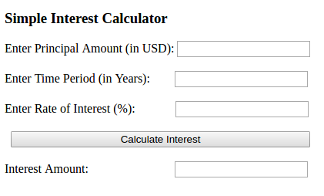

* Write a JavaScript function to take the values entered in the first, second and third text boxes and calculate the simple interest and display the result in the Interest Amount text box when the *Calculate Interest* button is clicked.
* Save the assignment in your **All_102Submissions f**older.

#### Update All_Index.html

1. Add a link to lab13a*xx*.html and lab13b*xx*.html.