CSCE 102 Lab 10 — Grade Calculator

General information
- Read the entire assignment before you start.
- Always maintain backup copies of your work, and work on the X- drive during lab.
- Never share your password or flash drive with anyone.
- Never email your code to anyone.
- Maintain the standards of academic honesty discussed in lecture and in previous labs. The work you turn in must be your work.

Part I — lab10axx.html – Due at the end of class
- Create a table that is structured, with input elements, exactly as shown in Figure A below on the left. You do not need to use a form.
- Insert an h1 below the table that has an id and no content.
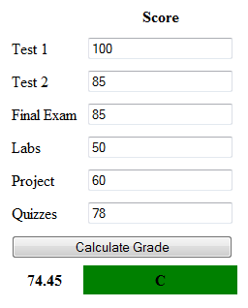
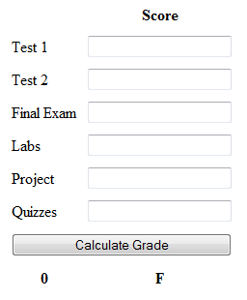

Figure A: lab10axx example Figure B: lab10bxx example

Part II— lab10bxx.html

Save lab10axx.html as lab10bxx.html and write the code to complete the calculations:

- When the button is clicked call a function that:

- Calculates the grade using the weights listed on the class web page.
- Rounds the grade using the JavaScript function Math.round.
- Writes the numeric grade in the bottom left cell of the table.

- Writes the associated letter grade in the bottom right cell of the table.
Use the letter grading scale for this class:
A 100-90
B+ 89-87
B 86-80
C+ 79-77
C 76-70
D+ 69-67
D 66-60
F < 60
- If the grade is passing the background color of the letter grade cell changes to green. If the grade is failing the background color of the letter grade cell will turn black and the letter grade will turn white.
- If the grade is an A have the h1 below the table change to read: You got the A!

- Use the debugger in Firefox, to find errors in your JavaScript function.
- Open Lab-10 in Mozilla Firefox, press the ALT button on the keyboard. This makes the menu bar visible at the top of the page. Click on
TOOLS -> WEB DEVELOPER -> DEBUGGER
You can see the debugger at the bottom of the page, it shows you the errors in the <script> element. After debugging your code, make sure you turn off the debugger by accessing TOOLS -> WEB DEVELOPER -> DEBUGGER
Keyboard Shortcut to turn on/off the debugger Ctrl+Shift+S
- Save your assignment in your All_102Submissions folder.
Part III — Test case
- Carefully test your code and make sure it is correct.

Part IV — Update All_Index.html
- Include a link to lab10axx.html and lab10bxx.html in the list of links in All_Index.html file

