CSCE 102 Lab 11 — Grade Calculator

General information
- Read the entire assignment before you start.
- Always maintain backup copies of your work, and work on the X- drive during lab.
- Never share your password or memory stick with anyone.
- Never email your code to anyone.
- Maintain the standards of academic honesty discussed in lecture and in previous labs. The work you turn in must be your work.

Part I — lab11axx.html – Due at the end of class
- Create a table that is structured, with input elements, exactly as shown in Figure A below.
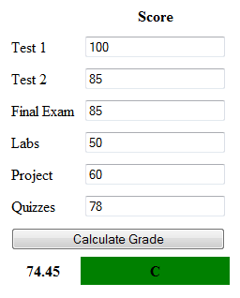
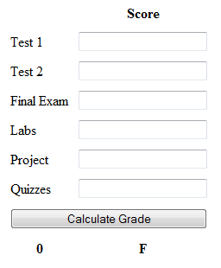

Figure A: lab11axx example Figure B: lab11bxx example

Part II— lab11bxx.html

Text & button input elements
Save lab11axx.html as lab11bxx.html and continue working.

When the button is clicked call a function that:

- Writes the numeric grade in the bottom left cell of the table,

- And the associated letter grade in the bottom right cell of the table.
- For this problem use:
A 100-90
B+ 89-87
B 86-80
C+ 79-77
C 76-70
D+ 69-67
D 66-60
F < 60
- If the grade is passing the background color of the letter grade cell changes to green. If the grade is failing the background color of the letter grade cell should turn red.
- Use the debugger in Firefox, to find errors in your JavaScript function.
- Open Lab-11 in Mozilla Firefox, press the ALT button on the keyboard. This makes the menu bar visible at the top of the page. Click on
TOOLS -> WEB DEVELOPER -> DEBUGGER
You can see the debugger at the bottom of the page; it shows you the errors in the <script> element. After debugging your code, make sure you turn off the debugger by accessing TOOLS -> WEB DEVELOPER -> DEBUGGER
Keyboard Shortcut to turn on/off the debugger Ctrl+Shift+S
- Save your assignment in your All_102Submissions folder.
Part III — Test case
- Carefully test your code and make sure it is correct.

Part IV — Update All_Index.html
- Include a link to lab11axx.html and lab11bxx.html in the list of links in All_Index.html file

