Connected Environments

CASA0021 Group Project Report

Tea for Three

A Set of Connected Ambient Devices for Remote Tea Rituals

Group 2
Chaoshuo Han Junrong Wang Tianrui Min Zihang He

UCL Centre for Advanced Spatial Analysis 26 April 2026

Word count: 2154 words

Project Resources
Demo Video: https://www.youtube.com/watch?v=3P0uTwmVIM8 GitHub Repository: https://github.com/xms12138/Tea-for-Three Source Code: Final version

Introduction
"Tea for Three" is a set of three connected ambient tea devices designed to support a subtle sense of shared presence between close family members or friends living in different places. Developed in response to the theme Connected Ambient Devices Across the Miles, the project explores how a familiar daily ritual can become a medium for remote connection. The following sections explain the design context, user problem, design and technical iterations, and reflections that shaped the final prototype.

Literature Review
"Tea for Three" draws on calm technology and peripheral interaction research. Building on Weiser and Brown's foundational vision, Bakker, van den Hoven, and Eggen (2015) argued that interactive systems should support both perception and physical interaction in the periphery of attention, allowing technology to embed into everyday routines without demanding focus. Bakker and Niemantsverdriet (2016) extended this with an "interaction-attention continuum," showing that well-designed systems should be usable across varying levels of attention. In "Tea for Three," the LED feedback is intended to operate in this peripheral mode — glanceable and ambient — so users can sense a remote partner's presence without actively reading a screen.
The project also connects with slow technology. Odom, Stolterman, and Chen (2022) extended Hallnäs and Redström's original theory through artifact analysis, identifying design qualities such as implicit slowness and ongoingness that characterise artifacts designed for reflection rather than efficiency. "Tea for Three" follows this direction: it does not notify, measure, or demand a reply. Instead, it creates a quiet shared moment through a familiar tea ritual.
Within the Connected Environments research agenda, "Tea for Three" sits at the intersection of distributed IoT sensing and ambient interaction design. Rather than treating networked devices as tools for data exchange or remote control, the project explores how synchronised physical artifacts — communicating through MQTT and embedded force sensing — can mediate social presence across geographical distance. This positioning shapes several key technical decisions discussed later in the report: the choice of a publish/subscribe architecture rather than a centralised server; the use of a physical action (cup placement) as input rather than a screen-based interface; and the deliberate restriction of feedback to glanceable LED states. In doing so, the project extends the concerns of connected environments from monitoring and automation toward the emotional and ritual dimensions of everyday domestic life.

Problem Statement and Scenario

Motivation
Close relationships maintained across geographical distance often lose small daily moments of togetherness. Video calls and messages are effective for direct communication, but they can feel too deliberate or demanding for casual presence. Many people may want to express "I am here" or "I am joining you" without starting a full conversation. The project therefore asks: How can a set of connected ambient tea devices support a subtle sense of shared presence between close family members or friends who are physically separated?

User scenario
The intended users are small groups who share a close relationship but live apart — international students and their families, friends separated by work or migration, and relatives who cannot meet regularly. These users do not necessarily need another notification-based platform; they may benefit more from a quiet, unobtrusive way to feel connected during an ordinary part of the day.

Project Objectives
The project pursues three connected objectives:
- Conceptual: explore how connected devices can preserve the emotional bond between close family or friends sharing tea across a distance, conveying presence, care and companionship.
- Technical: develop three independent but synchronised devices that detect local interaction and communicate state to the others in real time over long distances.
- Design & commercialisation: create a form that conveys warmth and ritual whilst remaining intuitive, replicable through feasible manufacturing methods, and suitable for further development as a consumer product.

Prototype Overview

5.1 Product form
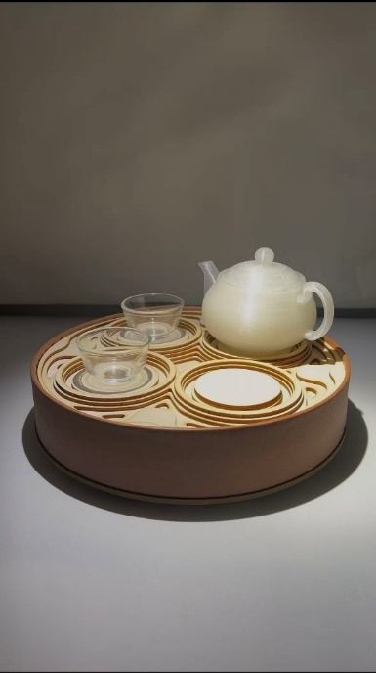
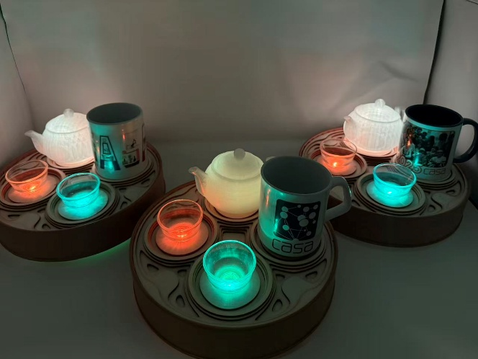
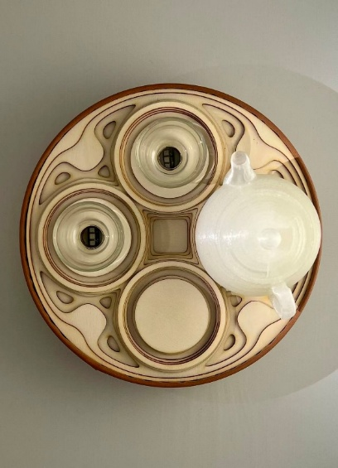
The "Tea for Three" product comprises three interconnected ambient devices that can be used in different spaces and remain synchronised over the network. Each device features a cup-holding area as the user interaction zone, two indicator lights shaped like teacups, and one teapot-shaped indicator. Each device is powered via USB.
Figure 1,2,3: Final prototype — three devices forming a complete Tea for Three set

5.2 User Instruction
Once a user begins drinking tea, they place their teacup on the sensor area. The device detects the user's presence and transmits this status to the connected system. When other devices receive this message, the indicator light corresponding to that user illuminates. When the system detects that all three users are online, the teapot-shaped indicator activates with a special ambient lighting effect, marking the moment when all participants have joined the remote tea gathering.

Project implementation
This section details the hardware and software system implementation of the final Tea for Three prototype. The system consists of three identical physical devices, achieving low-latency remote state synchronisation through IoT technology.

6.1 Hardware & Circuit Design
The core microcontroller of the system is the Arduino MKR WiFi 1010, combined with an FSR402 force sensitive resistor to detect the cup placement status, providing visual feedback via WS2812B RGB and Adafruit NeoPixel Stick LED strips.
Regarding circuit wiring, to ensure the stable operation of multiple LEDs, the system utilises an external, independent 5V power supply. The specific pin assignments are as follows:
- LED Data Pins: LED1 (representing participant B) is connected to D6, and LED2 (representing participant C) is connected to D7.
- Sensor Reading: The FSR402 is connected to analog pin A6 in series with a 10kΩ pull-down resistor connected to GND, ensuring the stability and accuracy of the 3.3V analogue signal reading.

6.2 Software Architecture
The software follows a dual-mode operation model. On boot, the device first checks whether valid WiFi credentials exist in flash memory. If not, it enters Config Mode and opens an AP hotspot with a local web server at 192.168.4.1, allowing users to enter network details through a browser. Once credentials are stored, the device automatically switches to Normal Mode, which runs the main MQTT loop, polls the FSR sensor, and drives the LED feedback. An automatic reconnection mechanism handles temporary disconnection.

6.3 Sensor Input & MQTT Communication
To suppress noise from the analogue FSR readings, the input pipeline applies a moving average over 10 samples, a dual-threshold hysteresis (press ≥ 50, release ≤ 35) and a stable-count check requiring 3 consecutive matching cycles before a state change is confirmed. This combination eliminates flicker and false triggers in steady use.
For inter-device communication, the system uses the lightweight MQTT protocol in a publish/subscribe topology. Each device acts as both a publisher and a subscriber. When the FSR state of Device A changes, it publishes an "on" or "off" payload to the student/MUJI/hzh/A topic, whilst subscribing to topics B and C. When all three devices report "on" simultaneously, the system triggers the "Warm flowing tea-light" animation in the teapot area, providing the collective feedback that marks a complete shared moments.

Project iterations

7.1 Initial concept
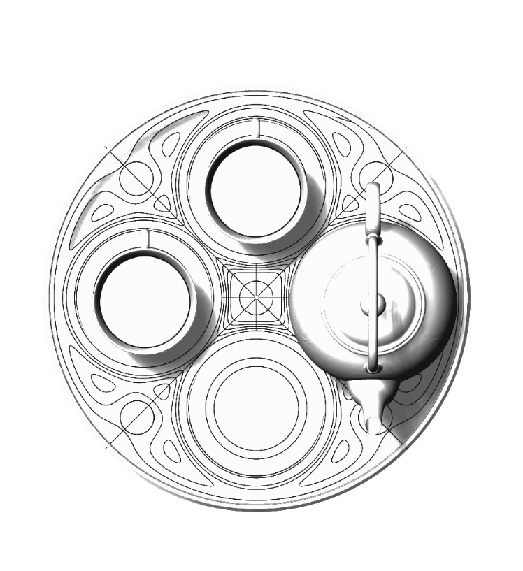
The initial design featured an oval-shaped tray with two indicator lights, a space for a teapot and a space for a teacup. The surface of the tray is engraved with curved patterns, which provide a stable base for the teacup and teapot, and also allow water droplets to flow along the grooves towards the drain. However, in view of waterproofing and electrical safety concerns, the load-bearing capacity of the tray material, and the uncertainty regarding the size of the teapot, this proposal was rejected. Instead, the solution adopted was to place a decorative teapot-style indicator on the tray.
Figure 4: Initial concept sketch of the oval tea tray design

7.2 3D printing version
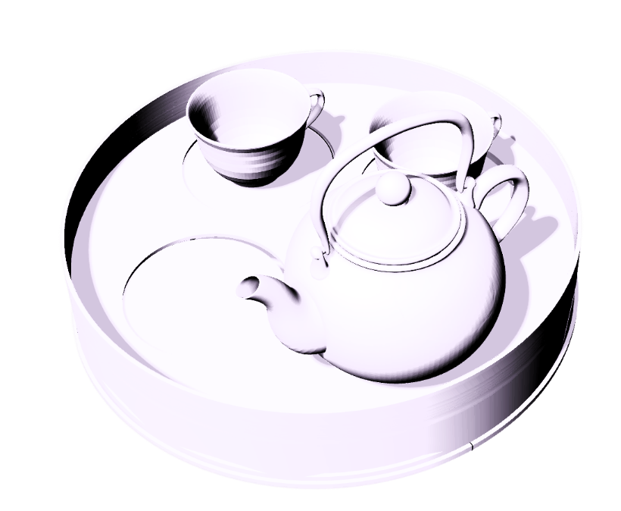
Early versions attempted to use 3D printing technology to manufacture the entire device, including the casing, tray and decorative elements. However, this design presented a number of problems: the production cycle was lengthy, it required a large amount of material, and the finished product had a cheap feel to it, with rough surface details, making it difficult to meet the requirements of a household tea set. Furthermore, it proved quite challenging to neatly integrate sensors, wires and LED lights within a single printed component.
Figure 5: Early 3D-printed prototype showing integrated tray and teapot form

7.3 Laser-cut + 3D print with soft-wrapped version
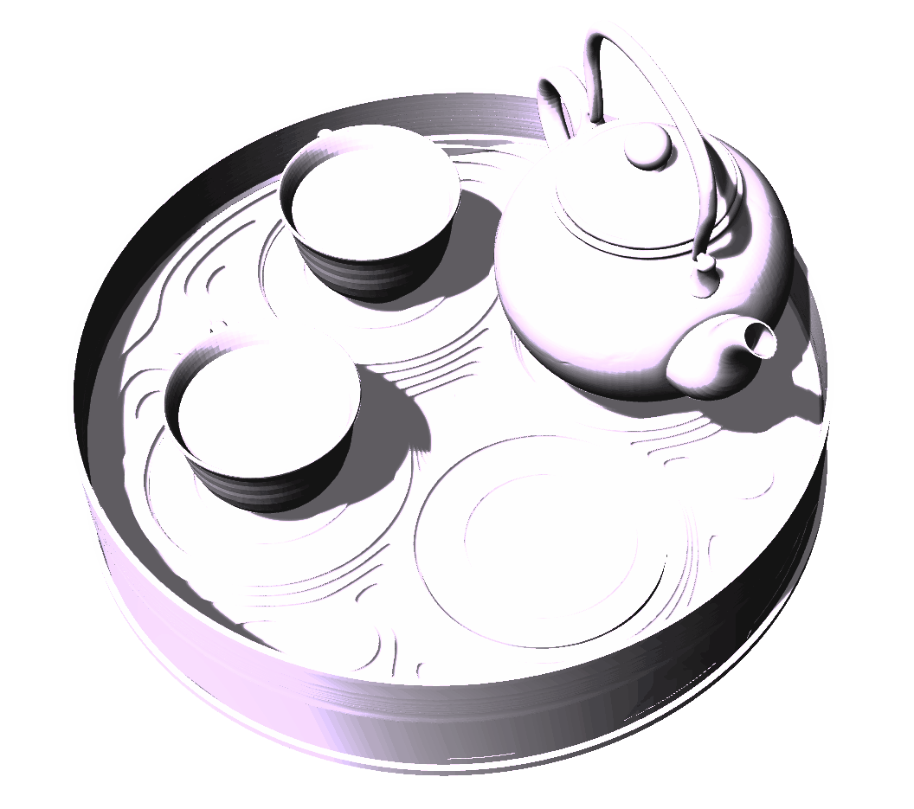
The final version replaces the original single-printed body with a laser-cut plywood base and a 3D-printed shell. Wood was chosen for the tray material due to its inherent warmth, which naturally evokes a sense of calm and tranquillity. Furthermore, wood is well-suited to modular assembly and replication. This version also features a soft material (faux leather) wrapping the outer shell, enhancing the product’s aesthetic appeal and lending it a homely feel. The decorative elements remain 3D-printed, and the teapot-shaped light diffuser is retained as the core design feature. This hybrid manufacturing approach makes the device easier to assemble, repair and replicate.
Figure 6: Final iteration combining laser-cut plywood base with 3D-printed shell and faux leather wrapping

7.4 Iteration of Sensor Reading Algorithm (Debouncing)
Force sensitive resistors generate considerable analogue noise. Three iterations were carried out at the input layer. The initial implementation read the analogue pin values directly, causing the lights to flicker even when the cup was stationary. A moving-average smoothing filter mitigated high-frequency noise but still allowed the state to bounce at the moment a cup was placed. The final design combined dual- threshold hysteresis with a stable-count check: a state change is only confirmed when the condition is met for several consecutive cycles, eliminating false triggers entirely.

7.5 Iteration of Network Architecture & Robustness
The stability of multi-device collaboration evolved from "fragile" to "robust." Early prototypes hardcoded WiFi and MQTT credentials, requiring the program to be reflashed whenever the testing location changed. To address this, a Captive Portal was developed: when no valid credentials are present in flash, the device boots as an Access Point with a local configuration web page. Field tests then revealed that occasional network jitter caused devices to drop offline or lose packets. The final iteration added an automatic recovery mechanism alongside a periodic state-publishing logic, so that even if a state-switch message is lost, the device republishes its own state at regular intervals. This ensures that all devices — including those joining late or experiencing brief disconnections — eventually reach a synchronised state.

Evaluation and Reflection

Final Progress
The final prototype successfully demonstrates the core concept of "Tea for Three" as a connected ambient system. A complete set of three devices was implemented, allowing three physically separated users to participate in the same remote tea ritual. During internal testing, the three devices were placed in different rooms across separate networks, and consistently achieved state synchronisation within one to two seconds of cup placement, with the teapot animation reliably triggering when all three users joined. The most effective aspect of the prototype is its use of a simple physical gesture — cup placement — as the basis for remote communication. This makes the interaction feel more connected to the act of drinking tea than a button or app interface would, supporting the project's aim of creating a subtle sense of companionship across distance.

Limitations
Some limitations are worth noting. First, the interaction range remains relatively simple: the system can only indicate whether each participant is present, and cannot convey more nuanced emotional states such as waiting, inviting or missing someone. Second, the feedback medium is not sufficiently expressive: when all three users have joined, the teapot lights up to mark collective participation, but this acts more as a binary completion signal than as a rich emotional symbol of companionship.

Future work
Given sufficient time, there are several avenues to explore in order to develop the prototype into a more refined product. Firstly, the interactive vocabulary could be expanded so that it is not limited to simple ‘present’ and ‘absent’ states, but can also convey a richer range of emotional states. This could be achieved through gesture input, cup temperature sensing, or the duration for which the cup is placed on the stand. Technically, in terms of physical construction, improvements to water resistance, optimised cable management and additional battery options would help support genuine long-term domestic use. Finally, conducting longitudinal field studies with groups of friends and family members across different time zones would help assess whether the device can effectively enhance the sense of remote companionship in real-world use.

Conclusion
"Tea for Three" explores how connected ambient devices can support emotional connection between family members or close friends who are physically separated. Rather than focusing on verbal communication, screens or information exchange, the project uses a familiar tea-drinking ritual to create a subtle sense of shared presence across distance. The work demonstrates that remote communication does not always need to be direct or attention-demanding: small physical gestures and glanceable ambient feedback can create a softer form of connection. Whilst the prototype still requires further refinement, it provides a clear foundation for a connected ambient product that transforms tea drinking into a shared remote experience.

References
Bakker, S. and Niemantsverdriet, K. (2016) 'The interaction-attention continuum: Considering various levels of human attention in interaction design', International Journal of Design, 10(2), pp. 1–14.
Bakker, S., van den Hoven, E. and Eggen, B. (2015) 'Peripheral interaction: characteristics and considerations',
Personal and Ubiquitous Computing, 19(1), pp. 239–254.
Hallnäs, L. and Redström, J. (2001) 'Slow technology: Designing for reflection', Personal and Ubiquitous Computing, 5(3), pp. 201–212.
Odom, W., Stolterman, E. and Chen, A.Y.S. (2022) 'Extending a theory of slow technology for design through artifact analysis', Human–Computer Interaction, 37(2), pp. 150–179.
Weiser, M. and Brown, J.S. (1997) 'The coming age of calm technology', in Denning, P.J. and Metcalfe, R.M. (eds.) Beyond Calculation: The Next Fifty Years of Computing. New York: Springer, pp. 75–85.

