**1. Figures**

<Figure 1.>

<Figure 2.>

<Figure 3.>

<Figure 4.> <Figure 5.>

<Figure 6.>

<Figure 7.>

<Figure 8.>

<Figure 9.>

<Figure 10.> <Figure 11.>

<Figure 12.>

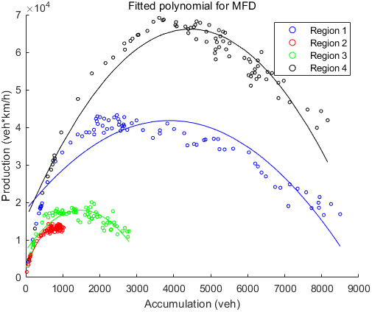

<Figure 13.>

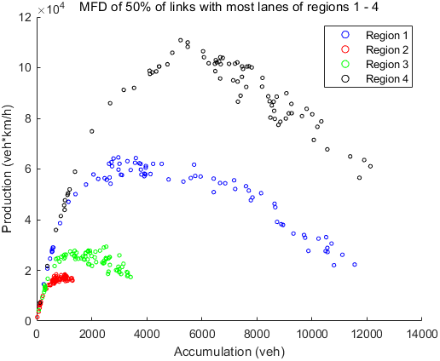

<Figure 14.>

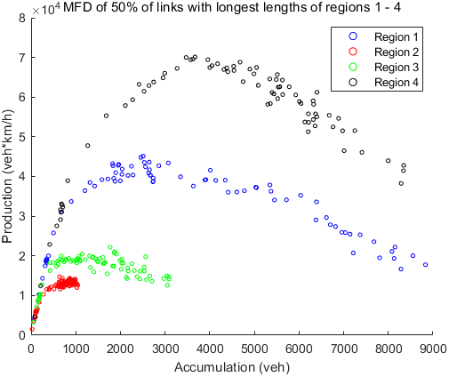

<Figure 15.>

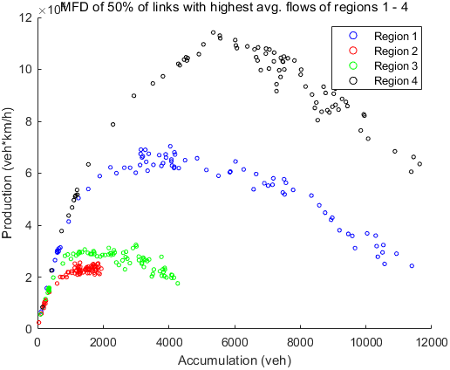

<Figure 16.>

<Figure 17.>

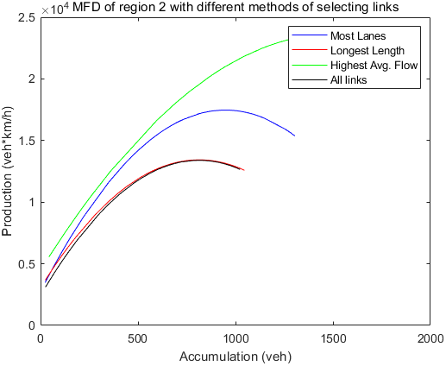

<Figure 18.>

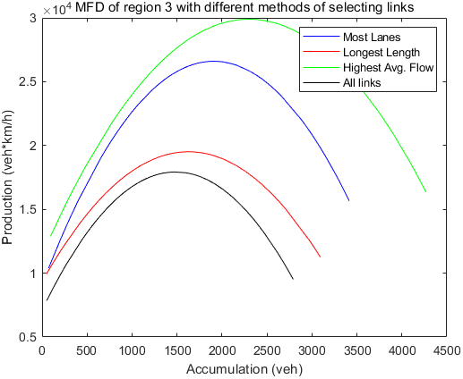

<Figure 19.>

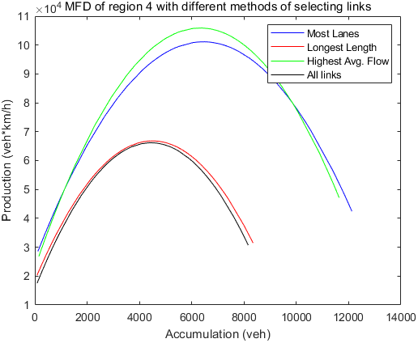

<Figure 20.>

<Figure 21.>

<Figure 22.>

<Figure 23.>

<Figure 24.>

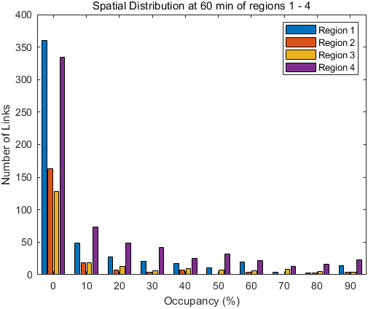

<Figure 25.>

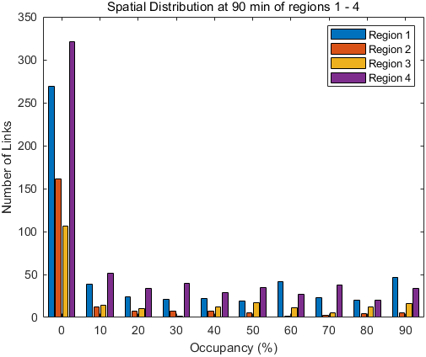

<Figure 26.>

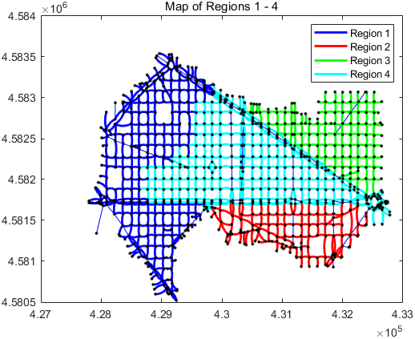

<Figure 27.>

**2. Tables**

<Table 1.> <Table 2.>

<Table 3.>

|  |  |  |  |
| --- | --- | --- | --- |
| Frechet Disance | Most Lanes | Longest Length | Highest Avg. Flow |
| Region 1 | 20290.14 | 1053.086 | 24354.58 |
| Region 2 | 4074.287 | 571.9451 | 10283.02 |
| Region 3 | 8684.965 | 2087.415 | 11997.7 |
| Region 4 | 35031.4 | 2791.435 | 39791.59 |

<Table 4.>

|  |  |  |  |  |
| --- | --- | --- | --- | --- |
| Frechet Disance | Most Lanes | Longest Length | Highest Avg. Flow | Random Selection |
| Region 1 | 20290.14 | 1053.086 | 24354.58 | 1528.801 |
| Region 2 | 4074.287 | 571.9451 | 10283.02 | 1172.004 |
| Region 3 | 8684.965 | 2087.415 | 11997.7 | 1204.2 |
| Region 4 | 35031.4 | 2791.435 | 39791.59 | 3393.016 |

<Table 5.>

|  |  |  |
| --- | --- | --- |
| Total Variance | 60 min | 90 min |
| 1 / 2 / 3 / 4 (4 clusters) | 0.975736 | 0.971186 |
| 1 & 4 / 2 / 3 (3 clusters) | 0.988875 | 0.97174 |
| 1 & 3 / 2 / 4 (3 clusters) | 0.976674 | 0.970494 |
| 1 & 4 / 2 & 3 (2 clusters) | 0.994587 | 0.989384 |
| 1 & 3 / 2 & 4 (2 clusters) | 0.996766 | 0.991441 |
| 1 & 2 & 3 & 4 (1 cluster) | 1 | 1 |

<Table 6.>