题目一（简单）

展示电影 ID 为 2116 这部电影各年龄段的平均影评分。

Select b.age , avg(a.rate) as avgrate from t_rating_naxu a

inner join t_user_naxu b on a.userid=b.userid

inner join t_movie_naxu c on a.movieid=c.movieid

where c.movieid = 2116

group by b.age

sort by b.age;

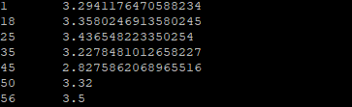

题目二（中等）

找出男性评分最高且评分次数超过 50 次的 10 部电影，展示电影名，平均影评分和评分次数。

select b.sex, c.moviename, avg(a.rate ) as avgrate, count(a.rate) as total

from t_rating_naxu a

inner join t_user_naxu b on a.userid=b.userid

inner join t_movie_naxu c on a.movieid=c.movieid

where b.sex = 'M'

group by c.moviename, b.sex

having total>=50

sort by avgrate desc

limit 10;

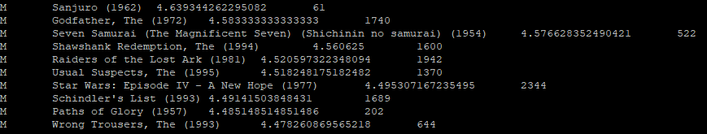

题目三（选做）

找出影评次数最多的女士所给出最高分的 10 部电影的平均影评分，展示电影名和平均影评分（可使用多行 SQL）。

Select c.moviename , avg(a.rate) as avgrate

from t_rating_naxu a inner join t_user_naxu b on a.userid=b.userid inner join t_movie_naxu c on a.movieid=c.movieid

where a.movieid in

(

select temp_a.movieid from

(select c.movieid as movieid , a.rate, b.userid

from t_rating_naxu a inner join t_user_naxu b on a.userid=b.userid inner join t_movie_naxu c on a.movieid=c.movieid

where b.userid in

(select temp.userid from (select bb.userid as userid ,count(aa.rate) as total from t_rating_naxu aa inner join t_user_naxu bb on aa.userid=bb.userid where bb.sex='F' group by bb.userid sort by total desc limit 1) temp)

sort by a.rate desc limit 10) temp_a

)

group by c.moviename;

