Supplementary Material

Distinguishing and Quantifying the Impacts of SARS-CoV-2 Prevention Measures and Transmission on Prevalent Infectious Diseases: A Model-based Study in Mainland China

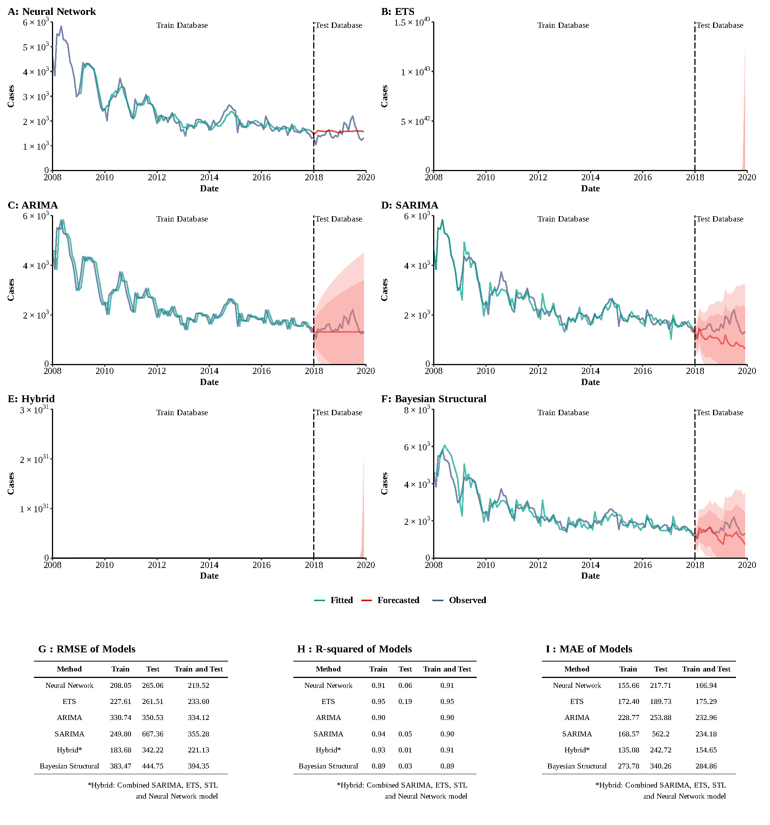

**Supplementary Figure 1**

**Training and comparing variant time series models for HAV.** (A) Neural Network model; (B) ETS model; (C) ARIMA model; (D) SEARIMA model; (E) Hybrid models combining SARIMA, ETS, STL, and neural network model; (F) Bayesian structural model; (G) Root mean square error (RMSE) of variant models; (H) R-squared of variant models; (J) Mean absolute error (MAE) of variant models.

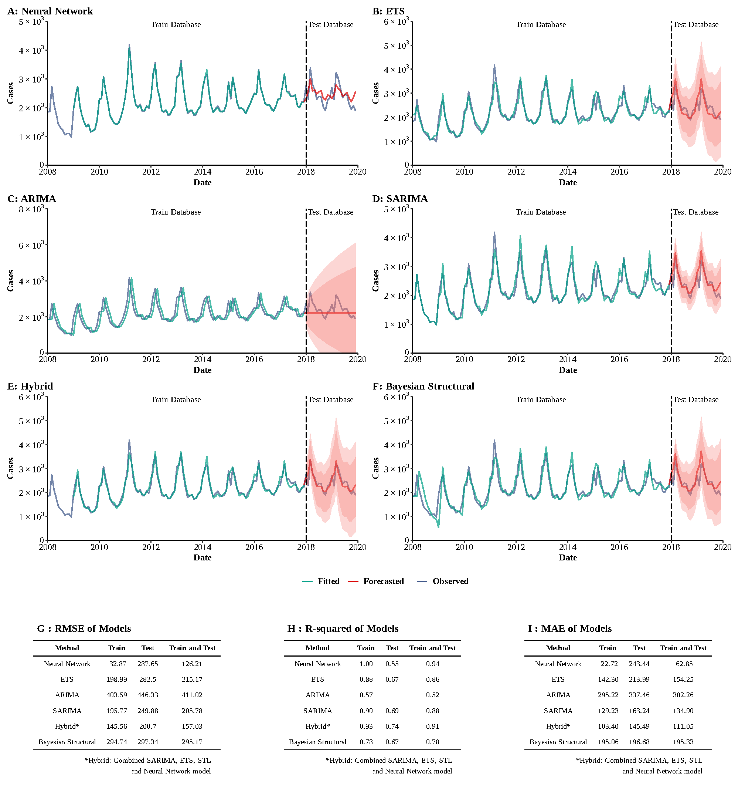

**Supplementary Figure 2**

**Training and comparing variant time series models for HEV.** (A) Neural Network model; (B) ETS model; (C) ARIMA model; (D) SEARIMA model; (E) Hybrid models combining SARIMA, ETS, STL, and neural network model; (F) Bayesian structural model; (G) Root mean square error (RMSE) of variant models; (H) R-squared of variant models; (J) Mean absolute error (MAE) of variant models.

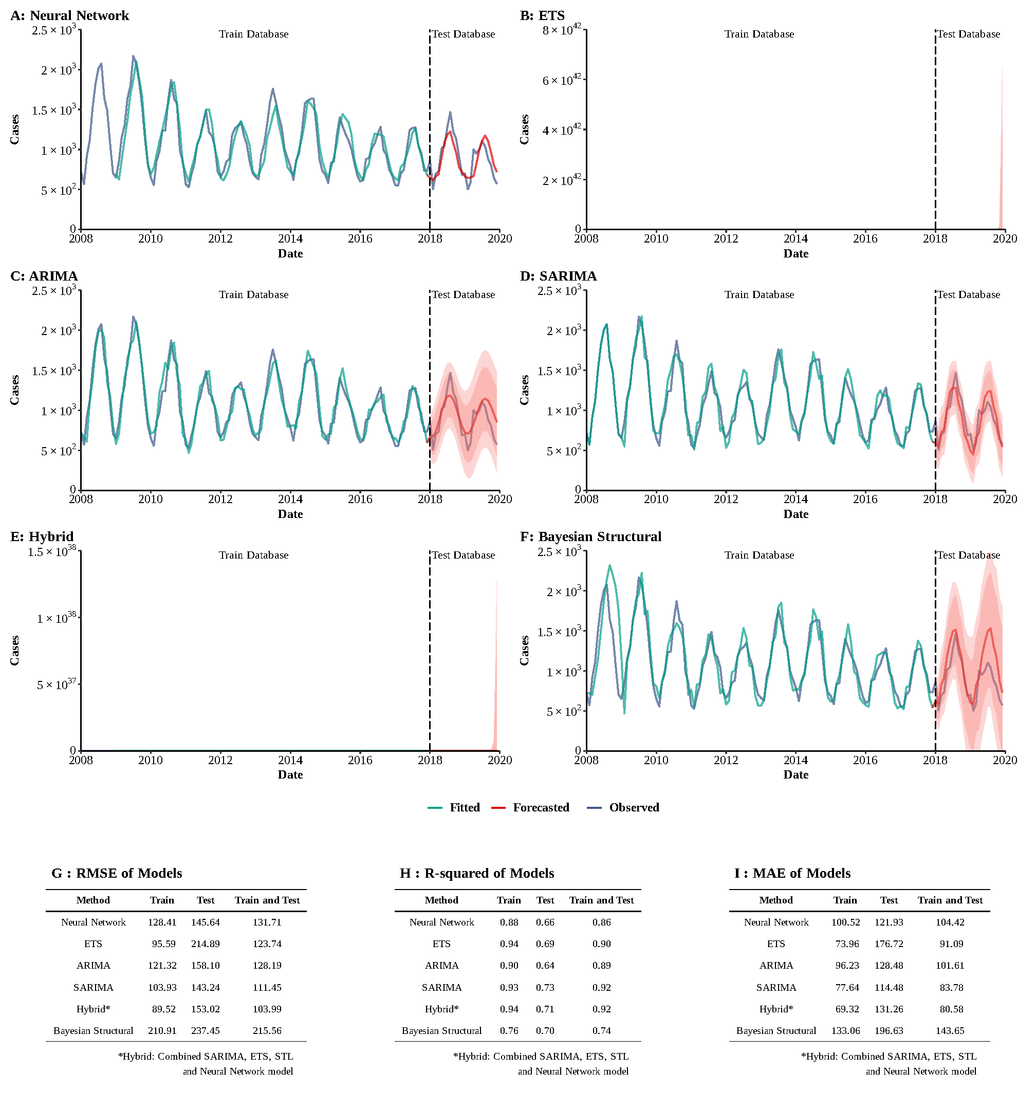

**Supplementary Figure 3**

**Training and comparing variant time series models for Typhoid fever and paratyphoid fever.** (A) Neural Network model; (B) ETS model; (C) ARIMA model; (D) SEARIMA model; (E) Hybrid models combining SARIMA, ETS, STL, and neural network model; (F) Bayesian structural model; (G) Root mean square error (RMSE) of variant models; (H) R-squared of variant models; (J) Mean absolute error (MAE) of variant models.

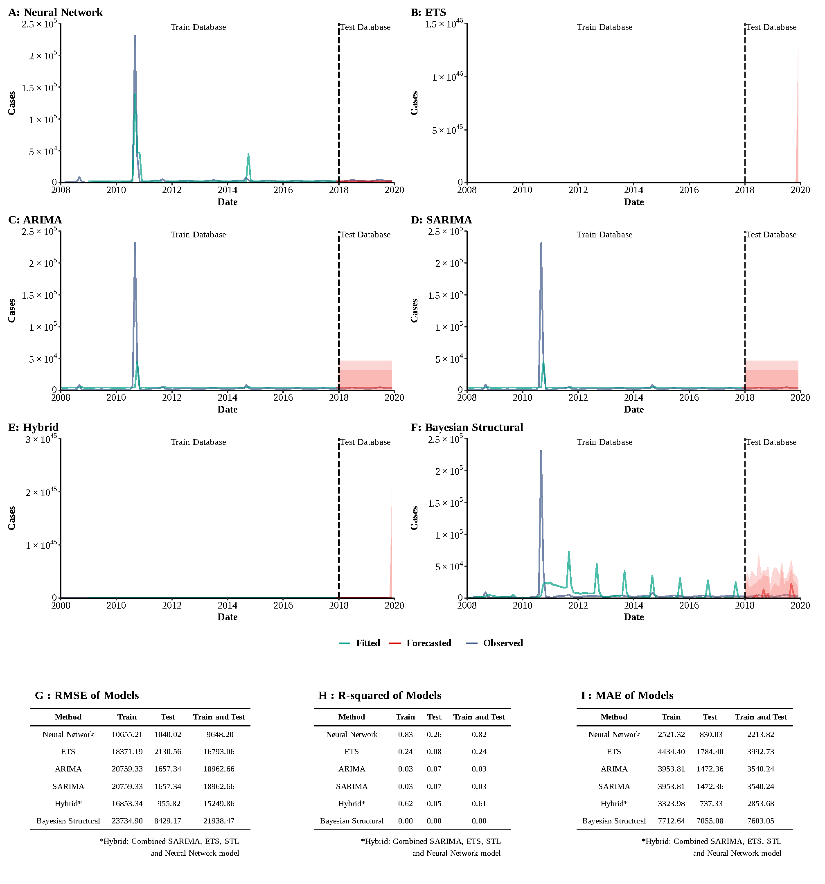

**Supplementary Figure 4**

**Training and comparing variant time series models for Acute hemorrhagic conjunctivitis.** (A) Neural Network model; (B) ETS model; (C) ARIMA model; (D) SEARIMA model; (E) Hybrid models combining SARIMA, ETS, STL, and neural network model; (F) Bayesian structural model; (G) Root mean square error (RMSE) of variant models; (H) R-squared of variant models; (J) Mean absolute error (MAE) of variant models.

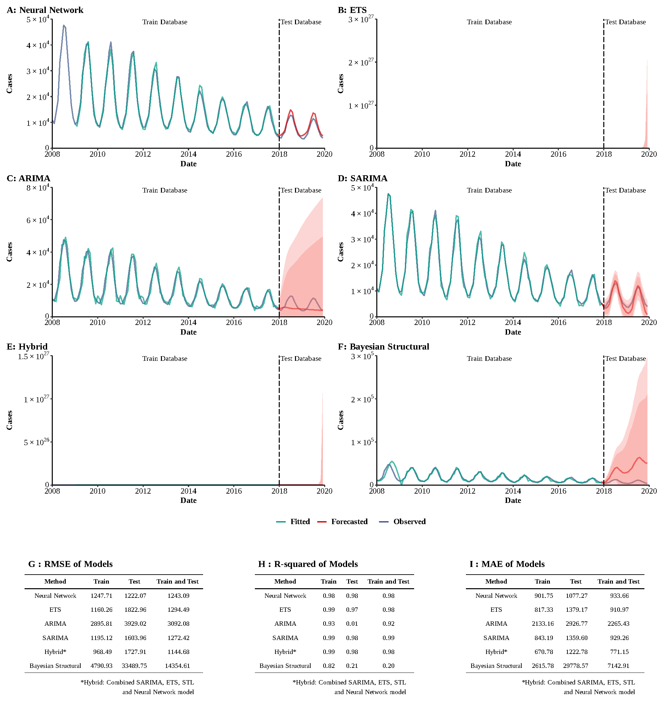

**Supplementary Figure 5**

**Training and comparing variant time series models for Dysentery.** (A) Neural Network model; (B) ETS model; (C) ARIMA model; (D) SEARIMA model; (E) Hybrid models combining SARIMA, ETS, STL, and neural network model; (F) Bayesian structural model; (G) Root mean square error (RMSE) of variant models; (H) R-squared of variant models; (J) Mean absolute error (MAE) of variant models.

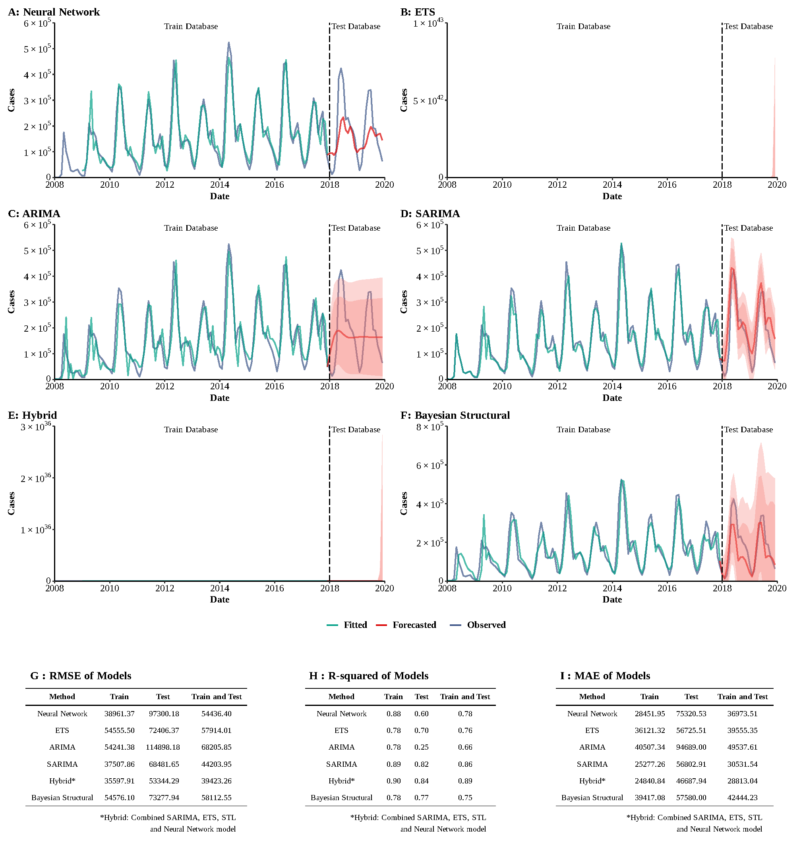

**Supplementary Figure 6**

**Training and comparing variant time series models for HFMD.** (A) Neural Network model; (B) ETS model; (C) ARIMA model; (D) SEARIMA model; (E) Hybrid models combining SARIMA, ETS, STL, and neural network model; (F) Bayesian structural model; (G) Root mean square error (RMSE) of variant models; (H) R-squared of variant models; (J) Mean absolute error (MAE) of variant models.

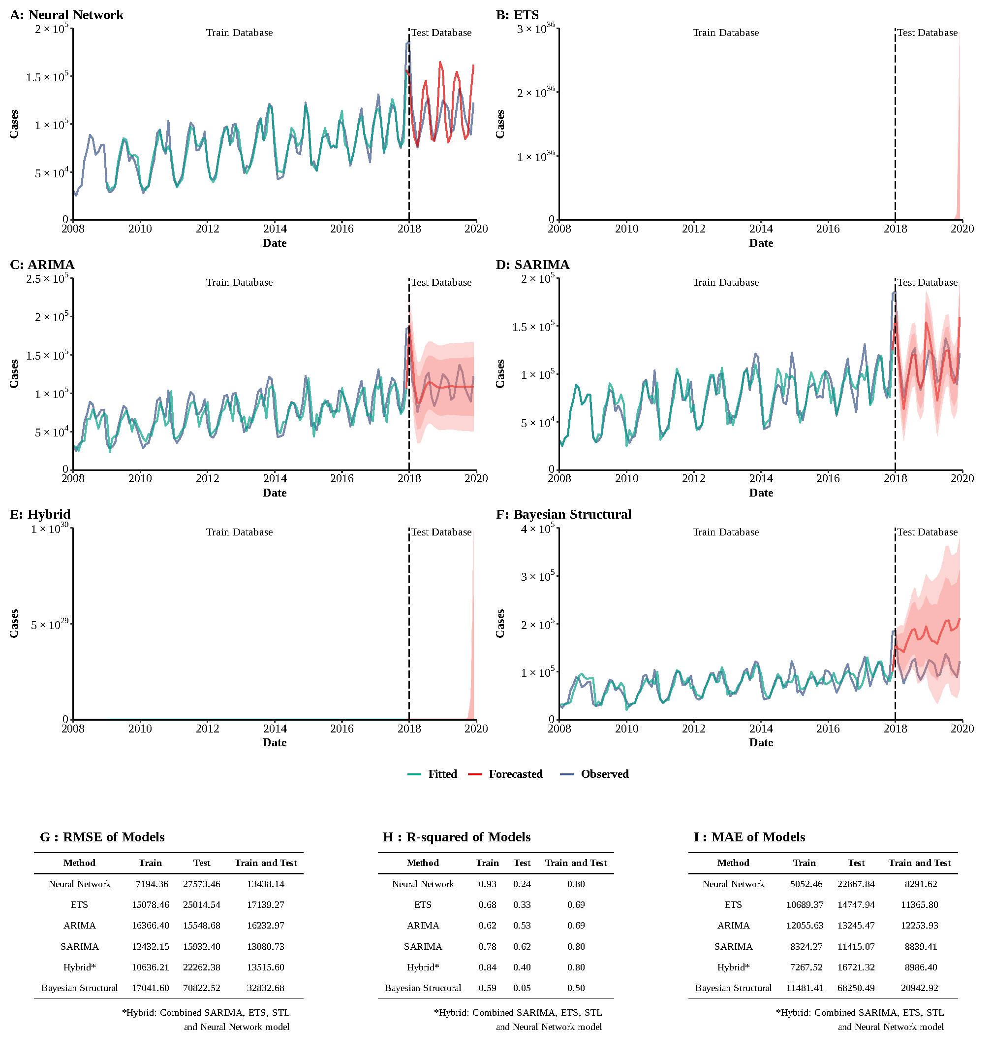

**Supplementary Figure 7**

**Training and comparing variant time series models for Other infectious diarrhea.** (A) Neural Network model; (B) ETS model; (C) ARIMA model; (D) SEARIMA model; (E) Hybrid models combining SARIMA, ETS, STL, and neural network model; (F) Bayesian structural model; (G) Root mean square error (RMSE) of variant models; (H) R-squared of variant models; (J) Mean absolute error (MAE) of variant models.

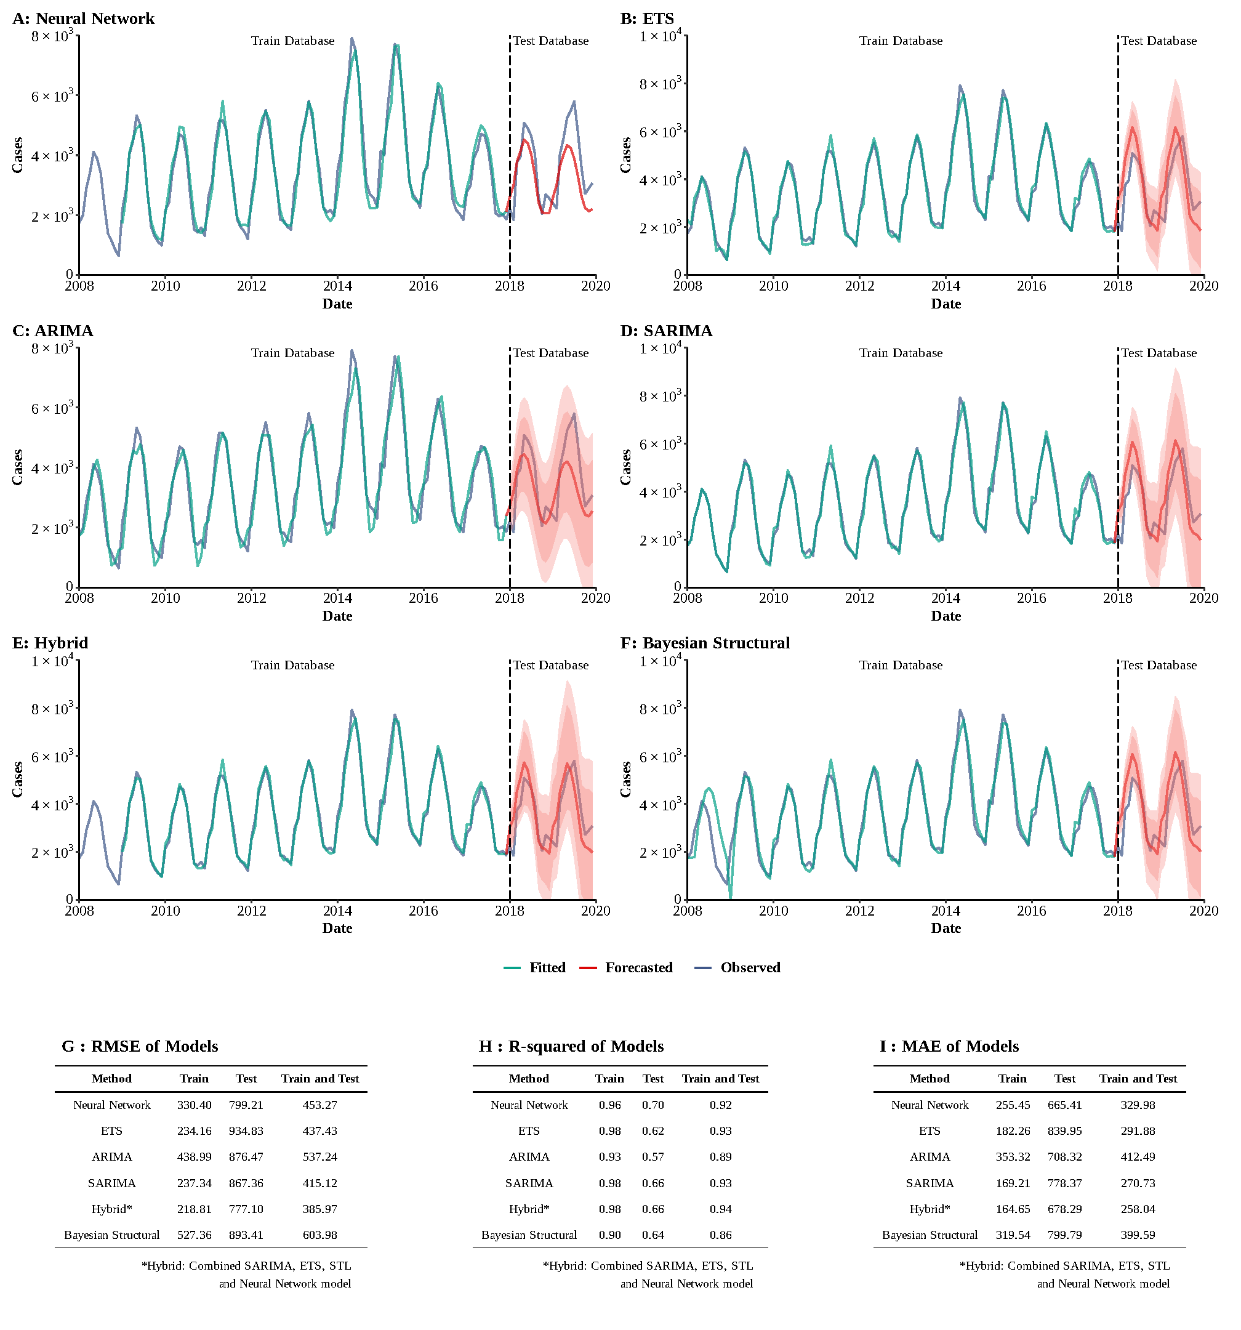

**Supplementary Figure 8**

**Training and comparing variant time series models for Brucellosis.** (A) Neural Network model; (B) ETS model; (C) ARIMA model; (D) SEARIMA model; (E) Hybrid models combining SARIMA, ETS, STL, and neural network model; (F) Bayesian structural model; (G) Root mean square error (RMSE) of variant models; (H) R-squared of variant models; (J) Mean absolute error (MAE) of variant models.

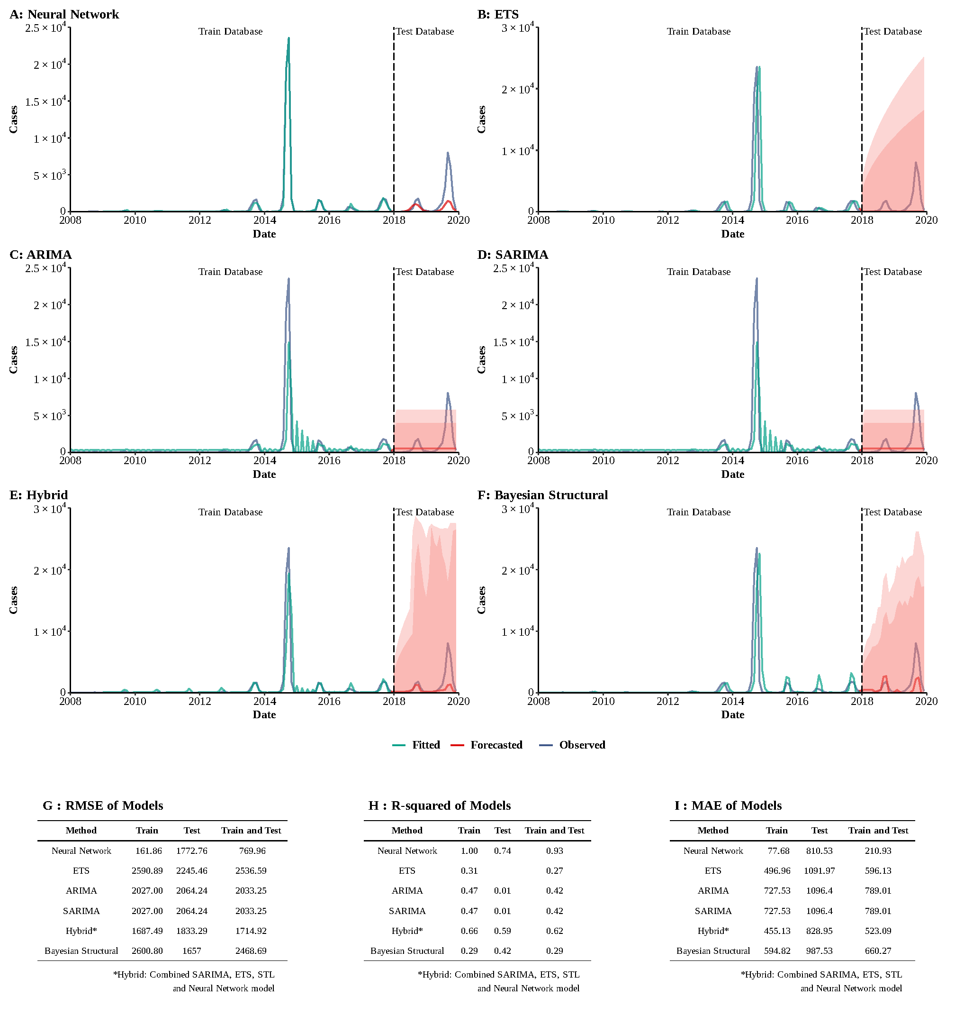

**Supplementary Figure 9**

**Training and comparing variant time series models for Dengue fever.** (A) Neural Network model; (B) ETS model; (C) ARIMA model; (D) SEARIMA model; (E) Hybrid models combining SARIMA, ETS, STL, and neural network model; (F) Bayesian structural model; (G) Root mean square error (RMSE) of variant models; (H) R-squared of variant models; (J) Mean absolute error (MAE) of variant models.

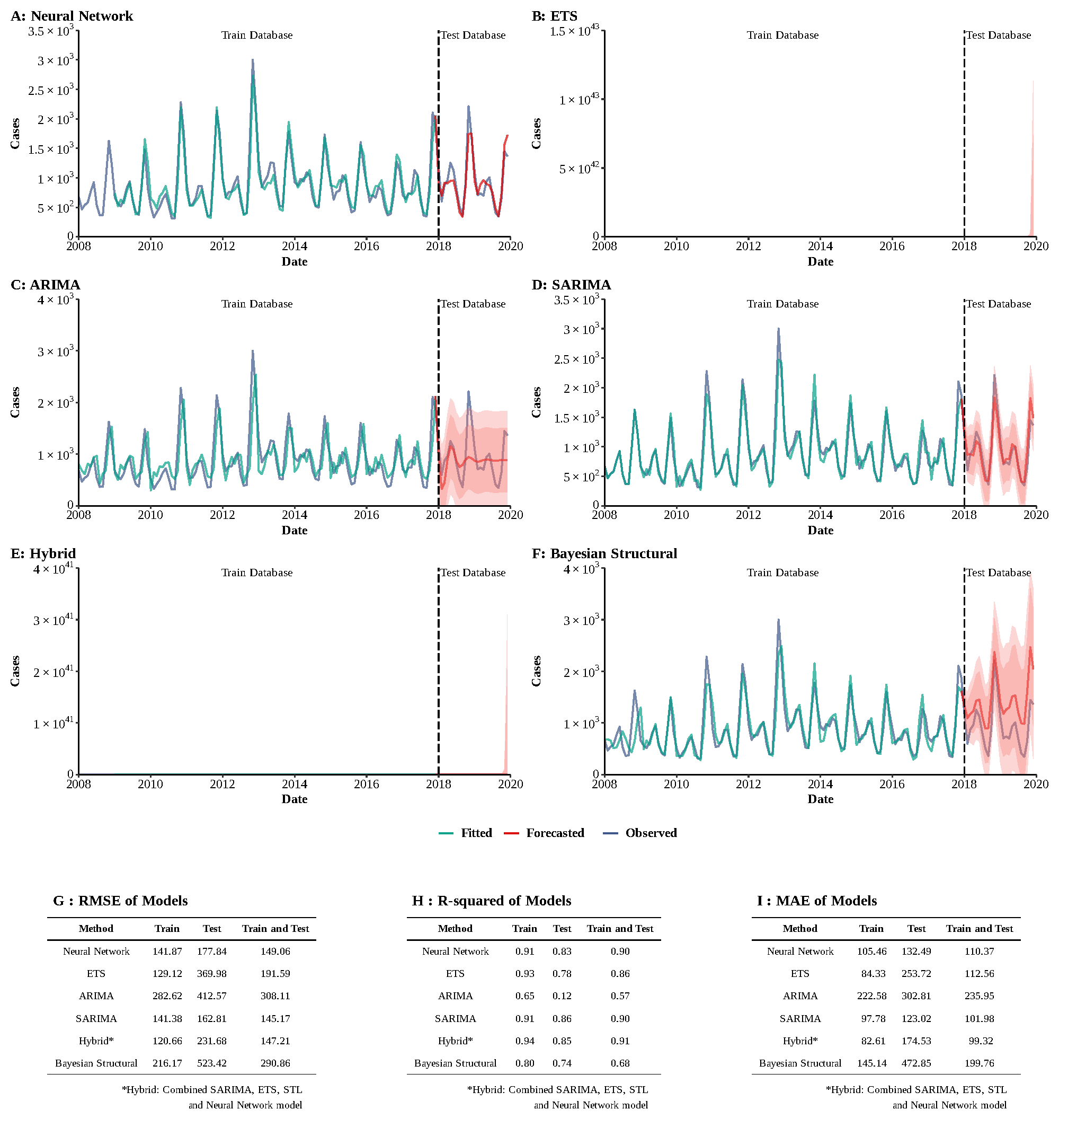

**Supplementary Figure 10**

**Training and comparing variant time series models for HFRS.** (A) Neural Network model; (B) ETS model; (C) ARIMA model; (D) SEARIMA model; (E) Hybrid models combining SARIMA, ETS, STL, and neural network model; (F) Bayesian structural model; (G) Root mean square error (RMSE) of variant models; (H) R-squared of variant models; (J) Mean absolute error (MAE) of variant models.

=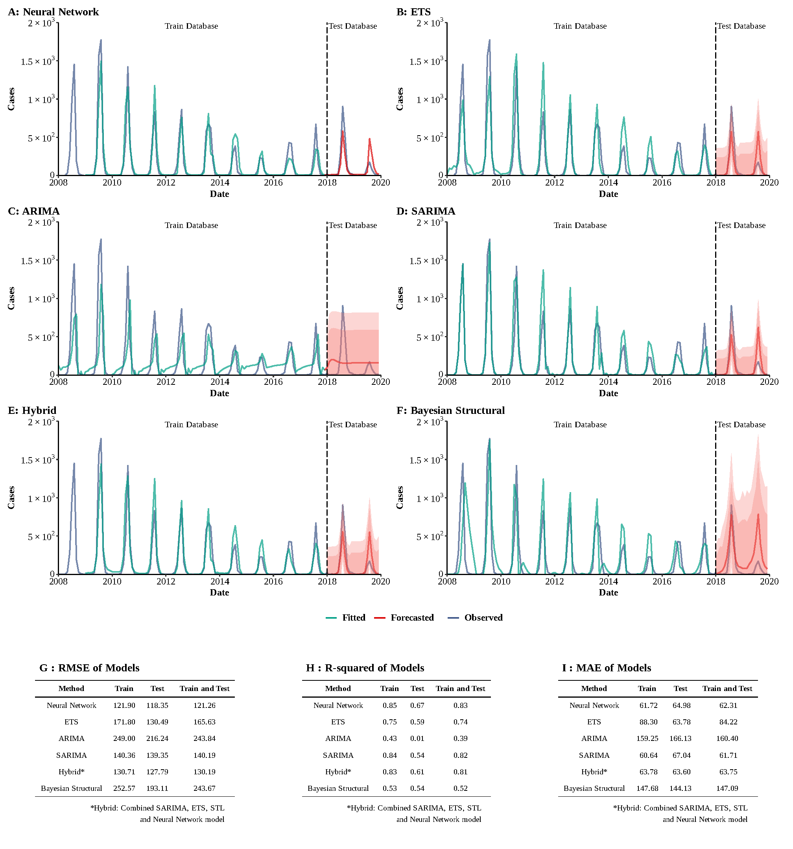

**Supplementary Figure 11**

**Training and comparing variant time series models for Japanese encephalitis.** (A) Neural Network model; (B) ETS model; (C) ARIMA model; (D) SEARIMA model; (E) Hybrid models combining SARIMA, ETS, STL, and neural network model; (F) Bayesian structural model; (G) Root mean square error (RMSE) of variant models; (H) R-squared of variant models; (J) Mean absolute error (MAE) of variant models.

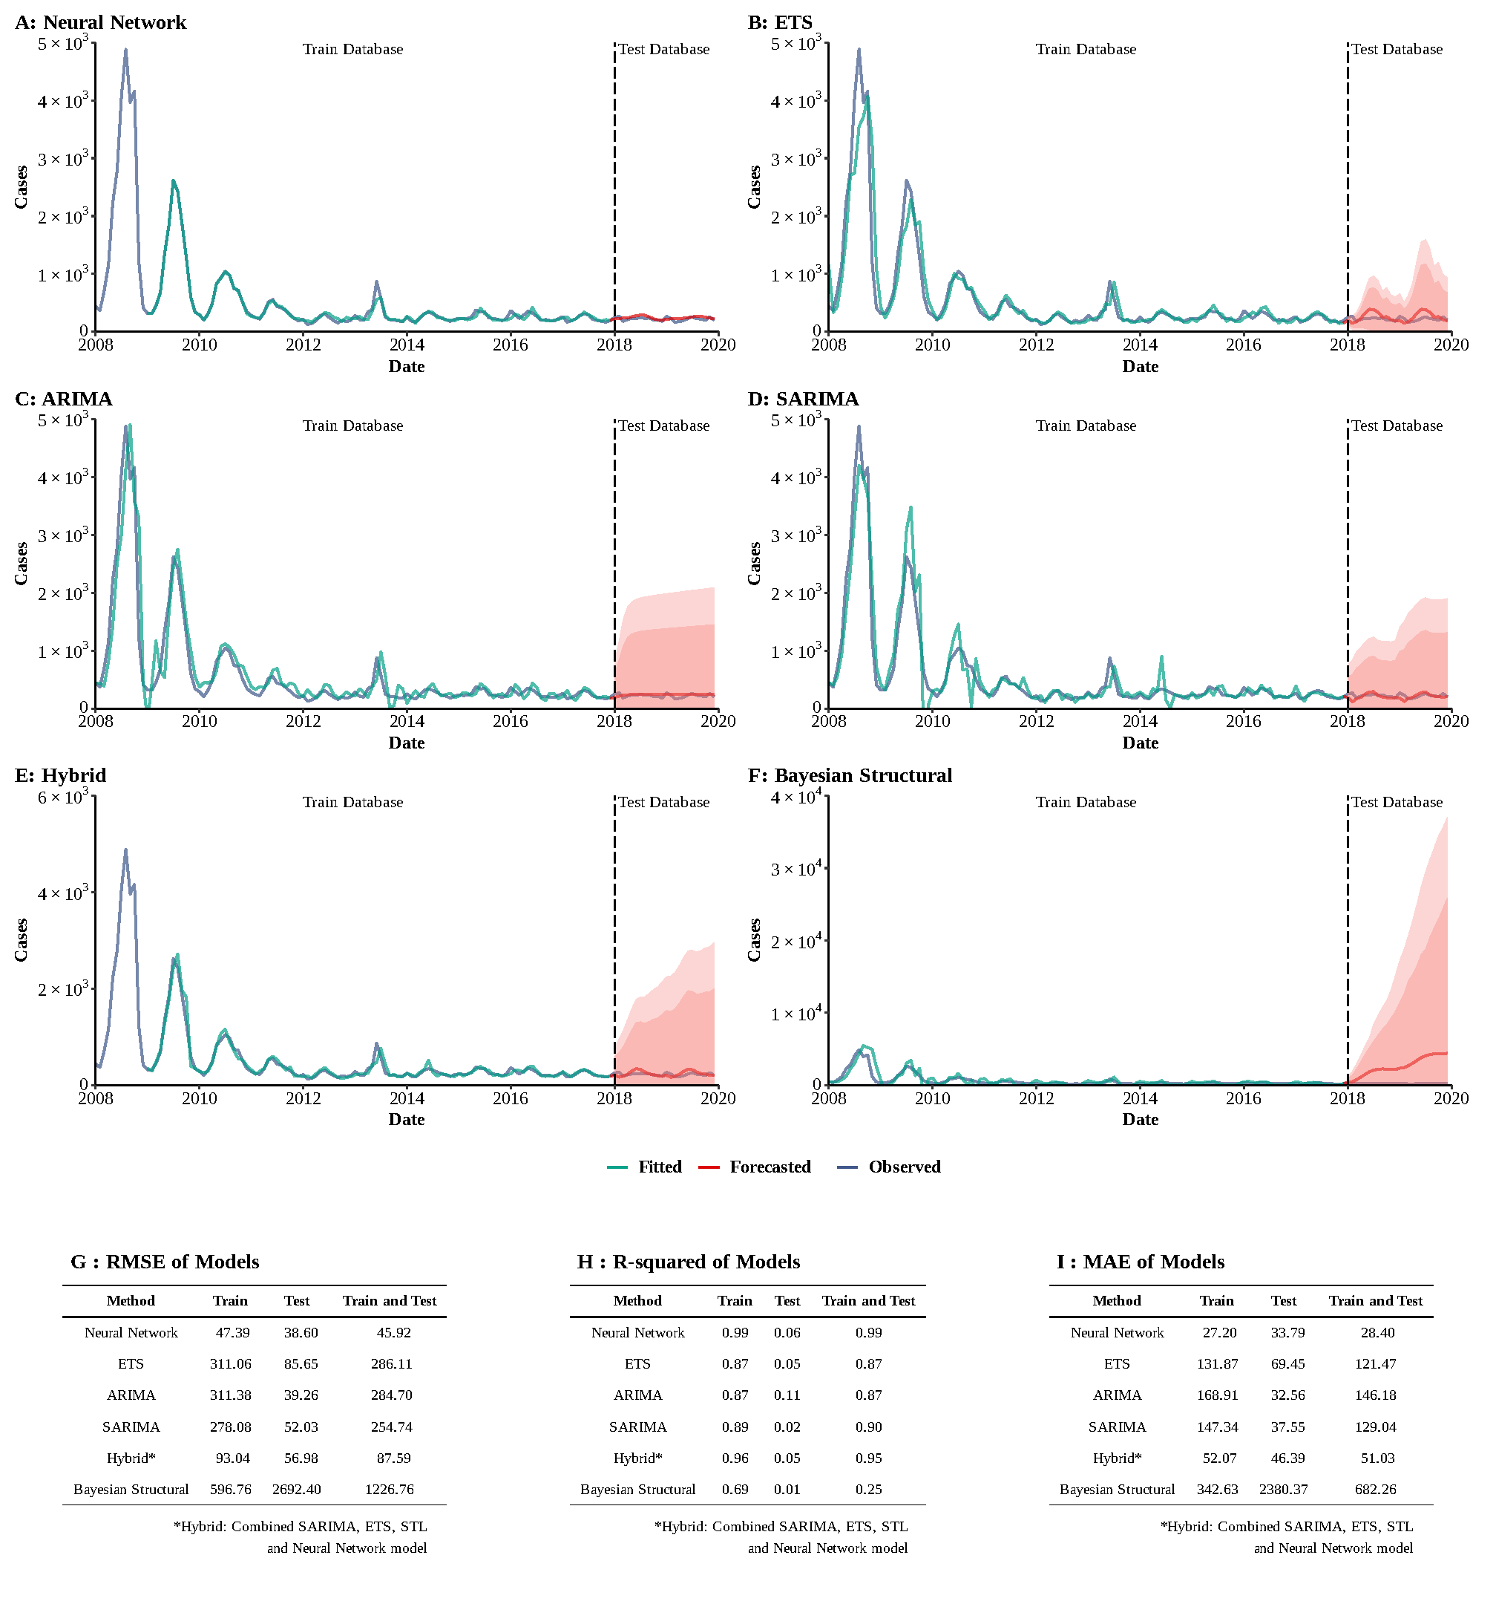

**Supplementary Figure 12**

**Training and comparing variant time series models for Malaria.** (A) Neural Network model; (B) ETS model; (C) ARIMA model; (D) SEARIMA model; (E) Hybrid models combining SARIMA, ETS, STL, and neural network model; (F) Bayesian structural model; (G) Root mean square error (RMSE) of variant models; (H) R-squared of variant models; (J) Mean absolute error (MAE) of variant models.

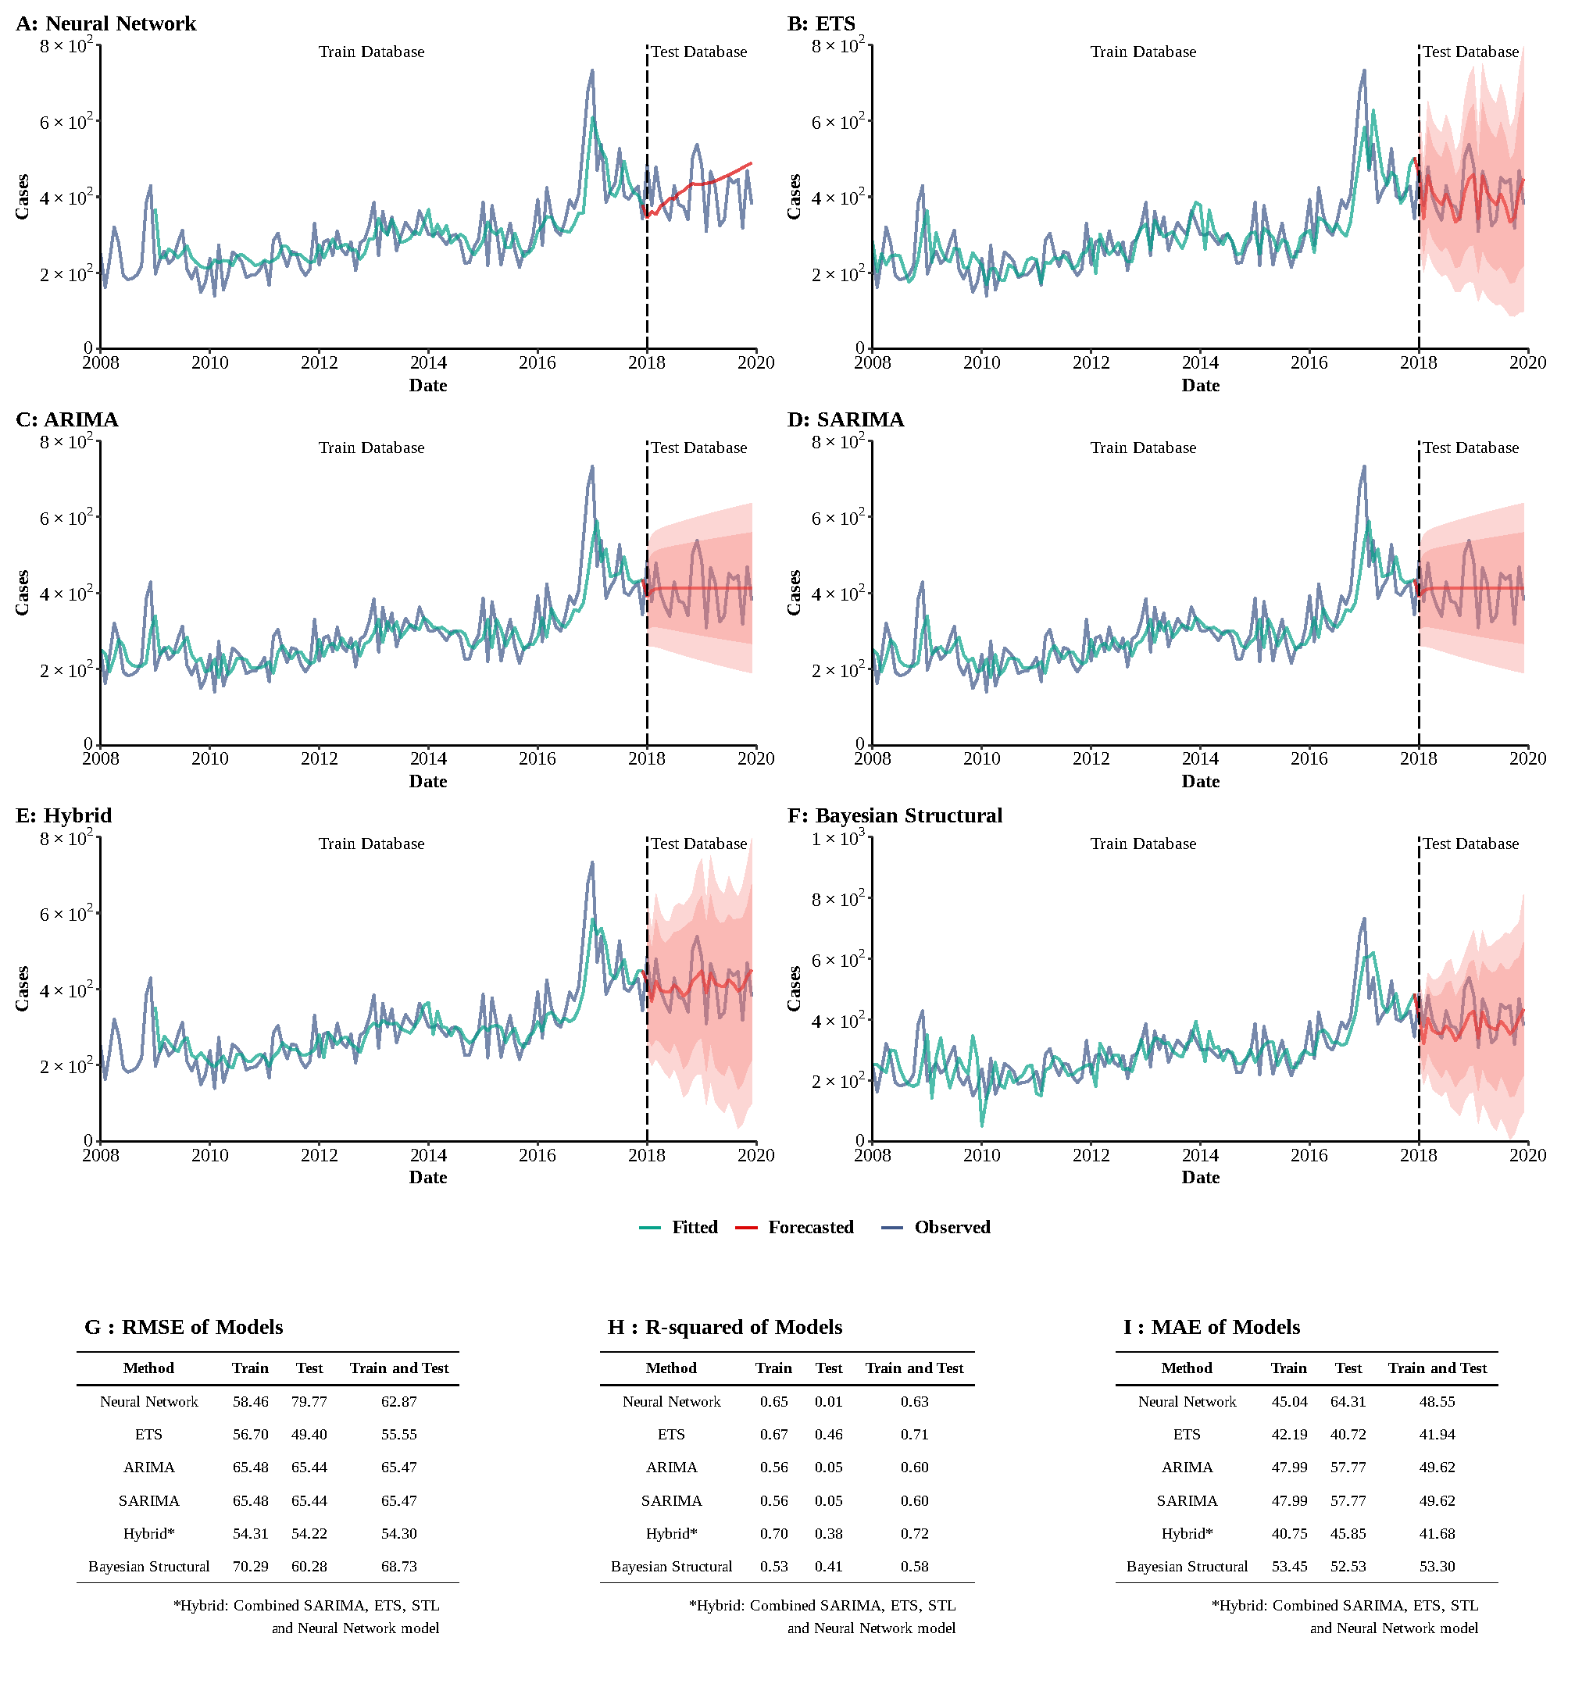

**Supplementary Figure 13**

**Training and comparing variant time series models for Hydatidosis.** (A) Neural Network model; (B) ETS model; (C) ARIMA model; (D) SEARIMA model; (E) Hybrid models combining SARIMA, ETS, STL, and neural network model; (F) Bayesian structural model; (G) Root mean square error (RMSE) of variant models; (H) R-squared of variant models; (J) Mean absolute error (MAE) of variant models.

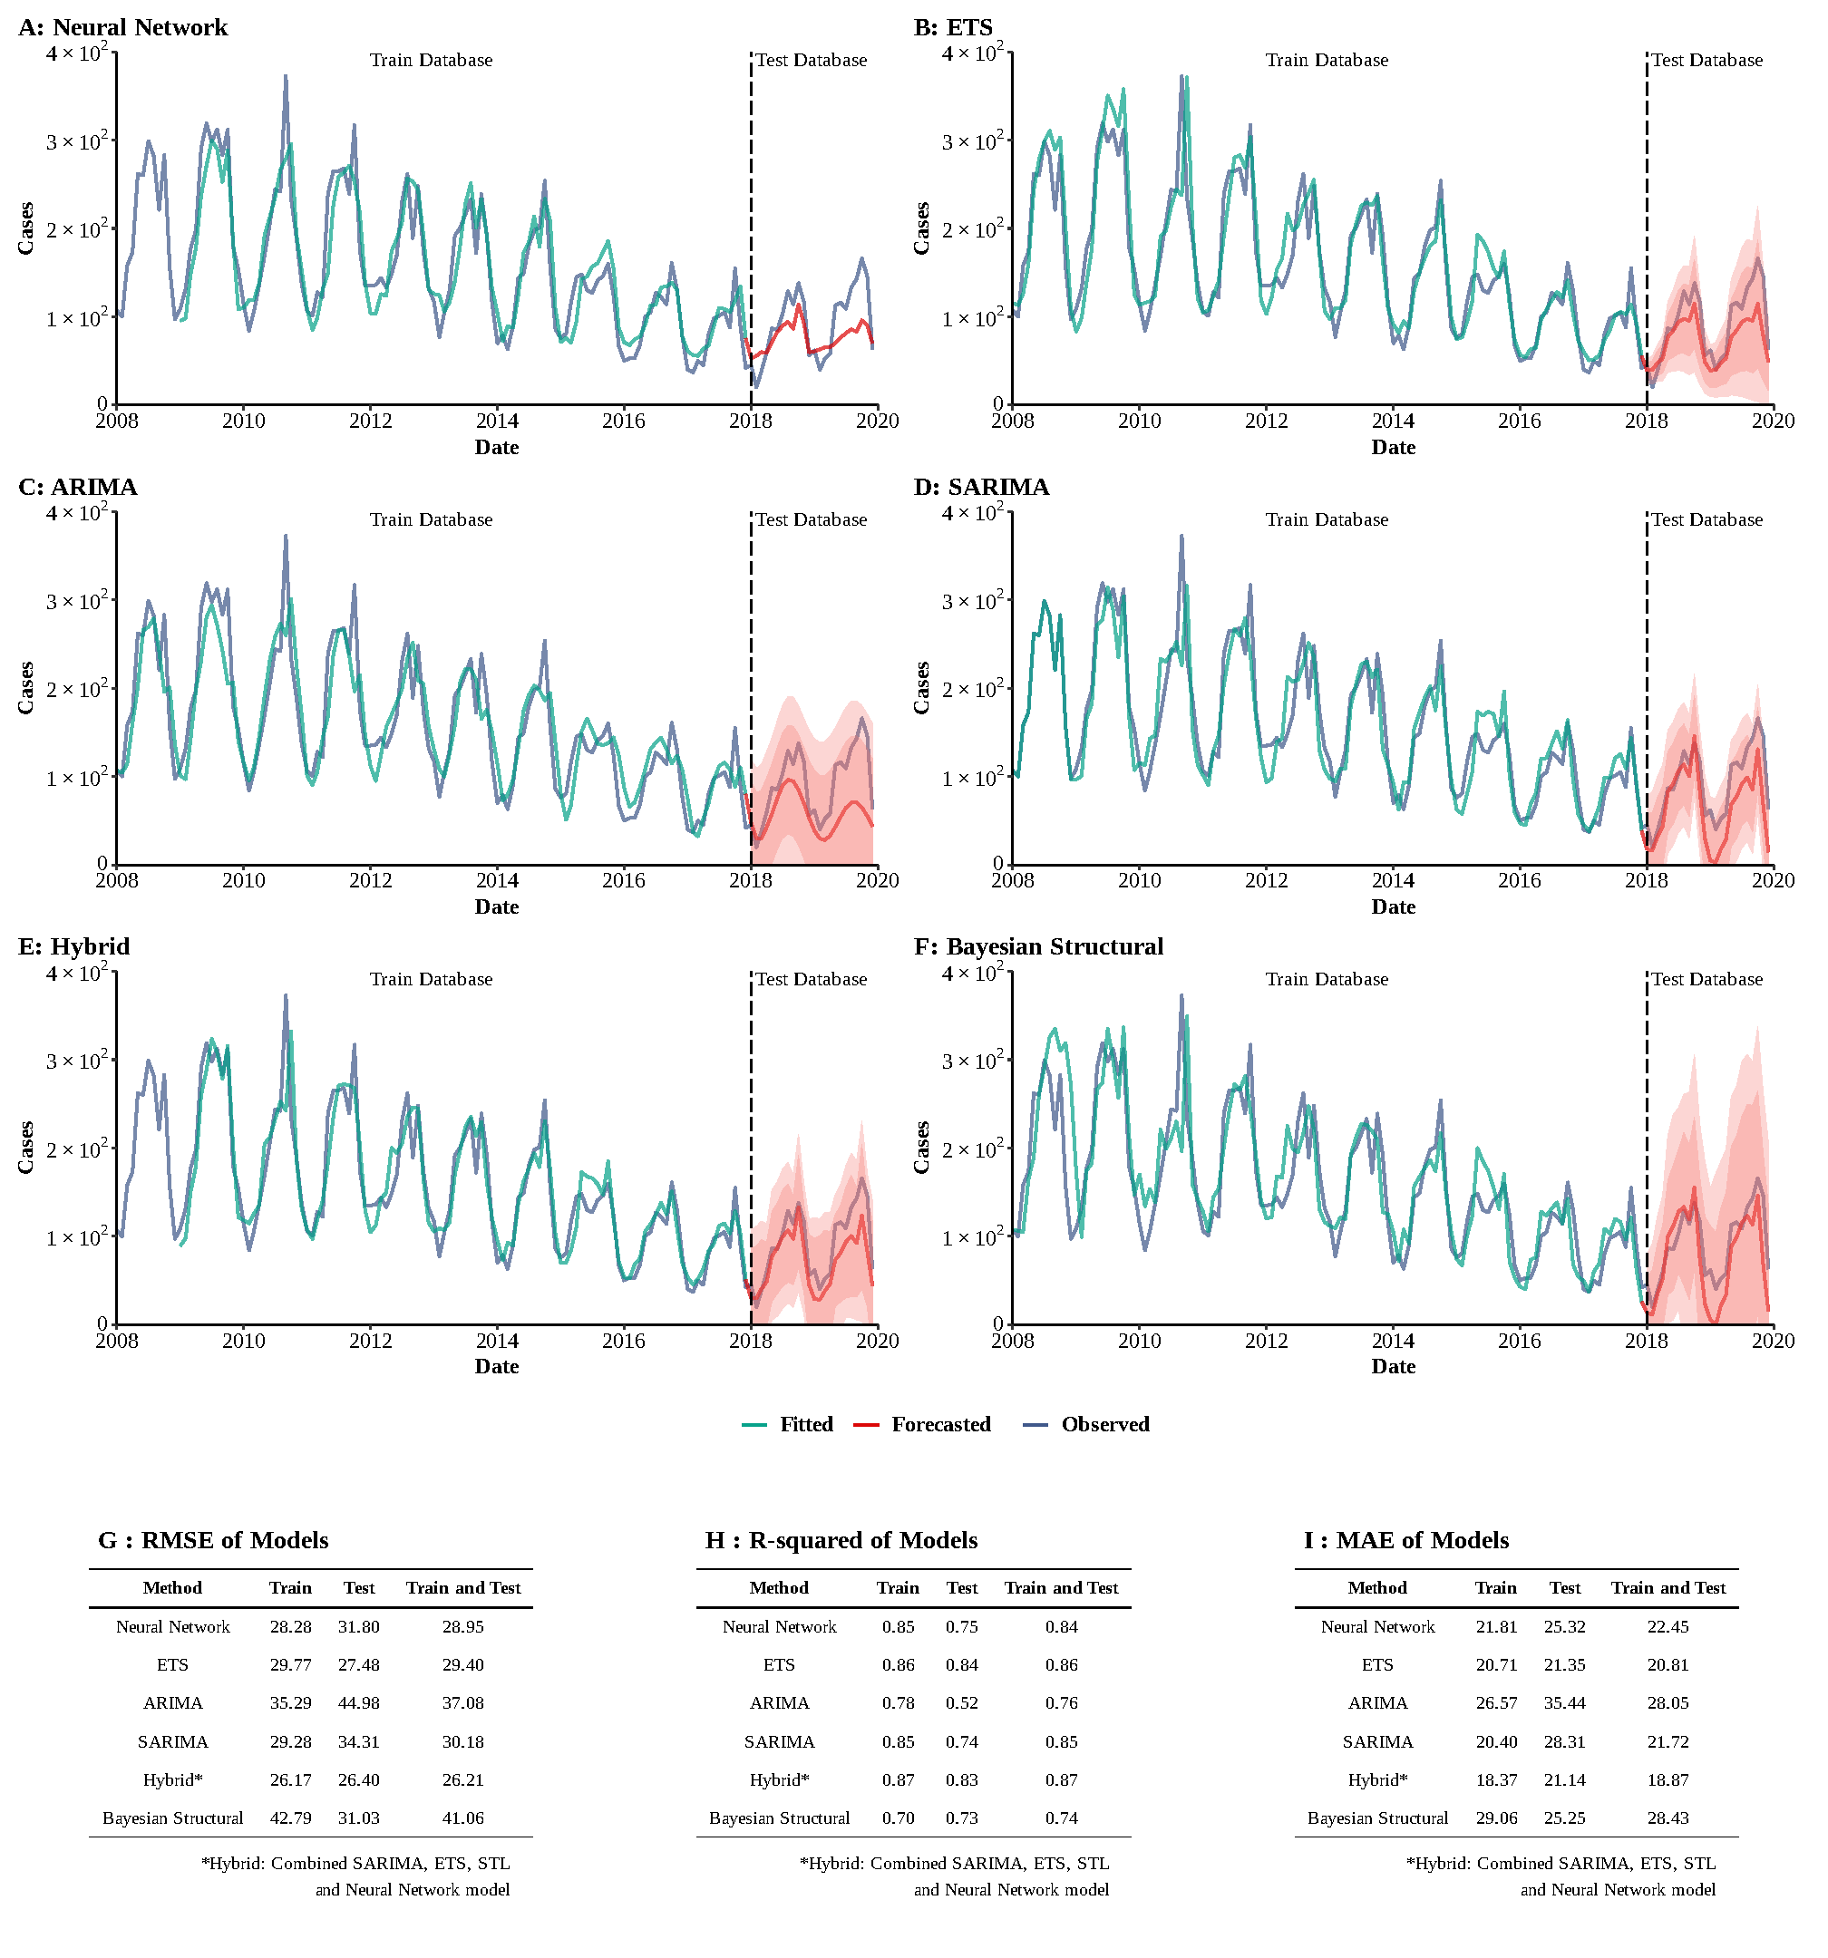

**Supplementary Figure 14**

**Training and comparing variant time series models for Typhus.** (A) Neural Network model; (B) ETS model; (C) ARIMA model; (D) SEARIMA model; (E) Hybrid models combining SARIMA, ETS, STL, and neural network model; (F) Bayesian structural model; (G) Root mean square error (RMSE) of variant models; (H) R-squared of variant models; (J) Mean absolute error (MAE) of variant models.

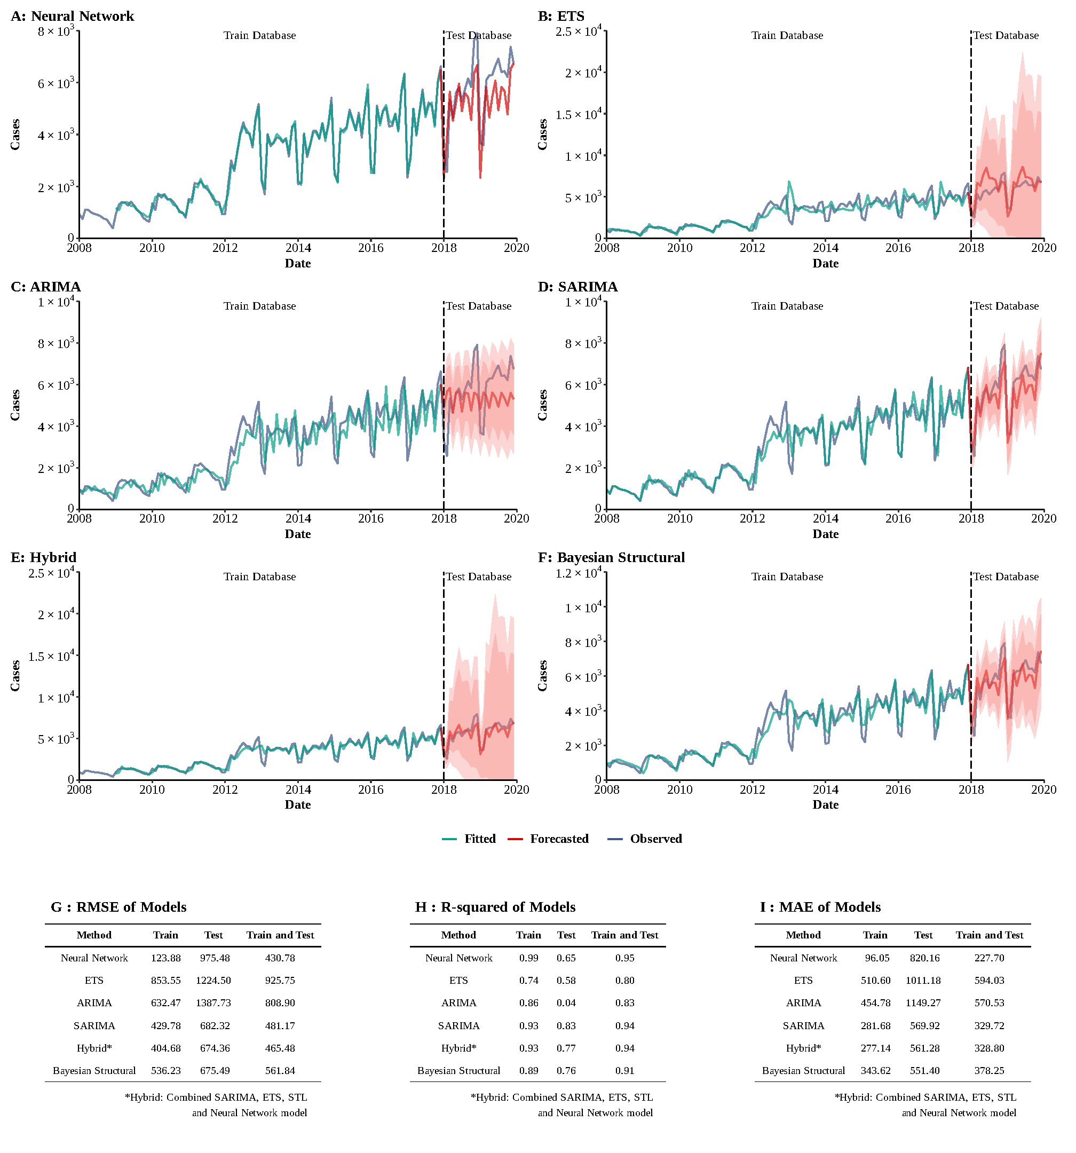

**Supplementary Figure 15**

**Training and comparing variant time series models for AIDS.** (A) Neural Network model; (B) ETS model; (C) ARIMA model; (D) SEARIMA model; (E) Hybrid models combining SARIMA, ETS, STL, and neural network model; (F) Bayesian structural model; (G) Root mean square error (RMSE) of variant models; (H) R-squared of variant models; (J) Mean absolute error (MAE) of variant models.

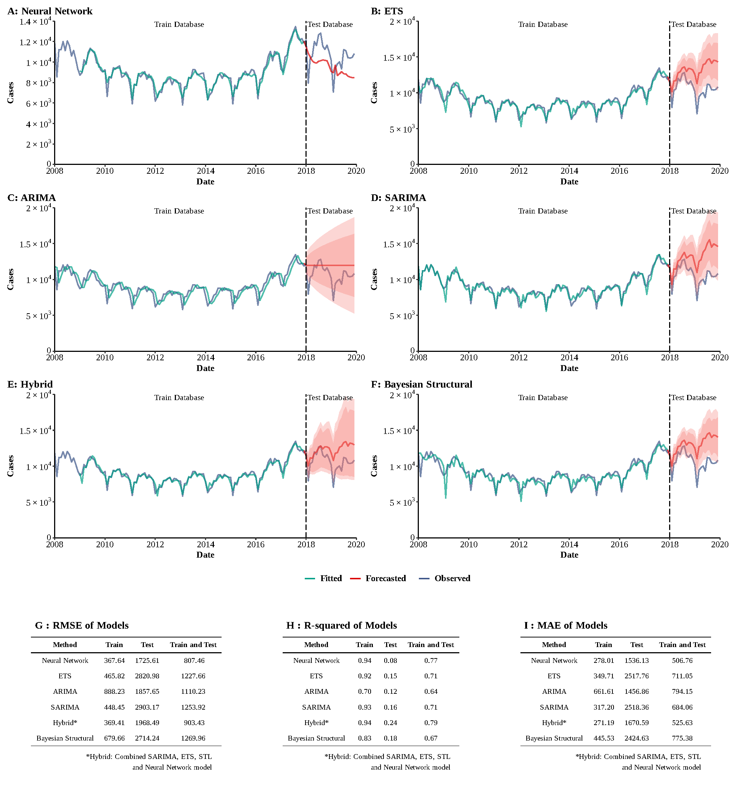

**Supplementary Figure 16**

**Training and comparing variant time series models for Gonorrhea.** (A) Neural Network model; (B) ETS model; (C) ARIMA model; (D) SEARIMA model; (E) Hybrid models combining SARIMA, ETS, STL, and neural network model; (F) Bayesian structural model; (G) Root mean square error (RMSE) of variant models; (H) R-squared of variant models; (J) Mean absolute error (MAE) of variant models.

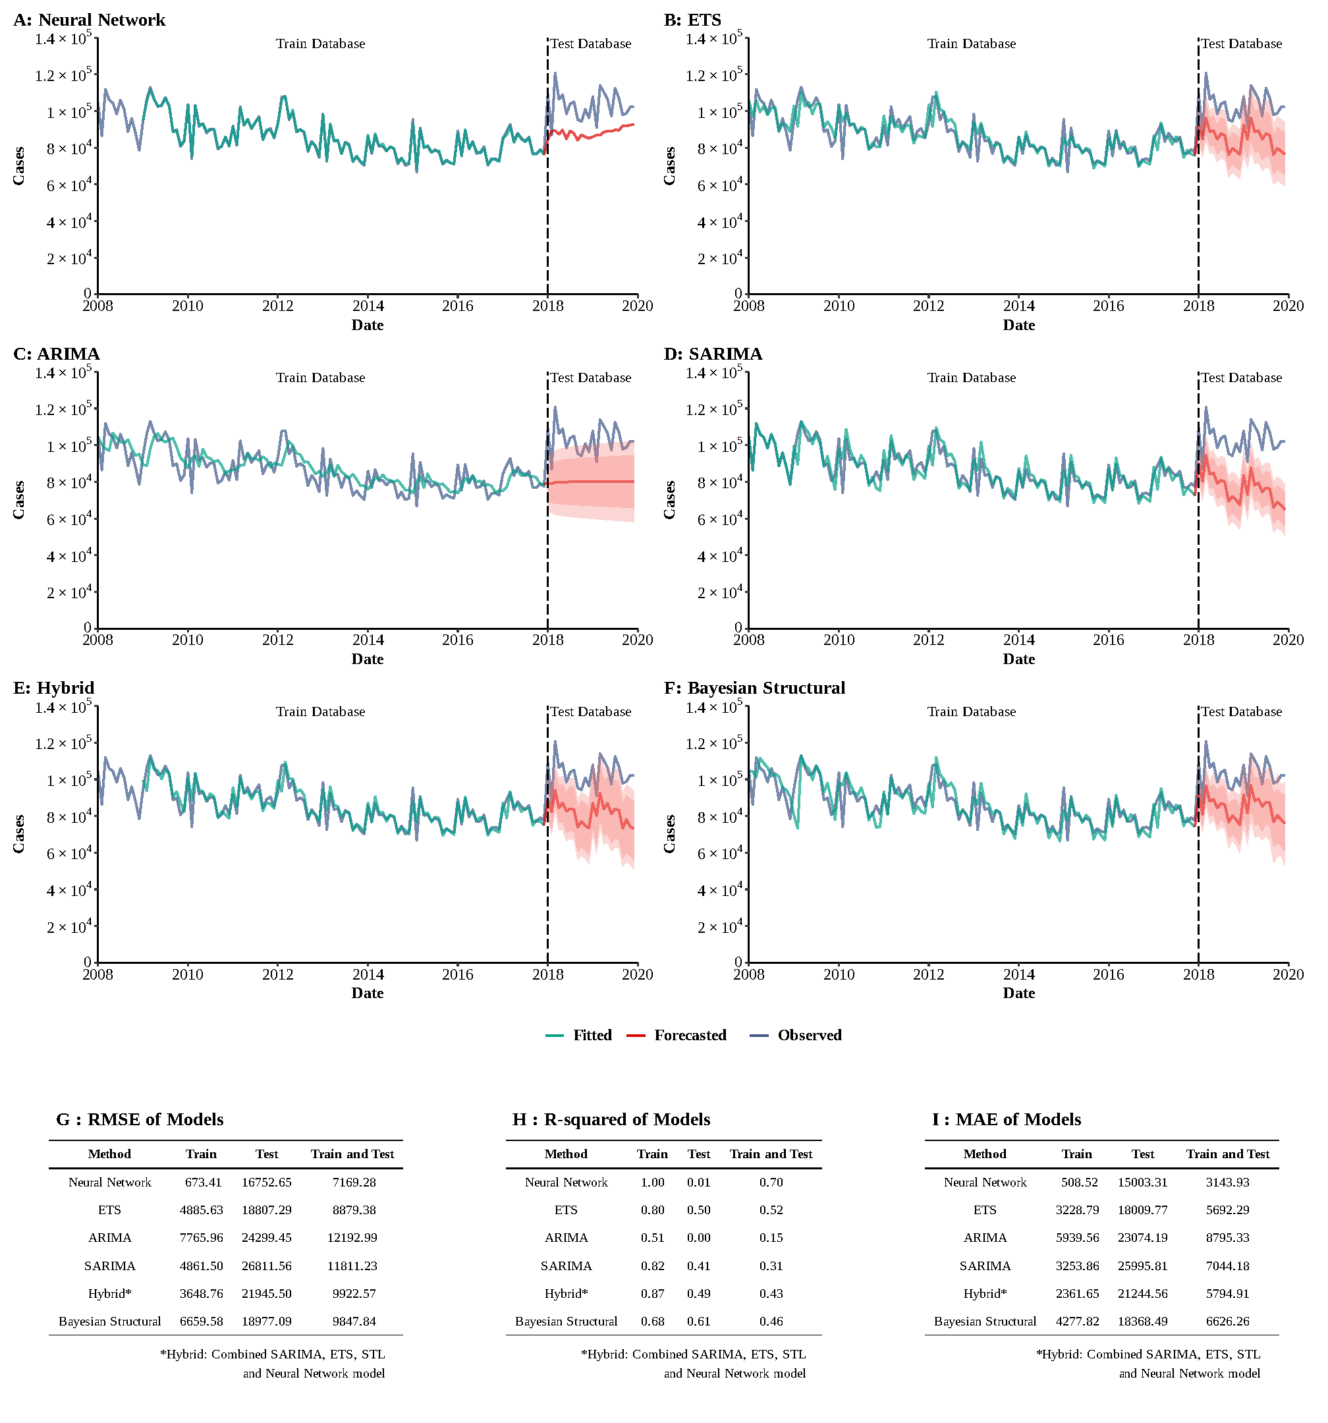

**Supplementary Figure 17**

**Training and comparing variant time series models for HBV.** (A) Neural Network model; (B) ETS model; (C) ARIMA model; (D) SEARIMA model; (E) Hybrid models combining SARIMA, ETS, STL, and neural network model; (F) Bayesian structural model; (G) Root mean square error (RMSE) of variant models; (H) R-squared of variant models; (J) Mean absolute error (MAE) of variant models.

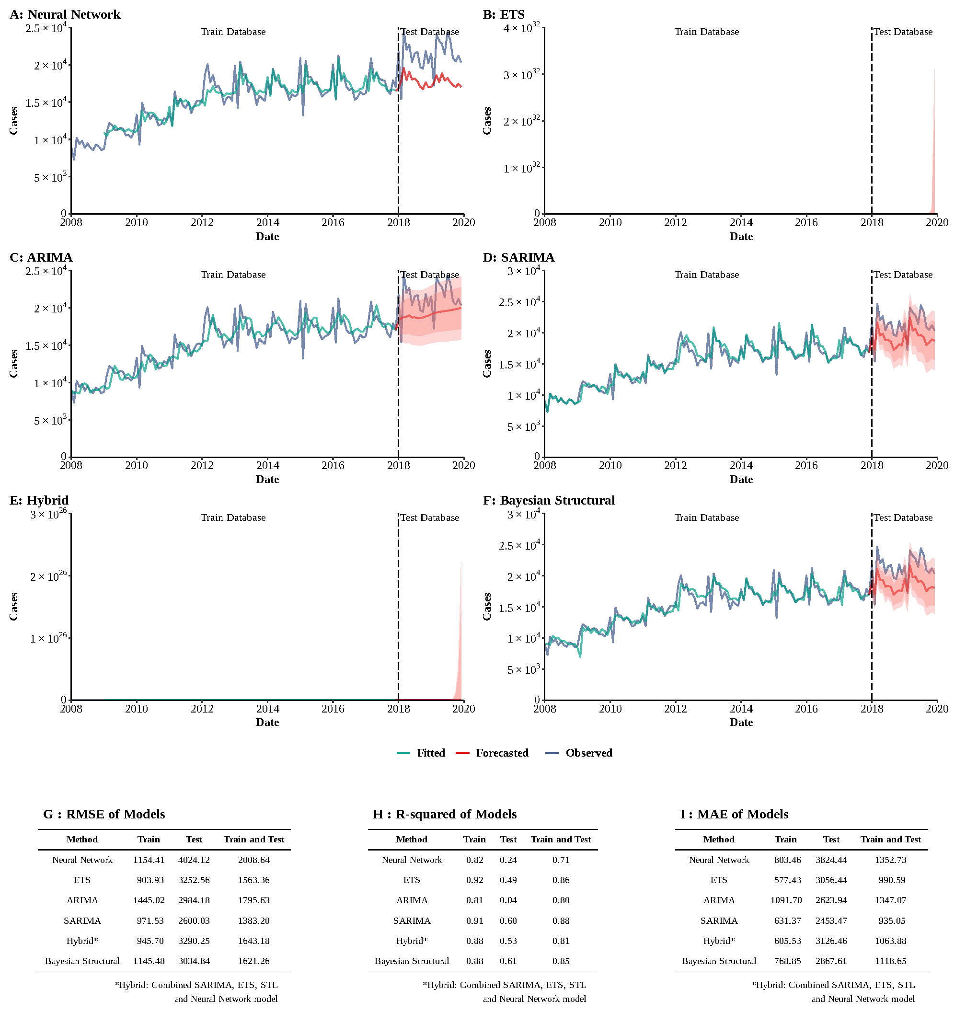

**Supplementary Figure 18**

**Training and comparing variant time series models for HCV.** (A) Neural Network model; (B) ETS model; (C) ARIMA model; (D) SEARIMA model; (E) Hybrid models combining SARIMA, ETS, STL, and neural network model; (F) Bayesian structural model; (G) Root mean square error (RMSE) of variant models; (H) R-squared of variant models; (J) Mean absolute error (MAE) of variant models.

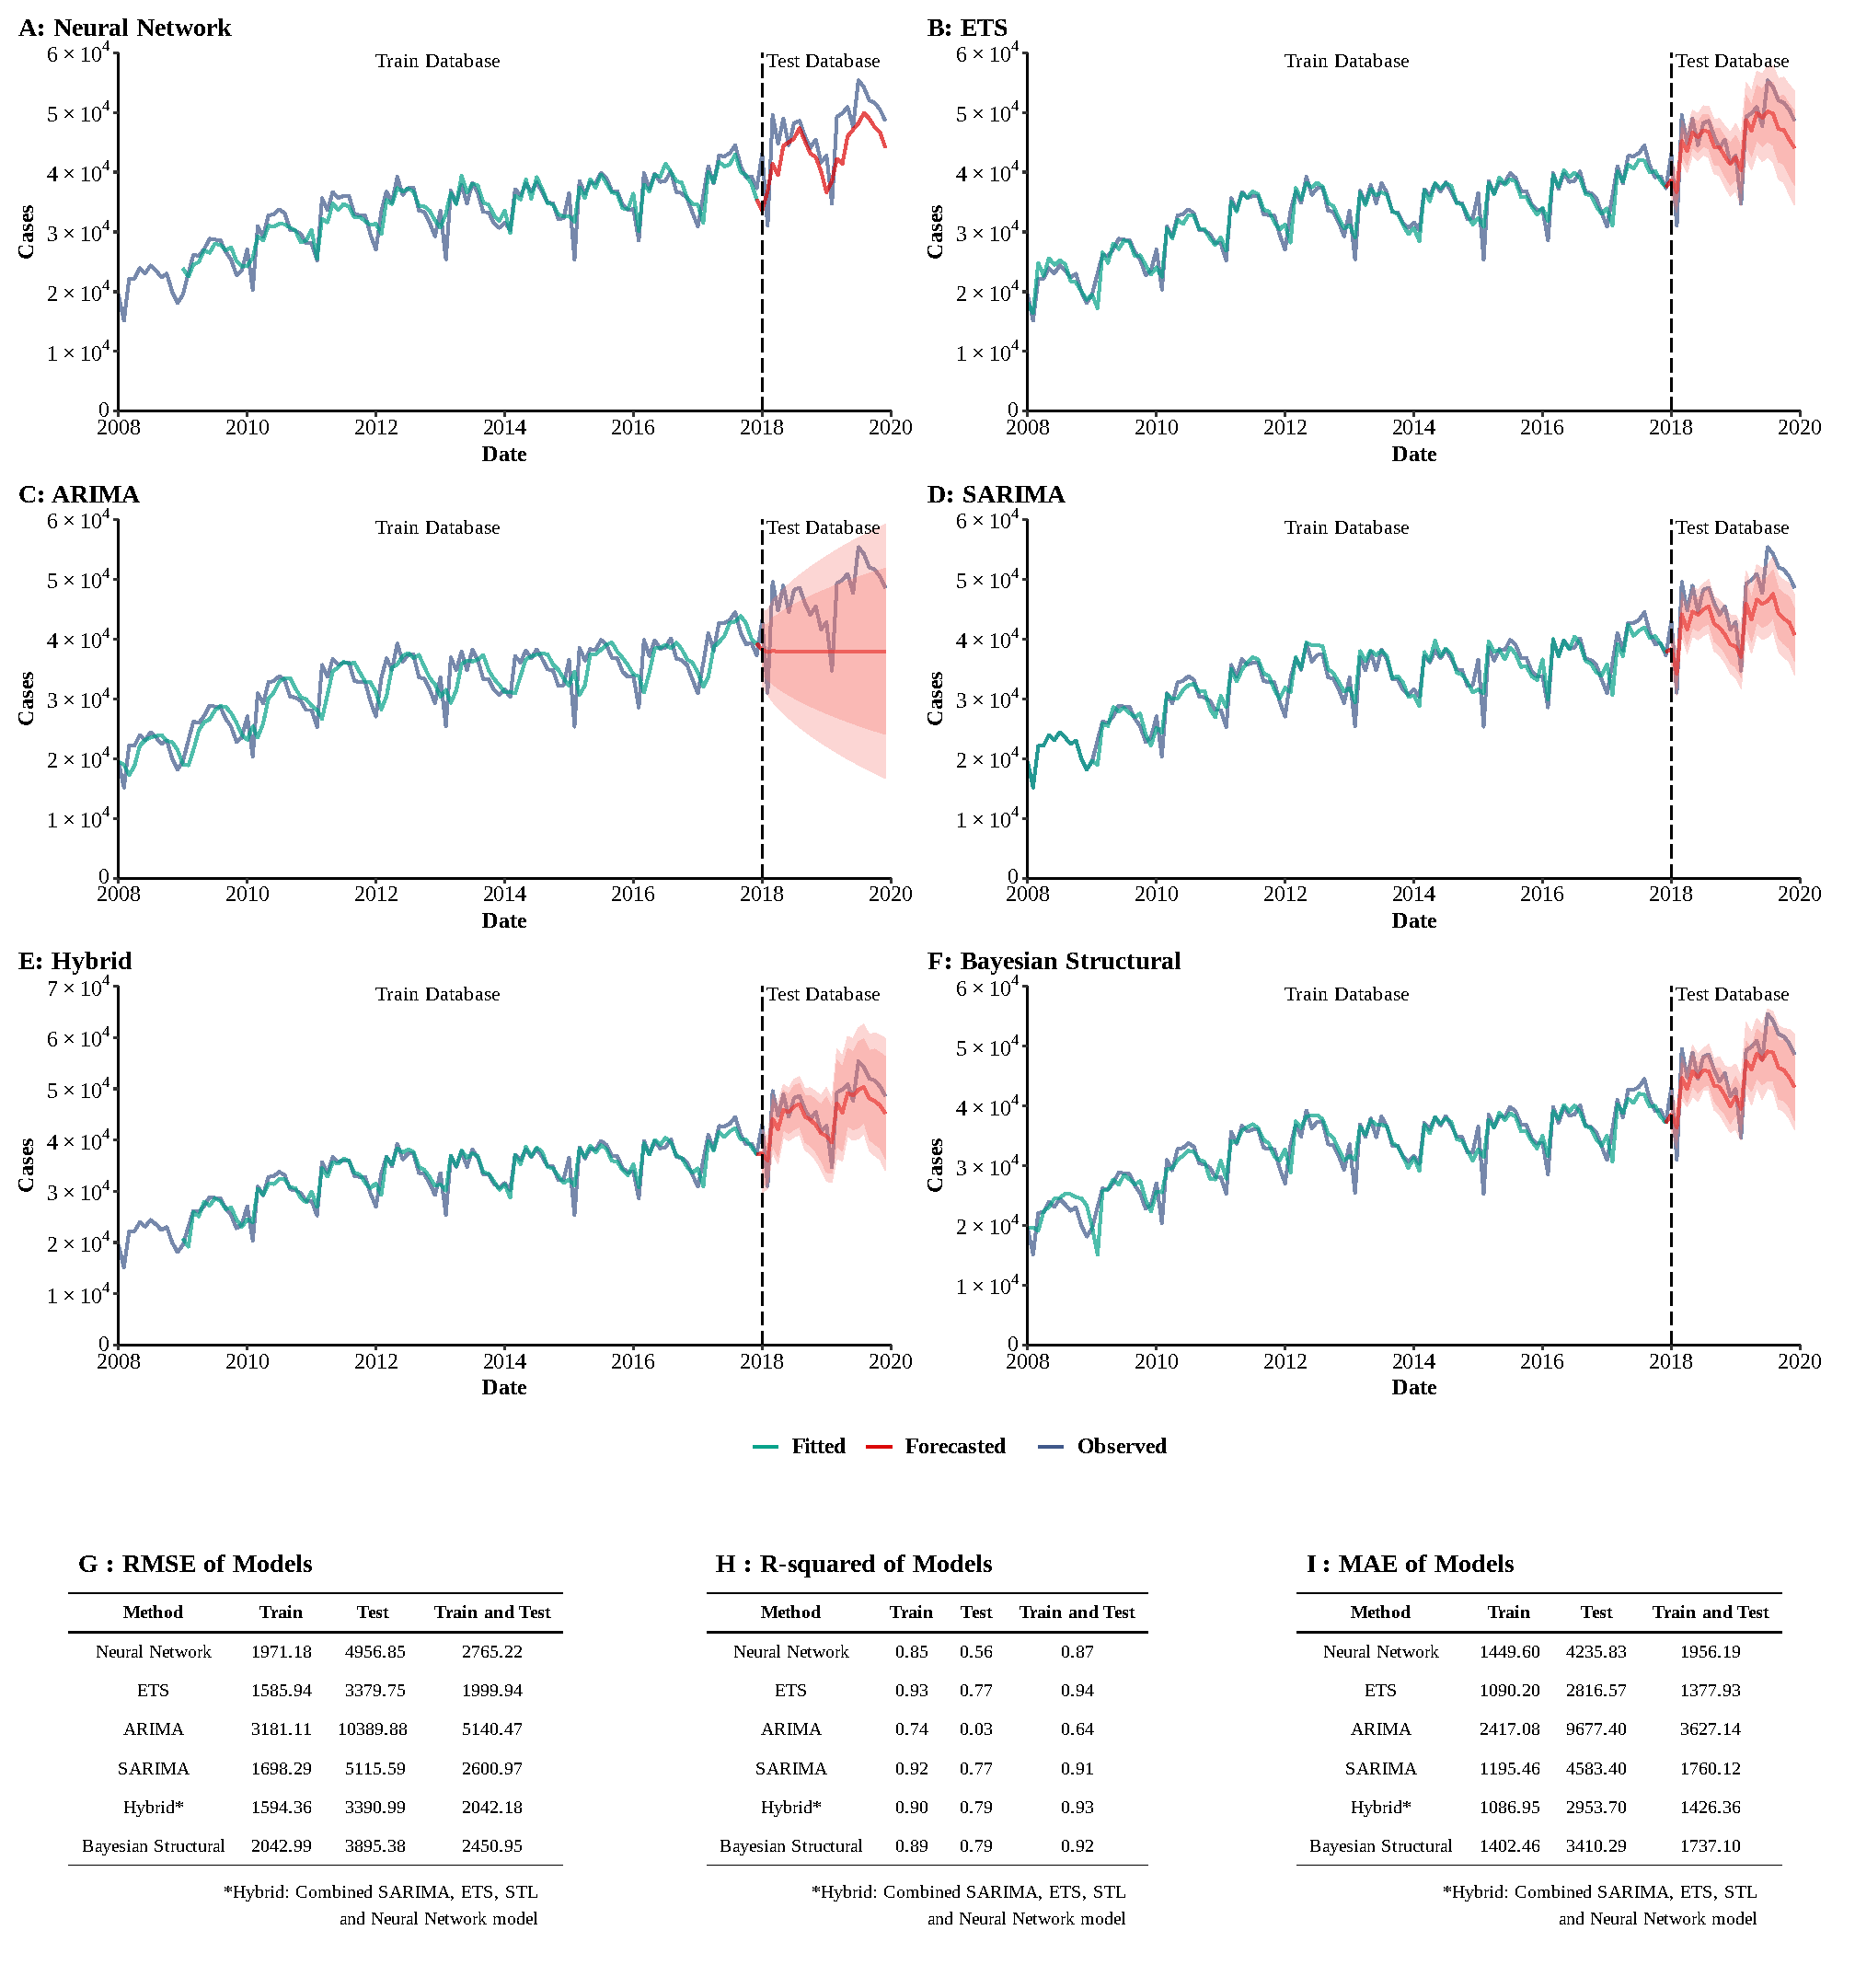

**Supplementary Figure 19**

**Training and comparing variant time series models for Syphilis.** (A) Neural Network model; (B) ETS model; (C) ARIMA model; (D) SEARIMA model; (E) Hybrid models combining SARIMA, ETS, STL, and neural network model; (F) Bayesian structural model; (G) Root mean square error (RMSE) of variant models; (H) R-squared of variant models; (J) Mean absolute error (MAE) of variant models.

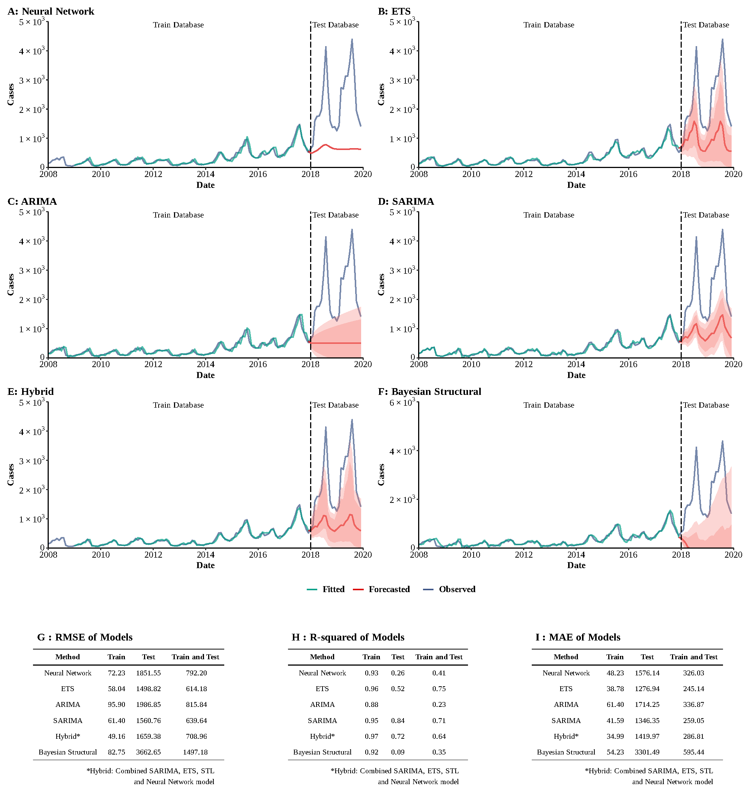

**Supplementary Figure 20**

**Training and comparing variant time series models for Pertussis.** (A) Neural Network model; (B) ETS model; (C) ARIMA model; (D) SEARIMA model; (E) Hybrid models combining SARIMA, ETS, STL, and neural network model; (F) Bayesian structural model; (G) Root mean square error (RMSE) of variant models; (H) R-squared of variant models; (J) Mean absolute error (MAE) of variant models.

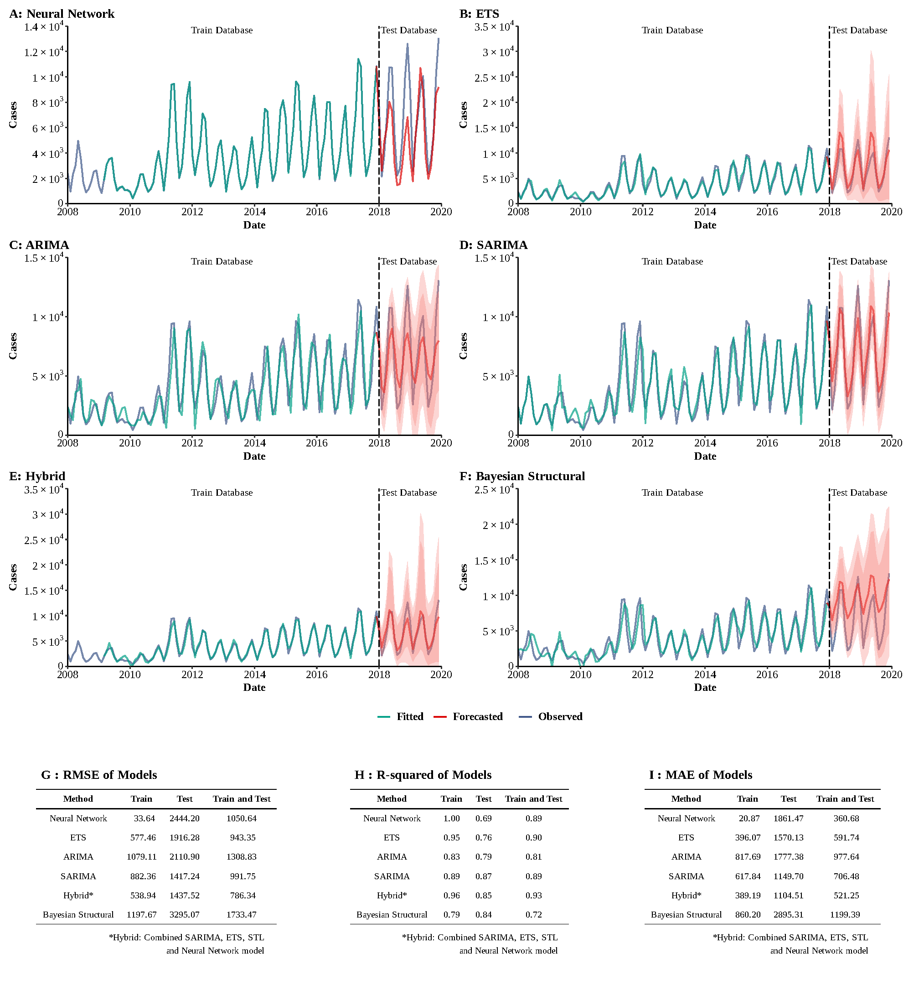

**Supplementary Figure 21**

**Training and comparing variant time series models for Scarlet fever.** (A) Neural Network model; (B) ETS model; (C) ARIMA model; (D) SEARIMA model; (E) Hybrid models combining SARIMA, ETS, STL, and neural network model; (F) Bayesian structural model; (G) Root mean square error (RMSE) of variant models; (H) R-squared of variant models; (J) Mean absolute error (MAE) of variant models.

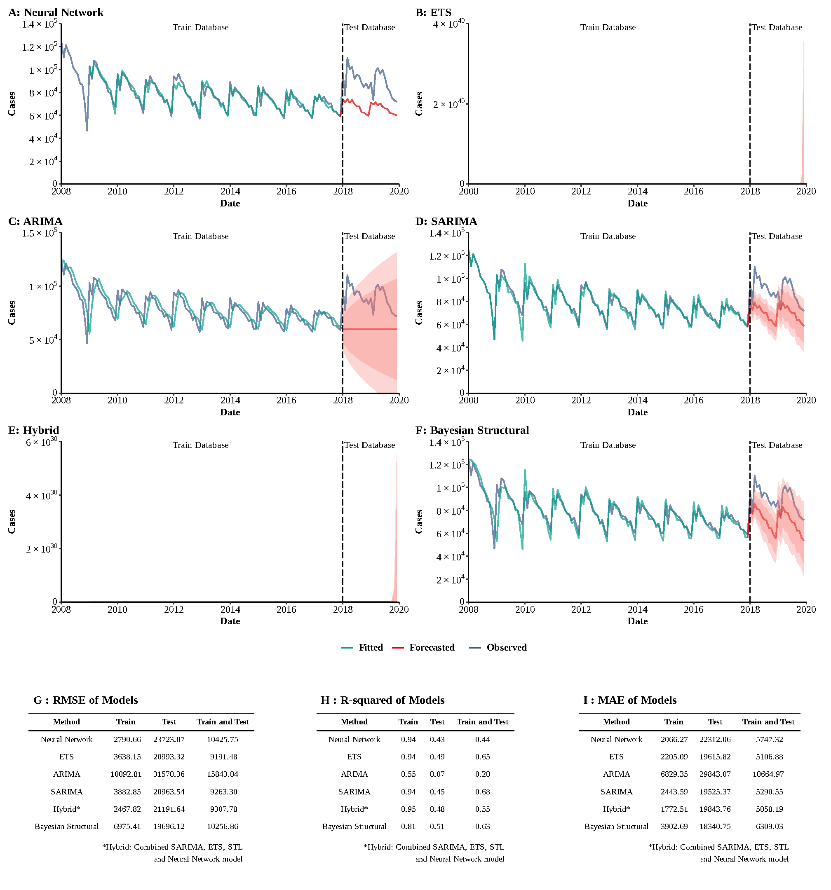

**Supplementary Figure 22**

**Training and comparing variant time series models for Tuberculosis.** (A) Neural Network model; (B) ETS model; (C) ARIMA model; (D) SEARIMA model; (E) Hybrid models combining SARIMA, ETS, STL, and neural network model; (F) Bayesian structural model; (G) Root mean square error (RMSE) of variant models; (H) R-squared of variant models; (J) Mean absolute error (MAE) of variant models.

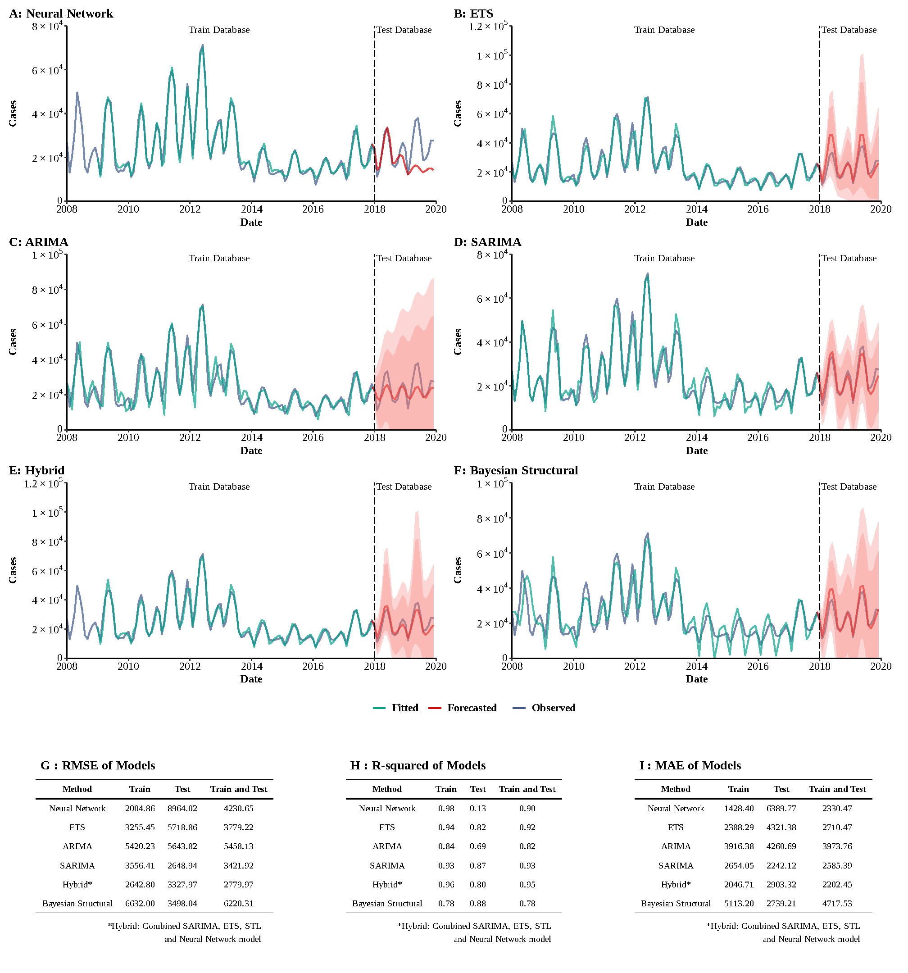**Supplementary Figure 23**

**Training and comparing variant time series models for Mumps.** (A) Neural Network model; (B) ETS model; (C) ARIMA model; (D) SEARIMA model; (E) Hybrid models combining SARIMA, ETS, STL, and neural network model; (F) Bayesian structural model; (G) Root mean square error (RMSE) of variant models; (H) R-squared of variant models; (J) Mean absolute error (MAE) of variant models.

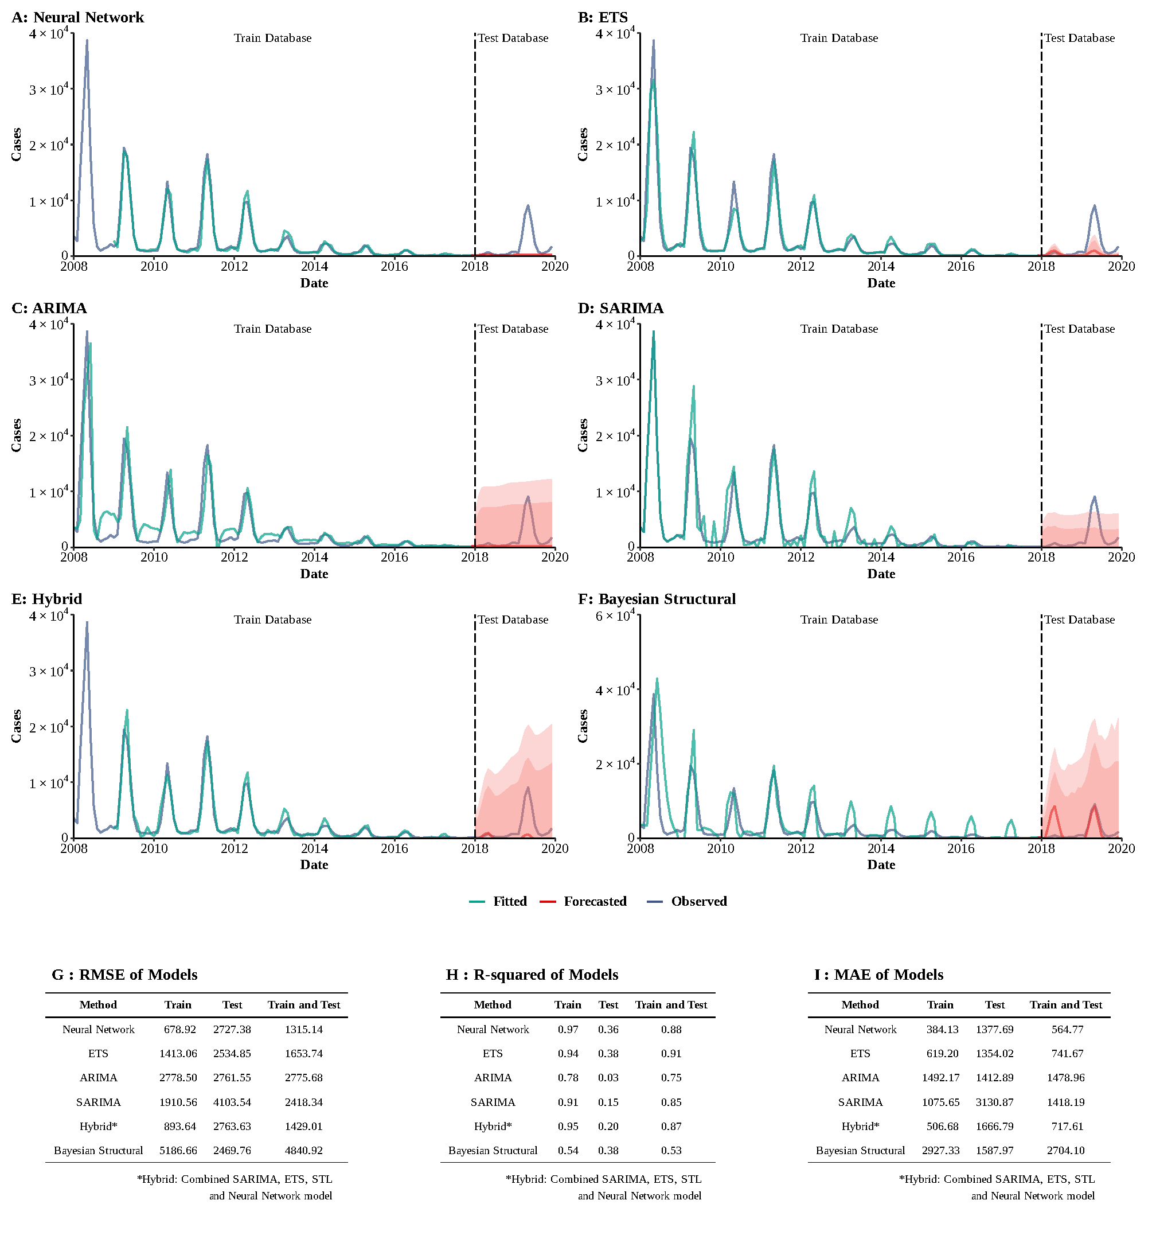**Supplementary Figure 24**

**Training and comparing variant time series models for Rubella.** (A) Neural Network model; (B) ETS model; (C) ARIMA model; (D) SEARIMA model; (E) Hybrid models combining SARIMA, ETS, STL, and neural network model; (F) Bayesian structural model; (G) Root mean square error (RMSE) of variant models; (H) R-squared of variant models; (J) Mean absolute error (MAE) of variant models.