Supplementary Material

Temporal trends and shifts of 24 notifiable infectious diseases in China before and during the COVID-19 epidemic

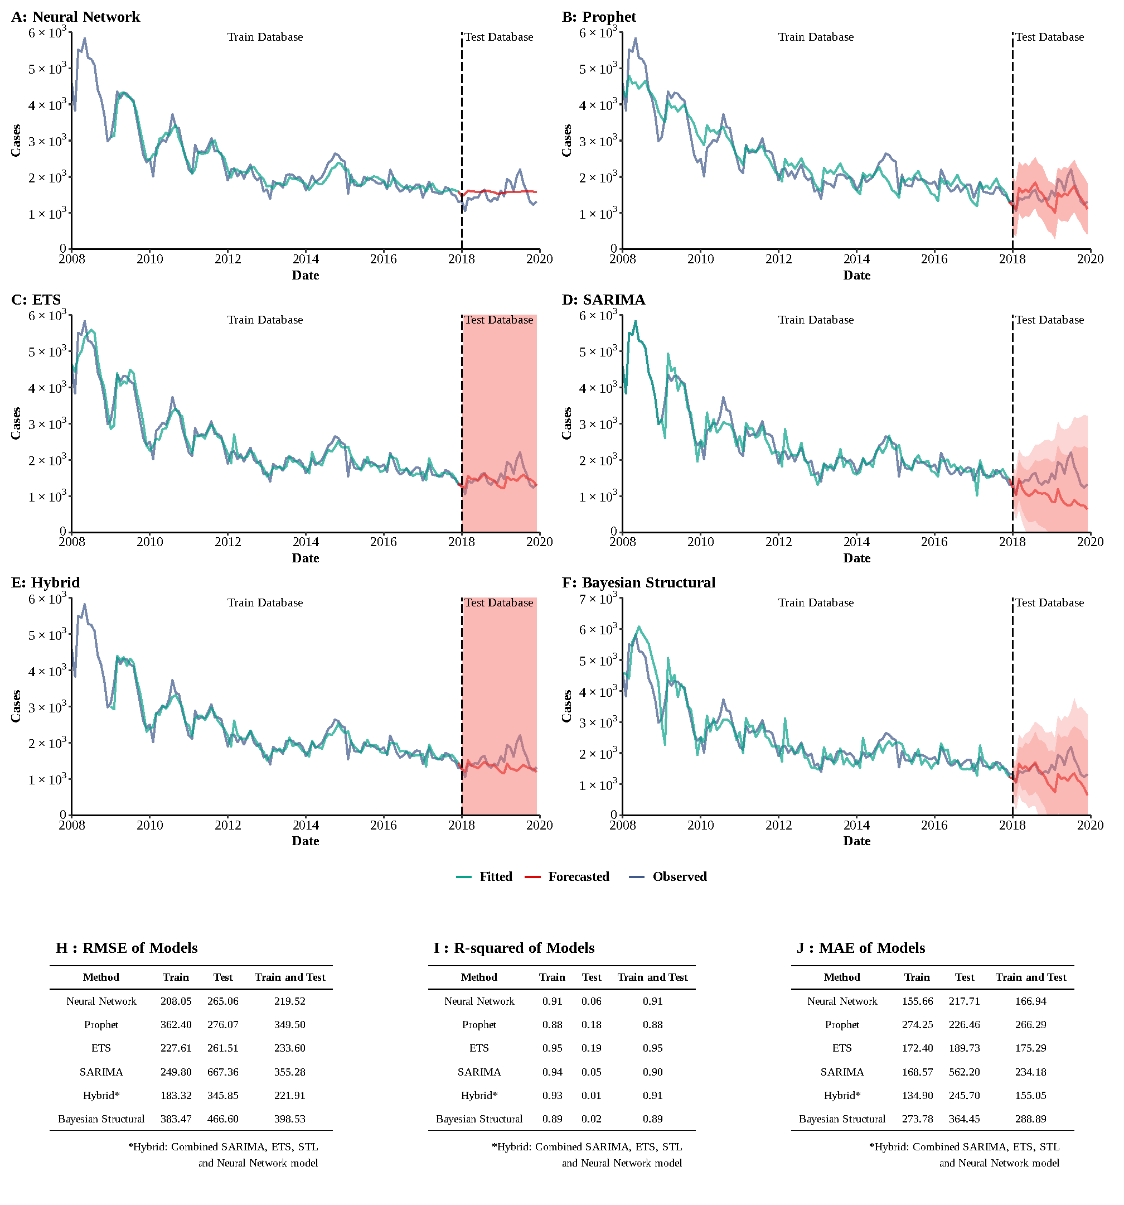

**Supplementary Figure 1**

**Training and comparing variant time series models for HAV.** (A) Neural Network model; (B) ETS model; (C) ARIMA model; (D) SEARIMA model; (E) Hybrid models combining SARIMA, ETS, STL, and neural network model; (F) Bayesian structural model; (G) RMSE of variant models; (H) R-squared of variant models; (J) MAE of variant models.

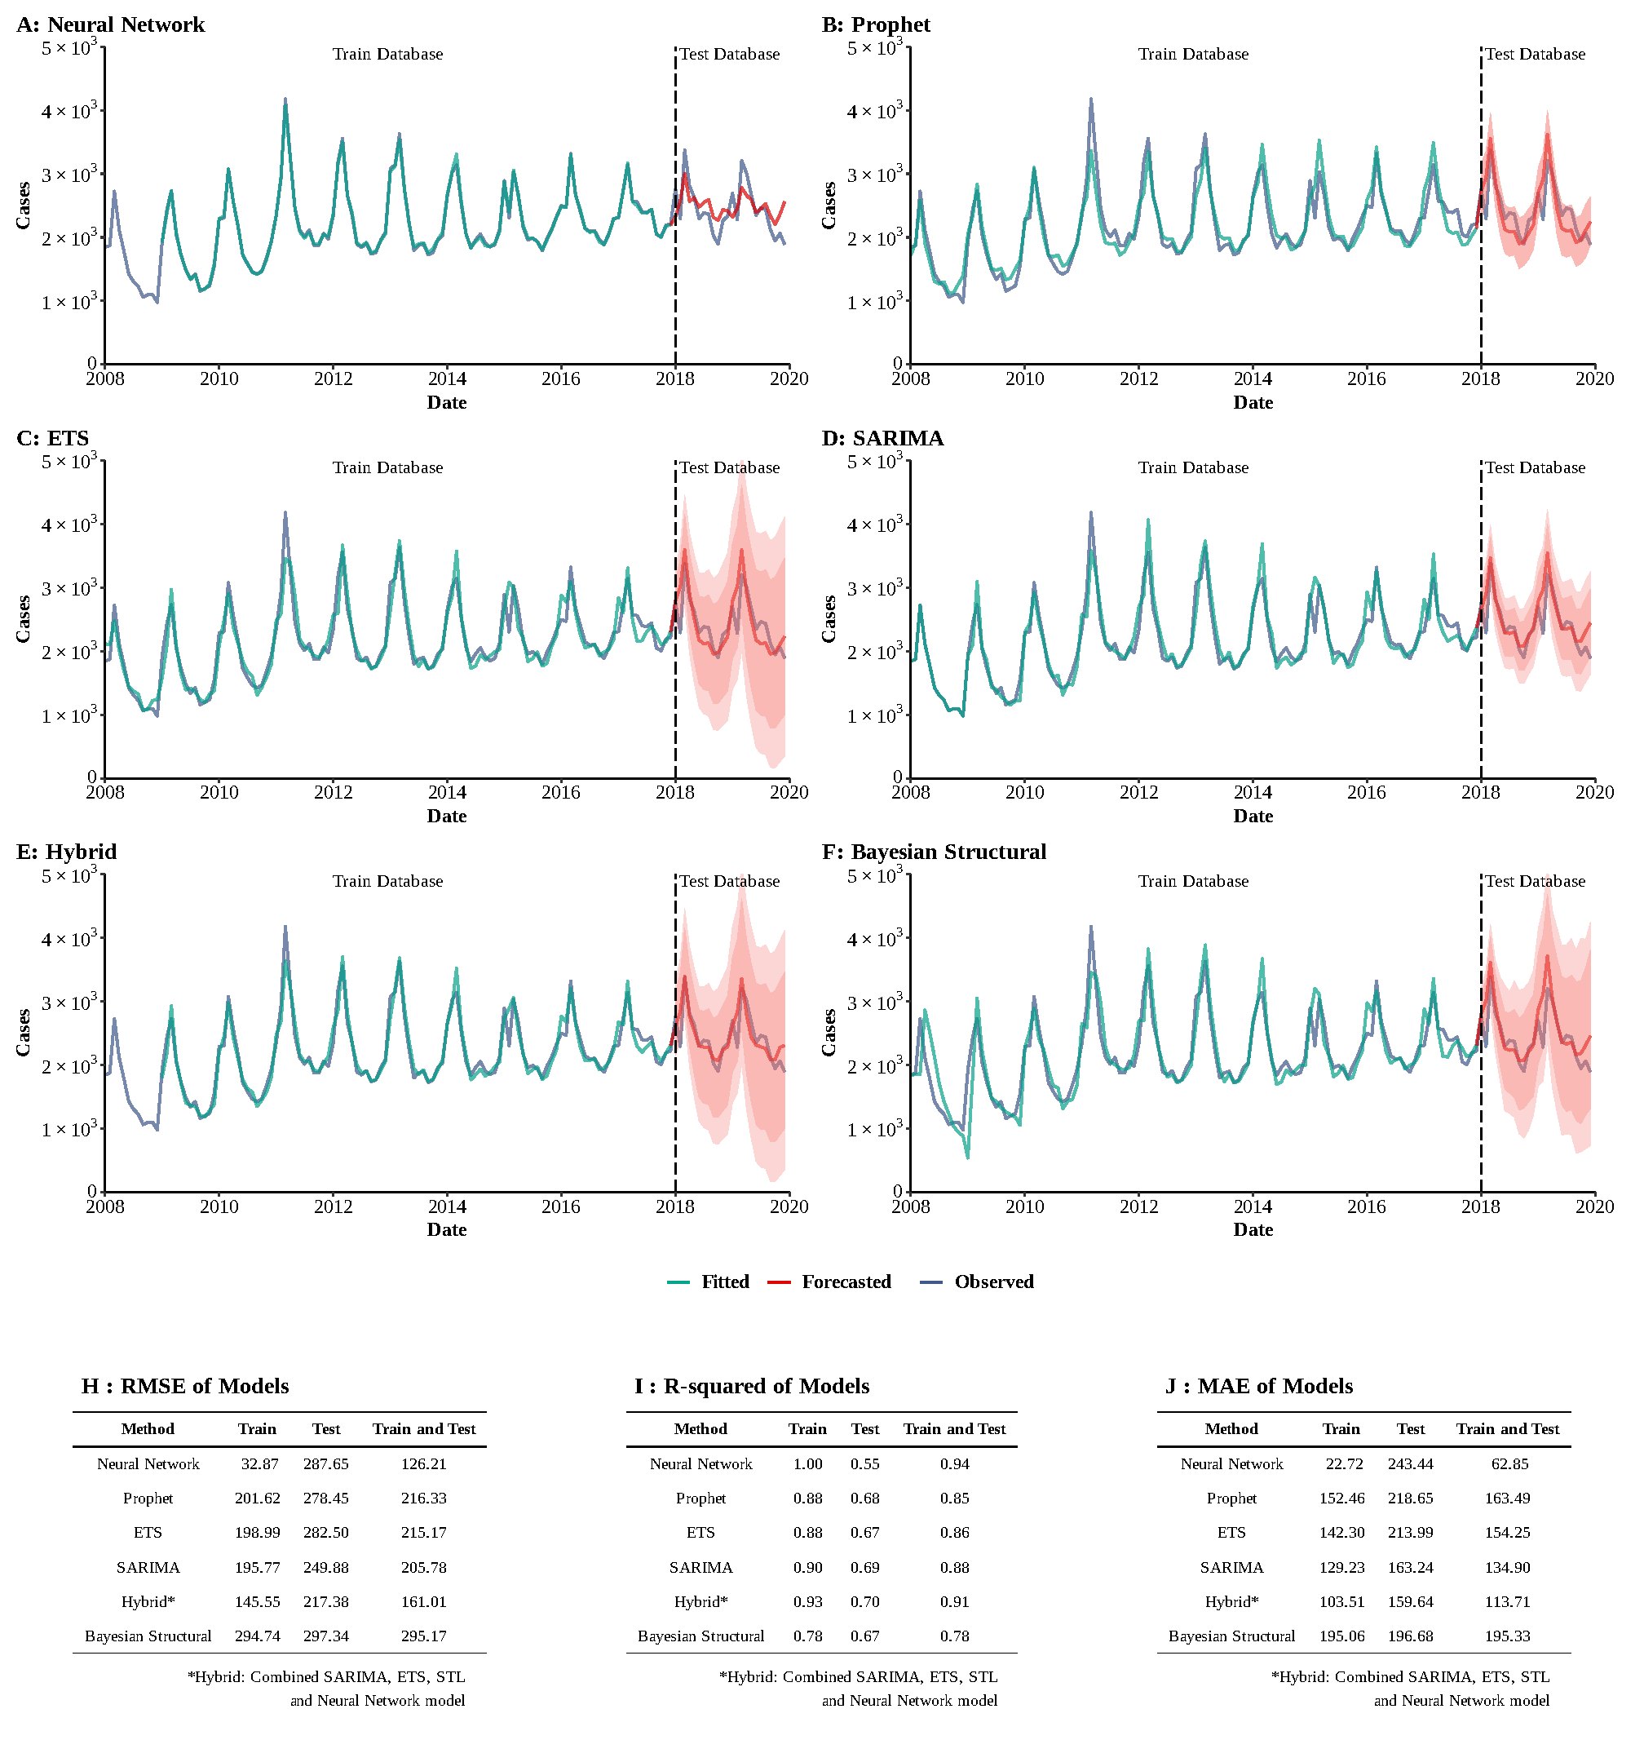

**Supplementary Figure 2**

**Training and comparing variant time series models for HEV.** (A) Neural Network model; (B) ETS model; (C) ARIMA model; (D) SEARIMA model; (E) Hybrid models combining SARIMA, ETS, STL, and neural network model; (F) Bayesian structural model; (G) RMSE of variant models; (H) R-squared of variant models; (J) MAE of variant models.

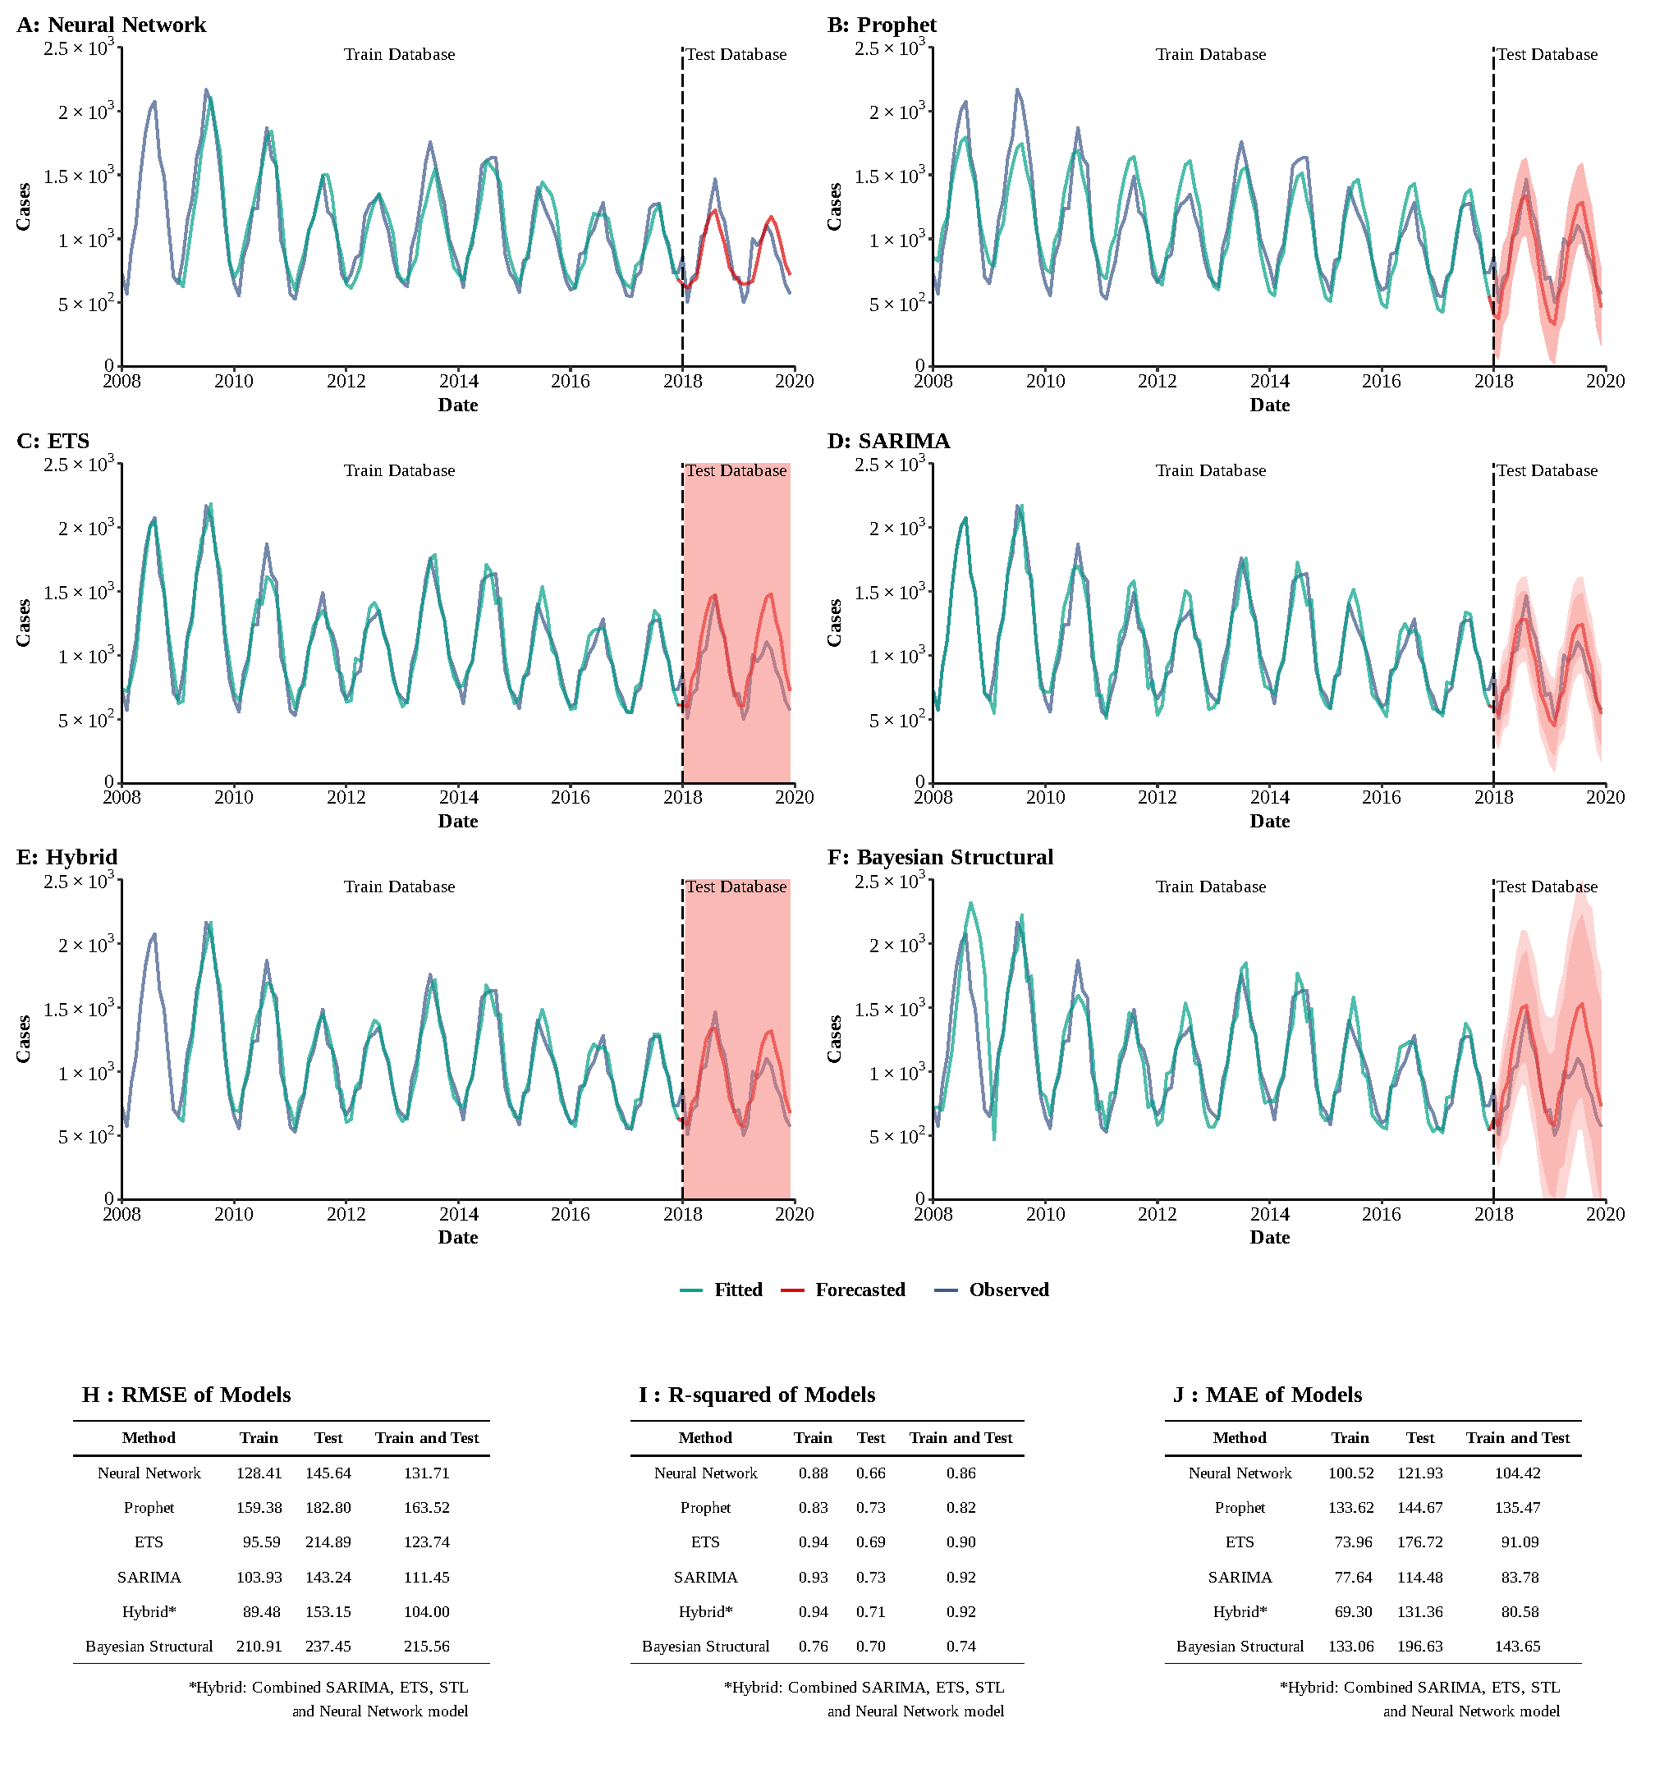

**Supplementary Figure 3**

**Training and comparing variant time series models for typhoid and paratyphoid fever.** (A) Neural Network model; (B) ETS model; (C) ARIMA model; (D) SEARIMA model; (E) Hybrid models combining SARIMA, ETS, STL, and neural network model; (F) Bayesian structural model; (G) RMSE of variant models; (H) R-squared of variant models; (J) MAE of variant models.

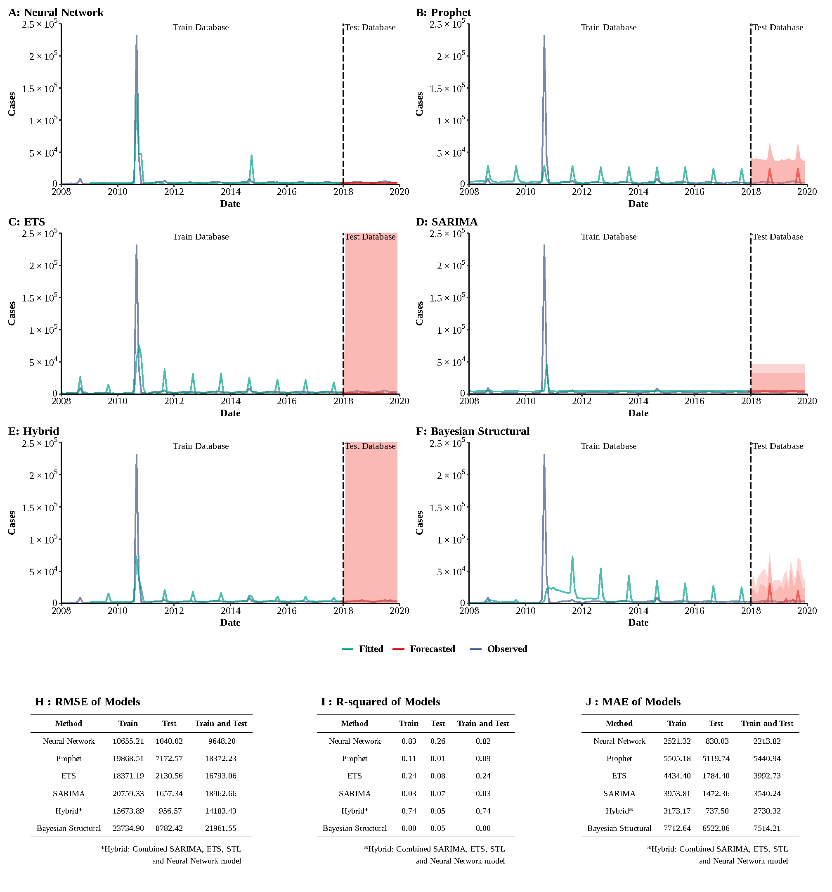

**Supplementary Figure 4**

**Training and comparing variant time series models for AHC.** (A) Neural Network model; (B) ETS model; (C) ARIMA model; (D) SEARIMA model; (E) Hybrid models combining SARIMA, ETS, STL, and neural network model; (F) Bayesian structural model; (G) RMSE of variant models; (H) R-squared of variant models; (J) MAE of variant models.

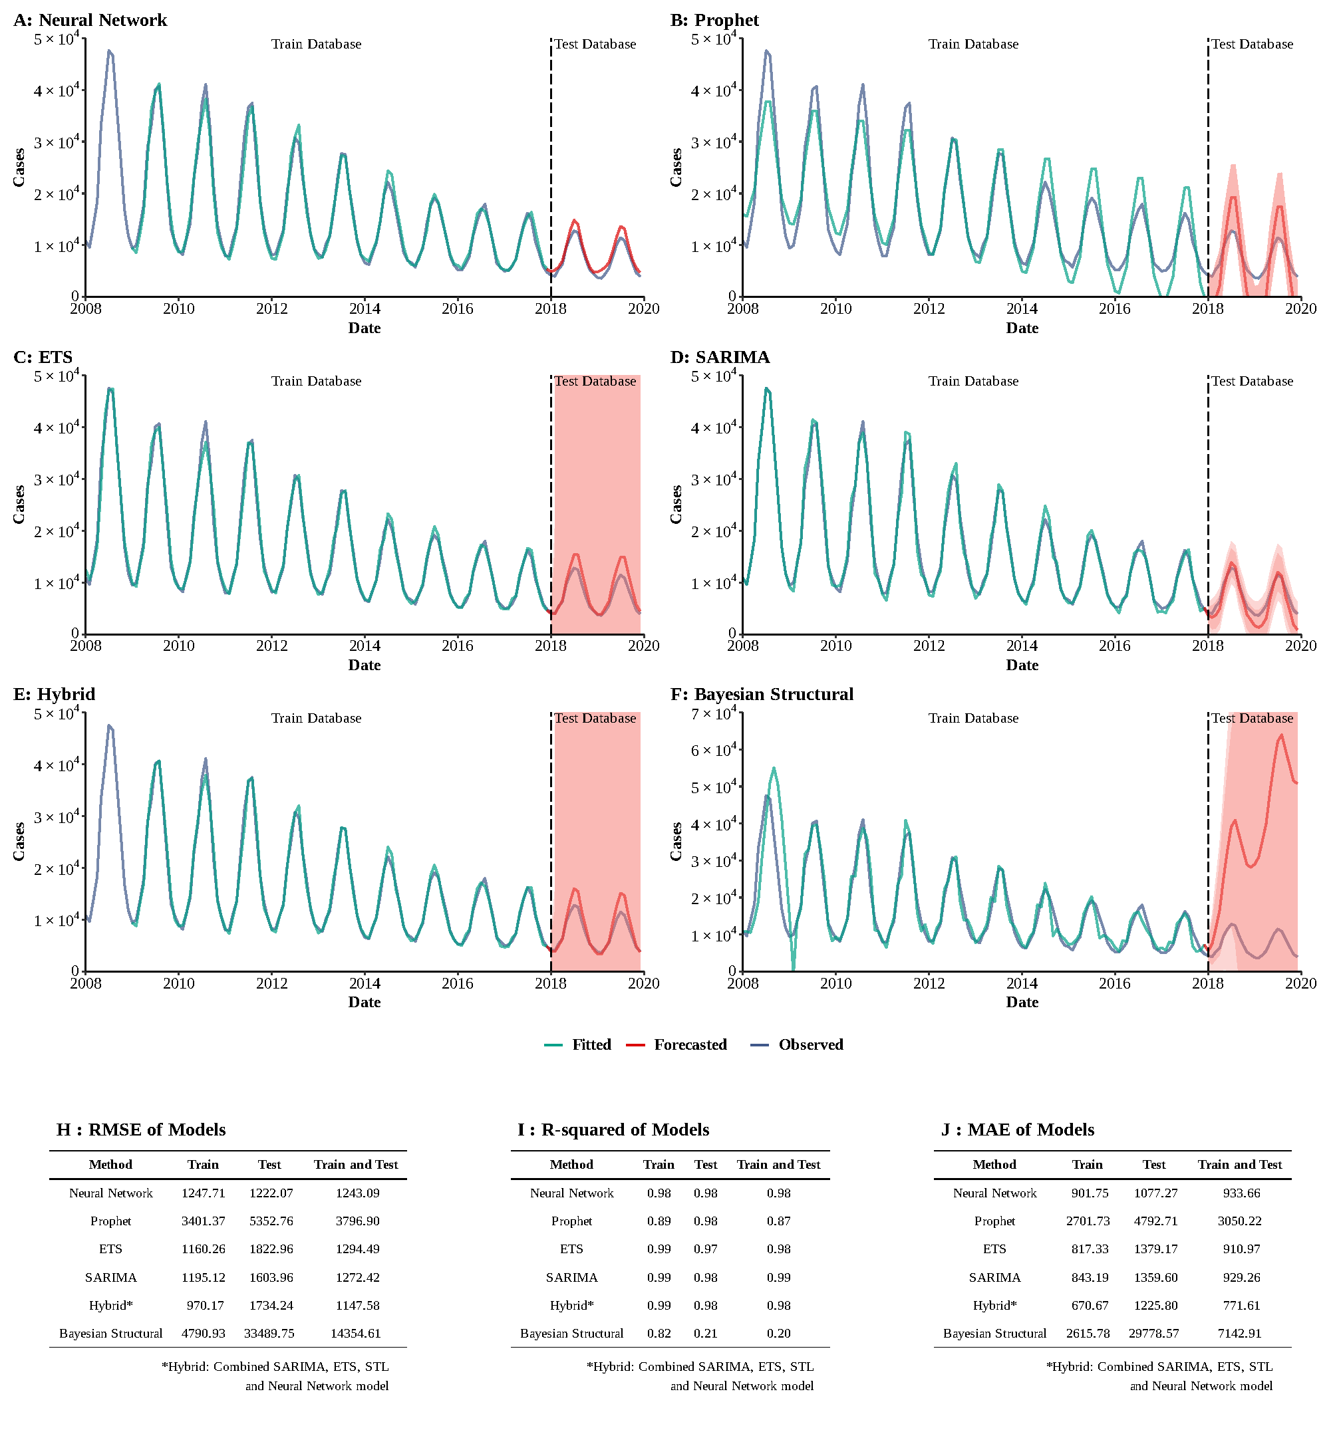

**Supplementary Figure 5**

**Training and comparing variant time series models for dysentery.** (A) Neural Network model; (B) ETS model; (C) ARIMA model; (D) SEARIMA model; (E) Hybrid models combining SARIMA, ETS, STL, and neural network model; (F) Bayesian structural model; (G) RMSE of variant models; (H) R-squared of variant models; (J) MAE of variant models.

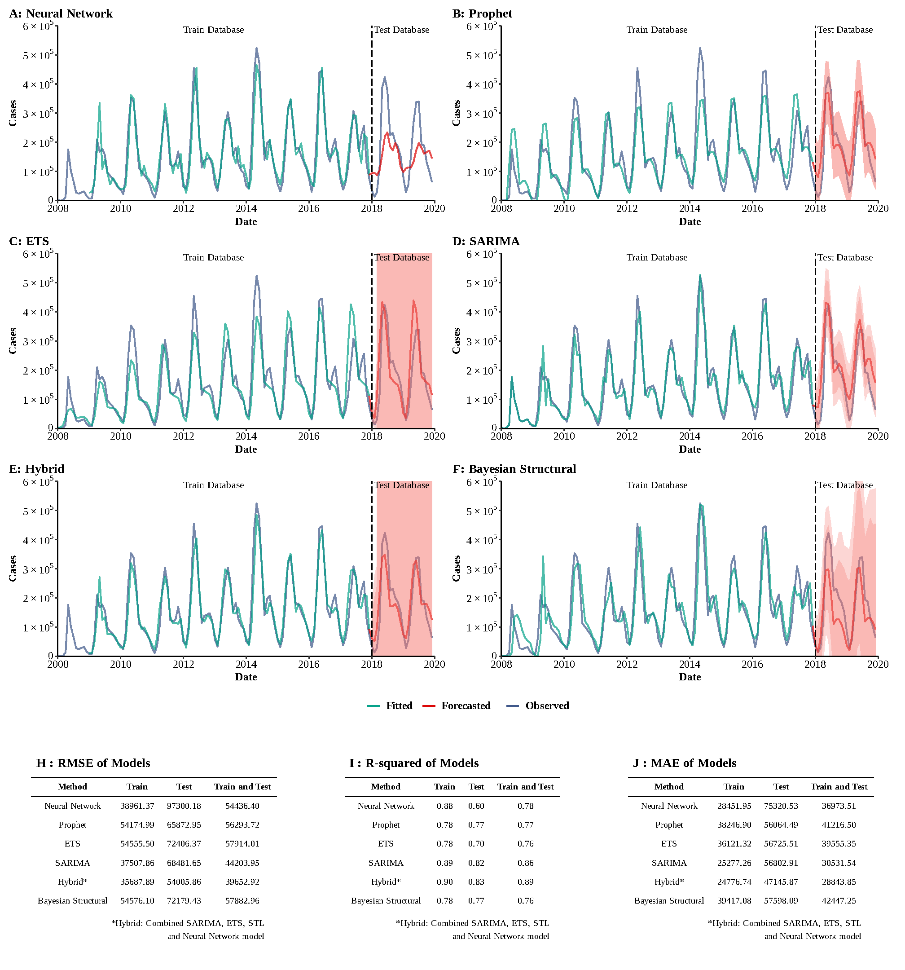

**Supplementary Figure 6**

**Training and comparing variant time series models for HFMD.** (A) Neural Network model; (B) ETS model; (C) ARIMA model; (D) SEARIMA model; (E) Hybrid models combining SARIMA, ETS, STL, and neural network model; (F) Bayesian structural model; (G) RMSE of variant models; (H) R-squared of variant models; (J) MAE of variant models.

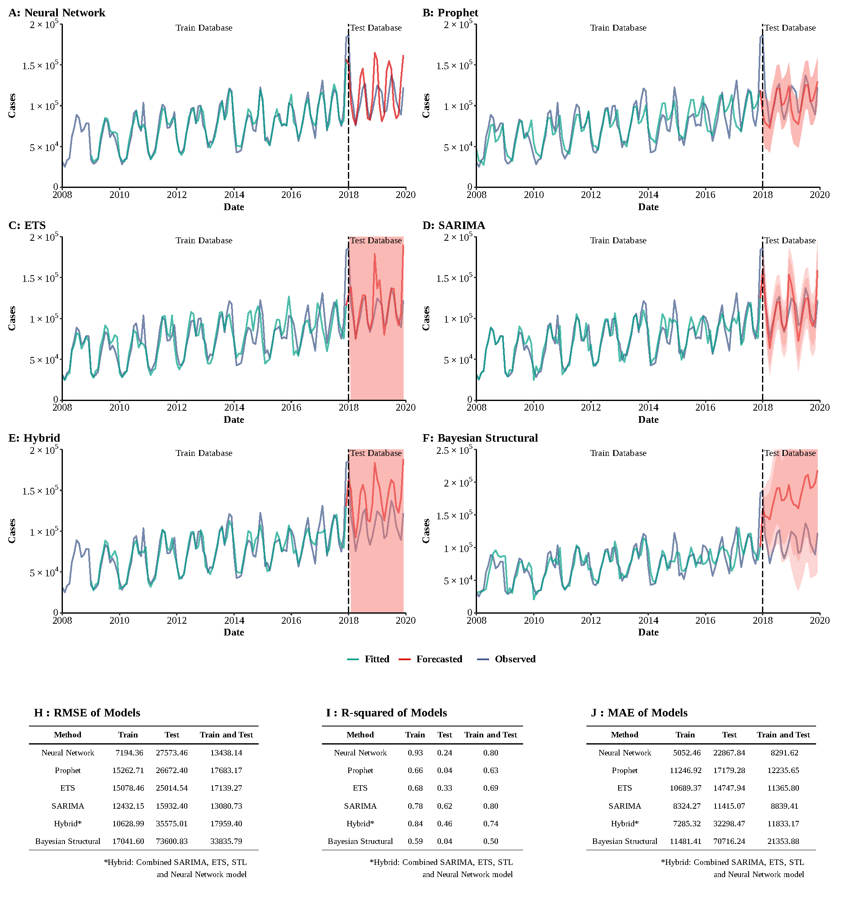

**Supplementary Figure 7**

**Training and comparing variant time series models for other infectious diarrhea.** (A) Neural Network model; (B) ETS model; (C) ARIMA model; (D) SEARIMA model; (E) Hybrid models combining SARIMA, ETS, STL, and neural network model; (F) Bayesian structural model; (G) RMSE of variant models; (H) R-squared of variant models; (J) MAE of variant models.

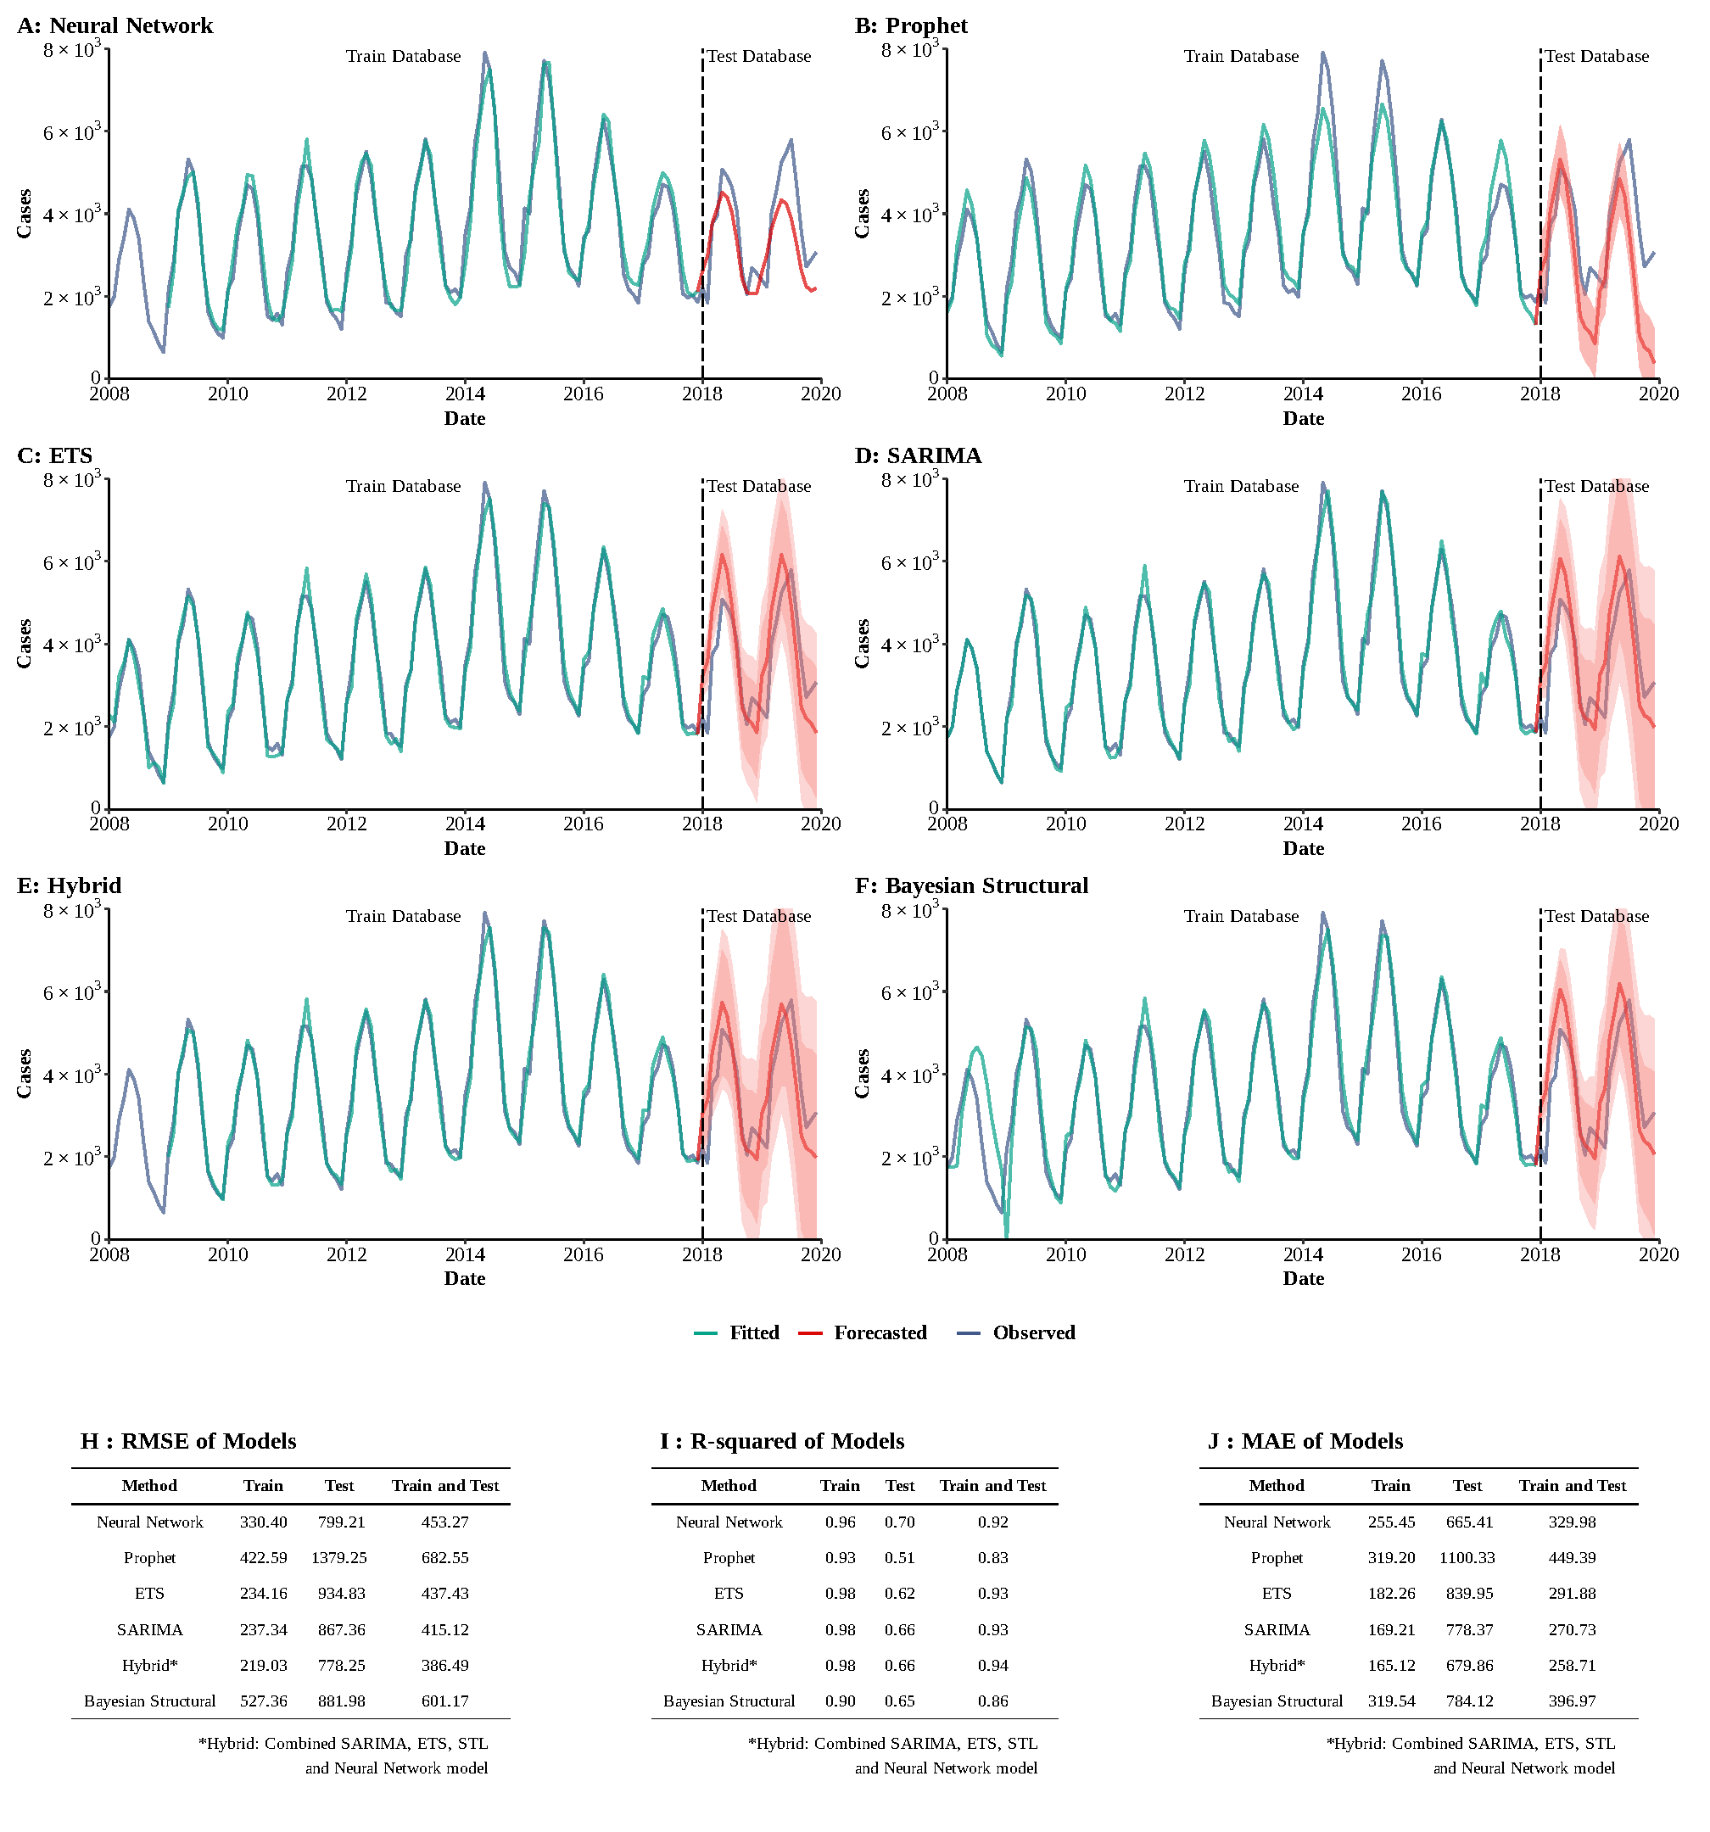**Supplementary Figure 8**

**Training and comparing variant time series models for brucellosis.** (A) Neural Network model; (B) ETS model; (C) ARIMA model; (D) SEARIMA model; (E) Hybrid models combining SARIMA, ETS, STL, and neural network model; (F) Bayesian structural model; (G) RMSE of variant models; (H) R-squared of variant models; (J) MAE of variant models.

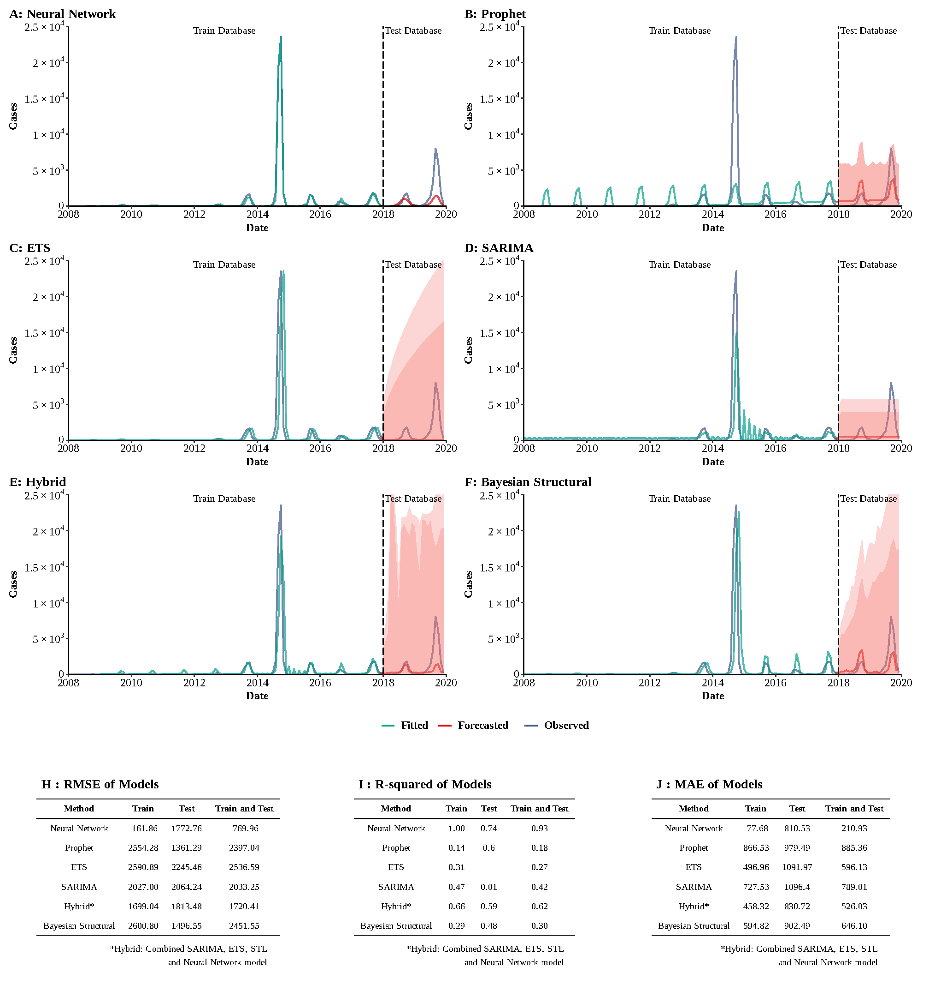

**Supplementary Figure 9**

**Training and comparing variant time series models for dengue fever.** (A) Neural Network model; (B) ETS model; (C) ARIMA model; (D) SEARIMA model; (E) Hybrid models combining SARIMA, ETS, STL, and neural network model; (F) Bayesian structural model; (G) RMSE of variant models; (H) R-squared of variant models; (J) MAE of variant models.

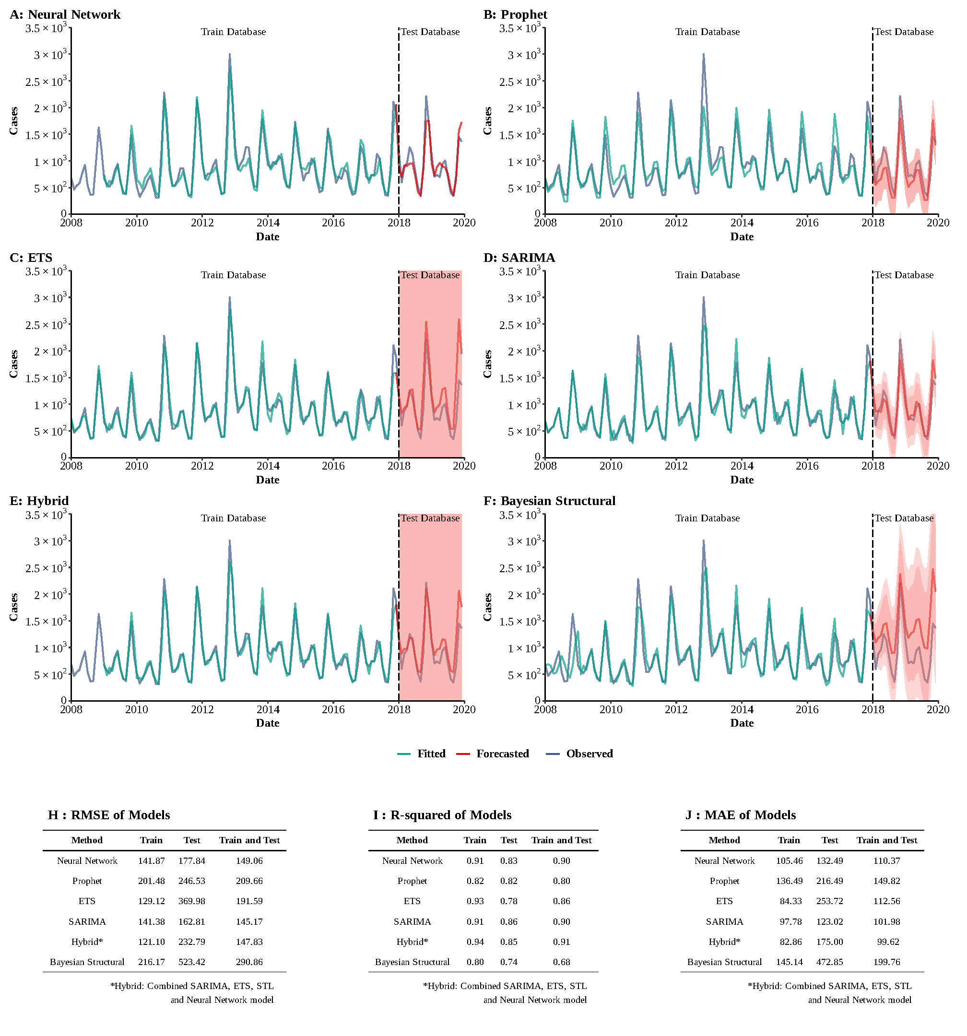

**Supplementary Figure 10**

**Training and comparing variant time series models for HFRS.** (A) Neural Network model; (B) ETS model; (C) ARIMA model; (D) SEARIMA model; (E) Hybrid models combining SARIMA, ETS, STL, and neural network model; (F) Bayesian structural model; (G) RMSE of variant models; (H) R-squared of variant models; (J) MAE of variant models.

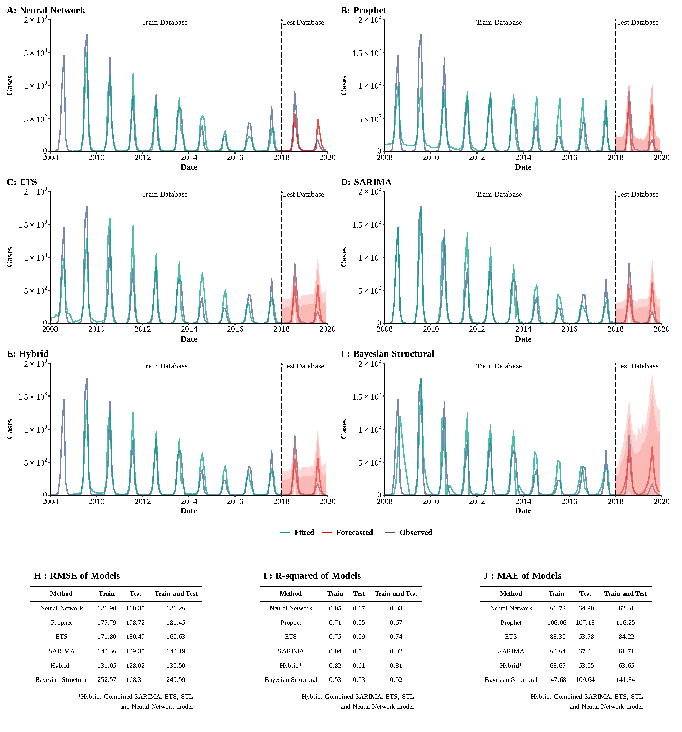

**Supplementary Figure 11**

**Training and comparing variant time series models for Japanese encephalitis.** (A) Neural Network model; (B) ETS model; (C) ARIMA model; (D) SEARIMA model; (E) Hybrid models combining SARIMA, ETS, STL, and neural network model; (F) Bayesian structural model; (G) RMSE of variant models; (H) R-squared of variant models; (J) MAE of variant models.

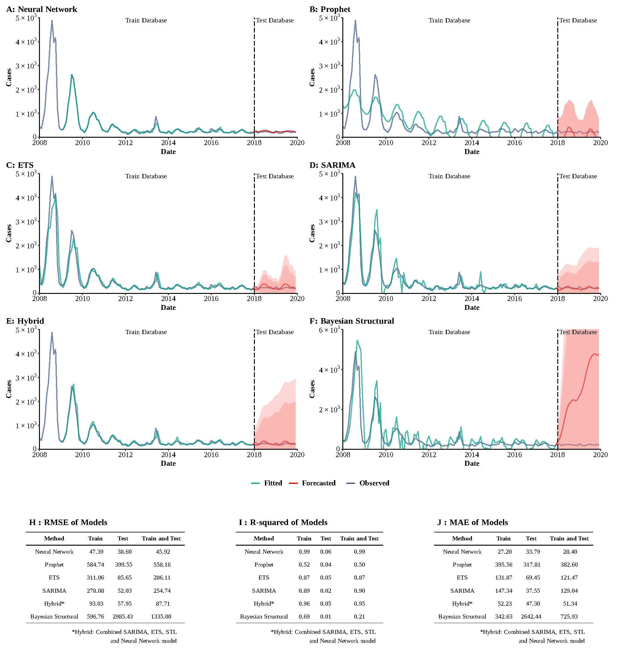**Supplementary Figure 12**

**Training and comparing variant time series models for malaria.** (A) Neural Network model; (B) ETS model; (C) ARIMA model; (D) SEARIMA model; (E) Hybrid models combining SARIMA, ETS, STL, and neural network model; (F) Bayesian structural model; (G) RMSE of variant models; (H) R-squared of variant models; (J) MAE of variant models.

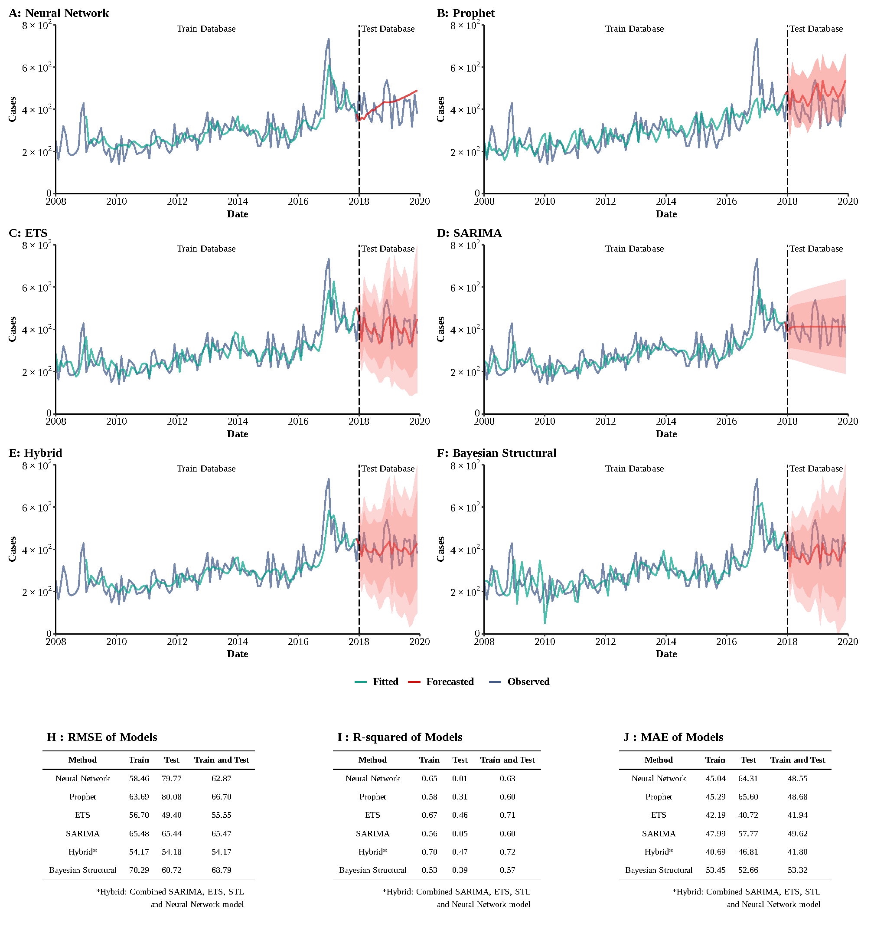

**Supplementary Figure 13**

**Training and comparing variant time series models for hydatidosis.** (A) Neural Network model; (B) ETS model; (C) ARIMA model; (D) SEARIMA model; (E) Hybrid models combining SARIMA, ETS, STL, and neural network model; (F) Bayesian structural model; (G) RMSE of variant models; (H) R-squared of variant models; (J) MAE of variant models.

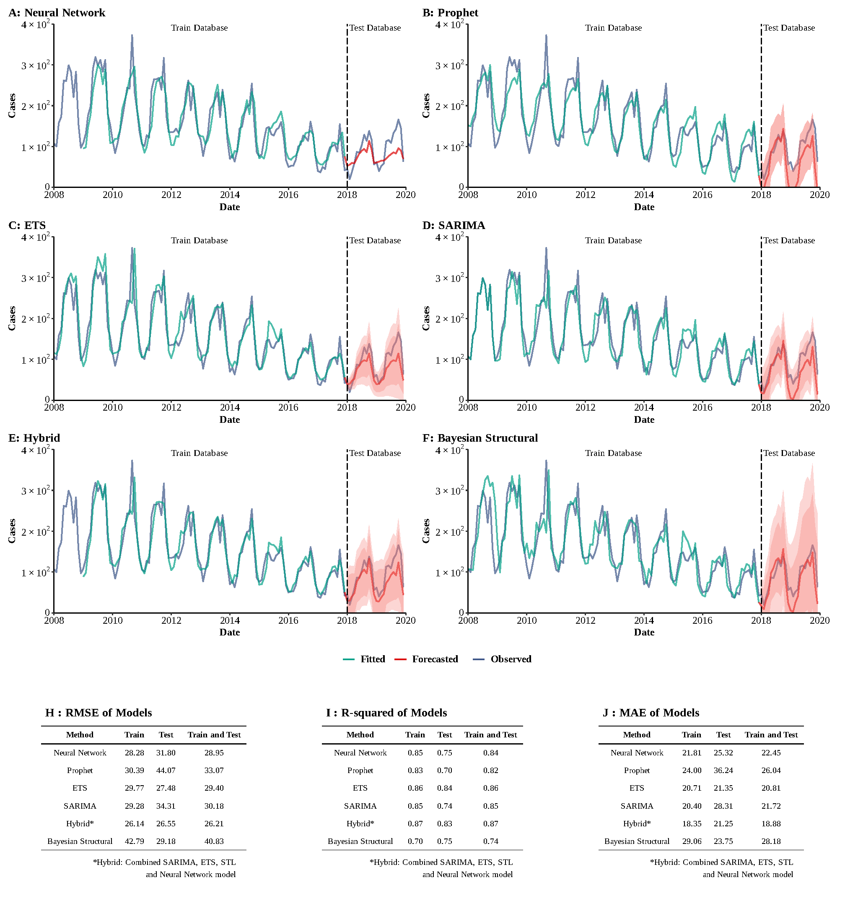**Supplementary Figure 14**

**Training and comparing variant time series models for typhus.** (A) Neural Network model; (B) ETS model; (C) ARIMA model; (D) SEARIMA model; (E) Hybrid models combining SARIMA, ETS, STL, and neural network model; (F) Bayesian structural model; (G) RMSE of variant models; (H) R-squared of variant models; (J) MAE of variant models.

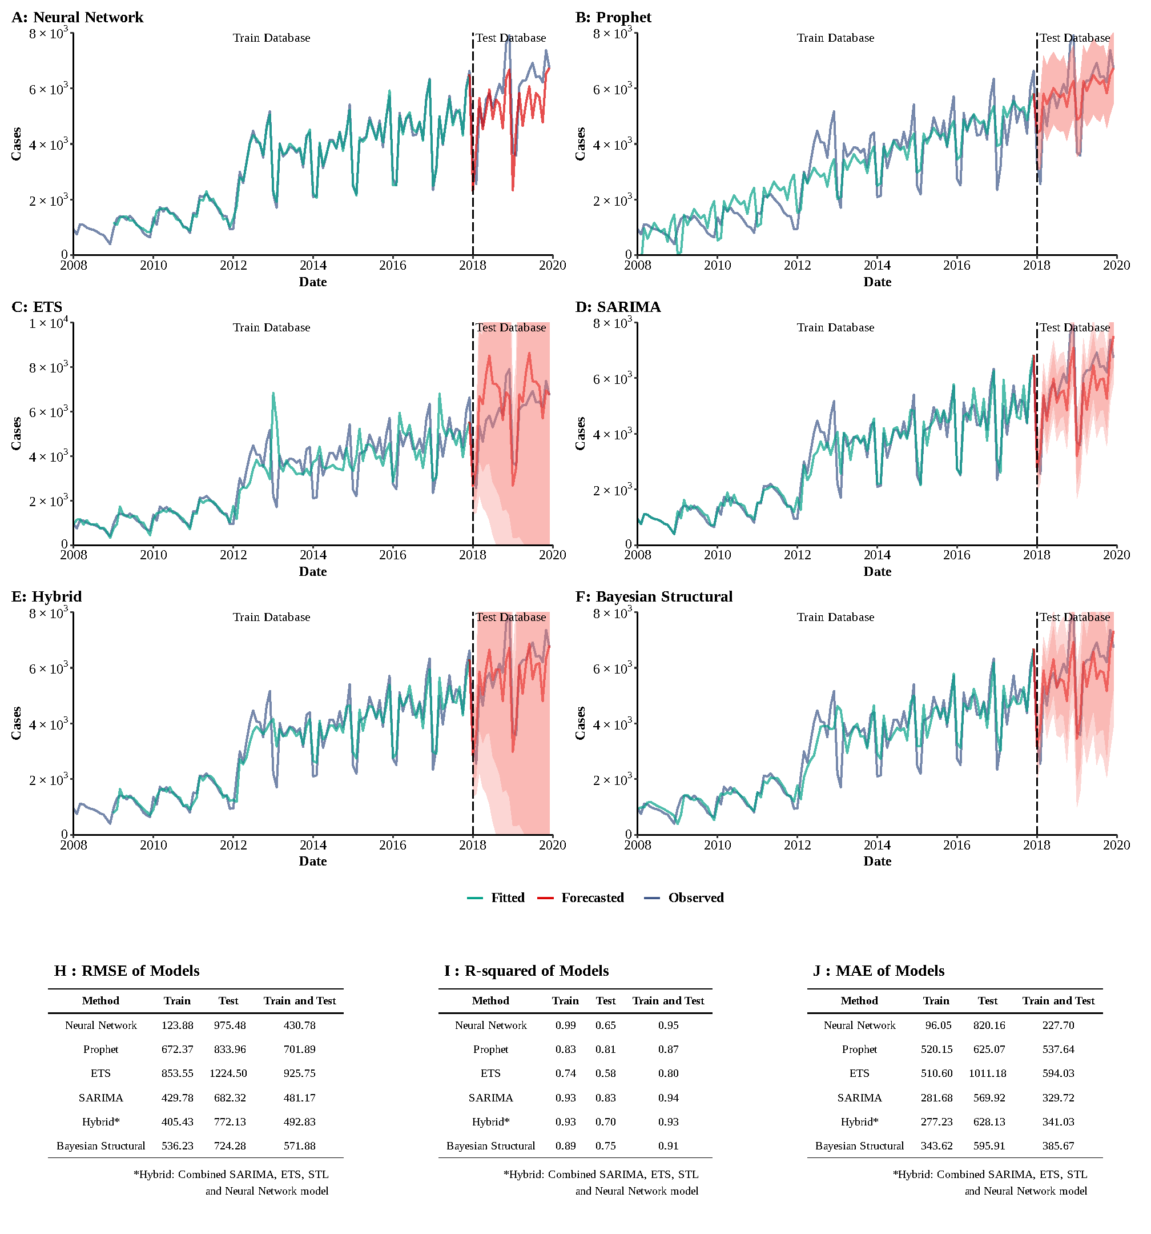

**Supplementary Figure 15**

**Training and comparing variant time series models for AIDS.** (A) Neural Network model; (B) ETS model; (C) ARIMA model; (D) SEARIMA model; (E) Hybrid models combining SARIMA, ETS, STL, and neural network model; (F) Bayesian structural model; (G) RMSE of variant models; (H) R-squared of variant models; (J) MAE of variant models.

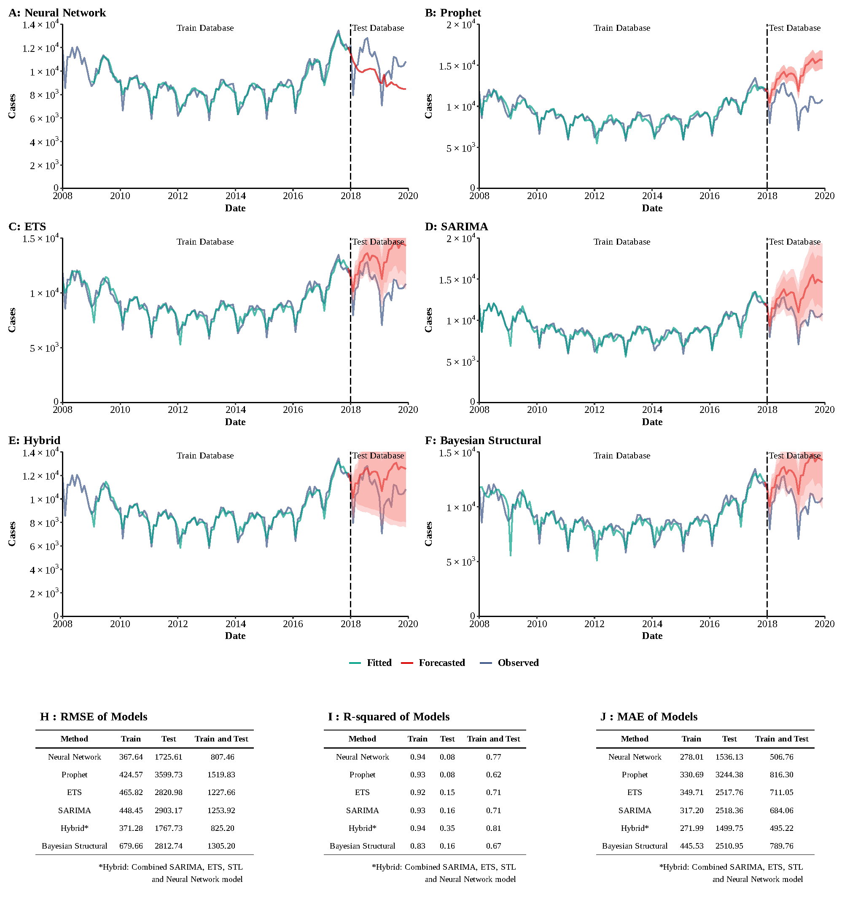

**Supplementary Figure 16**

**Training and comparing variant time series models for gonorrhea.** (A) Neural Network model; (B) ETS model; (C) ARIMA model; (D) SEARIMA model; (E) Hybrid models combining SARIMA, ETS, STL, and neural network model; (F) Bayesian structural model; (G) RMSE of variant models; (H) R-squared of variant models; (J) MAE of variant models.

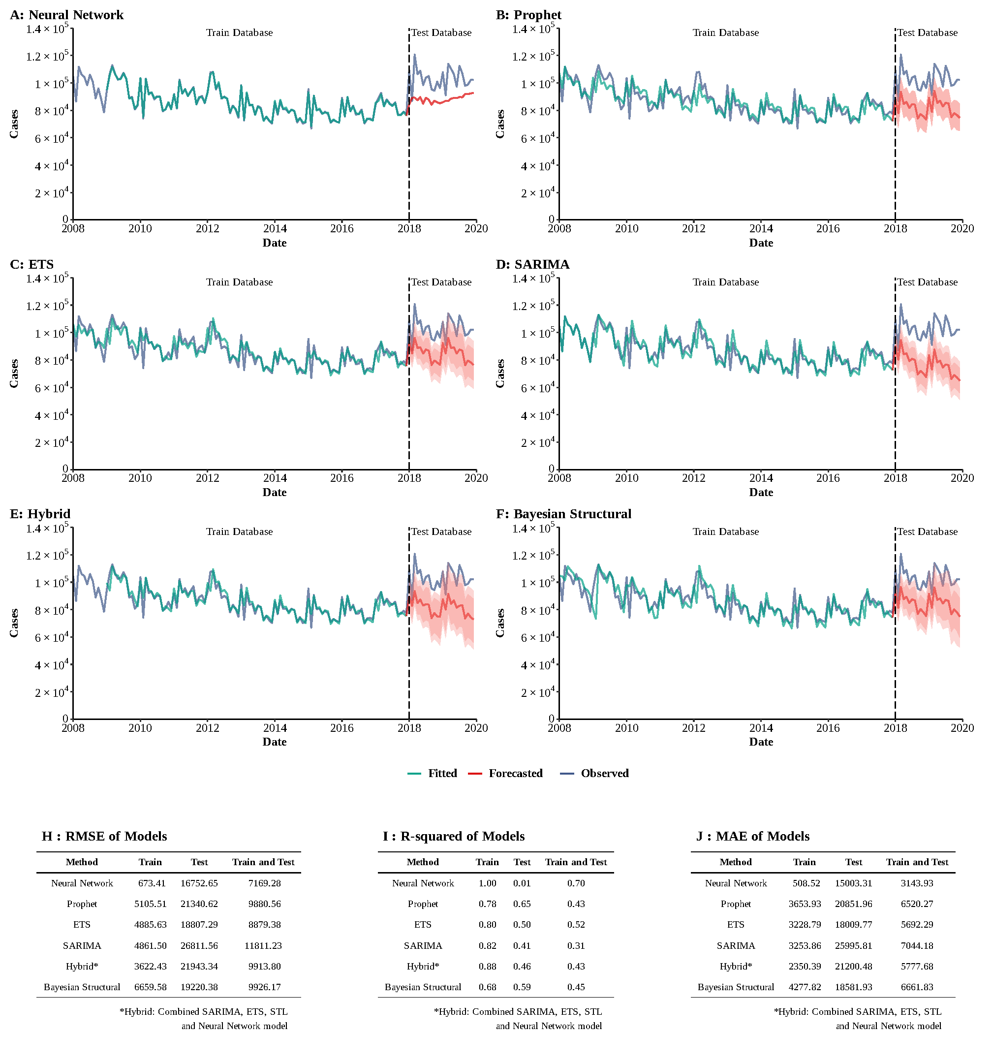

**Supplementary Figure 17**

**Training and comparing variant time series models for HBV.** (A) Neural Network model; (B) ETS model; (C) ARIMA model; (D) SEARIMA model; (E) Hybrid models combining SARIMA, ETS, STL, and neural network model; (F) Bayesian structural model; (G) RMSE of variant models; (H) R-squared of variant models; (J) MAE of variant models.

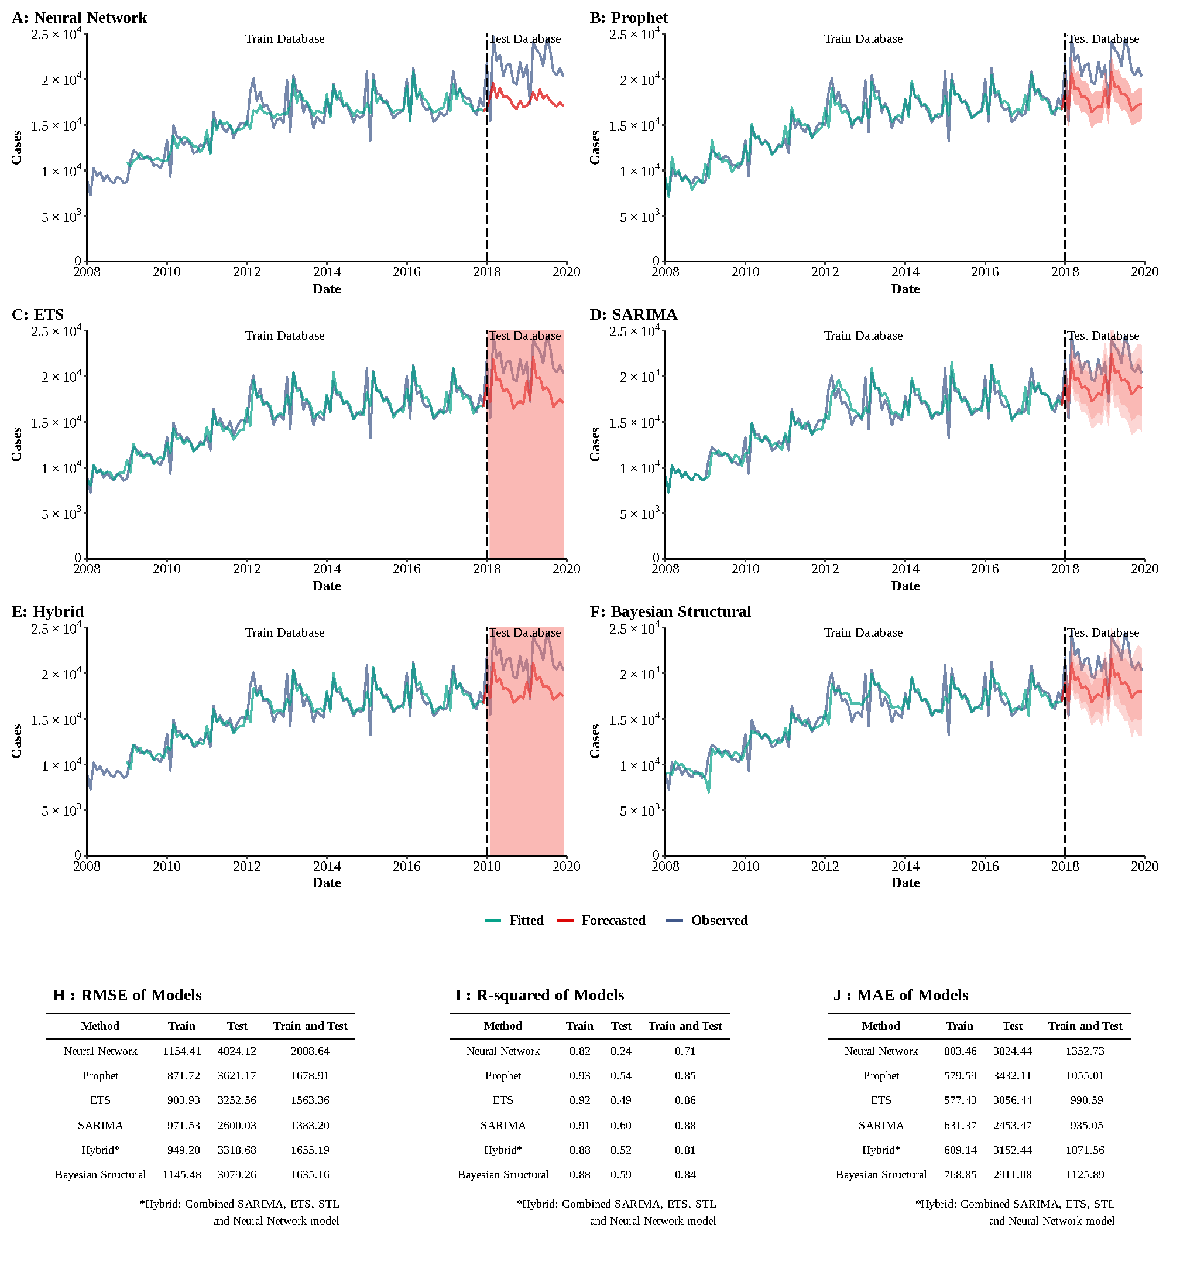

**Supplementary Figure 18**

**Training and comparing variant time series models for HCV.** (A) Neural Network model; (B) ETS model; (C) ARIMA model; (D) SEARIMA model; (E) Hybrid models combining SARIMA, ETS, STL, and neural network model; (F) Bayesian structural model; (G) RMSE of variant models; (H) R-squared of variant models; (J) MAE of variant models.

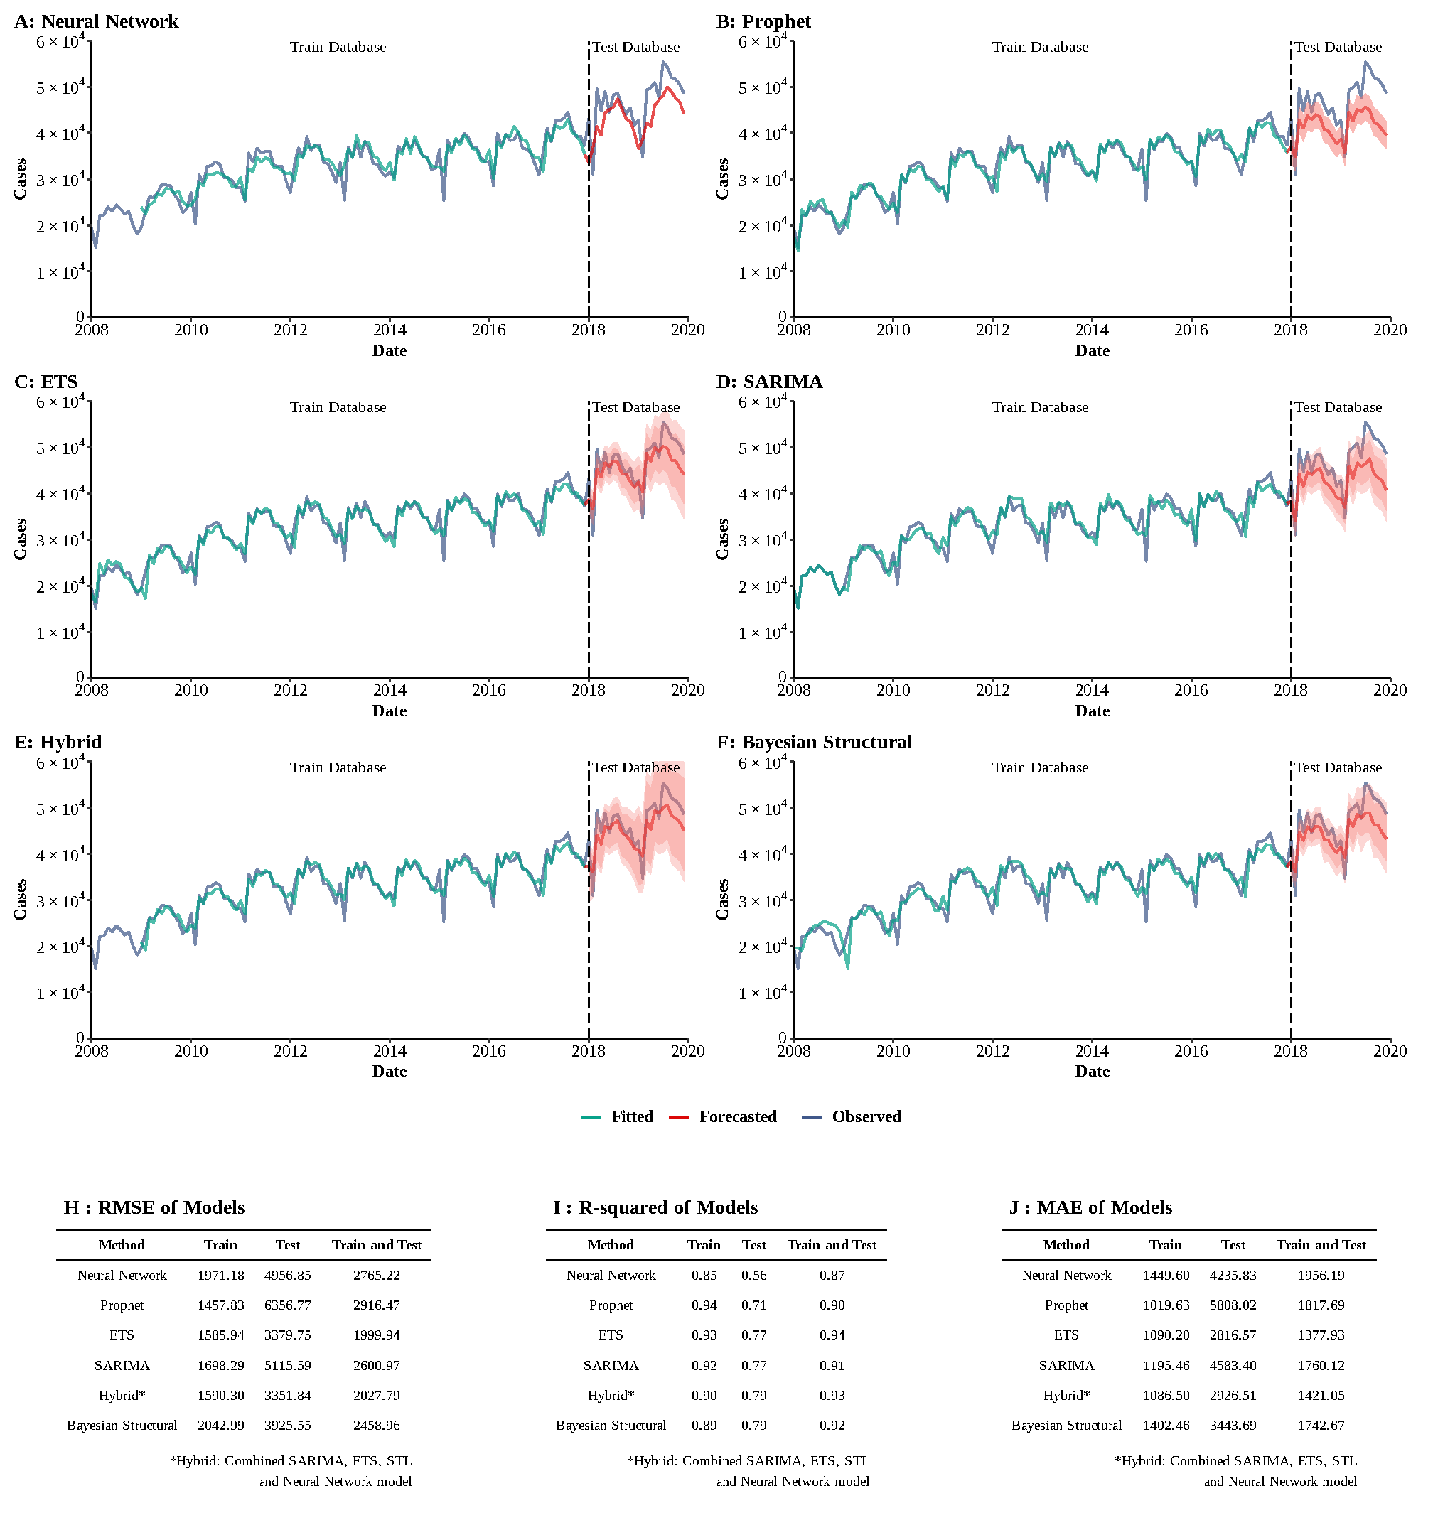**Supplementary Figure 19**

**Training and comparing variant time series models for syphilis.** (A) Neural Network model; (B) ETS model; (C) ARIMA model; (D) SEARIMA model; (E) Hybrid models combining SARIMA, ETS, STL, and neural network model; (F) Bayesian structural model; (G) RMSE of variant models; (H) R-squared of variant models; (J) MAE of variant models.

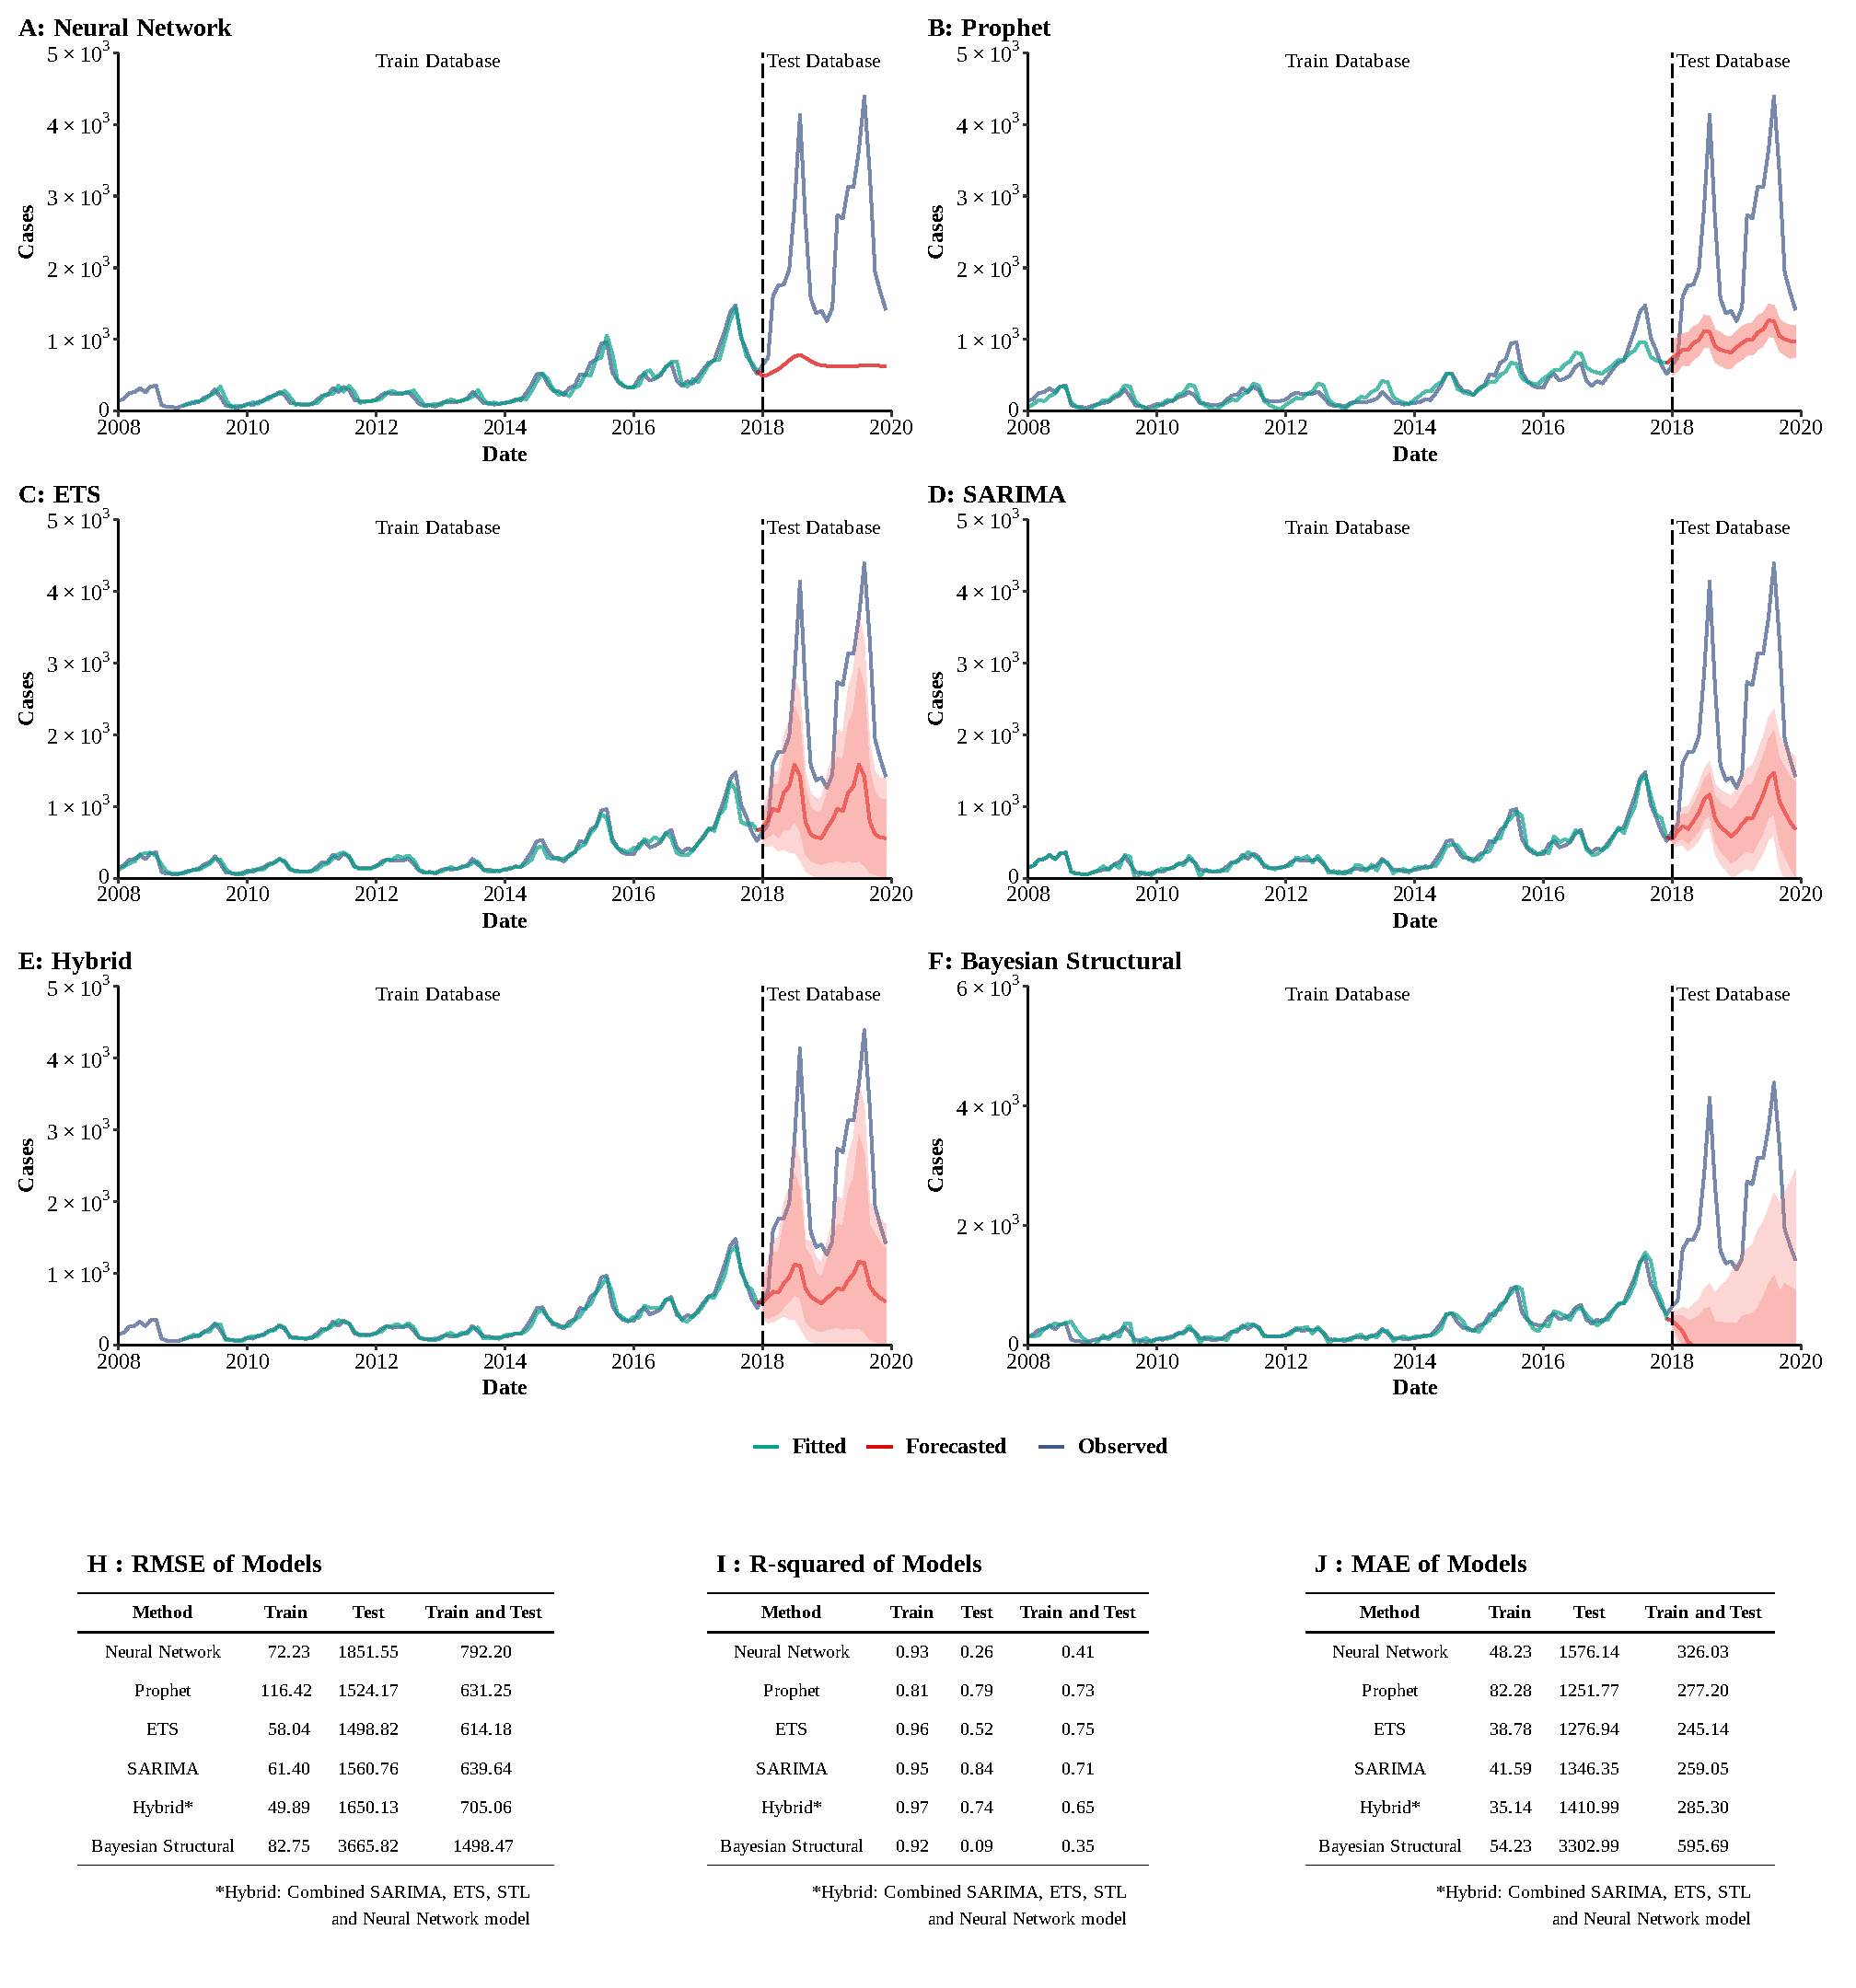

**Supplementary Figure 20**

**Training and comparing variant time series models for pertussis.** (A) Neural Network model; (B) ETS model; (C) ARIMA model; (D) SEARIMA model; (E) Hybrid models combining SARIMA, ETS, STL, and neural network model; (F) Bayesian structural model; (G) RMSE of variant models; (H) R-squared of variant models; (J) MAE of variant models.

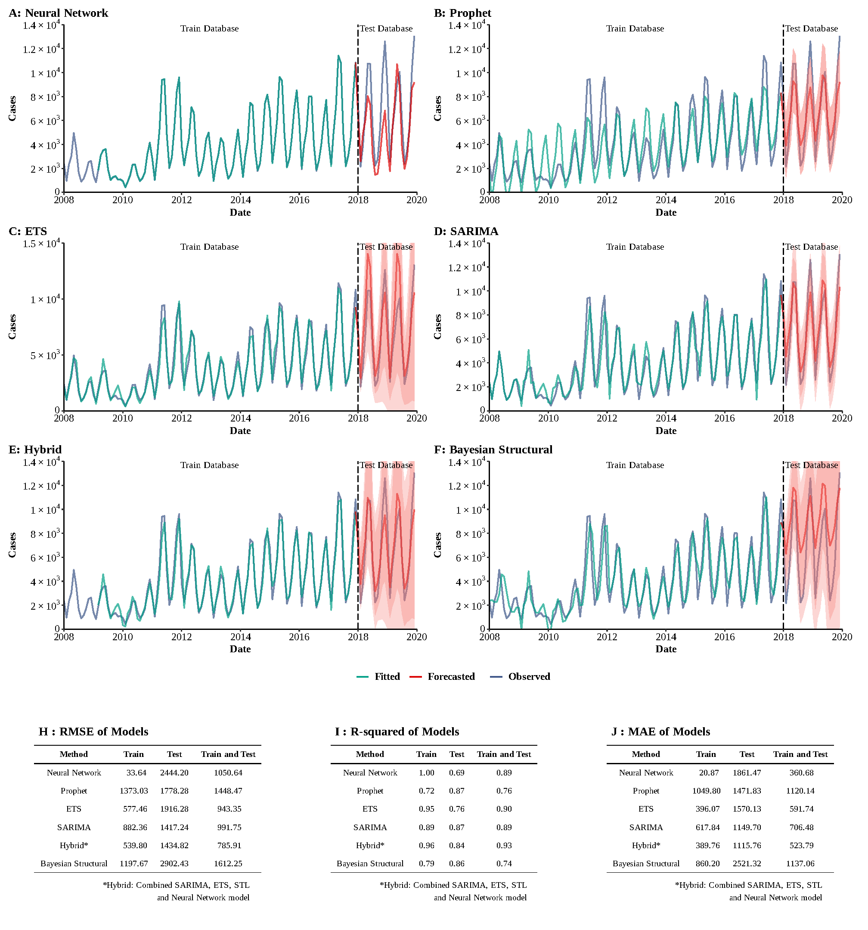**Supplementary Figure 21**

**Training and comparing variant time series models for scarlet fever.** (A) Neural Network model; (B) ETS model; (C) ARIMA model; (D) SEARIMA model; (E) Hybrid models combining SARIMA, ETS, STL, and neural network model; (F) Bayesian structural model; (G) RMSE of variant models; (H) R-squared of variant models; (J) MAE of variant models.

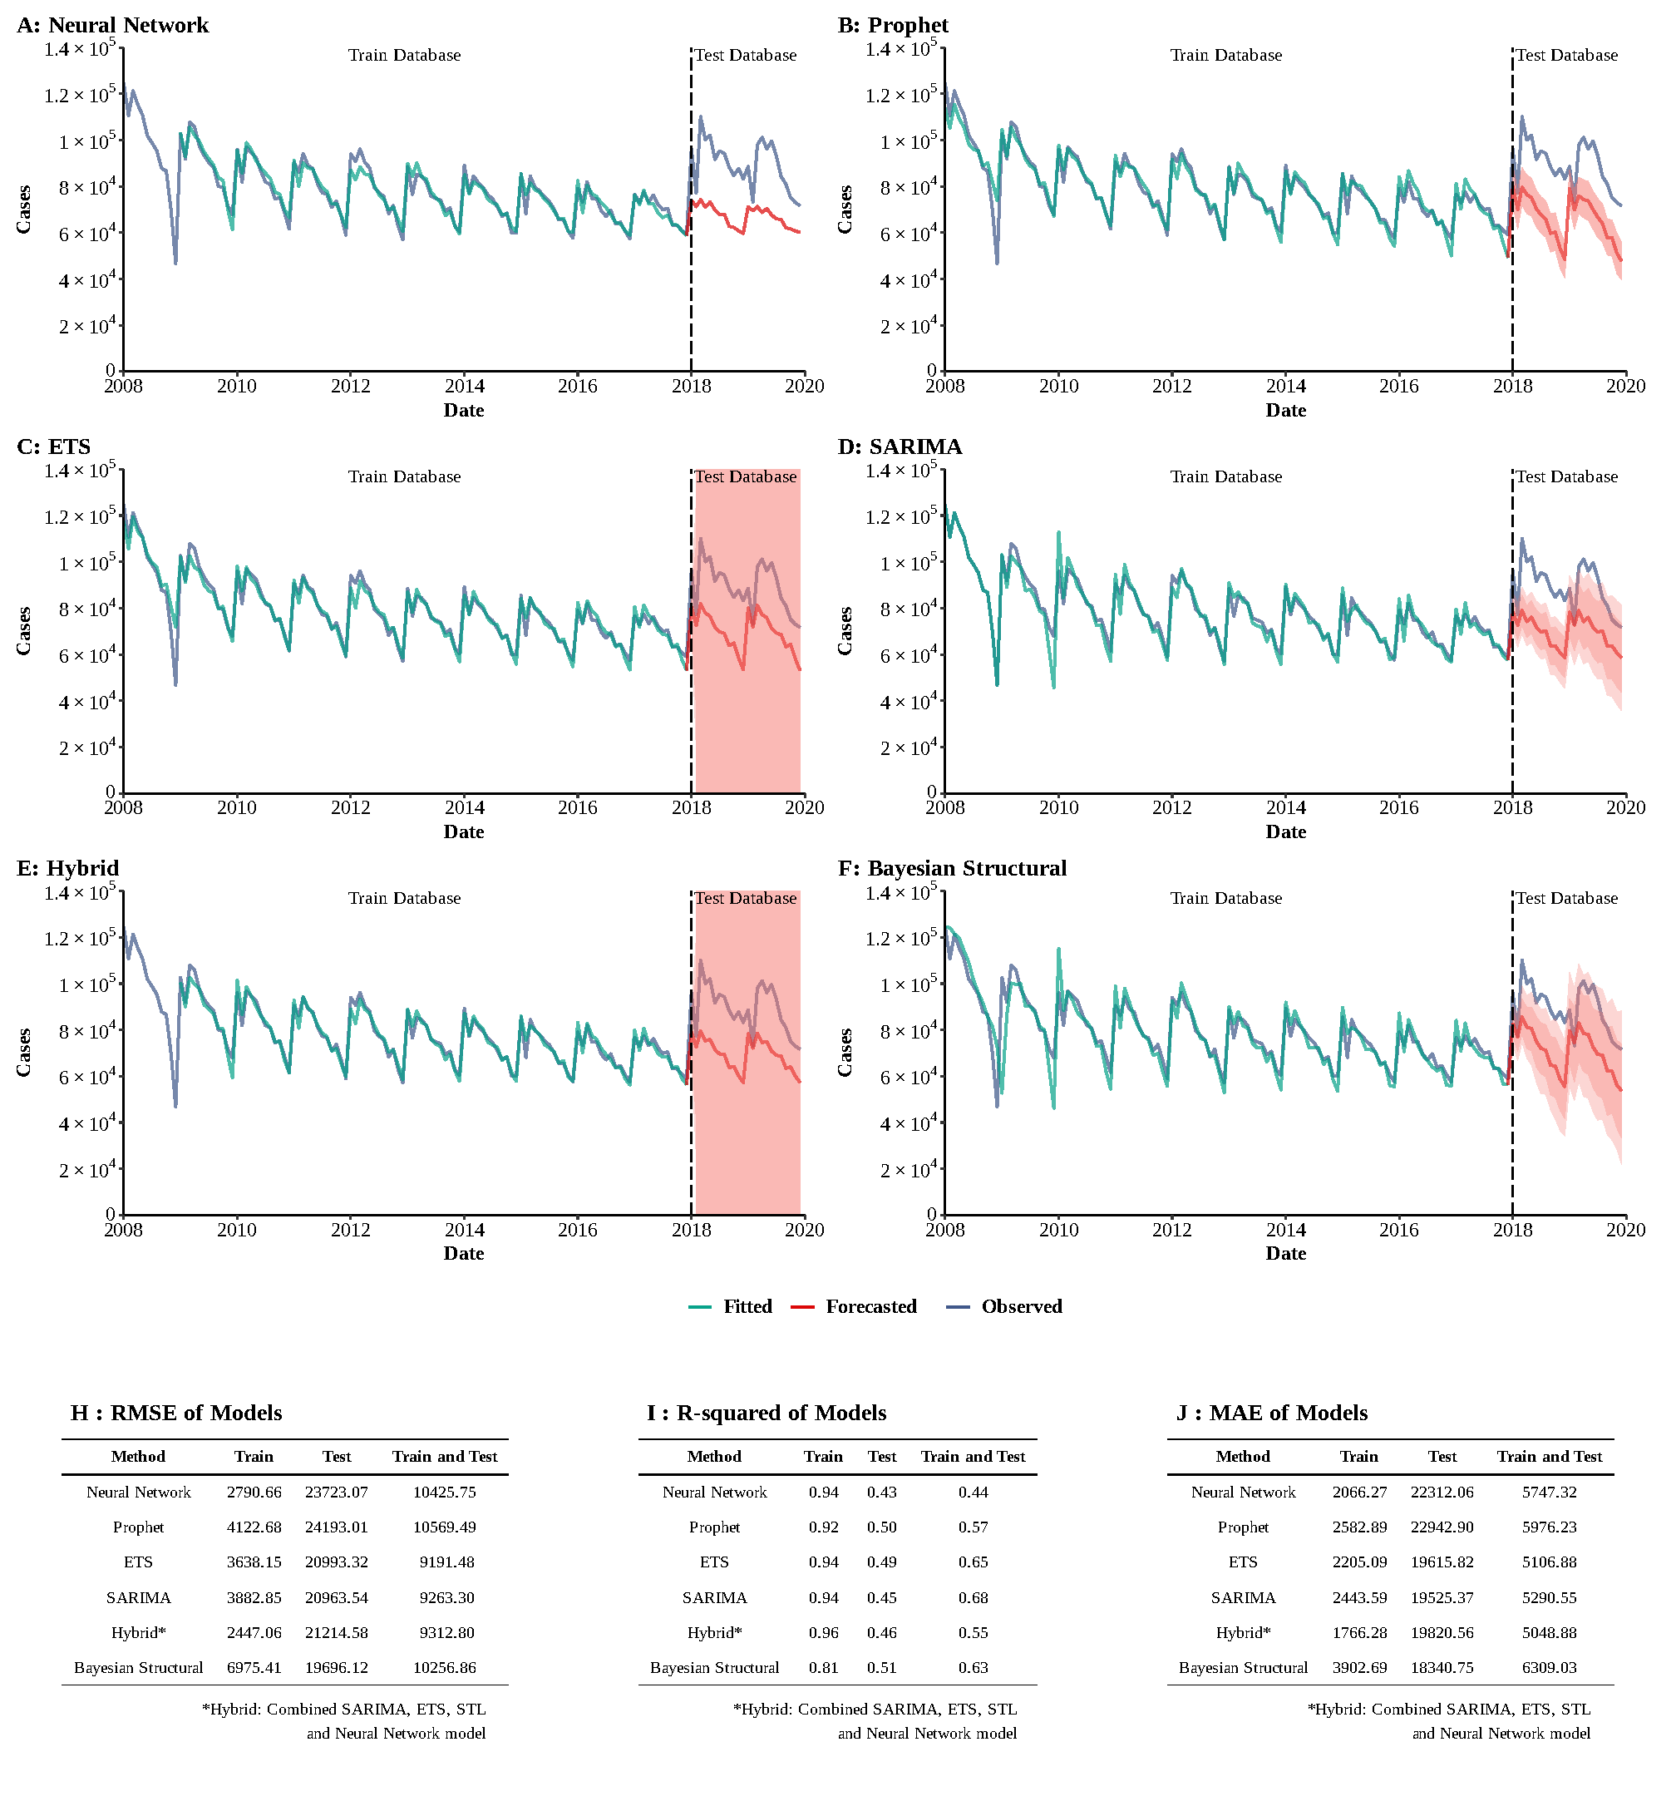**Supplementary Figure 22**

**Training and comparing variant time series models for tuberculosis.** (A) Neural Network model; (B) ETS model; (C) ARIMA model; (D) SEARIMA model; (E) Hybrid models combining SARIMA, ETS, STL, and neural network model; (F) Bayesian structural model; (G) RMSE of variant models; (H) R-squared of variant models; (J) MAE of variant models.

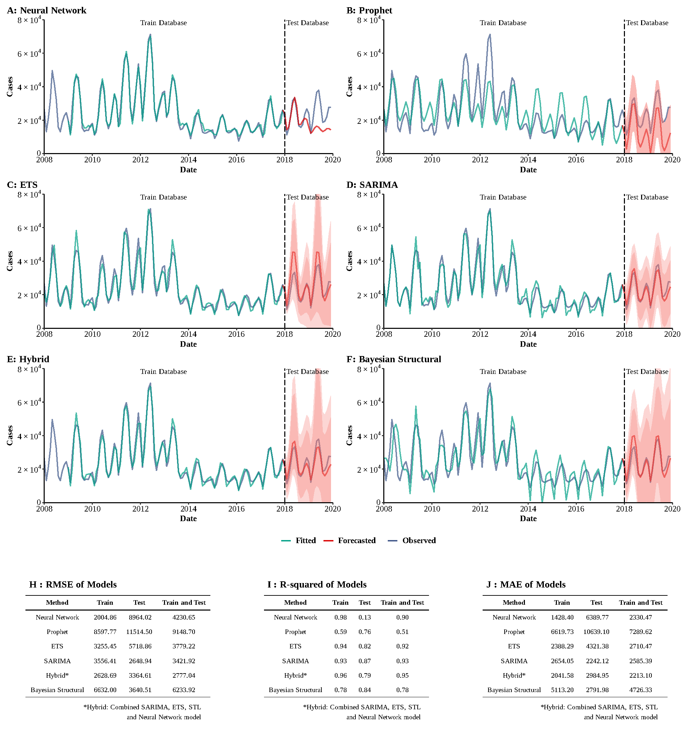**Supplementary Figure 23**

**Training and comparing variant time series models for mumps.** (A) Neural Network model; (B) ETS model; (C) ARIMA model; (D) SEARIMA model; (E) Hybrid models combining SARIMA, ETS, STL, and neural network model; (F) Bayesian structural model; (G) RMSE of variant models; (H) R-squared of variant models; (J) MAE of variant models.

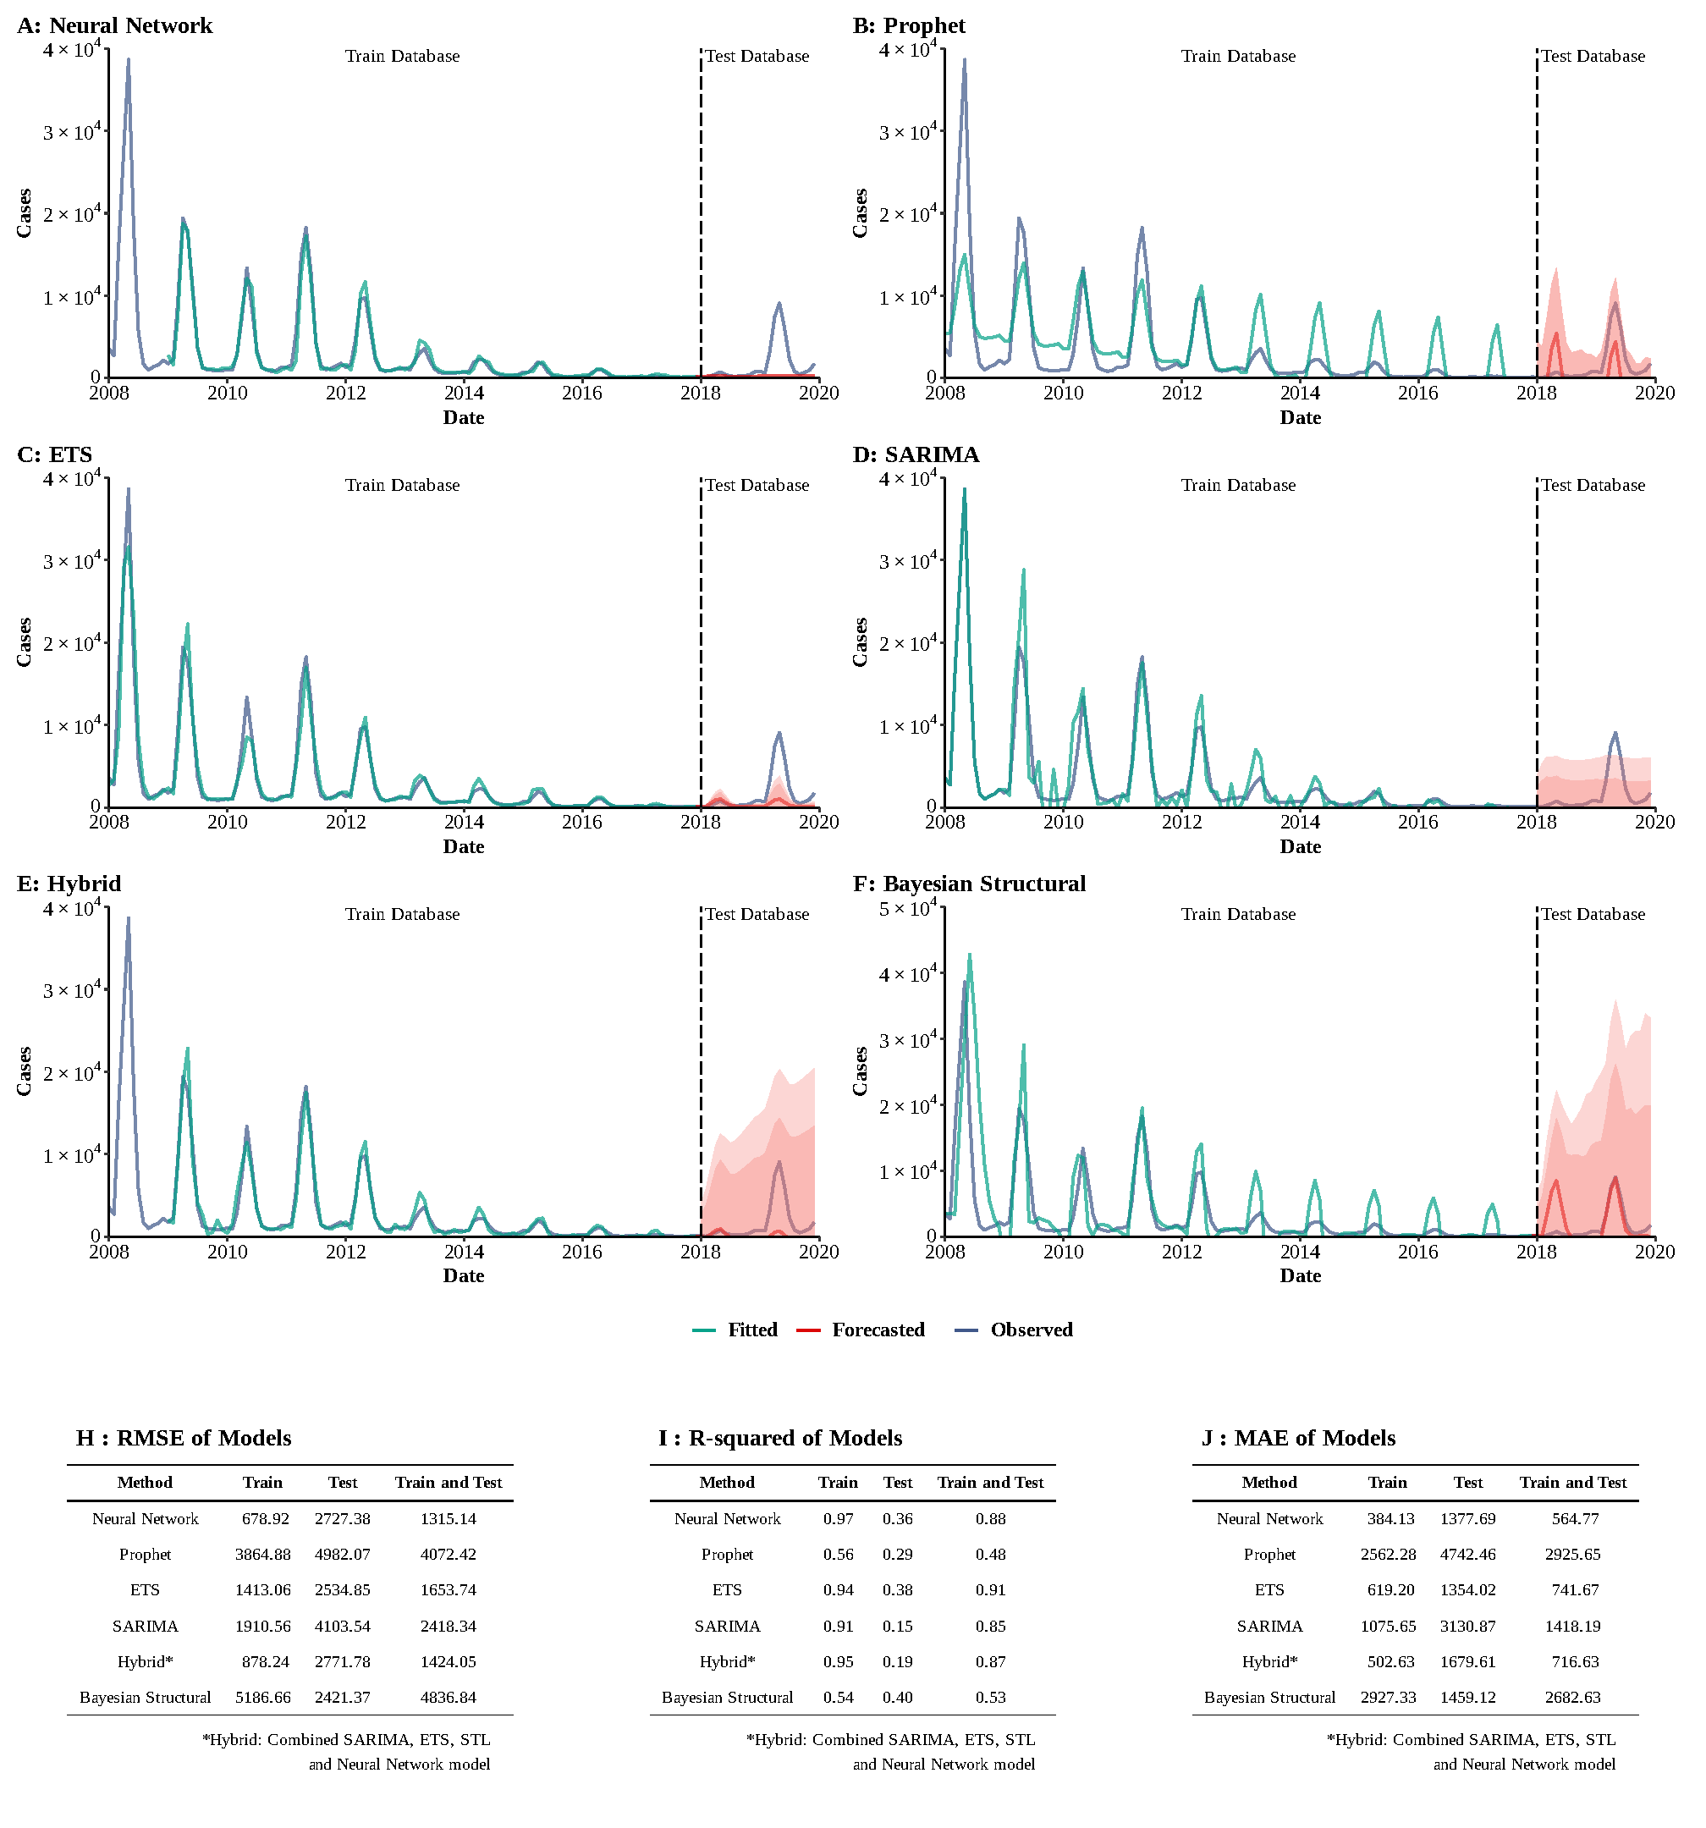**Supplementary Figure 24**

**Training and comparing variant time series models for rubella.** (A) Neural Network model; (B) ETS model; (C) ARIMA model; (D) SEARIMA model; (E) Hybrid models combining SARIMA, ETS, STL, and neural network model; (F) Bayesian structural model; (G) RMSE of variant models; (H) R-squared of variant models; (J) MAE of variant models.