**Python sql数据库处理**

选课系统

郑永豪 22920152203952

根据题目要求做出相应的er图：

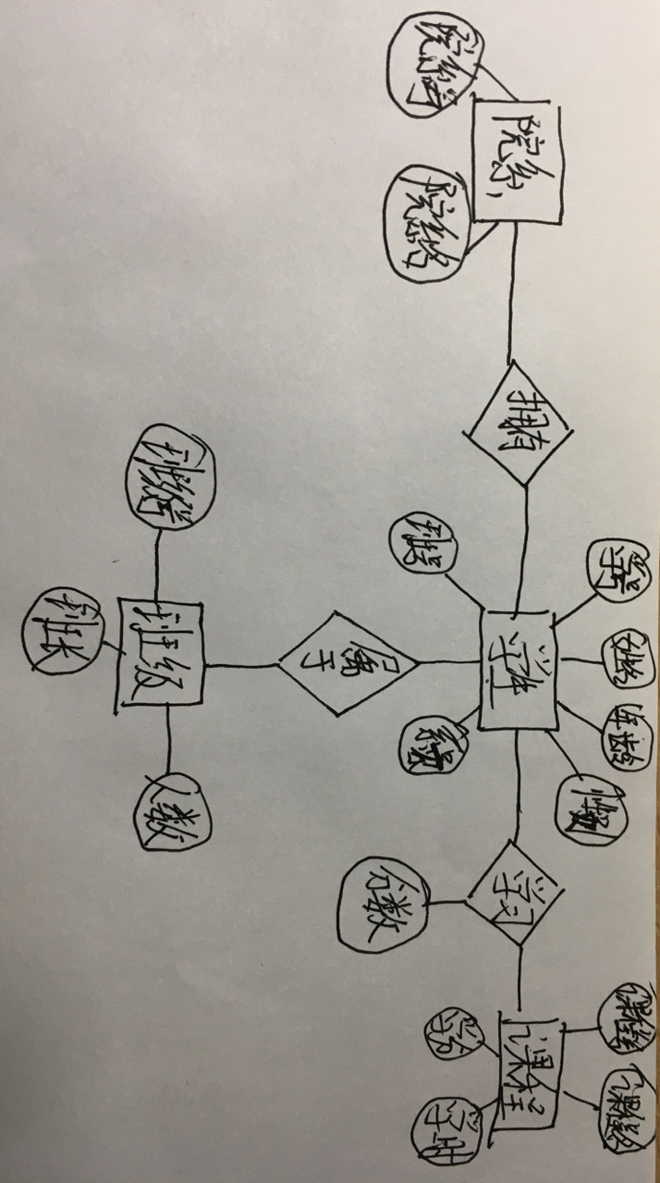

设计相应的表格：

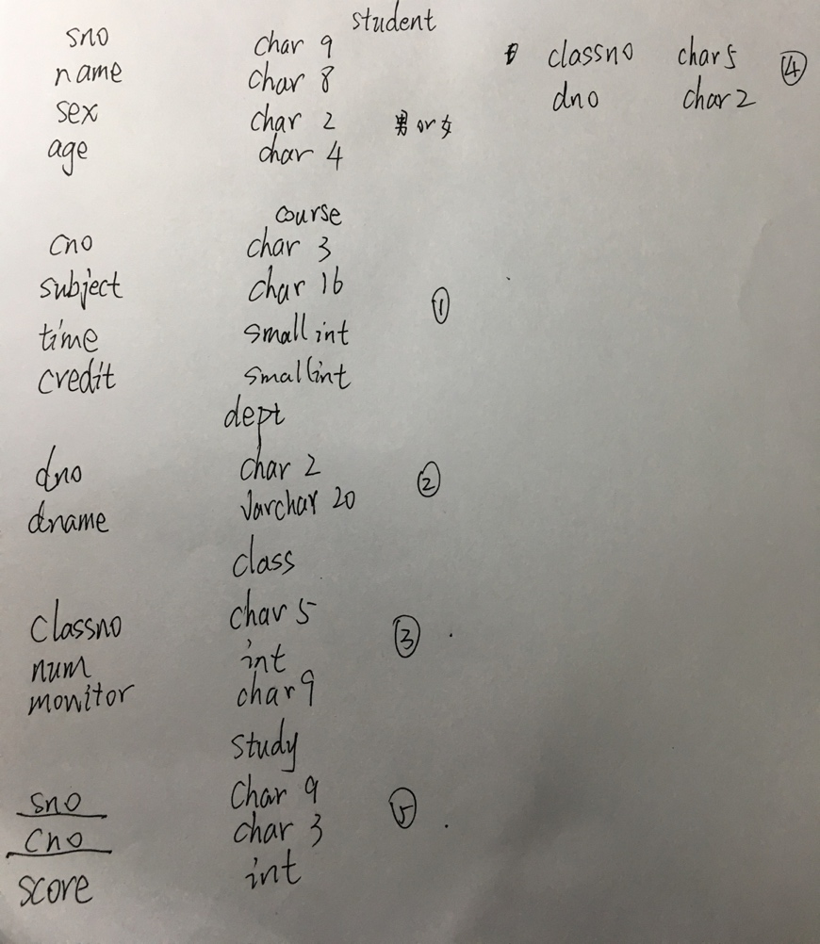

环境安装：

在mac 上安装sql；

安装mysql-python包

测试连接sql数据库：

*#!/usr/bin/python  
# -*- coding: UTF-8 -*-***import** MySQLdb  
db = MySQLdb.connect(host=**"localhost"**,user=**"root"**,passwd=**""**,db=**"zyhtest"**,port=3306,charset=**"utf8"**)  
cursor = db.cursor()

cursor.execute(**"SELECT VERSION()"**)  
data = cursor.fetchone()  
**print "Database version : %s "** % data  
db.close()



测试成功，可以进行数据库相应操作

按照设计的表格创建table：

#!/usr/bin/python

# -*- coding: UTF-8 -*-

import MySQLdb

db = MySQLdb.connect("localhost","testuser","test123","TESTDB" )

cursor = db.cursor()

cursor.execute("DROP TABLE IF EXISTS student")

sql = """create table student(

sno char(9) primary key,

name char (8) not null ,

gender char (2) check(gender IN ('男','女')),

age char(4)) """

cursor.execute(sql)

db.close()

替换sql的值创建其他table

create table course(

    cno char(3),

    subject char(16) not null,

    time smallint check( time>0 ),

    credit smallint check( credit>0 ),

primary key (cno))

create table dept(

    dno char(2) not null primary key ,

    dname varchar(20) not null ,

tele char(10))

create table class(

  classno char(5),

  num int,

  monitor char(9),

  primary key (classno),

  foreign key (monitor) references student(sno))

create table study(

    sno char(9) not null,

    cno char(3) not null ,

    score int,

    primary key (sno,cno),

    foreign key (sno) references student(sno),

foreign key (cno) references course(cno))

修改表格

alter table student

add classno char(5)

foreign key classno

references class(classno)

alter table student

add dno char(2)

foreign key dno

references dept(dno)

建立索引

create unique index sindex

     on student(sno)

create unique index cindex

     on course(cno)

create unique index dindex

     on dept(dno)

create unique index lindex

     on class(classno)

建立视图

create view stuscore1

     (sno,name,cno,subject,score)

    as

    select student.sno, student .name,course.cno,course.subject,study.score

    from student , course,study

    where student.sno=study.sno and course.cno= study.cno

create view stuscore2

     (sno,name,dname,cno,subject,score)

    as

    select student.sno, student .name,dept.dname,course.cno, course.subject,study.score

    from student , course,study,dept

where student.sno=study.sno and course.cno= study.cno and dept.dno=student.dno

插入数据

*#!/usr/bin/python  
# -*- coding: UTF-8 -*-***import** MySQLdb  
db = MySQLdb.connect(host=**"localhost"**,user=**"root"**,passwd=**""**,db=**"zyhtest"**,port=3306,charset=**"utf8"**)  
cursor = db.cursor() **sql = """  
 insert into study values('000000001','001',99)  
 """  
try:  
 cursor.execute(sql)  
 db.commit()  
   
except:  
 db.rollback()  
 print "error"**

db.close()

修改insert 中的指令 进行插入

到此 数据库的建立与存储数据完成

数据库查询：

**sql = "SELECT * FROM student"  
try:  
 cursor.execute(sql)  
 results = cursor.fetchall()  
 for row in results:  
 sno = row[0]  
 name = row[1]  
 sex = row[2]  
 age = row[3]  
 print "sno:%s name:%s sex:%s age:%s"%(sno,name,sex,age)  
except:  
 print "Error: unable to fecth data"**

修改sql中的语句 并且修改for中间的参数来完成数据库的查询

**sql = "SELECT * FROM stuscore2"**

也可以设置view视图来显示内容，方便快捷可以反复使用。

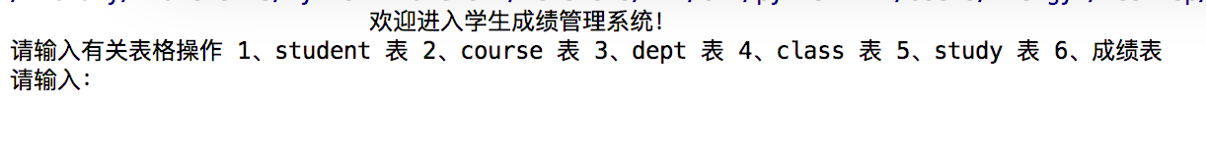

表格：

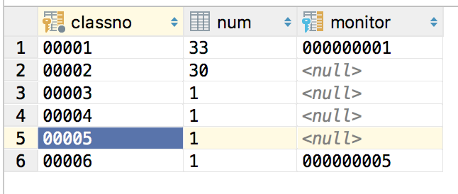

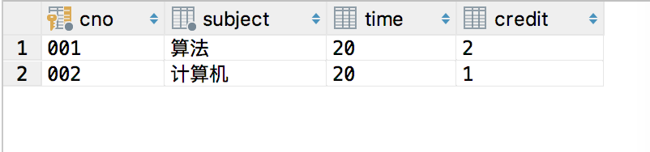

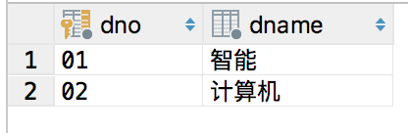

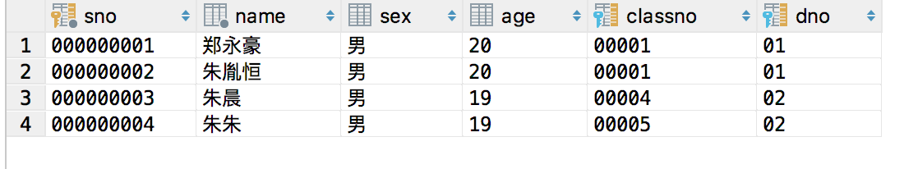

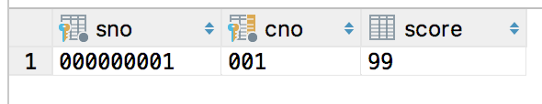



项目代码：

*#!/usr/bin/python  
# -*- coding: UTF-8 -*-***import** MySQLdb  
  
  
db = MySQLdb.connect(host=**"localhost"**,user=**"root"**,passwd=**""**,db=**"zyhtest"**,port=3306,charset=**"utf8"**)  
cursor = db.cursor()  
  
**def** stu_in():  
  
 sno=raw_input(**'sno:\n'**)  
 name=raw_input(**'name:\n'**)  
 sex=raw_input(**'sex:\n'**)  
 age=raw_input(**'age:\n'**)  
 classno=raw_input(**'classno:\n'**)  
 dno=raw_input(**'dno:\n'**)  
 **try**:  
 cursor.execute(**"insert into student values('%s' , '%s' , '%s' , '%s','%s','%s')"**%(sno,name, sex, age, classno, dno))  
 db.commit()  
 **except**:  
 db.rollback()  
 **print "error"** sql = **"SELECT** *\** **FROM student"  
 try**:  
 cursor.execute(sql)  
 results = cursor.fetchall()  
 **for** row **in** results:  
 sno = row[0]  
 name = row[1]  
 sex = row[2]  
 age = row[3]  
 classno=row[4]  
 dno=row[5]  
 **print "sno:%s name:%s sex:%s age:%s classno:%s dno:%s"** % (sno, name, sex, age,classno,dno)  
 **except**:  
 **print "Error: unable to fecth data"  
  
def** stu_out():  
 sno=raw_input(**'sno:\n'**)  
 **try**:  
 cursor.execute(**"delete from student where sno=%s"**%(sno))  
 db.commit()  
 **except**:  
 db.rollback()  
 **print "error"** sql = **"SELECT** *\** **FROM student"  
 try**:  
 cursor.execute(sql)  
 results = cursor.fetchall()  
 **for** row **in** results:  
 sno = row[0]  
 name = row[1]  
 sex = row[2]  
 age = row[3]  
 classno=row[4]  
 dno=row[5]  
 **print "sno:%s name:%s sex:%s age:%s classno:%s dno:%s"** % (sno, name, sex, age,classno,dno)  
 **except**:  
 **print "Error: unable to fecth data"  
  
def** course_in():  
 cno = raw_input(**'cno:\n'**)  
 subject = raw_input(**'subject:\n'**)  
 time = input(**'time:\n'**)  
 credit = input(**'credit:\n'**)  
 **try**:  
 cursor.execute(**"insert into course values('%s','%s','%d' ,'%d')"** % (cno, subject, time, credit))  
 db.commit()  
 **except**:  
 db.rollback()  
 **print "error"** sql = **"SELECT** *\** **FROM course"  
 try**:  
 cursor.execute(sql)  
 results = cursor.fetchall()  
 **for** row **in** results:  
 cno = row[0]  
 subject = row[1]  
 time = row[2]  
 credit = row[3]  
 **print "cno:%s subject:%s time:%d credit:%d"** % (cno, subject, time, credit)  
 **except**:  
 **print "Error: unable to fecth data"  
def** course_out():  
 cno=raw_input(**'cno:\n'**)  
 **try**:  
 cursor.execute(**"delete from course where cno=%s"**%(cno))  
 db.commit()  
 **except**:  
 db.rollback()  
 **print "error"** sql = **"SELECT** *\** **FROM course"  
 try**:  
 cursor.execute(sql)  
 results = cursor.fetchall()  
 **for** row **in** results:  
 cno = row[0]  
 subject = row[1]  
 time = row[2]  
 credit = row[3]  
 **print "cno:%s subject:%s time:%d credit:%d"** % (cno,subject,time,credit)  
 **except**:  
 **print "Error: unable to fecth data"  
def** dept_in():  
 dno = raw_input(**'dno:\n'**)  
 dname = raw_input(**'dname:\n'**)  
 **try**:  
 cursor.execute(**"insert into dept values('%s','%s')"** % (dno,dname))  
 db.commit()  
 **except**:  
 db.rollback()  
 **print "error"** sql = **"SELECT** *\** **FROM dept"  
 try**:  
 cursor.execute(sql)  
 results = cursor.fetchall()  
 **for** row **in** results:  
 dno = row[0]  
 dname = row[1]  
 **print "dno:%s dname:%s"** % (dno, dname)  
 **except**:  
 **print "Error: unable to fecth data"  
  
def** dept_out():  
 dno=raw_input(**'dno:\n'**)  
 **try**:  
 cursor.execute(**"delete from dept where dno=%s"**%(dno))  
 db.commit()  
 **except**:  
 db.rollback()  
 **print "error"** sql = **"SELECT** *\** **FROM dept"  
 try**:  
 cursor.execute(sql)  
 results = cursor.fetchall()  
 **for** row **in** results:  
 dno = row[0]  
 dname = row[1]  
 **print "dno:%s dname:%s"** % (dno,dname)  
 **except**:  
 **print "Error: unable to fecth data"  
def** class_in():  
 classno = raw_input(**'classno:\n'**)  
 num = input(**'num:\n'**)  
 **try**:  
 cursor.execute(**"insert into class(classno, num) values('%s','%d')"** % (classno, num))  
 db.commit()  
 **except**:  
 db.rollback()  
 **print "error"  
  
 print "请输入%d名学生:"**%num  
 **for** i **in** range(0,num):  
 stu_in()  
  
 monitor=raw_input(**'请设置班长输入sno:\n'**)  
 **try**:  
 cursor.execute(**"update class set monitor='%s' where classno='%s'"** % (monitor,classno))  
 db.commit()  
 **except**:  
 db.rollback()  
 **print "error"** sql = **"SELECT** *\** **FROM class"  
 try**:  
 cursor.execute(sql)  
 results = cursor.fetchall()  
 **for** row **in** results:  
 classno = row[0]  
 num = row[1]  
 monitor=row[2]  
 **print "classno:%s num:%d monitor:%s"** % (classno, num,monitor)  
 **except**:  
 **print "Error: unable to fecth data"  
  
  
def** class_out():  
 classno = raw_input(**'classno:\n'**)  
 **print** classno  
 **try**:  
 cursor.execute(**"delete from class where classno=%s"**%(classno))  
 db.commit()  
 **except**:  
 db.rollback()  
 **print "error"** sql = **"SELECT** *\** **FROM class"  
 try**:  
 cursor.execute(sql)  
 results = cursor.fetchall()  
 **for** row **in** results:  
 classno = row[0]  
 num=row[1]  
 monitor=row[2]  
 **print "classno:%s num:%d monitor:%s"** % (classno,num,monitor)  
 **except**:  
 **print "Error: unable to fecth data"  
  
def** study_in():  
 sno = raw_input(**'sno:\n'**)  
 cno = raw_input(**'cno:\n'**)  
 score=input(**'score:\n'**)  
 **try**:  
 cursor.execute(**"insert into study values('%s','%s','%d')"** % (sno, cno,score))  
 db.commit()  
 **except**:  
 db.rollback()  
 **print "error"** sql = **"SELECT** *\** **FROM study"  
 try**:  
 cursor.execute(sql)  
 results = cursor.fetchall()  
 **for** row **in** results:  
 sno = row[0]  
 cno = row[1]  
 score=row[2]  
 **print "sno:%s cno:%s score:%d"** % (sno, cno,score)  
 **except**:  
 **print "Error: unable to fecth data"  
  
def** study_out():  
 sno = raw_input(**'sno:\n'**)  
 cno = raw_input(**'cno:\n'**)  
 **try**:  
 cursor.execute(**"delete from study where sno=%s and cno=%s"** % (sno,cno))  
 db.commit()  
 **except**:  
 db.rollback()  
 **print "error"** sql = **"SELECT** *\** **FROM study"  
 try**:  
 cursor.execute(sql)  
 results = cursor.fetchall()  
 **for** row **in** results:  
 sno = row[0]  
 cno =row[1]  
 score=row[3]  
 **print "sno:%s cno:%s score:%d"** % (sno, cno,score)  
 **except**:  
 **print "Error: unable to fecth data"  
  
def** show_view():  
 sql = **"SELECT** *\** **FROM stuscore2"  
 try**:  
 cursor.execute(sql)  
 results = cursor.fetchall()  
 **for** row **in** results:  
 sno = row[0]  
 name=row[1]  
 dname=row[2]  
 cno = row[3]  
 subject=row[4]  
 score = row[5]  
 **print "sno:%s name=%s dname=%s cno:%s subject=%s score:%d"** % (sno,name,dname,cno,subject,score)  
 **except**:  
 **print "Error: unable to fecth data"  
  
  
  
  
while** 1:  
 **print** (**' 欢迎进入学生成绩管理系统！'**)  
 t=raw_input(**"请输入有关表格操作 1、student 表 2、course 表 3、dept 表 4、class 表 5、study 表 6、成绩表\n请输入："**)  
 **if** t==**'1'**:  
 s=input(**"输入1.插入 2.删除\n"**)  
 **if** s==**'1'**:  
 stu_in()  
 **elif** s==**'2'**:  
 stu_out()  
 **elif** t==**'2'**:  
 s = input(**"输入1.插入 2.删除\n"**)  
 **if** s == **'1'**:  
 course_in()  
 **elif** s == **'2'**:  
 course_out()  
 **elif** t==**'3'**:  
 s = input(**"输入1.插入 2.删除\n"**)  
 **if** s == **'1'**:  
 dept_in()  
 **elif** s == **'2'**:  
 dept_out()  
 **elif** t==**'4'**:  
 s = input(**"输入1.插入 2.删除\n"**)  
 **if** s == **'1'**:  
 class_in()  
 **elif** s == **'2'**:  
 class_out()  
 **elif** t==**'5'**:  
 s = input(**"输入1.插入 2.删除\n"**)  
 **if** s == **'1'**:  
 study_in()  
 **elif** s == **'2'**:  
 study_out()  
 **elif** t==**'6'**:  
 show_view()  
 input()