Agent Used: Single Agent
Model Used: gpt-4o-mini
Description: This screenshot demonstrates the Single Agent correctly answering a 3-turn chain with memory. It successfully resolved "that" to NVIDIA's P/E ratio and "the two" to NVIDIA and AMD when fetching their news sentiment.
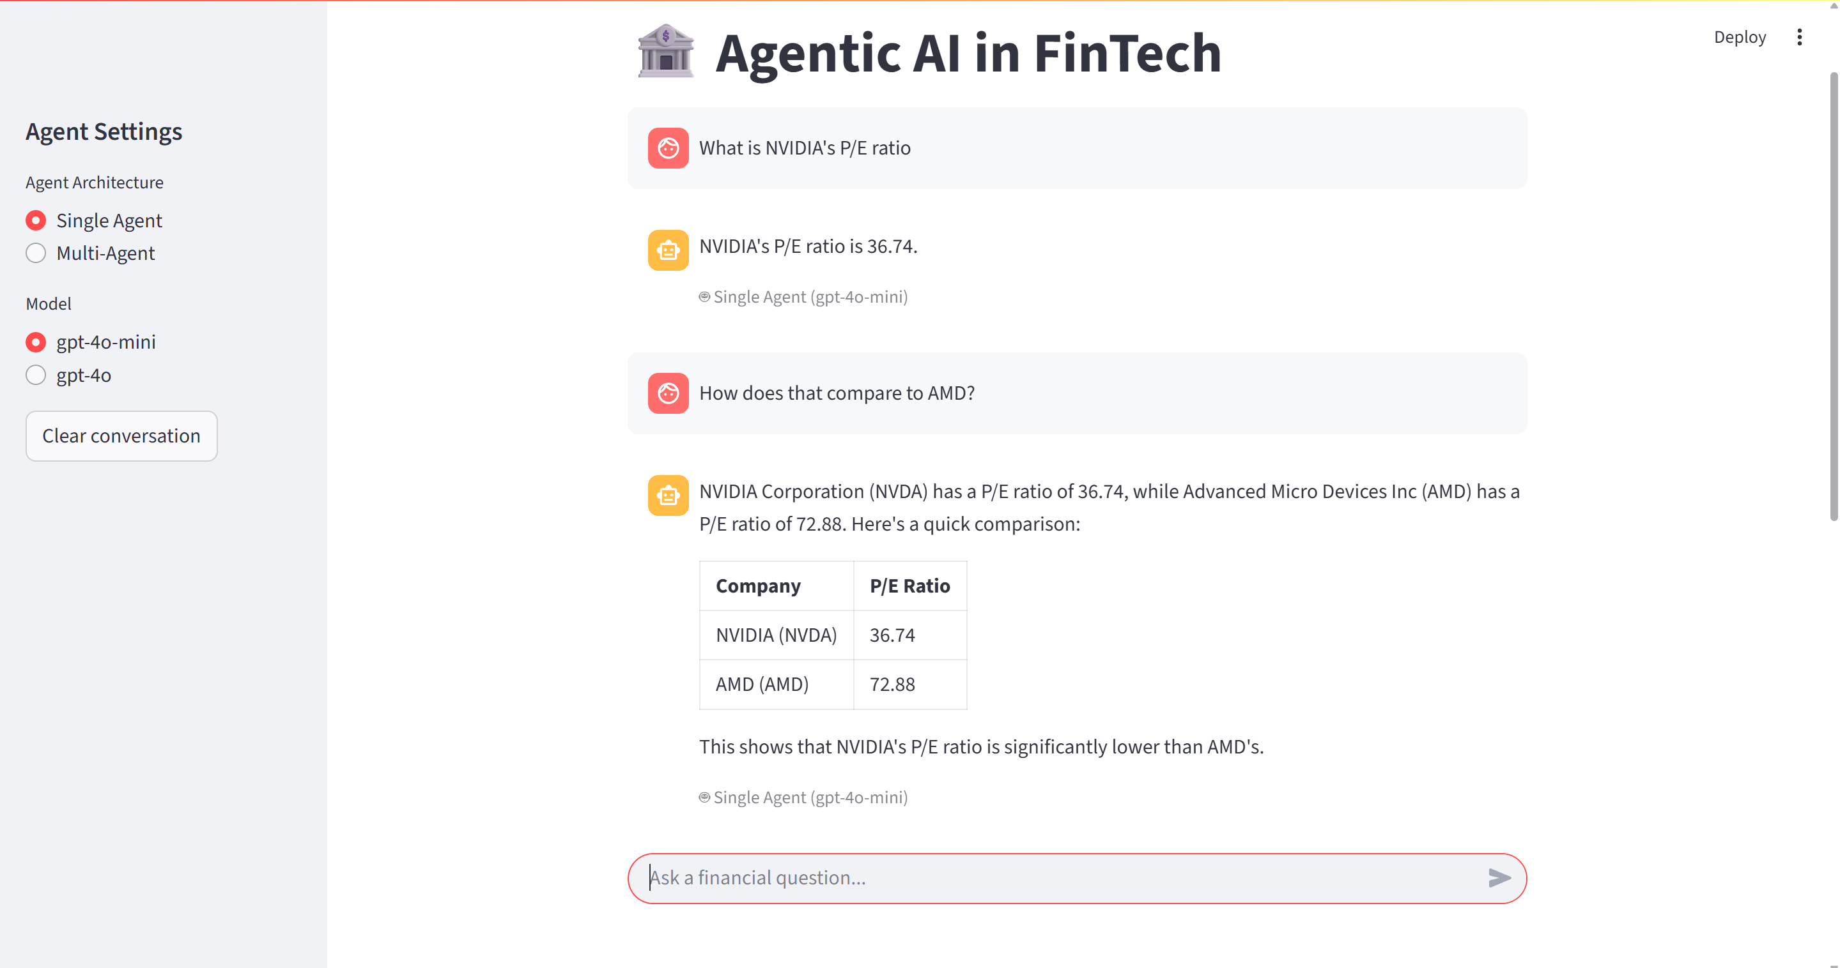
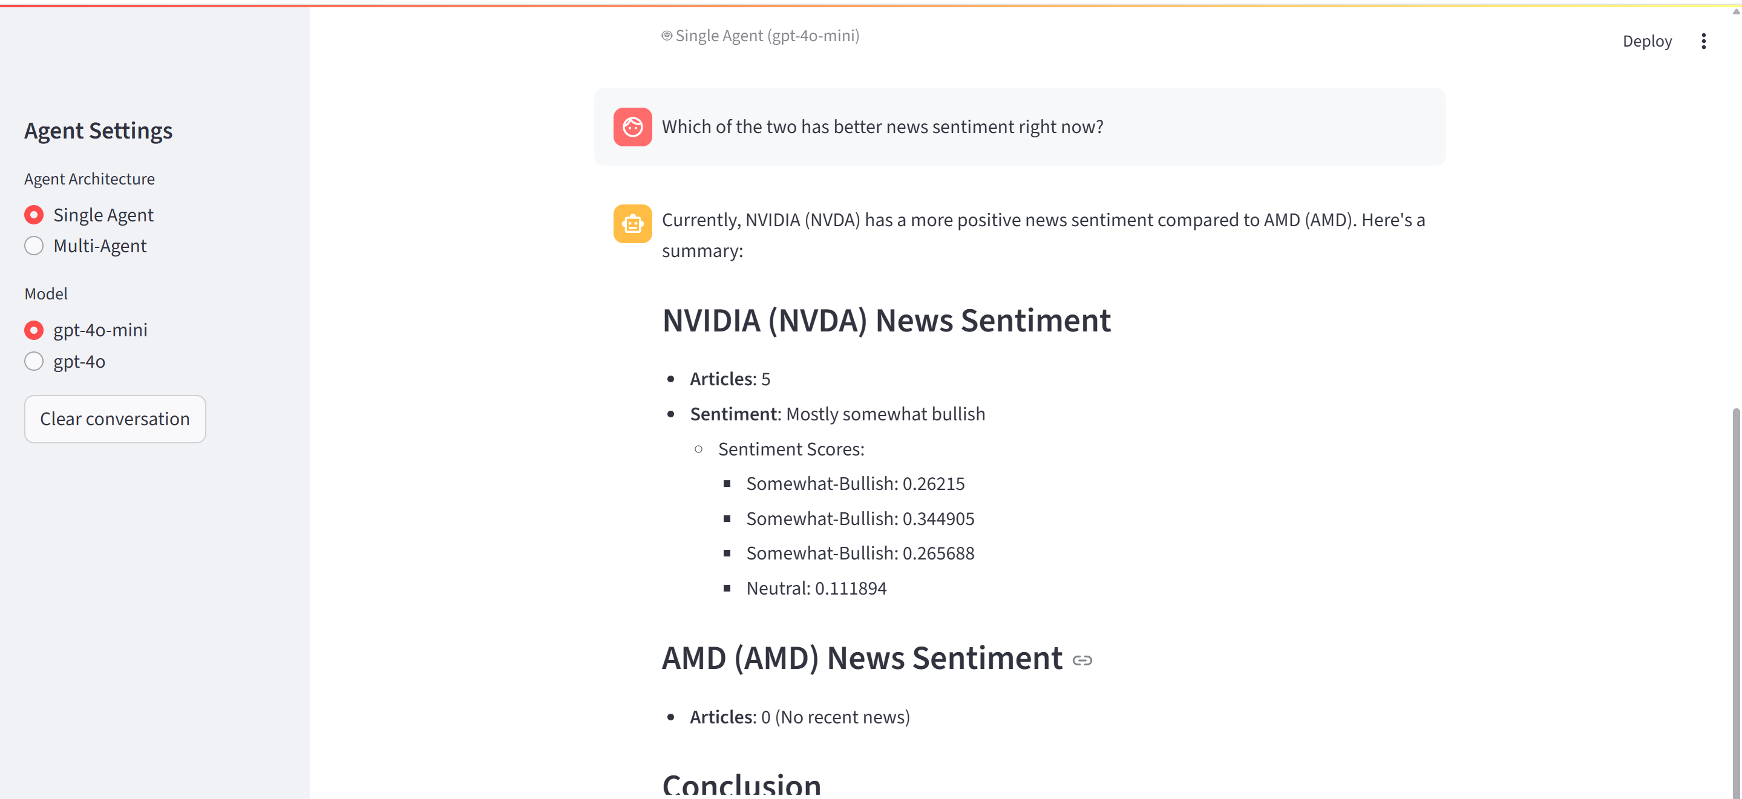
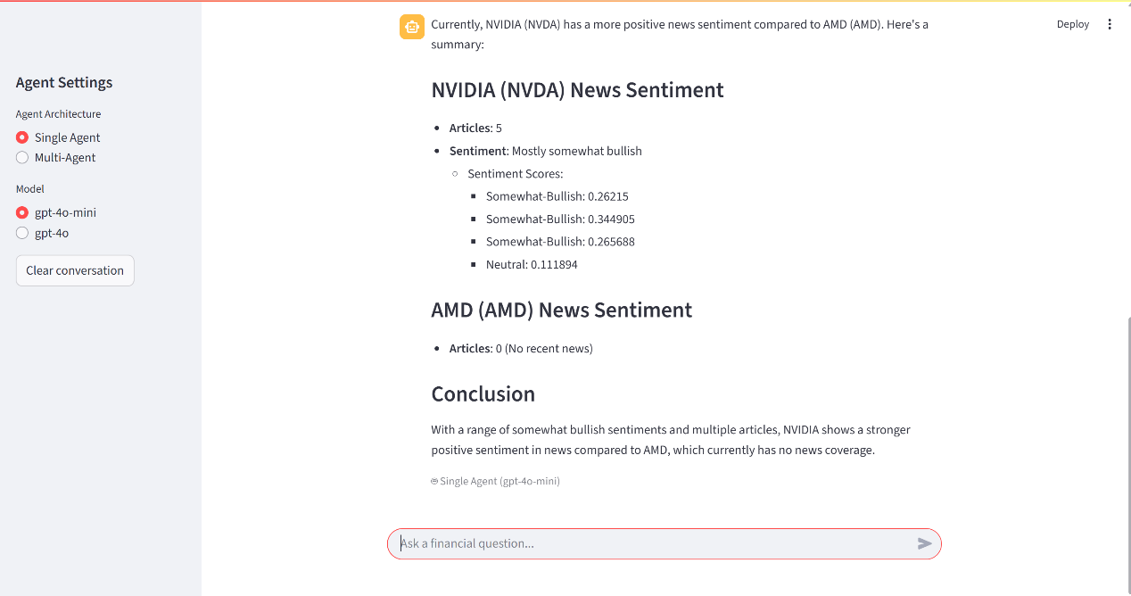
Agent Used: Multi-Agent
Model Used: gpt-4o-mini
Description: This screenshot demonstrates the Multi-Agent system tracking conversation context. The Orchestrator correctly delegated the follow-up tasks (Price Performance for "its" and News Sentiment for "their") to the correct specialist agents based on the conversation history.
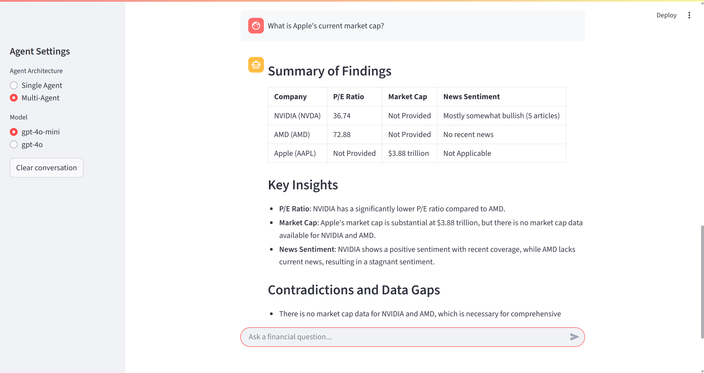
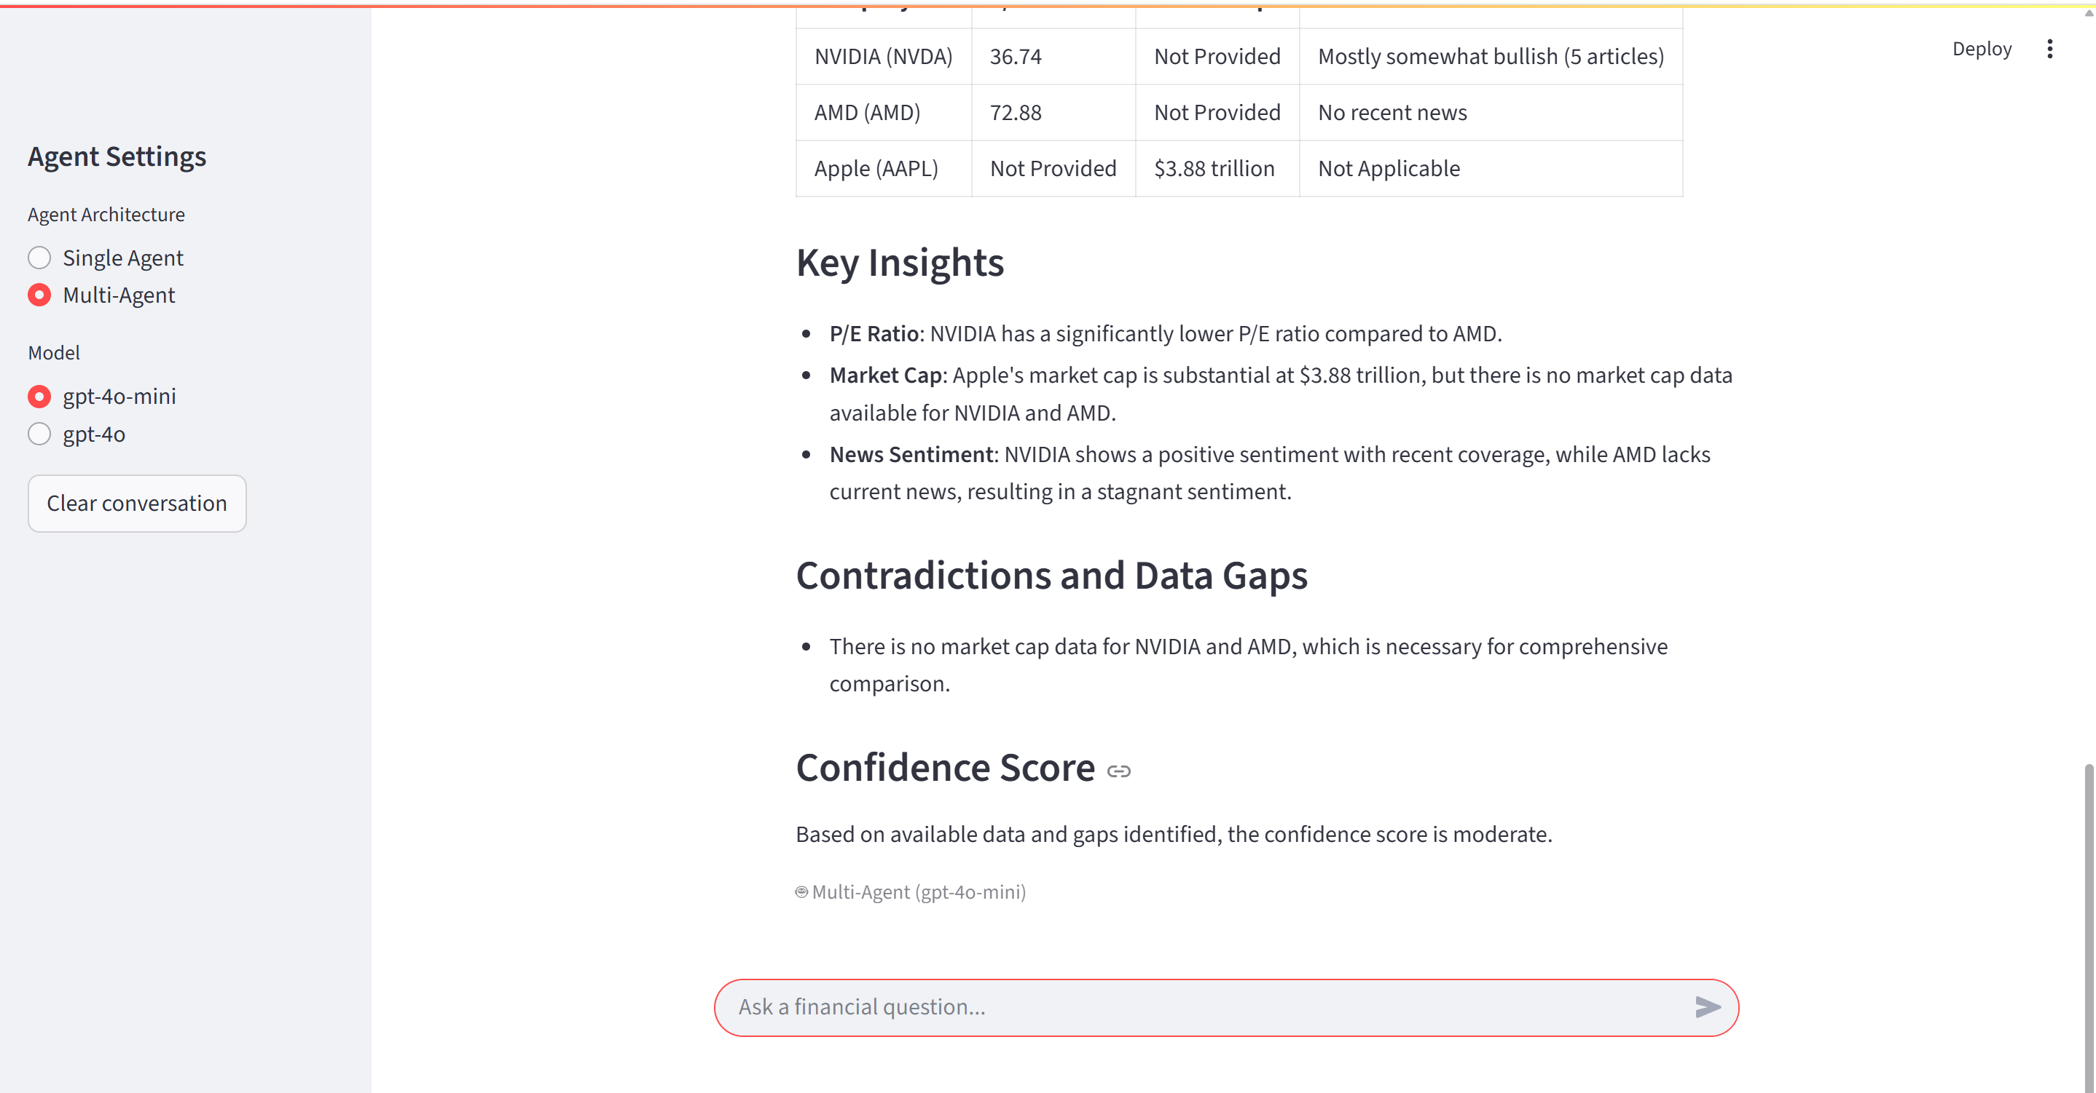
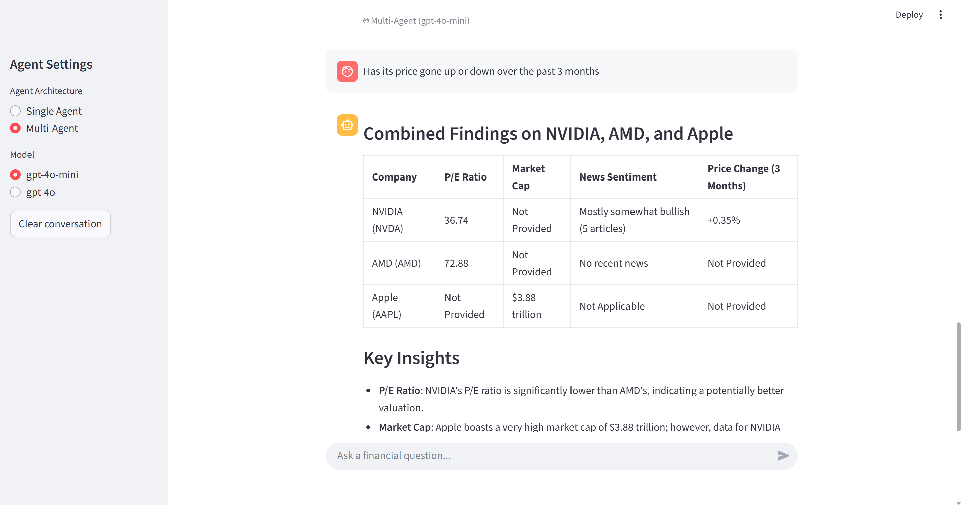
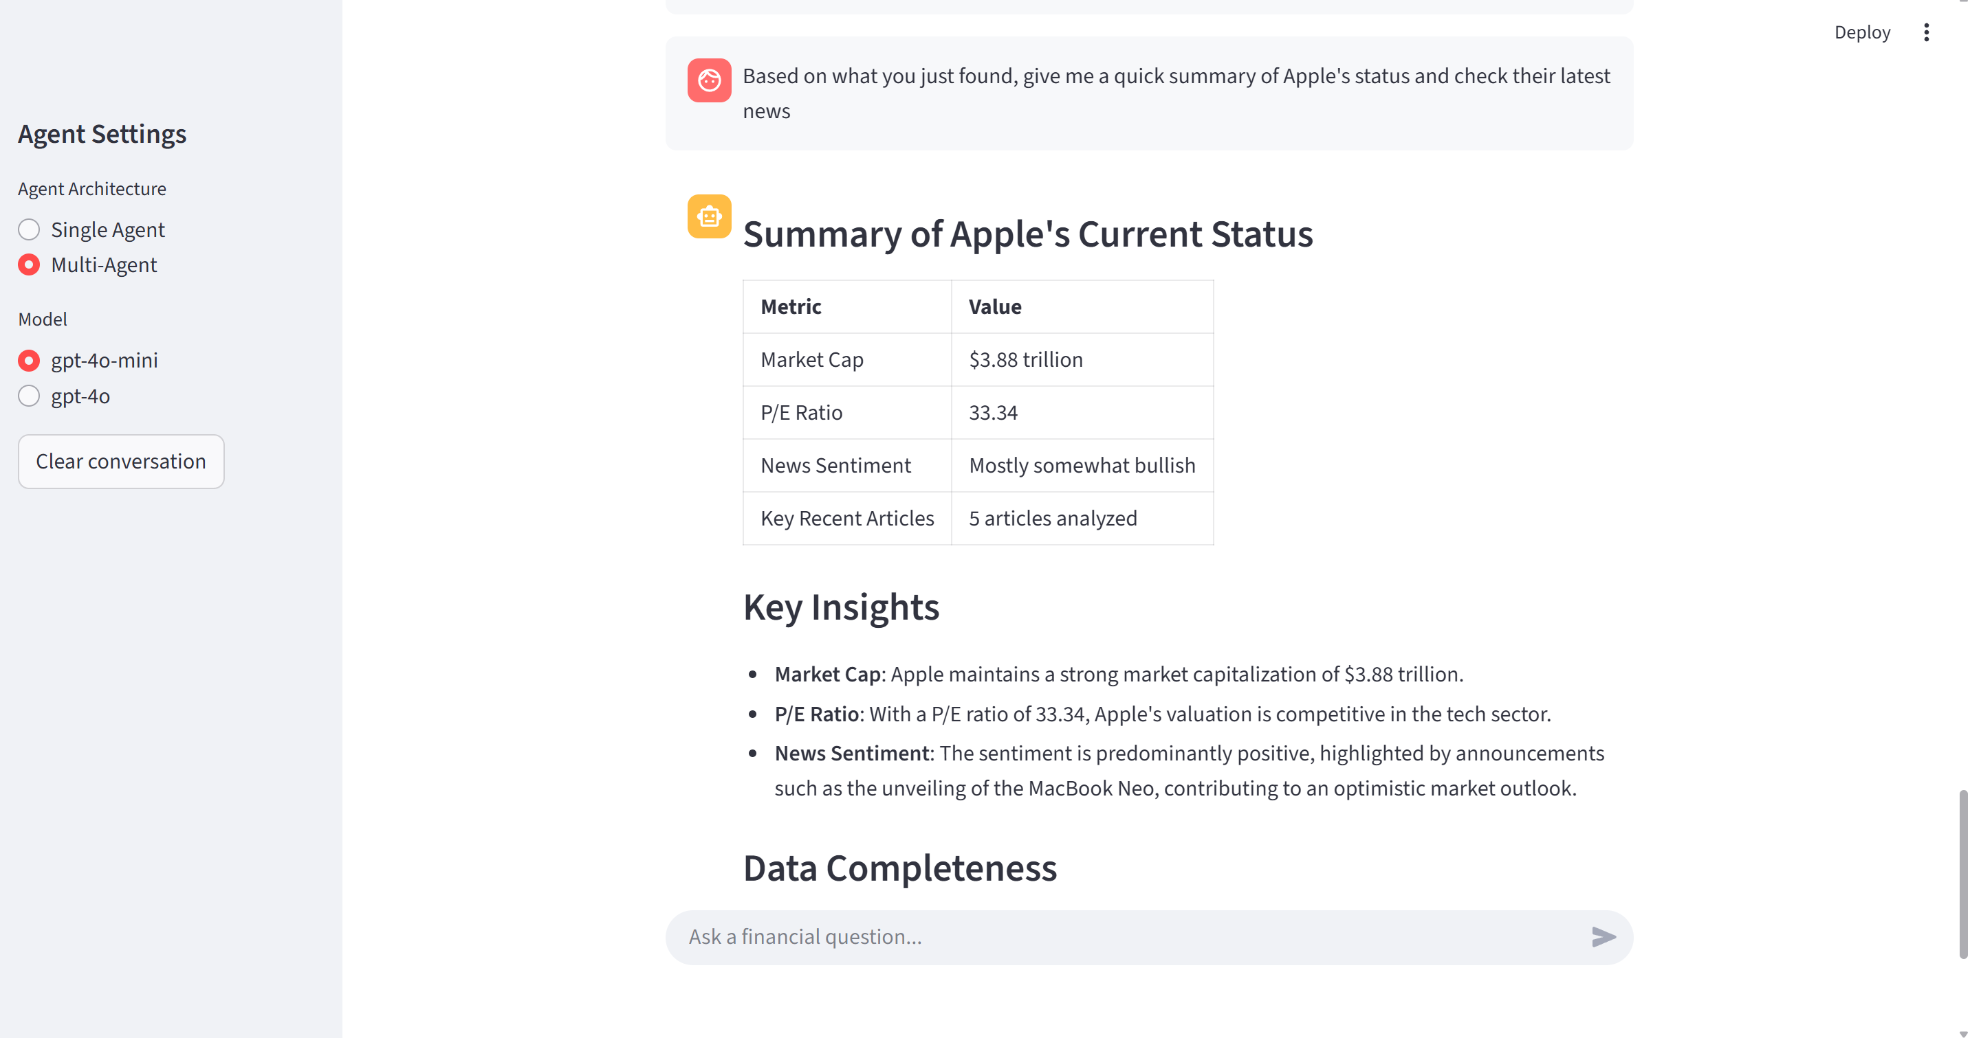
The successful Streamlit deployment of this project demonstrates the significant performance difference between Single Agent and Multi-Agent architectures when handling complex financial queries. The system robustly implements conversational memory for more than three rounds using `st.session_state`, accurately parsing pronoun references such as "that," "the two," and "its," ensuring logical continuity across contexts. The Single Agent architecture exhibits extremely high responsiveness when handling P/E ratio queries and real-time news sentiment analysis. In contrast, the Multi-Agent architecture demonstrates superior structured output capabilities when handling complex tasks containing multidimensional data (such as market capitalization, price changes, and sentiment integration). It not only proactively identifies and labels Data Gaps but also provides a Confidence Score to assess the reliability of responses. This differentiated performance fully demonstrates the rigor and deep insight of multi-agent collaborative systems when dealing with unstructured financial data.
Agent Used: Single Agent
Model Used: gpt-4o
Description: This screenshot demonstrates the Single Agent correctly answering a 3-turn chain with memory. It successfully resolved "that" to NVIDIA's P/E ratio and "the two" to NVIDIA and AMD when fetching their news sentiment.
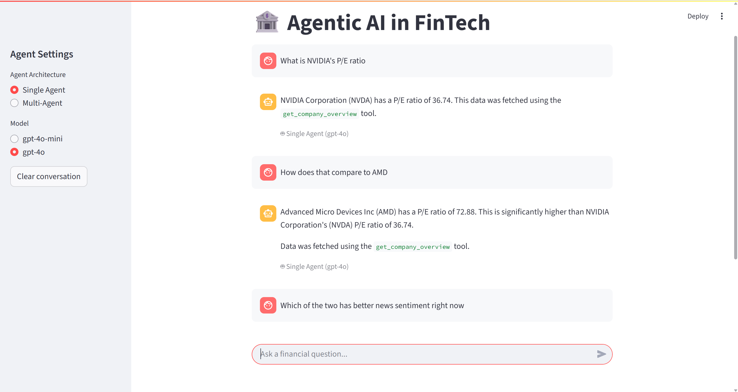
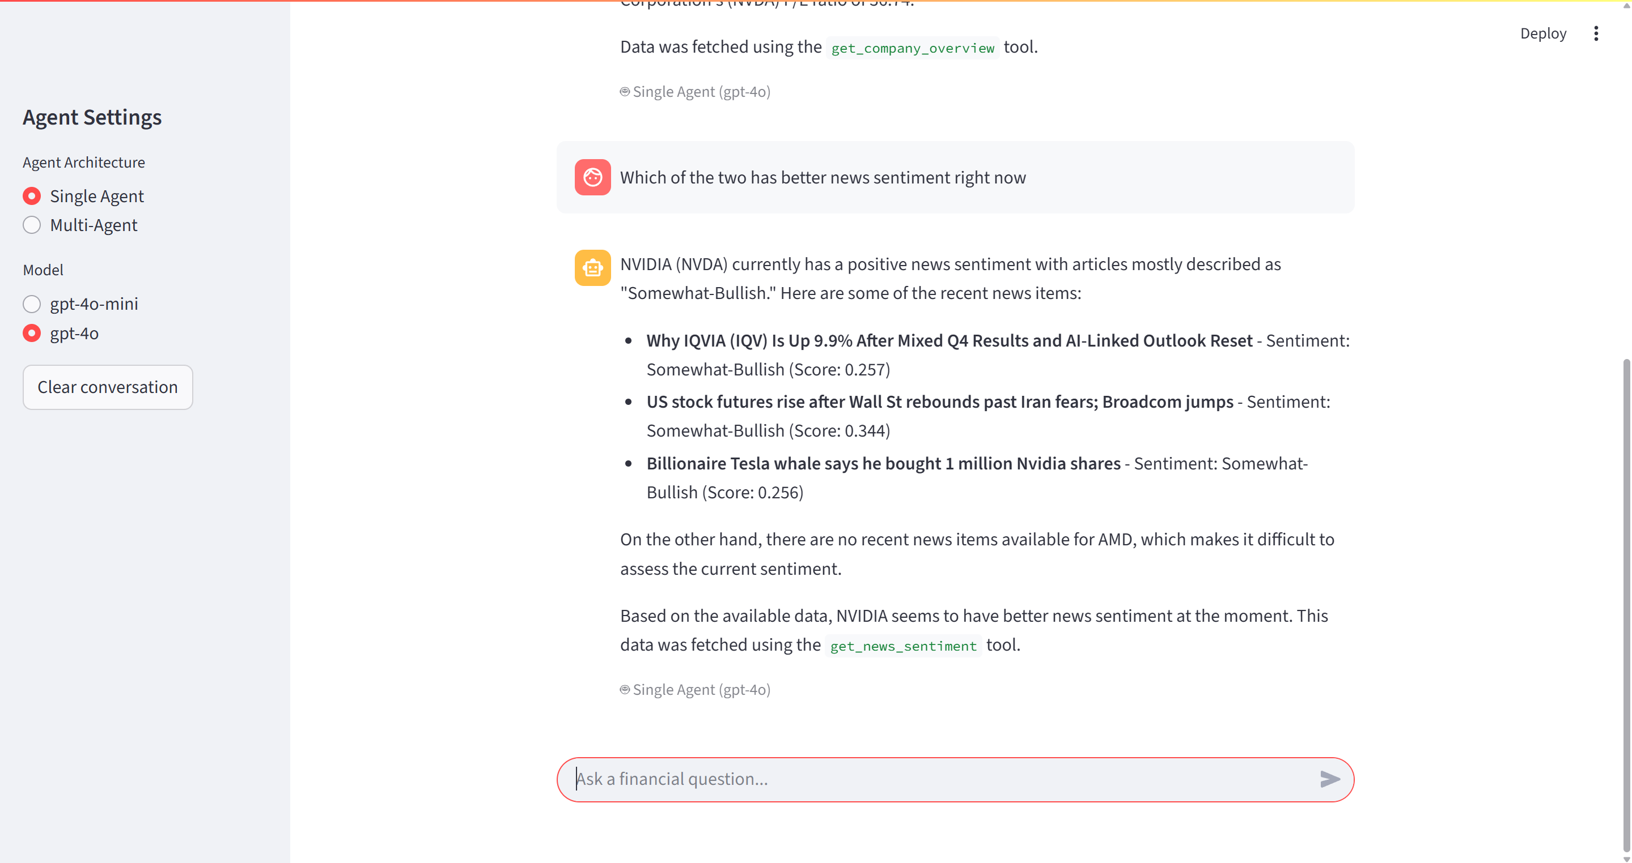
Agent Used: Multi-Agent
Model Used: gpt-4o-mini
Description: This screenshot demonstrates the Multi-Agent system tracking conversation context. The Orchestrator correctly delegated the follow-up tasks (Price Performance for "its" and News Sentiment for "their") to the correct specialist agents based on the conversation history.
