<https://blog.csdn.net/chenkfkevin/article/details/70761849>

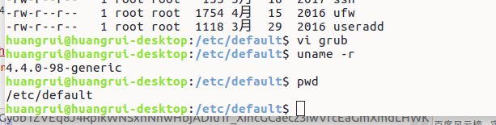

将/boot下非98移掉

<https://www.cnblogs.com/yezuhui/p/6853271.html>

Git管理word　需要pandoc

# [github 提交报403 forbidden的错误解决](https://www.cnblogs.com/linuxbug/p/5637002.html)

<https://www.cnblogs.com/linuxbug/p/5637002.html>

error: The requested URL returned error: 403 Forbidden while accessing https://github.com/xmxn3559/richang.git/info/refs