[huangrui@helium2 bch_rram0416]$ echo $VCS_HOME

/opt/synopsys/vcs201209/amd64

[huangrui@helium2　bch_rram0416]$ export VCS_HOME=/opt/synopsys/vcsmx201509/amd64

[huangrui@helium2 bch_rram0416]$ make -f Makefile_cv

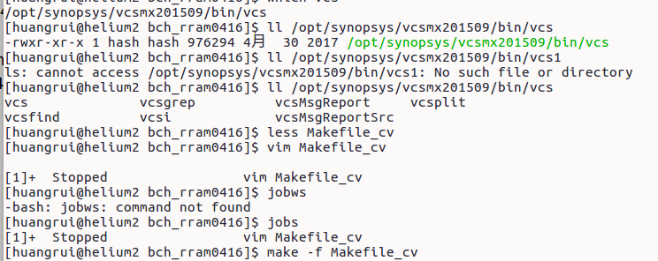

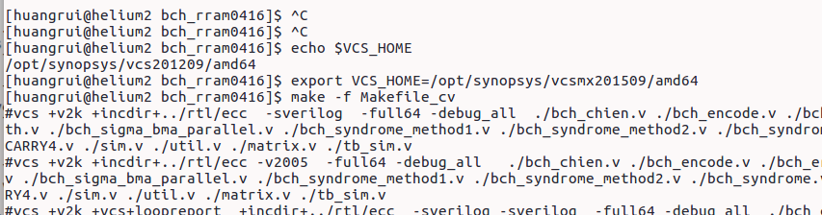

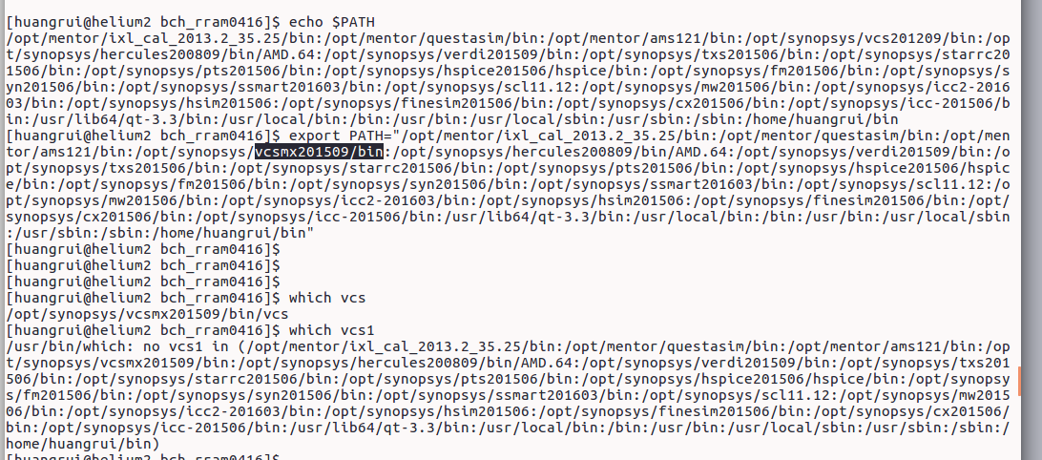

export VCS_HOME=/opt/synopsys/vcsmx201509/amd64

export PATH=/opt/synopsys/vcsmx201509/bin:$PATH

优先找前面