Exercise 1

1 - Introduction.ipynb. 1

2 - Data types and expressions.ipynb. 1

3 - Control Structures.ipynb. 8

4 - Functions and exceptions.ipynb. 10

5 - Modules and pip and PyPi.ipynb. 13

6 - File IO and String processing.ipynb. 15

7 - NumPy.ipynb. 22

Answer for the questions: 25

Exercise 1-7 from ‘python-introduction/notebooks/exercises’

snapshots of the code:

## 1.

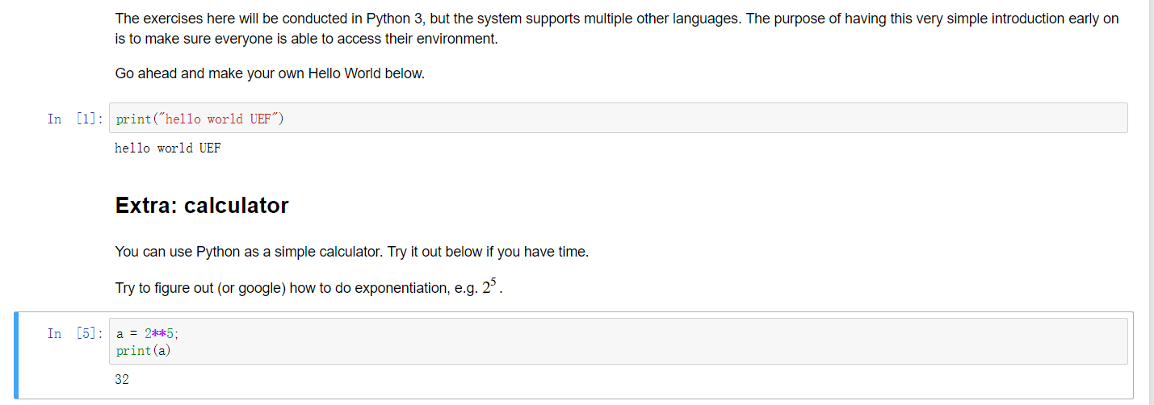

## 2.

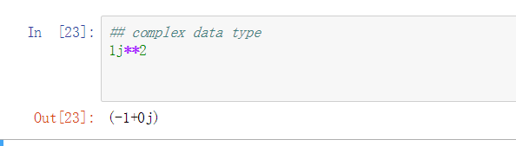

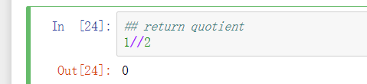

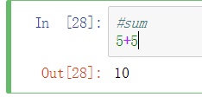

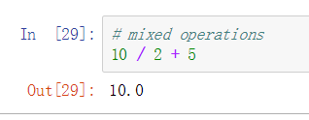

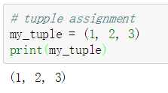

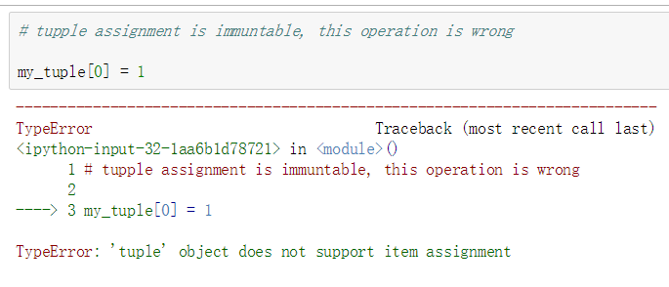

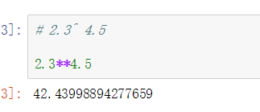

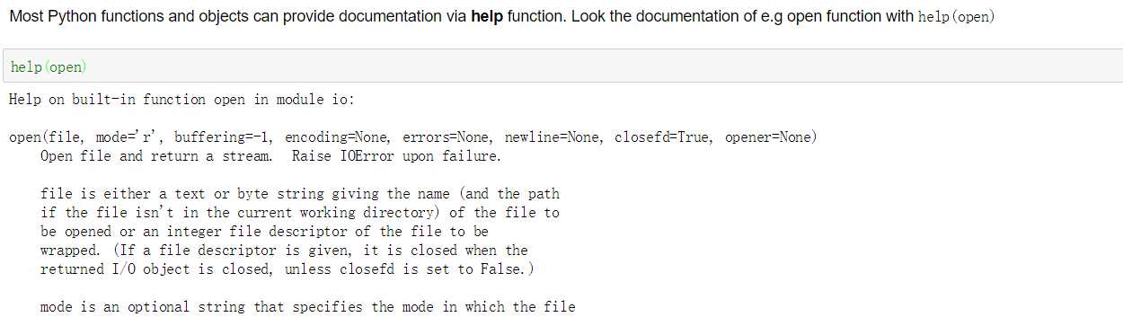

(here we get the documentation of open() by input help(open))

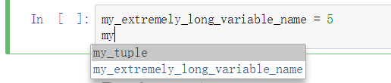

( when use TAB button after ‘my’, the word appear for option)

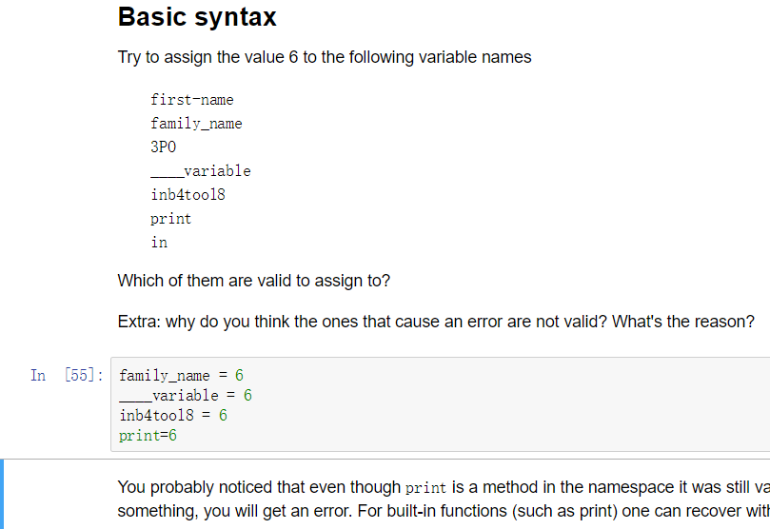

(1.‘family-name’ is invalid cause it is not variant to use the ‘-‘ when name a variant

2.’3P0’ is invalid cause the first letter should not be a number

3. ‘in’ is invalid cause the keyword should not be a variant name

)

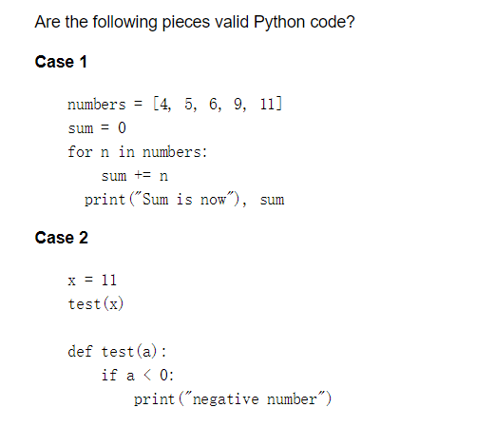

For case1:

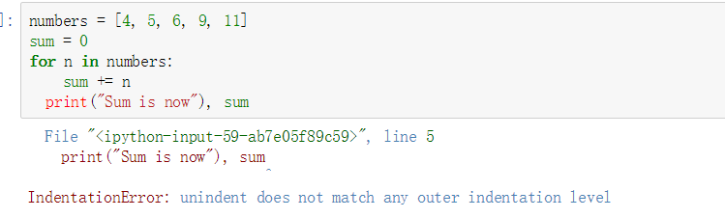

For case 2:

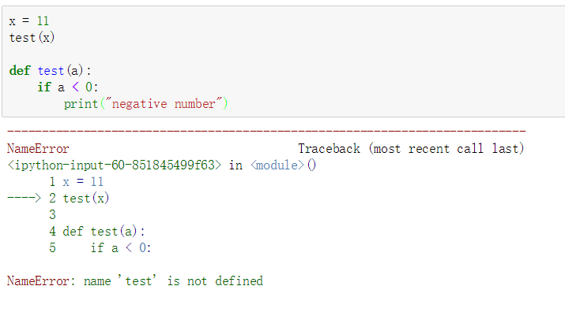

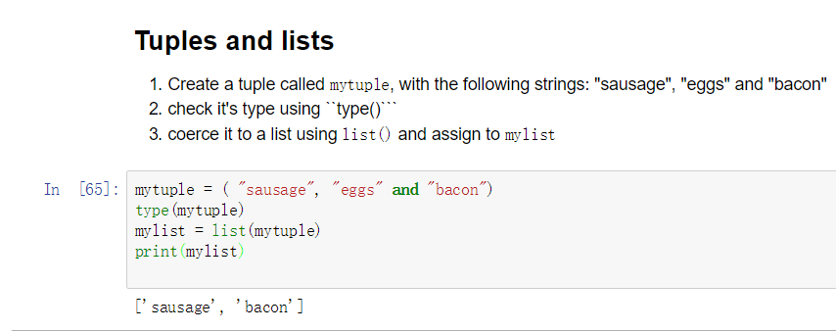

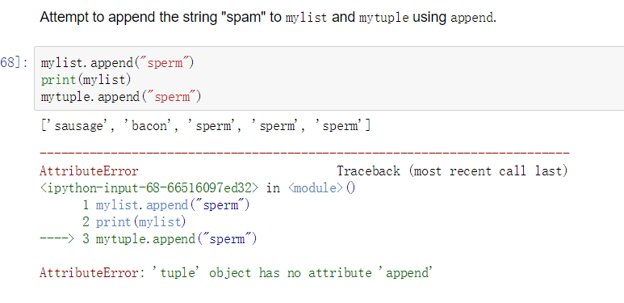

(list can use append(), but tuple is immutable, it can’t use append())

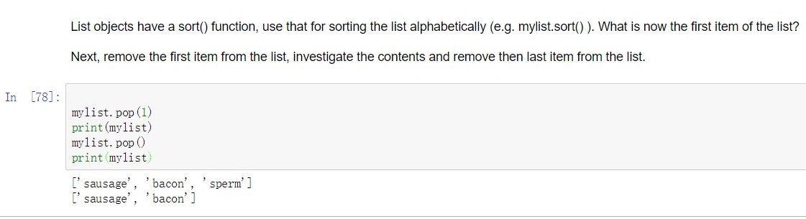

(use pop(1) to remove the first item in list, use pop() to remove the last item in the list)

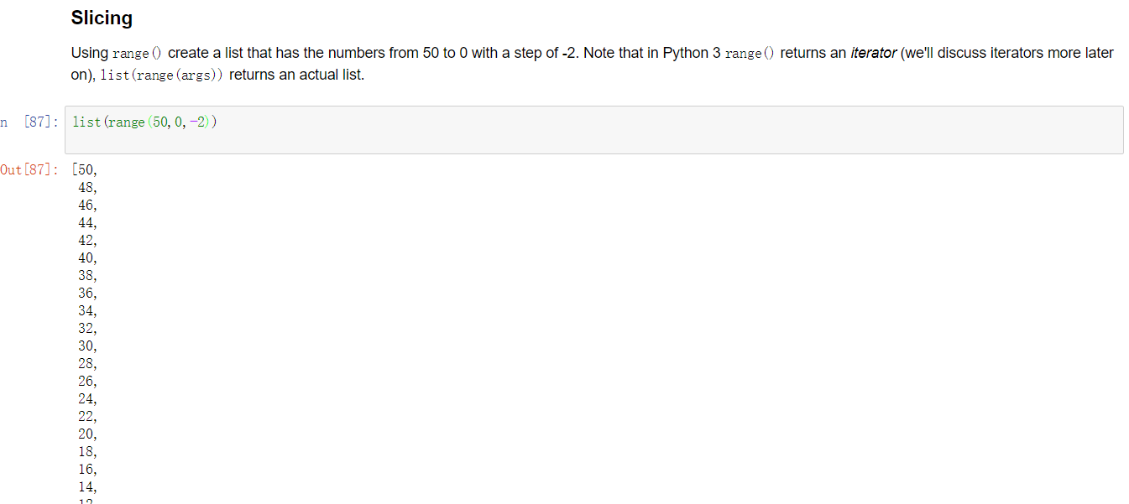

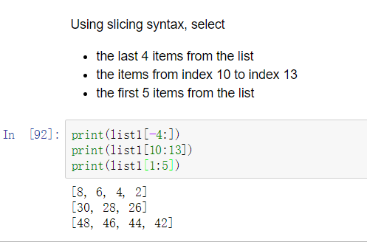

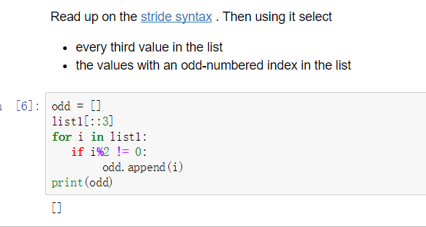

(in this list we can find there is no odd number in the list)

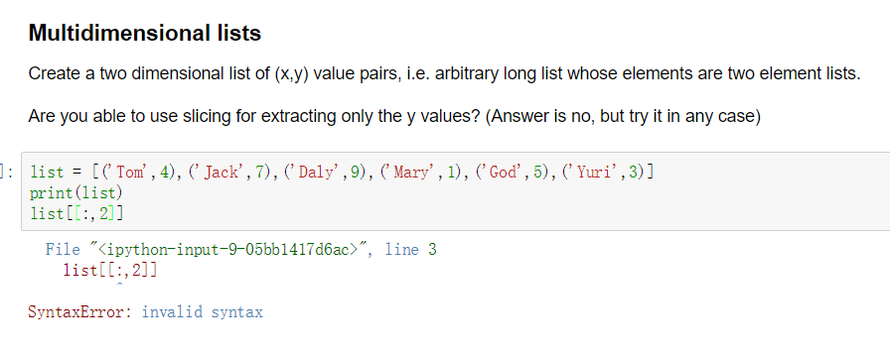

(it is unable to extract the ‘y’ value from the 2-dimensional list)

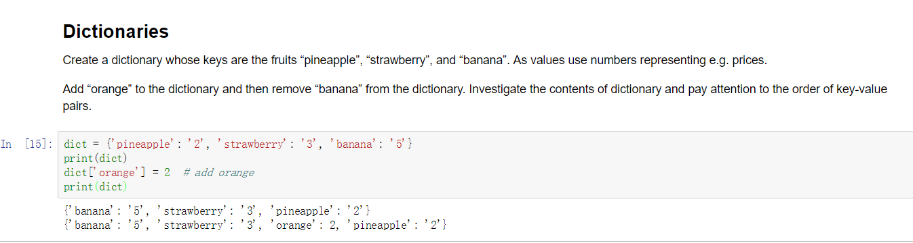

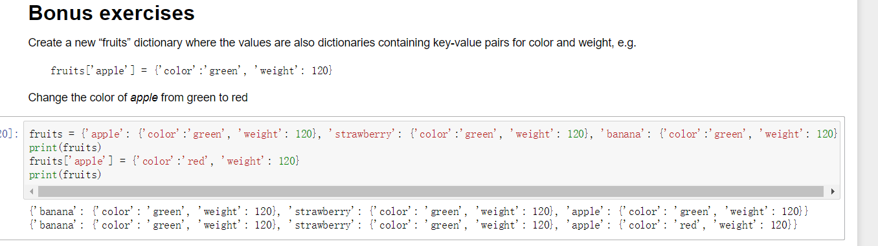

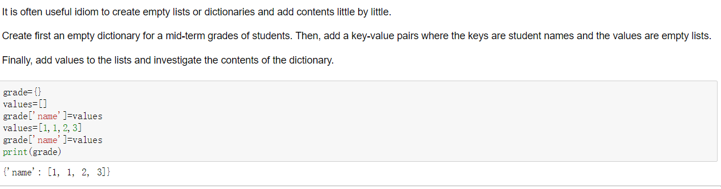

## 3.

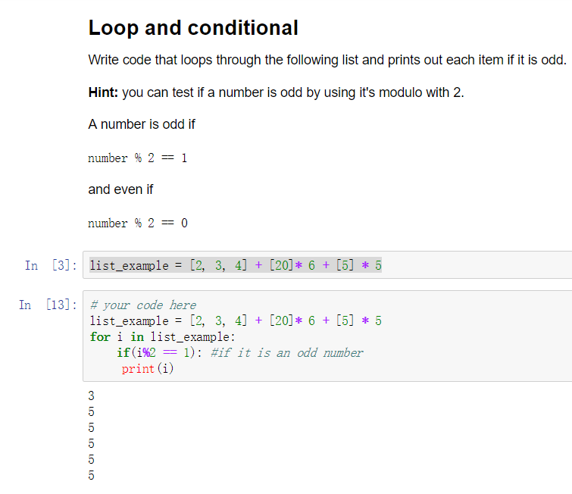

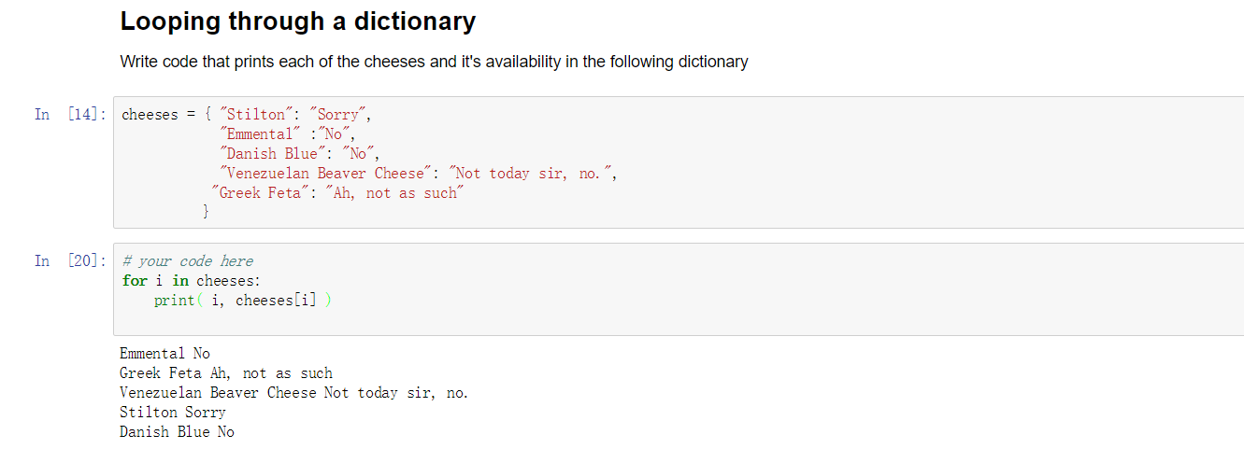

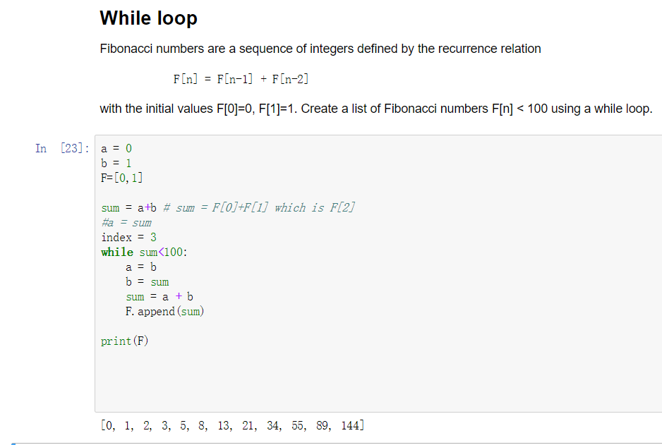

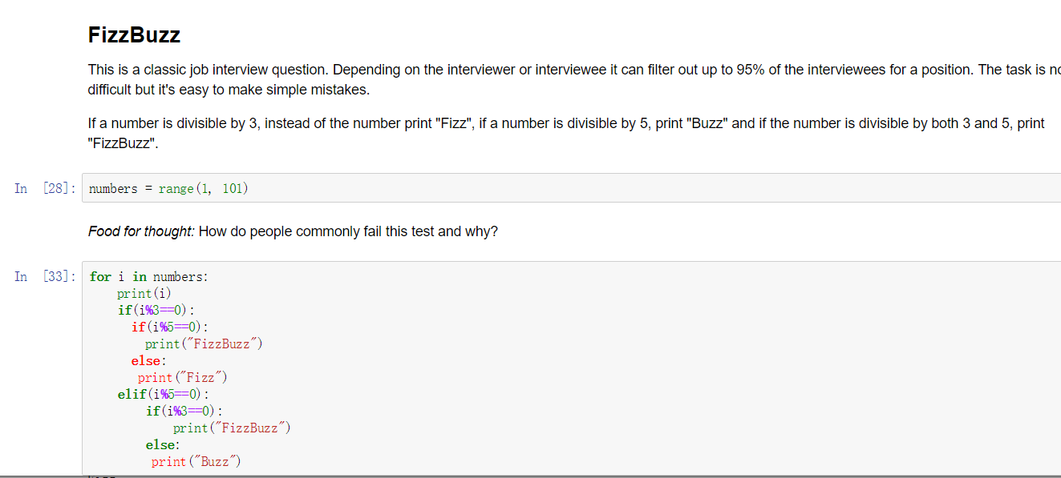

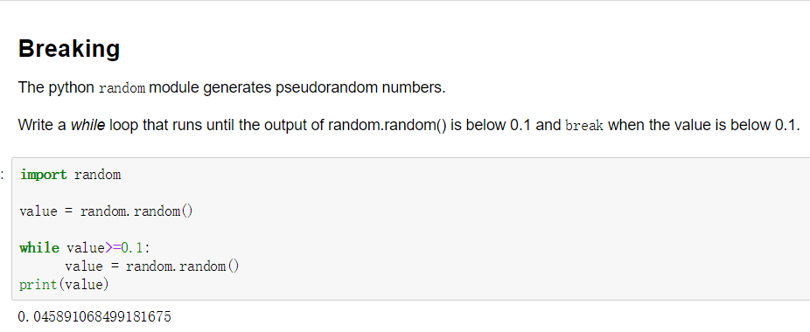

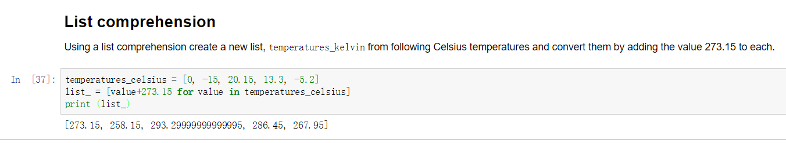

## 4.

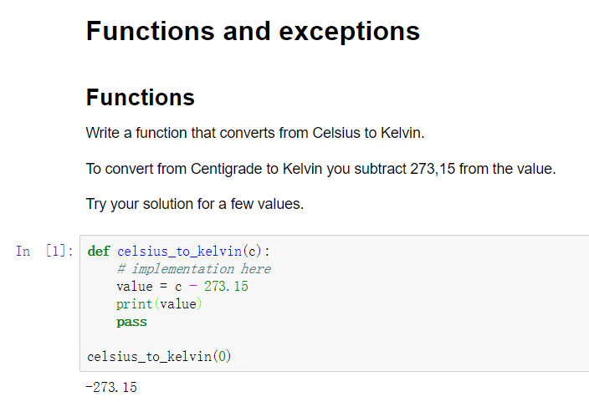

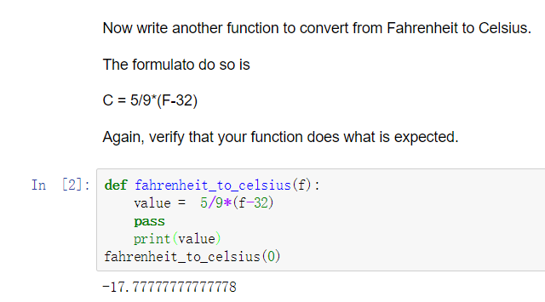

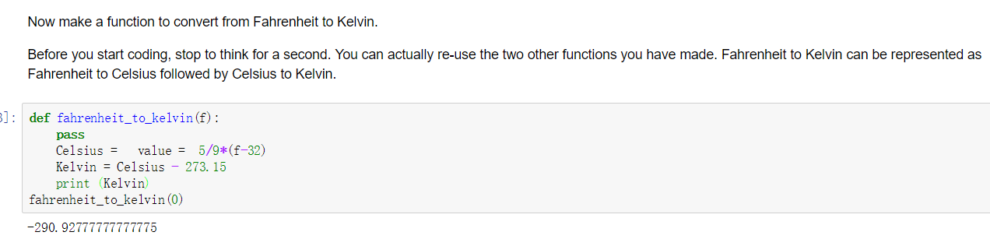

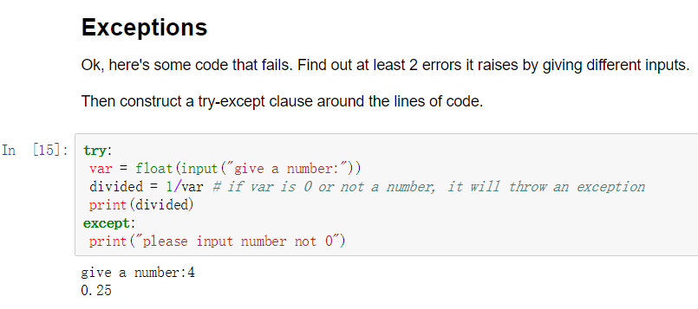

（2 kinds of errors: if var is 0 or not a number, it will throw an exception）

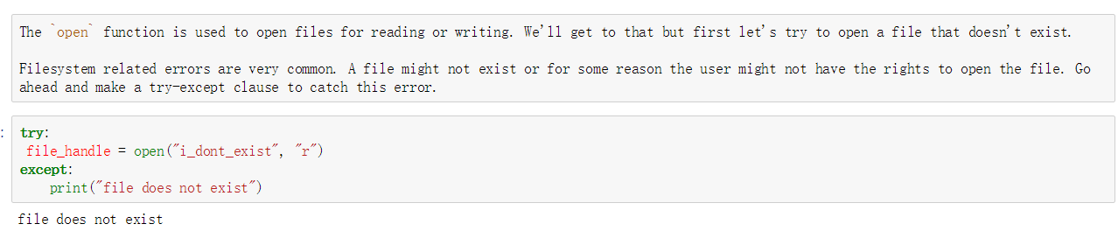

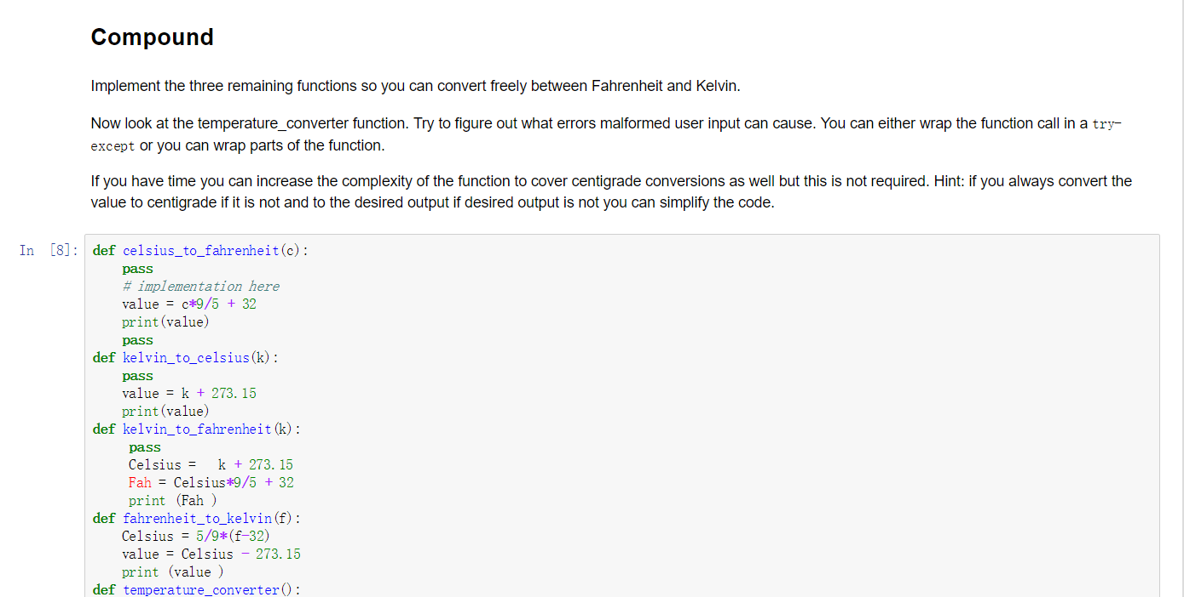

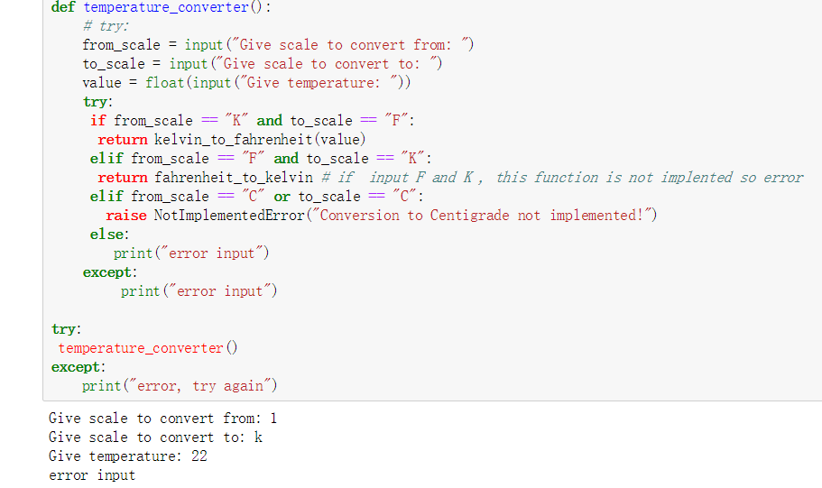

(serval kinds of errors may happen before adding exception: user may input other words instead of’ F’ or ‘K’ to the program such as ‘Kelvin’;

In degree number input, user may input the value which is not a number, or user may not input the correct combination such as ‘K’ and ‘C’ is wrong.)

## 5.

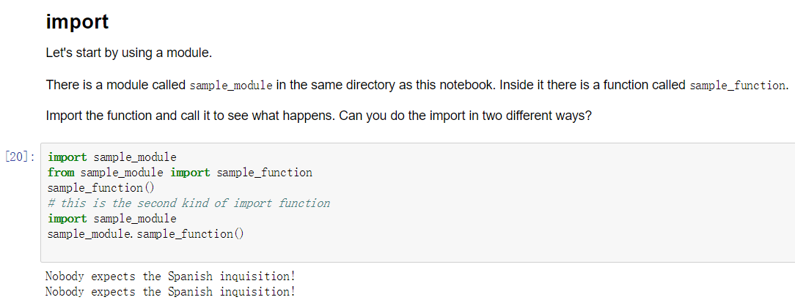

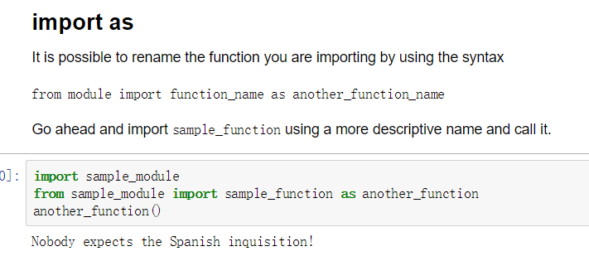

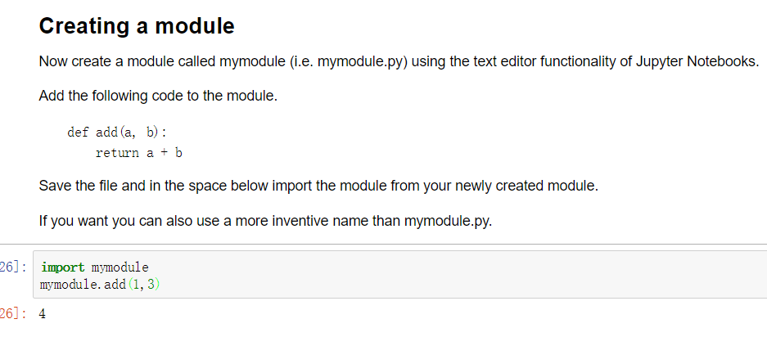

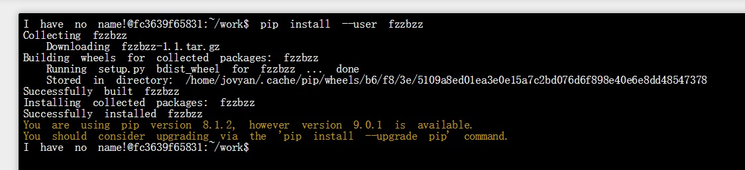

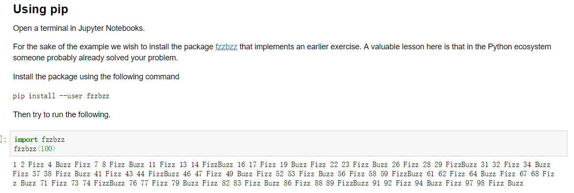

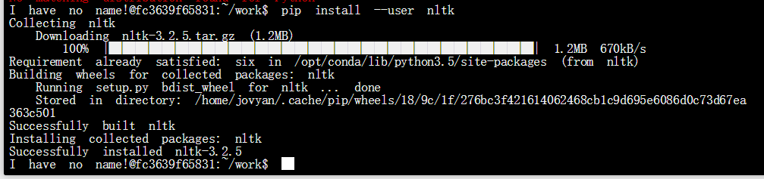

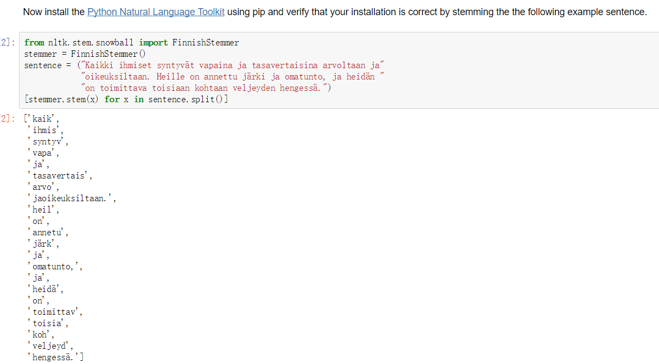

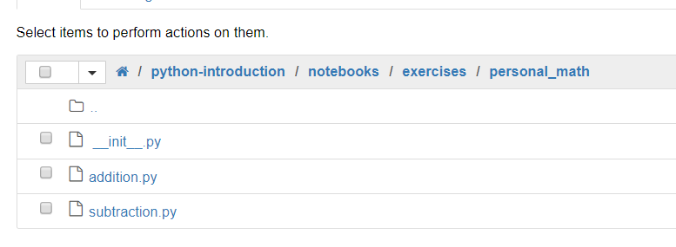

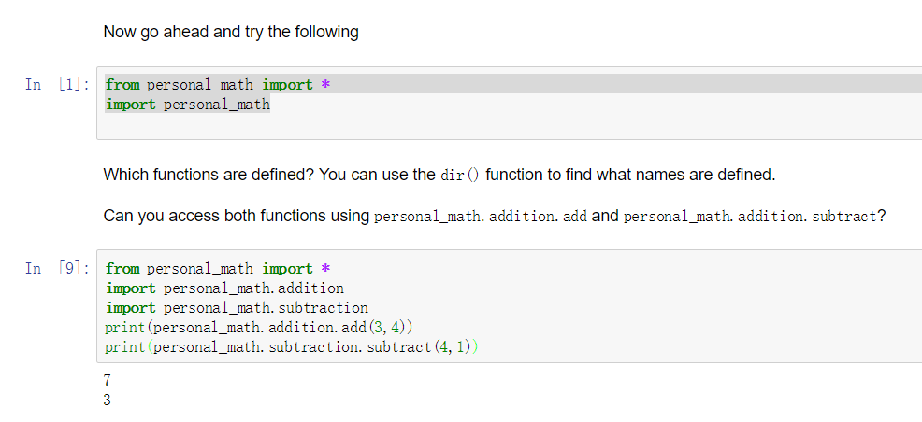

（So we can see that after the import of functions in personal_math, we can access both functions）

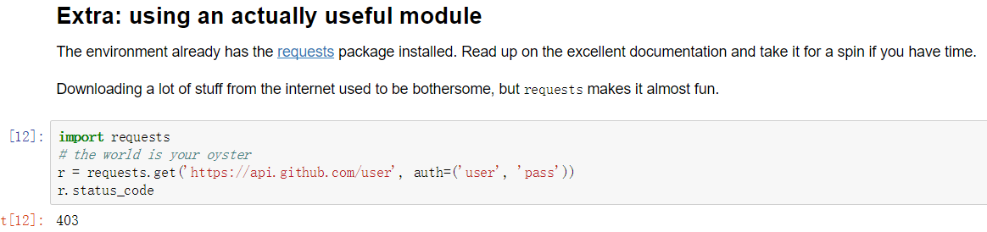

## 6.

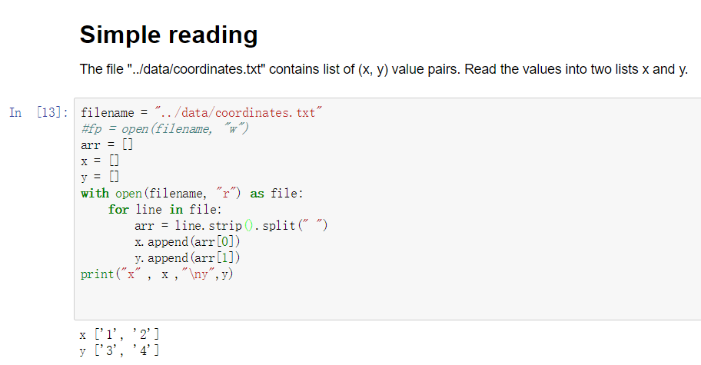

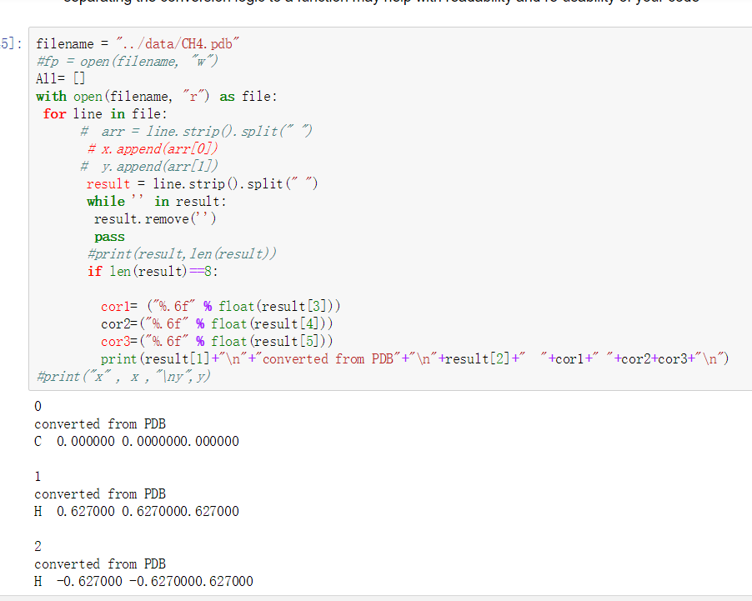

If we write the output into the file:

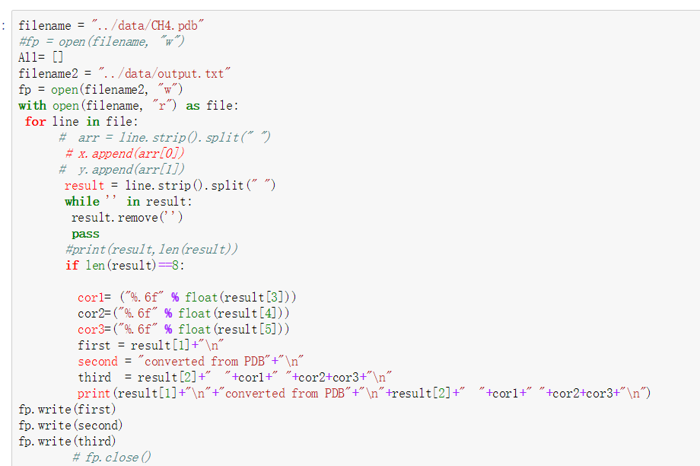

The result is:

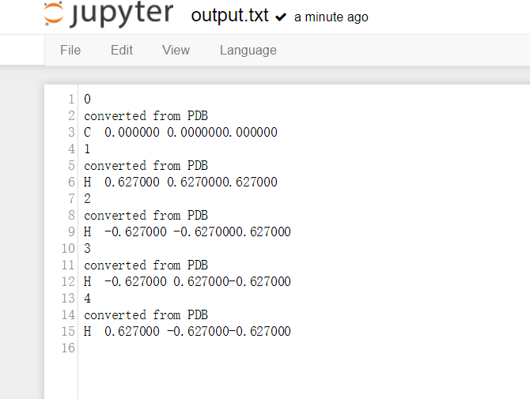

In order to find a sub-string, use strip() and find()

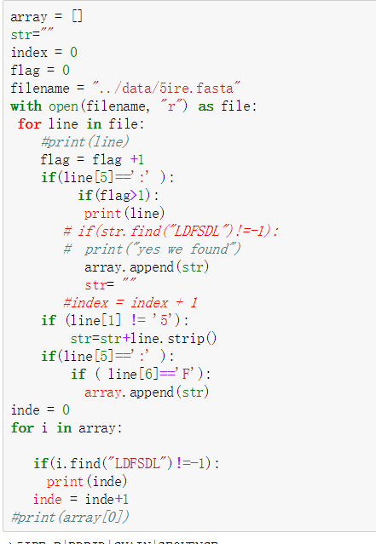

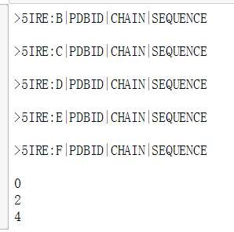

Here we find A, C,E chain has the sub-string

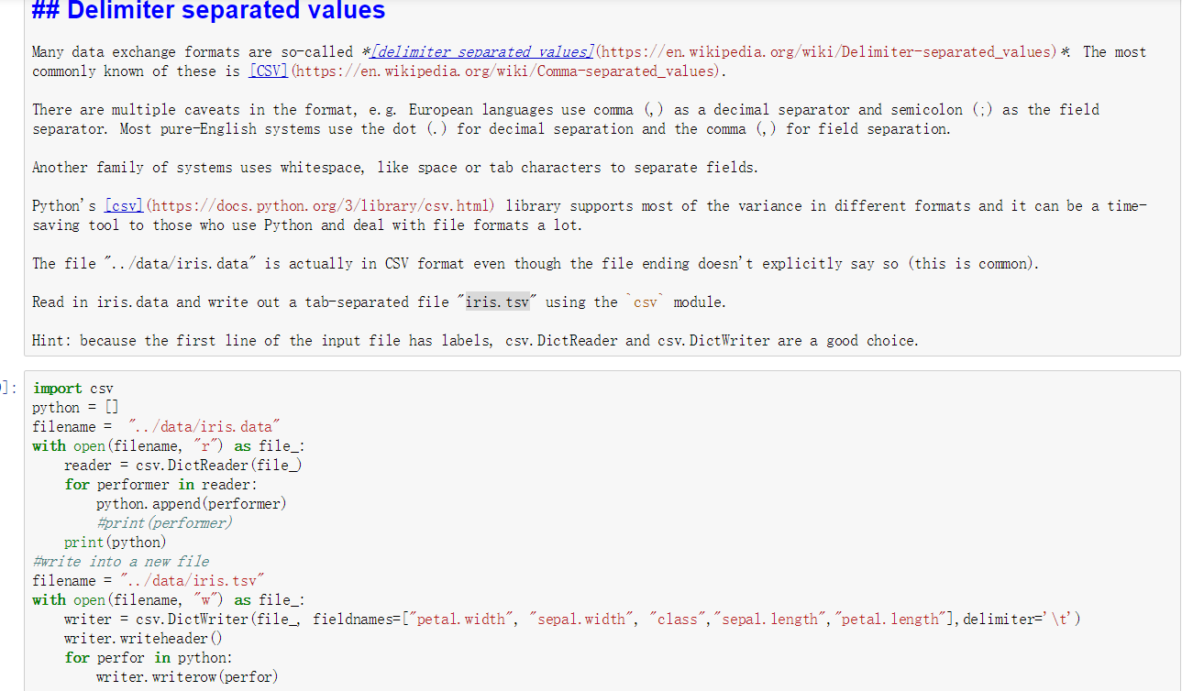

Then we get output in iris.tsv that the diameter is changed

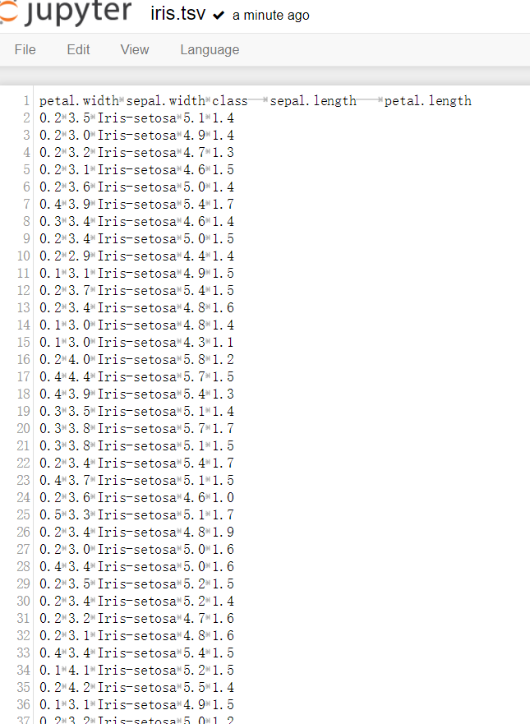

Words count:

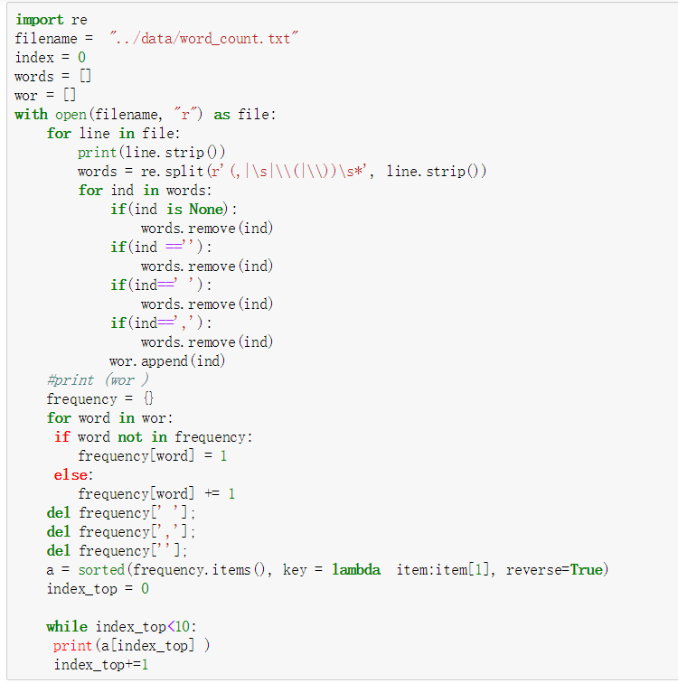

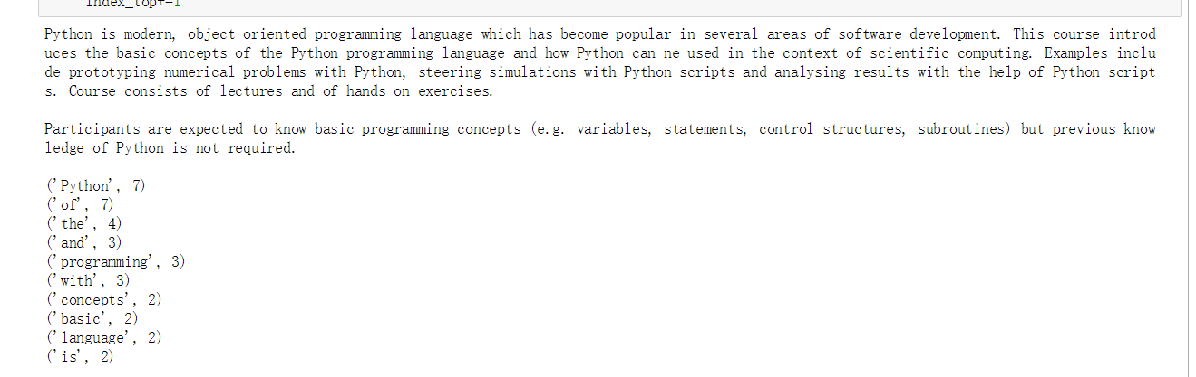

## 7.

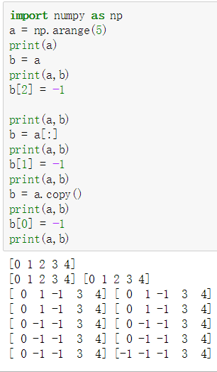

arrange(5): from 0 to 4: 5 integers, with the change of b, a also changes

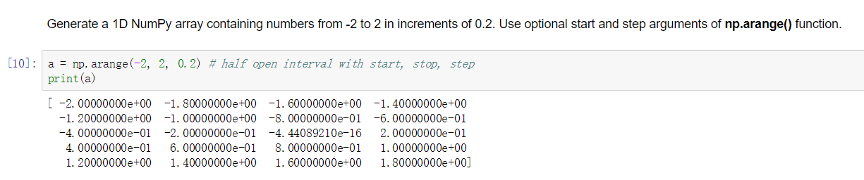

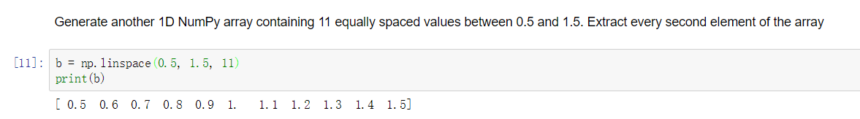

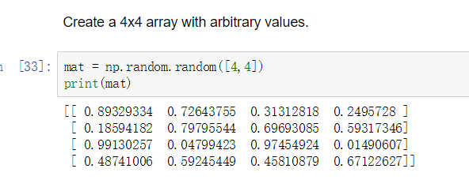

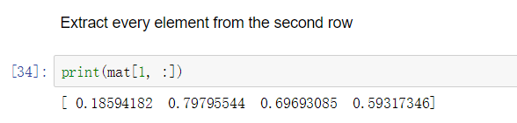

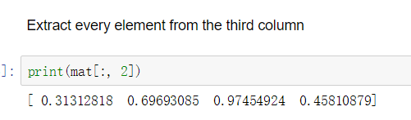

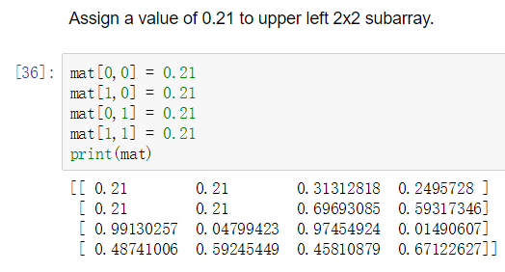

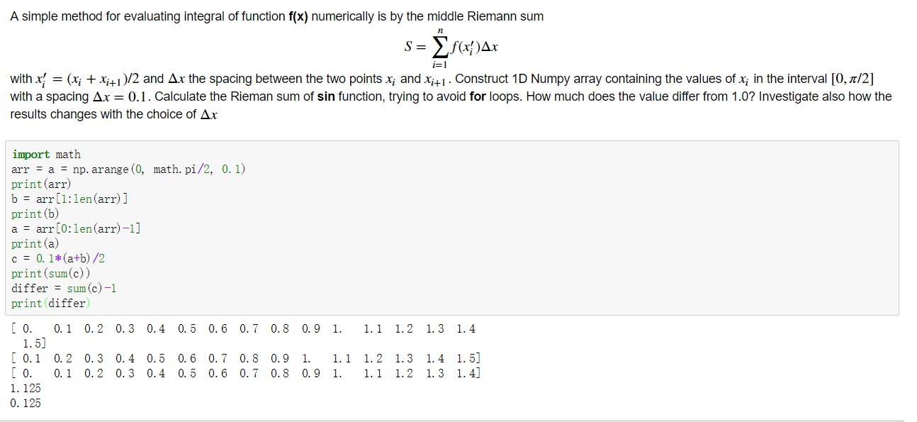

With the increasing of Δx, the differ will become larger

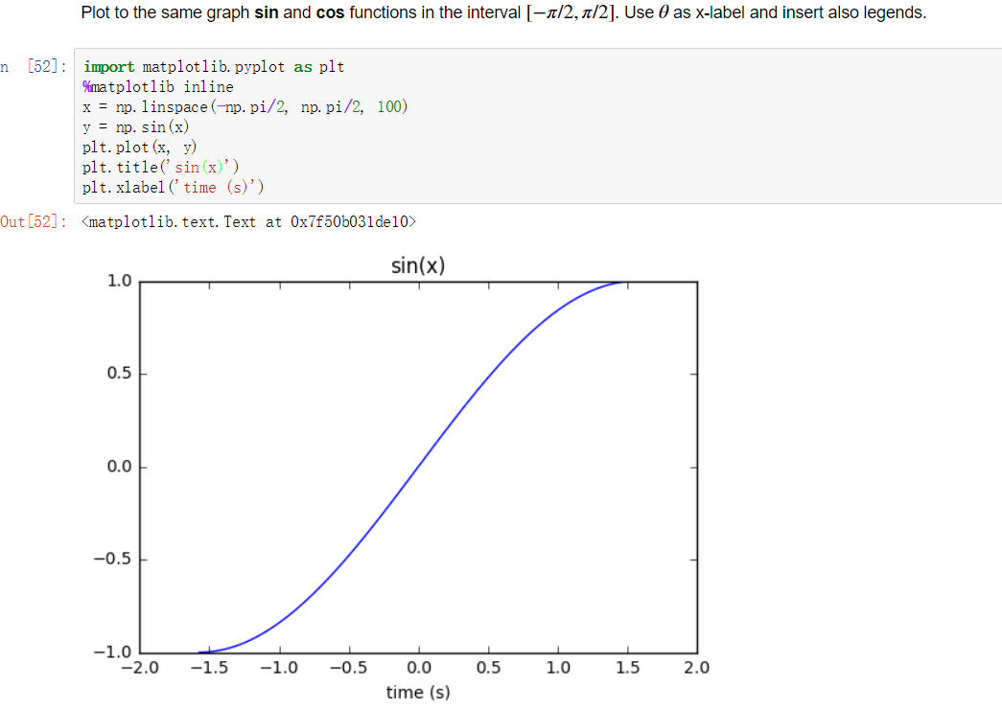

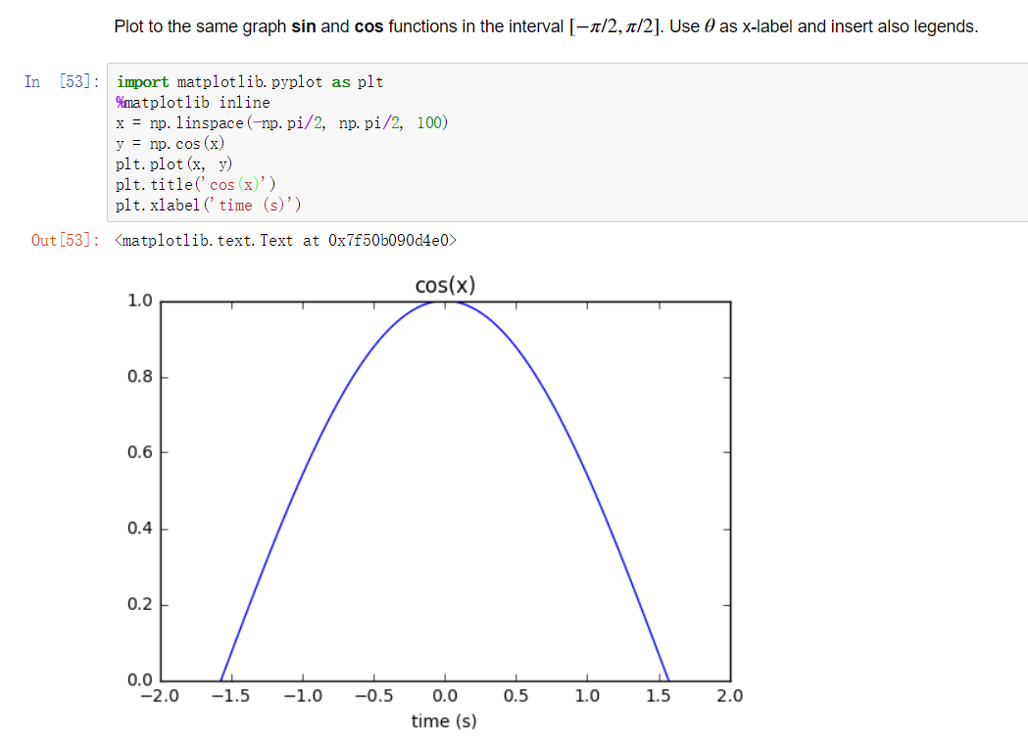

## Answer for the questions:

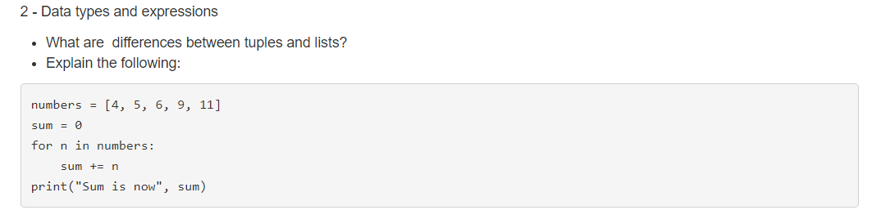

(the difference between tuples and lists: tuples can’t be changed, list can be changed after assignment, and tuple doesn’t have methods such as remove(), append() and so on)

3.

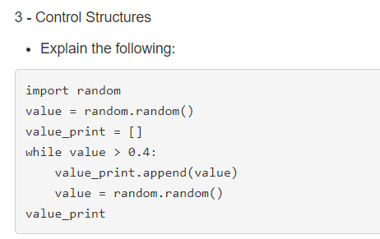

(it imports a package called ‘random’, and use the function random() to generate a random value, then there is a empty list called ‘ value_print’, this list will append the randomly generated value until this value is small than 0.4)

4.

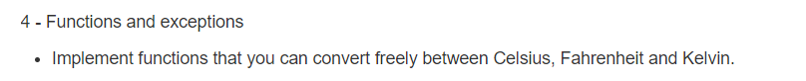

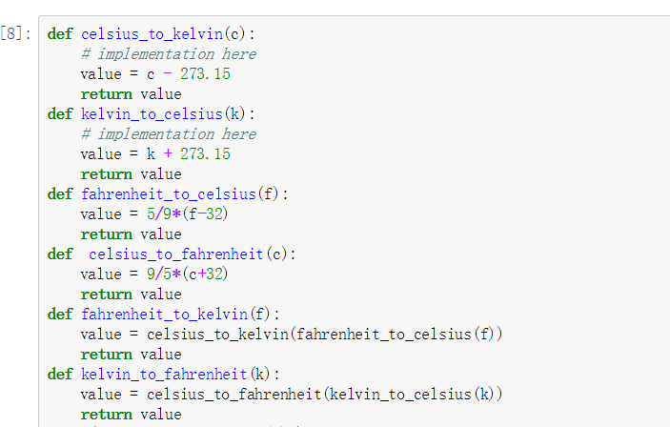

5.

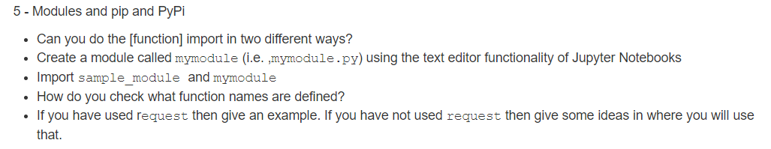



First method: from package_name import function_name

Second method: import package_name, use package_name.function_name

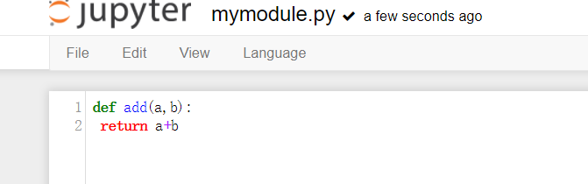

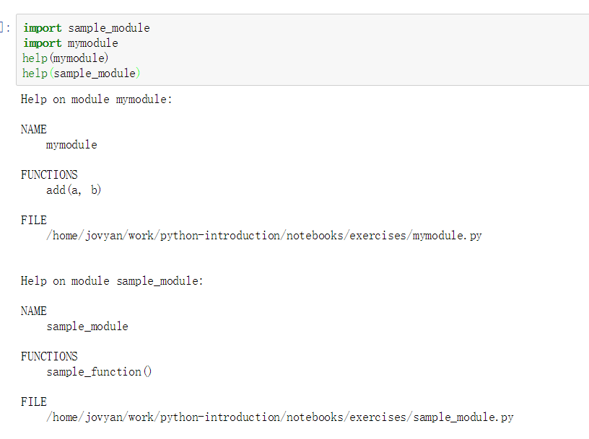

Use help() function we can find the functions defined in packages

The situation for using request: use requests to send http request, such as ,so we can get a object r to get the response result from http, also, it can be used for constructing url by input the parameters with dictionary. Use requests.get() to construct url.

6.

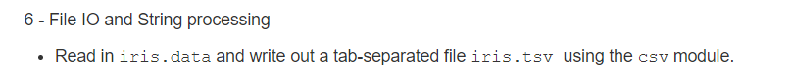

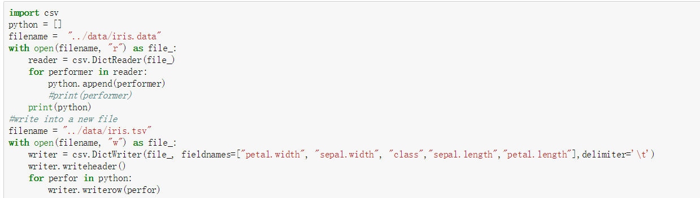

Output:

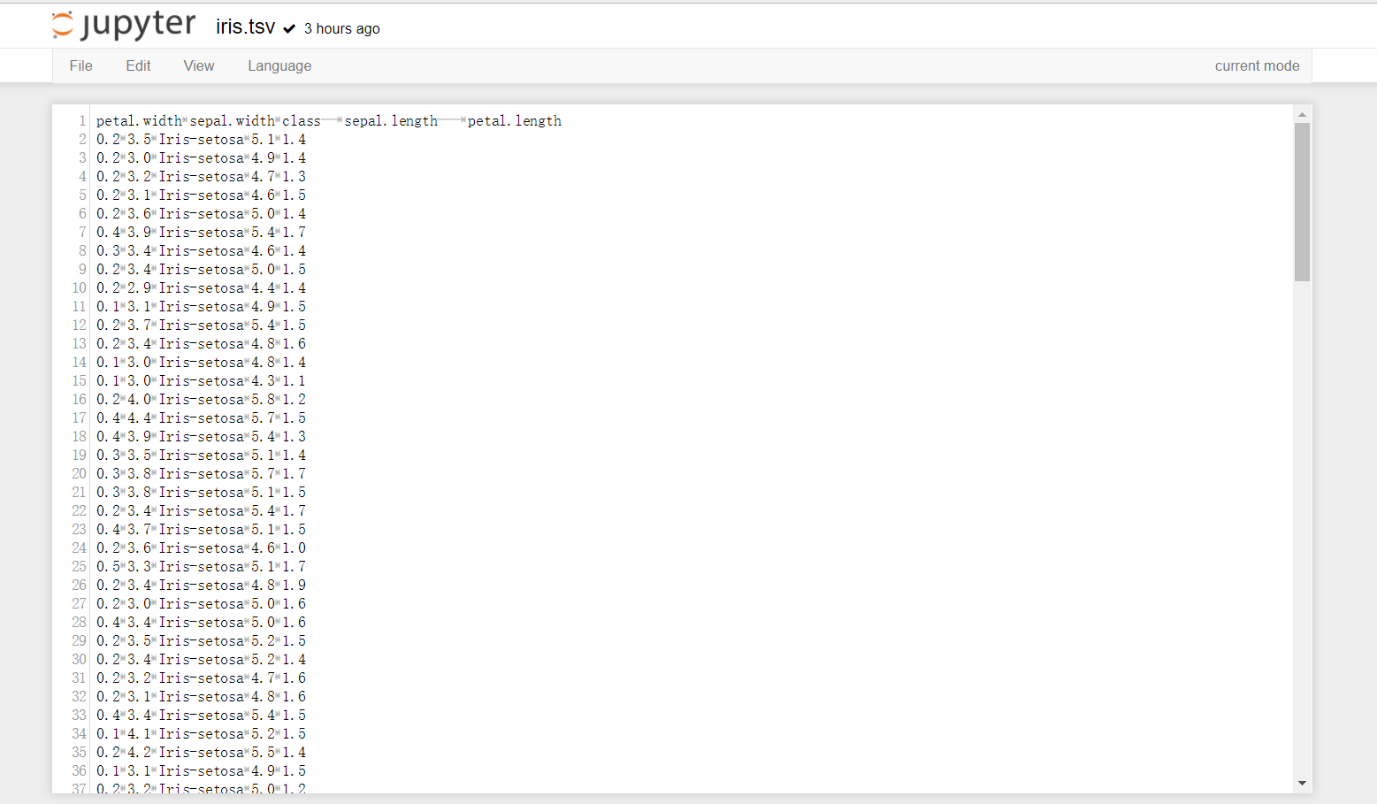

7.

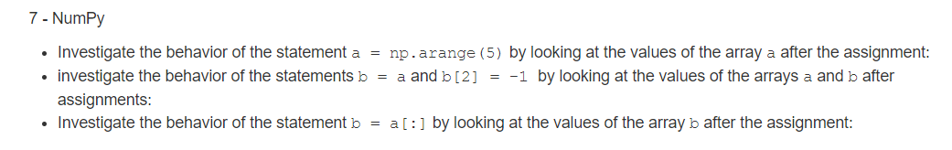

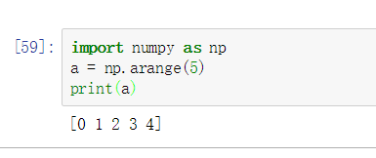

We can find that this np.arrange(5) generates 5 integers start from 0-4

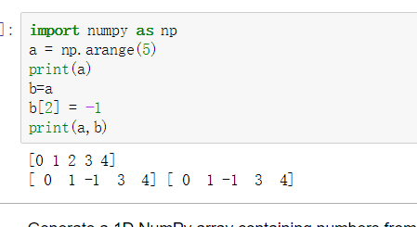

We find that after changing the value in b, the value of a is also changing, simple assignment creates a reference to array. If a and b are references to same array, changing contents of b changes also contents of a.

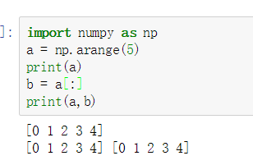

We can find a[:] assign the values in a to b