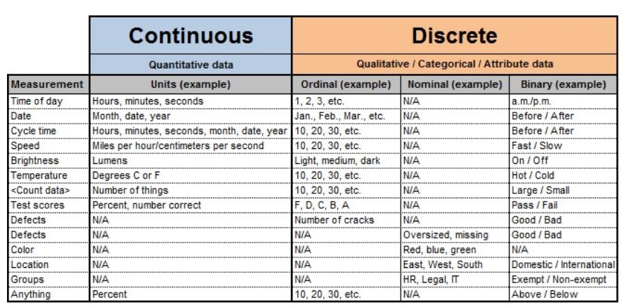

The file containing loan data through the "present" contains complete loan data for all loans issued through the previous completed calendar quarter. I chose the loan data from 2007-2011 loan data.

* a numbers of the rows： 42530 rows for data
* quantitative variables (i.e., the name of the variable and a distribution of the values)
  1. loan amnt: The listed amount of the loan applied for by the borrower. If at some point in time, the credit department reduces the loan amount, then it will be reflected in this value.
  2. funded_amnt: The total amount committed to that loan at that point in time.
  3. funded_amnt_inv: The total amount committed by investors for that loan at that point in time.
  4. int_rate: Interest Rate on the loan
  5. installment: The monthly payment owed by the borrower if the loan originates.
  6. annual_inc: The self-reported annual income provided by the borrower during registration.
  7. open_acc: The number of open credit lines in the borrower's credit file.
  8. revol_bal: Total credit revolving balance
* qualitative variables (i.e., the name of the variable and frequencies of the values).
  1. id: A unique LC assigned ID for the loan listing. (This column is an empty column when downloaded)
  2. member_id: A unique LC assigned Id for the borrower member.(This column is an empty column when downloaded)
  3. term: The number of payments on the loan. Values are in months and can be either 36 or 60.
  4. grade: LC assigned loan grade
  5. sub_grade: LC assigned loan subgrade
  6. emp_title: The job title supplied by the Borrower when applying for the loan.
  7. emp_length: Employment length in years. Possible values are between 0 and 10 where 0 means less than one year and 10 means ten or more years.
  8. home_ownership: The home ownership status provided by the borrower during registration or obtained from the credit report. Our values are: RENT, OWN, MORTGAGE, OTHER
  9. verification_status: Indicates if income was verified by LC, not verified, or if the income source was verified
  10. issue_d: The month which the loan was funded
  11. loan_status: Current status of the loan
  12. pymnt_plan: Indicates if a payment plan has been put in place for the loan