1. Install TPOT: first install tpot in the Jupyter Notebook terminal:

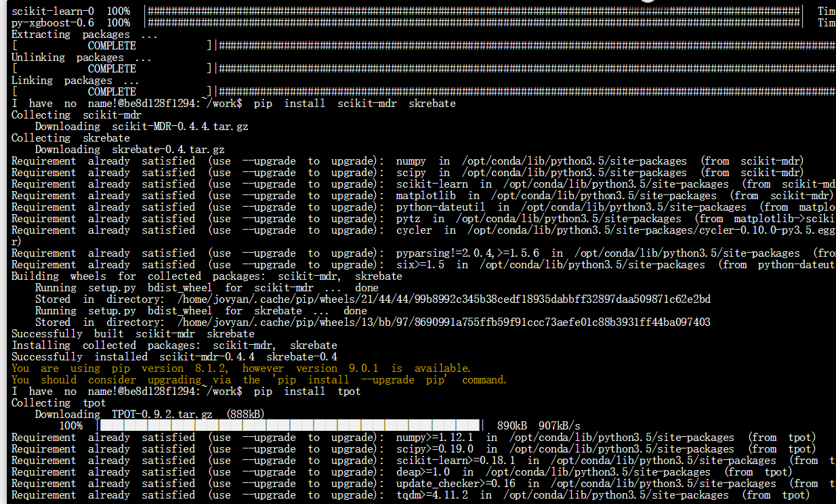

1. 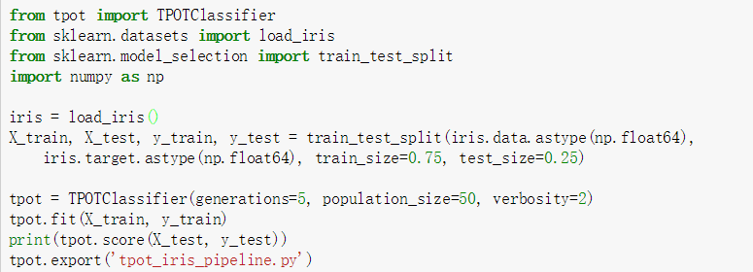

The code above is separating the data-‘iris’ into train set and test set, train set take 75% of total data, and test set take 25% of the data. Then use TPOT classifier to do 5 times of generations in order to get the machine learning code, then put train data set and test data set into the classifier made by tpot, we can get the prediction and accuracy of this classifier.

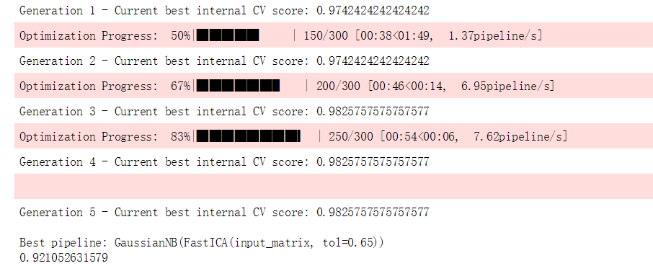

Next we do the data munging of the iris.csv which is download from UCI database:

Name the class label into ‘target’ ,

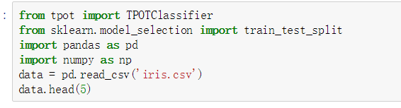

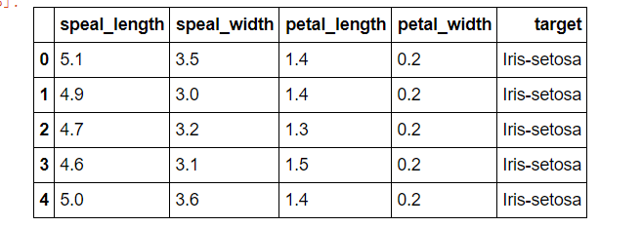

Since the class label is categorical variable, we change it into numerical type,

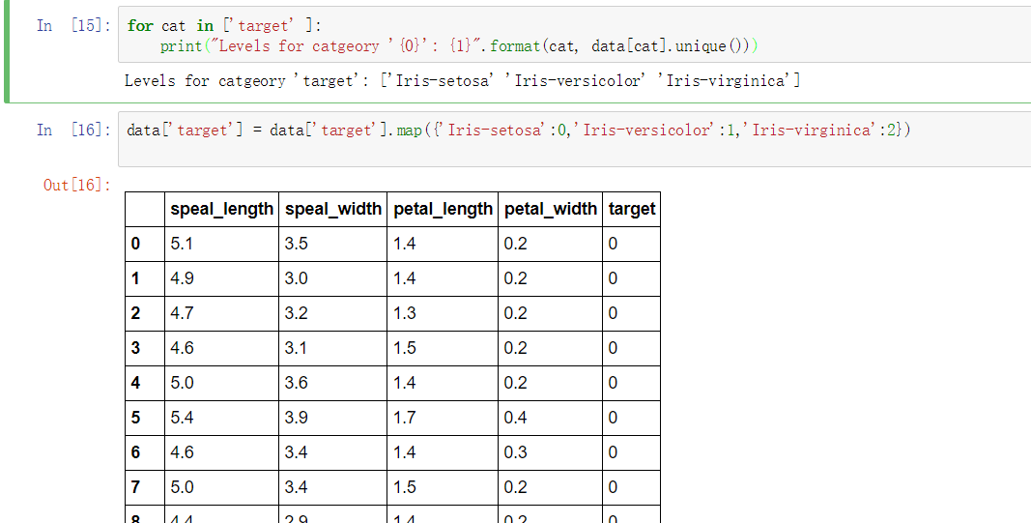

So the class type is : 0, 1, 2

In order to get the changed data, we fit data into data frame format

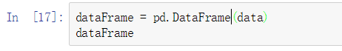

Thus we can use to_csv function to write into csv



Then the data can be used into the python code generated by TPOT.

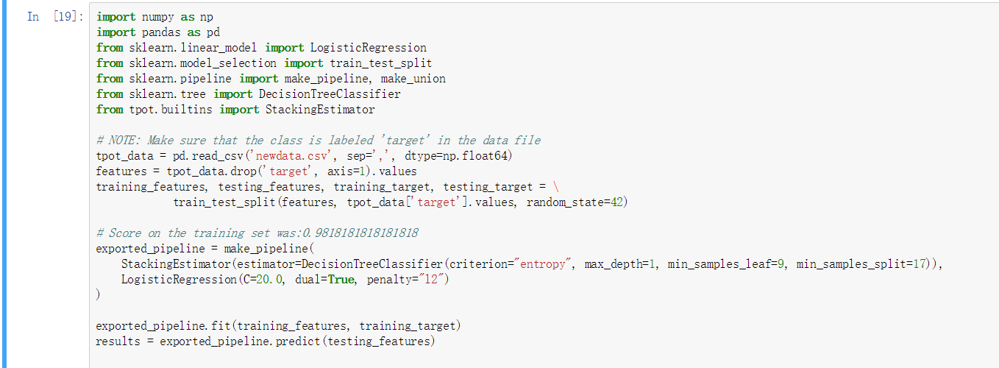

Replace to file path to ‘newdata.csv’, separator: ‘,’

Then we can get the predicted results:

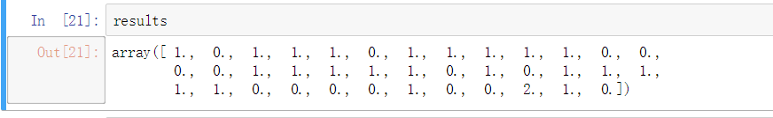

This is the original test target:

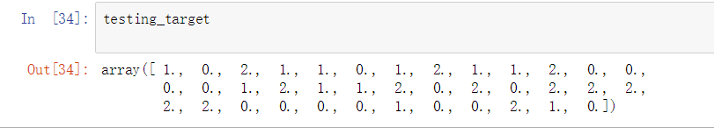

Then we can calculate the accuracy by comparing those two arrays

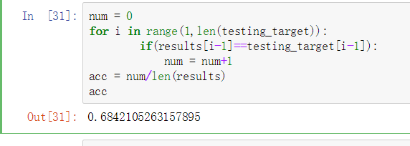

So the accuracy of this generated classifier is : 68.42%