EE175AB Final Report Template
Autonomous Trash Picking Robot
EE 175AB Final Report
Department of Electrical Engineering, UC Riverside

Project Team Member(s) | Justin Mazon, Ryan Lansang, Kaisen Leong, Hector Jimenez
Date Submitted | 3/19/2024
Section  Professor | Pamodya Peiris
Revision | Final Revision
URL of Project YouTube Videos, Wiki/Webpage | Youtube Demo:  https://www.youtube.com/watch?v=zVrcM-32XTs&ab_channel=JustinMazon  Source Code:  https://github.com/KLeong91/KHRJ---Senior-Design
Permanent Emails of all team members | jmazo002@ucr.edu  rlans002@ucr.edu  kleon059@ucr.edu  hjime016@ucr.edu

Summary
This report presents documentation on the Autonomous Trash Picking Robot for EE 175 Senior Design.
Note:
- Sections marked with * are required
- In each section, you must clearly identify which team member is responsible for which objectives, modules or tasks.
Revisions
Version | Description of Version | Author(s) | Date Completed | Approval
0.5 | First draft | Justin Mazon, Ryan Lansang, Kaisen Leong, Hector Jimenez | 01/01/2023
1.0 | Final Version | Justin Mazon, Ryan Lansang, Kaisen Leong, Hector Jimenez | 03/19/2023

This template serves as a basis for the EE175 Senior Design Project Final Report.
This document should be customized to the needs of each specific project. This template is only a starting point.
This template does not imply that all components listed in this template should be included (except the sections marked with *) nor does it imply that this template includes all the necessary components needed for a specific project. Instead this template provides a basic starting point that will work well in many situations. The design team must modify and/or expand the contents in order to meet the specific requirements of their project.

If a section is not marked with an * but is irrelevant to your project, do not remove it and do not renumber it. Just indicate that it is not applicable to your project.

Table of Contents

1 * Executive Summary 5
2 * Introduction 7
2.1 * Design Objectives and System Overview 7
2.2 * Backgrounds and Prior Art 9
2.3 * Development Environment and Tools 10
2.4 * Related Documents and Supporting Materials 11
2.5 * Definitions and Acronyms 11
3 * Design Considerations 12
3.1 * Realistic Constraints 12
3.3 * Industry Standards 13
3.4 * Knowledge and Skills 13
3.5 * Budget and Cost Analysis 14
3.6 * Safety 15
3.7 * Documentation 15
4 * Experiment Design and Feasibility Study 16
4.1 * Experiment Design 16
4.2 * Experiment Results, Data Analysis and Feasibility 20
5 * Architecture and High Level Design 23
5.1 * System Architecture and Design 23
5.2 * Hardware Architecture 23
5.3 * Software Architecture (only required if your design includes software) 25
5.4 * Rationale and Alternatives 26
6 * Low Level Design 27
6.1 Lidar Module 27
6.1.1 Processing narrative for Lidar Module
A Lidar measures distances by illuminating a target with laser light and analyzing the reflected light. 27
6.1.2 Obstacle Avoidance Module interface description 27
6.1.3 Obstacle Avoidance Module processing details 28
6.2 Webcam Module 28
6.2.1 Processing narrative for Webcam Module
Captures video/frames in real-time. 28
6.2.2 Obstacle Avoidance Module interface description 28
6.2.3 Obstacle Avoidance Module processing details 28
6.3 Arduino Module 28
6.3.1 Processing narrative for Arduino Module
A Programmable microcontroller board with a small form factor. 28
6.3.2 Arduino Module interface description 28
6.3.3 Arduino processing details 28
6.4 Servo Controller Module 28
6.4.1 Processing narrative for Servo Controller Module
A device used to precisely control the position, speed, and sometimes torque of a servo motor. 28
6.4.2 Servo Controller Module interface description 28
6.4.3 Servo Controller processing details 28
7 * Technical Problem Solving 29
7.1 * The Arm Problem 29
7.2 * Solving the Arm Problem 29
7.3 * The WiFi Problem 29
7.4 * Solving the Wifi Problem 29
8 * Test Plan 31
8.1 * Test Design 31
8.2 * Bug Tracking 32
8.3 * Quality Control 32
8.4 * Identification of critical components 32
8.5 * Items Not Tested by the Experiments 33
9 * Test Report 34
9.1 * Test 1 Obstacle Avoidance (Kaisen) 34
9.2 * Test 2 Accuracy of Detecting Desired Object (Ryan) 34
9.3 * Test 3 Robotic Arm Collection (Justin) 35
10 * Conclusion and Future Work 36
10.1 * Conclusion 36
10.2 Future Work 36
10.3 * Acknowledgement 36
11 * References 37
12 * Appendices 38

* Executive Summary
The Autonomous Trash Picking Robot (ATPR) aims to solve the world’s trash problem by reducing the human labor required to dispose of waste. The ATPR is able to autonomously navigate an environment, look for specific waste items such as bottles and oranges. The ATPR will then collect the items using a robotic arm and store it in onboard compost and recycle bins for later disposal. The ATPR utilizes technical capabilities including obstacle avoidance, object detection, waste collection, and teleoperation control to achieve these overall objectives.
The motivation behind the ATPR is to reduce labor and to encourage environmentally practices. The goal of this project is to design a robot which can navigate spaces using LiDAR while avoiding dangerous collisions. Additionally the robotic system must be able to detect objects of interest and collect them. The last goal of the Autonomous Trash Picking Robot is to provide a fail safe in hardware and software in case of operational failures. Another motivation for the robot was to have a system that is modular and can be expanded in the future for different industries.
The design objective of the ATPR is to build an adaptable waste collection robotic system which can navigate its surroundings, avoid obstacles, detect and collect intended objects. The next objective is to design a robot within a budget of seven hundred dollars, and to build it within six months. The robot must have its own power source, can carry out its autonomous directives and also receive human commands as a safety precaution in case of malfunction.
Some of the key features of the robot are the Lidar for avoiding obstacles and navigation, computer vision for object detection, robotic arm, and teleoperation capability. The Lidar provided telemetry data for the robotic system. The Lidar sensor provides a key feature of adaptability so that programmers can implement their own automated behavior. For computer vision, the openCV library is used together with a webcam to detect bottles and oranges, which the robotic arm picks up. A Playstation 4 controller is used for remote control in case the robot is not operating properly and needs to be manually controlled. Another key feature of the robotic system was the robotic arm allowing remote and autonomous operation.
The project was validated using a set of performance tests. The following testing methods were designed and performed: obstacle avoidance test, object detection test, and object collection test. The tests were designed in order to quantify the performance of the robotic system in the areas of obstacle avoidance, object detection, and object collection. The first test focused on the robots ability to avoid collisions during autonomous navigation. The team measured the distance at which the robot could detect and avoid obstacles from. Through multiple tests, the team determined that 0.25 meters was the ideal stopping distance that the robot can safely navigate around obstacles. The second test evaluated the accuracy of the robot's object detection system. These tests revealed the computer vision system was able to detect oranges with 80% accuracy and bottles with 70% accuracy. The team made necessary adjustments to the computer vision system to improve the detection of bottle objects. The third test evaluated the robot’s ability to pick up objects. The success rate was only 40% due to the Lidar threshold values and the placement of the Lidar. After adjustments to the Lidar and permanently fixing the Lidar to the chassis the accuracy of our trash collection capabilities increased. The validation process provided valuable information that assisted our team in adjusting the robotic system and meeting out initial requirements.
In conclusion, the team successfully met the project requirements and is satisfied with the result. The robot has onboard power and can autonomously navigate its surroundings while avoiding obstacles, can detect bottles and oranges with acceptable accuracy, and can collect and sort items. The ATPR was built in 6 months for a cost of $614, which was under budget by $86. Safety measures like power shutoff switches and teleoperation were implemented into the hardware and software design. All design objectives were met.

* Introduction

* Design Objectives and System Overview

Design Concept
The robot is designed to carry out a ROS2 based autonomous waste collection algorithm running on a Raspberry Pi 4 Model B installed with Ubuntu 20.04. The robot incorporates DC motor control, Lidar based obstacle avoidance, component communication, object recognition, and autonomy.
Technical Principles
The technical principles for this project involved integrating both hardware components and software frameworks. The ROS2 Foxy (Robotic Operating System) framework serves as the communication layer for the different node processes running on the Raspberry Pi. Utilizing ROS2 added modularity to the system that could be further developed to integrate more sensors and actuators. Navigation was implemented by integrating encoded DC wheels and a LiDAR sensor. The LiDAR is used to measure distances between the robot and any object in its way. Object detection is achieved by using a USB interfaced webcam combined with a computer vision library (OpenCV). The model used was YOLOv3 (https://github.com/ultralytics/yolov3). This model is pre-trained and open source for anyone to use. Oranges (compost bin) and bottles (recycle bin) were chosen as the desired objects to be detected and picked up. Other object models can be added in the future.
Project Meaning
The design of this project aligns with the trends of environment practices, robotics, automation, and artificial intelligence. Utilizing robotics to outsource menial tasks like trash collection results in a cleaner planet while also reducing human labor. The artificial intelligence algorithms on this project trend with computer vision applications used in the industry today. Another important meaning behind the project is that all the software is open source therefore it’s open to being edited by anybody.
Intended Application
The intended application for our design is waste management. There already exists similar autonomous cleaning products, but none that offer abilities beyond normal vacuum cleaners. This project is capable of cleaning not only domestic settings, but industrial and commercial as well. The robot can be adapted through both hardware and software to have a wide variety of applications like industrial automation, warehouse logistics, security, and assistance for elderly and disabled. Additionally, our robot can be deployed in hazardous situations like natural disasters where human access is limited. The robot can be programmed to seek and collect virtually any item that can be identified by computer vision and that can be grasped by its robotic arm.
Relation to Electrical Engineering
In relation to electrical engineering this design combines several electrical engineer concepts including, but not limited to, control systems, signal processing, embedded systems, and sensing and actuation. An understanding of microcontrollers, sensors, actuators, communication protocols, and Python programming is necessary.
Overall Goals
The overall goals for this project is to implement a ROS2 robotic system that integrates our hardware and software, accurate motor control, Lidar based obstacle avoidance/navigation/mapping, and object detection. In summary there are 3 key goals:
1. Autonomous navigation without hitting any obstacles.
2. Effective waste collection with the ability to pick up oranges and bottles.
3. Accurate sorting capability to sort between oranges and bottles.

High Level Description
The high level description of this system consists of a Raspberry Pi 4 Model B running Ubuntu 20.04 as the main computer of the robot. An Arduino Nano acts as the motor controller for the encoder based wheels. The encoder on the wheels provides odometry. The Arduino Nano connects to the Raspberry Pi by USB. A Lidar sensor is used to provide 2D environment perception. The Lidar connects to the Raspberry Pi by USB. The webcam connects to the Raspberry Pi by USB. The mechanical arm with 6 servos is connected to a servo controller. The servo controller connects to the Raspberry Pi by USB. ROS acts as the communication layer between the numerous processes running.
Functionalities
The functionality of this design includes autonomous navigation, mapping capability, obstacle avoidance, object recognition, precise motor control, remote control, and real-time communication between components.
Interactions with External Systems
This system interacts with one external network in order to perform the communication between the various processes.
System Issues
Challenges included integration complexities between hardware and software components.
Operating Environment
The robotic system is designed for indoor environments with controlled lighting. The drive system is adaptable to multiple terrains and the obstacle avoidance system is capable of avoiding objects in a typical indoor environment but can be scaled for outdoor use.
User Environment
The user can interact with the robotic system remotely via an external bluetooth controller or by executing commands on the terminal via a secure shell connection with the robot.
Inputs
Sensor Data from Lidar, Webcam frames, Encoder Wheels, Commands for Motor control, Bluetooth Controller Button and Joystick Inputs.
Outputs
Motor Velocity Commands, Object Recognition Results, Navigation Decisions, Arm Motor Control.
Technical Design Objectives and Responsibilities
Justin Mazon

Ryan Lansang
- Test to see if system detects objects such as an orange and a plastic bottle at an accuracy of at least 75%
- Integrate mechanical arm with the robot chassis.
Kaisen Leong
- Experimentally determine the optimal distance, x, in meters to stop in front of a detected object for successful obstacle avoidance.
- Design hardware to implement physical emergency power shutoff.
Hector Jimenez

CONTRIBUTIONS
Justin Mazon
- Object Detection Node with webcam (Software)
- Obstacle Avoidance Node with Lidar (Software)
- Mechanical Controller Arm Node (Software)
- OpenCV/YOLOv3 integration (Software)
- Testing of arm functionality, mechanical arm functionality, and obstacle avoidance functionality
Ryan Lansang
- Object Detection Node with webcam (Software)
- Robotic Arm Node (Software)
- Attached the Robotic Arm to Chassis (Hardware)
- Helped integrate hardware components (Hardware)
- Soldered some of the wires together (Hardware)
Kaisen Leong
- Obstacle Avoidance Node with DC Motors(Software)
- Obstacle Avoidance Node with Lidar(Software)
- Drive and battery system soldering and wiring(Hardware)
- Tank chassis alterations and component placement(Hardware)
- Independent purchasing of certain components(Budget)
- Motor control and obstacle avoidance tests
Hector Jimenez
- Prototyping ROS differential drive robot(Software/Hardware)
- Design of Mechanical Prototype Chassis in Solidworks
- Testing of Drive System and Ultrasonic sensing via ROS
- Integrating Encoder Wheel drive system
- Simulation Modeling (Creating Solidworks Model of Tank and Converting to URDF)

* Backgrounds and Prior Art
Though there exist products similar to our proposed design, none offered all the desired characteristics. The functionality requirements were for the robotic system to self navigate an environment while avoiding obstacles and detecting trash for collection and sorting. The hardware design must use reliable components that fall within a total budget of $700. The design must also be modular and adaptable to various tasks and environments.
Robot #1
https://www.youtube.com/watch?v=fR2VynbYyuk&ab_channel=WestonRobot
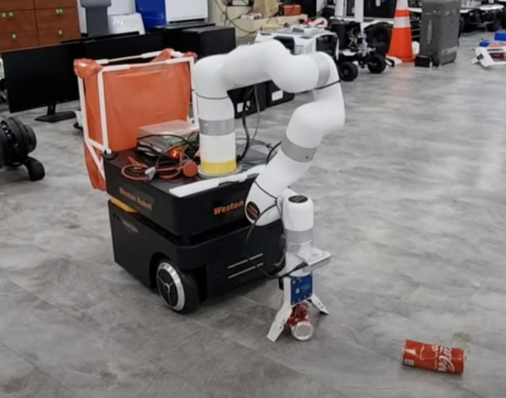
Robot #2
https://www.youtube.com/watch?v=0PN5dczy9tw&ab_channel=As_im_awan
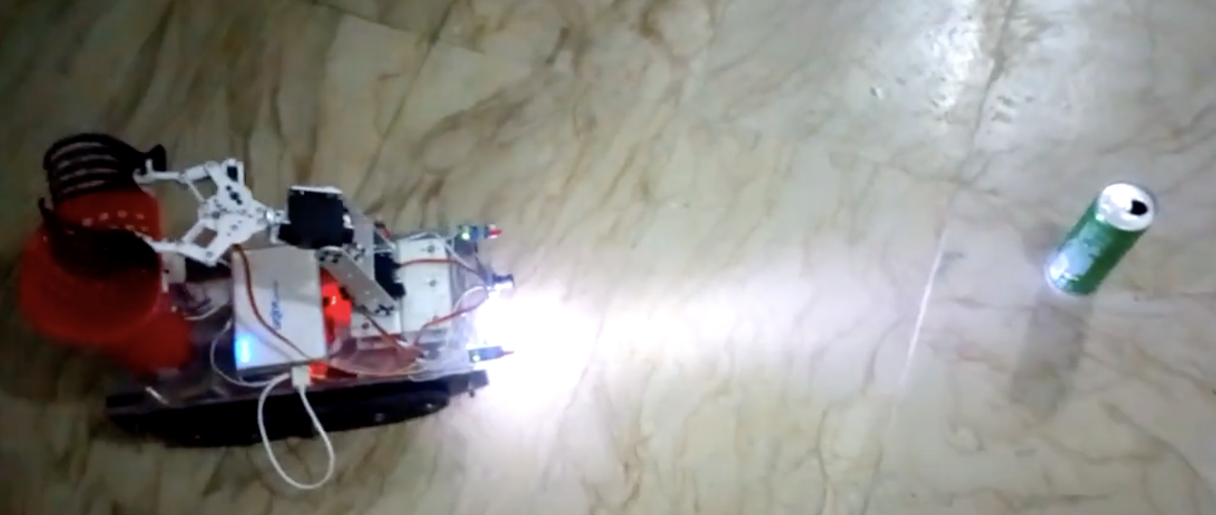
First robot observations: The robot in the first Youtube video shows a highly articulated robot arm with several degrees of freedom. The chassis appears to be custom made from quality materials but also looks large and heavy. The software functionality seems accurate and effective. Although the technical performance of the robot is adequate, the design exceeds our budgeted resources and is not applicable to the timeframe available for prototyping and manufacturing. Also, this robot does not seem to implement obstacle avoidance. The advantages of the design portrayed in the youtube video is high quality components and accurate and effective functionality. The disadvantages are the physical scale of the design and the cost of manufacturing.
Second robot observations: This robot design looks to be built from commercially available components and falls within the physical scale and scope of our project. The functionality seems to be similar to the desired functionality of the senior design project, though, it lacks object detection and sorting capabilities. The advantages of this system are its maneuverability due to its smaller footprint and its simpler design leading to easier manufacturing. The disadvantages of this system is that the chassis does not have room to store different collected objects and the functionality does not seem to incorporate object sorting.

* Development Environment and Tools
For hardware development, the Raspberry Pi 4 Model B was utilized as the main controller of the system running on the Linux Ubuntu 20.04 operating system. Additionally, an Arduino Nano was used as a secondary controller to manage the DC motors and a servo controller was used to operate the servos on the robotic arm.
Visual Studio Code with the ROS 2 framework was utilized for software development. To communicate with the Raspberry Pi from a personal computer SSH was used. All the code was written in Python and C++.
Software Tools:
- Visual Studio Code for SSH and coding development.
- ROS2 Foxy Fitzroy for communication framework.
- OpenCV Python Library for computer vision.
- YOLOv3 for object detection algorithm.
- Gazebo for simulation.
- Rviz2 for visualization.
Hardware Tools:
- Raspberry Pi 4 with Ubuntu 20.04 for main microcontroller.
- Arduino Nano for DC encoded motor control
- Servo Controller
- Digital Multimeter for measuring voltage and current for power calculations.
- Soldering Iron to connect wires together.
- Drills to make holes for mounting.
- Phillip Screwdriver to mount various hardware components like the robotic arm to the chassis.

* Related Documents and Supporting Materials
ROS2 Foxy: https://docs.ros.org/en/foxy/Installation.html
YOLOv3: https://github.com/ultralytics/yolov3
Lewansoul Arm: https://xarm-lewansoul-ros.readthedocs.io/en/latest/user_guide/1_1_introduction.html
ROS2 Robot Tutorial: https://articulatedrobotics.xyz/mobile-robot-full-list/

* Definitions and Acronyms
Lidar - Light Detection and Ranging
LiPo - Lithium-ion Polymer Battery
OpenCV - Open Computer Vision
ROS(2) - Robot Operating System (2)
RPI (4) - Raspberry Pi (4)
GPIO Pin - General Purpose Input Output Pin
SSH - Secure Shell
USB - Universal Serial Bus
VSCode – Visual Studio Code
YOLOv3 - You Only Look Once, Version 3

* Design Considerations

* Realistic Constraints
There were eight main constraints in building this project: processor constraints, weight/size constraints, voltage/current constraints, component software compatibility constraints, power constraint, physical constraints, drive system constraints, and safety system constraints.
Noticeable Constraints of our System:
Processor speed/Memory size Constraints: The Raspberry Pi 4 ,which is used as the main controller, has 8GB of RAM and a 1.5-GHz quad-core 64-bit CPU, so the amount of objects the system can detect using computer vision was limited to only two items: a bottle and an orange, to prevent the controller from overheating and slowing down.
Weight/Size Constraints: During the robot’s rotation there is a slight chance of it bumping into obstacles. Limited chassis real estate restricted available spots for component placement and thus considerations must be made relating placement and obstacle avoidance success.
Component Voltage/Current Constraints: The Raspberry Pi 4 can only output a continuous 3 A at 5 V. Some components require 12 V and 7.4 V. Voltage regulation is necessary.
Component Software Compatibility Constraints: All components must be compatible with ROS2 Foxy and Ubuntu 20.04 software environment.
Power Consumption Constraints: The battery for the Raspberry Pi lasts about 2 hours so it would either need to be replaced or the batteries would have to be charged.
Physical Constraints: The tank chassis must be large and strong enough to carry a robotic arm, all other components, and collected trash items. Additionally it must have sufficient space to store the necessary electronics.
Drive System Constraints: Drive systems must be powerful enough to physically drive the entire robotic system. The drive system should draw a low current so as to not affect the rest of the system.
Safety System Constraints: System must have both physical and electronic safety features in place for emergency shutoff and human intervention.

  - System Environment and External Interfaces
The system consolidates hardware components such as the RPLidar A1 Lidar scanner, Logitech C270 webcam, 12 V DC encoded motors, LewanSoul 6 degree of freedom robotic arm, and Raspberry Pi 4 and Arduino Nano. These hardware components combined with software like ROS2 Foxy running on Ubuntu 20.04 provide the necessary component integration and functionality for the system. The system environment included the wireless network and the robotic system. In terms of software the system interfaces with ROS2 Foxy library packages like: ros2_control and teleop_twist. Additionally our system also interfaces with Gazebo software to provide dynamic simulations and visualizations of the robotic system. The programming language primarily used to interface with the microcontroller was Python.
The system interfaced with external servers at Github to handle the version control of the software. Additionally the robotic system interfaced the various hardware components using TCP protocols via ROS. The hardware components such as the camera and Lidar interfaced with the RPI4 and Arduino Nano using standard USB 2.0 and 3.0 connectors. The external remote controllers were interfaced with the RPI4 using Bluetooth 802.15. The entire network system interfaced with external desktops using SSH protocol.

* Industry Standards

Industry standards
- USB2.0 and USB3.0
- Bluetooth 802.15
- Wifi 2.4GHz
- TCP/IP
- LiPo batteries with common T-Deans connectors
Programming Languages/Environments
- Linux Ubuntu 20.04
- ROS2 Foxy
- CMake
- Python
- C++
- Git
- XML (URDF - Unified Robot Description Format)
- ROS2 Standard Packages
In addition to the GPIO pins, the Raspberry Pi has four serial connection ports: two USB 2.0 ports and two USB 3.0 ports. This required the design to use components that had compatibility with these connection methods. This also limited the design to a maximum of four USB connected components. The LiPo battery used as the main power source for the tank DC motors and arm servos utilized T-Deans connectors while the L298N Motor Driver and DFRobot Voltage Regulator used standard jumper wire pins as inputs. This required some wire connections to be soldered with the appropriate connector.

Using the USB ports of the Raspberry Pi limited the voltage of the components connected to it to 5V to prevent damage and ensure operation. The components connected to the GPIO pins were limited to 3.3V.

* Knowledge and Skills

Knowledge and Skills Required
The main knowledge and skills required for this project include embedded systems, computer vision, Python and C++ programming, electronic circuits, circuit analysis, and soldering. Knowledge of embedded systems is needed because the system requires the use of a microcontroller, which is used to interface with the various hardware components and perform the specific function. Computer vision is used to perform object detection to distinguish between the different types of trash. Python and C++ are the programming languages used to write the code for the program. Electronics and circuit analysis knowledge are required to connect the various hardware components together and ensure they are operating correctly at safe voltage and current levels. Finally, soldering is needed to connect wires together.
Justin:
- Prior Knowledge and Skills: Embedded Systems, Computer Vision, OpenCV, Python programming
- New Knowledge and Skills: ROS, Robotics, Lidar
Ryan:

- Prior Knowledge and Skills: Embedded Systems, Electronic Circuits, Soldering, Python, Sensing and Actuation
- New Knowledge and Skills: Computer Vision, ROS, Linux
Kaisen:
- Prior Knowledge and Skills: Embedded Systems, Electronic Circuits, Soldering, Python, Arduino, Raspberry Pi, DC Motor Control, Modeling and Simulation of Dynamic Systems
- New Knowledge and Skills: Linux, ROS, Robotics, Differential Drive Kinematics, Lidar Obstacle Avoidance algorithm
Hector:
- Prior Knowledge and Skills: Electronics Circuits, Circuit Analysis, Introduction to Programming
- New Knowledge and Skills: Linux, Robotics, Sensing and Actuation

* Budget and Cost Analysis

Component | Amount | Total Cost($)
Robotic Arm | 1 | 111
Tank Chassis | 1 | 79
12v DC Encoded Motor | 2 | 14
RPLidar A1 Laser Scanner | 1 | 99
Racepow 11.1v LiPo Battery | 2 | 49
Logitech C270 Webcam | 1 | 24
Raspberry Pi 4 8 gig | 1 | 75
Arduino Nano | 1 | 6
Gl.inet Travel Router | 1 | 33
L298N Motor Driver | 1 | 3
DFRobot Voltage Regulator | 1 | 8
Plastic Baskets | 2 | 10
Waveshare UPS Hat B | 1 | 24
18650 Li-Ion Battery | 2 | 17
Wood Board | 1 | 3
Inline Fuse | 1 | 1
Various USB/Jumper Cables | N/A | 20
Various Mounting Hardware | N/A | 8
Dualshock 4 Controller | 1 | 30
Figure 3.1 Quantity and Estimated Cost of Components of the ATPR

Total: $614
Budget: $700

Total costs are 13.2% below budget.

* Safety
The robots normal navigation directives include obstacle avoidance algorithms that prevent the robot from driving into obstacles. Velocity commands built into the software are designed to approach detected objects with three different speed levels that decrease the closer the robot gets to the object. This allows, not only smooth operation of the robots autonomous trash collection directives, but also reduces the potential for collisions when in close proximity to dynamically moving obstacles.
Also, there are three emergency shutoff methods implemented into the design of the robot in case it malfunctions. There are two physical hardware emergency shutoff switches. One is located on the rear of the robot below the trash baskets that physically severs the connection between the power source and the other components. The second is located on the RPI4 Waveshare Hat and severs the connection between the power source and the RPI4, which sets all voltage regulators and motor drivers to default settings of outputting zero current, effectively shutting off power delivery on the logic level. The third emergency shutoff is implemented in the software and can be triggered by a development machine connected to the robot’s RPI by ssh by stopping the nodes through the terminal using the command “ctrl + c”.
Additionally, manual control can be activated by teleoperation using the Dualshock 4 Playstation bluetooth controller. There is a button that toggles between manual control and the robots internal autonomous navigation directives. When manual control is toggled, all current velocity commands are ceased and the robot stops until human input from the controller.

* Documentation
The primary form the design was recorded was through git version control. The version control procedures followed:
          - Performing Modifications to the Codebase
          - Committing and Pushing Changes to our remote Repository

* Experiment Design and Feasibility Study

Three experimental design and feasibility studies were conducted for this project: a feasibility study to determine whether the project can be completed within the given time frame, a DC motor experiment to compare whether 300 RPM motor or a 100 RPM motor works better for this system, and a series of Lidar experiments to evaluate how well a Lidar performs in obstacle avoidance.

* Experiment Design
- Due Diligence/Feasibility Study (Group)

- ROS 2 Research
In this project, the overall concept needs to be tested and judged for feasibility before any commitments to purchasing components.
- Objective: Perform due diligence on topics related to ROS to judge the feasibility of an autonomous tank robot that picks up trash with a robotic arm that operates on a ROS based software framework.

- Setup: (Group) Completed respective research on each of our own free time.

- Procedure: (Group) Completed respective research on each of our own free time.
a) (Kaisen Leong) Completed a 25 hour Udemy class on ROS2 called “Self Driving and ROS 2 - Learn by Doing! Odometry and Control” by Antonio Brandi.
b) (Ryan Lansang) Completed an 18 hour Udemy class on ROS2 called “Robotics and ROS 2 - Learn by Doing! Manipulators” by Antonio Brandi.
c) (Hector Jimenez) Completed the ROS tutorials at https://docs.ros.org/ and completed/built the prototype for - Getting Start with ROS (Canonical Ubuntu on Youtube)
d) (Justin Mazon) Watched various youtube tutorials of ROS2 and Ubuntu 20.04 Setup
4. Result Prediction: It was predicted that the concept of an autonomous tank robot with a trash picking robotic arm that operates on a ROS software framework was feasible. In conclusion, it is not only feasible but there are also several existing examples of robots that have similar functionality.
This experiment was conducted by all members.

- DC Motor Experiment

- 300 RPM DC Motor vs. 100 RPM DC Motor Test (Kaisen Leong)

In this robotic system the Lidar’s motor drive system needs to be tested to ensure the motors provide the necessary motor control for the obstacle avoidance system.

Objective: Compare the distance of travel and angle of rotation of a 12 V, 300 RPM DC Motor (Motor A) and a 12 V, 100 RPM DC Motor (Motor B) from one full power velocity command input. Goal is to choose which motor allows finer velocity control to aid in obstacle avoidance and navigation.

- Setup: Position 1: Place tank on floor. Place measuring tape extending forward next to the tank. The 14 inch marking of the tape is directly lateral to the forward-most point of the tank and will serve as the relative zero position. Position 2: Place tank on floor. Mark starting position of point on tank (point chosen to be line drawn on wood board forward and below the Lidar). Point is marked on the floor and chosen to be the relative zero degree position. A counter-clockwise rotation will be treated as a positive angle of rotation.

- Procedure:
- Attach Motor A to the tank chassis.
- Place tank in Position 1.
- Input a single full power(o 255 255) velocity forward command.
- Record distance traveled.
- Place tank in Position 2.
- Input full power(o -255 255) left rotation command.
- Record final angular position of chosen point on tank.
- Repeat steps 1-7.
- Repeat steps 1-9 for Motor B.
- Compare tabulated results.
- Motor that travels less distance per full power velocity command is selected to be capable of delivering finer and smoother control.

- Result Prediction: The lower RPM motor (Motor B) would output lower distance traveled from a full power velocity command input. The results confirmed that this was true. Motor B was selected.
This experiment was conducted by Kaisen Leong. The two motors used for comparison were chosen by Kaisen Leong. The Procedure was designed by Kaisen Leong.

- Lidar Experiments

  - Object Item Detection (Hector Jimenez)
In this robotic system, the RPLidar A1 Lidar laser scanner unit’s ability to output distance readings needs to be tested for accuracy. The results will conclude whether the RPLidar A1 unit is sufficient for the project needs.

    - Objective: Compare the distance output by the RPLidar A1 laser scanner unit to the true measured distance of an object from the laser scanner.

    - Setup: Place the robotic system with the Lidar sensor in a position with a clear view of the testing space and ensure there are sufficient lighting conditions

    - Procedure:
      - Position the object at various distances from the Lidar sensor, ranging from 0 meter to 3.5 meters.
      - Activate the Lidar sensor using the Lidar node and initiate the object detection process.
      - Record the true distance of the object from the sensor.
      - Note down the distance value output by the Lidar sensor
      - Calculate the error between the actual distance and the output distance value for each object.

    - Result Prediction: The RPLidar A1 laser scanner unit will accurately detect items within its specified range of 12 m. The error will be within 2%. This concluded to be true.
Hector Jimenez was responsible for design and setup of the experiment, which included the distances chosen to be tested, the desired accuracy of measurements, and data analysis.

  - Object Obstacle Avoidance (Ryan Lansang)
In this system, the Lidar is used for obstacle avoidance. To ensure that it is effective, tests will be conducted to determine how well it avoids different types of obstacles at different locations.

    - Objective: To measure how well the robot avoids different types of obstacles using the Lidar sensor.
    - Setup: Place the robotic system with the Lidar sensor in a position with a clear view of the testing space and ensure there are sufficient lighting conditions. The objects will be placed in front of the robot at different distances. The obstacle avoidance algorithm will drive forward and stop 4 inches (10.16 cm) in front of the object. Turning was not coded into the robot navigation directives at the time of this test.

    - Procedure:
      - Position the object at 25 cm from the the Lidar sensor
      - Activate the obstacle avoidance algorithm.
      - Record avoidance success during obstacle encounters.
      - Repeat a-c at 50 cm
      - Repeat the procedure for each object

    - Result Prediction: The robot’s obstacle avoidance capabilities in regards to the Lidar will be determined by factors such as object height and translucency. The robot will avoid objects that occupy the Lidar’s line of sight, which is a flat plane extending 180 degrees in front of it. The plane has a z-axis offset of 9 cm above ground level and in turn cannot detect objects with heights below this offset. The robot will also effectively avoid non-translucent items within this line of sight. These predictions concluded to be true.
Ryan Lansang was responsible for design of the obstacle avoidance test, which included the setup of the different types of objects for the Lidar sensor and fine tuning the avoidance capabilities. The data analysis was performed by Hector Jimenez.

  - Object Color Detection (Hector Jimenez)
In this robotic system the Lidar’s color detection system needs to be tested at different distances with varying colored objects to ensure the Lidar is functioning

    - Objective: To measure the accuracy of object color detection at specific distances using the Lidar sensor.

    - Setup: Place the robotic system with the Lidar sensor in a position with a clear view of the testing space and ensure there are sufficient lighting conditions

    - Procedure:
      - Position objects of different colors at specified distances (e.g., 1 meter and 2 meters) from the Lidar sensor.
      - Activate the Lidar sensor using the Lidar node
      - Record whether the Lidar sensor successfully detects the object of each color at the 1 meter and 2 meters
      - Repeat steps 1-3 for each object.

    - Result Prediction: The Lidar sensor will accurately detect the objects of different colors at both 1 meter and 2 meters distances. The error in color detection will be within 2%
Hector Jimenez was responsible for the design of the color detection test, which included the setup of the different colored objects for the Lidar sensor and performing the data analysis of the distance data collected.

* Experiment Results, Data Analysis and Feasibility
- ROS2 Research Due Diligence/Feasibility Study

- Results: General understanding of the ROS software environment was acquired and concluded to offer the software and hardware component integration that was needed for the project.

- Feasibility: It was concluded that the concept of an autonomous tank robot with a robotic trash picking arm that operates on a ROS software framework was feasible. There exist many products that offer similar functionality as our proposed project.

- 300 RPM DC Motor vs. 100 RPM DC Motor Test (Kaisen)

- Results:
The results of the motor test experiment prove the feasibility of the 300 RPM DC motors to provide the necessary power for accurate motor control. The motors chosen were both within budget and satisfied the drive systems power needs. The same motors could be used in future experiments.
Section #4 Figure #1: Motor Test Results
 | Motor A(300 RPM) | Motor B(100 RPM)
Distance Traveled (Forward) Test 1 | 6.43 inches | 1.53 inches
Distance Traveled (Forward) Test 2 | 6.61inches | 1.59 inches
Angle Traveled (C-C Rotation) Test 1 | 322 degrees | 82.78 degrees
Angle Traveled (C-C Rotation) Test 2 | 317 degrees | 84.1 degrees
- Analysis: The desired characteristics were low distance of forward travel and angle of rotation. The results show that motor B exhibited the desired characteristics.

- Feasibility: This test proved that we can accomplish finer motor control with lower RPM motors. If one motor of a particular RPM proves to not offer the level of control we need, we can return it and purchase a lower RPM motor.

- Lidar Experiments
- Lidar Distance Accuracy Test
  - Results:
The results of the Lidar distance experiment prove the capability for the RPLidar A1 laser scanner to measure distance accurately. These results support the usage of the RPLidar A1 laser scanner unit for autonomous object avoidance.
Section #4 Figure #2: Lidar Distance Accuracy Test Results
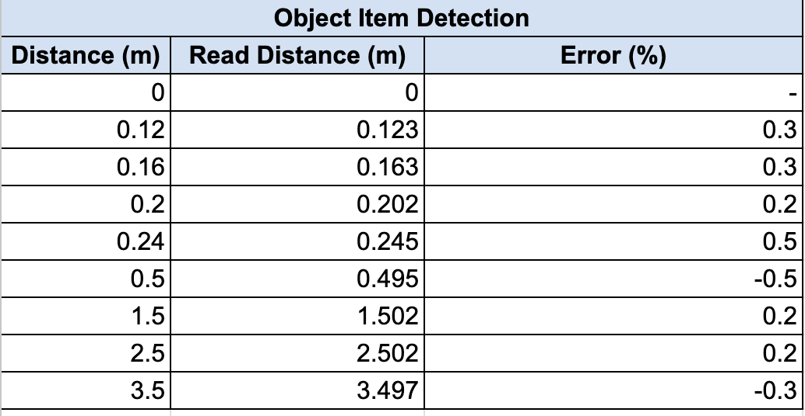
  - Analysis: Upon evaluating the data from the object item detection test, it was found that the objects were detected true to their positions within an error of 2 percent. This shows that the Lidar sensor accurately measured the distances to the various objects. This demonstrates that the Lidar sensor provides reliable performance in object detection. This test confirms the consistency in detecting objects within the specified distances. Also it further supports that the Lidar sensor is effective at accomplishing accurate object detection.

- Object Starting Distance Test
  - Results: The results of the object obstacle avoidance prove the feasibility of the Lidar sensor to avoid different colored objects. The results confirm the Lidar is capable of providing color accurate sensing capabilities.
Section #4 Figure #3: Object Obstacle Avoidance Test Results
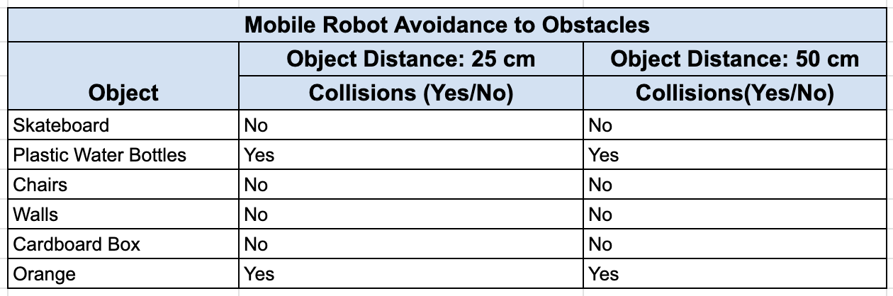
  - Analysis: Upon analysis of the data collected from the obstacle avoidance test. The robot collided with the plastic water bottle and the orange and avoided all other objects. The orange had a height of only 4.5 cm and did not meet the threshold of 9cm. The water bottle did not have a wrapper and was almost completely translucent. The observations made were that at the two distances of 1 meter and 2 meters the robot successfully avoided the obstacles that were not transparent and were tall enough to occupy the Lidar units line of sight. This proves the effectiveness of the obstacle avoidance mechanism based on the Lidar sensor. The consistent success in avoiding the different objects indicates the robot is capable of avoiding various types of objects in an environment.

- Object Color Detection
  - Results: The results of the experiment prove the feasibility of the Lidar sensor and proves the efficiency of the model chosen for future experiments.
Section #4 Figure #4: Object Color Detection Test Results
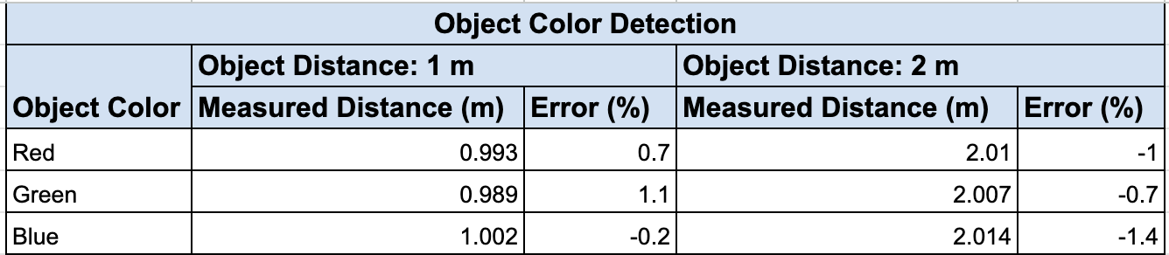
  - Analysis: Upon collecting the data for the object color detection test, it was determined that the Lidar sensor accurately detects various objects of varying colors. The objects of colors red, green, and blue were accurately measured at the distance of 1 meter and 2 meters. The overall error was within 2% as predicted. These results suggest the Lidar sensor can accurately identify and detect objects of varying colors. This test proves the perception capabilities of the robotic system.

* Architecture and High Level Design

* System Architecture and Design
The main directive of the robot is to self navigate an environment, search for and detect trash, then collect and sort the trash. In order to achieve this, the robot required a sufficiently powerful drive system with distance sensors, a sensor to perceive the environment for self-navigation and obstacle avoidance, a sensor for trash detection and identification, a manipulator to collect and sort the trash, and a strong chassis to support the components necessary for these functions. It also required a power source with large enough capacity for the robot to achieve its directives. These are the reasons why certain design choices were made.
For the drive system, encoded DC wheels were used for precise control and navigation. The wheels were equipped with digital encoders which provided feedback on the position of the wheel. The encoder feedback was necessary for implementing telemetry for the robot. The data from the encoder allowed the wheels to accurately measure the distance traveled. Additionally, the data provided by the encoded wheels integrated with ROS in order to allow the utilization of off the shelf implementations of SLAM. The wheels played a crucial role in the robot’s capabilities in terms of navigating complex areas without collisions.
The network module of the robot was configured for easy communication between the system and an external computer. The onboard Linux computer served as the central device which then connected to external remote devices using a travel router based network. The microcontroller used was equipped with onboard Wi-Fi allowing direct communication with the travel router. The network configuration used supported high data transfer which was essential for sensor data being processed.
A differential style drive system was chosen for several reasons beneficial to the project. Differential drive systems are commonly regarded as simple systems compared to four wheeled systems because steering is achieved with motor control alone. Differential drive systems consist of only two motors, which not only reduces material costs but also requires less programming logic to implement. Zero degree rotational movement about the z-axis with negligible x and y axis travel is easily achieved by driving one wheel forward and the other wheel backward. This ability allows the robot to navigate environments and avoid obstacles with less chance of collisions than a four wheeled system.
Lidar, short for “Light Detection and Ranging”, is a time-of-flight device which consists of a rotating disk that shoots lasers in a 360 degree pattern around the unit. Distance readings are calculated by measuring the time it takes for the laser beam to leave the unit, and then bounce off a reflective surface back to the Lidar. The distance data includes the angle it was shot from relative to the zero angle of the Lidar unit. A 360 degree Lidar sensor was concluded to be the best sensor choice for navigation and obstacle avoidance despite its high cost because it provides a wide field of view, high SNR, accurate distance readings, and requires only one unit to achieve its goal. Lidar distance readings would be used in the navigation and obstacle avoidance algorithms to judge the distance between the robot and environmental features.
To accurately navigate, SLAM algorithms were used in combination with the LiDAR and encoded wheels. This allowed the robot to navigate and map the environment effectively. SLAM allowed the system to construct a real time map of the environment while using telemetry data to maintain accurate positioning. ROS processed the data from the sensors using SLAM algorithms to generate a map which was later used to plan clear paths, perform maneuvers, and avoid obstacles. SLAM technology ensured the system was reliable and capable of operating in an autonomous manner.
The webcam is used as the hardware component to detect and identify trash. The webcam was chosen instead of an ultrasonic sensor because the webcam together with OpenCV can recognize what kind of object is in front of it. With an ultrasonic sensor, it can only detect if an object is in front of it, but not identify what it is. The system uses the webcam to distinguish two types of trash: compost and recyclables. An orange was chosen to signify compost and a plastic bottle for recyclables.
The robotic arm with its six servos is then used to pick up the trash after it has been detected and throw it into its designated trash bin located on the back of the chassis. The robotic arm was chosen because of its six degrees of freedom. The compost and recyclables have different dimensions so an arm with claws that have a wide range of movement is needed to grab the objects. Also, because of the limited space on top of the chassis, the trash bins are close to the robotic arm so a flexible arm is needed to throw the trash in the trash bins.
The robot required a power source that was wireless and had enough power and capacity for the ATPR to achieve its autonomous directives. Lithium-polymer, or LiPo, batteries were chosen due to their high current output and capacity. LiPo batteries are also inexpensive and readily available for purchase.
A full metal tank style chassis with treads was chosen because it not only operates on differential drive kinematics but also provides superior traction in various uneven environments compared to traditional rubber wheels. This additional traction would aid in carrying the heavy load of the components and trash collected.
The system is divided into two modules, which consist of individual components. The modules are referred to as the Tank Module, and the Arm Module. Each module interacts mainly with certain components specific to the module, but some components interact with both modules. The Arm Module receives image data from the camera for object detection. The DC motors only connect to the Arduino in the Tank Module. The Lidar unit interacts with both the Tank and Arm Module.

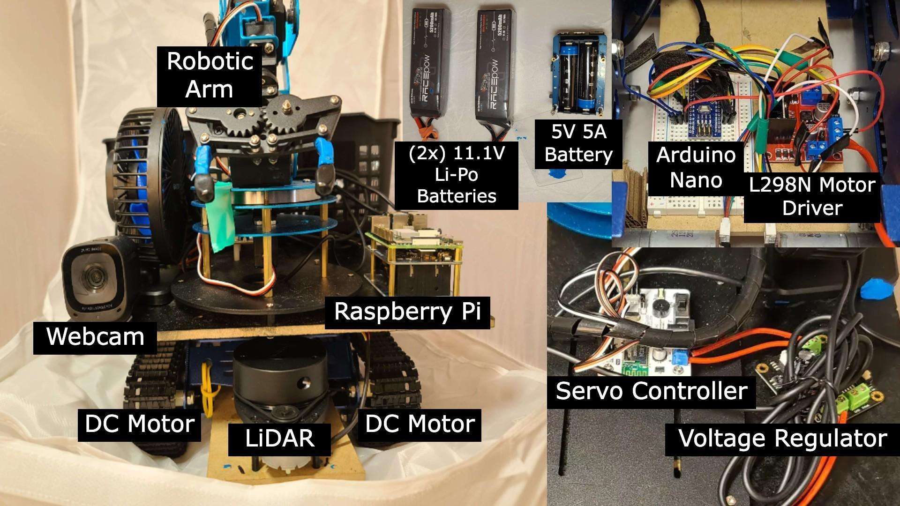
Figure 5.1 Autonomous Trash Picking Robot Components

Robotic Arm Module: Justin, Ryan
Tank Module: Hector, Kaisen

* Hardware Architecture
The hardware system consists of a RPI4 which serves as the main controller. Connected by USB to the RPI4 are the Arduino Nano, RPLidar A1 Lidar unit, servo controller, and Logitech C270 webcam. Connected to the Arduino is an L298N motor driver which serves as the hub between two parallel 11.1 V LiPo batteries and two DC encoded motors. The LewanSoul robotic arm is connected to the servo controller, which is connected to a DFRobot voltage regulator, which is connected to the LiPo batteries.
The RPLidar A1 unit is directly connected to the RPI4 by USB for direct data transfer. It is positioned on a wooden board protruding from the lower front of the tank. This was due to being the only available space in which the Lidar can have sufficient field of view while also being out of the way of the arm. It also was positioned low enough to detect short objects. The wooden board was modified in order to meet the dimensions required for the design.
The Arduino Nano serves as the microcontroller for the motor to decrease computational costs for the RPI4. As the Nano only has a current draw of between 20-30 mA this made it an ideal low power motor controller. The Arduino Nano calculates the encoder data from the DC motors. The L298N motor driver serves as the hub for the LiPo batteries and DC encoded motors before the connection to the Arduino Nano. The RPI4 sends velocity commands from the Arduino, then commands to the motor drive, which regulate the voltage and current from the batteries to the DC motors. The modularity of having a dedicated drive motor controller allowed the Arduino to handle the motor drive signals.
The Logitech C270 webcam is connected directly to the RPI4 by USB for fast and direct data transfer and processing.
The LewanSoul robotic arm is connected to a servo controller, which is connected to the DFRobot voltage regulator before the connection to the batteries because it operates at 7.4 V and the battery voltage needs to be reduced from 11.1 V.

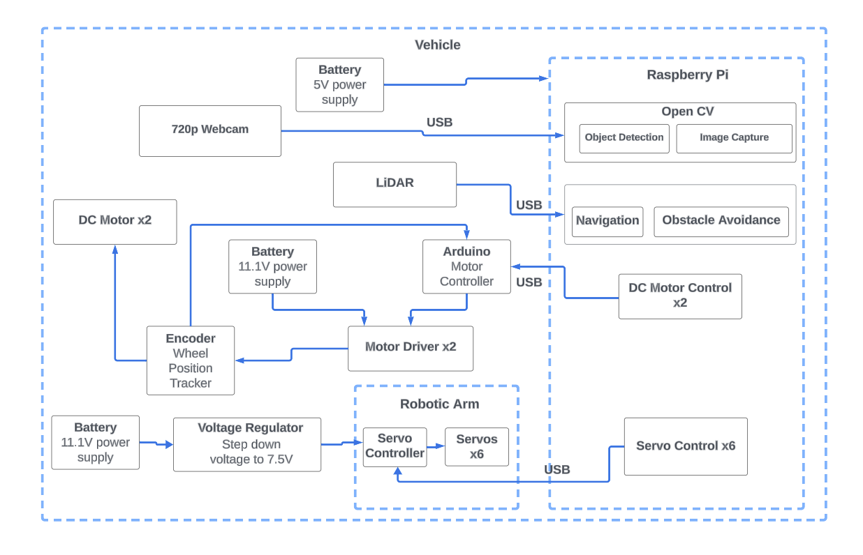
Figure 5.2 System Block Diagram of the Autonomous Trash Picking Robot

Distribution of Module Hardware Tasks
Object Detection/OpenCV/Webcam: Justin, Ryan
Battery/Power/Motors/Encoders: Kaisen, Hector
Obstacle Avoidance/Lidar: Justin, Hector, Kaisen
Robotic Arm: Justin, Ryan

* Software Architecture (only required if your design includes software)

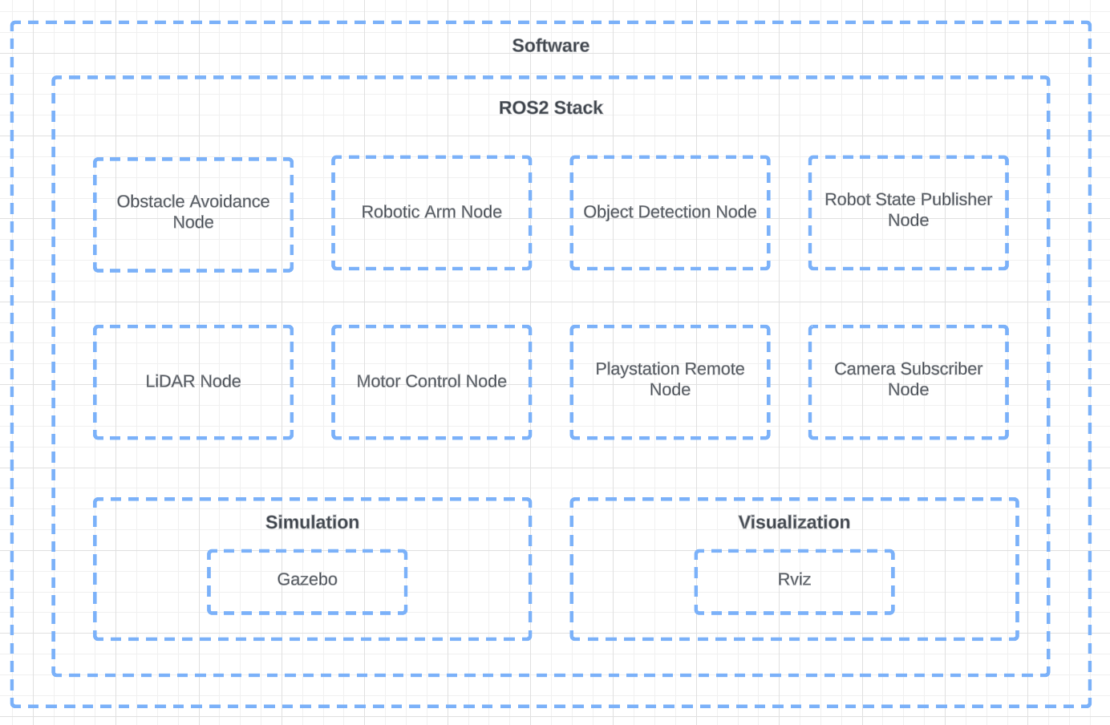
Figure 5.3 Software Architecture
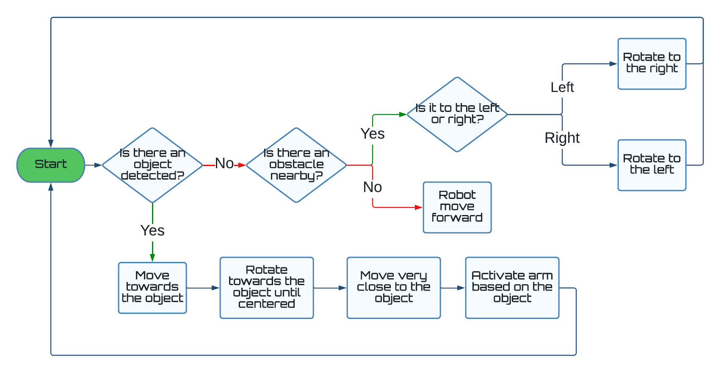
Figure 5.4 System Flow Chart

Distribution of Software Module Tasks:
Obstacle Avoidance Node: Justin, Kaisen
Robotic Arm Node: Justin, Ryan
Object Detection Node: Justin, Ryan
Playstation Remote Node: Justin, Kaisen
Camera Subscriber Node: Justin
Simulation and Visualization: Hector
Testing and Debugging: Hector

* Rationale and Alternatives
The architecture used for this system was chosen due to budget constraints and ease of system integration.
The sensors chosen were cheap and could be obtained from major online retailers in a timely manner. The webcam sensor was chosen due to its ability to provide high quality images for our machine learning application. Additionally the webcam provided modularity because any microcontroller with USB2.0/3.0 is compatible. An alternative to the webcam used was a raspberry pi camera however to enforce modularity the webcam was utilized.
The encoded drive actuator chosen provided precise control and sufficient torque at a low cost. The drive actuator was also easier to integrate with our software than other encoded motors. Additionally the wheels chosen were readily available and within a reasonable voltage range. An alternative solution was higher voltage motors but the increase in power needs was too great. Another potential solution were stepper motors. The reason stepper motors were avoided was due to space constraints from the tank chassis. The tank chassis chosen for the project used brushed dc motors therefore stepper motors would not have been compatible with our chassis.
The actuated robotic arm was chosen because it provided precise control while maintaining a small footprint on the system. Additionally the arm chosen provided 6 DOF functionality, affordability, and availability. An alternative option considered was a 3D printed robotic arm. The rationale behind this was to reduce the costs of the system. However an off-the-shelf arm was chosen to facilitate rapid development and a durable robot.
In terms of the software, the rationale behind choosing ROS was due to its messaging capabilities and modular design. The ease of hardware and software integration that ROS provided allowed us to develop the system faster.

* Low Level Design
The system has five main modules: the main controller, obstacle avoidance, motor control, object detection, and manipulator modules. The obstacle avoidance module maps out the environment and feeds this data to the main controller module. The main controller then directs the motor module on how to traverse around the obstacles. If the object identification module detects one of the trash, however, it sends this data to the main controller module, which then directs the motor module to go there instead. When the robot gets close enough, the manipulator module picks up the trash and deposits it to a trash bin located on the back of the vehicle.
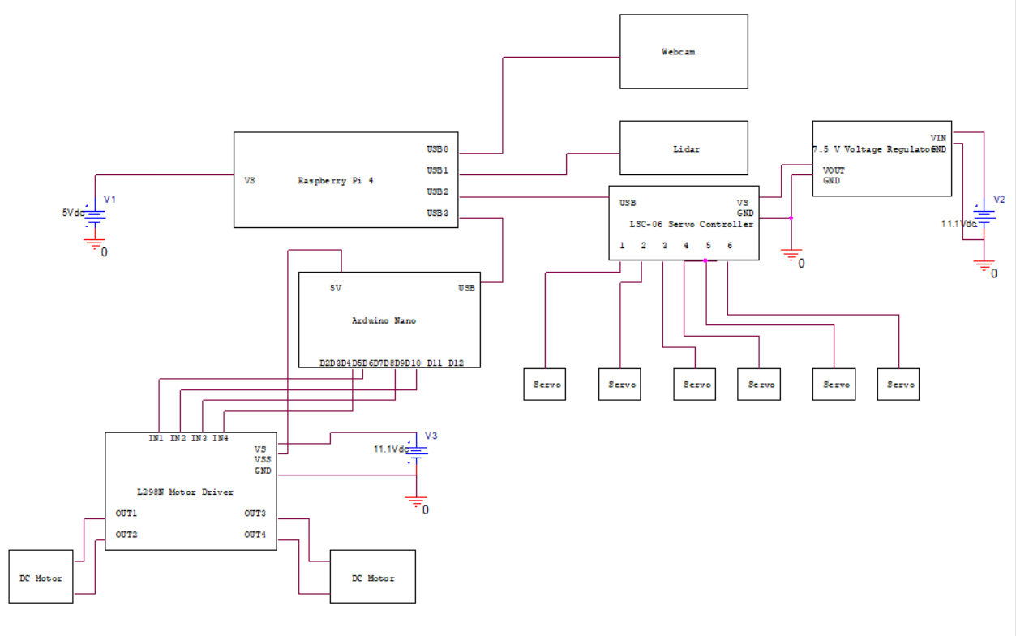
Figure 6.1 Schematic Diagram of the Autonomous Trash Picking Robot

Main Controller Module

Processing narrative for Main Controller Module
The Main Controller Module consists of a Raspberry Pi 4, which serves as the main controller for the system. It intakes input from the Arduino Nano from the Motor Control Module, the Logitech C270 webcam from the Object Identification Module, and RPLidar A1 Lidar scanner from the Obstacle Avoidance Module. It also outputs manipulator commands to the LSC-04 servo controller in the Manipulator Arm Module and outputs velocity commands to the Arduino Nano in the Motor Control Module. The Main Controller Module also runs Ubuntu Server Operating System with the various software used by the rest of the system.

Main Controller Module interface description
Inputs: The Main Controller Module through the Raspberry Pi 4 takes encoder data from the Arduino, image data from the webcam, and ranging data from the Lidar.
Outputs: The Main Controller Module outputs velocity commands from the Raspberry Pi 4 to the Arduino and servo controller.
Connectivity: All components are connected to the Raspberry Pi 4 by USB 2.0 or 3.0.

Main Controller processing details
Functionality: It is directly connected to all other modules and serves as the central processing hub. The Raspberry Pi 4 processes various types of data from different sensors and makes algorithmic decisions to achieve its autonomous objective.

Object Identification Module

Processing narrative for Object Identification Module
The Object identification module uses a camera to capture images of objects in front of it. These images are used as input for the Raspberry Pi. The OpenCV library and YOLOv3 algorithm are then used to identify whether the images contain either an orange or a plastic bottle.

Object Identification Module interface description
Inputs: The camera uses an image of what it sees as input
Outputs: Outputs [image data to the RPI4] object to monitor.
Connectivity: Camera to Raspberry Pi via USB

Object Identification Module processing details
Functionality: The Object Identification Module is used to identify two types of trash: compost and recyclables. If any of these types of trash are detected, the Raspberry Pi sends data to the robotic arm module for the robotic arm to pick these items up.

Obstacle Avoidance Module

Processing narrative for Obstacle Avoidance Module
The Obstacle Avoidance Module consists of an RPLidar A1 Lidar scanner, from which laser beams are fired outward from the origin in a 360 degree fashion. The laser beams collide with surfaces in the environment and are reflected back to the Lidar unit. The time from firing the laser to the time it is reflected back to the unit is measured. The distance between the Lidar unit and the reflected surface is calculated from the time of flight data. The distance measured and the angle from which it was measured are stored in an array and output to the Main Controller Module for further processing.

Obstacle Avoidance Module interface description
Inputs: The Obstacle Avoidance Module takes angle and distance data from the Lidar.
Outputs: The Obstacle Avoidance Module outputs an array of distance values and angles to the Raspberry Pi 4 in the Main Controller Module for further processing.
Connectivity: The Obstacle Avoidance Module is connected to the Main Controller Module through the Raspberry Pi 4 by USB 3.0 interface. It both transmits data to, and accepts power from, the RPI4.

Obstacle Avoidance Module processing details
Functionality: The Obstacle Avoidance Module grants the ATPR spatial awareness for autonomous movement without collision with environmental features. The Obstacle Avoidance Module sends distance and angle data of features to the Main Controller Module, which then sends velocity commands to the Motor Control Module.

Motor Control Module

Processing narrative for Motor Control Module
The Motor Control Module consists of an Arduino Nano, L298N motor driver, and two 12 V DC encoded motors. The two DC encoded motors are connected to the L298N motor driver by jumper pins, which is connected to the Arduino Nano also by pins. The Nano is connected to the Main Controller Module by USB to the Raspberry Pi 4. The Arduino receives encoder distance data from DC encoded motors and sends that data to the Raspberry Pi for processing. It also receives velocity commands from the Raspberry Pi, then translates and sends those commands back to the motor driver, which controls the velocity of the motors.

Motor Control Module interface description
Inputs: The Motor Control Module receives input velocity commands from the Raspberry Pi 4 in the Main Controller Module. The Motor Control module receives input encoder distance data from its DC encoded motors.
Outputs: The Motor Control Module sends output velocity command data to the L298N motor driver encoder distance data to the Raspberry Pi 4 in the Main Controller Module.
Connectivity: USB to Raspberry Pi

Motor Control processing details
Functionality: The Motor Control Module handles all the processing of commands and data related to the drive system. It translates velocity commands to physical translational or rotational movement of the ATPR’s differential drive system. There is no direct connection between the Motor Control Module and the Obstacle Avoidance Module, but the velocity commands the Motor Control Module receives from the Main Controller Module are based on data received from the Obstacle Avoidance Module.

Robotic Arm Module

Processing narrative for Robotic Arm Module
The Robotic Arm Module consists of a mechanical arm with a servo connected to each of the six joints allowing six degrees of movement. Each servo is connected to a servo controller for actuation and the controller is connected to the Raspberry Pi for input. When the robotic arm receives input from the Raspberry Pi, the robotic arm outputs the necessary movements to pick up the object.

Robotic Arm Module interface description
Inputs: A Raspberry Pi signal when one of the types of trash is detected.
Outputs: Commands to move the position and speed of the servos on the robotic arm.
Connectivity: Servos to servo controller then to the Raspberry Pi via USB

Robotic Arm processing details
Functionality: The Robotic Arm is used to pick up two types of trash: an orange for compost and a plastic bottle for recyclables. The Robotic Arm deposits these items into the designated trash bin located on the back of the robot. The Robotic Arm Module is used as the final output after the Object Identification module detects trash.

* Technical Problem Solving

In developing the robotic system, our team encountered and overcame various technical problems. The technical issues involved power management, network connectivity, and hardware operation. Most notably, we encountered operational issues when Justin was the arms grabbing functionality. The operational issue slowed down the development of the system and affected the precision of the robotic control. Additionally, we experienced network connectivity issues when establishing a stable SSH connection between our laptops and the microcontroller. In addition to connectivity problems, we also encountered power management issues which affected the robotic systems functionality and stability. The power management issues were a result of the system's excessive current draw. Through our team's collaboration we implemented solutions for each problem encountered. As a result we developed a robust and efficient system based on iterative design.

* The Arm Problem
While testing the object detection/OpenCV code with the robotic arm to pick up an object, Ryan discovered that the arm would attempt to pick up that object multiple times instead of just once everytime the system detects the object. The issue was caused by a bug in the code instructing the system to search for the object with no delay after the object has already been detected the first time causing the servos to receive multiple signals to pick up the object within a fraction of a second.

* Solving the Arm Problem
Justin solved this problem by implementing a two second delay after the system detects the object. This adjustment prevented the controller from sending multiple commands to the arm to pick up the object within a fraction of a second. As a result, the arm only performed one picking command when the object was detected.

* The WiFi Problem
The team encountered a series of problems when attempting to connect the microcontroller to the school’s Wi-Fi network. Establishing this connection was essential for the project, as it allowed access and control of the microcontroller via SSH from a laptop.

* Solving the Wifi Problem
In order to overcome this problem, the team edited the network configuration file on the microcontroller by updating the netplan file with the updated SSID and password. This approach was not successful in establishing a connection. As a result the team purchased a travel router in order to duplicate UCR’s WiFi network. This approach utilized a different SSID and password, and allowed multiple connections to be established with a set of credentials. The travel router allowed us to establish a network connection without the need for authentication.

7.5 * The Power Problem
A current draw problem between the Raspberry Pi 4 and its components that caused some features to malfunction was identified while testing navigation functionality. While the RPLidar unit, Arduino Nano, and webcam were connected and all functions were actuated, the wireless ssh connection between the development laptop and the Raspberry Pi 4 would become unstable and would eventually drop. Also, any activity in the terminal of the RPI4 would lag considerably and require a reboot of the entire system.

7.6 * Solving the Power Problem
Kaisen purchased a dedicated power source for the RPI that had an uninterruptible 5 V, 5 amp output. The power source ran on two 18650, 3.7 V, 2500 milliamp hour, high current drain batteries. This solved our power draw problem and all the components ran fine after. The power source, the Waveshare UPS Hat (B), also provided additional functionality by including a physical shut off switch and saving space as it connected directly to the bottom of the RPI through POGO pins.

* Test Plan

Three types of tests were performed during the design phase of the robot: one to evaluate how effectively the robot avoids obstacles, another to observe how accurately the robot detected trash it was designed to pick up, and finally a test that assessed how effectively the robot picked up trash and sorted it.

* Test Design
- Test 1: Does the robot effectively avoid obstacles?

- Objective: Since the Lidar sensor was positioned offset from the origin of the robot, the distance and angle from a detected object to the Lidar sensor changed when the robot rotated about the z-axis during execution of its obstacle avoidance algorithm. This caused the robot to move forward before rotating enough to successfully clear the obstacle. This resulted in a collision. The objective of this test was to measure the optimal distance, x, the robot should stop in front of an object to ensure no collisions during execution of its obstacle avoidance algorithm.

- Setup: Place the robotic system with the Lidar sensor in a position with a clear view of the testing space. The object is placed in front of the robot 2 meters away from the Lidar sensor. The obstacle avoidance algorithm will drive forward, detect the object, and stop at a distance, x, then rotate away from the object, then drive around to avoid the object.

- Procedure:
  - Position the object distance 2 meters away from the robot’s Lidar sensor.
  - Set stop distance in code for obstacle avoidance algorithm distance x.
  - Activate the obstacle avoidance algorithm.
  - Record avoidance success during obstacle encounter for distance x.
  - Repeat the procedure for various distances until a minimum optimal distance, Xp, is determined.

- Prediction: There will be a threshold distance determined which will provide optimal space for a successful rotation during obstacle avoidance. Once this distance is set the robot should avoid most stationary obstacles.

- Test 2: Does the robot effectively detect desired objects?

- Objective: The objective of this test was to evaluate the accuracy of the object detection algorithm and computer vision tool, OpenCV. The computer vision tool is to be tested for its capability in identifying an orange and a plastic bottle. The test will be using different shapes of plastic bottles and oranges, and placing these objects at various locations in front of the camera to evaluate how well these items are identified.

- Setup: Place the camera at a fixed position on top of the robot and centered in the front.
- Procedure:
- Place an object that the robot is supposed to detect – bottles and oranges – in front of the camera.
- Check if the robot is able to detect it.
- If the robot detects it, add a 1 to the number of times it detects the object correctly.
- If the robot does not detect it, add a 1 to the number of times the robot incorrectly detects the object.
- Repeat a-d 10 times for each object.
D. Prediction: The system has an accuracy of 80% or greater in detecting the bottles and oranges. The objects of interest can be detected as long as they are within the frame of the camera.

- Test 3: Does the robot effectively pick up and sort trash?

- Objective: Measure how accurately the robot can pick up and deliver objects to the bin. Another objective is to test the robotic arm positioning during the pick up and sort procedure to ensure proper clearance from collisions.

- Setup: Place the robot in front of a bottle/orange and start the robot obstacle avoidance.

- Procedure:
  - Place an object that the robot is supposed to detect – bottles and oranges – in front of the camera.
  - Check if the robot is able to detect it.
  - Watch the robot try and pick up the object.
  - For every time the robot can accurately pick up the object and deliver it to the bin, add a point.
  - Repeat a-d 10 times for each object.

- Prediction: The robot has more than 50% accuracy in picking up trash. The objects collected may not land properly within the designated containers.

* Bug Tracking
A database will be used to track defects found while performing the test cases. All defects will be logged as they are discovered. Defects will be assigned to Person A to fix, or to Person B to investigate.

* Quality Control
The completed test cases will be reviewed to ensure that all cases were run; that all were completed successfully; and that any deviations from the test cases were noted accordingly. Each step should be marked as Passed or Failed. Failed cases should be marked with the date and time of the failure, and the associated test track number. When a failed case is fixed, the date and time of the retest should be noted

* Identification of critical components
Describe the components that are critical and demand particular attention during testing are identified.
- Lidar - For Test 1, the lidar is the critical component since the device measures the distances of surrounding objects and the test evaluates the optimal distance the robot should stop to avoid hitting these objects. Similarly for Test 3, the lidar is also a critical component since the robot has to stop a certain distance away from the object before picking the object up.

- Camera - For Test 2, the camera is the important component since the test requires images of the objects that the robot will identify and the camera is responsible for capturing these images for processing.

- Chassis Drive System and Robotic Arm with 6 servos - For Test 3, the robotic arm is another key component since the test evaluates how accurately the robot picks up trash and places these items into bins. The arm is the component that directly picks up these items.

* Items Not Tested by the Experiments

* Test Report
The results of the three tests are covered in this section. For Test 1, the minimum safe distance for the robot to avoid objects is 0.25 meters. For Test 2, the system was able to detect oranges at 80% accuracy and bottles at 70% accuracy. Finally for Test 3, the system demonstrated to have a low success rate of 40% in picking up objects and disposing them.

* Test 1 Obstacle Avoidance (Kaisen)

Stopping Distance x (meters) | Avoided First Run? | Avoided Second Run? | Avoided Third Run?
0.40 | yes | yes | yes
0.35 | yes | yes | yes
0.30 | yes | yes | yes
0.25 | yes | yes | yes
0.20 | no (rear of tank collision) | no (rear of tank collision) | no (rear of tank collision)
0.15 | no (rear of tank collision) | no (rear of tank collision) | no (rear of tank collision)
0.1 | no (rear of tank collision) | no (rear of tank collision) | no (rear of tank collision)

- Result: Collisions occurred for all stopping distances below 0.25 meters. No collisions occurred for distances above or equal to 0.25 meters. A second and third run of the test was done to confirm results. Further runs of the test were not needed.
- Takeaway: The analysis concludes that a minimum stopping distance of 0.25 meters, or 9.84 inches, was ideal to ensure successful rotations during obstacle avoidance.
- Adjustment: Adjustments were the varying of distance x itself.

* Test 2 Accuracy of Detecting Desired Object (Ryan)

Object | Correct | Incorrect
Bottle | 7 | 3
Orange | 8 | 2
- Result: 70% accuracy for bottle, 80% accuracy for orange.
- Takeaway: The orange is detected more accurately than the bottle.
- Adjustment: Lower the openCV confidence rating of the bottle, so that it is able to detect it easier.

* Test 3 Robotic Arm Collection (Justin)

Attempt | Success/Fail
#1 | no
#2 | yes
#3 | yes
#4 | no
#5 | no
#6 | no
#7 | yes
#8 | yes
#9 | no
#10 | no

- Result: 40% success rate out of 10 attempts. This result is not as expected. Very low success rate.
- Takeaway: Not the best success rate so we had to update the Lidar threshold values and make adjustments.
- Adjustment: Superglue the Lidar to the robot so it will stay in the same position. The robot collection was more accurate afterwards.

* Conclusion and Future Work

* Conclusion
The team completed the majority of the objectives for this project. The team was able to build a robot that is capable of navigating its environment autonomously using a lidar sensor, detect two types of trash using computer vision, collect them with a robotic arm, and deposit them into designated trash bins located on the back of the robot. However, two objectives that were not met is the robot being able to detect when the trash bins are full and emptying out the contents into a larger trash bin. Ryan was responsible for achieving this goal but was unable to complete it within the given time constraints due to the complexity of the task which involves a complex algorithm based on inverse kinematics.
During the process of building this robot, the team acquired valuable insights into the engineering design process, such as defining the problem, conducting research, brainstorming solutions, and testing. Additionally, the team gained various technical skills and knowledge in robotics such as the ROS2 framework, OpenCV for computer vision, and integrating hardware components. The team also enhanced soft skills including teamwork and time management.
Overall, the robot has proven to be capable in assisting humans with waste management. If the system goes into mass production, the quality of life for everybody will improve by making the environment cleaner and safer.
Ryan: I enhanced my ability to work with a team. In terms of technical skills, I learned OpenCV and ROS.
Justin: I learned that teamwork is not easy and requires everyone to be on the same page. I also learned ROS which I am pretty proud of. Opens up the door for future projects that have ROS.
Hector: Learned about hardware and software design and using open source libraries and the complexity of interfacing hardware and software.
Kaisen: Teamwork is essential to completion of goals. Sacrifice is essential to teamwork. Completing this project confirmed the significance of what I learned in school about electronic systems. It also proved that learning does not stop outside the classroom. I learned how to use ROS2 to build a functioning robotic system.

Future Work
In the future, the team plans to upgrade the main controller from a Raspberry Pi 4 to a Jetson Nano, so that the robot has more computational power. This will allow the robot to handle more faster and accurate object detection algorithms and tools such as PyTorch and Tensor Flow. Also, the robot will be able to process a larger data set to train the robot for identifying objects. Additionally, the team plans to make the robot more accurate in picking up objects by implementing an algorithm that allows the arm to pick up objects dynamically, instead of a fixed point.

* Acknowledgement
Articulated Robotics by Josh Newmans
Lots of useful tutorials on ROS, Lidar, motors, and Raspberry Pi
Link: https://articulatedrobotics.xyz/mobile-robot-full-list/

* References
Example Robot #1: https://www.youtube.com/watch?v=fR2VynbYyuk&ab_channel=WestonRobot
Example Robot #2: https://www.youtube.com/watch?v=0PN5dczy9tw&ab_channel=As_im_awan
Lewansoul Arm: https://xarm-lewansoul-ros.readthedocs.io/en/latest/user_guide/1_1_introduction.html
ROS2 Foxy: https://docs.ros.org/en/foxy/Installation.html
ROS2 Robot Tutorial: https://articulatedrobotics.xyz/mobile-robot-full-list/
YOLOv3: https://github.com/ultralytics/yolov3

* Appendices
Presents information that supplements the design specification, including:
* Appendix A: Parts List
- Raspberry Pi 4 Model B 8GB
- Arduino Nano
- 2 Racepow 11.1V 3S 5200mah LiPo Batteries
- Slamtec RPLidar A1
- Logitech C270 HD Webcam
- LewanSoul 6DOF Robotic Arm
- Hiwonder LSC-06 Servo Controller
- Xiaor Robot Chassis
- 2 Bemonoc 12V DC Motors with Encoders
- L298N Motor Driver
- DFRobot Voltage Regulator
- 4 USB Cables
- Jumper Wires
- Waveshare UPS Hat
- 2 18650 Batteries
- 2 10’’x 6.5’’x4.5’’ Baskets
- 20 6-32x3/4 in. Screws with Nuts
* Appendix B: Equipment
- Computer
- Phillips-Head Screwdriver
- Power Drill
- Multimeter
- Travel Router
- Soldering Iron
* Appendix C: Software List (URL to online drive or SVN server, with sharing set to Public. Can omit this appendix if your project didn’t involving writing a program)
- ROS2 Foxy Fitzroy
- Visual Studio Code
- Ubuntu 20.04
- Github repository: https://github.com/KLeong91/KHRJ---Senior-Design
Appendix D: Special Resources
Appendix E: User's Manual - If your design requires instructions for future use, here is the place to put that information.
Appendix F to Z: Whatever Else You Wish To Add; for instance, here, you may include detailed solution methods or derivations, which you need for your future review of this report or whoever else is interested to pursue this study. Some side drawings and print outs that are of value to people who will continue this work should be given herein. Some information about the vendors and how to locate parts for similar projects must be included herein. In other words, information that is important about the overall construction of the project should be given herein.)

