**实验三：顺序结构程序设计**

1. **目的要求**
2. 熟悉I/O流。
3. 进一步熟悉C语言的基本语句。
4. 熟悉顺序结构中语句的执行过程。
5. 能设计简单的顺序结构程序。
6. **上机实验**

上机题1：编写程序：输入任意3个整数，求他们的平均值。

# include <iostream.h>

# include <iomanip.h>

void main()

{

int num1, num2, num3;

float average;

cout<<"Please input three numbers:";

cin>>num1>>num2>>num3;

average = (num1 + num2 + num3)/3.0;

cout<<setiosflags(ios::fixed)<<setprecision(2)<<average<<endl;

}

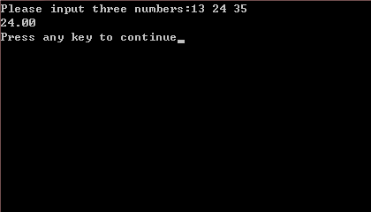编译运行结果：

上机题2：输入并运行以下程序（设将x赋值为5，y赋值为6， ch1赋值为’a’，ch2赋值为’b’，赋值为’c’)。

# include <iostream.h>

void main()

{

int x, y;

char ch1, ch2, ch3;

cin>>x>>y;

cout<<"x = "<<x<<","<<"y = "<<y<<endl;

cin>>ch1>>ch2>>ch3;

cout<<"ch1 = "<<ch1<<","<<"ch2 = "<<ch2<<","<<"ch3 = "<<ch3<<endl;

cout<<"ch1 = "<<(int)ch1<<","<<"ch2 = "<<(int)ch2<<","<<"ch3 = "<<(int)ch3<<endl;

}

编译运行结果：

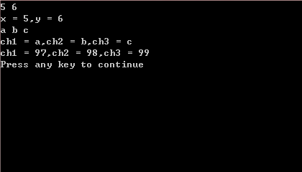

上机题3：输入并运行以下程序，分析运算结果。

# include <iostream.h>

# include <iomanip.h>

void main()

{

cout<<setiosflags(ios::right)

<<setw(5)<<"1"

<<setw(5)<<"2"

<<setw(5)<<"3"<<endl;

cout<<setiosflags(ios::left)

<<setw(5)<<"1"

<<setw(5)<<"2"

<<setw(5)<<"3"<<endl;

}

编译运行结果：

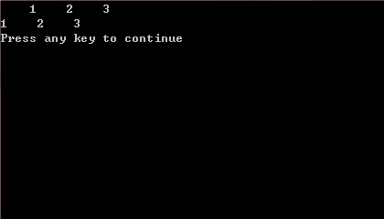

上机题4：输入并运行以下程序，分析运算结果。

# include <iostream.h>

# include <iomanip.h>

void main()

{

cout<<10<<" "<<-20<<endl;

cout<<setiosflags(ios::showpos)

<<10<<" "<<-20<<endl;

}

编译运行结果：

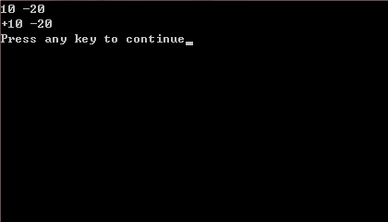

上机题5：输入并运行以下程序，分析运算结果。

# include <iostream.h>

# include <iomanip.h>

void main()

{

cout<<10.0/5<<endl;

cout<<setiosflags(ios::showpoint)

<<10.0/5<<endl;

}

编译运行结果：

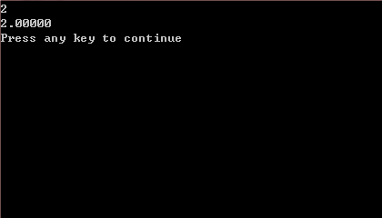

上机题6：编程实现：从键盘输入圆半径，求圆的周长和面积。 请将空白处补充完整。

# include <iostream.h>

# include <iomanip.h>

void main()

{

float r, l, s, pi;

cin>>r;

pi = 3.14159;

l = 2 * pi * r;

s = r * r * pi;

cout<<setiosflags(ios::fixed)<<setprecision(4)<<"l = "<<setw(8)<<l<<endl;

cout<<setiosflags(ios::fixed)<<setprecision(4)<<"s = "<<setw(8)<<s<<endl;

}

编译运行结果：

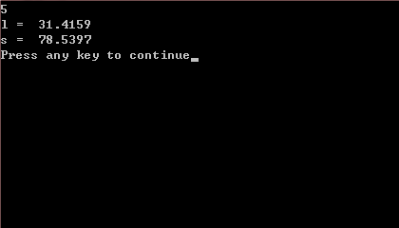

上机题7：编程实现：从键盘输入2个变量的值，其中a=5,b=6， 然后将2个变量的值进行交换，使得a=6,b=5。

# include <iostream.h>

# include <iomanip.h>

void main()

{

int a, b, t;

cout<<"Enter a b:";

cin>>a>>b;

t = a;

a = b;

b = t;

cout<<"a = "<<a<<","<<"b = "<<b<<endl;

}

修改后：

# include <iostream.h>

void main()

{

int a, b, t;

cout<<"Enter a b:";

cin>>a>>b;

a = a + b;

b = a - b;

a = a - b;

cout<<"a = "<<a<<","<<"b = "<<b<<endl;

}

编译运行结果：

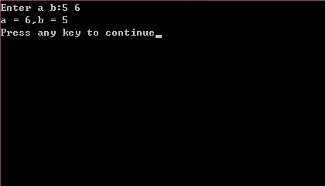

1. **小结**

没有