**19. Remove Nth Node From End of List**

Question

Given a linked list, remove the *n*th node from the end of list and return its head.

For example,

Given linked list: **1->2->3->4->5**, and ***n* = 2**.

After removing the second node from the end, the linked list becomes **1->2->3->5**.

**Note:**  
Given *n* will always be valid.  
Try to do this in one pass.

**Quick Navigation**

* [Summary](https://leetcode.com/articles/remove-nth-node-end-list/#summary)
* [Solution](https://leetcode.com/articles/remove-nth-node-end-list/#solution)
  + [Approach #1 (Two pass algorithm)](https://leetcode.com/articles/remove-nth-node-end-list/#approach-1-two-pass-algorithm)
  + [Approach #2 (One pass algorithm)](https://leetcode.com/articles/remove-nth-node-end-list/#approach-2-one-pass-algorithm)

**Summary**

This article is for beginners. It introduces the following idea: Linked List traversal and removal of nth element from the end.

**Solution**

**Approach #1 (Two pass algorithm)**

**Intuition**

We notice that the problem could be simply reduced to another one : Remove the (L−n+1)(L - n + 1)(L−n+1) th node from the beginning in the list , where LLL is the list length. This problem is easy to solve once we found list length LLL.

**Algorithm**

First we will add an auxiliary "dummy" node, which points to the list head. The "dummy" node is used to simplify some corner cases such as a list with only one node, or removing the head of the list. On the first pass, we find the list length LLL. Then we set a pointer to the dummy node and start to move it through the list till it comes to the (L−n)(L - n)(L−n) th node. We relink next pointer of the (L−n)(L - n)(L−n) th node to the (L−n+2)(L - n + 2)(L−n+2) th node and we are done.

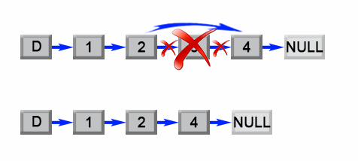

*Figure 1. Remove the L - n + 1 th element from a list.*

**Java**

**public** ListNode **removeNthFromEnd(**ListNode head**,** **int** n**)** **{**

ListNode dummy **=** **new** ListNode**(**0**);**

dummy**.**next **=** head**;**

**int** length **=** 0**;**

ListNode first **=** head**;**

**while** **(**first **!=** **null)** **{**

length**++;**

first **=** first**.**next**;**

**}**

length **-=** n**;**

first **=** dummy**;**

**while** **(**length **>** 0**)** **{**

length**--;**

first **=** first**.**next**;**

**}**

first**.**next **=** first**.**next**.**next**;**

**return** dummy**.**next**;**

**}**

**Complexity Analysis**

* Time complexity : O(L)O(L)O(L).

The algorithm makes two traversal of the list, first to calculate list length LLL and second to find the (L−n)(L - n)(L−n) th node. There are 2L−n2L-n2L−n operations and time complexity is O(L)O(L)O(L).

* Space complexity : O(1)O(1)O(1). We only used constant extra space.

**Approach #2 (One pass algorithm)**

**Algorithm**

The above algorithm could be optimized to one pass. Instead of one pointer, we could use two pointers. The first pointer advances the list by n+1n+1n+1 steps from the beginning, while the second pointer starts from the beginning of the list. Now, both pointers are exactly separated by nnn nodes apart. We maintain this constant gap by advancing both pointers together until the first pointer arrives past the last node. The second pointer will be pointing at the nnnth node counting from the last. We relink the next pointer of the node referenced by the second pointer to point to the node's next next node.

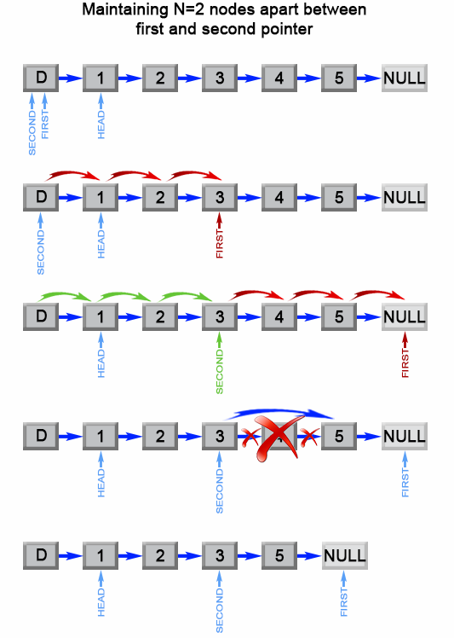

*Figure 2. Remove the nth element from end of a list.*

**Java**

**public** ListNode **removeNthFromEnd(**ListNode head**,** **int** n**)** **{**

ListNode dummy **=** **new** ListNode**(**0**);**

dummy**.**next **=** head**;**

ListNode first **=** dummy**;**

ListNode second **=** dummy**;**

*// Advances first pointer so that the gap between first and second is n nodes apart*

**for** **(int** i **=** 1**;** i **<=** n **+** 1**;** i**++)** **{**

first **=** first**.**next**;**

**}**

*// Move first to the end, maintaining the gap*

**while** **(**first **!=** **null)** **{**

first **=** first**.**next**;**

second **=** second**.**next**;**

**}**

second**.**next **=** second**.**next**.**next**;**

**return** dummy**.**next**;**

**}**

**Complexity Analysis**

* Time complexity : O(L)O(L)O(L). The algorithm makes one traversal of the list of LLL nodes. Therefore time complexity is O(L)O(L)O(L).
* Space complexity : O(1)O(1)O(1). We only used constant extra space.