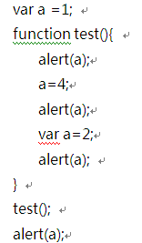

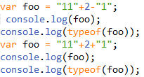

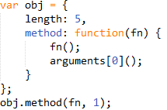

**var a = 10;**

**a.pro = 10;**

**console.log(a.pro + a);**

**var s = “hello”;**

**s.pro = 'world';**

**console.log(s.pro + s);**

**var length = 2;**

**function fn() {**

**console.log(this.length);**

**}**

**var obj = {**

**length: 5,**

**method: function(fn) {**

**fn();**

**arguments[0]();**

**}**

**};**

**obj.method(fn,1,2,3);**

function show(){

console.log(this);

}

var arr=[1,2,3];

arr.a=show;

setTimeout(arr.a,100)//?

arr.a();//?

var fn1=arr.a;

oDiv.onclick=function(){

arr.a();//?

fn1();//?

}