3D modelling in architectural design
  - Inquiry Learning Report Template
Student Name: _____________
Date: ______________________
Pre-reading
Before a product is manufactured or a building goes under construction, designers, engineers and architects often construct digital 3D models to analyse its dimensions, volume, surface area and other geometric properties. Computer programs such as AutoCAD and Blender are widely used to model and analyse real-world 3D objects.
In this task, you will investigate the geometry of standard cube with the help of a modelling tool “Tiny CAD” (link) to visualise points, lines, triangles and their positions in 3D space. You can rotate and zoom in/out to explore the 3D geometry from different angles. In this tool, two types of commands are available to draw points and lines by specifying Cartesian coordinates and colour (or black by default):
Point (3,4,5) red
Line (0,0,1) to (0,1,0) blue
Commands for drawing four vertices (0,0,0), (1,0,0), (0,1,0), (0,0,1) and 3 edges of the cube are already provided as a scaffold. Complete the following items in this task and record the response in the worksheet (this document!) either in writing or by editing this worksheet as a Word document.
You will be assessed on:
- Correct understanding of geometric concepts and proficiency in using coordinate methods in modelling and analysis
- Mathematical reasoning and justification
- Systematic investigation and the ability to extend beyond obvious examples
- Communication of mathematical ideas and results
- Application of mathematical findings to design recommendation

Tasks
- Use “TinyCAD” and syntax mentioned above to complete the cube by adding appropriate points and lines
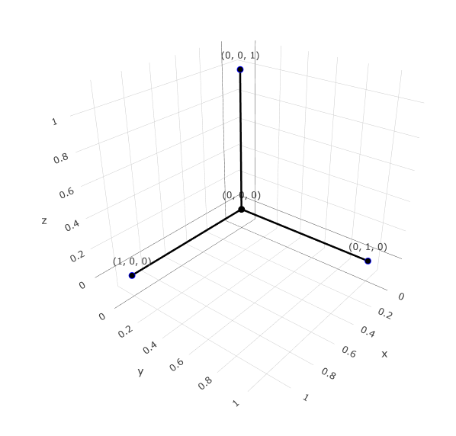
Fill in the blank:
There are ____ vertices, ____ edges, ____ faces in a cube.

The coordinates of the other vertices are: ______________________________________
_____________________________________________________________________________
The command I used to draw all the edges are:
_____________________________________________________________________________
_____________________________________________________________________________
_____________________________________________________________________________
_____________________________________________________________________________
_____________________________________________________________________________
_____________________________________________________________________________
_____________________________________________________________________________
_____________________________________________________________________________
_____________________________________________________________________________
_____________________________________________________________________________
_____________________________________________________________________________
- Organise the vertices into groups according to their distances to the origin (0,0,0)
Include exact value for distance, no calculator!
Here are some surds to help you save time from having to edit and insert formulas:
$\sqrt{2}$, $\sqrt{3}$, $\sqrt{5}$, $\sqrt{6}$, $\sqrt{7}$, $\sqrt{10}$, these should be more than enough for you.

Group # | List of vertex coordinates | Distance to (0,0,0)
1 | (0,0,0) | 0
2
3

There are in total ____ groups

- How many different triangles can you make with vertices of the cube? Draw all of them!
- label all side lengths and angles in exact value (no calculators!)
- label coordinates (in space) of all vertices
- only draw a new triangle if it is not congruent to the one you already have

I found a total of _____ such triangles up to congruence (i.e., if two or more triangles are congruent, we count them only once)

Use TinyCAD to help visualise the triangle

Example:
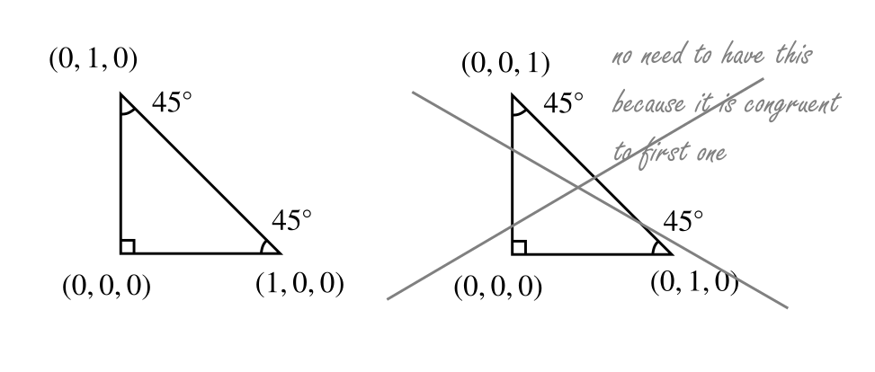

Do you think you found all such triangles up to congruence? Why or why not? Offer your reasoning:
__________________________________________________________________________
__________________________________________________________________________
__________________________________________________________________________
__________________________________________________________________________
__________________________________________________________________________
__________________________________________________________________________
__________________________________________________________________________
__________________________________________________________________________
__________________________________________________________________________
__________________________________________________________________________
__________________________________________________________________________
__________________________________________________________________________

- What shapes (i.e., cross sections) can result by intersecting the cube with a plane? List as many shapes as you can and provide your reason (you may wish to use coordinates of points on edges of the cube that are also on the plane, use TinyCAD to help visualise):
Squares,___________________________________________________________
___________________________________________________________________
___________________________________________________________________

After further exploration, you may wish to return and revise your list.

Let’s explore one such cross section:
- Describe the shape made by the set of points in space at equal distances to (0,0,0) and to (1,1,1).
____________________________________________________________________
- Identify 6 edges whose midpoints have equal distances to (0,0,0) and to (1,1,1). Fill them in the following table
 | End point 1 coordinate | End point 2 coordinate
Edge 1
Edge 2
Edge 3
Edge 4
Edge 5
Edge 6
- Using TinyCAD, draw lines on the surface of the cube to connect these edge-midpoints.
- What shape did you get? ____________

List all cross-section shapes you found and have learned about below. Include information such as coordinates of the vertices of cross-section polygons and a screenshot of TinyCAD after you’ve created it. (You may also include code for me to reproduce the diagram)
__________________________________________________________________________
__________________________________________________________________________
__________________________________________________________________________
__________________________________________________________________________
__________________________________________________________________________
__________________________________________________________________________
__________________________________________________________________________
__________________________________________________________________________
__________________________________________________________________________
__________________________________________________________________________

- You are an architect commissioned to by art museum and you have decided to design a cube-shaped museum building by slicing the cube with a plane to create a large window. Recommend a cross-sectional design, justify your choice (you may wish to consider aesthetics, energy efficiency, structural stability etc.). Construct the 3D model using the modelling tool, provide sufficient information in your report to recreate the design and connect your justification to geometric measurements.

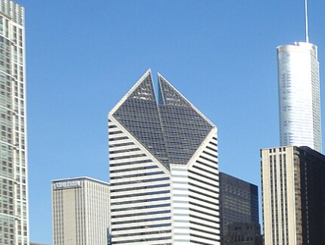
(An example of such a design in real life. Photo of Smurfit-Stone building in Chicago’s CBD from Wikimedia).

__________________________________________________________________________
__________________________________________________________________________
__________________________________________________________________________
__________________________________________________________________________
__________________________________________________________________________
__________________________________________________________________________
__________________________________________________________________________
__________________________________________________________________________
__________________________________________________________________________
__________________________________________________________________________
__________________________________________________________________________
__________________________________________________________________________
__________________________________________________________________________
__________________________________________________________________________
__________________________________________________________________________
__________________________________________________________________________
__________________________________________________________________________
__________________________________________________________________________
__________________________________________________________________________
__________________________________________________________________________
__________________________________________________________________________

