# LampytV0.1 Operation Quick Check

Lampyt is a compact tool software. Lampyt can load data files (any type) into payment files at the issuer, commonly known as file boxing; The recipient retrieves the data file based on whether to pay, commonly known as file boxing. Payment files can be transmitted through any channel using blockchain encryption technology.

LampytV0.1 version supports Xna neurai blockchain coins.

Cooperation hotline: Xna@lampyt.com

## 1. Document packing

Step 1: Select the file you want to package;

Step 2: Click on file packing;

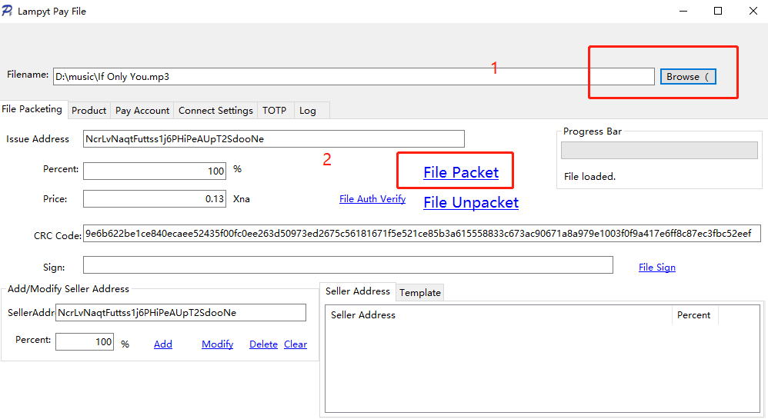

After packing, generate a payment file with a suffix named. xna, located in the same directory as the original data file:

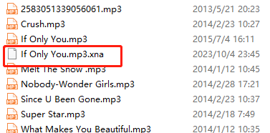

Now you can send the "If Only You. mp3. xna" file to others. If others want to know the content, they must perform a "file unboxing" to obtain it.

## 2 Document unboxing

Step 1: Select the XNA payment file you want to package;

Step 2: Click on the file to open the box;

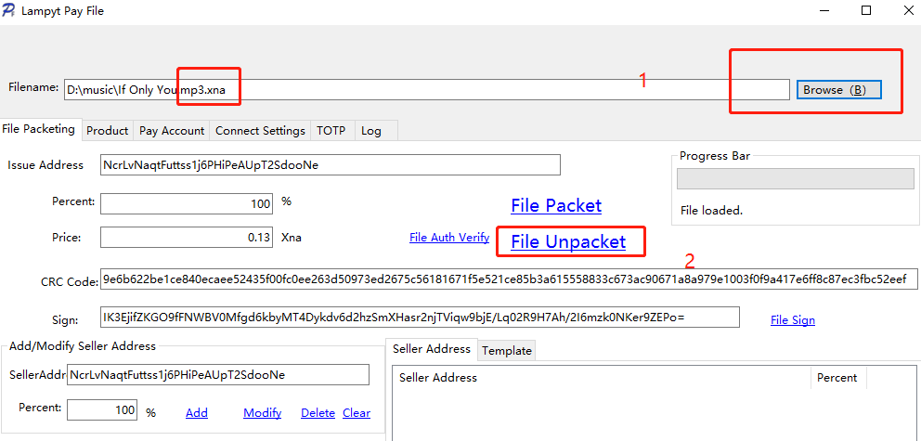

Step 3: Obtain the "If Only You. mp3" file from the same directory as the payment file.

## 3 Configuration Lampyt

To configure an RPC server, usually a neurai wallet, where the neurai wallet must be configured with: rpcallowip=0.0.0.0/0

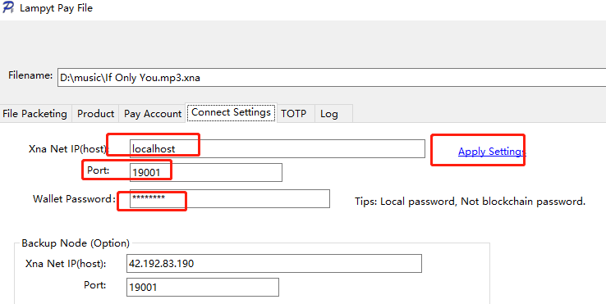

The password is a wallet password that can be modified at any time in the Neurai wallet.

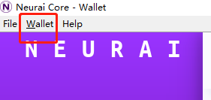

The following payment account addresses must be found in Neurai Wallet.

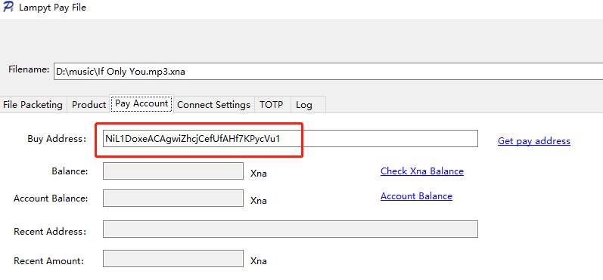

By default, the donation mode is enabled, with a rate of 1%. If you do not want to donate, simply set Donate to 0 in the Lampyt.ini file.