Assignment 2
  - CSS Grid and Flexbox
Alimzhan Almukhambetov
Group IT-2510
27 September 2026

About this assignment
This report covers a geometric composition, a library of five Flexbox components, and a reading journal with three layouts. The pages use HTML and CSS without Bootstrap, JavaScript, or media queries. The screenshots show the completed pages and the CSS rules that control their layout.

Source code
https://github.com/xnionn/Web2
The repository contains the pages, stylesheets, local illustrations, and screenshots. Open index.html, task2.html, or task3.html in a browser to view each task.

Files used in the report
Task | HTML | CSS
1 | index.html | task1.css
2 | task2.html | task2.css
3 | task3.html | task2.css and task3.css

Task 1 Geometric composition
Source files: index.html and task1.css
I divided the composition into six equal columns and six equal rows. Each rectangle occupies a range of grid lines; the blue block, for example, spans two columns and three rows. The black background shows through the gaps. Matching padding creates the outside edge. The square uses aspect-ratio: 1 and the smaller of 90vw and 90dvh, so it scales with the window and fits within the screen height.
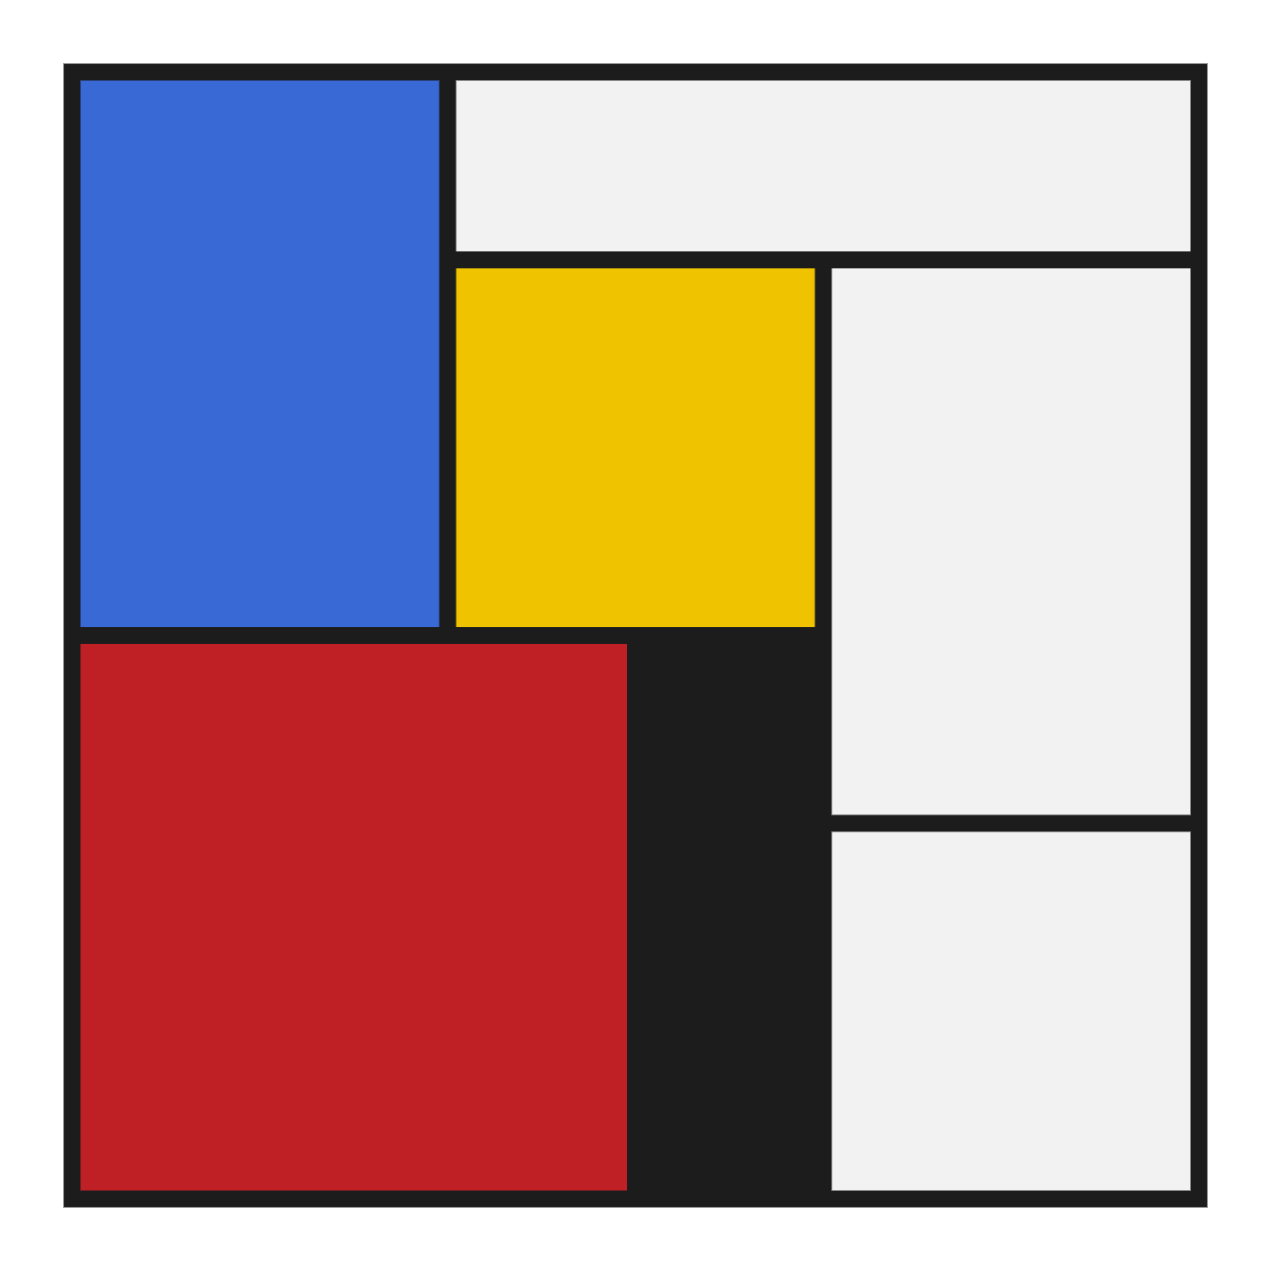
Figure 1. The finished square from index.html.
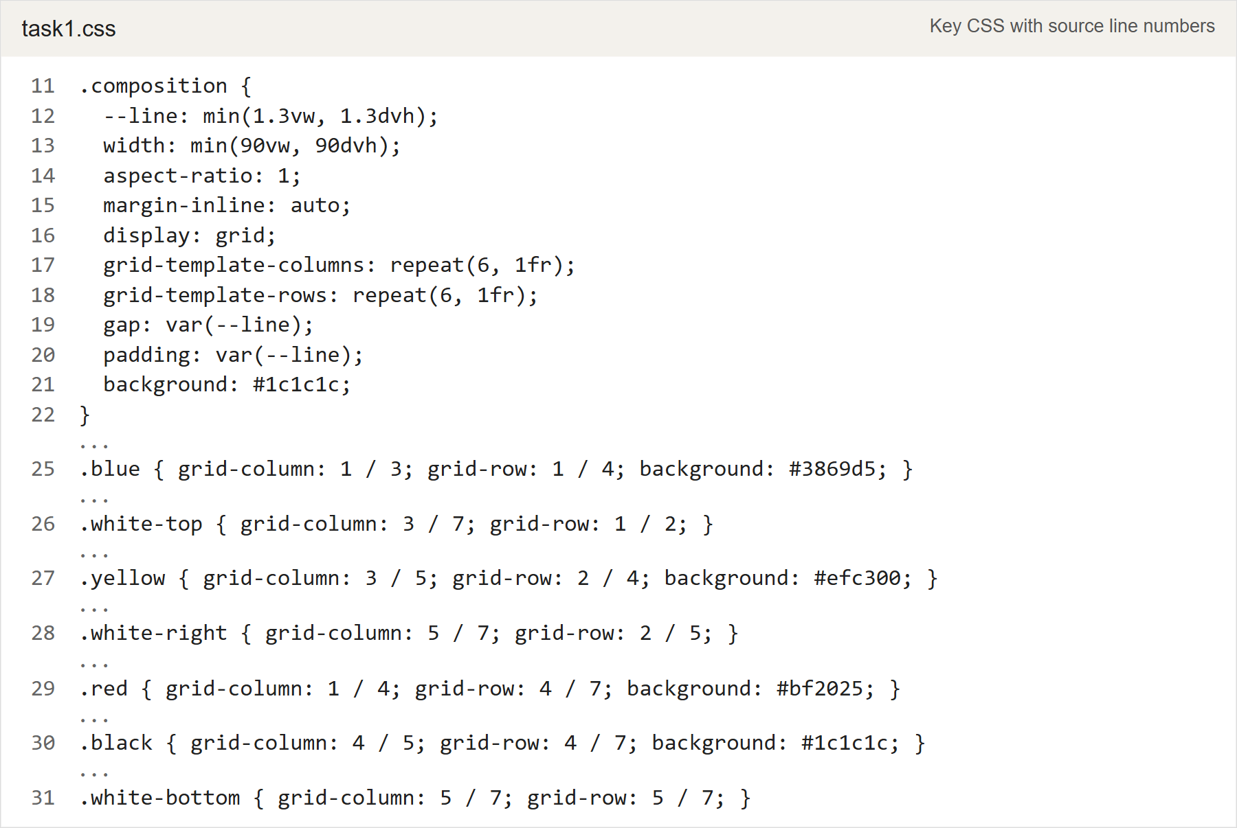
Figure 2. task1.css: the six by six grid and the placement of each block.

Task 2 Component library
Source files: task2.html and task2.css
I used a book club called Bookbound to give the five components a common subject. They share one stylesheet, with variables for colors and spacing and the same fonts throughout. All five components use Flexbox.

Navigation
The navigation bar can wrap. Its links take the available space, while margin-inline-start: auto keeps the action buttons at the right edge. When the groups need another line, the buttons still stay on the right.
Figure 3. The logo, links, and action buttons in task2.html.
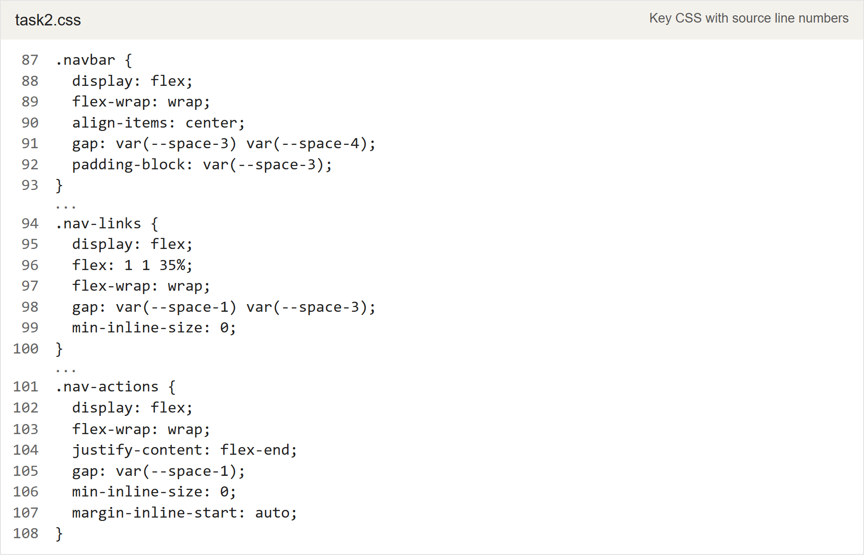
Figure 4. task2.css: wrapping links and automatic space before the action group.

Task 2 Cards
The book descriptions have different lengths, but Flexbox stretches the cards to the same height within each row. Each card is also a column flex container. I used margin-top: auto to push its button to the bottom. Matching labels and shared button styles keep the buttons the same height without setting a fixed height.
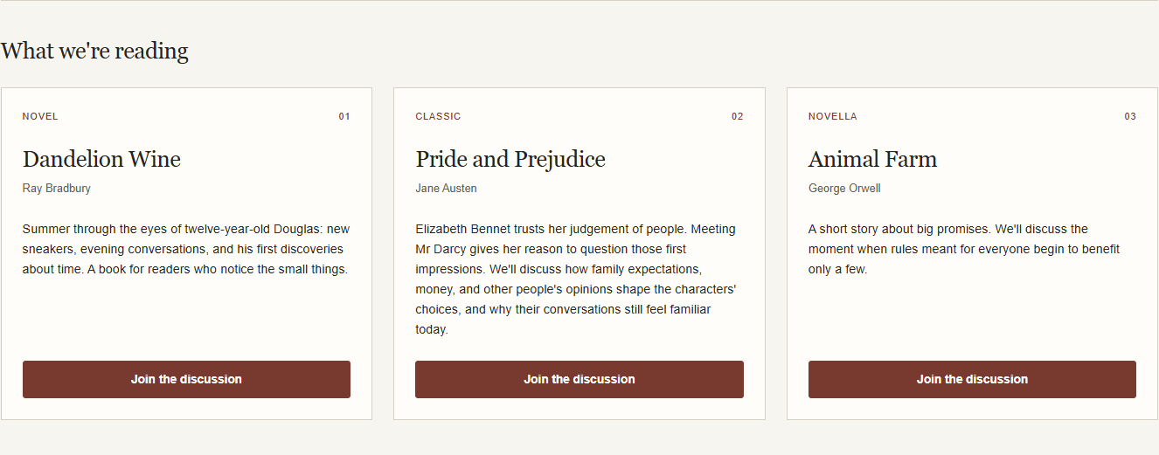
Figure 5. Three cards in task2.html with aligned buttons and different description lengths.
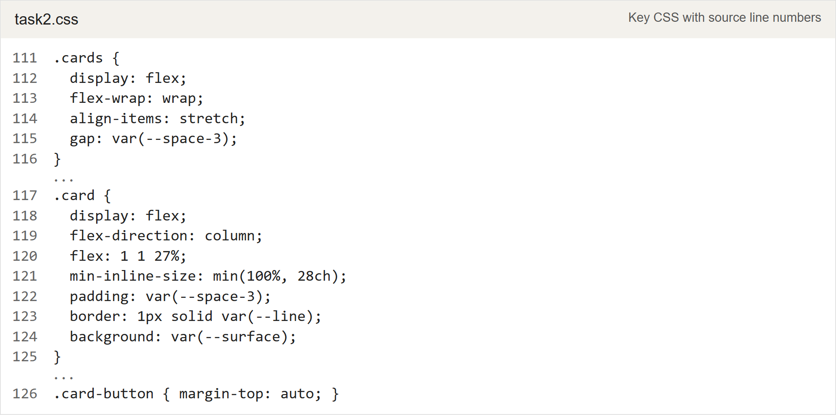
Figure 6. task2.css: equal heights within a row and space above each button.

Task 2 Pagination
I divided the bar into three equal flex areas: an empty balancing area, the page controls, and the result count. This keeps the page numbers centered across the whole bar while the count stays on the right. The areas wrap on narrow screens. The pagination is a static component example.
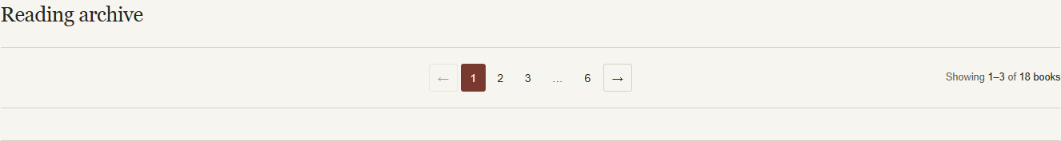
Figure 7. Centered page numbers, arrows on either side, and the result count at the right.
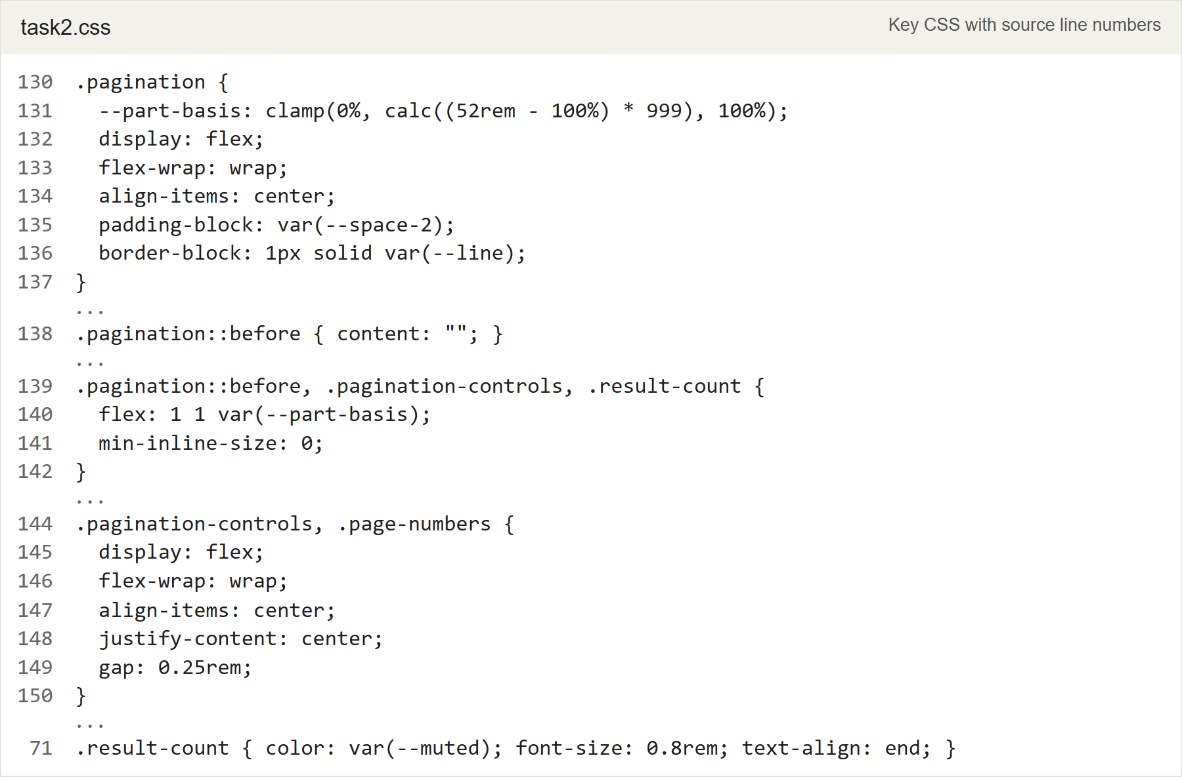
Figure 8. task2.css: balanced flex areas and wrapping pagination controls.

Task 2 Comment
The avatar and comment body are separate flex items. The avatar keeps its size, while the text column can shrink and wrap. Setting min-inline-size: 0 and allowing long words to wrap keeps the text beside the avatar, including on a narrow screen.
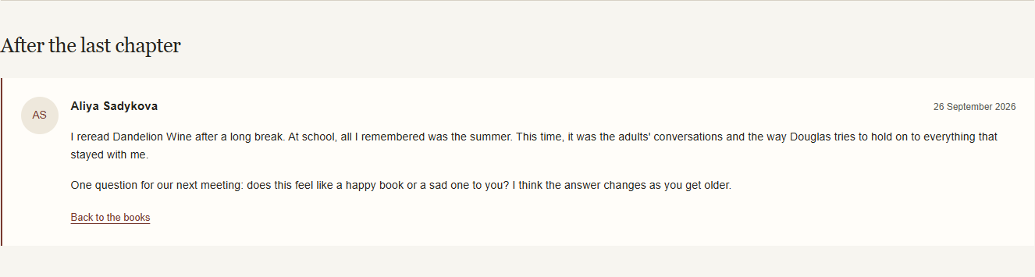
Figure 9. The comment in task2.html keeps its text in a separate column beside the avatar.
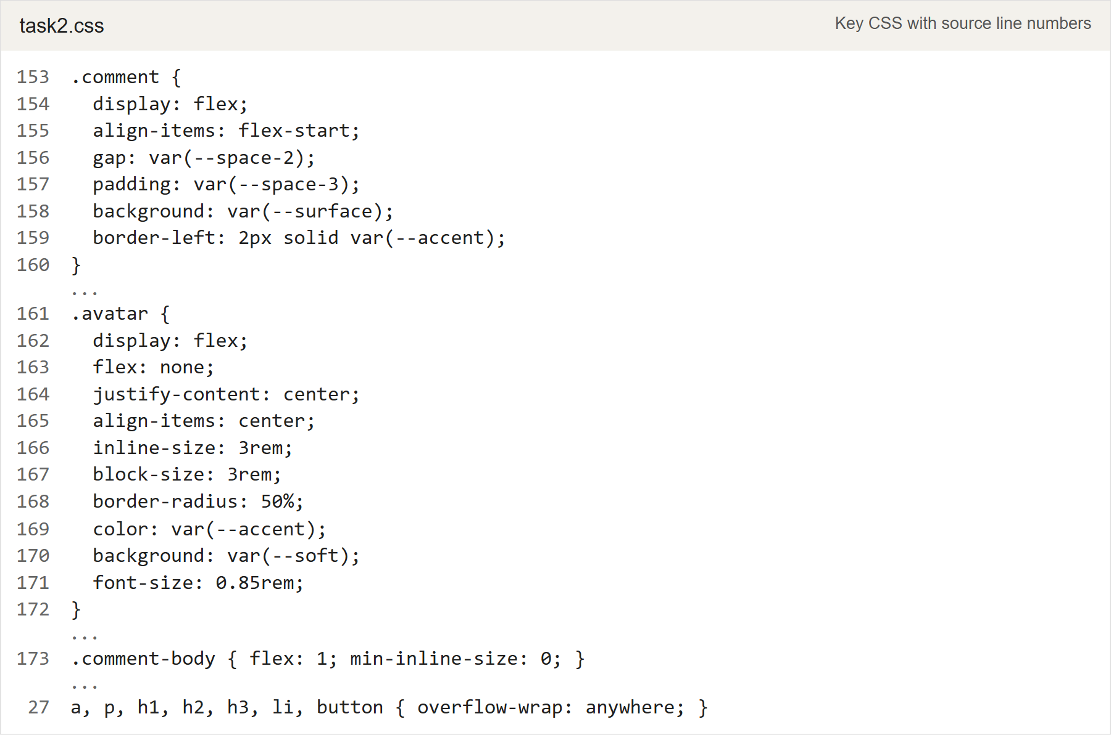
Figure 10. task2.css: a fixed avatar and a flexible text column.

Task 2 Pricing
The plans stretch within their flex row, and the content determines their height. The ordinary plans have vertical margins. The recommended plan has no vertical margin and uses more padding, which makes it taller than its neighbors in the same row without a fixed height.
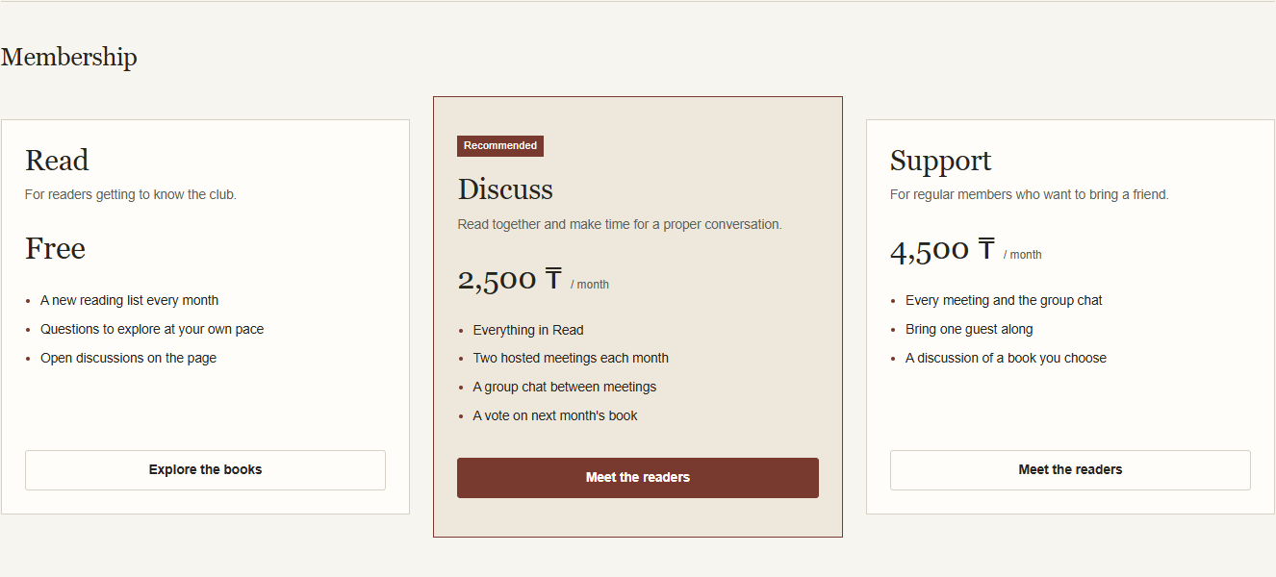
Figure 11. The recommended Discuss plan is taller than the adjacent plans.
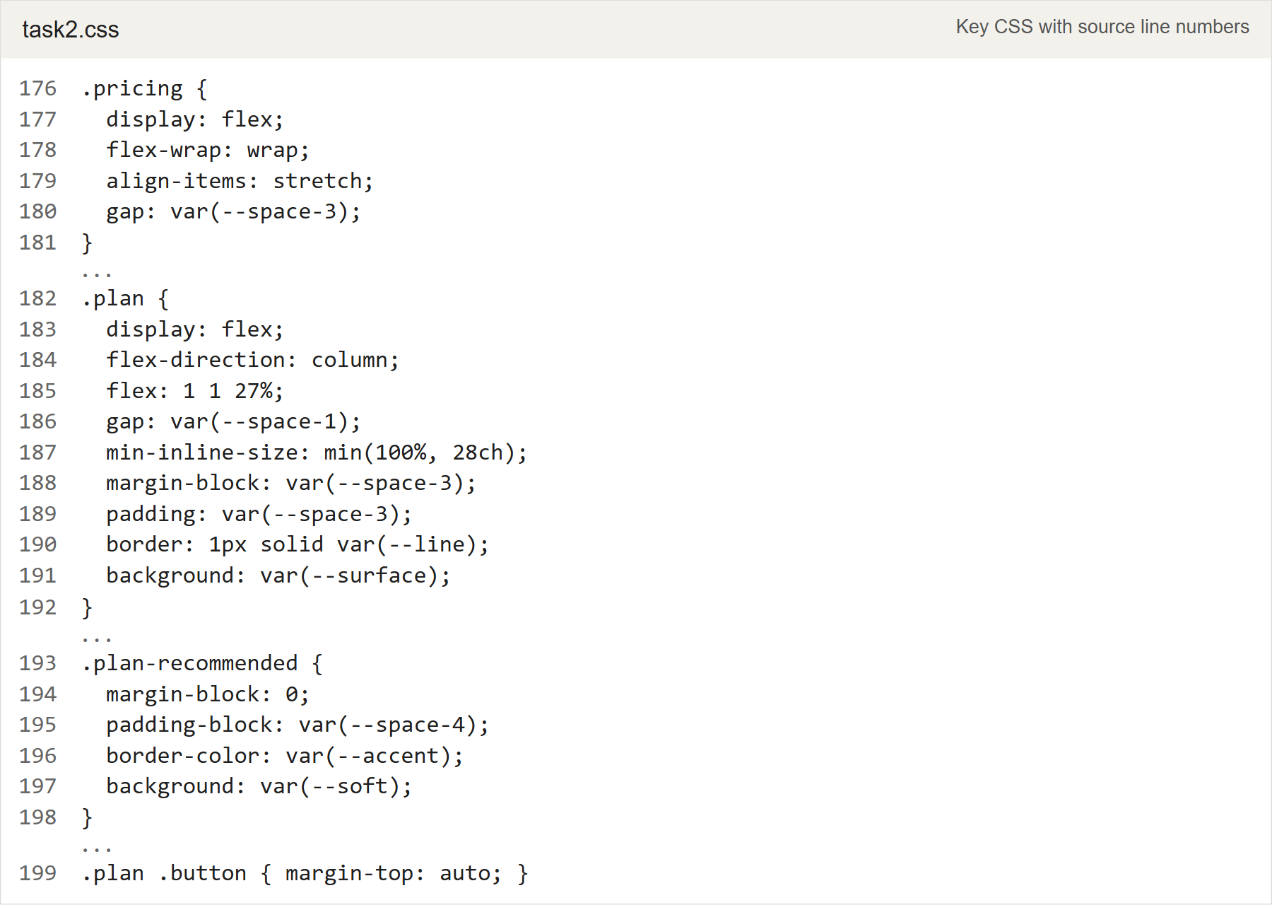
Figure 12. task2.css: content-based plan heights and the recommended plan.

Task 3 Grid layout
Source files: task3.html, task3.css, and the shared theme in task2.css
I placed twelve reading notes in one container. Changing its class to view-grid, view-list, or view-magazine changes the layout while keeping every article unchanged. The native radio controls provide an optional CSS preview; without a selected preview, the container class defines the view.
Grid uses auto-fit and minmax() to adjust the number of columns, while Flexbox arranges each card's contents vertically.
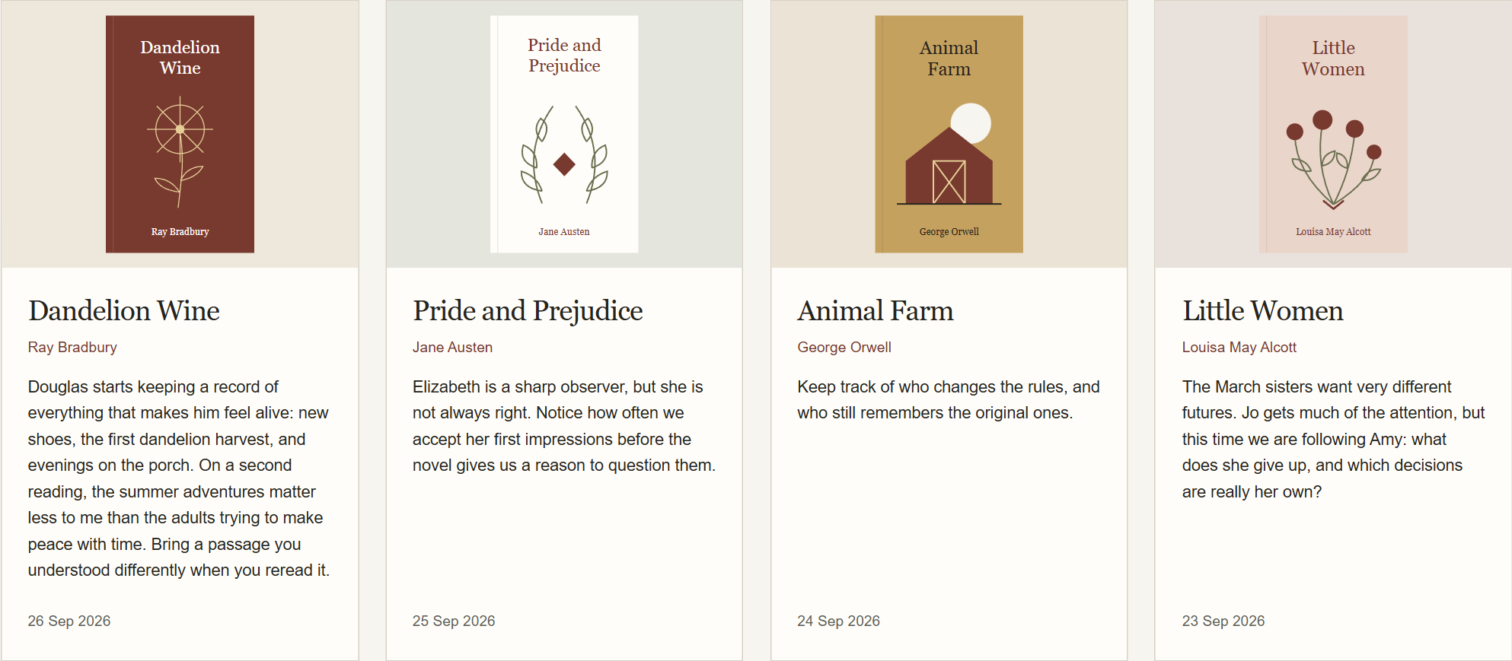
Figure 13. The first four of twelve reading notes in grid mode.
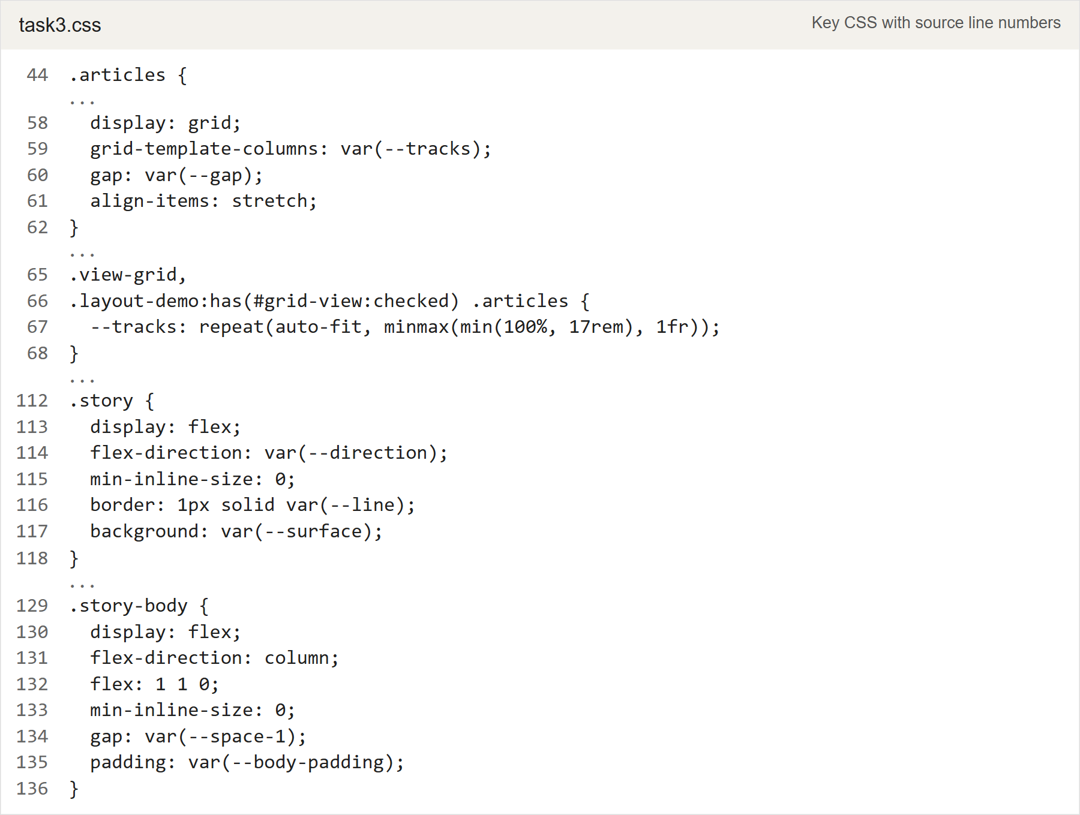
Figure 14. task3.css: responsive Grid tracks and Flexbox inside each article.

Task 3 List layout
Grid creates one column of articles, while Flexbox places the image, text, and date in a row with the date at the right edge. The text uses the remaining space between the image and date. It can shrink and wrap when the window becomes narrow.
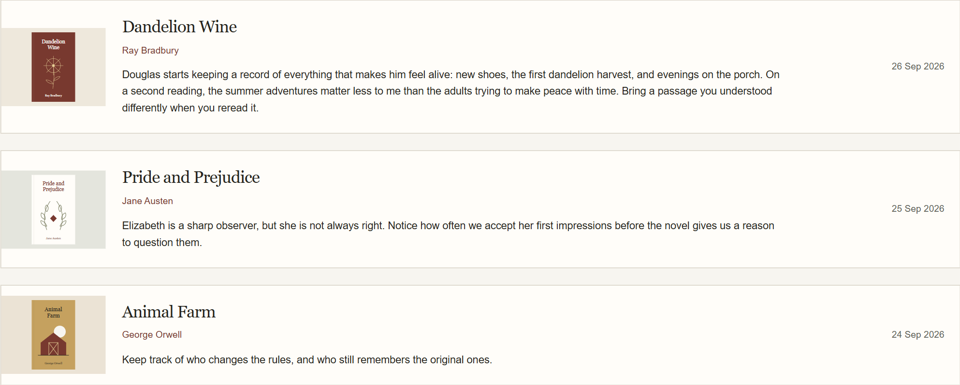
Figure 15. The first three notes in list mode using the same article markup.
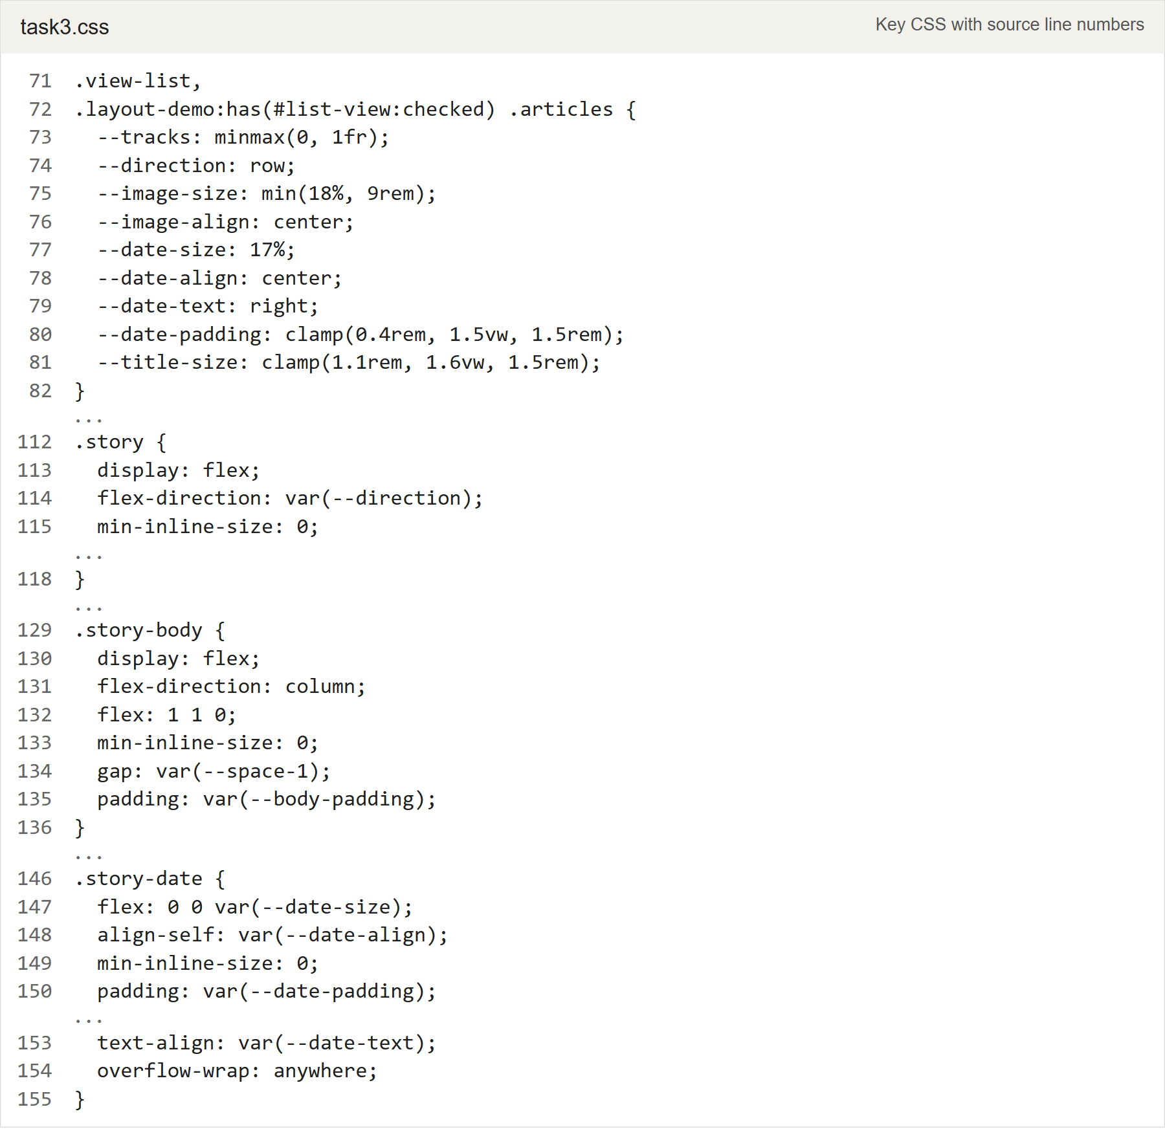
Figure 16. task3.css: a single Grid column and a flexible horizontal article.

Task 3 Magazine layout
Grid gives the lead article a two-column, two-row span, while Flexbox arranges the contents inside each article. The track minimum can shrink to half the available width minus half a gap. This leaves room for two columns even on a narrow screen, so the lead does not create an overflowing extra column.
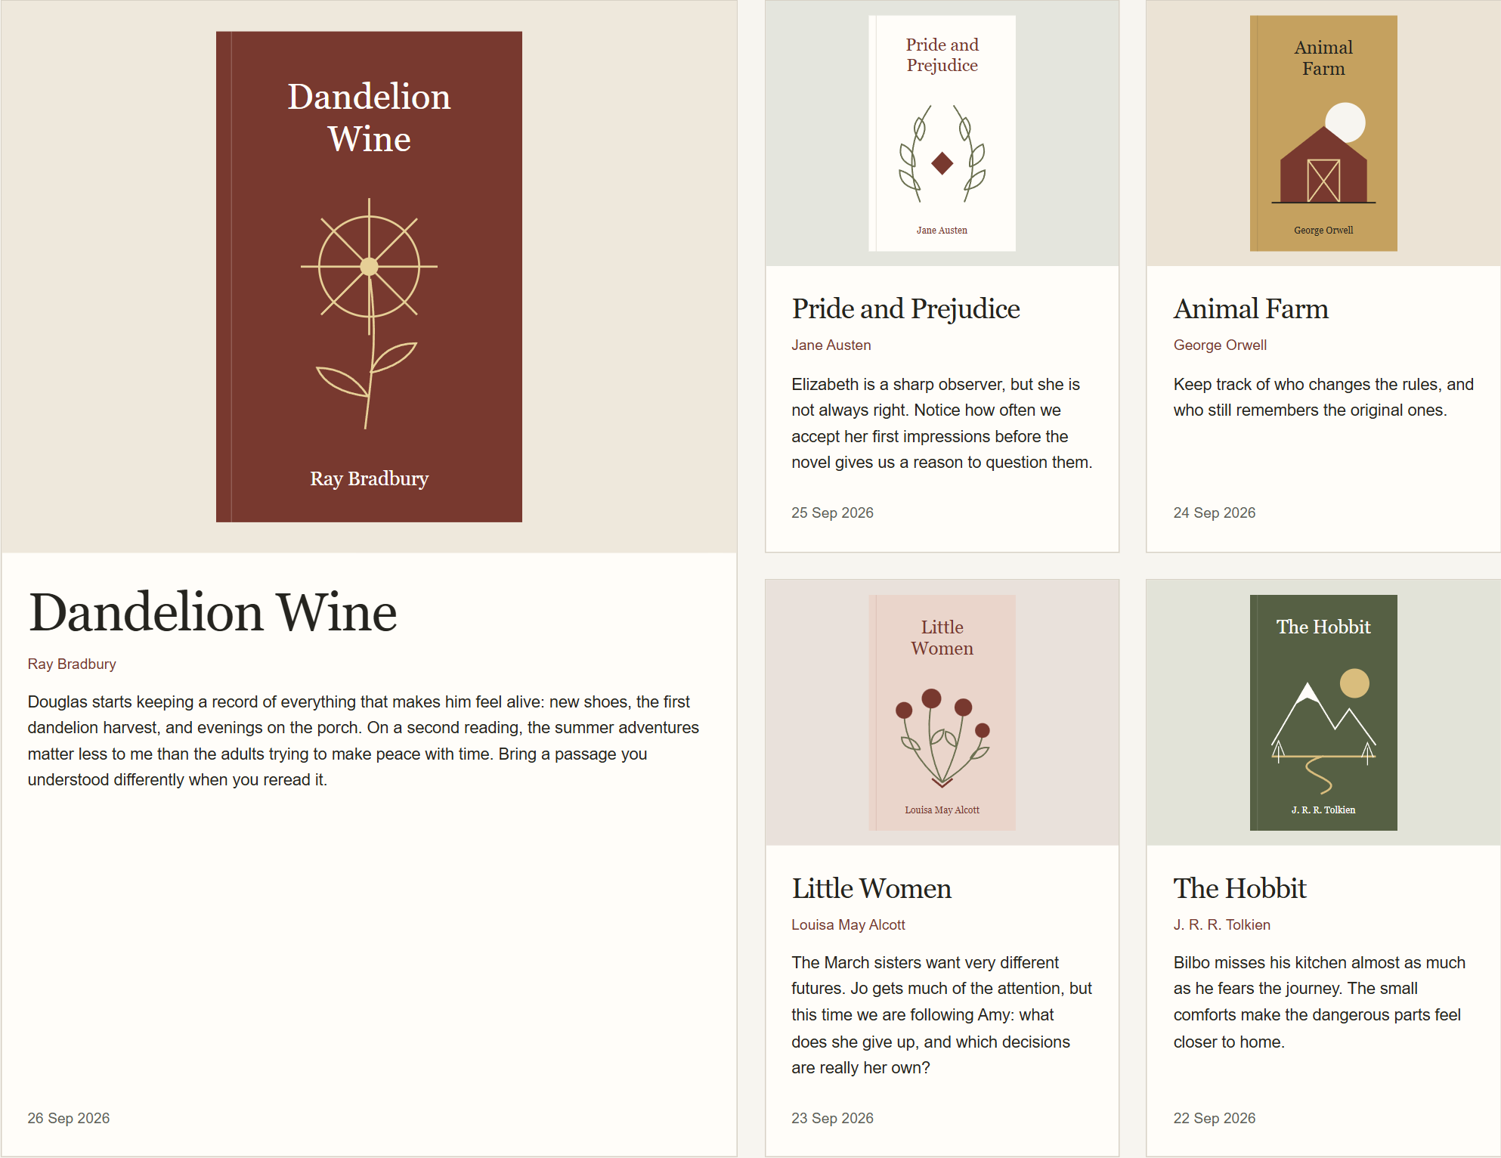
Figure 17. The lead reading note spans two columns and two rows; four notes fill the space beside it.
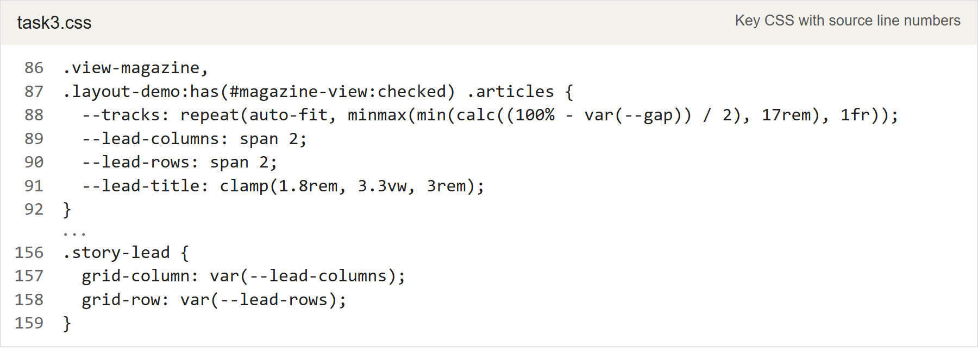
Figure 18. task3.css: flexible magazine tracks and the lead article span.

Checks and conclusion
I checked the components and all three journal layouts at widths from 320 to 1920 pixels. Longer titles and unbroken words stayed inside their containers. The card buttons aligned within each row, the list dates stayed on the right, and the magazine lead kept its two-column span. The layout previews also worked from the keyboard.
The three screenshots below show the journal at a width of 390 pixels, in grid, list, and magazine order. The complete screenshots are saved in screenshots/task3 in the repository.
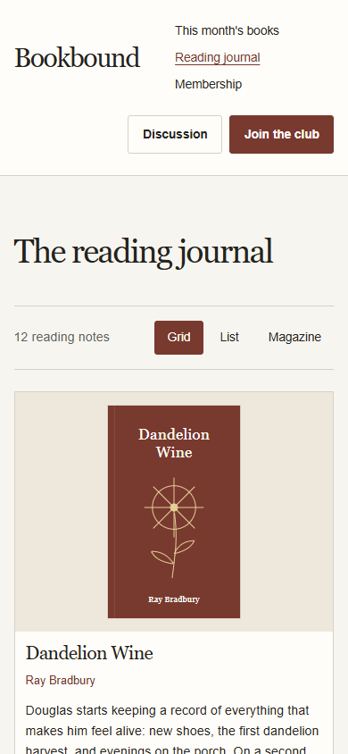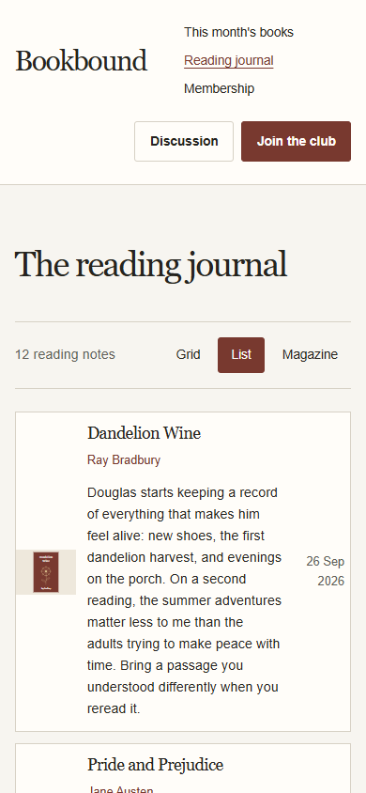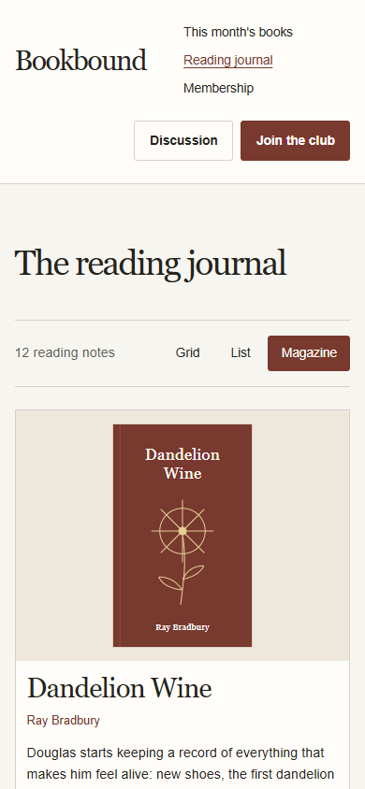
Figure 19. Mobile grid, list, and magazine views from task3.html.

Conclusion
I learned how grid lines control a composition and how Flexbox distributes space when descriptions have different lengths. Automatic margins were useful for aligning buttons. Task 3 also showed me how much the same HTML can change through the container's CSS alone.
Source code on GitHub: https://github.com/xnionn/Web2

