AHSANULLAH UNIVERSITY OF SCIENCE AND TECHNOLOGY

DHAKA-1208, BANGLADESH.

Department of Computer Science and Engineering

Spring 2019

Program: Bachelor of Science in Computer Science and Engineering

|  |  |
| --- | --- |
| Course No | CSE 2200 |
| Course Title | Software Development III |

|  |
| --- |
| Project Report |
| Project Name: AUST_ians |

|  |  |
| --- | --- |
| Submitted To | Mr. Md. Aminur Rahman |
|  | Lecturer, Department of CSE, AUST. |
|  |  |
|  | Mr. Md. Siam Ansary |
|  | Adjunct Faculty, Department of CSE, AUST. |

|  |  |
| --- | --- |
| Submitted By | |
|  | |
| Name : Tahiya Ahmed Chowdhury | |
| Student ID : 170204048 | |
|  |  |
| Name : Tamanna Nazmin | |
| Student ID : 170204052 | |
|  |  |
| Lab Group : A2 | |

**Introduction:**

Our project is basically a social networking app designed for the students of Ahsanullah University of Science and Technology or shortly known as AUST. Hence the name Aust_ians. This is an android application compiled with the language Java on the compiler Android Studio.

**Motivation:**

The students of AUST usually communicate with each other via Facebook groups where various posts regarding different matters are being posted everyday. But having a separate app where all the posts will be sorted according to categories such as help posts, rent posts and borrow posts can make it swift and easy.

**List of Features:**

As soon as the user logins he will have access to a navigation bar which will contain features such as :

* Add New Post**:** The user can post his queries or problems under different sections like help post, rent posts, lend books and lend instruments. Image can be added as well.
* Home: In the home ,the posts and posted images will be displayed along with information such as posted by whom and when.
* Borrow Books **:** If a student wants to borrow a book from someone then he can search posts regarding it in this section.
* Borrow Instruments **:** Similar to borrow books, posts regarding instruments in this section will be added.
* Rent rooms **:** The posts related to room or hostel vacancies will appear here.
* Events **:**  Upcoming events will be displayed here and can as well be added.
* IUMS:By clicking on the iums, the user can directly open the iums website on their browsers.

**Description of Activities:**

After starting the app, a page with logo and buttons sign in and sign up appears.

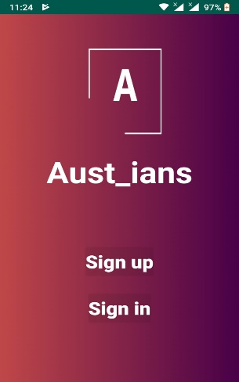

Then a sign in page or registration page appears based on which button is pressed

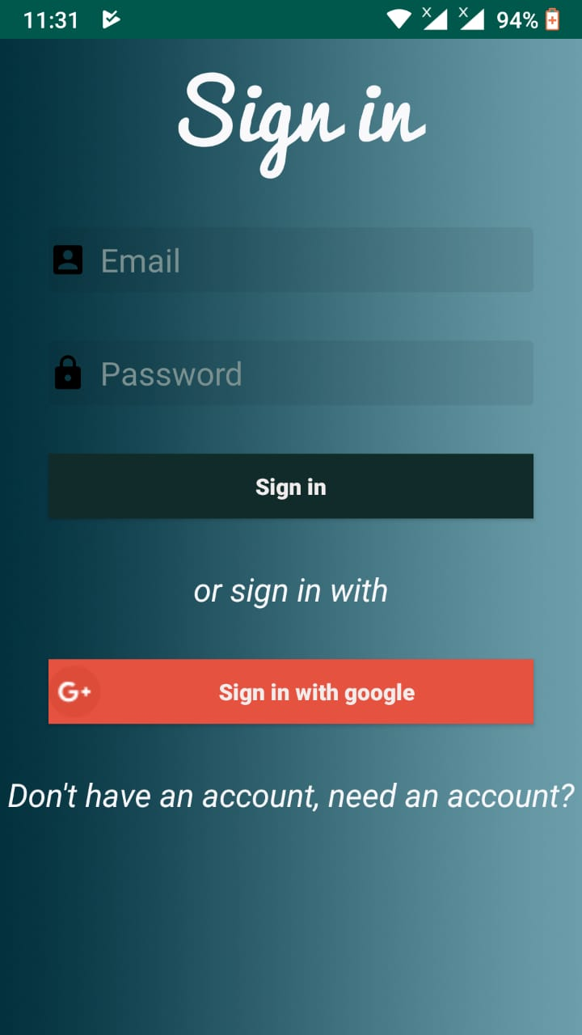 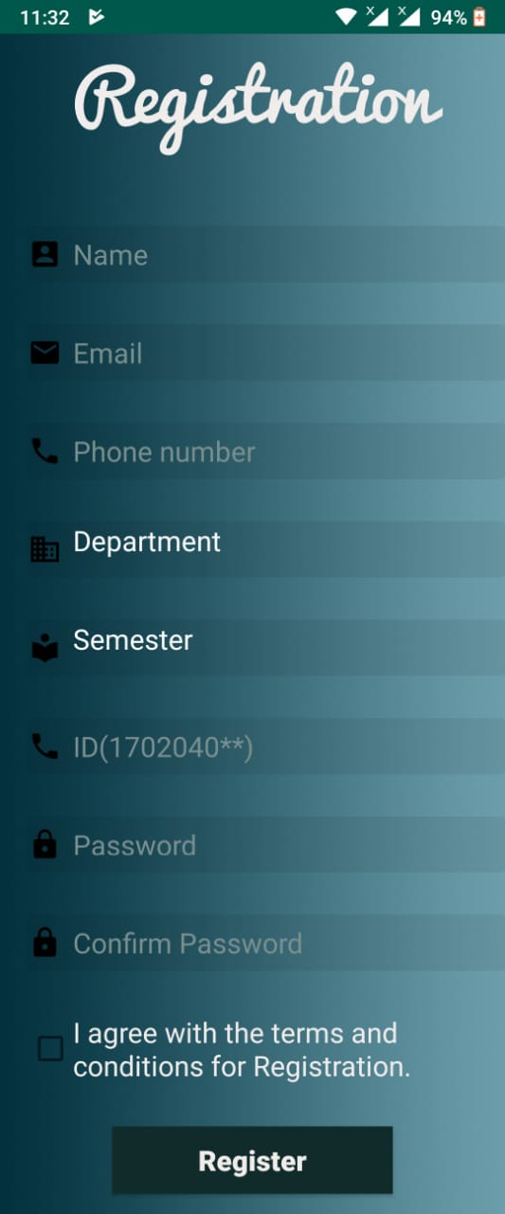

After completing sign up or registration a toast message is displayed and user enters the home. In home activity, a navigation drawer can be stretched out containing multiple options.

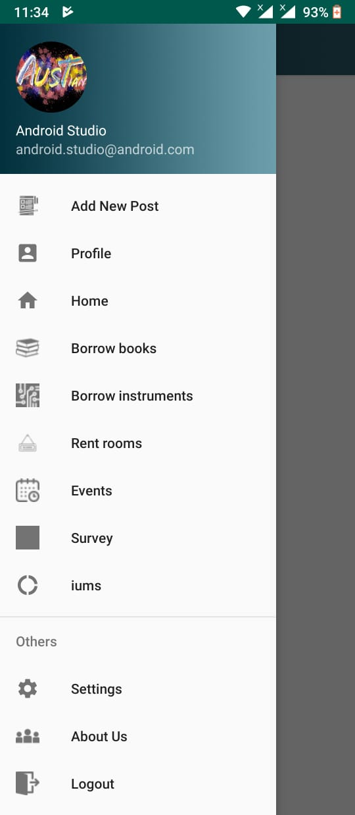 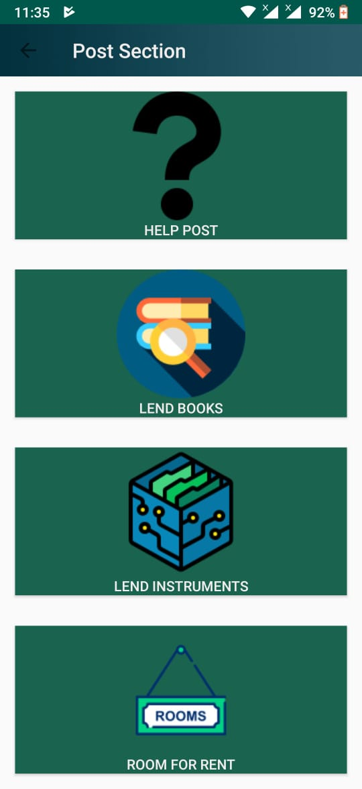 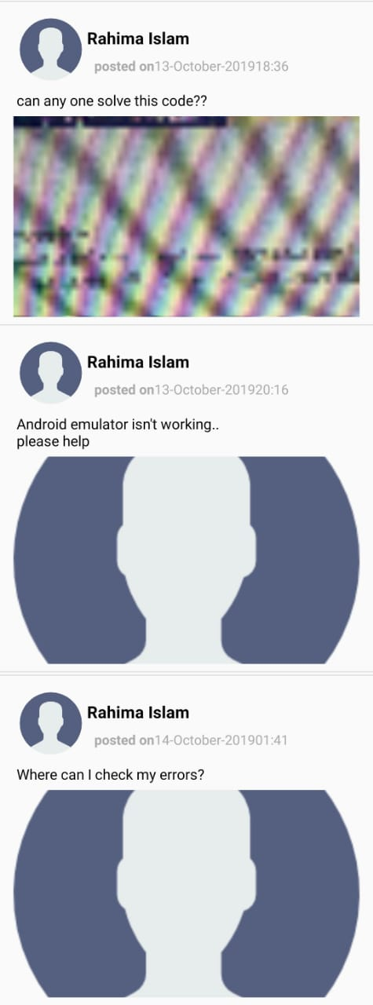

The add new post button of navigation drawer will take us to post section and home to the activity where posts are displayed. Also user can set up his/her profile by clicking onto profile. The menu’s borrow books, borrow instruments, rent rooms contain posts like in home of their respective categories. Clicking on to iums will directly take user to AUST iums website on browser. And there is also provision for logging out which is placed at the bottom of the navigation drawer.

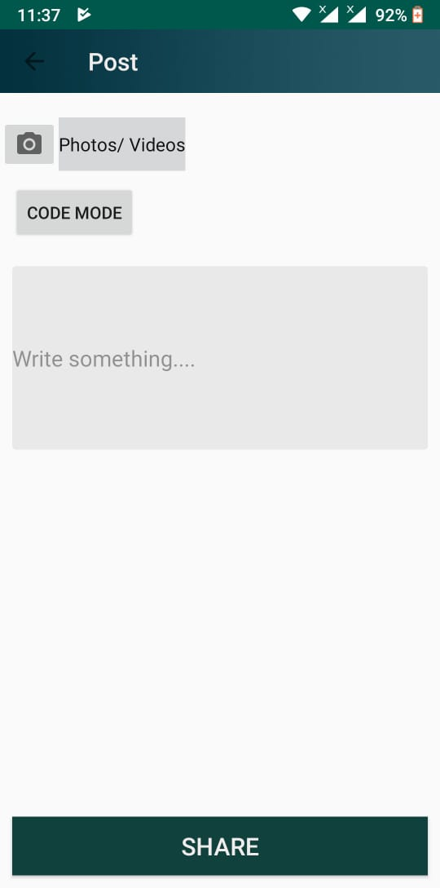 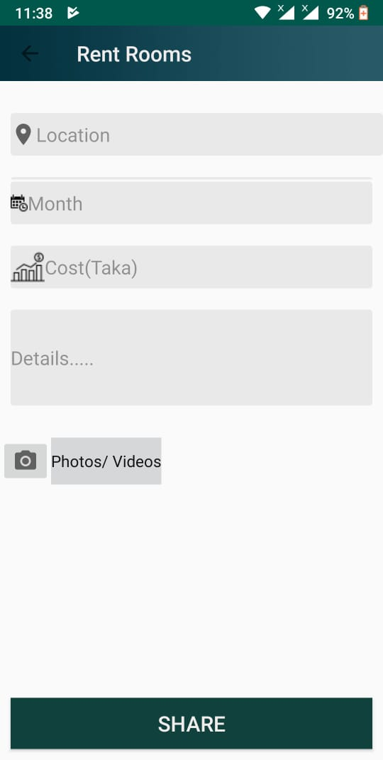

**Description of Database:**

The main database name is austians which contains 7 childs which are :

* Users : Contains data of user.
* Posts : Contains information of help posts.
* Posts For Instruments : Contains information of posts for lending instruments.
* Posts For Books : Contains information of posts for lending books.
* Posts For Room : Contains information of posts for renting rooms.

**Future works:**

We plan to extend our app by adding more features such as including provisions for text messaging, commenting on posts, deleting posts and updating posts. Also we would like to make our app more secure so that only Austians can use the app. However we would like to implement this app for guest users that is non Austians so that they can post their queries about AUST. But they will not be able to access to the institutions internal posts rather will have a separate home page.