

**Ahsanullah University of Science and Technology**

*Department of Computer Science & Engineering*

|  |  |
| --- | --- |
| Course No. | CSE 4108 |
| Course Name | Artificial Intelligence Lab |
| Assignment No. | 02 |

**Submitted To:**

Md. Siam Ansary Tonmoy Hossain

Department of CSE, AUST Department of CSE, AUST

**Submitted By:**

|  |  |
| --- | --- |
| Name | Tahiya Ahmed Chowdhury |
| ID No. | 17.02.04.048 |
| Session | Fall – 2020 |
| Section | A (A2) |

**Date of Submission:** July 19, 2021

**k-Nearest Neighbor Classifier:**

**Python code:**

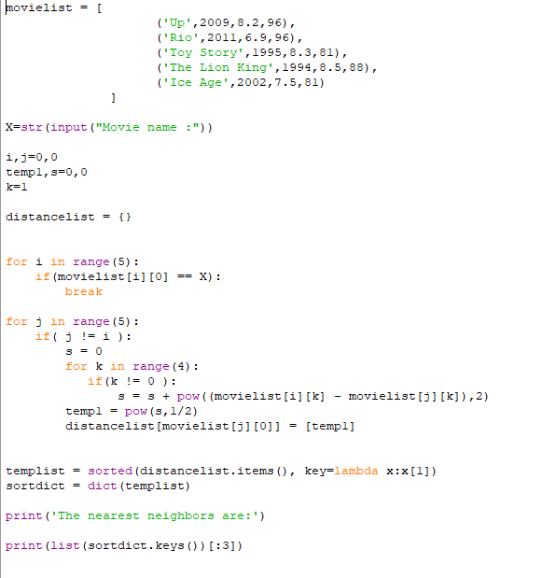

**Output:**

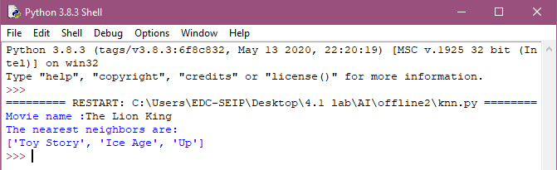

**k-Means Clustering:**

**Python code:**

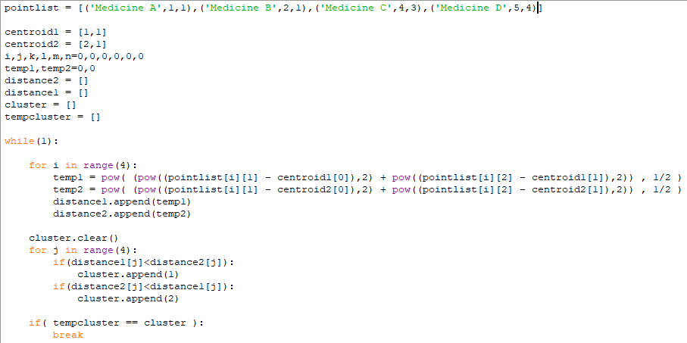

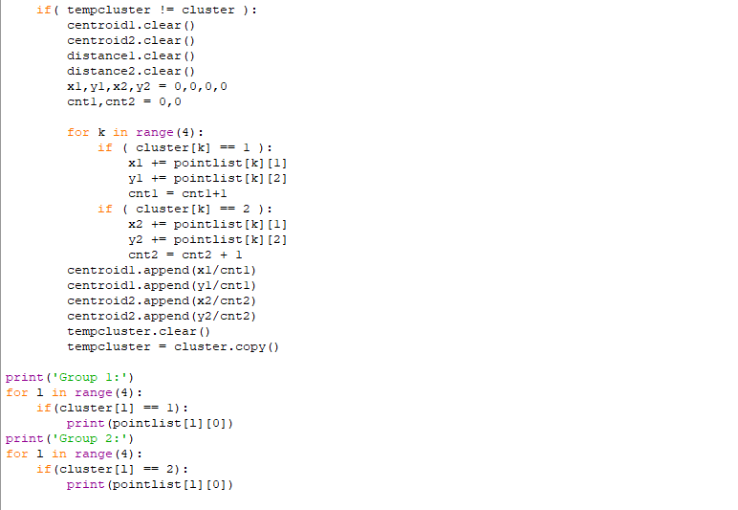

**Output:** 