

**Ahsanullah University of Science and Technology**

*Department of Computer Science & Engineering*

|  |  |
| --- | --- |
| Course No. | CSE 4108 |
| Course Name | Artificial Intelligence Lab |
| Assignment No. | 03 |

**Submitted To:**

Md. Siam Ansary Tonmoy Hossain

Department of CSE, AUST Department of CSE, AUST

**Submitted By:**

|  |  |
| --- | --- |
| Name | Tahiya Ahmed Chowdhury |
| ID No. | 17.02.04.048 |
| Session | Fall – 2020 |
| Section | A (A2) |

**Date of Submission:** August 9, 2021

**Question 03:** Define a recursive procedure in Python and in Prolog to find the sum of 1st n terms of an equal-interval series given the 1st term and the interval.

**Prolog code:**

sum**(**A**,**_**,**1**,**A**):-**

**!.**

sum**(**A**,**D**,**N**,**S**):-**

N1 is N**-**1**,**

sum**(**A**,**D**,**N1**,**S1**),**

S is S1**+(**A**+**N1**\*D).**

**Prolog output:**

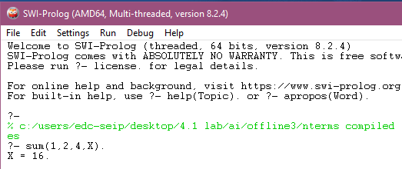

**Analyzing code and above input and output:**

In the prolog code, a recursive function sum(A,D,N,S) has been implemented where S is the sum of first N terms of a series starting with term A and difference D. If N = 1 then sum = first term i.e. A is the base case condition. For our output, we enter the values for the series 1+3+5+7+ … … and obtain the sum of first four terms i.e. 16.

**Python code:**

**def** sumFunc**(**a**,**d**,**n**):**

**if** n **==** 1**:**

**return** a

**else:**

**return** a **+** **(**n**-**1**)\***d **+** sumFunc**(**a**,**d**,**n**-**1**)**

a **=** **int(input(**'Enter the first element of series: '**))**

n **=** **int(input(**'Number of Elements to Calculate the Sum: '**))**

d **=** **int(input(**'Interval among consecutive numbers: '**))**

result **=** sumFunc**(**a**,**d**,**n**)**

**print(**'The sum is: '**,** result**)**

**Python output:**

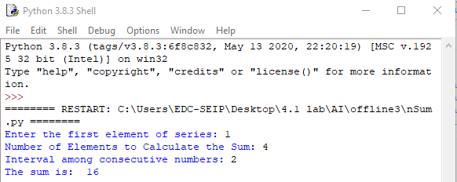

**Analyzing code and above input and output:**

Similar to the prolog code, we implement a recursive function sum with base condition to return the sum of first n numbers of a series with first term a and difference d. After running the code, the values a = 1, n = 4 and d = 2 was entered to obtain result 16.

**Question 04:** Define a recursive procedure in Python and in Prolog to find the length of a path between two vertices of a directed weighted graph.

**Prolog code:**

neighbor**(**i**,**a**,**35**).** neighbor**(**i**,**b**,**45**).** neighbor**(**a**,**c**,**22**).**

neighbor**(**a**,**d**,**32**).** neighbor**(**b**,**d**,**28**).** neighbor**(**b**,**e**,**36**).**

neighbor**(**b**,**f**,**27**).** neighbor**(**c**,**d**,**31**).** neighbor**(**c**,**g**,**47**).**

neighbor**(**d**,**g**,**30**).** neighbor**(**e**,**g**,**26**).**

pathLength**(**X**,**Y**,**L**):-** neighbor**(**X**,**Y**,**L**),** **!.**

pathLength**(**X**,**Y**,**L**):-** neighbor**(**X**,**Z**,**L1**),** pathLength**(**Z**,**Y**,**L2**),** L is L1**+**L2**.**

**Prolog output:**

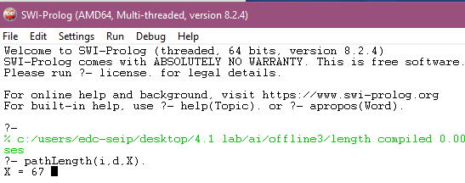

**Analyzing code and above input and output:**

In our code, we implemented the recursive function pathlength(X,Y,L) which works on determining L, the length between path X and Y when the credentials of a directed weighted graph was represented by neighbor(_,_,_). If there is no direct path between X and Y then the function finds intermediate path between them to connect. But if it fails then none is returned as answer. For checking our code, we provided two vertices of our graph : i and d and got 67.

**Python code:**

**def** pathValue**(**x**,**y**):**

**if** **(**x**,**y**)** **in** neighborList**:**

**return** neighborDict**[(**x**,**y**)]**

**for** **(**i**,** j**)** **in** neighborList**:**

**if** i **==** x**:**

t1 **=** neighborDict**[(**x**,** j**)]**

t2 **=** pathValue**(**j**,**y**)**

**return** t1**+**t2

neighborDict **=** **{(**'i'**,** 'a'**)** **:** 35**,** **(**'i'**,** 'b'**)** **:** 45**,** **(**'a'**,** 'c'**)** **:** 22**,** **(**'a'**,** 'd'**)** **:** 32**,**

**(**'b'**,** 'd'**)** **:** 28**,** **(**'b'**,** 'e'**)** **:** 36**,** **(**'b'**,** 'f'**)** **:** 27**,** **(**'c'**,** 'd'**)** **:** 31**,**

**(**'c'**,** 'g'**)** **:** 47**,** **(**'d'**,** 'g'**)** **:** 30**,** **(**'e'**,** 'g'**)** **:** 26**}**

neighborList **=** **[(**'i'**,** 'a'**),** **(**'i'**,** 'b'**),** **(**'a'**,** 'c'**),** **(**'a'**,** 'd'**),**

**(**'b'**,** 'd'**),** **(**'b'**,** 'e'**),** **(**'b'**,** 'f'**),** **(**'c'**,** 'd'**),**

**(**'c'**,** 'g'**),** **(**'d'**,** 'g'**),** **(**'e'**,** 'g'**)]**

start **=** **str(input(**'Enter Starting point: '**))**

end **=** **str(input(**'Enter Ending point: '**))**

**print(**'The length of path is: '**)**

**print(**pathValue**(**start**,** end**))**

**Python output:**

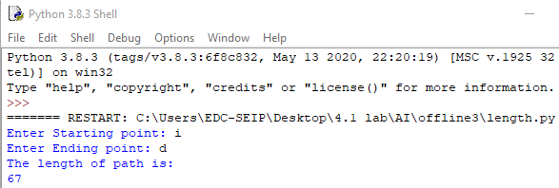

**Analyzing code and above input and output:**

For the python code also the recursive function pathValue() was implemented. Here as well the length was returned if direct path was found. Else the length of intermediate paths were stored in the sum and finally returned as output. Like in output, we provided i and d. Since no direct path exists among them hence the path calculated was i🡪a and a🡪d which was 32+35 i.e. 67.

**Question 05:** Write the Python and Prolog codes to find discussed h2

**Prolog code:**

gtp**(**1**,**1**,**1**).** gtp**(**2**,**1**,**2**).** gtp**(**3**,**1**,**3**).** gtp**(**4**,**2**,**3**).**

gtp**(**5**,**3**,**3**).** gtp**(**6**,**3**,**2**).** gtp**(**7**,**3**,**1**).** gtp**(**8**,**2**,**1**).**

gblnk**(**2**,**2**).**

tp**(**1**,**1**,**2**).** tp**(**2**,**1**,**3**).** tp**(**3**,**2**,**1**).** tp**(**4**,**2**,**3**).**

tp**(**5**,**3**,**3**).** tp**(**6**,**2**,**2**).** tp**(**7**,**3**,**2**).** tp**(**8**,**1**,**1**).**

blnk**(**3**,**1**).**

go**:-**

calcH**(**1**,[],**L**),**sumList**(**L**,**V**),write(**'Heuristics:'**),write(**V**).**

calcH**(**9**,**X**,**X**):-!.**

calcH**(**T**,**X**,**Y**):-**

dist**(**T**,**D**),** append**(**X**,[**D**],**X1**),** T1 is T**+**1**,** calcH**(**T1**,**X1**,**Y**).**

dist**(**T**,**V**):-**

tp**(**T**,**A**,**B**),** gtp**(**T**,**C**,**D**),**V is **abs(**A**-C)** **+** **abs(**B**-**D**).**

sumList**([],**0**):-** **!.**

sumList**(**L**,**V**):-**L**=[**H**|**T**],**sumList**(**T**,**V1**),**V is V1**+**H**.**

**Prolog output:**

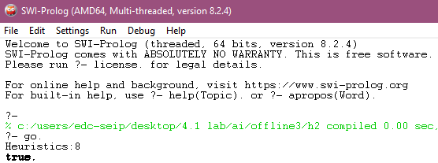

**Analyzing code and above input and output:**

gtp represented goal state and tp represented current state. The differences in positions for the entries were calculated using Manhattan distance formula in dist() function. For our given set of input, the heuristic value i.e. h2 was 8 which means 8 entries were mismatched from the goal state.

**Python code:**

gtp **=** **[(**1**,**1**,**1**),(**2**,**1**,**2**),(**3**,**1**,**3**),(**4**,**2**,**3**),(**5**,**3**,**3**),(**6**,**3**,**2**),(**7**,**3**,**1**),(**8**,**2**,**1**)]**

gblnk **=** **(**2**,**2**)**

tp**=[(**1**,**1**,**2**),(**2**,**1**,**3**),(**3**,**2**,**1**),(**4**,**2**,**3**),(**5**,**3**,**3**),(**6**,**2**,**2**),(**7**,**3**,**2**),(**8**,**1**,**1**)]**

blnk **=** **(**3**,**1**)**

i**,**h **=** 0**,**0

d **=** **[]**

**while(**i**<=**7**):**

**if(** **(**gtp**[**i**][**1**]** **!=** tp**[**i**][**1**])** **or** **(**gtp**[**i**][**2**]** **!=** tp**[**i**][**2**])** **):**

d**.**append**(** **abs(**gtp**[**i**][**1**]** **-** tp**[**i**][**1**])** **+** **abs(**gtp**[**i**][**2**]** **-** tp**[**i**][**2**])** **)**

i **=** i**+**1

**for** e **in** d**:**

h **=** h**+**e

**print(**"Heuristic 2: "**,**h**)**

**Python output:**

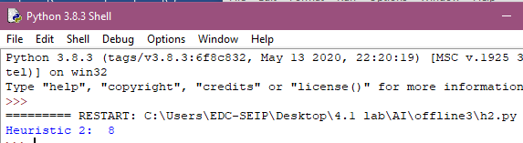

**Analyzing code and above input and output:**

The Manhattan distance was calculated in a loop by comparing the vertices of each current state entries with that of goal state and stored in a list d. Finally the sum of list d was calculated which was 8 i.e. our h2.

**Question 06:** Write Python code to find the discussed h3.

**Python code:**

positionList **=** **[(**1**,**2**),(**1**,**8**),(**3**,**6**),(**4**,**5**),(**5**,**3**),(**6**,**1**),(**7**,**4**),(**8**,**7**)]**

h **=** 0

**for** i **in** **range(**0**,**7**):**

**for** j **in** **range(**i**+**1**,**7**):**

**if** positionList**[**i**][**0**]** **==** positionList**[**j**][**0**]:**

h **=** h**+**1

**else:**

t1 **=** **abs(**positionList**[**i**][**0**]** **-** positionList**[**j**][**0**])**

t2 **=** **abs(**positionList**[**i**][**1**]** **-** positionList**[**j**][**1**])**

**if** t1 **==** t2**:**

h **=** h**+**1

**print(**"Heuristic 3: "**,**h**)**

**Python output:**

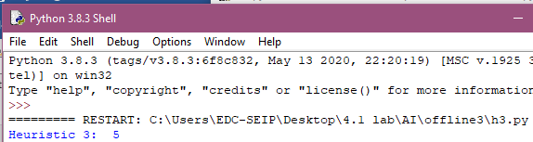

**Analyzing code and above input and output:**

For finding an heuristic function (h3) that returns the number of attacking pairs of queens in an 8 Queens problem, we compared the positions of all queens present to the others starting from bottom to top. If any two were horizontally or diagonally aligned then h3 was incremented. Finally h3 was 5 for 4 diagonal matches and one horizontal match.