Table 1. Baseline characteristics of the training and internal validation cohorts.
Variable | All (N=188) | Training (N=131) | Validation (N=57) | P
Massive haemoptysis |  |  |  | 0.929
no | 146 (77.66) | 101 (77.10) | 45 (78.95)
yes | 42 (22.34) | 30 (22.90) | 12 (21.05)
Age (years) | 61.0 [54.0, 70.0] | 60.0 [53.0, 69.5] | 65.0 [55.0, 70.0] | 0.222
Sex |  |  |  | 0.709
female | 58 (30.85) | 42 (32.06) | 16 (28.07)
male | 130 (69.15) | 89 (67.94) | 41 (71.93)
Smoking status |  |  |  | 0.688
no | 75 (39.89) | 54 (41.22) | 21 (36.84)
yes | 113 (60.11) | 77 (58.78) | 36 (63.16)
Duration of smoking (years) | 15.5 [0.0, 40.0] | 20.0 [0.0, 40.0] | 15.0 [0.0, 40.0] | 0.786
Cancer |  |  |  | 0.185
no | 157 (83.51) | 113 (86.26) | 44 (77.19)
yes | 31 (16.49) | 18 (13.74) | 13 (22.81)
Tuberculosis |  |  |  | 0.103
no | 159 (84.57) | 115 (87.79) | 44 (77.19)
yes | 29 (15.43) | 16 (12.21) | 13 (22.81)
Bronchiectasis |  |  |  | 0.222
no | 118 (62.77) | 78 (59.54) | 40 (70.18)
yes | 70 (37.23) | 53 (40.46) | 17 (29.82)
Fungal infection |  |  |  | 1.000
no | 165 (87.77) | 115 (87.79) | 50 (87.72)
yes | 23 (12.23) | 16 (12.21) | 7 (12.28)
BAA |  |  |  | 0.049
no | 150 (79.79) | 110 (83.97) | 40 (70.18)
yes | 38 (20.21) | 21 (16.03) | 17 (29.82)
Antiplatelet drugs |  |  |  | 0.757
no | 176 (93.62) | 123 (93.89) | 53 (92.98)
yes | 12 (6.38) | 8 (6.11) | 4 (7.02)
Antithrombotic drugs |  |  |  | 1.000
no | 182 (96.81) | 127 (96.95) | 55 (96.49)
yes | 6 (3.19) | 4 (3.05) | 2 (3.51)
PLT (10⁹/L) | 204.0 [177.5, 256.3] | 206.0 [184.0, 249.5] | 203.0 [169.0, 258.0] | 0.529
D-dimer (mg/L) | 0.34 [0.20, 0.69] | 0.38 [0.19, 0.66] | 0.33 [0.23, 0.70] | 0.772
INR | 0.98 [0.92, 1.05] | 0.98 [0.94, 1.03] | 0.98 [0.92, 1.07] | 0.828
Fibrinogen (g/L) | 3.28 [2.51, 4.18] | 3.31 [2.46, 4.05] | 3.24 [2.60, 4.27] | 0.582
Data are n (%) for categorical variables and median [Q1, Q3] for continuous variables. BAA, bronchial artery abnormality, defined as the presence of bronchial artery–pulmonary fistula (BAPF), bronchial artery malformation (BAM), or both (n=27 BAPF and n=18 BAM, with 7 patients carrying both). PLT, platelet count; INR, international normalised ratio.

Table 2. Univariable and multivariable logistic regression for massive haemoptysis (training cohort).
Variable | Univariable OR (95% CI) | P | Multivariable OR (95% CI) | P
Age | 1.02 (0.983–1.047) | 0.360 | —
Sex | 1.40 (0.563–3.461) | 0.472 | —
Smoking status | 0.89 (0.392–2.037) | 0.789 | —
Duration of smoking | 1.00 (0.977–1.018) | 0.813 | —
Cancer | 0.64 (0.171–2.368) | 0.501 | —
Tuberculosis | 4.23 (1.429–12.505) | 0.009 | 5.18 (1.419–18.931) | 0.013
Bronchiectasis | 2.36 (1.031–5.409) | 0.042 | —
Fungal infection | 1.14 (0.339–3.838) | 0.831 | —
BAA | 5.27 (1.960–14.162) | 0.001 | 4.32 (1.325–14.098) | 0.015
Antiplatelet drugs | 0.46 (0.055–3.921) | 0.480 | —
Antithrombotic drugs | 1.13 (0.113–11.244) | 0.919 | —
PLT | 1.00 (0.990–1.003) | 0.290 | —
D-dimer | 1.13 (0.920–1.380) | 0.247 | —
INR | 0.09 (0.001–7.670) | 0.284 | —
Fibrinogen | 0.57 (0.386–0.830) | 0.004 | 0.65 (0.446–0.947) | 0.025
Rad-score | 7.96 (2.745–23.105) | <0.001 | 4.73 (1.530–14.632) | 0.007
OR, odds ratio; CI, confidence interval. Only variables retained in the multivariable model carry an adjusted estimate; — denotes not retained. Abbreviations as in Table 1; Rad-score, radiomics score.

Table 3. Diagnostic performance of the clinical–radiomic nomogram.
Cohort | Accuracy | Sensitivity | Specificity | AUC (95% CI)
Training (n=131) | 0.824 (108/131) | 0.767 (23/30) | 0.842 (85/101) | 0.850 (0.775–0.925)
Validation (n=57) | 0.684 (39/57) | 0.750 (9/12) | 0.667 (30/45) | 0.794 (0.631–0.958)
Accuracy, sensitivity and specificity were obtained at an estimated-probability cut-point of 0.255, derived from the maximum Youden index in the training cohort and applied unchanged to the validation cohort. AUC, area under the receiver operating characteristic curve.

Table 4. Distribution of the Rad-score by presentation group.
Cohort | Group | n | Median (Q1, Q3) | P
Training | Non-massive haemoptysis | 101 | −1.361 (−1.640, −1.062) | 1.49×10⁻⁵
 | Massive haemoptysis | 30 | −1.043 (−1.189, −0.706)
Validation | Non-massive haemoptysis | 45 | −1.189 (−1.523, −0.954) | 0.122
 | Massive haemoptysis | 12 | −1.029 (−1.275, −0.596)
Groups were compared with the Mann–Whitney U test. Q1, first quartile; Q3, third quartile.

Table 5. Discrimination of the three models and pairwise comparison (DeLong test), by cohort.
Cohort | Comparison | AUC (Model 1) | AUC (Model 2) | Z | P
Training | Combined vs. Rad-score | 0.850 | 0.761 | 2.058 | 0.040
 | Combined vs. Clinical | 0.850 | 0.796 | 1.841 | 0.066
 | Rad-score vs. Clinical | 0.761 | 0.796 | −0.514 | 0.608
Validation | Combined vs. Rad-score | 0.794 | 0.647 | 1.373 | 0.170
 | Combined vs. Clinical | 0.794 | 0.744 | 0.967 | 0.333
 | Rad-score vs. Clinical | 0.647 | 0.744 | −0.665 | 0.506
Model AUCs with 95% CIs — training: combined 0.850 (0.775–0.925), clinical 0.796 (0.693–0.898), Rad-score 0.761 (0.672–0.850); validation: combined 0.794 (0.631–0.958), clinical 0.744 (0.555–0.934), Rad-score 0.647 (0.456–0.839). Combined model = Rad-score + tuberculosis + BAA + fibrinogen; clinical model = tuberculosis + BAA + fibrinogen. With three comparisons per cohort, a Bonferroni-corrected threshold is P=0.0167.

Table 6. Continuous NRI and IDI of the combined model versus the clinical model.
Cohort | NRI (95% CI) | P | IDI (95% CI) | P
Training | 0.428 (0.029, 0.827) | 0.036 | 0.062 (0.013, 0.111) | 0.013
Validation | 0.544 (−0.076, 1.165) | 0.085 | 0.064 (−0.044, 0.171) | 0.245
NRI, continuous net reclassification improvement; IDI, integrated discrimination improvement, for adding the Rad-score to the clinical model. Continuous NRI rejects the null more often than its nominal level implies and should be read alongside the IDI.

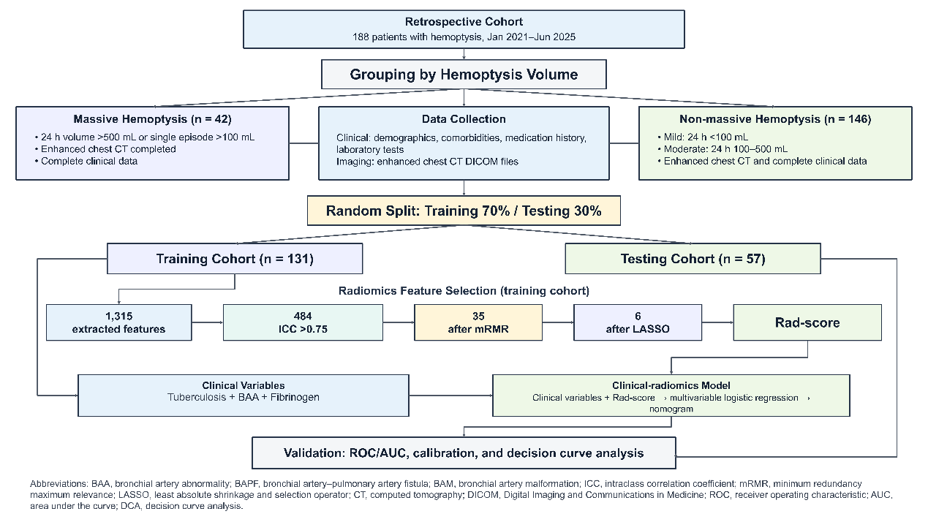
Fig.1 Flowchart.

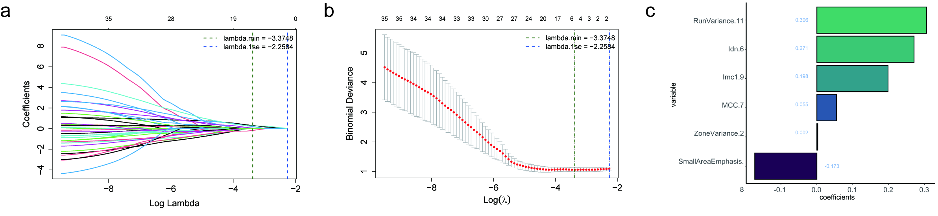
Fig.2 Radiomics feature selection using the LASSO binary logistic regression model.(a) LASSO coefficient profiles of the radiomics features;(b) Optimal parameter (lambda) selection in the LASSO model;(c) Distribution of the selected radiomics features and their coefficients.

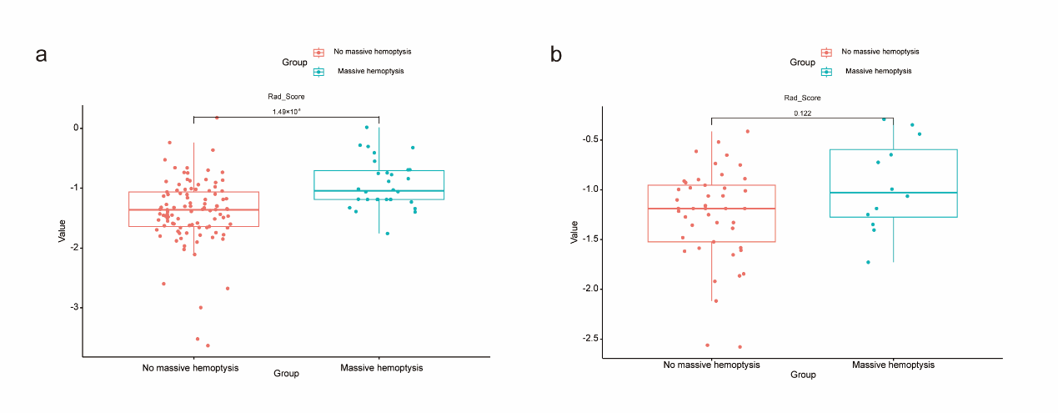
Fig.3 Comparison of Rad-score distributions between patients with massive and non-massive hemoptysis in the training and internal validation cohorts.Box-and-jitter plots show the distributions of Rad-score in patients with non-massive and massive hemoptysis in the training cohort (a) and internal validation cohort (b). The center line represents the median, the box represents the interquartile range, the whiskers represent 1.5 times the interquartile range, and each dot represents an individual patient. The P values for between-group comparisons are shown above the brackets.

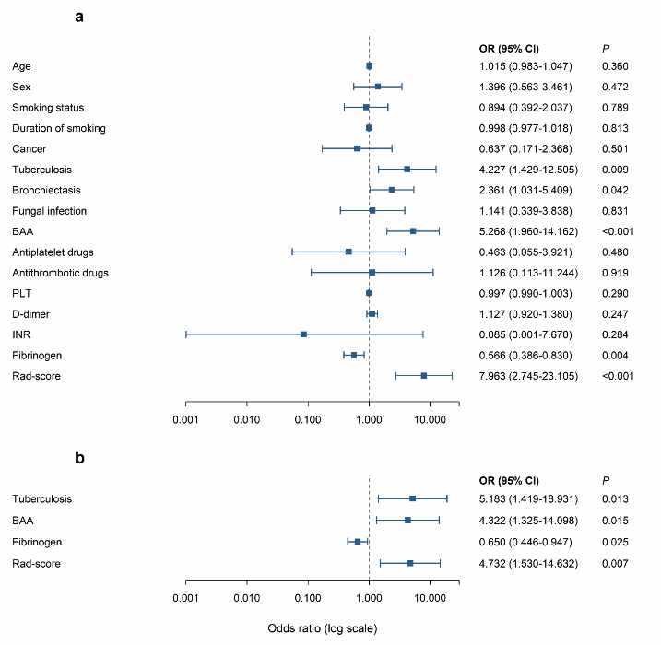
Fig.4 Forest plots of factors associated with massive hemoptysis in the training cohort.Forest plots show the results of univariable (a) and multivariable (b) logistic regression analyses for massive hemoptysis. Squares represent odds ratios (ORs), horizontal lines represent 95% confidence intervals (CIs), and the vertical dashed line indicates the reference value of OR = 1. The x-axis is displayed on a logarithmic scale. BAA was defined as the presence of either BAPF or BAM. OR, odds ratio; CI, confidence interval; BAA, bronchial artery abnormality; BAPF, bronchial artery–pulmonary artery fistula; BAM, bronchial artery malformation; PLT, platelet count; INR, international normalized ratio; Rad-score, radiomics score.

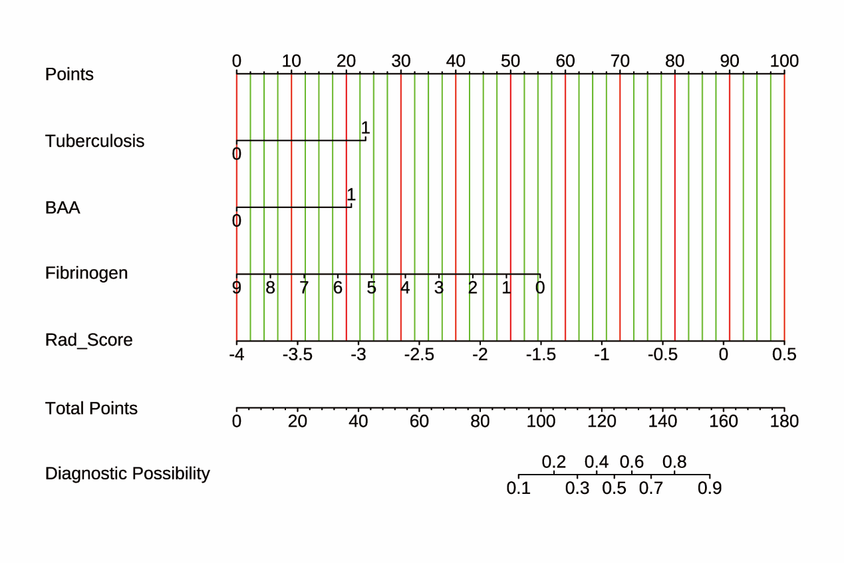
Fig.5 Nomogram developed to differential diagnosis and risk stratification of hemoptysis. The nomogram was developed based on the multivariable logistic regression model incorporating tuberculosis, bronchial artery abnormality (BAA), fibrinogen, and Rad-score. For each patient, the value of each predictor is projected upward to the “Points” axis to obtain the corresponding score. The individual scores are summed to obtain the total points, which are then projected downward to estimate the predicted probability of massive hemoptysis.

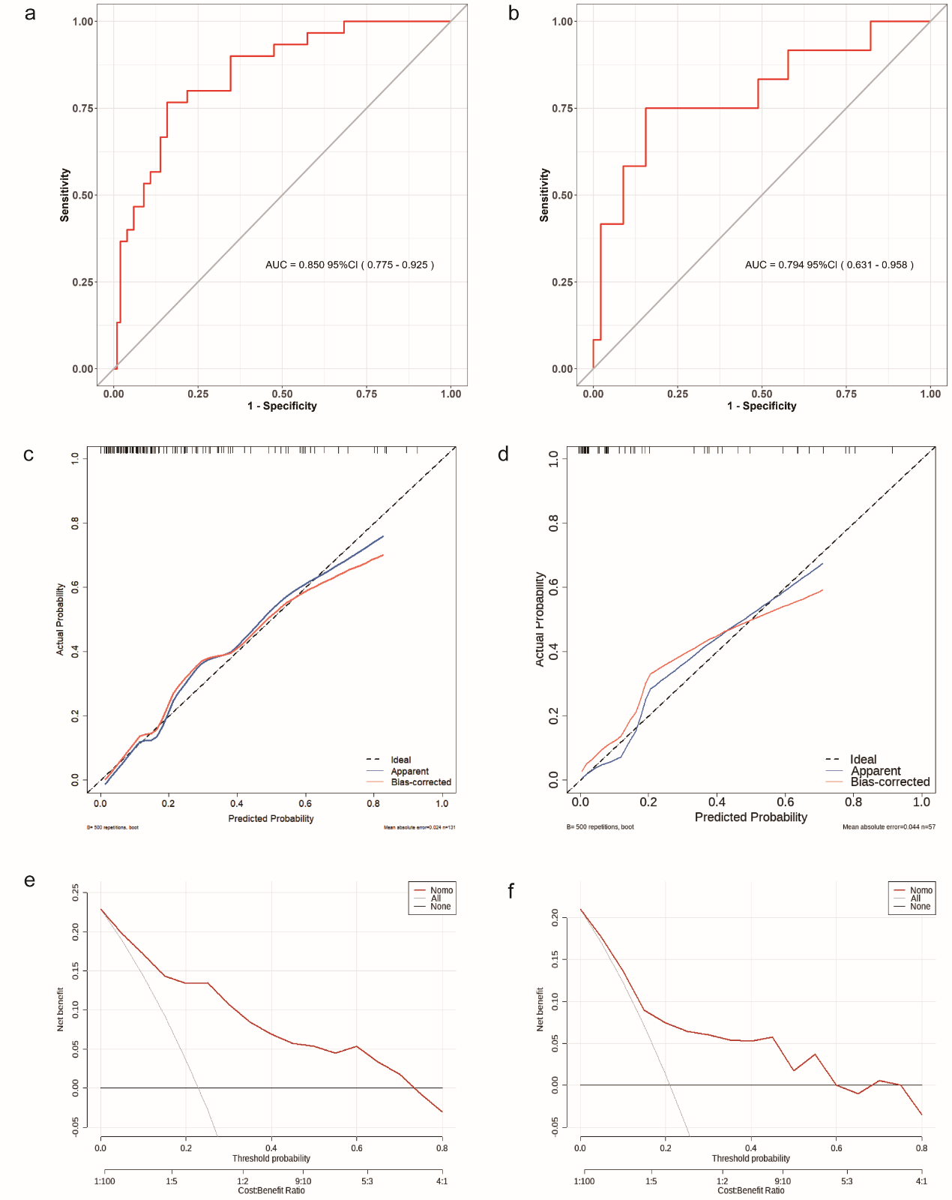
Fig.6 Evaluation of the predictive performance of the clinical-radiomics nomogram.

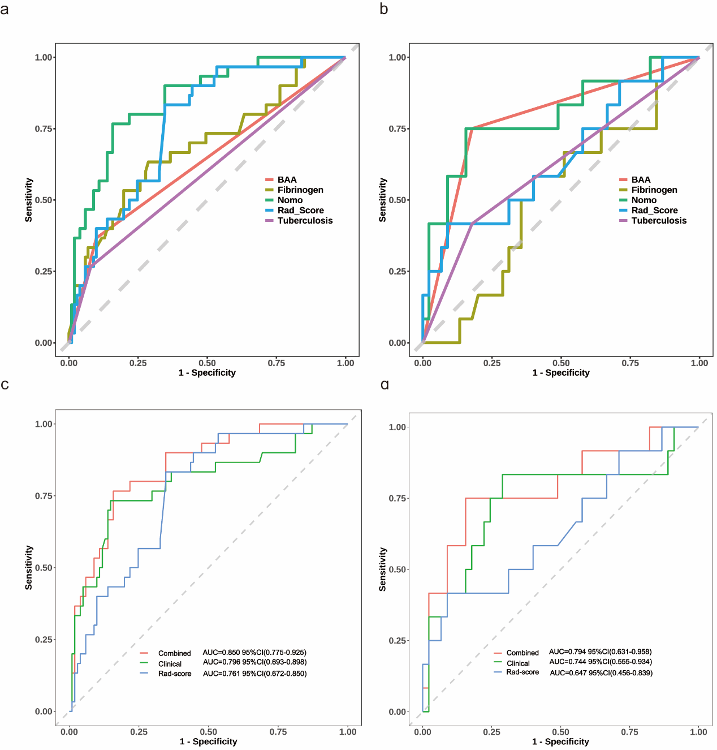
Fig.7 Rationality analysis: Area Under the Curve (AUC) of various influencing factors and Multi-model comparison. (a,c) training cohort ;(b,d)validation cohort.

