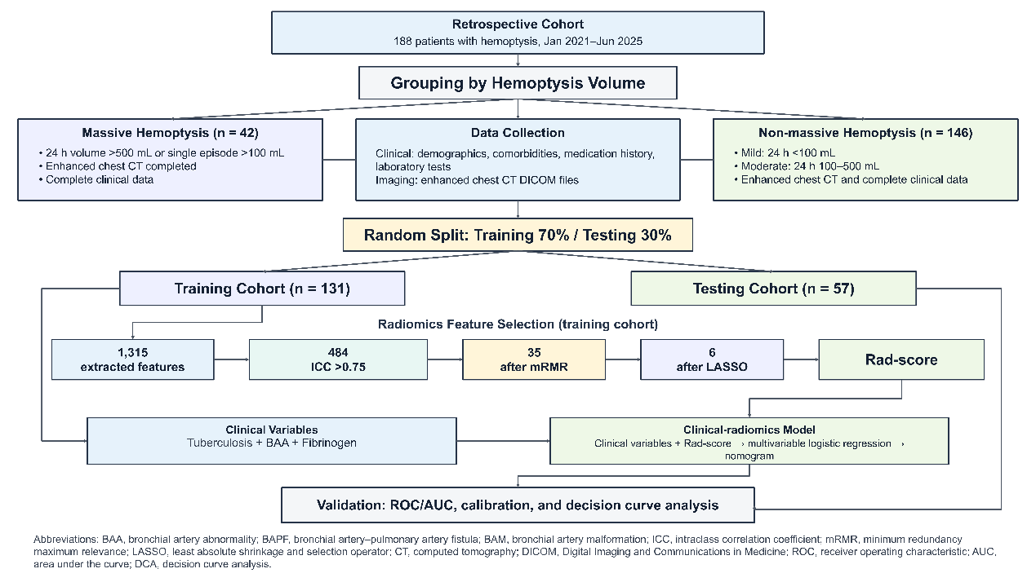
Fig.1 Flowchart.

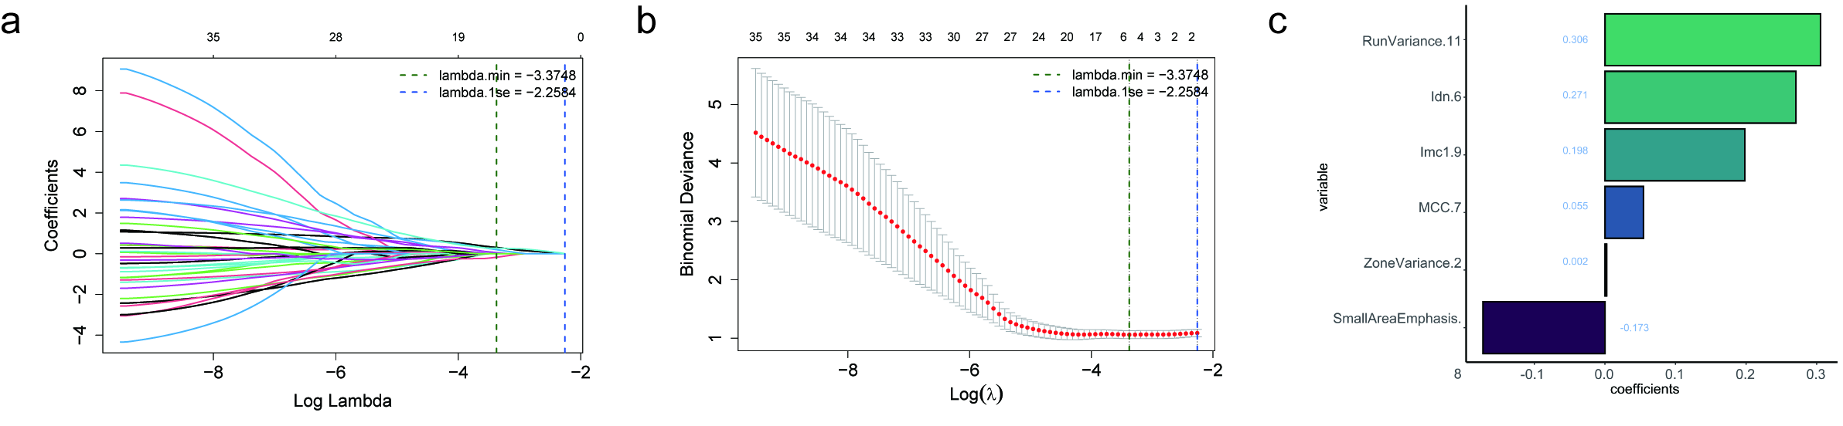
Fig.2 Radiomics feature selection using the LASSO binary logistic regression model.(a) LASSO coefficient profiles of the radiomics features;(b) Optimal parameter (lambda) selection in the LASSO model;(c) Distribution of the selected radiomics features and their coefficients.

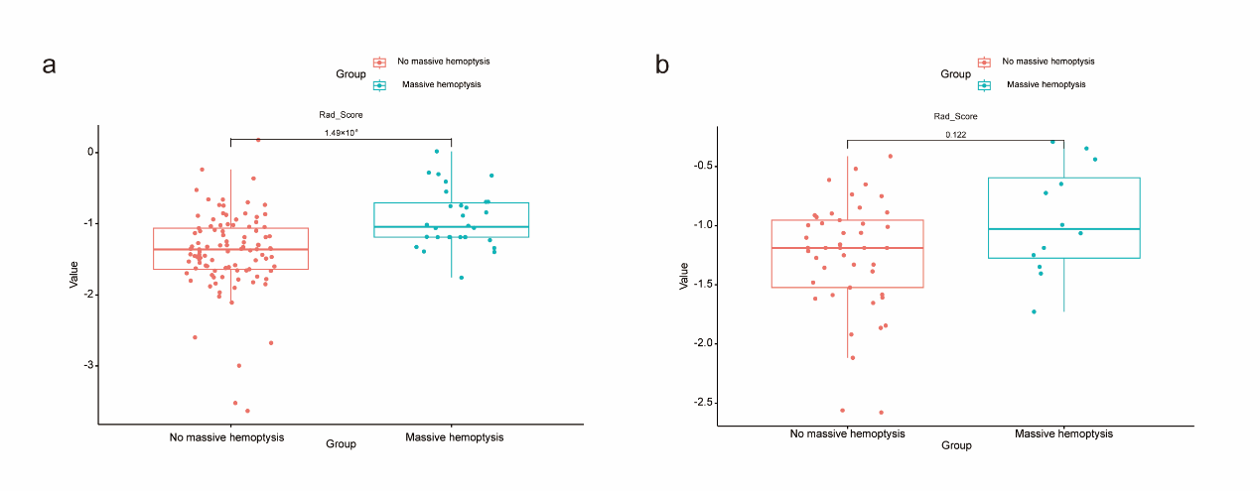
Fig.3 Comparison of Rad-score distributions between patients with massive and non-massive hemoptysis in the training and internal validation cohorts.Box-and-jitter plots show the distributions of Rad-score in patients with non-massive and massive hemoptysis in the training cohort (a) and internal validation cohort (b). The center line represents the median, the box represents the interquartile range, the whiskers represent 1.5 times the interquartile range, and each dot represents an individual patient. The P values for between-group comparisons are shown above the brackets.

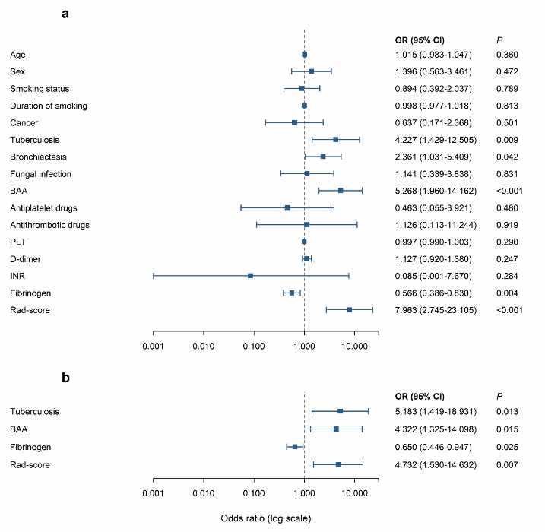
Fig.4 Forest plots of factors associated with massive hemoptysis in the training cohort.Forest plots show the results of univariable (a) and multivariable (b) logistic regression analyses for massive hemoptysis. Squares represent odds ratios (ORs), horizontal lines represent 95% confidence intervals (CIs), and the vertical dashed line indicates the reference value of OR = 1. The x-axis is displayed on a logarithmic scale. BAA was defined as the presence of either BAPF or BAM. OR, odds ratio; CI, confidence interval; BAA, bronchial artery abnormality; BAPF, bronchial artery–pulmonary artery fistula; BAM, bronchial artery malformation; PLT, platelet count; INR, international normalized ratio; Rad-score, radiomics score.

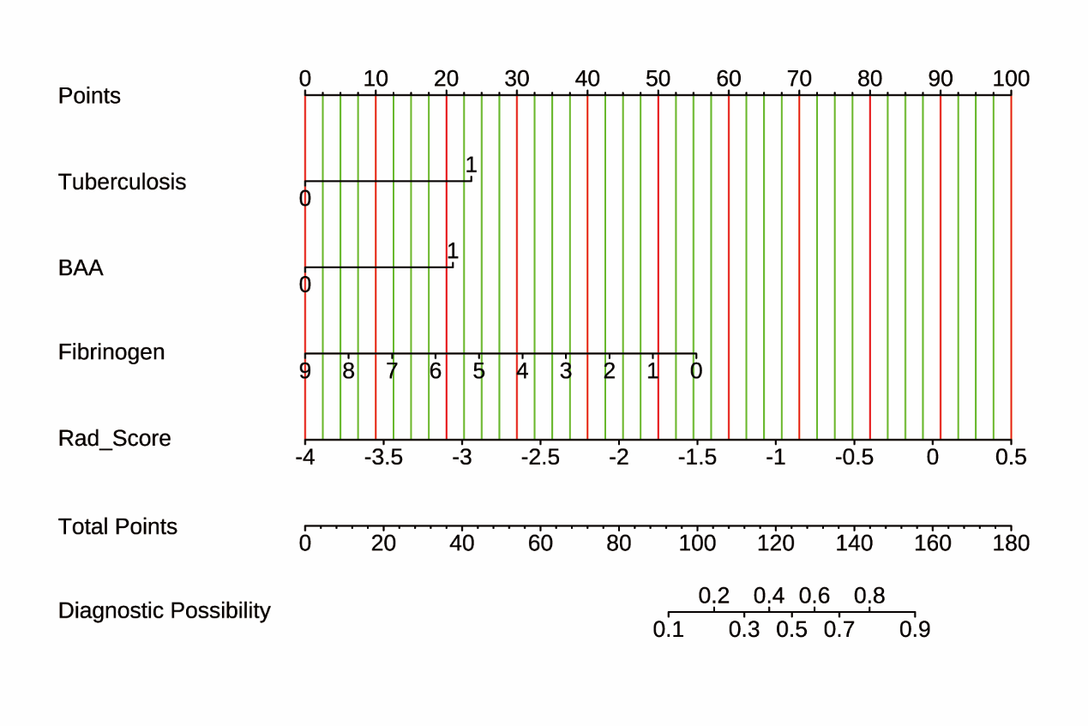
Fig.5 Nomogram developed to differential diagnosis and risk stratification of hemoptysis. The nomogram was developed based on the multivariable logistic regression model incorporating tuberculosis, bronchial artery abnormality (BAA), fibrinogen, and Rad-score. For each patient, the value of each predictor is projected upward to the “Points” axis to obtain the corresponding score. The individual scores are summed to obtain the total points, which are then projected downward to estimate the predicted probability of massive hemoptysis.

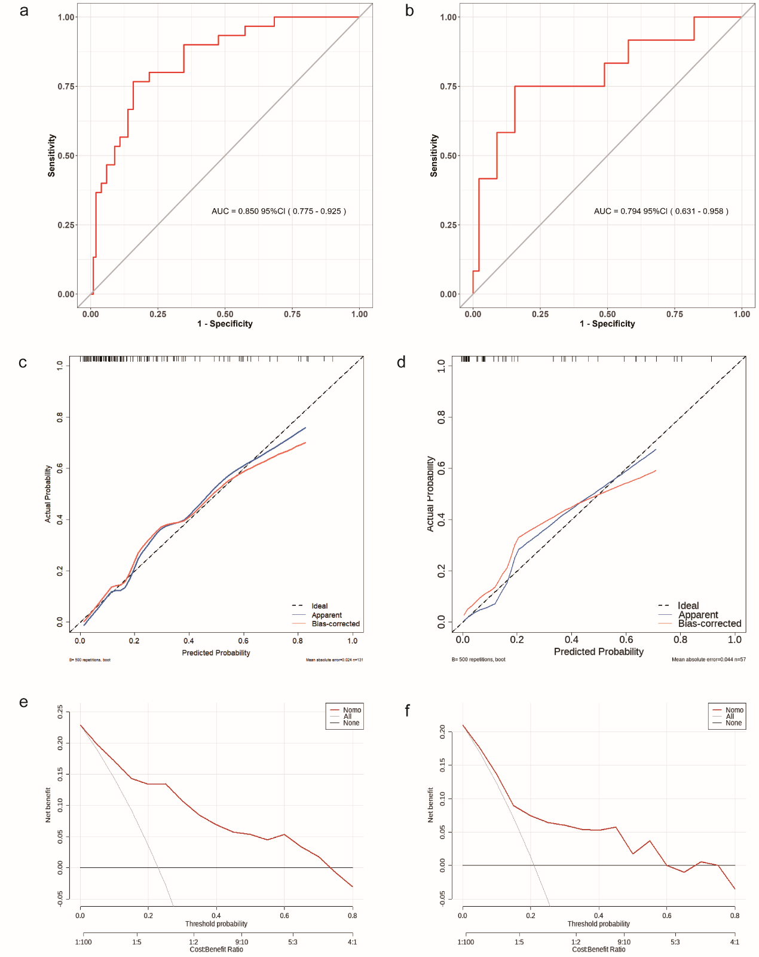
Fig.6 Evaluation of the predictive performance of the clinical-radiomics nomogram.

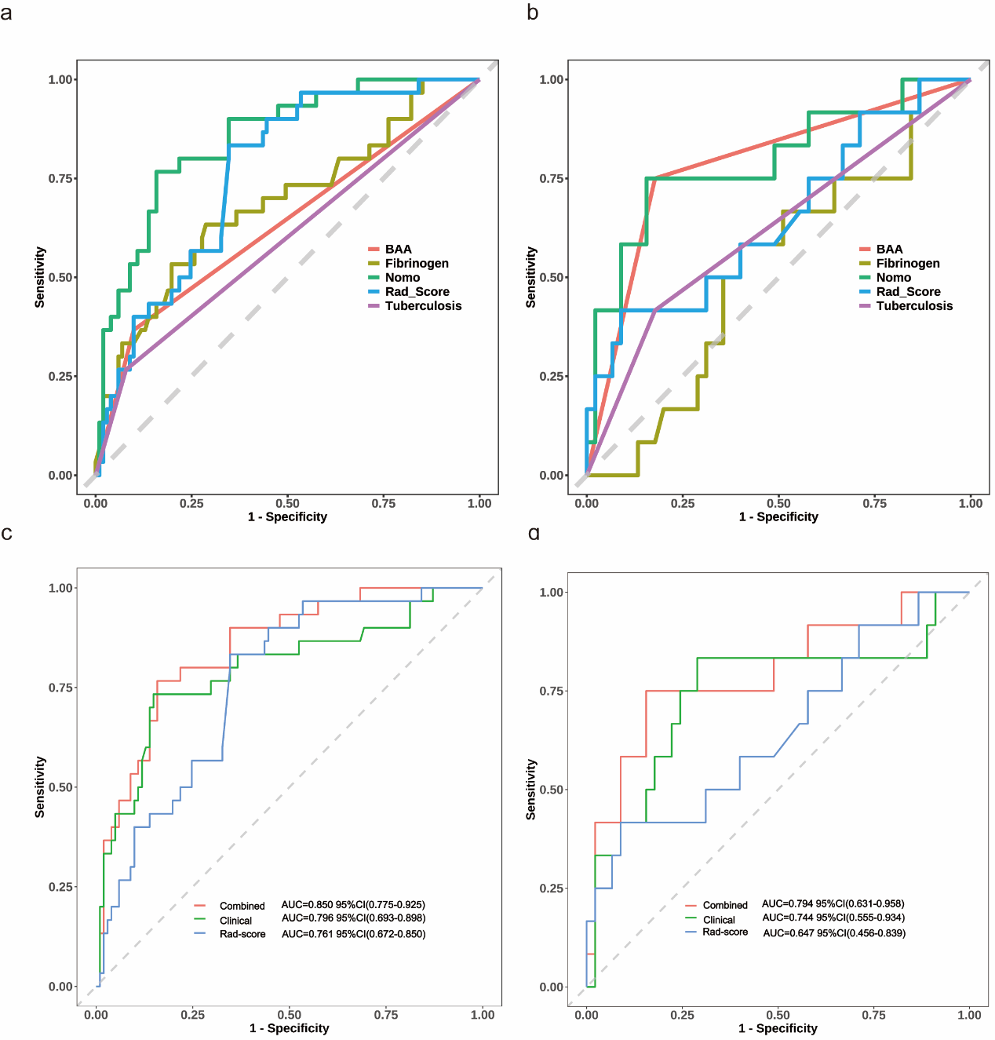
Fig.7 Rationality analysis: Area Under the Curve (AUC) of various influencing factors and Multi-model comparison. (a,c) training cohort ;(b,d)validation cohort.

