**Dav centanury college**

**N.I.T ( FARIDABAD )**

**PRACTICAL FILE ON**



**Object Technology and Programming using Java .**

**SUBMITED BY: SUMITTED To:**

**Aniket Chauhan Mrs uttama MAMBCA 3rd year ROLLNO:**

**SEM : 6TH SEMESTER 1221783011117**

**BCA – 6THSem**

**Object Technology and Programming using Java (Practical Assignment)**

|  |  |  |  |  |
| --- | --- | --- | --- | --- |
| **Sno.** | **Index** |  | **Date** | **sign** |
| **1.** | **WAP to input two number from CommandLine argument.** |  |  |  |
| **2.** | **WAP to input N number Scanner class & print maxi ,minimum and average.** |  |  |  |
| **3.** | **WAP to input 10 number in an array using Scanner class and print first , second &v third largest .** |  |  |  |
| **4.** | **WAP to 10 Element in array and perform bubble sort.** |  |  |  |
| **5.** | **WAP to input in 3X3 matrix and print the row sum and column sum.** |  |  |  |
| **6.** | **WAP to Create a customer class having customer name , purchase and paid . Create constructor to initialize the detail and method to print the pending amountof spe-cific customer.** |  |  |  |
| **7.** | **WAP to Create a Bank class.**  **Perform deposit , withdrawn& display operation** |  |  |  |
| **8.** | **WAP to implement multilevel inheritance and also use the super keyword.** |  |  |  |
| **9.** | **WAP to Create an interface named Stack. Add necessary method and implement these in class.** |  |  |  |
| **10.** | **WAP to Create a class for handling various exceptions as ArithmeticException , ArrayIndexOutBoundException.** |  |  |  |
| **11.** | **WAP to Create your own Exception named AgeException , which checks for specific age for voting in elections.** |  |  |  |
| **12.** | **WAP to implement the concept of user defined packages.** |  |  |  |
| **13.** | **WAP to Create multiple threads using a.) Thread class b.) Runnable interface.** |  |  |  |
| **14.** | **WAP to implement file handling using read and write operations.** |  |  |  |
| **15.** | **WAP to input a string & perform various String operations using String methods.** |  |  |  |

1. **WAP to input two number from command Line argument and perform addition , subtraction , multiplication & division operations.**

**class Cmdlarg{**

**public static void main(String s[ ])**

**{**

**int a=Integer.parseInt(s[0]);**

**int b=Integer.parseInt(s[1]);**

**System.out.println("Addition of number :" +(a+b));**

**System.out.println("Subtract of number :" +(a-b));**

**System.out.println("Multiply of number :" +(a*b));**

**System.out.println("division of number :" +(a/b));**

**}**

**}**

**Output :**

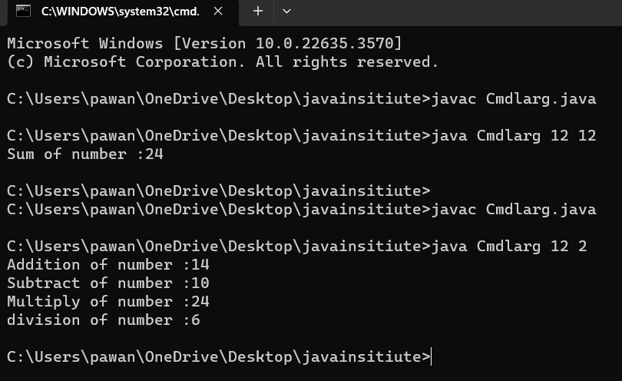

1. **WAP to input N number using Scanner class & print maximum , minimum and average .**

* Programs ………………….

import java.util.*;

class Scannerinput{

public static void main(String args[ ]) {

int sum = 0;

int inputNum;

int counter;

float average;

double Max = 0;

double Min = 101;

Scanner NumScanner = new Scanner(System.in);

Scanner charScanner = new Scanner(System.in);

System.out.println("Enter the total number of exams you want a average");

counter = NumScanner.nextInt();

System.out.println("Please enter " + counter + " numbers:");

for(int i = 1; i<=counter ;i++)

{

inputNum = NumScanner.nextInt();

sum = sum + inputNum;

System.out.println();

if(inputNum > Max){

Max = inputNum;

}

if(inputNum < Min){

Min = inputNum;

}

if(inputNum > -1 && inputNum < 101){

sum = sum + inputNum;

}

else{

System.out.println("You entered a number that wasn't in the range of 0 to 100");

}

}

average = sum / counter;

System.out.println("Maximum number is :" +Max);

System.out.println("Maximum number is :" +Min);

System.out.println("Average number is :" +average);

}

}

**OUTPUT:**

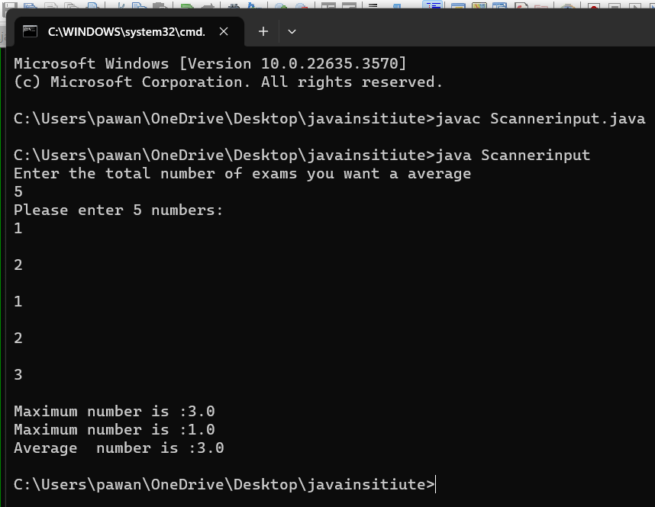

1. **WAP to input 10 number in array using Scanner class and print first , Second & third largest .**

import java.util.*;

class FindLargest{

public static void main(String s[]){

Scanner scanner = new Scanner(System.in);

int numbers[]=new int [10];

System.out.println("Enter 10 numbers:");

for(int i=0;i<10;i++){

numbers[i]=scanner.nextInt();

}

int first=Integer.MIN_VALUE;

int second= Integer.MIN_VALUE;

int third= Integer.MIN_VALUE;

for(int number:numbers){

if(number>first){

third=second;

second=first;

first=number;

}

else if(number>second&&number!=first){

third=second;

second=number;

}

else if(number>third&&number!=first&&number!=second){

third=number;

}

}

System.out.println("First largest" +first);

System.out. println("Second largest" +second);

System.out.println("Third largest" +third);

scanner.close();

}

}

**OUTPUT :**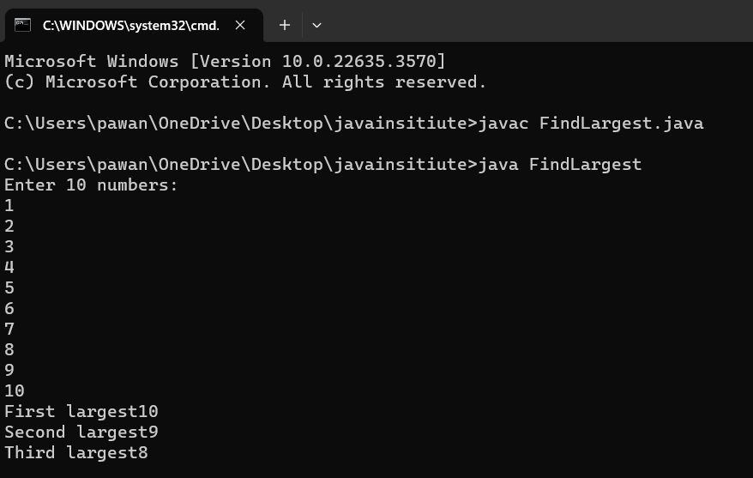

1. **WAP to 10 Element in array and perform bubble sort.**

**import java.util.*;**

**public class BubbleSort**

**{**

**public static void main(String args[]) {**

**Scanner in = new Scanner(System.in);**

**System.out.println("Enter the how maney number sort :");**

**int n =in.nextInt();**

**int arr[] = new int[n];**

**System.out.println("Enter the elements of the array:");**

**for (int i = 0; i < n; i++) {**

**arr[i] = in.nextInt();**

**}**

**//Bubble Sort**

**for (int i = 0; i < n - 1; i++) {**

**for (int j = 0; j < n - i - 1; j++) {**

**if (arr[j] < arr[j + 1]) {**

**int t = arr[j];**

**arr[j] = arr[j+1];**

**arr[j+1] = t;**

**}**

**}**

**}**

**System.out.println("Sorted Array:");**

**for (int i = 0; i < n; i++) {**

**System.out.print(arr[i] + " ");**

**}**

**}**

**}**

**OUTPUT:-**

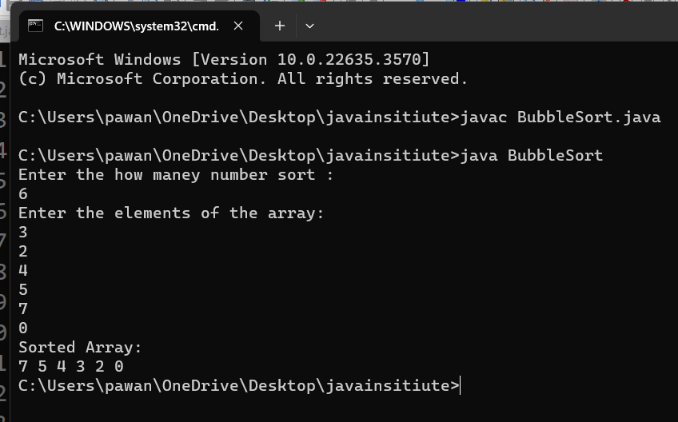

1. **WAP to input in 3X3 matrix and print the row sum and column sum.**

**import java.util.*;**

**class Matrix{**

**public static void main(String s[ ]){**

**Scanner scan = new Scanner(System.in);**

**int array[][]=new int[3][3];**

**System.out.println("Enter the 3X3 matrix :");**

**for(int i=0;i<3;i++)**

**{**

**for(int j=0; j<3; j++){**

**array[i][j]=scan.nextInt();**

**}**

**}**

**System.out.println("The 3X3 matrix :");**

**for(int i=0;i<3;i++)**

**{**

**for(int j=0; j<3; j++){**

**System.out.print(array[i][j]);**

**System.out.print("\t");**

**}**

**System.out.println();**

**}**

**int sum=0;**

**System.out.println("Row wise Sum :-");**

**for(int i=0;i<3;i++)**

**{ int r=0;**

**for(int j=0;j<3;j++){**

**sum=sum+array[i][j];**

**r = r + array[i][j];**

**}**

**System.out.println("Row" +(i+1)+"sum of row " +r);**

**}**

**System.out.println("Column wise Sum :-");**

**for(int i=0;i<3;i++)**

**{ int c=0;**

**for(int j=0;j<3;j++){**

**c = c + array[i][j];**

**}**

**System.out.println("Column" +(i+1)+"sum of row " +c);**

**}**

**}**

**}**

**OUTPUT:-**

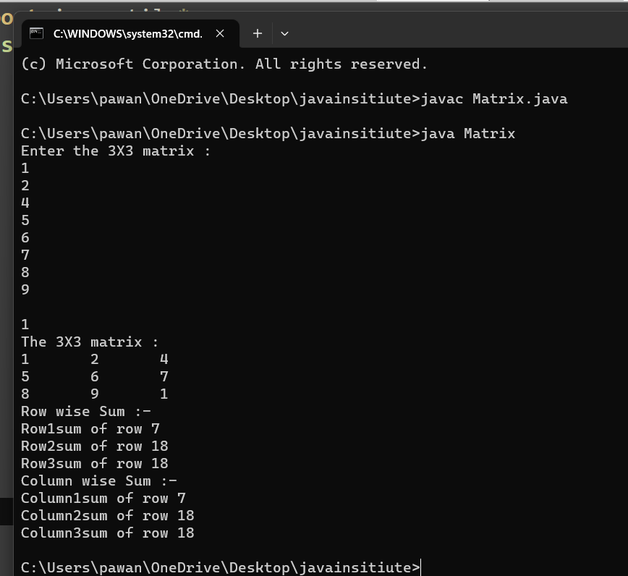

1. **WAP to Create a customer class having customer name , purchase and paid . Create constructor to initialize the detail and method to print the pending amountof spe-cific customer.**

**import java.util.*;**

**class Customer{**

**String customerName ;**

**double purchaseAmount;**

**double amountPaid;**

**public Customer(String customerName,double purchaseAmount,double amountPaid)**

**{**

**this.customerName=customerName;**

**this.purchaseAmount=purchaseAmount;**

**this.amountPaid=amountPaid;**

**}**

**public void displayPendingAmount(){**

**double pendingAmount = purchaseAmount-amountPaid;**

**System.out.println("Customer Name : " +customerName);**

**System.out.println("Pending Amount :" +pendingAmount);**

**}**

**public static void main(String s[ ]){**

**Scanner scan=new Scanner(System.in);**

**System.out.println("Enter the Customer Name :");**

**String name=scan.nextLine();**

**System.out.println("Enter the Purchase Amount :");**

**int pAmount=scan.nextInt();**

**System.out.println("Enter the Paid Amount :");**

**int paid=scan.nextInt();**

**Customer customer1 =new Customer(name,pAmount,paid);**

**customer1.displayPendingAmount();**

**} }**

**OUTPUT:-**

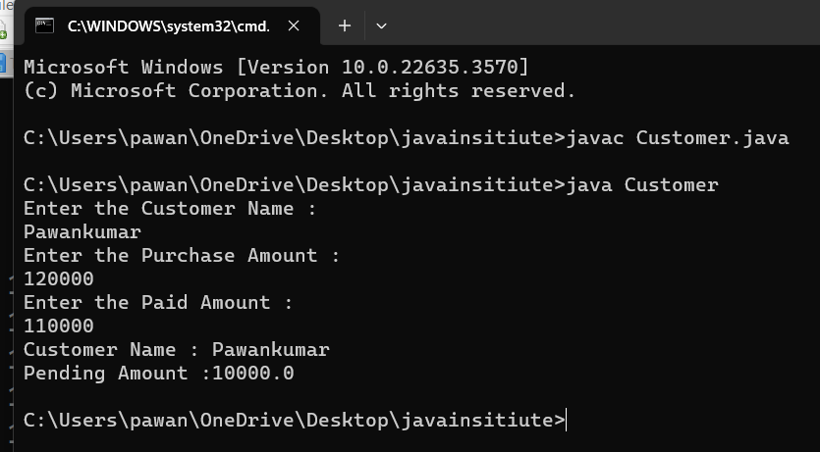

1. **WAP to Create a Bank class. Perform deposit , withdrawn& display operation.**

**import java.util.*;**

**class Bank{**

**public void BankD(){**

**Scanner scan=new Scanner(System.in);**

**System.out.println("Enter the CustomerName :");**

**String customerName =scan.nextLine();**

**System.out.println("Enter the your Deposit Amount :");**

**int depositAmount=scan.nextInt();**

**System.out.println("Enter the Withdraw Money :");**

**int withdraw=scan.nextInt();**

**int withdraw1=depositAmount-withdraw;**

**System.out.println("===============================================");**

**System.out.println("Customer Name :" +customerName);**

**System.out.println("Your Deposit Amount " +depositAmount);**

**System.out.println("Your Withdraw Amount " +withdraw);**

**System.out.println("Your Total Balance :"+withdraw1);**

**}**

**public static void main(String b[ ]){**

**Bank bank1=new Bank();**

**bank1.BankD();**

**}**

**}**

**OUTPUT:-**

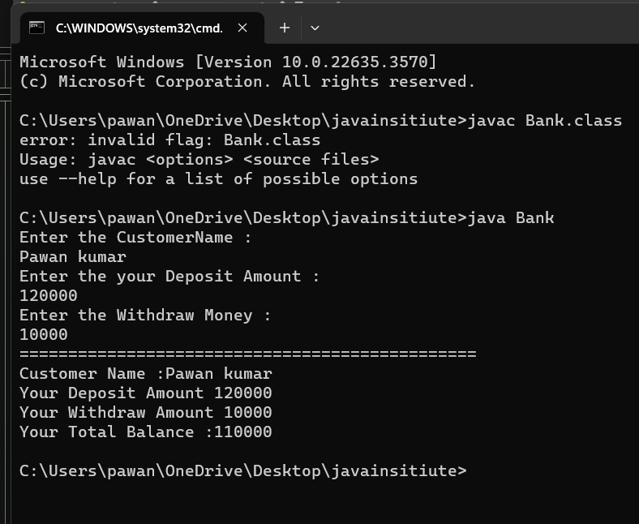

1. **WAP to implement multilevel inheritance and also use the super keyword.**

**import java.util.*;**

**class Grandparent{**

**String name;**

**Grandparent( String name ){**

**this.name=name;**

**System.out.println("Grandparent constructor called ");**

**}**

**void display(){**

**System.out.println("Grandparent name :" +name);**

**}**

**}**

**class Parent extends Grandparent{**

**int age ;**

**Parent(String name , int age ){**

**super(name);**

**this.age=age;**

**System.out.println("Parent constructor called");**

**}**

**void display(){**

**super.display();**

**System.out.println("Parent age :"+age);**

**}**

**}**

**class Child extends Parent{**

**String profession;**

**Child(String name, int age,String profession){**

**super(name,age);**

**this.profession=profession;**

**System.out.println("Child constructor called");**

**}**

**void display(){**

**super.display();**

**System.out.println("Child profession :" +profession);**

**}**

**}**

**public class Inheritance{**

**public static void main(String s[ ]){**

**Scanner scan=new Scanner(System.in);**

**System.out.println("Enter the Grandparent name :");**

**String name1=scan.nextLine();**

**System.out.println("Enter the Parent age :");**

**int age1=scan.nextInt();**

**Scanner scan1=new Scanner(System.in);**

**System.out.println("Enter the Child profession :");**

**String profession1=scan1.nextLine();**

**Child child=new Child(name1,age1,profession1);**

**child.display();**

**} }**

**OUTPUT:-**

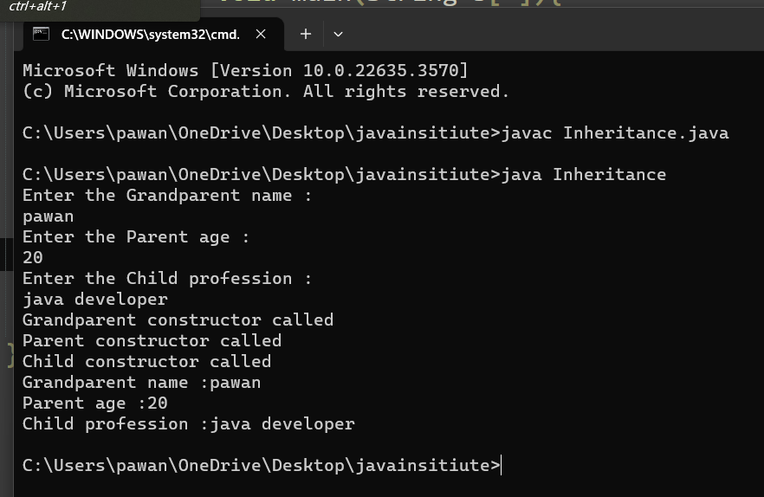

1. **WAP to Create an interface named Stack. Add necessary method and implement these in class.**

**// Stack implementation in Java**

**class Stack {**

**// store elements of stack**

**private int arr[];**

**// represent top of stack**

**private int top;**

**// total capacity of the stack**

**private int capacity;**

**// Creating a stack**

**Stack(int size) {**

**// initialize the array**

**// initialize the stack variables**

**arr = new int[size];**

**capacity = size;**

**top = -1;**

**}**

**// push elements to the top of stack**

**public void push(int x) {**

**if (isFull()) {**

**System.out.println("Stack OverFlow");**

**// terminates the program**

**System.exit(1);**

**}**

**// insert element on top of stack**

**System.out.println("Inserting " + x);**

**arr[++top] = x;**

**}**

**// pop elements from top of stack**

**public int pop() {**

**// if stack is empty**

**// no element to pop**

**if (isEmpty()) {**

**System.out.println("STACK EMPTY");**

**// terminates the program**

**System.exit(1);**

**}**

**// pop element from top of stack**

**return arr[top--];**

**}**

**// return size of the stack**

**public int getSize() {**

**return top + 1;**

**}**

**// check if the stack is empty**

**public Boolean isEmpty() {**

**return top == -1;**

**}**

**// check if the stack is full**

**public Boolean isFull() {**

**return top == capacity - 1;**

**}**

**// display elements of stack**

**public void printStack() {**

**for (int i = 0; i <= top; i++) {**

**System.out.print(arr[i] + ", ");**

**}**

**}**

**public static void main(String[] args) {**

**Stack stack = new Stack(5);**

**stack.push(1);**

**stack.push(2);**

**stack.push(3);**

**stack.push(4);**

**stack.push(5);**

**System.out.print("Stack: ");**

**stack.printStack();**

**// remove element from stack**

**stack.pop();**

**System.out.println("\nAfter popping out");**

**stack.printStack();**

**}**

**}**

**Output :-**

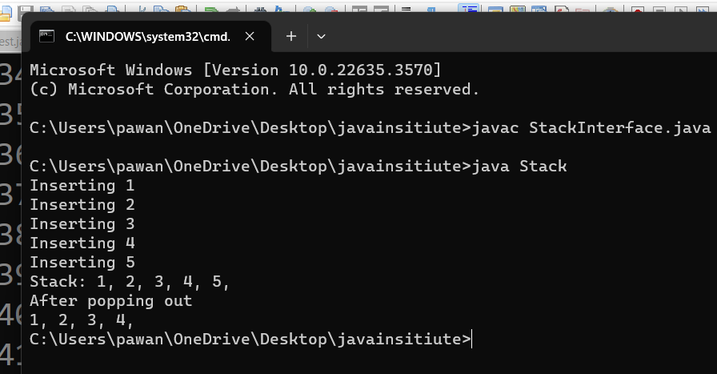

1. **WAP to Create a class for handling various exceptions as ArithmeticException ,ArrayIndexOutBoundException.**

**// Java Program to Handle multiple exception**

**import java.io.*;**

**class GFG {**

**public static void main(String[] args)**

**{**

**try {**

**int number[] = new int[20];**

**number[21] = 30 / 9;**

**// this statement will throw**

**// ArrayIndexOutOfBoundsException e**

**}**

**catch (ArrayIndexOutOfBoundsException**

**| ArithmeticException e) {**

**System.out.println(e.getMessage());**

**}**

**} }**

**OUTPUT:-**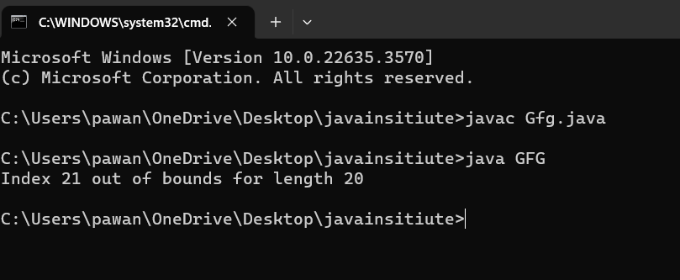

1. **WAP to Create your own Exception named Age Exception , which checks for specific age for voting in elections.**

**import java.util.*;**

**class InvalidAgeException extends Exception**

**{**

**InvalidAgeException(String msg){**

**System.out.println(msg);**

**}**

**}**

**class Vote{**

**public static void main(String [ ] as){**

**Scanner scan=new Scanner(System.in);**

**System.out.println("Enter the your Name :");**

**String name=scan.nextLine();**

**System.out.println("Enter the your Age :");**

**int age=scan.nextInt();**

**try**

**{**

**vote(name,age);**

**}**

**catch(Exception e){**

**System.out.println(e);**

**}**

**}**

**public static void vote( String name,int age) throws InvalidAgeException**

**{**

**if(age<18){**

**throw new InvalidAgeException(name+"\t Not eligible for voting");**

**}**

**else {**

**System.out.println(name+"\tEligible for voting ");**

**}**

**}**

**}**

**OUTPUT:-**

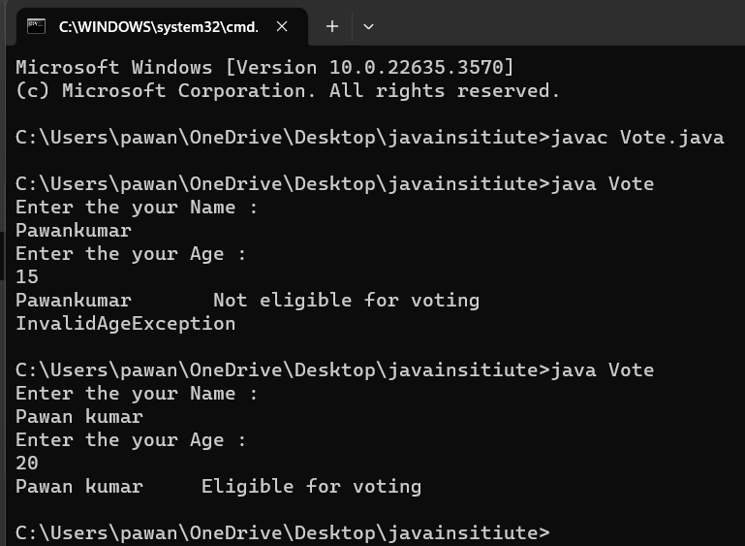

1. **WAP to implement the concept of user defined packages.**

package pawan;

class A

{

private void show(){

System.out.println("Hello world !");

}

public static void main(String as[]){

A r=new A();

r.show();

}

}

**OUTPUT:-**

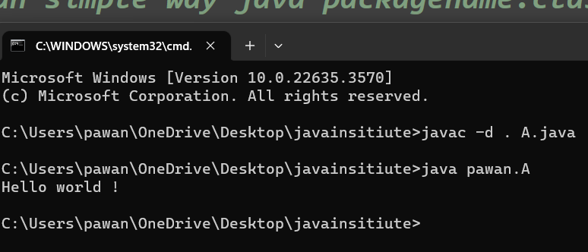

1. **WAP to Create multiple threads using a.) Thread class b.) Runnable interface.**

class t1 implements Runnable{

@Override

public void run(){

System.out.println("Thread is running ");

}

}

public class ClassName{

public static void main(String[ ] as){

t1 obj1=new t1();

Thread t=new Thread(obj1);

t.start();

}

}

**OUTPUT:-**

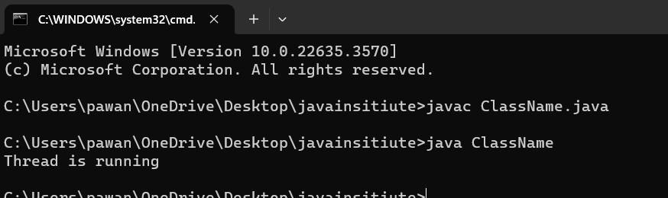

1. **WAP to implement file handling using read and write operations.**

**CreateFile 🡺**

**import java.io.*;**

**class FileHandling**

**{**

**public static void main(String as[])throws IOException**

**{**

**Filef=newFile("C:\\Users\\pawan\\OneDrive****\\Desktop****\\javainsitiute\\Pb4.txt");**

**if(f.createNewFile())**

**{**

**System.out.println("File successfully Create...!");**

**}**

**else**

**{**

**System.out.println("File Already Exist..!");**

**}**

**}**

**}**

**Create file output:-**

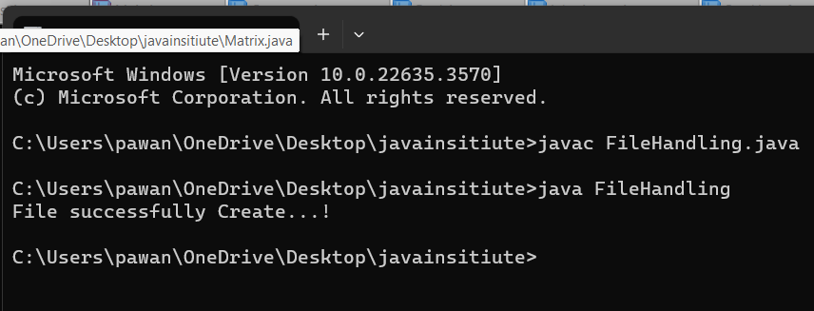

**Write on File🡺**

**import java.io.*;**

**class FileHandling**

**{**

**public static void main(String as[])throws IOException**

**{**

**try**

**{**

**FileWriter f=new FileWriter("C:\\Users****\\pawan\\****OneDrive\\Desktop\\www.txt");**

**try{**

**f.write("Java Programming is the best Language...!");**

**}**

**finally**

**{**

**f.close();**

**}**

**System.out.println("Successfully Data Wrote in File...!");**

**}**

**catch(IOException i)**

**{**

**System.out.println(i);**

**}**

**}**

**}**

**Write in File :**

**OUTPUT:-**

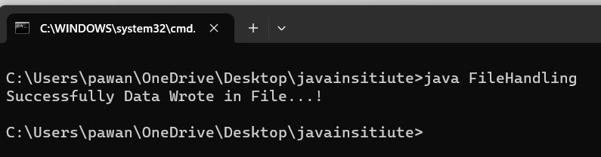

**File in wrote:-**

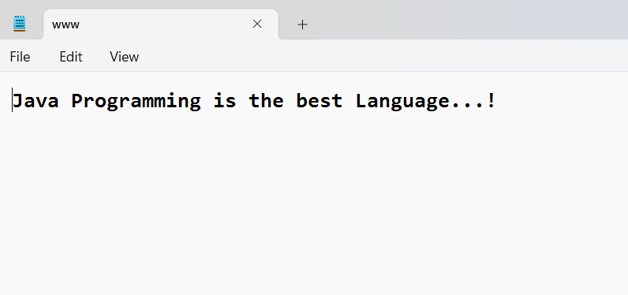

**Readfile operation Perform:-**

**import java.io.*;**

**import java.util.*;**

**class Readtest{**

**public static void main(String args[]) throws FileNotFoundException{**

**File f=new File("C:\\Users\\pawan\\OneDrive\\Desktop\\www.txt");**

**Scanner scan=new Scanner(f);**

**while(scan.hasNextLine()){**

**System.out.println(scan.nextLine());**

**}**

**}**

**}**

**OUTPUT :-**

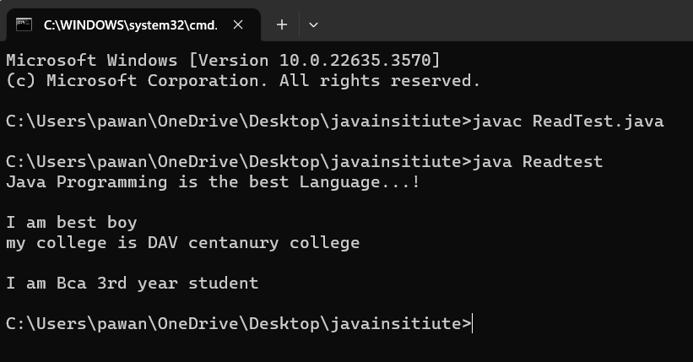

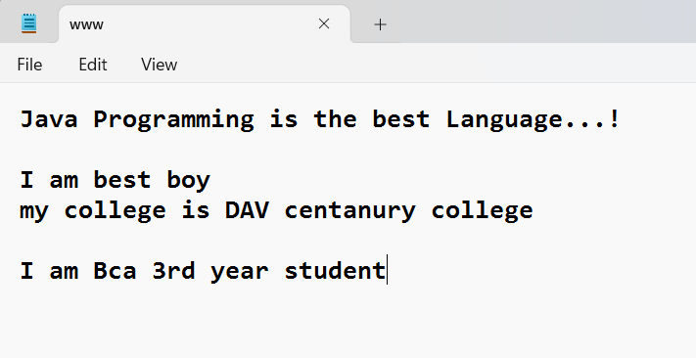

1. **WAP to input a string & perform various String operatio -ns using String methods.**

/*string methods*/

import java.util.*;

class B

{

public static void main(String as[])

{

Scanner scan=new Scanner(System.in);

System.out.println("Enter the Capital String : " );

String a=scan.nextLine();

System.out.println("Enter the small String :");

String b=scan.nextLine();

System.out.println("Lower case :"+a.toLowerCase());

System.out.println("Upper case :"+b.toUpperCase());

System.out.println("Merge case :"+b.concat(a));

System.out.println("Check for Size :"+b.length());

String c=" Pawan ";

String d="";

System.out.println("Trim case :"+c.trim());

System.out.println("Empty case :"+d.isEmpty());

System.out.println("charAt case :"+b.charAt(2));

System.out.println("Index case :"+c.indexOf('a'));

System.out.println("Equal case :"+b.equals(a));

System.out.println("replace case:"+c.replace('P','R'));

}

}

**OUTPUT:-**

