Crowdfunding Analysis

# Given the data, what are three conclusions that we can draw about crowdfunding campaigns?

Most of the campaigns in this dataset have either a funding goal less than 10,000 or more than 50,000 in the local currencies (Figure 1).

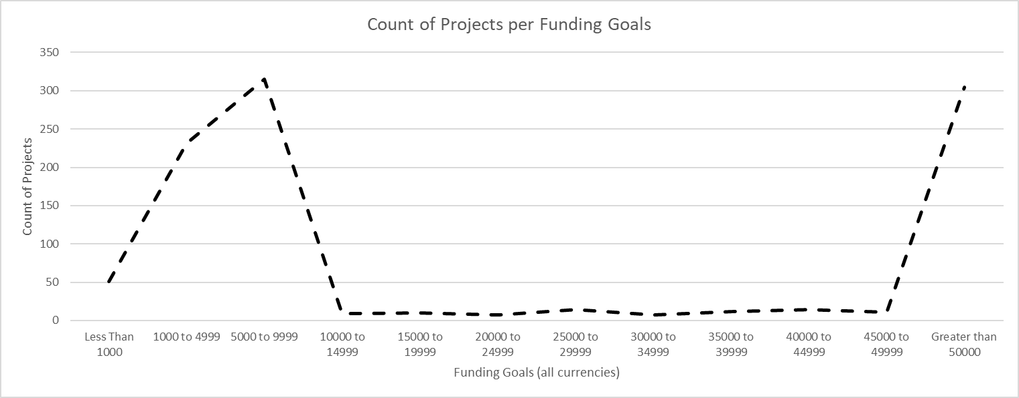

Figure : Number of projects as a function of the funding goal.

The Top Three categories in this dataset are Theater, Film & Video, and Music (Figure 2).

With the exception of the Journalism campaigns that can be considered as outliers (only four campaigns all located in the US), the percentages of the failed and canceled campaigns are in the 30% to 51% range across the categories (Figure 3), which indicates a weak correlation between the outcome and the category of the project.

|  |  |
| --- | --- |
| Figure : Counts of the number of campaigns and their outcomes per category | Figure : Outcome of crowdfunding campaigns per categories (live campaigns and the Journalism category have been excluded from the graph) |

# What are some limitations of this dataset?

This dataset is dominated with projects from the United States (76.3%). The individual contributions of the other six countries are less than 5% (Table 1) and some of them might not be statistically representative.



Table . Origin of the projects in the dataset

The high percentages of successful campaigns in the 15,000 to 35,000 funding goal range do not take into account that the number of projects in the corresponding bins is very small (Figure 4).

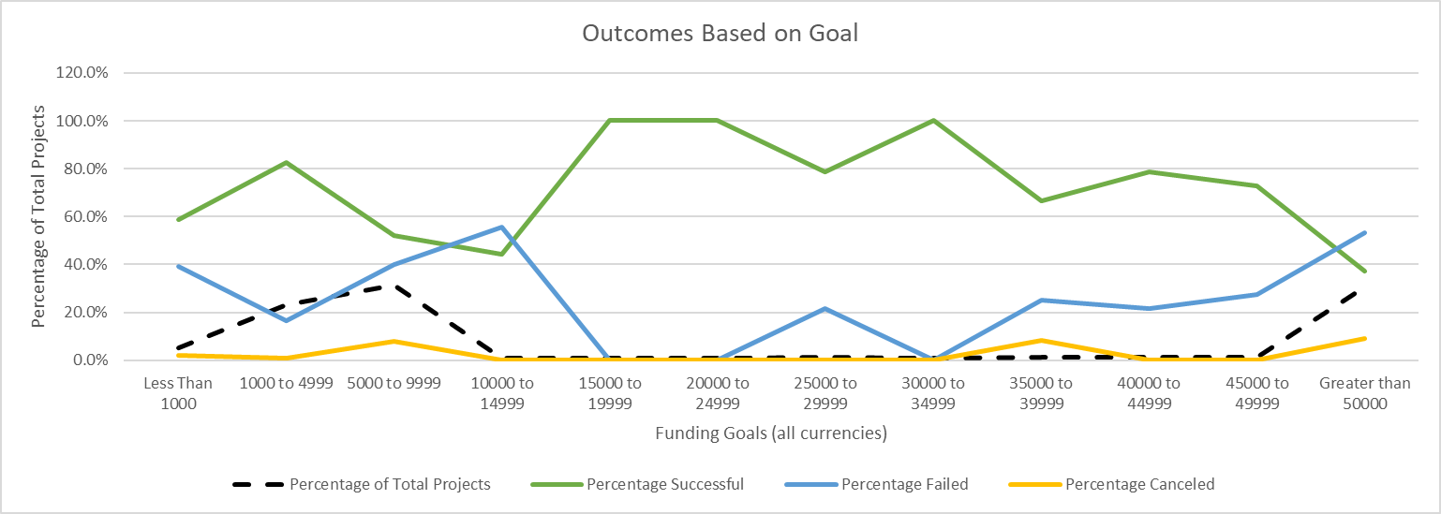

Figure : Project Outcome as a function of the Funding Goal

The dataset is not corrected for the exchange rate between the different currencies (Table 2), which invalidates conclusions based on the binning of funding.

|  |  |  |  |  |  |
| --- | --- | --- | --- | --- | --- |
| 1.55 AUD | 1.36 CAD | 0.89 CHF | 6.92 DKK | 0.93 EUR | 0.79 GBP |

Table : Exchange rate for 1 USD as of 9/2/2023 (Source Google)

The combination of these two last limitations makes impossible to infer if the funding goal can be a predictor of the success of a campaign.

# What are some other possible tables and/or graphs that we could create, and what additional value would they provide?

We could have looked if this list included professional fundraisers that might have the experience and the organization to drive projects with a higher success rate. The dataset only indicates 24 entries with more than one projects, and the numbers are too small to draw conclusions (Table 3).



Table : Fundraisers with more than 1 project

We could also have investigated if the funding goal could be a predictor of the success of the campaign by limiting the study to the US (76.3% of the projects measured with a unique currency). Such a correlation does not exist over the full range of the funding goals (Figure 5), but could be true for the goals less than $10,000 where the odds for a successful campaign show to be more favorable (Figure 6).

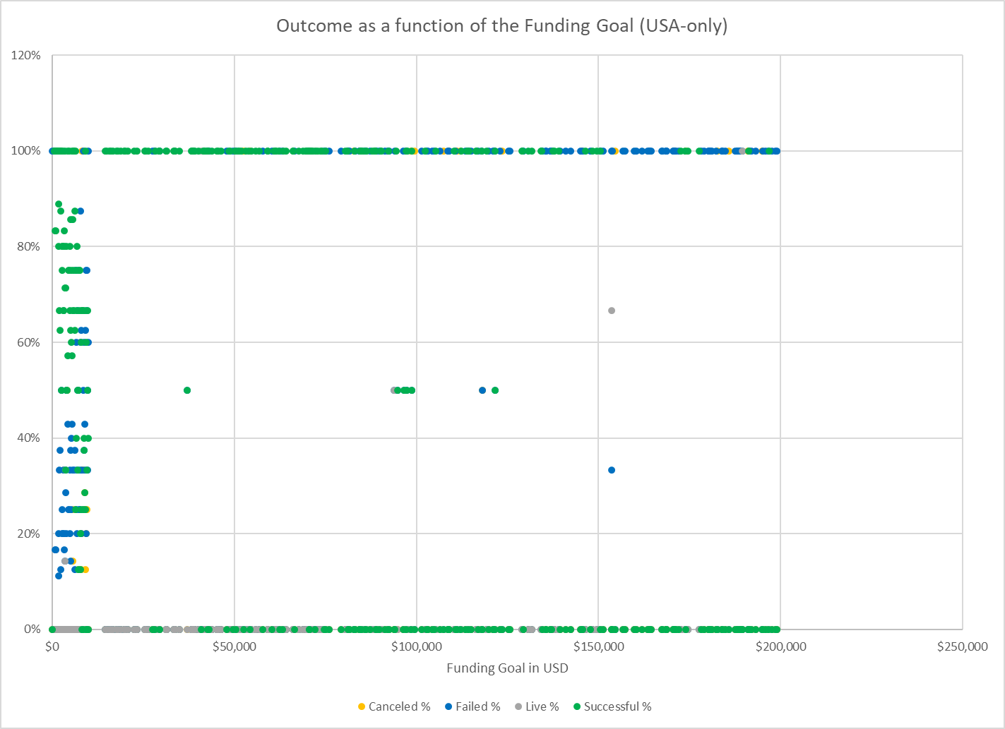

Figure : Outcome as a function of the initial funding goal (US data only)

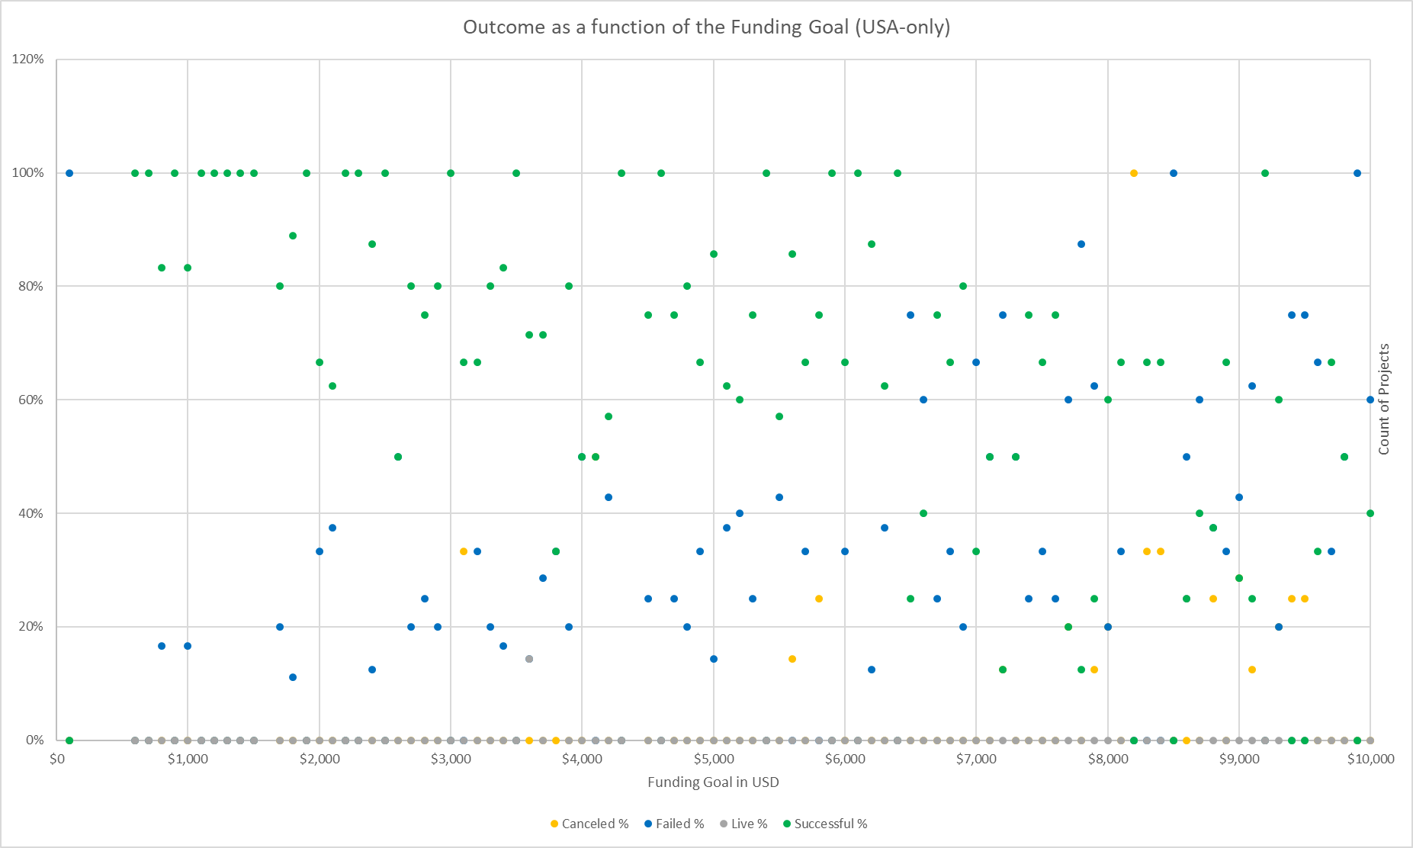

Figure : Outcome as a function of the initial funding when <$10,000

More investigations could have been done to evaluate the impact on the outcome of the length of the funding period, and of the possible boost effect to be a Staff Pick or to be spotlighted.