Electronic Supplementary Information

Synthesis of fibrous monodisperse core–shell Fe₃O₄/SiO₂/KCC-1
Kejie Yu, Xuebin Zhang, Hongwu Tong, Xiangyan Yan, Shaomin Liu*
Department of Chemistry, University of Science and Technology of China, Hefei, 230026, P.R. China, Hefei, Anhui, 230026, China, Fax: +86 551 63492147; Tel: +86 551 63492147,
E-mail: liusm@ustc.edu.cn.

Part 1. Synthesis and Characterizations section
Tab.S1. The molar ratios of the reactants for the synthesis of Fe₃O₄/SiO₂/KCC-1
Materials | TEOS (mmol) | CPB (mmol) | TEOS/CPB
Fe₃O₄/SiO₂/KCC-1-a | 3.40 | 1.3 | 2.6
Fe₃O₄/SiO₂/KCC-1-b | 5.60 | 1.3 | 4.3
Fe₃O₄/SiO₂/KCC-1-c | 7.85 | 1.3 | 6.0
Fe₃O₄/SiO₂/KCC-1-d | 10.09 | 1.3 | 7.8
Fe₃O₄/SiO₂/KCC-1-e | 2.80 | 0.65 | 4.3
Fe₃O₄/SiO₂/KCC-1-f | 11.22 | 2.6 | 4.3

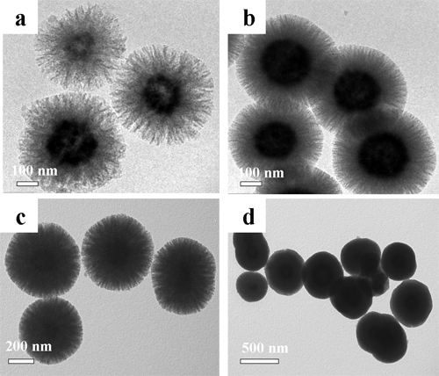

Fig.S1. The morphology of Fe₃O₄/SiO₂/KCC-1 when added different amounts of TEOS, and CPB (0.5g) was constant. (a) Fe₃O₄/SiO₂/KCC-1-a. (b) Fe₃O₄/SiO₂/KCC-1-b. (c) Fe₃O₄/SiO₂/KCC-1-c. (d) Fe₃O₄/SiO₂/KCC-1-d.
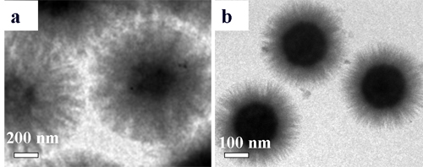
Fig.S2. Comparation of the length of the fibrous layer when the ratio of TEOS/CPB was constant. (a) Fe₃O₄/SiO₂/KCC-1-e. (b) Fe₃O₄/SiO₂/KCC-1-f.
Part 2. Adsorption experiment section
Adsorption isotherms
Both Langmuir and Freundlich isotherm models were used to fit the adsorption data for MB on the absorbents. Langmuir isotherm is represented as:
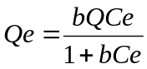 (1)
where Qe is the adsorption amount of materials for MB (mg g^{–1}) and Ce is the equilibrium concentration (mg L^{–1}); b is the constant related to the free energy of adsorption (L mg^{–1}), Q (mg g^{–1}) is the maximum adsorption capacity.
Freundlich isotherms:
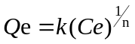 (2)
where k is the Freundlich constant representing of the adsorption capacity of the adsorbent (mg g^{–1}), 1/n is the adsorption intensity.
Tab.S2. Corresponding parameters of Langmuir and Freundlich isotherm models.
Sample | Isotherm model
Sample | Langmuir |  |  | Freundlich
Sample | b  (L mg^{–1}) | Q  (mg g^{–1}) | R² | k  (mg g^{–1}) | 1/n | R²
After calcined | 0.62 | 49.21 | 0.997 | 33.78 | 0.09 | 0.945
Before calcined | 0.10 | 47.43 | 0.995 | 12.54 | 0.30 | 0.942

Kinetic experiments
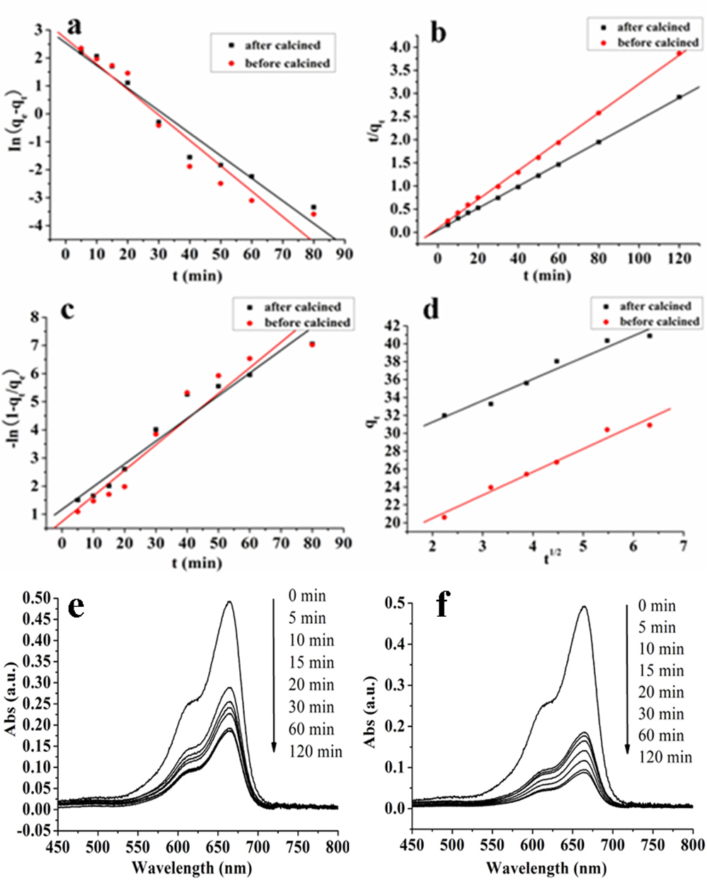
Fig.S3. Comparison of kinetic experimental data with model predictions: (a) fitted by pseudo-first order model. (b) fitted by pseudo-second order model. (c) fitted by liquid film diffusion model. (d) fitted by intraparticle diffusion model. UV–vis spectral of MB on Fe₃O₄/SiO₂/KCC-1 after different time intervals and all samples were diluted 20 times. (e) Fe₃O₄/SiO₂/KCC-1 before calcined. (f) Fe₃O₄/SiO₂/KCC-1 after calcined.

The dynamics model equation expressions are as follows:
Pseudo-first order model:
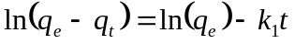 (3)
where k₁ (min^{–1}) is the first-level dynamics constant.
Pseudo-second order model:
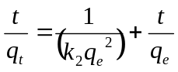 (4)
where k₂ (g (mg min) ^{–1}) is standard second-level dynamics speed constant. In the above dynamic equation, t (min) is the contact duration, q_{t} (mg g^{–1}) is the adsorption capacity of the materials at time t, q_{e} (mg g^{–1}) is the equilibrium adsorption capacity of materials for MB.
We found that both materials before and after calcined better fittd pseudo-second order model (Fig. S3b) with the R² is 0.999 and 1.0 (see Tab. S3) than pseudo-first order model (Fig. S3a). This indicated that adsorption mechanism for MB on Fe₃O₄/SiO₂/KCC-1 was not a single easy one. In addition, the adsorption capacities obtained from kinetic results, 32.07 and 41.95 mg g^{–1} for materials before and after calcined, respectively, were consistent with the results from experiment.
Tab.S3. Kinetic Parameters for the Adsorption of MB on Materials Fe₃O₄/SiO₂/KCC-1 before and after calcined.
Sample | C₀  (mg L^{–1}) | Kinetics model
Sample | C₀  (mg L^{–1}) | pseudo-first-order |  |  | pseudo-second-order
Sample | C₀  (mg L^{–1}) | q_{e}  (mg g^{–1}) | k₁  (min^{–1}) | R² | q_{e}  (mg g^{–1}) | k₂  g (mg min) ^{–1} | R²
After calcined | 50 | 12.69 | 0.081 | 0.953 | 41.95 | 0.013 | 1.0
Before calcined | 50 | 14.79 | 0.091 | 0.932 | 32.07 | 0.011 | 0.999

The fluid film diffusion model:
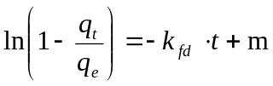 (5)
Where q_{e} (mg g^{–1}) is the equilibrium adsorptive capacity, q_{t} (mg g^{–1}) is adsorptive capacity at time t (min), m is the intercept, k_{fd} (h^{–1}) is the diffusion rate constant.
Then intraparticle diffusion model:
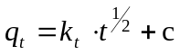 (6)
Where q_{t} (mg g^{–1}) is adsorptive capacity at time t (min), c is the intercept, k_{t} (mg (g min^{1/2})^{–1}) is the intraparticle diffusion rate constant, which was used for fitting the adsorption dynamics date before equilibrium.
According to the fluid film diffusion model, if the plot of - ln(1-q_{t}/q_{e}) vs. t presented as a straight line with a zero intercept, the kinetics of the sorption might be controlled by film diffusion process. The constants of fitting curve of Fe₃O₄/SiO₂/KCC-1 before and after calcined (Fig. S3c) for MB was 0.932 and 0.953 with the intercept of 0.74 and 1.17 (Tab. S4) instead of zero, which indicated the fluid film process was not the only rate-determining step and other factors might exist in the adsorption process. The point of fitted curve (Fig. S3d) and y axis was not at zero, showing intraparticle diffusion was not the only rate-determining step in adsorption process, either. However, the fitting constant R² is 0.976 and 0.963 of Fe₃O₄/SiO₂/KCC-1 before and after calcined fitted by intraparticle diffusion model, were larger than fluid film diffusion model. This indicated that in the adsorption process, the intraparticle diffusion was the main step accompanying fluid film diffusion process for controlling its adsorption rate.
Tab.S4. Diffusion Model Parameters for the Adsorption of MB on Materials Fe₃O₄/SiO₂/KCC-1 before and after calcined.
Sample | C₀  (mg L^{–1}) | Diffusion model
Sample | C₀  (mg L^{–1}) | fluid film diffusion |  |  | intraparticle diffusion
Sample | C₀  (mg L^{–1}) | m  (mg g^{–1}) | K_{fd}  (min^{–1}) | R² | c  (mg g^{–1}) | K_{t}  (mg (g min^{1/2})^{–1}) | R²
After calcined | 50 | –1.17 | 0.081 | 0.953 | 26.43 | 2.41 | 0.963
Before calcined | 50 | –0.74 | 0.091 | 0.932 | 15.35 | 2.58 | 0.976

