Week 1
Exploratory Data Analysis

About This Project
This project involved exploring and analysing an international student application dataset from the higher education sector. The dataset covered application cycles from 2023 to 2025 and contained approximately 7,500 records across 80 fields.
The work in Week 1 focused on three things: understanding the structure of the data, identifying quality issues that needed to be fixed, and extracting early patterns from the raw records. All findings in this report are provisional. Full data cleaning takes place in Week 2.
All institution names, applicant names, contact details, and identifying reference numbers have been removed from this version. The methodology, data quality findings, and analytical patterns are fully preserved.

~7,500  Total Records  raw dataset | 80  Data Fields  columns per record | ~10.7%  Duplicate Rate  identified in raw data

Note: All figures are based on raw, uncleaned data. They will be recalculated from the cleaned dataset in Week 2 and should be treated as directional only.

Section 1: What the Data Shows

Chart 1: Applicant Distribution by Region
Applications were heavily concentrated in South and Southeast Asia. The chart below shows raw application counts by country of origin across the 2023-2025 intake cycles. Counts include duplicates and will shift after cleaning.

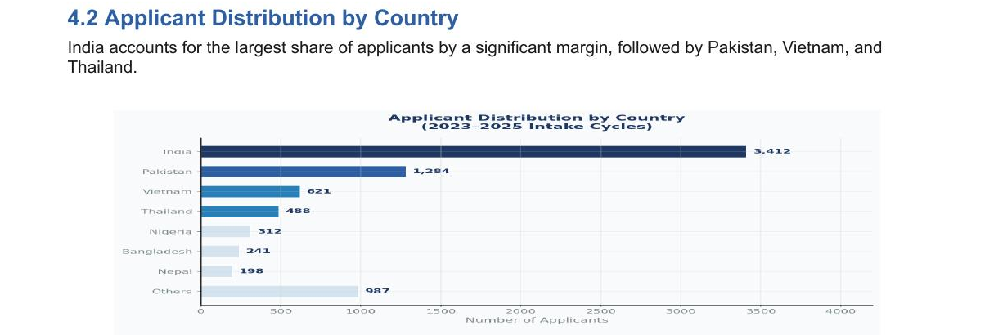

Finding
One country accounts for roughly 45% of all applications. Four countries combined represent over 70% of the total pool. This concentration likely reflects existing recruitment partnerships and counselor networks in those regions rather than the full scope of potential demand.

Chart 2: Program Preference Distribution
Technology and data-focused programs dominated applicant interest across all intake cycles. The chart below ranks programs by number of applications. Applicants selecting multiple programs are counted per selection.

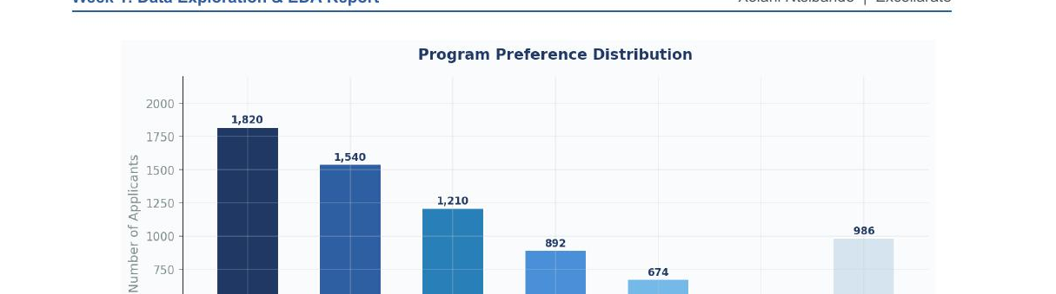

Finding
Three programs (Data Science at 24%, Artificial Intelligence at 20%, and Business Analytics at 16%) collectively account for 60% of all program selections. This aligns with global demand trends for analytical and technical skills and has direct implications for how recruitment messaging should be targeted.

Chart 3: Application Intake Distribution
Most applicants targeted Fall or Winter entry points. The pie chart below shows the share of applications by intake period. Spring is significantly underrepresented at just 5% of total volume.

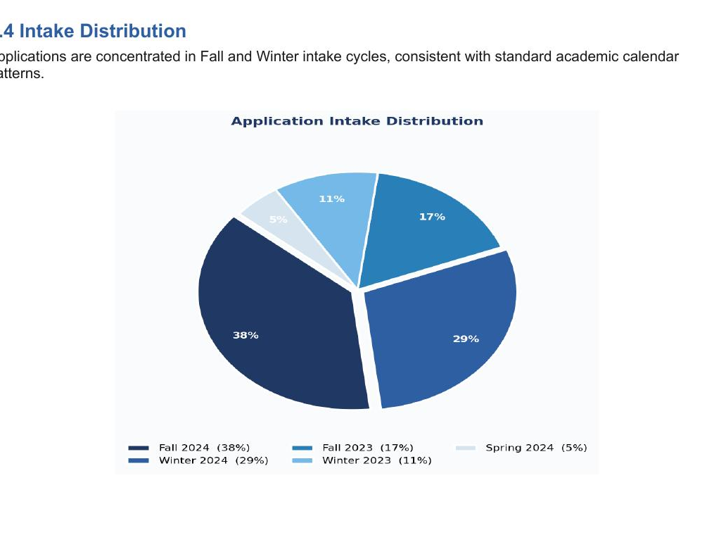

Finding
Fall (38%) and Winter (29%) together account for 67% of all applications. Spring sits at only 5%. This gap suggests applicants are either unaware of Spring entry options or have limited access to them. A targeted outreach review for Spring cycles is a clear opportunity.

Section 2: Data Quality Issues Found

Before any reliable reporting or modelling can happen, six categories of data problems need to be resolved. Each is explained below in plain terms, alongside what it blocks analytically.

Issue 1: Duplicate Records
Some applicants appeared in the dataset more than once with identical contact details, intake period, and email address. This is a system-level data capture problem, not a case of the same person applying twice.

Chart 4: Duplicate Record Distribution
The histogram below shows how many records exist per unique applicant. Most applicants have a single record. A subset appears up to five times.

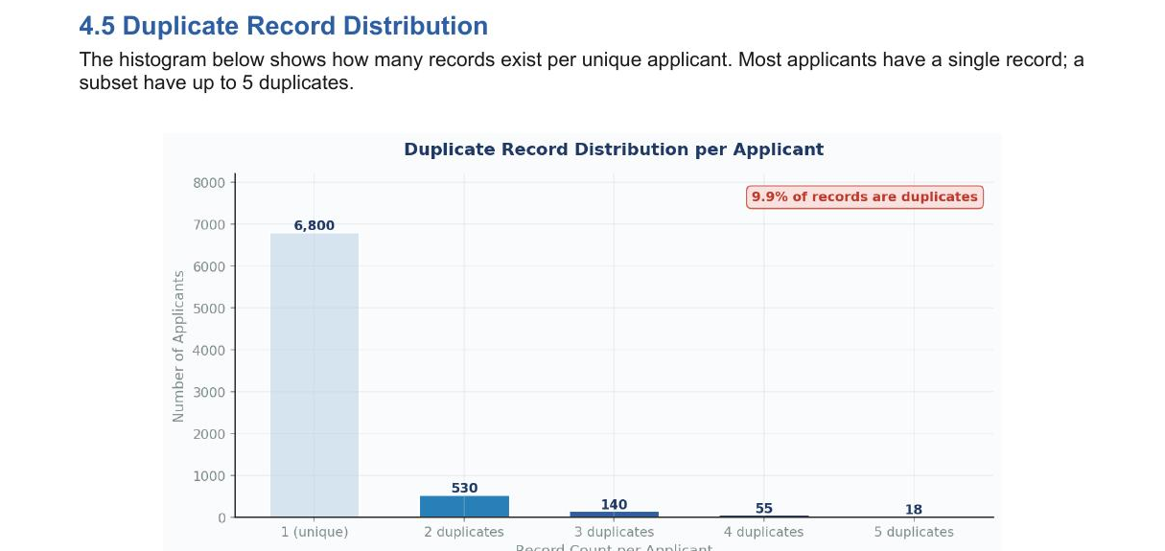

Impact
Roughly 10.7% of all records are duplicates. Until removed, every applicant count, program breakdown, and country distribution is overstated. This is the highest-priority fix before any downstream analysis.

Issue 2: Missing Data in Critical Fields
Four important columns had a high proportion of blank entries. Each gap directly blocks a specific type of analysis.

Missing Field | What It Prevents
Counselor / agent name | Cannot measure workload distribution or outreach performance
Degree type | Cannot segment applicants by qualification level
Admission decision date | Cannot track decision timelines or build a conversion funnel
Region | Cannot analyse geographic trends below country level

Issue 3: Inconsistent Data Formatting
The same information was stored in different formats across records, making grouping and comparison impossible without standardisation first.

Issue | Description
Phone numbers | Some stored in scientific notation (e.g. 9.20E+11) instead of full numeric format
Country names | Same country stored under multiple spellings and capitalisations
Combined fields | Country, institution, and qualification level merged into a single cell requiring splitting into three separate columns

Issue 4: Small Outreach Team with No Workload Data
All applicant outreach was managed by a team of four counselors. No role identifiers or standardised agent codes existed in the dataset, making it impossible to assess workload distribution or flag concentration risk.

Risk
With a small team handling all outreach and no workload visibility in the data, it is not possible to identify whether any one person is handling a disproportionate volume. This creates a blind spot in operational planning that data cleaning and field standardisation can resolve.

Issue 5: Unstructured Free-Text Fields
Two columns contained outreach outcome notes and general comments written freely by each team member. With no consistent format or coding schema, these fields could not be counted, grouped, or used for any trend analysis in their current state.

Issue 6: Structural and Naming Errors in the File
Several basic structural problems were present in the raw file.

- One column header was misspelled, causing import tools to misread the field name
- Some rows were misaligned, placing data values in the wrong columns on import
- Address information was spread across multiple rows in several records rather than contained in a single row

Why This Matters
Structural errors prevent reliable data import. No analysis tool, dashboard, or model can produce trustworthy results from a file with misaligned rows and broken field names. These must be corrected before any further work proceeds.

Section 3: Key Findings and Next Steps

Summary of Findings
Despite the data quality issues, the early patterns are consistent enough to be directionally useful. All figures below will be confirmed after cleaning.

1. Geographic concentration is high. Four countries account for over 70% of the raw applicant pool, pointing to a recruitment strategy that is regionally focused rather than globally distributed.
2. Program demand is dominated by three fields. Data Science, AI, and Business Analytics together account for 60% of selections, reflecting strong and consistent global demand for technical and analytical skills.
3. Fall and Winter intakes capture 67% of volume. Spring intake at 5% is a clear underutilised entry point that warrants a dedicated outreach review.
4. 10.7% of records are duplicates. This is a systemic data capture issue. All frequency-based findings are provisional until deduplication is complete.
5. Outreach is centralised in a small team with no visibility into workload distribution. This is a structural risk that data standardisation can address.
6. Four critical fields have high missing data rates. Outcome tracking, geographic segmentation, academic profiling, and agent attribution are all limited until these gaps are resolved.

Week 2 Plan
The following actions are scheduled for the next phase, in order of priority.

Action | Why It Matters
Remove all duplicate records | All applicant counts become accurate and reliable
Standardise country names and phone formats | Geographic analysis and filtering become possible
Split combined fields into separate columns | Country, institution, and qualification level become independently usable
Cross-tabulate region against program preference | Reveals whether geographic and academic demand are correlated
Recover or flag missing admission dates | Enables funnel analysis from application submission to decision
Define an encoding schema for free-text outcome fields | Makes outreach effectiveness measurable for the first time

Conclusion
The dataset is large enough and consistent enough in its early patterns to support meaningful analysis. The geographic concentration, program demand, and intake distribution findings are directionally reliable. However, every specific figure in this report must be treated as provisional until the deduplication and cleaning work in Week 2 is complete. No dashboards or predictive models should be built on the raw data.

Skills and Tools Used

Tool / Skill | How It Was Applied
Python (pandas, matplotlib, numpy) | Data loading, descriptive statistics, frequency analysis, chart generation
Microsoft Excel | Initial data inspection, pivot tables, duplicate identification
Exploratory Data Analysis (EDA) | Distribution analysis, missing value assessment, structural profiling
Data Quality Assessment | Identification and classification of six categories of data issues
Data Storytelling | Translation of technical findings into stakeholder-ready language
ISO 3166 / E.164 Standards | Reference standards used for country name and phone number normalisation recommendations

