Economic Update

Introduction

Global Economy

Economic growth
The Covid-19 pandemic is affecting the global economy negatively and it also has been inflicting high and rising human costs across the globe. Evidently International Monetary Fund(IMF) has projected that the global economy will decline by 3 per cent in 2020, which is higher than the economic downturn that was caused by the 2008-09 global financial crisis.
The impact of the Coronavirus (COVID-19) had already visible even before the virus spread across the world, as it affected China first. As the result, the output contractions that China had at the beginning of the pandemic affected the global economy, since China has a significant role the global supply chain, travel and commodity markets. Subsequent to the outbreak in China, the other major economies such as United States(US) and Europe had the similar effects to the global economy. Furthermore, other parts of the world also added to the impact at smaller scale.
Figure 1, shows that growth for advance economies and emerging market and developing economies (EMDEs) were heavily affected by the COVID-19 containment measures in the first quarter of 2020. A contraction of 6.1 per cent is expected for the advance economies, and a contraction 2.2 per cent for the EMDEs in 2020. Which reflects the disruption in the advance economics, where most parts these economies had a severe outbreak of the COVID-19.
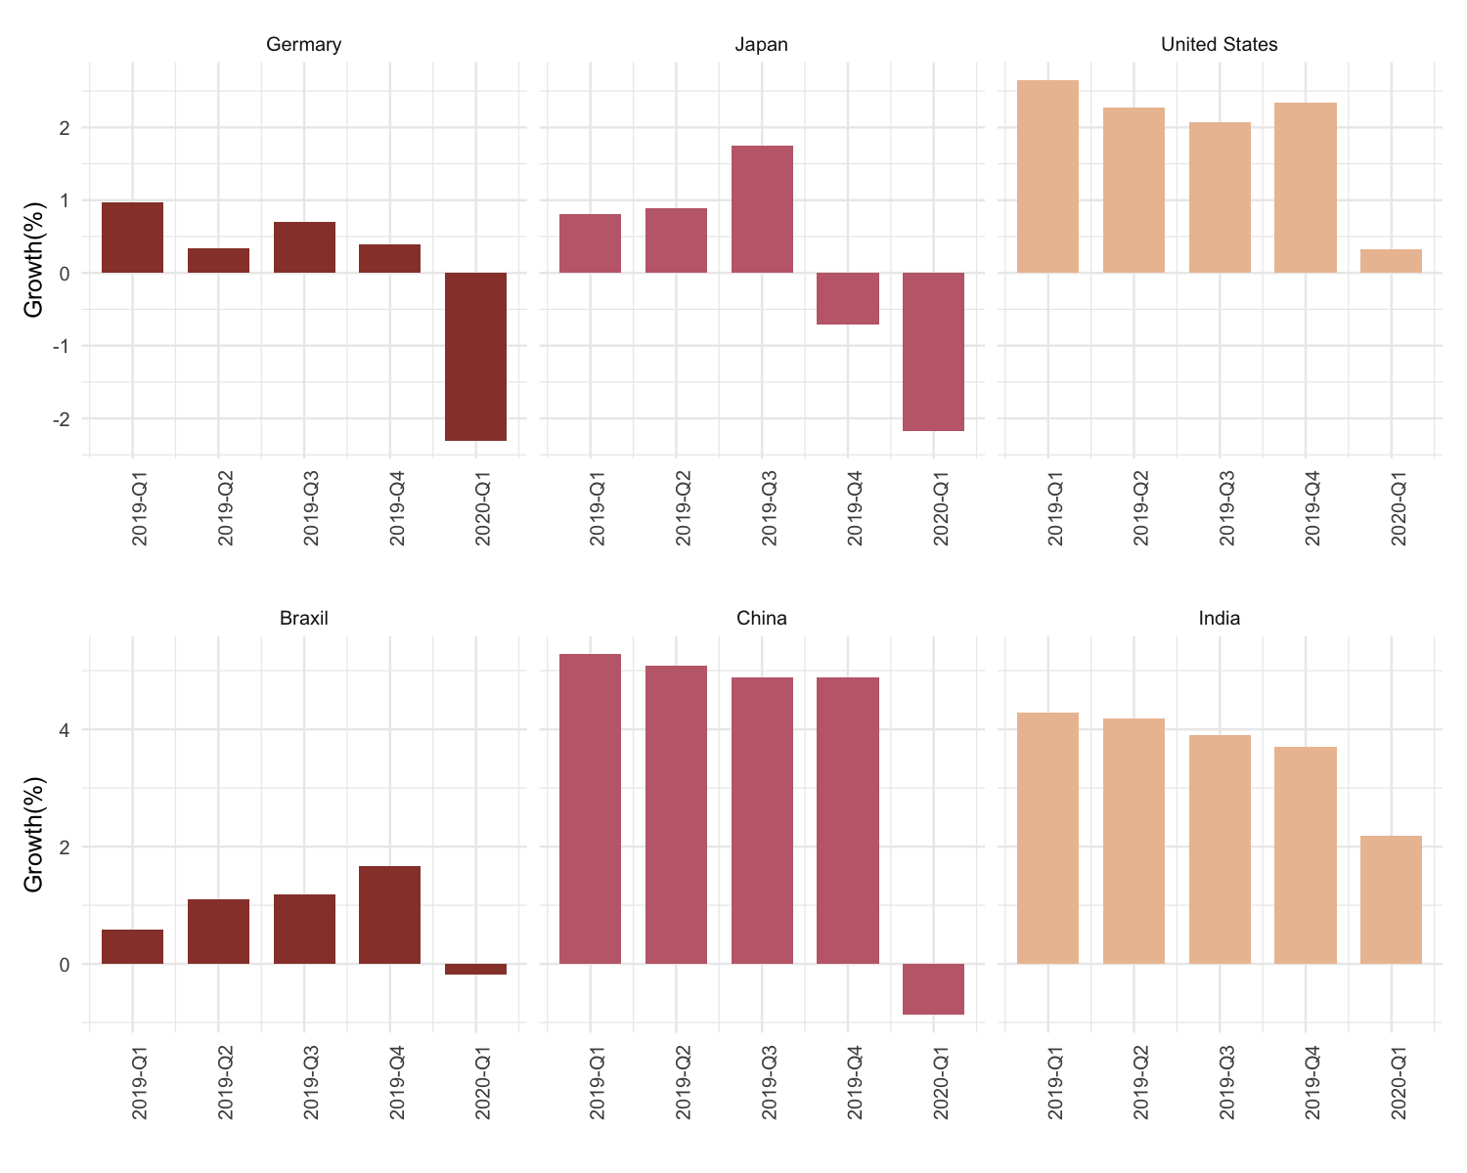

Figure 1: Advanced Economies and EMDEs Economic Growth. Source: Organization for Economic Cooperation and Development (2020)
Globally most the economies have contracted in the first quarter of 2020, and some of the economies had already had contractions in previous quarter. Most of these economies were European economies, such as Finland and Greece. In addition, significant downturns in the first quarter of 2020 were mostly visible in the advance economies, despite most projections citing the variability of the EMDEs.
Economic activity collapsed in the Sub-Saharan African (SSA) region in the first half of the year, as most of the authorities in this region enforced stringent containment measures to relief their most often fragile health systems, economic activity fell significantly in the first half of the year in two largest SSA’s economies (Nigeria and South Africa). SSA did not only suffer from its economic activity halt, it was also impacted by its affected major trading partners, fall in global commodity prices(especially oil and industrial metal exporters), and disruption in the global travel and supply chain. The region also had to face an unusual outflow of capital, as investors avoided the risk of losses, particularly in economies with weak health systems, large tourism sectors, balance sheet vulnerabilities to financing shocks, and that are dependent on commodity exports.

Commodity prices
The COVID-19 impact has affected the economy in various channels; amongst these channels was the financial markets taking a knock due the increase in uncertainty. This uncertainty in the markets have resulted in a flight to safe assets and investors to liquidate their holdings, and that caused an upward pressure on borrowing cost. Furthermore, commodity market has suffered a drop in prices, given the low global demand which is putting pressure on commodity exporting economies. Commodity prices which were mostly affected, were energy and non-energy commodity prices, but precious metal prices showed some resilience (see figure 2).
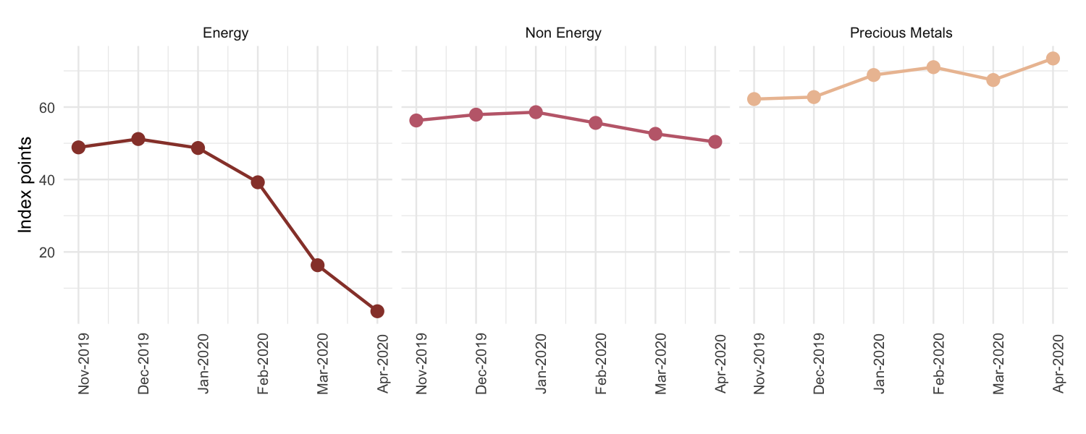

Figure 2: Global Commodity Price Index. Source: International Monetary Fund (2020)
The measures taken to contain the COVID-19 has directly impacted the commodity market and its supply chain, and the weaker global growth will further affect the global demand for commodity post-Covid-19 containment measures. Most the impact was visible in the energy commodity market, especially the oil prices. Evidently, oil prices led the fall in commodity prices with a price fall of about 70 per cent in the first quarter of 2020. This fall was caused by travel restrictions which significantly declined the demand for oil and other fuels which are used in transportation.
In the non-energy commodities, agriculture commodities were less affected than the industrial metals. Manifestly, the prices of the main food commodities had fallen by 9 per cent in the first four months of 2020. However, natural rubber prices behaved differently within the basket of agriculture commodities, it fell by 25 per cent, since two-thirds of its consumption is explained by the production of tires for the transport sector which was of the most affected sectors during the Covid-19 restrictions. Moreover, prices for Industrial metals were more impacted than other non-energy commodities with a fall of 19 per cent between January and April.
Precious metals prices were heavily sustained by the gold price, gold price has increased by 8 per cent between January and April, driven by investors search for safe assets. Contrarily, silver and platinum fell in March and remained low in April, both falling by about 70 per cent. These two commodities are more of a production input than an investors’ wealth creation asset, which explains the fall. Additionally, more than 40 per cent of the platinum demand is for the automobile production, and the production of the automobile has been halted by the responses pertaining to the Covid-19.
Like commodity market the overall International trade has also eased, the global trade value has declined by 3 per cent in the first quarter of 2020 when compared to the previous quarter. A further 27 percent decline is expected in the second quarter, as the effects of the Covid-19 containment measures continue to progress. Trade volume is also expected to decline, but at a moderate rate for the first half of the year. Most of the global trade declines was because of the sharp falls in China and East Asian.

Investment
Investment has fallen in most parts of the global economy, due to the increased uncertainty caused by the COVID-19 pandemic. However, some of the EMDEs have experience a boost to their investment. This is due to private investment being attracted by governments’ efforts to inject money to strengthen infrastructure that is related to fighting the Covid-19. This has clearly manifested in countries like Turkey, were there is evident continued investment recovery from a deep contraction in investment that was experienced in the previous year (See Figure 3).
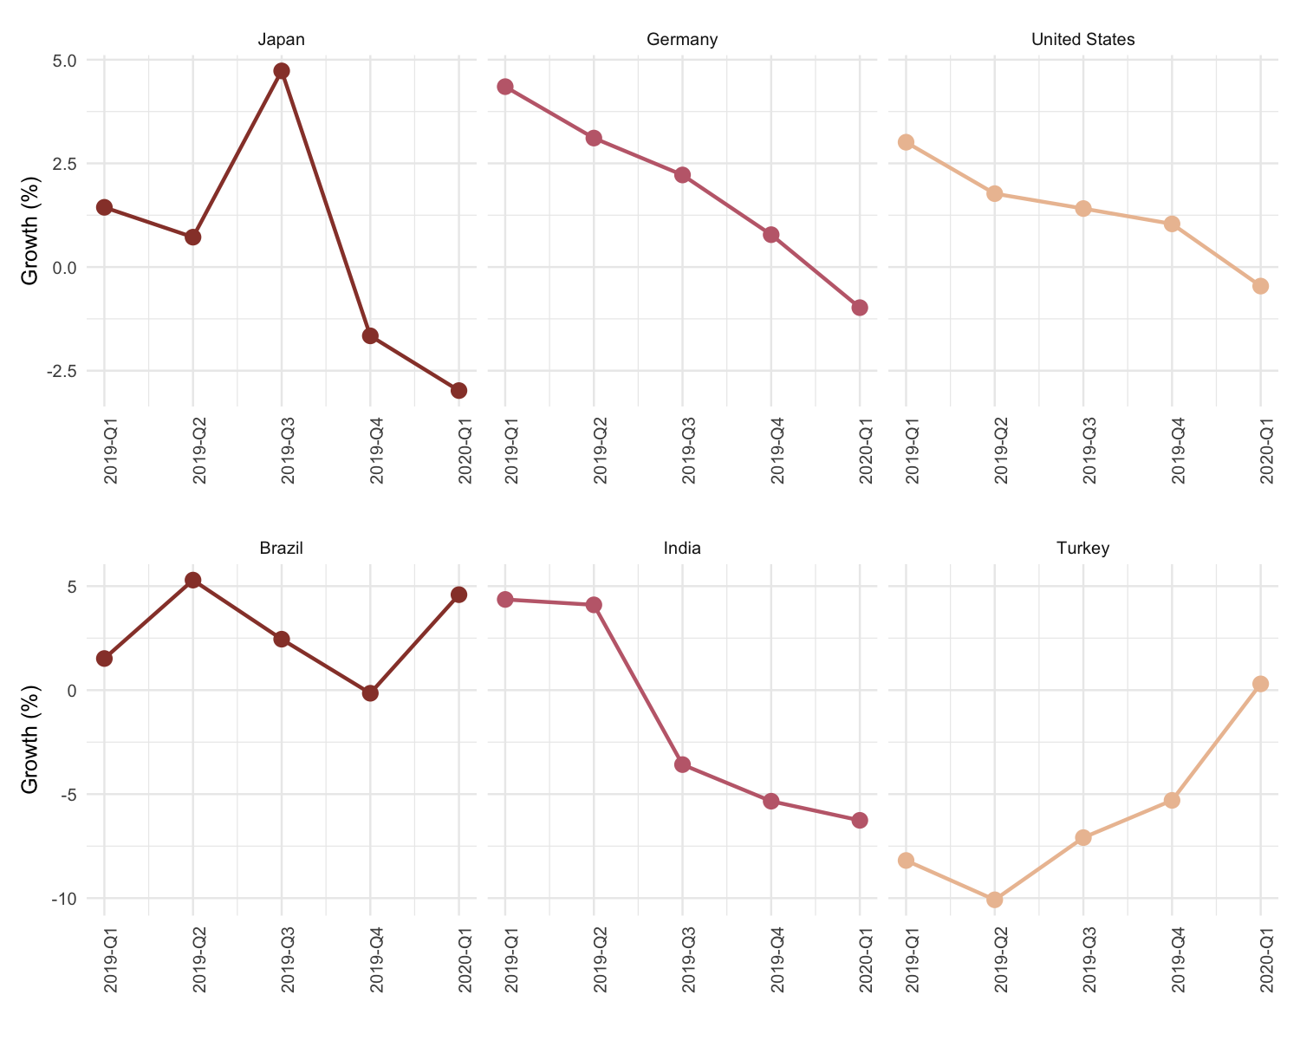

Figure 3: Global Investment. Source: Statistics South Africa (2020)
Investment decline in the United States(US) was reflected by the sharp decline in its Gross Domestic Production(GDP), the investment declined was a result of decrease in private inventory investment and nonresidential fixed investment. Moreover, Investment declines were also visible in other advance economies, as investment growth depends on international trade. The halted international trade due to COVID-19 was causing financial problems for firms to expand, and uncertainty also causing investors to delay expansions. Thus, affecting economies like Japan and Germany which are industrial intensive economies. Furthermore, in the EMDE group India is also one of the high industrial countries, and had a significant drop in its investment, amidst low level of industrial activity.

Policy interventions
The industrial activity has dropped across the globe, global manufacturing output has declined by 6 per cent in the first quarter of 2020. This was the first decline of this magnitude since the 2008/9 financial crisis, and the manufacturing output was already facing a gradual decline pre-Covid-19 impact, due to the 2019 global economic slowdown. In addition, the trade uncertainty caused by China and US’s trade dispute predominantly in 2019, has also contributed to the fall in manufacturing output. China’s weight on the decline in manufacturing output was the largest since it is the world’s largest manufacture, and it was the first country to go on lockdown. Evidently, China’s manufacturing output declined by 14.1 per cent in the first quarter. On the other hand, countries which initiated the lockdown at a later stage, had moderate contraction i.e. Industrialised economies with a later lockdown had a contraction 2.5 per cent in the first quarter.
The impact of the Covid-19 pandemic has intensified the need for monetary policy easing for most of the continued. However, there are economies which had already began with easing since 2019 due the 2019 global economic slow-down. Evidently, the Global Monetary Policy Tracker index signaled a monetary easing for the first time in March 2019 since in September 2016. In January 2020 the index was tracking closer to its neutral benchmark (zero) increased to 3.23 index points(ip), but in March 2020 it bounced to towards an extreme monetary easing benchmark (-10), it registered 9.65ip.
In EMDEs, monetary authorities have implemented a variety of traditional monetary policy measures which in aggregate they are of an easing manner. The prospects of a low inflation environment due the low oil prices and low aggregate demand has given the authorities much needed space to curb the effects of the Covid-19 pandemic on the economy. In the Advanced economies a significant scale of monetary easing was also evident. The US federal reserve bank has cut rates to almost zero, and it has made unlimited purchases debt, various bonds and mortgage-backed obligations.
Moreover, the European central bank has low-interest loans to banks, significantly boosted asset purchases, and allayed fears of member-country defaults by lifting distributional restrictions on its bond-buying program. Bank of Japan contributed to the easing of its economy by increasing its balance sheet, through more purchases of securities and corporate bonds. The measures made by the majors economies was not limited to those major economies only, other groups of economies and individual economies have also acted towards easing monetary policy stance.
Fiscal policy interventions by authorities in most economies have been put in place to neutralise the effects of the Covid-19 pandemic. The policies were aimed at boosting the health systems to fight the spread of Covid-19, and to curb the negative effects on the economy. In US, government has provided fiscal support of $3 trillion, and provided more than $1 trillion in loans to businesses, state and local governments. A further direct transfer to households is under considerations, to relief households. Member countries in the Euro Area have rolled out stimulus fiscal support packages, and loan guarantees for the corporate sector. Japan had already begun in the fourth quarter of 2019 to save its economy from the pandemic; in addition to the initial stimulus, Japan announced a cumulative fiscal support worth 40 per cent of its GDP.
Although, it was easier for advance economies to have sizeable fiscal measures as they have space to borrow more fund when it is needed or tap into their large reserves. However, it is not the same in the case of EMDEs and low-income countries, as they are mostly unable to service debt, or they already have high debt levels. Which limits their fiscal, and the nature of EMDEs by having more low-income and unemployed citizens relative to the advance economies, also poses as a challenge. Fiscal measures in EMDEs where mostly centered around health care systems and social welfare of its citizens

South Africa Economy

Economic growth
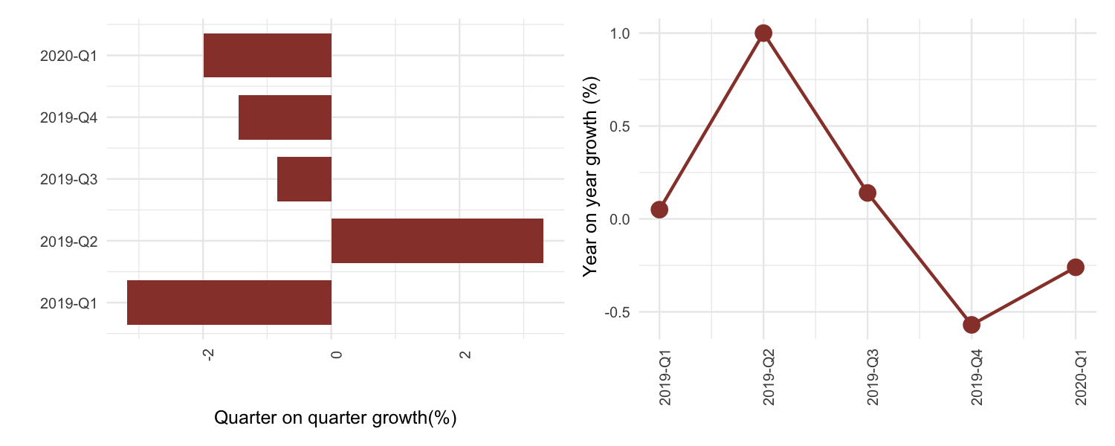

Figure 4: SA Gross Domestic Product. Source: Statistics South Africa (2020)
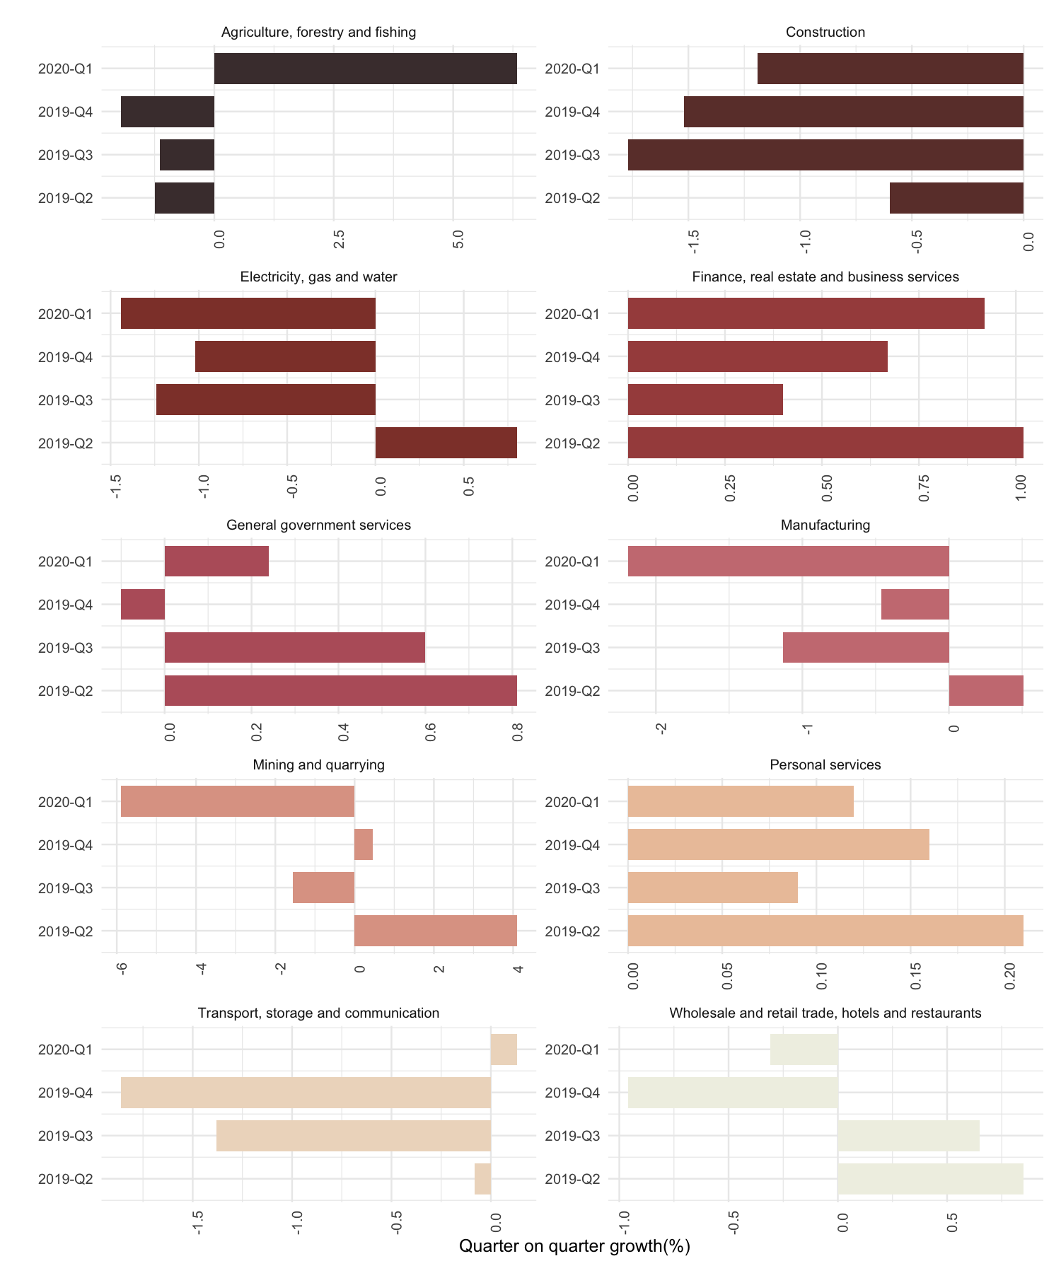

Figure 5: SA Industry Gross Domestic Product. Source: Statistics South Africa (2020)
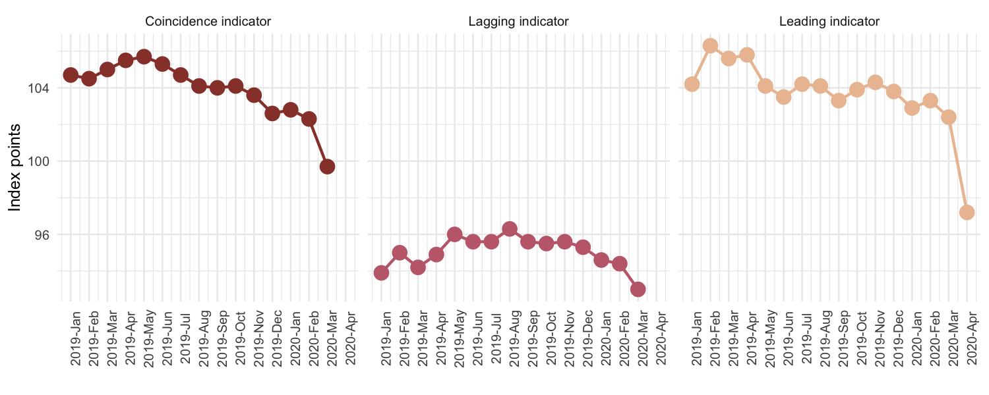

Figure 6: SA Business Cycle Indicators. Source: South African Reserve Bank (2020)

Consumer and business confindence
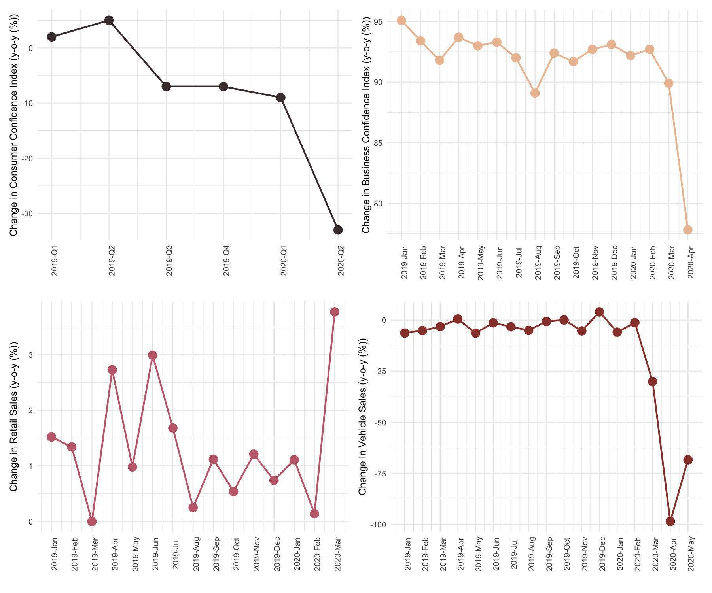

Figure 7: SA Consumer and Business Confidence. Source: Statistics South Africa (2020), Bureau for Economic Research (2020), National Association of Automobile Manufacturers of South Africa (2020)

Labour market
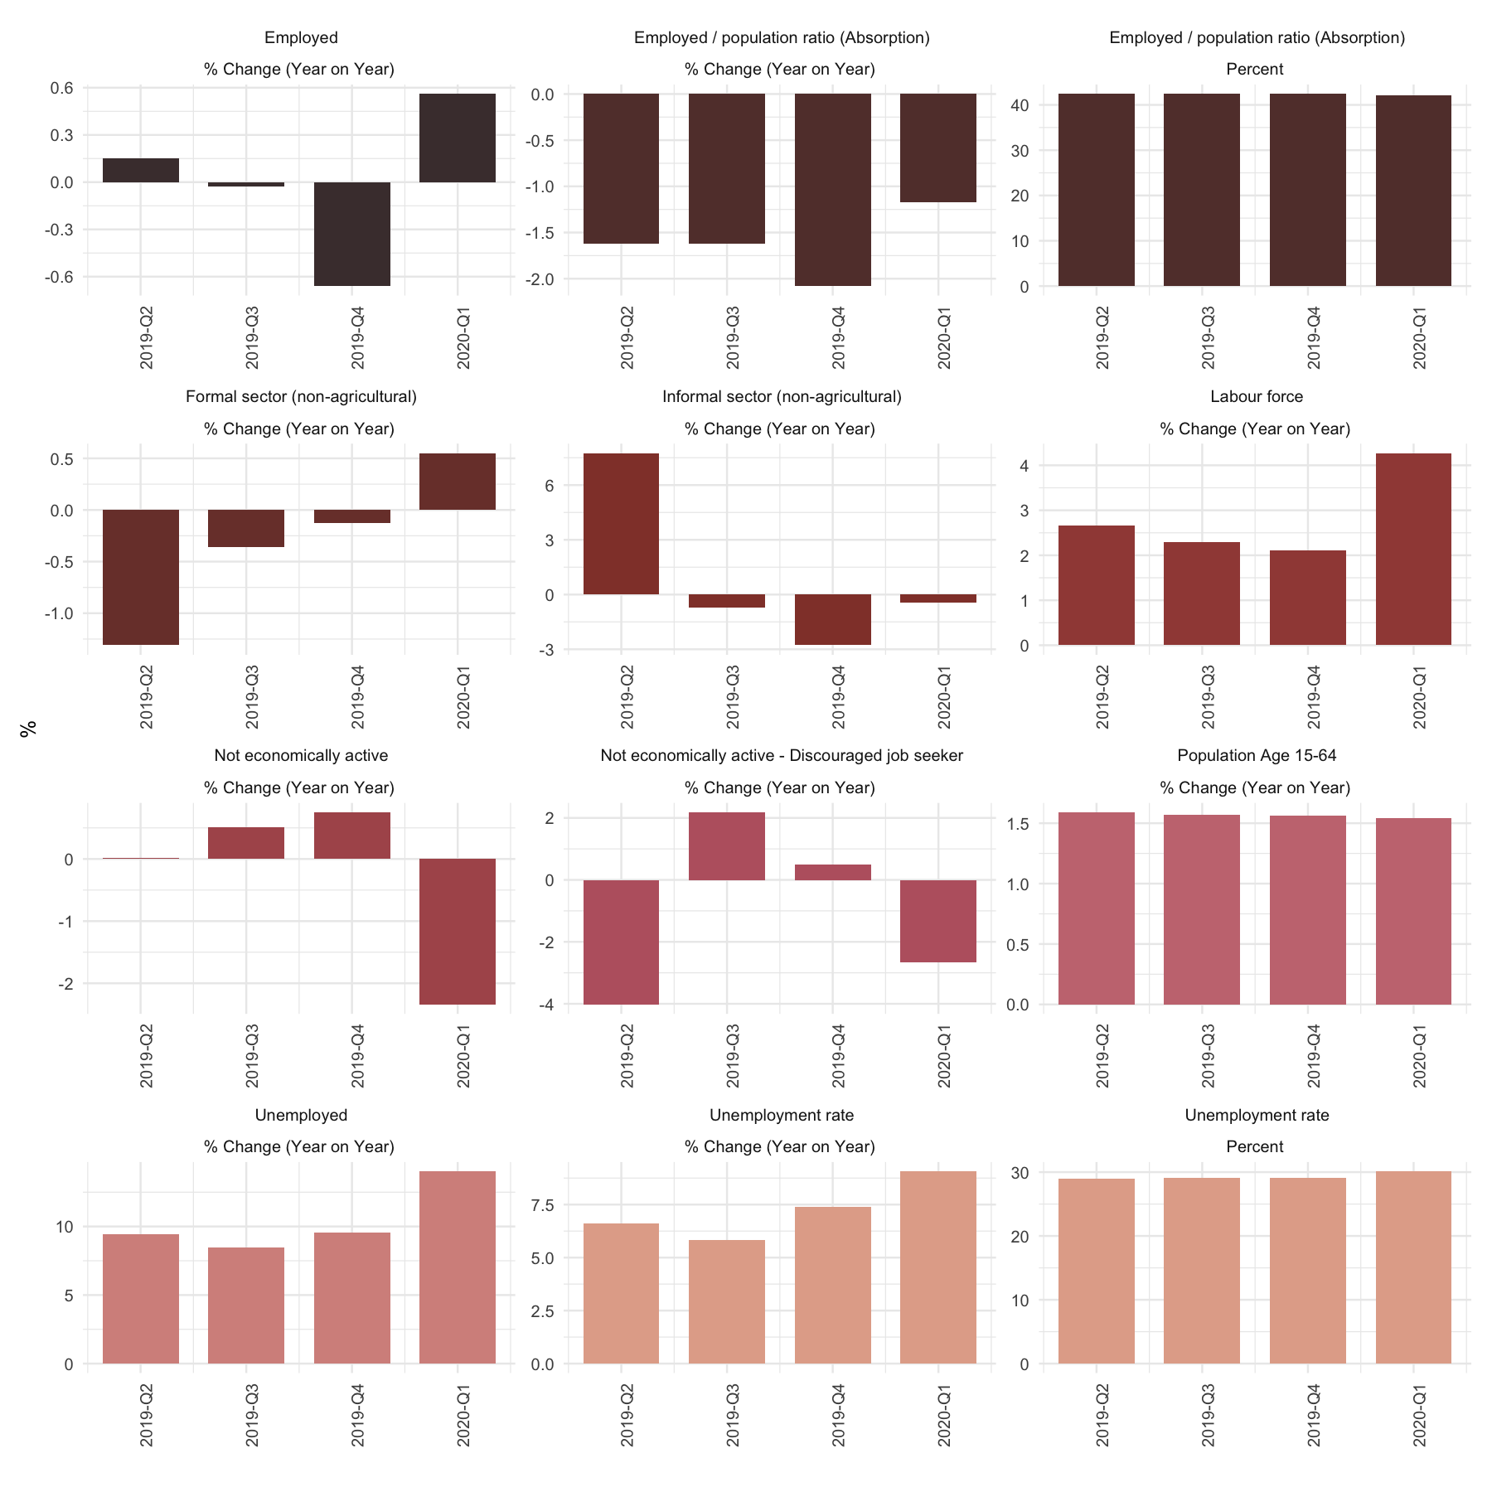

Figure 8: SA Labour Market. Source: Statistics South Africa (2020)

Consumer prices
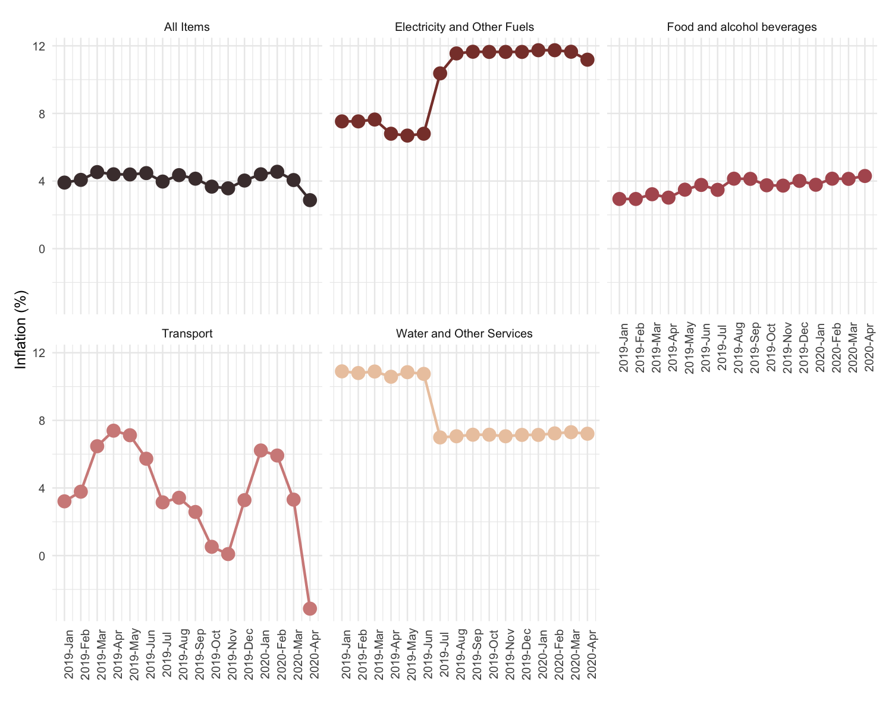

Figure 9: SA Consumer Inflation. Source: Statistics South Africa (2020)

Monetary policy
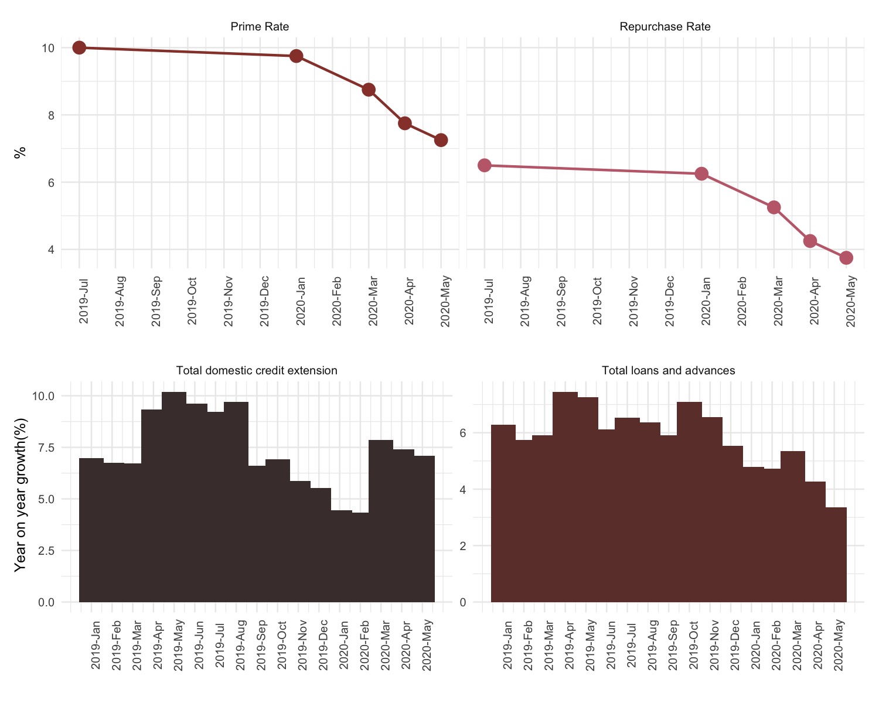

Figure 10: SA Monetary Policy. Source: South African Reserve Bank (2020)

Policy interventions

Gauteng Economy

Economic growth
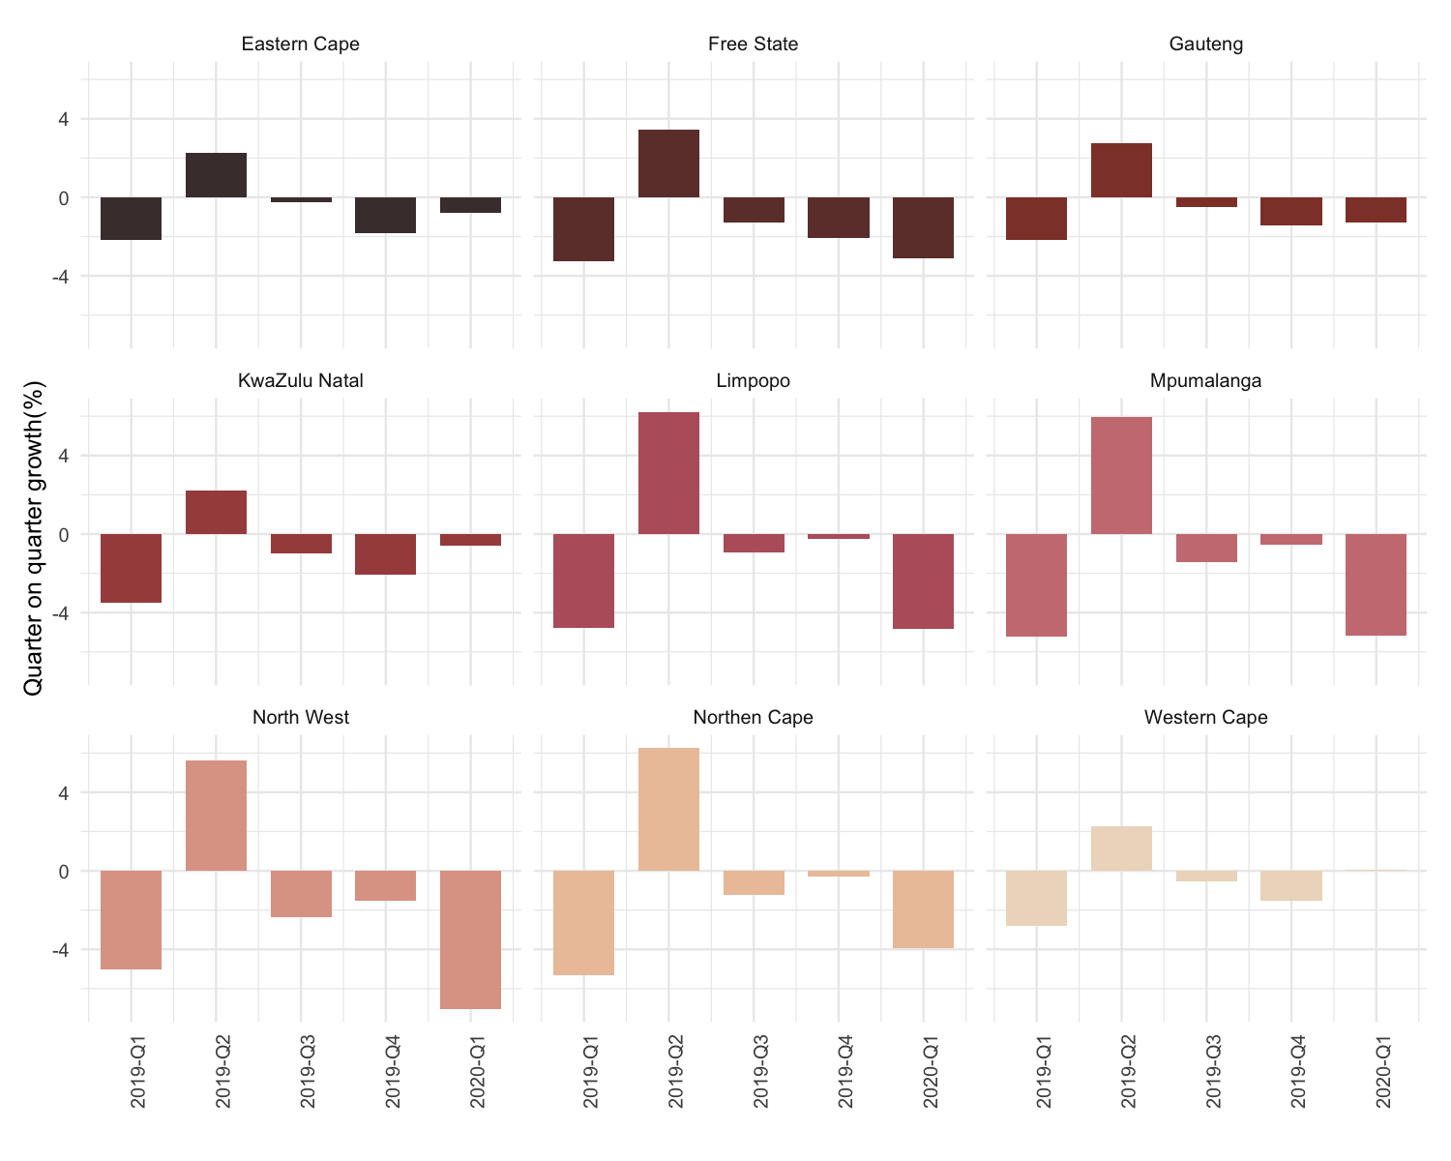

Figure 11: Gauteng Gross Domestic Product. Source: Quantec Research (2020)
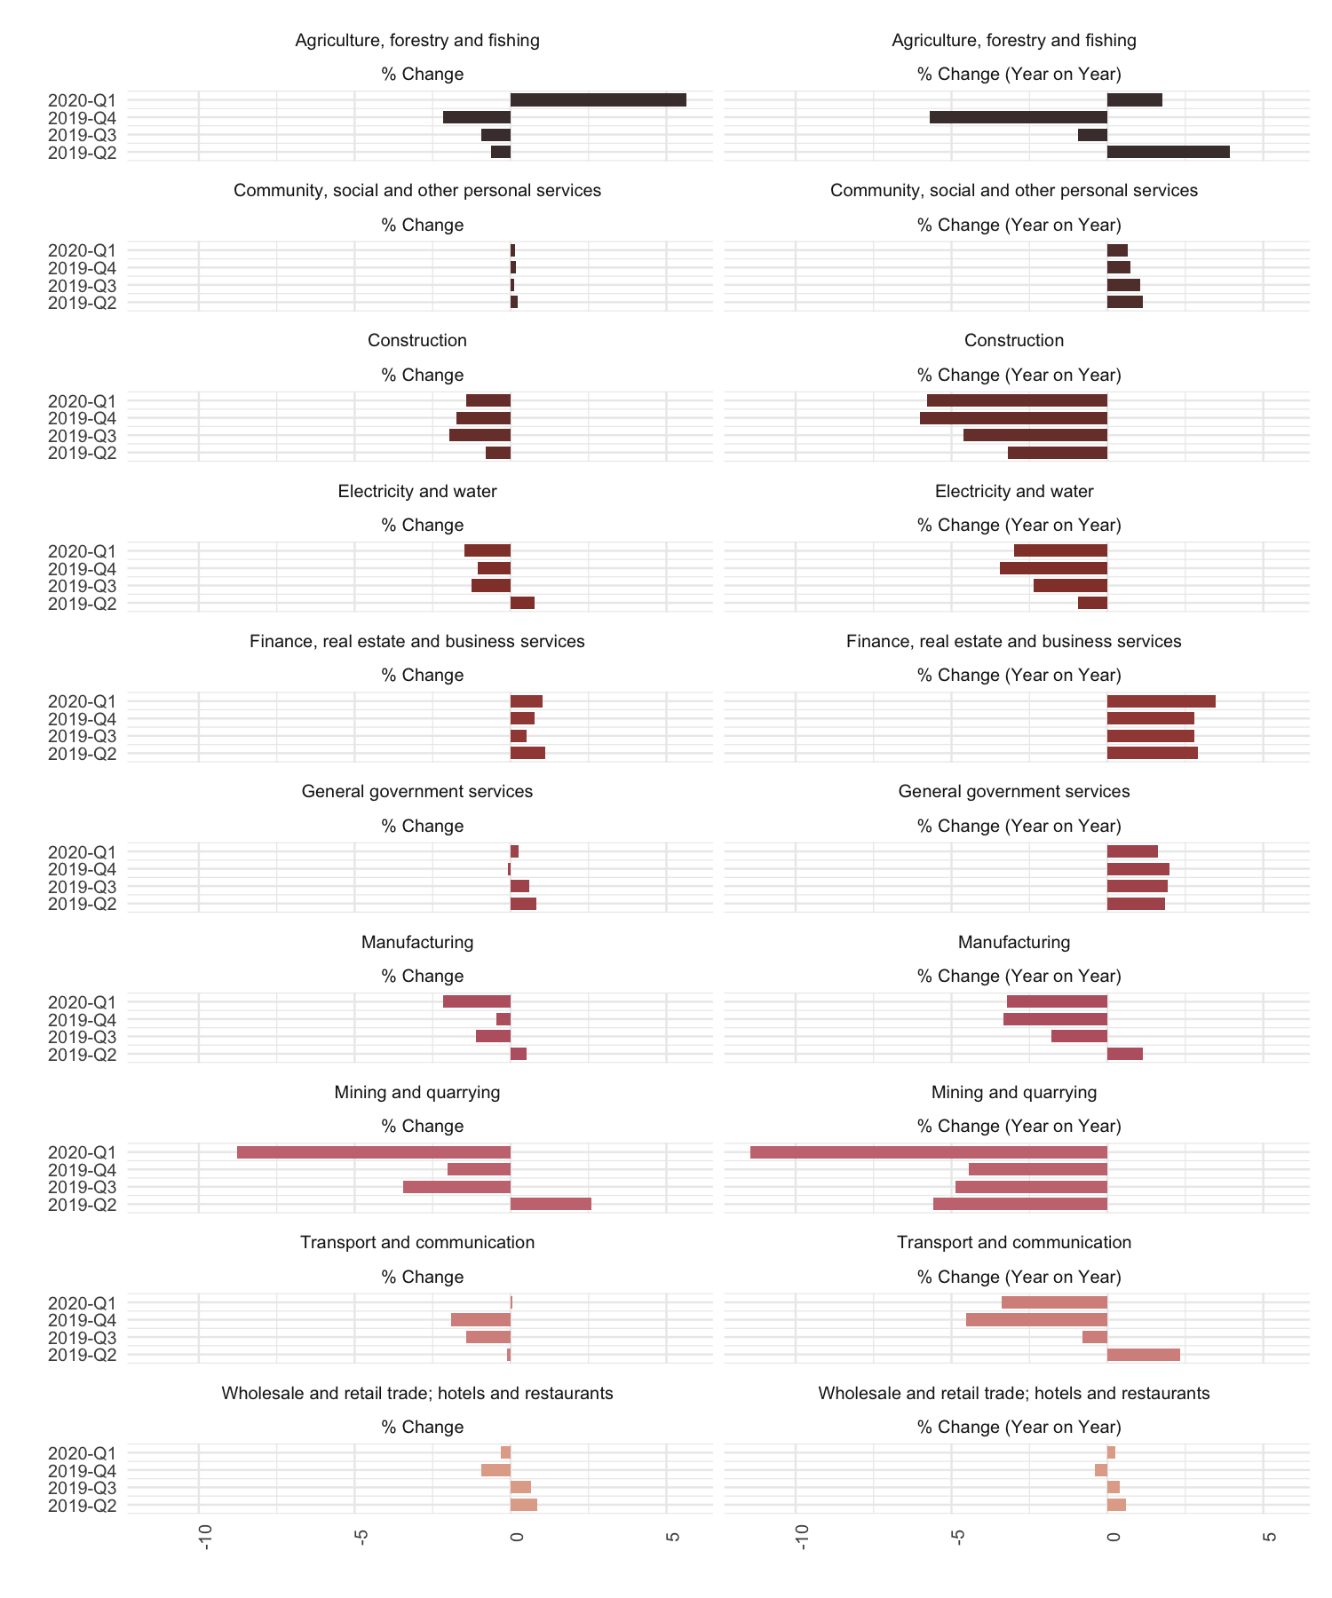

Figure 12: Gauteng Industry Gross Domestic Product. Source: Quantec Research (2020)

Labour market
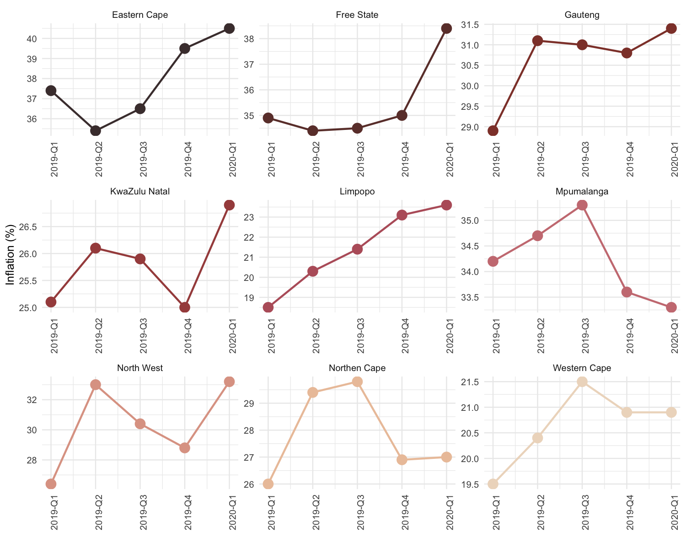

Figure 13: Provincial Unemployment Rates. Source: Statistics South Africa (2020)
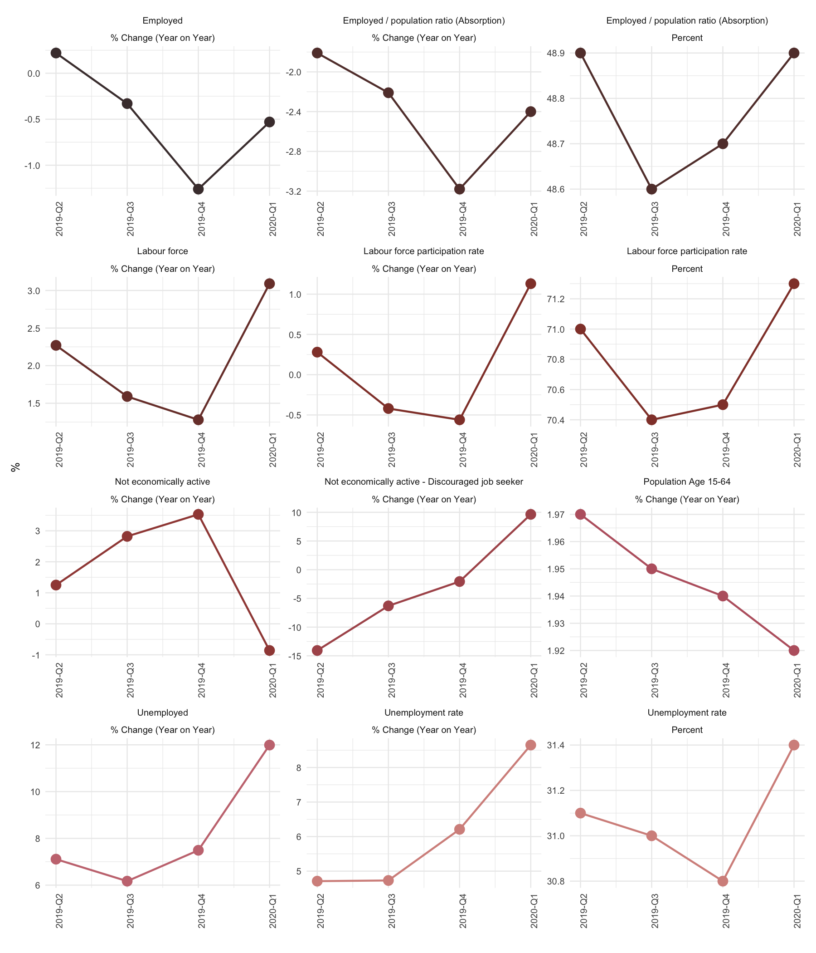

Figure 14: Gauteng Labour Market. Source: Statistics South Africa (2020)

Consumer prices
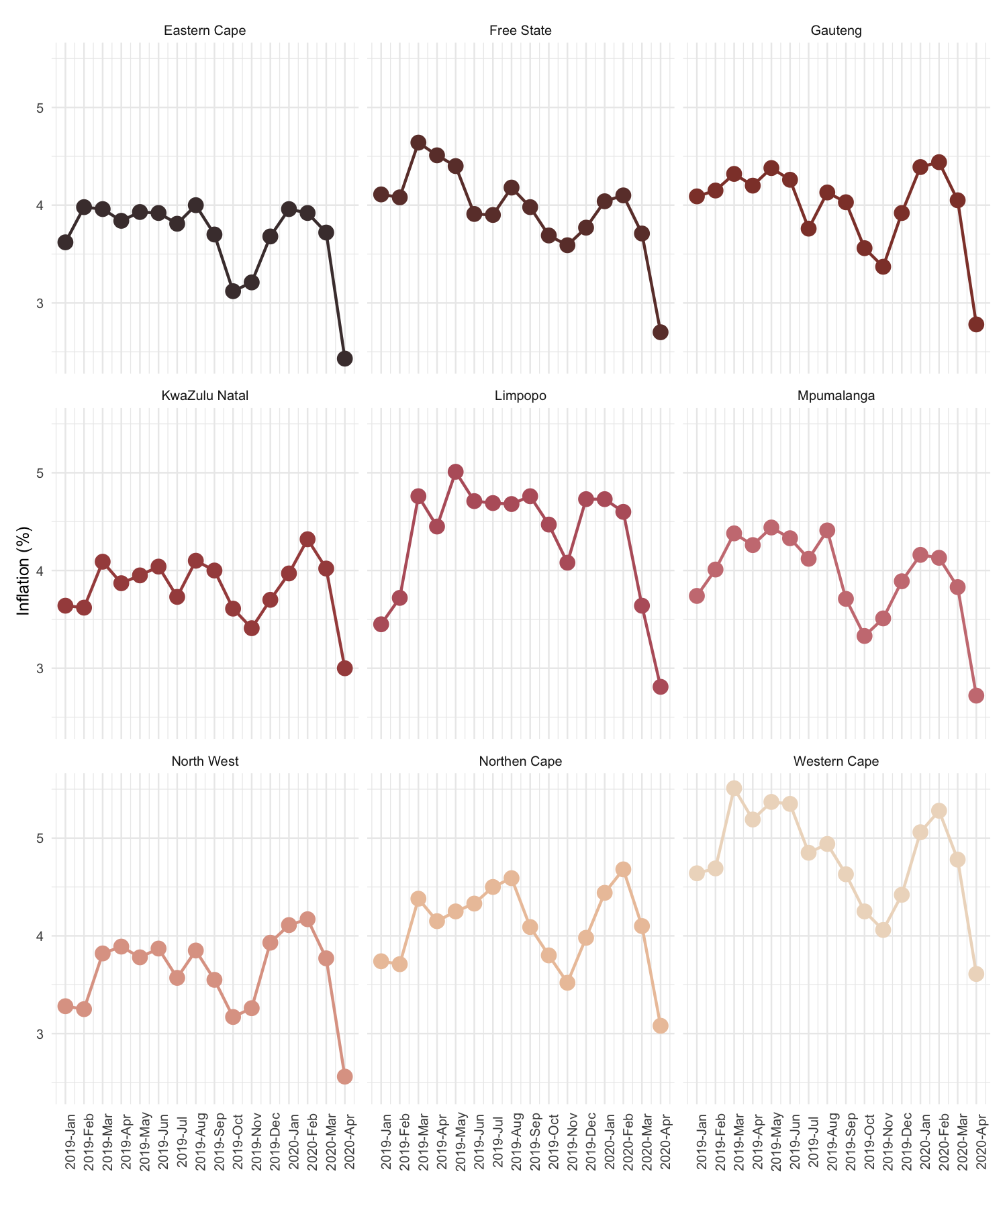

Figure 15: Provincial CPI. Source: Statistics South Africa (2020)

Policy interventions

Concluding Remarks

International Monetary Fund. (2020). World Economic Outlook, April 2020: The Great Lockdown.
World Bank. (2020). June 2020 Global Economic Prospects.
World Bank. (2020). Special Focus, A Shock Like No Other: The Impact of Covid-19 on Commodity Markets.
United Nation Conference on Trade and Development. (2020). Global Merchandise Trade Nowcast May 2020.
World Bank. (2020). June 2020 Global Economic Prospects.
Bureau of Economic Analysis. (2020). Gross Domestic Product, First Quarter 2020 (Second Estimate).
United Nations Industrial Development Organisation. (2020). World manufacturing growth in Quarter I 2020.
Global Monetary Policy Tracker is an index that is compiled by the Council on Foreign Relation, it compiles data from 54 countries around the world to highlight significant global trends in monetary policy. Who is tightening policy? Who is loosening policy? And what is the policy stance of the world as a whole
Council on Foreign Relation. (2020). Global Monetary Policy Tracker. www.cfr.org (accessed on the 17th June 2020)
World Bank. (2020). June 2020 Global Economic Prospects.
World Bank. (2020). June 2020 Global Economic Prospects.

