Introduction
Inflation is known to have adverse welfare effects through its distortion of relative prices which causes the misallocation of resources, production inefficiencies leading to lower real economic activity. This is well supported by both theoretical and empirical studies. This paper contributes to the empirical literature, by examining the relationship between inflation and relative price variability (RPV) in South Africa given the little evidence available and to better understand how this relationship has evolved and the implications for monetary policy.
The South African context can provide further insights into the relationship between inflation and RPV given the shifts in the inflation targets from 3- 6 per cent in 2000 to 4.5 per cent since 2017 as structural changes in inflation can affect the link between inflation and relative price variability (Caglayan and Filiztekin 2003) and that the functional form of relationship is U-shaped and dynamic (Fielding and Mizen 2000; Choi 2010). The latter motivates the estimation of the inflation rate that minimizes relative price distortions since if the relationship was linear then the optimal inflation rate would be zero. Given the inflation target reform towards a 3% in South Africa, this study contributes to the policy discussion on the appropriate inflation target and understating how dynamic relations between inflation and relative price variability has evolved.
The theoretical literature generally distinguishes between menu-cost and signal extraction models in explaining the positive relation between trend inflation and RVP. In these models’ firms follow a one-sided dynamic pricing rule when setting prices and face fixed non-zero costs of adjusting nominal prices (e.g. printing new menus) when inflation increases as the latter reduces the optimal real price of goods and services. Due to differences in administrative costs, these nominal price adjustment costs vary across firms moreover these adjustments occur at different times which implies staggard price setting behaviour which leads to relative price variability. Menu cost models predict a that higher expected inflation causes an increase in RVP (citations xxx) while Lucas-type signal extraction models (Lucas(1973); Hercowitz (1981); Cukierman (1984) xxxx more citatiosn) argue unexpected inflation uncertainty causes higher RVP because informational frictions make it difficult to distinguish between idiosyncratic relative shocks or an aggregate (inflationary) shock. Menu cost and signal-extraction models assume a positive and linear relationship making the optimal inflation rate zero, however, recently monetary search models (Head and Kumar 2005) show that this relationship is nonlinear making the optimal inflation rate somewhere between zero and positive inflation rate.

Citations
Adam, Alexandrov, and Weber (2024) Baglan, Yazgan, and Yilmazkuday (2016) Ball and Romer (1993) Benabou and Gertner (1993) Caglayan and Filiztekin (2003) Caglayan, Filiztekin, and Rauh (2008) Grier and Perry (1996) Lach and Tsiddon (1992) Nakamura et al. (2018) Ndou and Redford (2014) Ndou and Gumata (2017) Parks (1978) Parsley (1996) Rather, Durai, and Ramachandran (2018)

Literature review

Data and methodology

Results
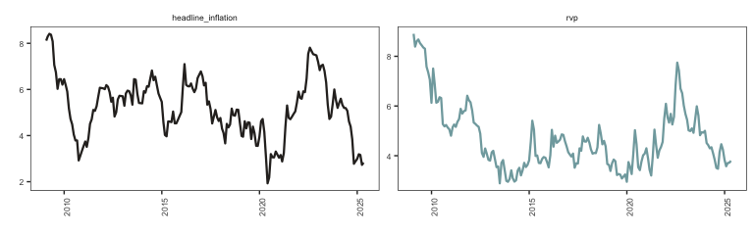
Figure 1: Relative price variance and headline inflation

Conclusion

References
Adam, Klaus, Andrey Alexandrov, and Henning Weber. 2024. Inflation Distorts Relative Prices: Theory and Evidence. 23/2024. Deutsche Bundesbank Discussion Paper.
Baglan, Deniz, M. Ege Yazgan, and Hakan Yilmazkuday. 2016. “Relative Price Variability and Inflation: New Evidence.” Journal of Macroeconomics 48: 263–82.
Ball, Laurence M., and David H. Romer. 1993. “Inflation and the Informativeness of Prices.” National Bureau of Economic Research Cambridge, Mass., USA.
Benabou, Roland, and Robert Gertner. 1993. “Search with Learning from Prices: Does Increased Inflationary Uncertainty Lead to Higher Markups?” The Review of Economic Studies 60 (1): 69–93.
Caglayan, Mustafa, and Alpay Filiztekin. 2003. “Nonlinear Impact of Inflation on Relative Price Variability.” Economics Letters 79 (2): 213–18.
Caglayan, Mustafa, Alpay Filiztekin, and Michael T. Rauh. 2008. “Inflation, Price Dispersion, and Market Structure.” European Economic Review 52 (7): 1187–1208.
Choi, Chi-Young. 2010. “Reconsidering the Relationship Between Inflation and Relative Price Variability.” Journal of Money, Credit and Banking 42 (5): 769–98. https://doi.org/10.1111/j.1538-4616.2010.00307.x.
Fielding, David, and Paul Mizen. 2000. “Relative Price Variability and Inflation in Europe.” Economica 67 (265): 57–78. https://doi.org/10.1111/1468-0335.00195.
Grier, Kevin B., and Mark J. Perry. 1996. “Inflation, Inflation Uncertainty, and Relative Price Dispersion: Evidence from Bivariate GARCH-M Models.” Journal of Monetary Economics 38 (2): 391–405.
Head, Allen, and Alok Kumar. 2005. “PRICE DISPERSION, INFLATION, AND WELFARE*.” International Economic Review 46 (2): 533–72. https://doi.org/10.1111/j.1468-2354.2005.00333.x.
Lach, Saul, and Daniel Tsiddon. 1992. “The Behavior of Prices and Inflation: An Empirical Analysis of Disaggregat Price Data.” Journal of Political Economy 100 (2): 349–89. https://doi.org/10.1086/261821.
Nakamura, Emi, Jón Steinsson, Patrick Sun, and Daniel Villar. 2018. “The Elusive Costs of Inflation: Price Dispersion During the US Great Inflation.” The Quarterly Journal of Economics 133 (4): 1933–80.
Ndou, Eliphas, and Nombulelo Gumata. 2017. Inflation Dynamics in South Africa: The Role of Thresholds, Exchange Rate Pass-Through and Inflation Expectations on Policy Trade-Offs. Springer.
Ndou, Eliphas, and Siobhan Redford. 2014. “Relative Price Variability: Which Components of the Consumer Price Index Contribute Towards Its Variability?” South African Reserve Bank Working Paper Series.
Parks, Richard W. 1978. “Inflation and Relative Price Variability.” Journal of Political Economy 86 (1): 79–95. https://doi.org/10.1086/260648.
Parsley, David C. 1996. “Inflation and Relative Price Variability in the Short and Long Run: New Evidence from the United States.” Journal of Money, Credit and Banking 28 (3): 323–41. https://www.jstor.org/stable/2077978.
Rather, Sartaj Rasool, Raja Sethu Durai, and Muthia Ramachandran. 2018. “Inflation and the Dispersion of Relative Prices: A Case for 4 % Solution.” Australian Economic Papers 57 (1): 81–91. https://doi.org/10.1111/1467-8454.12103.

Appendix

Data
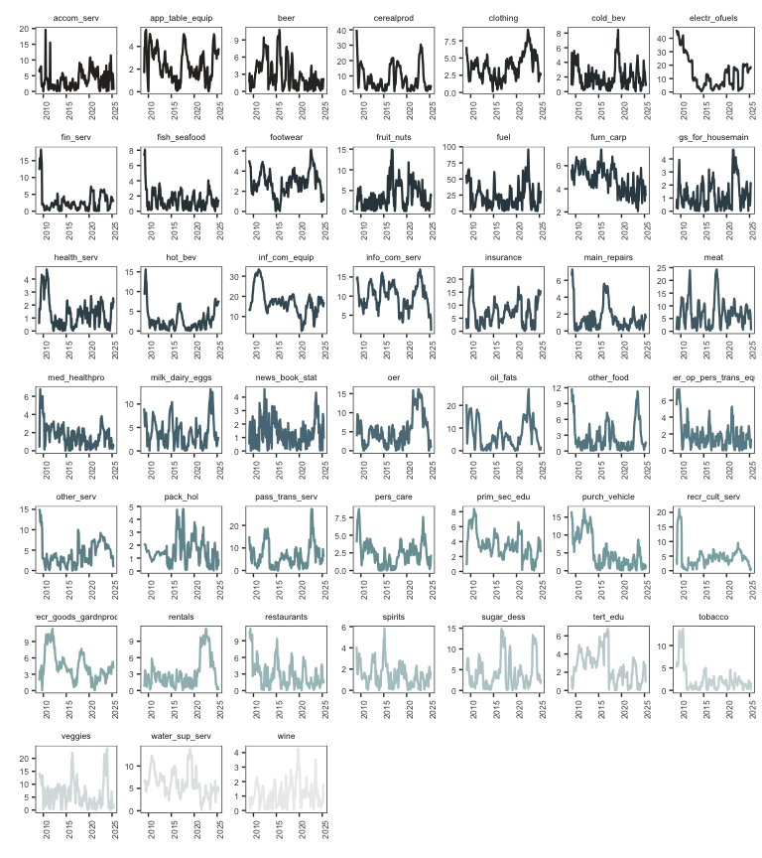
Figure 2: Price categories

