**Analysis of Rheologically Complex Maxwell Fluid**

For a mixture of a rheologically complex Maxwell fluid and a Newtonian fluid, the roots of the transcendental equation are found by solving the following equation:

 (20)

Considering that



certain parameters hold, equation (20) can be rewritten as:

or  (21)

If we let $s$ as , then equation (21) takes the following dimensionless form:



Through certain transformations, this equation can be rewritten in the form of a quadratic equation as:

 (22)

Here, . The obtained equation (22) has two roots, which are determined as . The corresponding solutions for these roots can be expressed as:

 (23)

 (24)

Here, 

Using the Maxwell model, we analyze the transition of a rheologically complex fluid from an unsteady (non-stationary) to a steady (stationary) state with the help of formula (24), after the pressure gradient is removed.

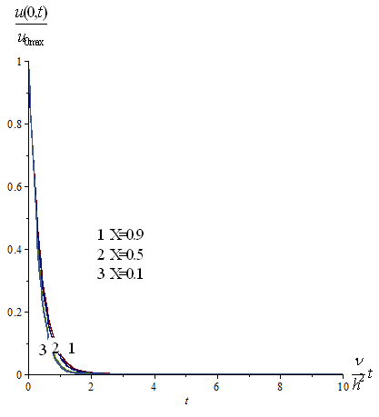

**Figure 2. Variation over time of the ratio between the instantaneous maximum velocity along the longitudinal axis and the steady-state flow velocity along the same axis (for a Maxwell-type fluid at various concentrations of Newtonian fluid in the mixture).**

Figure 2 shows the time variation of the ratio between the instantaneous maximum velocity along the longitudinal axis and the steady-state velocity, based on the Maxwell model(). From the figure, it can be seen that the transition of the maximum velocity from the unsteady to the steady state is almost identical to that observed in a Newtonian fluid flow.

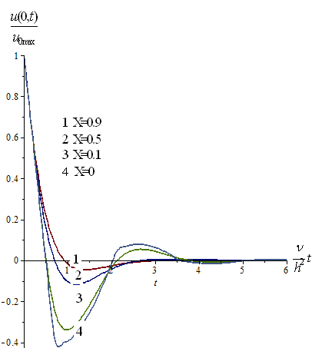

**Figure 3. Variation over time of the ratio between the instantaneous maximum velocity along the longitudinal axis and the steady-state flow velocity along the same axis (for a Maxwell-type fluid at different concentrations of Newtonian fluid in the mixture).**

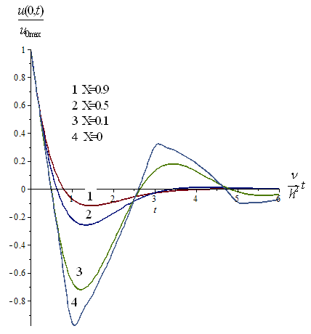

**Figure 4. Variation over time of the ratio between the instantaneous maximum velocity along the longitudinal axis and the steady-state flow velocity along the same axis (for a Maxwell-type fluid at different concentrations of Newtonian fluid in the mixture).**

At large values of the elasticity coefficient, an "elastic recoil" effect is observed in the Maxwell model. As a result of this effect, a reverse flow can appear in the rheologically complex fluid, moving in the direction opposite to the main flow. This process can be seen in the graphs in Figures 3 and 4. The occurrence of this phenomenon can lead to the premature failure of devices used in technical and technological systems.

Furthermore, as the elasticity coefficient increases, the duration of the transition from the unsteady to the steady state also increases. From the figures above, it is evident that when the elasticity coefficient increases tenfold, the transition time increases approximately 5–6 times.

It can also be observed from Figures 3 and 4 that adding a Newtonian fluid to a rheologically complex fluid stabilizes the sudden changes that occur during the transition process.

**Conclusion**

In a Newtonian fluid, the transition to a steady state occurs gradually and monotonically. However, in the generalized two-fluid Maxwell mixture model, after the pressure gradient is removed, an elastic recoil phenomenon appears in the rheologically complex fluid flow — a phenomenon absent in pure Newtonian flows.

After the removal of the pressure gradient, the velocity, flow rate, and other hydrodynamic quantities of the fluid become 1.5–2 times smaller than those of the Newtonian steady-state flow, and the motion occurs in the opposite direction of the flow.

To control this behavior, the concentration of the Newtonian component in the mixture can be adjusted — increasing it makes the mixture behave more like a Newtonian fluid, while decreasing it makes the flow resemble that of a rheologically complex fluid.