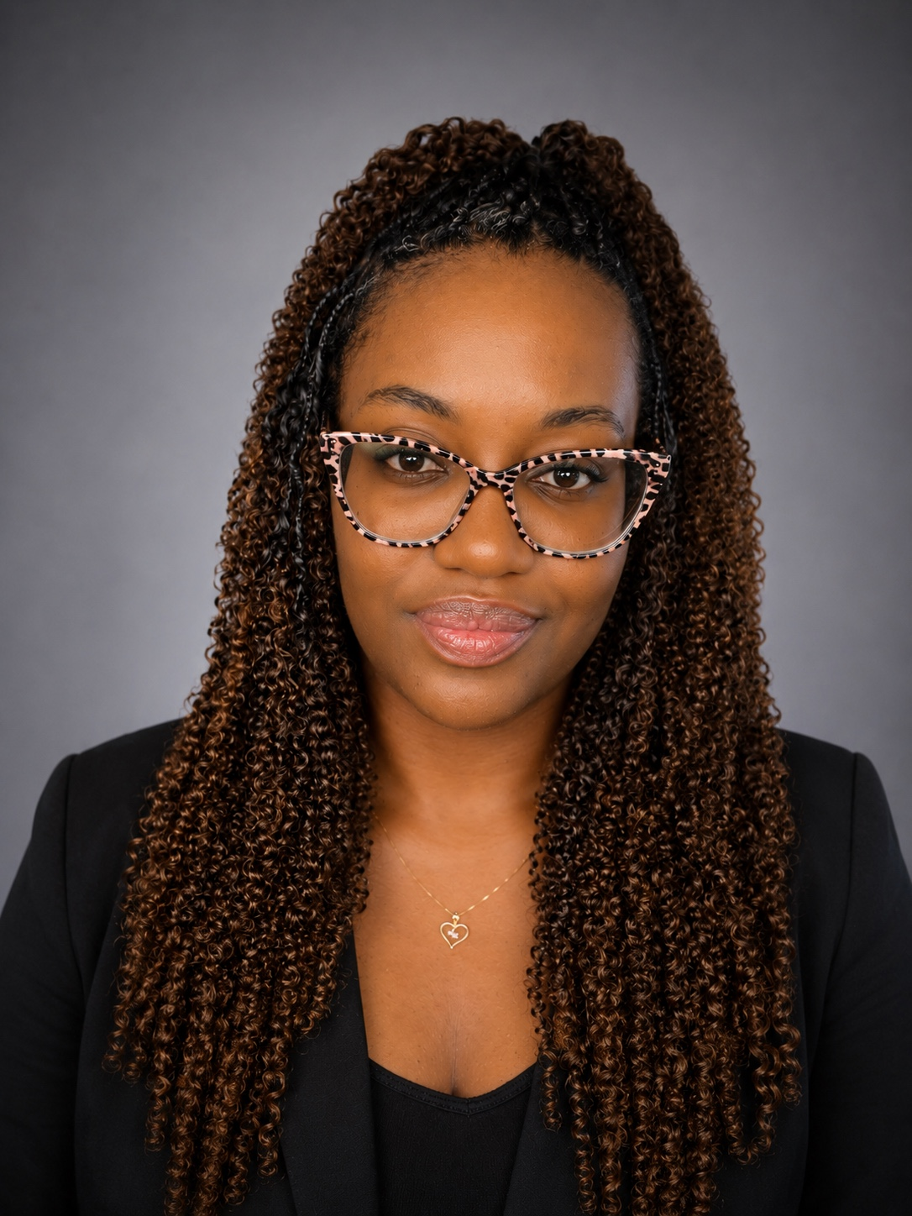 | ORIELLE JEFFREY  SEO & CONTENT STRATEGIST | LOCAL SEO | AEO | GEO  Trinidad & Tobago • 1 (868) 291-0725 • oriellejeffrey@gmail.com  linkedin.com/in/orielle-jeffrey-3039b9149 • GitHub: ______________________________
PROFESSIONAL SUMMARY
SEO is no longer just about ranking on Google. It’s about becoming the answer. SEO and digital content specialist with a background in communications, journalism, and content strategy, combining traditional search optimization with emerging AI search, Answer Engine Optimization (AEO) and Generative Engine Optimization (GEO) strategies. Experienced in technical SEO, keyword research, search intent analysis, on-page optimization, local SEO, content strategy, and website optimization. Leverage AI-powered tools as part of the SEO workflow to accelerate keyword and topic research, uncover searcher questions and content gaps, analyze search intent, develop content briefs, structure information for machine readability and optimize content for AI-driven search experiences.

CORE STRENGTHS  • SEO Strategy & Planning  • Content Strategy & Optimization  • Local SEO & Google Business Profile  • AEO (Answer Engine Optimization)  • GEO (Generative Engine Optimization)  • Keyword Research & Search Intent | CORE STRENGTHS  • Technical SEO & Site Optimization  • On-Page & Off-Page SEO  • Competitor & SERP Analysis  • Google Analytics 4 & Google Search Console  • AI Tools & Workflow Automation  • Copywriting & Content Creation

PROFESSIONAL EXPERIENCE
SEO/CONTENT STRATEGIST (FREELANCE) | Jan 2023 – Present
- Develop and execute SEO and content strategies that improve rankings, organic visibility, and conversions across client websites.
- Conduct keyword research, search-intent analysis, competitor research, and SERP analysis to identify growth opportunities.
- Optimize website content, title tags, meta descriptions, headers, schema markup, internal linking, and image alt text.
- Implement Local SEO strategies including Google Business Profile optimization, local landing pages, review generation, and local content.
- Apply AEO strategies to optimize content for featured snippets, People Also Ask, voice search, and direct-answer experiences.
- Apply GEO strategies to improve content visibility and contextual relevance across AI-powered search and generative engines.
- Use AI tools to accelerate research, content outlines, content creation, meta-data generation, clustering, summarization, and reporting.
- Monitor performance using Google Analytics 4, Google Search Console, SEMrush, Ahrefs, Screaming Frog, and PageSpeed Insights.
- Improved PageSpeed Insights score from 65 to 92 through technical optimization and image compression strategies.
- Set up and optimize Google Ads campaigns, including keyword targeting and A/B testing.
- Provide clients with clear, actionable performance reports and strategic recommendations.

SEO SPECIALIST | REMARC PHOTOGRAPHY STUDIOS LTD | Aug 2024 – Present
- Develop and implement SEO strategies to increase website visibility, organic traffic, and lead generation.
- Conduct keyword research and optimize website content around search intent and target audiences.
- Support content production, blog strategy, and social media initiatives aligned with SEO best practices.
- Perform technical SEO reviews including page speed, mobile optimization, crawlability, and indexation.
- Manage blog publishing and website content updates through WordPress.
- Collaborate on content planning and digital marketing initiatives to improve online reach and engagement.

SEO CONTENT SPECIALIST | WAH MEH BOUTIQUE | Apr 2025 – Present
- Develop and execute content strategies aligned with target audiences, search intent, and business goals.
- Conduct keyword research and use insights to guide website content, blog topics, and content planning.
- Create and publish SEO-focused blog posts designed to improve organic visibility and user engagement.
- Perform technical SEO checks and support website optimization for crawlability, indexation, page performance, and usability.
- Implement Local SEO strategies to strengthen local search visibility and optimize location-focused content.

COMMUNICATION OFFICER | MINISTRY OF EDUCATION | Sept 2019 – Present
- Developed and edited communications content for internal and external audiences, ensuring clear, accurate and engaging messaging.
- Created and managed digital content for education-related initiatives, campaigns, programmes and public information activities.
- Researched topics and translated complex information into accessible, audience-focused content for web and digital platforms.
- Supported content strategy and editorial planning across multiple communication channels.
- Drafted press releases, announcements, articles, social media copy, newsletters, speeches, briefs and other communication materials.
- Conducted research and fact-checking to ensure content was accurate, relevant, timely and aligned with Ministry messaging.
- Supported website content updates, including reviewing page copy, identifying content gaps, and improving on-page content structure.
- Monitored digital and social media trends to identify opportunities for improved audience engagement and content performance.
- Collaborated with internal departments, stakeholders and communications teams to gather information and develop timely content.
- Assisted with media monitoring and analysis of public sentiment, emerging topics, and issues affecting the Ministry.
- Maintained consistency in tone, branding, messaging, and editorial standards across communication materials.
- Utilized AI-assisted tools to support content research, ideation, editing, optimization, and workflow efficiency while maintaining accuracy and editorial oversight.

JOURNALISM INTERN | ONE CARIBBEAN MEDIA LTD | Jan 2018 – Aug 2018
- Produced digital news content, conducted interviews, and performed research for media publications.
- Created written content optimized for audience engagement and timely distribution.
- Developed strong research, communication, and storytelling skills applicable to content strategy and SEO.

COMMUNICATIONS INTERN | MINISTRY OF EDUCATION | Jul 2017 – Dec 2017
- Managed social media content, website updates, press releases, and digital communications.
- Monitored online engagement and media coverage related to Ministry activities and campaigns.
- Collaborated with media outlets and stakeholders to distribute communications and maintain public engagement.
- Supported content publishing, reporting, and online reputation management activities.

EDUCATION
Bachelor of Arts in Mass Communications | COSTAATT | 2018
Associate Degree in Journalism & Public Relations | COSTAATT | 2018
CERTIFICATIONS & PROFESSIONAL DEVELOPMENT
• AI SEO Course 2026: From Zero to Page One Results – Udemy
• Search Engine Optimization (SEO) Specialization – Coursera
• SEO Essentials – HubSpot Academy
• SEO Fundamentals – SEMrush Academy
• Google Analytics Certification – Google

AI, SEO & MARKETING TECHNOLOGY
Google Analytics 4 | Google Search Console | SEMrush
Ahrefs | Screaming Frog | Google Tag Manager
WordPress | Google Ads | PageSpeed Insights
Canva | Microsoft Office Suite | ChatGPT (OpenAI)
Claude (Anthropic) | Gemini (Google) | Perplexity
Hubspot
VALUE I BRING
I connect search behavior, content, local visibility, AI-powered search, and business goals to turn SEO insights into clear priorities and practical growth actions.

