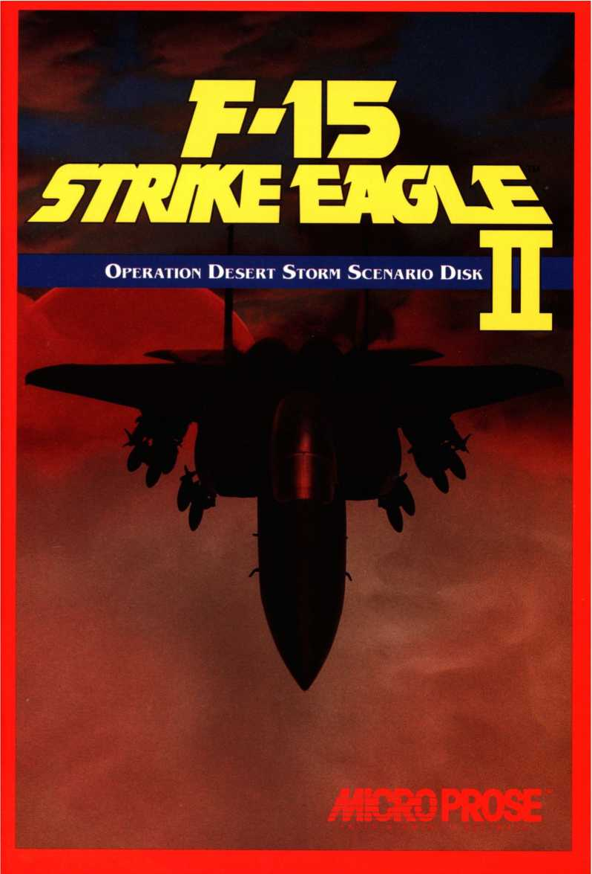


F-//7A
More Intense Air Combat Action from MPS Labs:
Knights of the Sky: You're a pilot in World War I, taking on Germany's most celebrated and dangerous aviators in furious one-on-one dogfights in the gallant tradition of the ancient knights. Duel for the coveted title of Ace of Aces, while also helping the Allies win World War I by participating in air attacks, bombing missions, balloon busting and more. Super 3-D Graphics and a special modem play feature make the action more thrilling than any W. W. I game on the market.
And Coming Soon
Gunship 2000: The updated and enhanced version of the world's most popular attack helicopter simulation gives you control of not just one helicopter, but five, from among six different classes, including Apaches, Longbows, Kiowa Warriors and Blackhawks. Take your squadron on thrilling missions in the trouble spots of the world, including the Persian Gulf. Improved Super 3-D Graphics present low-level flight with breathtaking clarity. Variable gameplay options make the game challenging for anyone.
F-l 17A Nighthawk Stealth Fighter 2.0: F-19 Stealth Fighter, voted Simulation of the Year by the Software Publishers Association, was a game they said couldn't be improved. It has been. F-117A Nighthawk features more missions, more scenarios, more regions of the world in which to fight. The Super 3-D Graphics are bolder and more detailed than ever before. Most importantly, the game is an even more accurate representation of the capabilities of the stealth fighter than its predecessor. Discover the awesome powers of stealth technology for yourself.
INTRODUCTION
Welcome to the first F-15 Strike Eagle //scenario disk. We think you'll enjoy this opportunity to expand your flyable world and your gameplay options. The recent Persian Gulf War, in which the United States led a U.N.- sponsored coalition against the military forces of Iraq in response to the Iraqi invasion of Kuwait, was the event that impelled us to create this disk. For years MicroProse has been the leading publisher of modern military computer simulations, producing a number of high-quality games all based on hypothetical conflicts. We were just as happy to have these conflicts remain hypothetical, but when the United States entered a real shooting war, involving weapons and situations we had speculated about for so long, we could not ignore it.
Our goal at MicroProse has been to put players into combat situations where they face the same kinds of decisions America's soldiers face in wartime. To a large degree, this has always been speculation on our part— well-informed and meticulously researched speculation, but speculation nonetheless. In the Desert Storm campaign, America's F-15 pilots flew actual combat sorties against a well-equipped foe, carrying out with skill and flair the missions they had diligently trained for. Through their experiences, we learned what it is really like to fly an F-15 when it is used in combat. This information is no longer hypothetical, so we decided to present as much as we can in the form of this scenario disk.
On this disk you'll find new features such as night missions (like so many of the sorties during Desert Storm), precision weapons such as laser-guided Paveway bombs and enhanced infrared-homing Maverick missiles, new targets such as chemical weapons plants and Scud missile launchers, attack sorties similar to actual missions flown in the war, and a new "world" to fly those missions in, the Desert Storm Theater. For good measure, we've thrown in two more "worlds" originally developed for F-l 9 Stealth Fighter that were not included in F-15 Strike Eagle II: the North Cape and Central Europe theaters. All of these new features are described in this supplementary manual.
So what are you waiting for? Hop in the cockpit and get going!
F-15 Strike Eagle II
Operation Desert Storm

Scenario Disk
Manual
MicroProse Software
180 Lakefront Drive
Hunt Valley, MD 21030
(301)771-1151
1st Edition
Copyright © 1991 MicroProse Software, Inc.
All rights reserved.
This book may not be reproduced in whole or in part, by mimeograph
or by any other means without permission, with the exception of
quoting brief passages for the purpose of reviews.
Printing History
Printing 98765432 1
IBM is a registered trademark of International Business Machines, Inc.
Tandy is a registered trademark of the Tandy Corporation.
Ad Lib is a registered trademark of Ad Lib Inc.
Roland is a registered trademark of the Roland Corporation.
F-15 Strike Eagle and F-15 Strike Eagle II are registered trademarks of
MicroProse Software, Inc.
F-19 Stealth Fighter Trademark, The Testor Corporation.
CONTENTS
INSTALLATION 4
GETTING STARTED 4
NEW FEATURES 5
NEW WEAPONS 6
ATTACKING WITH LASER-GUIDED BOMBS 10
NEW MISSIONS 11
THE F-15 IN THE DESERT STORM CAMPAIGN 14
DESERT STORM MAP 16
DESERT STORM THEATER 22
NORTH CAPE THEATER 25
CENTRAL EUROPE THEATER 28
DESERT STORM SCENARIO DISK CREDITS
Programming & Project Leadership
ANDY HOLLIS
Desert Storm World Data
BRUCE SHELLEY
Design Support and Manual Text
LAWRENCE SCHICK
Manual Layout and Graphics
IRIS IDOKOGI & JUANITA BUSSARD
Quality Assurance
CHRIS TAORMINO & ROB SNODGRASS
INSTALLATION
Caution: Just to be on the safe side, before you install the new files on this disk, we recommend that you have a look at the "Read Me" file to check for last-minute or later-version information not included in this manual. Insert your scenario disk in a floppy drive, type “TYPE READ.ME" and press Return.
HARD DISK INSTALLATION
- Make sure that F-15 Strike Eagle II is already installed on your hard disk.
- Make sure the directory F-15 II is in is your current directory.
- Use the DOS "COPY" command to copy the scenario disk (use as the file designators). For example, if the scenario disk is in drive "A:" and your hard disk is drive "C:", type "COPY A:*.' C:".
FLOPPY DISK INSTALLATION
- Make sure that you have previously installed F-15 Strike Eagle II onto floppy disk(s).
- Insert the scenario disk in the "A" drive and make that drive current.
- Type "Install" and press Return. Then follow the on-screen instructions, inserting your F-15 II copy disks as requested.
GETTING STARTED
TO START PLAY
Start F-15 Strike Eagle II in the normal way, and select from the option screens as usual. When you reach the "Theaters" screen, select "Other Areas."
You are presented with three options:
North Cape
Central Europe
Desert Storm
If you select "North Cape" or "Central Europe," the game generates a mission and you're off to combat.
If you select "Desert Storm," you have two new options:
General Air Strikes
Historical Missions
If you select "General Air Strikes," a Desert Storm mission is generated.
If you select "Historical Missions," new options appear, enabling you to select a mission similar to actual sorties flown in the Desert Storm campaign. Choose one of these historical missions and you're on your way.
NEW FEATURES
Sound Drivers
The scenario disk includes a sound driver for the Roland MT-32 synthesizer, as well as improved sound drivers for standard IBM sound and the Ad Lib sound board. These new drivers are automatically installed with the new scenarios, and appear as options when F-15 II boots up.
Night Missions (Desert Storm theater only)
In the Desert Storm campaign, a large percentage of ground attack sorties, perhaps the majority, were flown at night. Therefore we have added night missions to F-15 H's capabilities.
In a night mission the visible world is obviously much darker than in daytime, but that's not the only effect. At night your vision is impaired, so some targets that you would normally "see" at long range do not appear until you are closer to them. Likewise, those enemies that rely on visual systems to detect your Eagle won't notice you until you get considerably closer to them.
Note that objects that appear in your tracking camera CRT are displayed in reddish "false-color" images. This is because your tracking camera relies on infrared (heat) imagery in low light levels.
NOTE: During flight, Alt/N toggles the night condition on and off.
NEW WEAPONS
AIM-7M “Sparrow”
Medium range air-to-air missile with semi-active radar homing
Guidance: Semi-active radar homing (requires radar guidance from plane) Max. Number Carried: 4
Effective Range: 44 km
Missile Speed: Mach 3.7
Missile Maneuverability: Very good
Notes: Because the new AMRAAM missile had not yet proven its reliability by the time of the Desert Storm campaign, the U .S. Air Force relied on the aging but dependable AIM-7 Sparrow for long-range air-to-air engagements. In five different versions, the Sparrow has been America's standard radar AAM since the 1960s. The latest version, the AIM-7M, has enhanced avionicsthat improve its "look-down, shoot-down" capabilities, enabling it to home on aerial targets below without being confused by ground clutter. Its ability to cope with electronic countermeasures also has been improved. The AIM-7M's enhanced accuracy partly accounts for its excellent performance in the Gulf War.
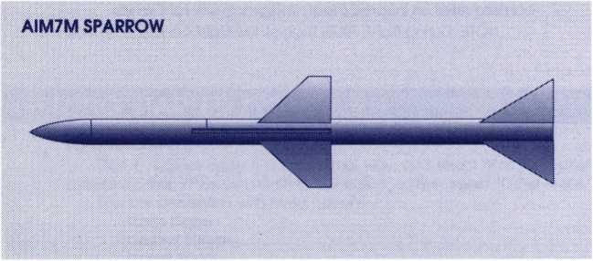

AGM-65G “Maverick”
Thermal-imaging air-to-ground guided missile
Max. Number Carried: 6
Best Targets: Bunkers, radar sites, oil facilities, missile sites
Effective Range: 32 kilometers
Maximum Speed: Mach 1 +
Attack Technique: Air-to-ground fire-and-forget launch
Minimum Launch Altitude: 500'
Maximum Launch Altitude: 40,000'
Notes: The Maverick is America's standard air-to-ground guided missile, and has a wide variety of guidance systems. The original design put a simple video camera in the missile's nose. While the missile remained attached to the plane the pilot used a miniature stick and screen to aim the
bomb at the target below, locked it in, and released the weapon. Once in flight the bomb steered toward the image locked into its computer brain. Later versions added zoom lenses, PAVE TACK laser guidance, and ultimately, in the "D" and "G" models, a FLIR (forward-looking infrared) thermal imaging system that can “see" through clouds, smoke, and night. These newer versions were used extensively in the Desert Storm campaign, greatly expanding the Air Force's night-mission capability.
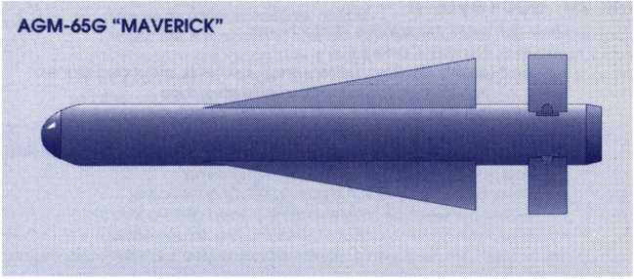

GBU-12 Paveway
Laser-guided glide bomb
Max. Number Carried: 8
Best Targets: Hangars, buildings, bridges, bunkers, depots, missile sites, radar sites, oil facilities
Effective Range: 2 kilometers per 1,000' of altitude
Maximum Speed: Glide bomb
Attack Technique: Toss bombing or level bombing
Toss Bombing Attack Altitude: 500' and climb
Level Bombing Attack Altitude: 2,000' and turn away
Notes: The GBU-12 is one of the standard laser-guided bombs in the US armory. The PAVE TACK laser guidance system is the most accurate way of placing a bomb on a target (short of using a guided missile like the
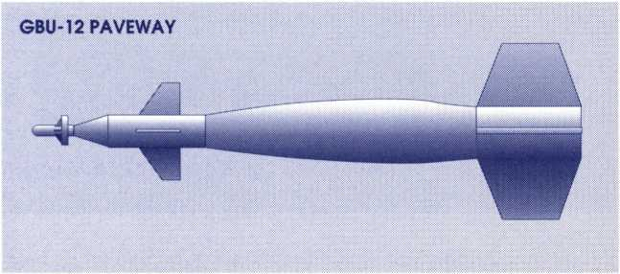
Maverick). The advantage of using a bomb is that the weapon weight is almost entirely explosive, while guided missiles must, of necessity, use some of their weight for the rocket motor.
The GBU-12 and GBU-15 Paveway bombs were the weapons used in some of the most spectacular precision attacks in the Desert Storm campaign, penetrating hardened bunkers, severing bridges, destroying oil pumping manifolds, and dropping down ventilator shafts into building interiors.
Mk 20 “Rockeye” II
Laser-guided high-explosive cluster bomb
Max. Number Carried: 4
Best Targets: Vehicles, artillery emplacements, grounded planes, buildings, depots, missile sites, ships
Effective Range: 2 kilometers per 1,000' of altitude
Maximum Speed: Glide bomb
Attack Technique: Toss bombing or level bombing Toss Bombing Attack Altitude: 500' and climb Level Bombing Attack Altitude: 2,000' and turn away Notes: This weapon marries a laser guided glide-bomb system with a Mk 20 Rockeye cluster munition. The bomb breaks open about 100' above the surface, spinning out 247 shaped-charge bomblets that can destroy buildings, armored vehicles, and people. The opening height and pattern can be preset for various types of targets. The laser guidance allows for earlier release and greater bomblet release accuracy. With an area weapon like a cluster bomb the former is more important, since it gives an increased safety margin to the launching aircraft.
The U.S. Navy discovered these bombs were enormously effective against small warships when a single cluster bomb wrecked a Libyan Nanuchka-class missile boat in 1986. This lesson was reinforced in the Desert Storm campaign, in which cluster bombs were used to striking effect against transport and armored vehicles, mobile Scud missile launchers, and antiaircraft sites. The terrible havoc wreaked on the Iraqi columns escaping from Kuwait City was largely the work of aircraft armed with Mk 20 Rockeyes.
MK20 ROCKEYE II

AGM-88A HARM
High-speed anti-radiation ("homes on radar") missile
Max. Number Carried: 4
Best Target: Ground radar stations
Effective Range: 20 kilometers
Maximum Speed: Mach 2+
Attack Technique: Air-to-ground fire-and-forget launch against any radar
Minimum Launch Altitude: 500'
Maximum Launch Altitude: 60,000'
Notes: This is America's most advanced anti-radar missile. It can lock and home on hostile radars even if theyjump frequencies or switch off. It can be programmed to target SAM radars, early warning radars, or even weather radars. It is extremely accurate and highly effective.
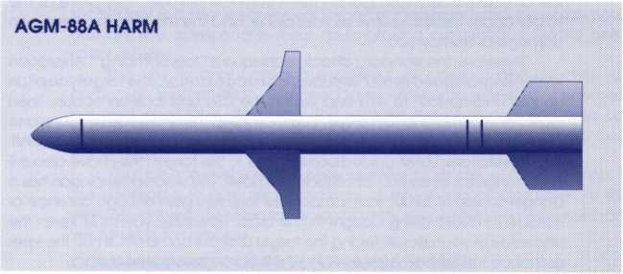
ATTACKING WITH LASER-GUIDED BOMBS
The GBU-12 Paveway and the Mk 20 Rockeye II are essentially motorless missiles. They glide from your plane to a target "painted" by the PAVE TACK laser mounted on the bottom of your plane.
Oval and CRT lock-on: The tracking box on the HUD shows your target. When the tracking box turns oval, the bomb is locked on and has a good chance of hitting. When the oval changes color, the bomb has superior accuracy.
You should always use the tracking camera with these weapons. When the box turns oval the "Missile Lock" crosshairs appear on the right-side CRT. If you are "toss-bombing" (see below) the HUD box/oval is often invisible, so the tracking camera message on the CRT is your only indication of lock-on.
Toss Bombing: The problem with glide bombs is that they travel about as fast as your plane. If you launch them from low altitude, they arrive at the target about the same time as your plane, and the resulting explosion can damage or destroy you.
Therefore, the standard attack technique is "toss bombing." Approach level, flying full speed at 500' altitude. At 3 km to 6 km from the target you pitch up into a climb (30° to 40°) and watch the CRT until lock-on occurs. Then launch the bomb and turn away. You must keep the underside of your plane aimed at the target until the bomb hits, so don't make the turn too violent!
Restrictions: Laser-guided bombs glide to the target; they have about 1 km of range for every 500' of altitude you have. The weapon explosion has a danger space of 3,000', so it's important that you gain enough distance or altitude to avoid being caught in the blast. However, you must keep the underside of your aircraft facing the target until the bomb hits. If not, the laser guidance for the bomb breaks and it will almost surely miss.
PAVE TACK
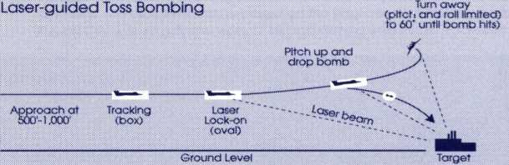
NEW MISSIONS
HISTORICAL MISSIONS
If you select "General Air Strikes" in the Desert Storm theater, your primary and secondary targets are assigned to you from the many military targets in Iraq and the Kuwaiti Theater of Operations (KTO). However, if you choose "Historical Missions," you have the opportunity to select from eight types of sorties that closely duplicate well-known missions from the Gulf war. Even these vary somewhat from mission to mission — most have multiple primaries of the same type to choose from, and usually the secondary target selection is even more variable.
SADDAM’S EYES (17 JANUARY 1991)
Your primary target is one of Iraq's early warning radar facilities. The secondary is a radar-equipped target in the same area for which your ordnance is appropriate. Your air-to-ground armament is HARM antiradar missiles.
The key to conducting a successful air combat and air defense campaign is information. You need to sense exactly where your enemies are and what they are doing. This explains the coalition's emphasis on "blinding" Iraq'sair defense network from the very first attack on the first day of the air war.
Your job is to knock out an early warning radar site, which is essential if the coalition is to gain air supremacy. Much of Iraq's radar system is still working on the date of this sortie, so you may encounter interceptor aircraft vectored in to stop you.
COMMAND AND CONTROL (17 JANUARY 1991)
Your primary target on this sortie is either the Defense Ministry or the Presidential Palace in Baghdad. The secondary is another strategic target in central Iraq. Your air-to-ground armament on this sortie will be Paveway laser-guided glide bombs.
The Defense Ministry and the Presidential Palace are the main nerve centersof the Iraqi military. Each is a hardened multi-levelfacility with secure communications lines and supposedly bombproof command centers. They are hard nuts to crack. Both were attacked on the first night of the air war, and several return attacks were made on later dates. Though the Iraqi Air Force generally was caught by surprise by the attacks of the 17th, you may still run into Iraqi fighter patrols, so be on your guard.
SCUD BUSTING (19 JANUARY 1991)
This mission consists of a primary attack on a fixed Scud missile site, with a mobile Scud launcher as the secondary target. The mobile Scud launcher was on the move when detected; you'll be given a last known position for the target. You'll just have to fly to that area and look around. Your air-to- ground armament on this sortie is Maverick missiles.
On 18 January Saddam began firing Scud missiles at targets in Israel and Saudi Arabia. Suddenly it became very important that his launch sites be shut down. Numerous Scud-busting sorties were flown on the 19th, in both eastern and western Iraq. At this time the Iraqi Air Force was still trying
to put up a fight, so you can expect some interference from them. For more details on Scud-busting, see the “Great Scud Hunt" section of The F-15 in the Desert Storm Campaign (page 14).
NO NUKES (20 JANUARY 1991)
Your primary target is one of Iraq's three nuclear weapons research facilities, at Mosul, Irbil, or "Factory 10" in Baghdad. Your secondary is another strategic target in the same area. Your air-to-ground armament on this sortie is Paveway laser-guided glide bombs.
Though no one seriously believed that Saddam Hussein had a nuclear weapons capability at the time of the Gulf war, it was clearly his intention to build one. In the interest of future stability in the region, this capability must be eliminated.
Saddam's nuclear plans had suffered a severe setback ten years earlier, when Israeli F-l6s bombed the Iraqi research reactor at Osirak in 1981. That made Saddam more determined than ever to build nuclear weapons, so following the Israeli attack he dispersed his research capabilities so he could not be stopped in one lightning raid. But in the first two weeks of Desert Storm, coalition bombers utterly destroyed all of his nuclear research facilities, both those in the northern cities of Mosul and Irbil and those in and around Baghdad.
“BABY MILK FACTORY” (22 JANUARY 1991)
Your primary target is a biological weapons or chemical weapons plant in central or northern Iraq. Your secondary is another strategic target in the same area. Your air-to-ground armament on this sortie is Paveway laser-guided glide bombs.
On 22 January coalition planes destroyed a factory in a Baghdad suburb that Iraq claimed was their only infant formula manufacturing plant. Western reporters were shown the rubble of the installation, which bore a conspicuous hand-painted sign that read "Baby Milk Factory" in English. Pentagon spokesmen claimed that the plant had been converted to manufacture biological weapons, and as evidence they pointed out that the plant had been provided with armed guards and antiaircraft defenses.
STOP THE SPILL (26 JANUARY 1991)
Your primary target is the Sea Island pumping station in the Persian Gulf off the coast of Kuwait. It is hoped that a bomb placed at the right point will dam up or diminish the flow of oil into the Gulf. Your secondary is another target in the same area. Your air-to-ground armament on this sortie is Paveway laser-guided glide bombs.
On or about 24 January Saddam Hussein, in a vicious act of environmental terrorism, ordered his forces occupying Kuwait to begin dumping Kuwaiti oil into the Persian Gulf. At Sea Island, one of Kuwait's main pumping stations for loading oil tankers, the valves were exploded and millions of gallons of crude oil began spilling into the sea. By accident or intention, the oil was ignited and began burning at the point where it reached the surface of the Gulf.
Coalition leaders quickly determined to do whatever they could to cut off the flow of oil and stop this crime. After careful consultation with the exiled Kuwaitis, on 26 January two F-l 1 Is were dispatched armed with GBU-15s, the
Air Force's largest laser-guided glide bombs. Their objective was the pumping manifold five miles inland from the coast, where the pipeline feeding the Sea Island spill protruded above the surface of the desert within a fort-like rectangle of raised earth berms. The precision bombs severed the pump manifold, and within 24 hours the oil gushing from the terminal had dwindled to almost nothing.
Your F-15's mission is to back up the F-l 1 Is by trying to seal off the pipeline at the terminal end. You may encounter Iraqi Air Force planes looking for easy naval targets or lone coalition aircraft, so be wary.
BRIDGES TO NOWHERE (27 JANUARY 1991)
Your primary and secondary targets on this sortie are the Euphrates and/or Tigris river bridges on the routes linking central Iraq with the Iraqi army in the Kuwaiti Theater of Operations (KTO). Your air-to-ground armament on this sortie is Paveway laser-guided glide bombs.
The half-million Iraqi troops in Kuwait and southeastern Iraq depended on supplies of food, ammunition and spare parts from Baghdad and other cities in central and northern Iraq. The coalition battle plan called for cutting off these units from resupply and reinforcement. The campaign to destroy over forty strategic bridges between Baghdad and Kuwait/Basra (and keep them destroyed) began in earnest in the second week of the air war. The flow of supplies down the Tigris-Euphrates valley soon diminished to a trickle.
REPUBLICAN GUARDS (20 FEBRUARY 1991)
Your primary and secondary targets are Republican Guard armored units stationed on the Iraq-Kuwait border southwest of Basra. Your main air- to-ground armament on this sortie is Rockeye cluster bombs.
(Due to targeting limitations, you will find that you can “lock on" to only the central tank in each armored group. If you wish to destroy the others, you can do so by strafing with your cannon or by dropping unlocked Rockeyes — a real test of your toss-bombing skill!)
Eliminating the Republican Guard's equipment and will to fight was a key aim of the Desert Storm air campaign. The aerial bombardment increased in the week before “G-Day," when the ground war began. It's your job to eliminate as many Guard tanks and armored vehicles as you can so they won't be there to kill coalition soldiers when the Army and Marines move into Kuwait.
THE F-15 IN THE DESERT STORM CAMPAIGN
OPERATION DESERT SHIELD
On August 2, 1990, Iraqi armored divisions crossed the border into Kuwait. Sweeping away all resistance, they conquered and occupied the country in less than three days. They then repositioned themselves along the Kuwait-Saudi border to the south, clearly threatening to do to the Saudis what they'd done to the Kuwaitis.
Caught flat-footed by the Iraqi invasion, grossly outnumbered and alarmed, on August 7th the kingdom of Saudi Arabia agreed to accept American military aid to ensure its defense in case of Iraqi invasion. Within 34 hours the first American fighter wings of “Operation Desert Shield" had arrived in Saudi Arabia. They found themselves part of a growing coalition of countries determined to oppose Iraqi aggression, a coalition legitimized by the backing of the United Nations and led by the United States.
Among the first F-15s to arrive were the F-15 Cs and Ds of the 1 st Tactical Fighter Wing, stationed at Langley Air Force Base, Virginia. It's a grueling 15- hour flight from the U .S. East Coast to Saudi Arabia, requiring several mid-air refuelings, but the 1 st TFW made it and were on station in a matter of hours, hoping Iraqi President Saddam Hussein would hesitate to attack Saudi Arabia if it meant taking on the United States as well.
The F-15s of the 1st TFW (and of the Saudi Air Force) were soon joined by many others, including the brand-new F-15Es of the 4th Tactical Fighter Wing, flown in from Seymour-Johnson Air Force Base in North Carolina. Within two weeks Saddam found that he was facing a force that made conquest of Saudi Arabia too tough to consider.
With the defense of Saudi Arabia essentially assured, the coalition began to alter its goal from defending against an Iraqi attack to the liberation of Kuwait. While President Bush gradually built up a consensus among the coalition partners for this new goal, the Desert Shield forces likewise built up their troop strength and supply base. The seeds for Desert Storm were sown in November when President Bush announced a doubling of American forces in the Gulf. Soon the coalition would have sufficient power to bring the war to Saddam.
In December the United Nations Security Council passed a resolution requiring Iraq to vacate Kuwait byJanuaryl5,1991,or face the use of force to eject them. President Saddam Hussein chose to ignore this deadline.
D-DAY FOR THE AIR WAR
In the wake of the successful coalition air campaign and the lightning 100-hour ground war, many people expressed the opinion that the Iraqi military had been greatly overestimated: that when push came to shove, they were pushovers. This does a great disservice to the coalition leaders and soldiers, who conceived a brilliant campaign, then carried it out with skill and initiative. The Iraqi Air Force and Army were defeated with so few losses to the coalition side because the coalition took careful advantage of those areas where they had superiority and exploited every opportunity the Iraqis gave them.
From the start the coalition military leader. General Norman Schwarzkopf, was determined that he must gain air supremacy early and then keep it. The Iraqis had an excellent air defense system and a sizable air force equipped with high quality Soviet- and French-built aircraft. Against this opposition, coalition air supremacy was by no means a preordained state of affairs.
In order to knock out the Iraqi Air Force and air defenses as quickly as possible, Schwarzkopf decided to muster every air combat resource he had to strike a sudden hammer blow from which the Iraqis would never recover. In the early morning hours of January 17th (Baghdad time), only seventeen hours after the U.N. deadline had expired, the hammer struck.
To ensure that the Iraqis wouldn't know what was coming, their early warning radars would have to be the first targets destroyed. Out of the dark came F-117A stealth fighters and ground-hugging Apache helicopters, which knocked out the southern radar bases, while longer-ranged F-15Es struck at the northern sites. Within minutes Iraq's early warning defenses were a sieve, and the combined air might of the coalition was pouring through the holes.
Strategic targets throughout Iraq and Kuwait were hit on the first night, with the emphasis on military command and communication centers, and on air defenses such as SAM sites, interceptor airbases, and radar facilities. The Defense Ministry and the Presidential Palace in Baghdad were hit hard by precision munitions from stealth fighters and ship-launched Tomahawk cruise missiles, while F-15s provided air cover above.
For the first three days of the air warthe coalition focused on airforce and air defense targets. A number of Iraqi fighter pilots got into the air and tried to oppose the coalition air assault. However, their command and control system had collapsed in the first attack; it never organized a coordinated response. This is the real reason why the Iraqi Air Force was defeated so quickly. Disorganized by the surprise attack, they were unable to respond in a coordinated manner. Their planes were then destroyed piecemeal.
Most of the Iraqi aircraft destroyed in the dogfights of the first three days were shot down by F-l 5s. By January 20th the Iraqi Air Force realized that its scattershot defense was worse than useless. It was getting them shot down for no gain, so they simply "went to ground" and quit, trusting to the safety of their hardened bunkers. They didn't come up again until they realized, in late January, that they had no safe haven, because the U.S. Air Force's precision- guided bombs could punch right through their hardened bunkers. Nearly all the Iraqi planes that flew from that point on were fleeing to Iran.
The unsung heroes in the air campaign were the support aircraft that made fighter and bomber air supremacy possible: the tankers, AW ACS and JSTARS aircraft. Tankers like the KC-10 refueled F-l5s in the air, sometimes dangerously close to combat zones, so that the fighters could get back into action quickly or maintain their positions orbiting on combat air patrol. E-3 AW ACS aircraft acted like flying air-traffic control towers, keeping track of hundreds of different coalition and enemy aircraft at a time, coordinating and controlling the air war, lifting the "fog of war" from coalition air operations. E-8 JSTARS aircraft fielded the still-experimental Joint Surveillance Target Attack Radar System, a revolutionary new reconnaissance
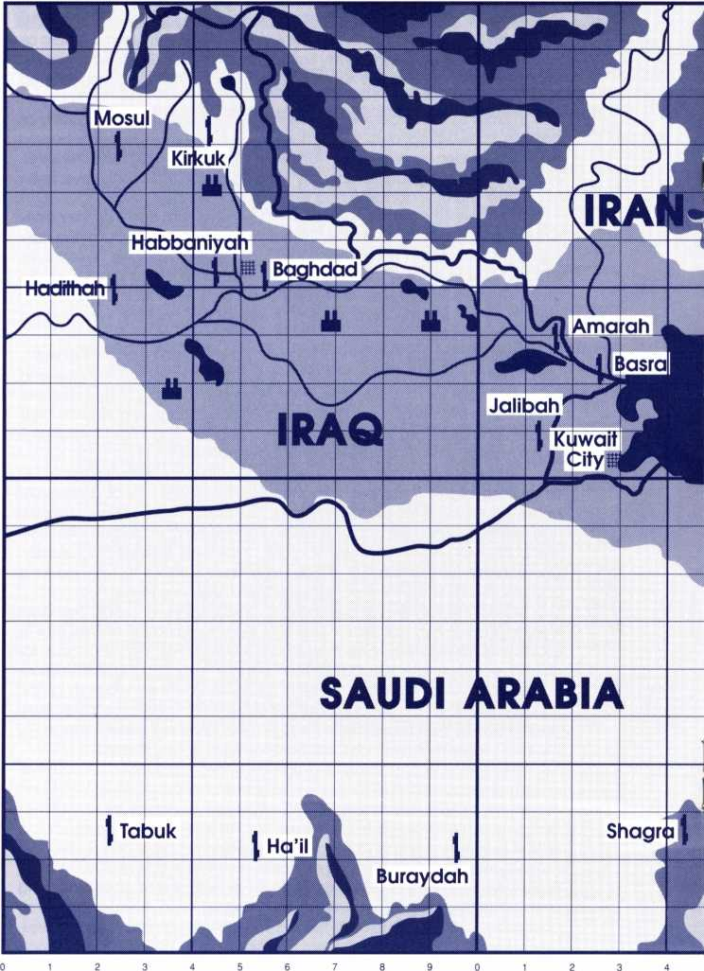
w
Mk

Desert
Storm

ONC
II CV Constellation r
Map Key
| Airbase
| Aircraft Carrier
IS City
M Chemical/ Biological Weapons Plant
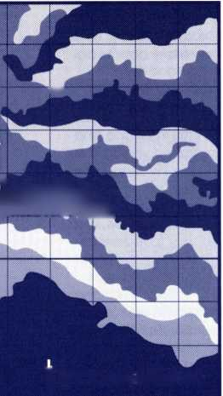

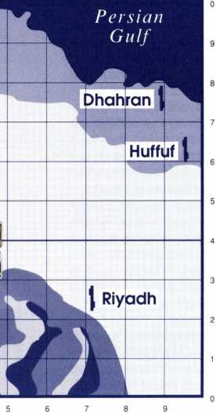
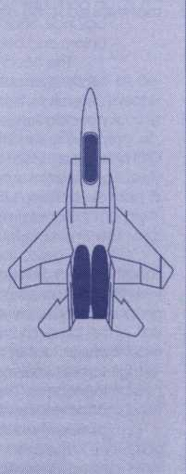
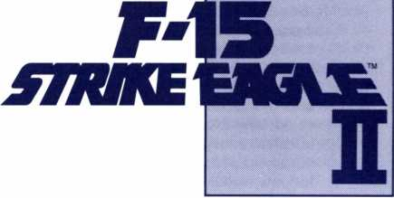

system that enabled the coalition to detect moving Iraqi ground targets at long range. In coordination with the AWACS planes, JSTARS were able to direct F-15s and other ground attack planes straight to Iraqi convoys and mobile Scud launchers. With JSTARS, the coalition knew more about Iraqi troop movements than the Iraqis did.
THE GREAT SCUD HUNT
"Scud" is the NATO designation for the Soviet SS-1 ballistic missile, originally developed in the 1950s for use with the Red Army in Europe and designed to deliver a tactical nuclear warhead. An improved version, the "Scud-B," was fielded in 1965, but it became obsolete in the 1970s and was retired from Soviet field service. In the mid-1970s the Soviets began selling them (without the nuclear warheads, of course) to their client states in the Middle East: Egypt, Syria, and Iraq. In the face of Israel's superior air force, Iraq in particular decided that ballistic missiles were a good way to redress the balance. Saddam ordered the purchase of numerous Scuds from the Soviet Union, and began producing his own missiles based on the Soviet design.
The Scud-B was designed as a tactical battlefield weapon, with the relatively short range of 175 miles. Saddam wanted to use them as strategic deterrents, but to fill this role in the vast deserts of the Middle East the Scud needed far greater range. Saddam hired French and East German engineers to modify the basic Scud; the result was the Al-Husayn and Al-Abbas missiles, which had two to three times the range of the original Scuds, at the price of much diminished payloads. Now Saddam had a weapon that could threaten the capitals of both Saudi Arabia and Israel.
Saddam threatened to use these modified Scuds to attack his enemies with chemical weapons, but in the Gulf War only conventional explosives were used. There is reason to doubt whether Saddam's engineers ever actually solved the difficult problem of equipping the warhead-reduced Al- Abbas missiles with a chemical weapon payload. It may be that the threat of Scuds carrying nerve gas was never more than bluff.
In any case, the Scuds fired on Israel and Saudi Arabia had a political impact far out of proportion to their military significance. The coalition air forces were obliged to devote significant effort to destroying the Scud launchers. "The Great Scud Hunt" lasted throughout the 43-day war, but after the first few days the fixed sites were neutralized. Thereafter the main concern was the pursuit and destruction of the mobile Scud launchers.
The fixed launch sites were hardened (concrete-armored) subterranean launch tubes, difficult to destroy, but the coalition knew exactly where to find them. Sometimes several attack runs were necessary to neutralize a fixed launch site, but the allies' precision laser-guided bombs were equal to the task of penetrating the Scuds' hardened bunkers. The sites built to launch on Saudi targets were in eastern Iraq, near Basra; the sites aimed at Tel Aviv, Jerusalem and Haifa were located in far western Iraq, near the" H2" and ”H3" points on the western Iraq oil pipeline.
The mobile Scud launchers were a more difficult proposition, First of all, coalition intelligence underestimated how many mobile launchers the Iraqis had, perhaps by as much as a factor of ten. Thus they initially devoted too few resources to destroy them all before the Iraqis could hide them. Second, the Iraqis got very good at hiding the mobile launchers, which are
transported on 40-foot heavy trucks. Not an easy thing to hide, you might think, but if you have tens of thousands of square miles to hide them in, even 40-foot trucks can disappear.
Hidden mobile Scud launchers proved very difficult to find. In practice, the coalition air forces had to rely on catching them while they were moving or set up for launch. Because the Al-Abbas Scud missiles had a fixed range, they could only be fired on Saudi and Israeli cities from certain areas; the coalition had noted these areas, and kept F-15s on continual orbit above them. After night fell the Iraqis would bring a few mobile launchers out of hiding, drive them into the firing zones and set them up for launch. If JSTARS ground-scanning radar detected large moving vehicles in those areas, or if spy satellites or radar detected an actual Scud launch, the F-15s would be vectored in on the target, in hopes of catching them before they got away. Frequently they did catch them, but it turned out that Iraq had such a large number of mobile launchers that a few of them were probably still intact even after the war ended.
“CUT IT OFF AND... KILL IT.”
Ultimately all the coalition's strategic air attacks were aimed at destroying Iraq's ability to support and protect its army in the Kuwaiti Theater of Operations. In General Colin Powell's pithy phrase, the plan for dealing with the Iraqi field army was to “Cut it off and... kill it." Cutting that army off, the strategic half of the plan, meant severing the road links between the KTO and central and northern Iraq by blowing up bridges and destroying supply convoys. Killing the Iraqi army, the plan's tactical half, meant destroying its ability to fight by demolishing its tanks, vehicles, artillery and ammunition. (Killing the troops themselves was a lesser consideration. In the modern era, an army without heavy equipment is no army at all.)
Faced with trying to survive under constant air assault, the Iraqi troops quickly dispersed and went to ground. This dispersal, combined with low clouds and bad weather during the second week, resulted in a frustrating time for those pilots whose job it was to wear down the Iraqi army. The “carpet-bombing" raids of the high-flying B-52s were of questionable effectiveness against dispersed and dug-in armored units, while the fighterbombers and A-10 tank busters, armed with precision weapons, couldn't use them if they couldn't see the targets. Some aircraft had to return to base with unused ordnance because the targets couldn't be found.
Gradually the coalition pilots began to develop methods of outwitting Iraqi camouflage and deception, and Iraqi casualties began to climb. Pilots armed with infrared-homing Mavericks discovered that if they went tankhunting right after sunset, the exposed metal on dug-in tanks (such as cannon barrels) still radiated heat, giving the Mavericks targets they could lock onto. Then at the end of January the weather cleared for a while, and the Iraqis made their ill-fated attack across the Saudi border to the town of Khafji. In support of the cross-border attacks, for several days Iraqi regular Army units abandoned their defensive positions and were on the move throughout southern Kuwait. The coalition ground-attack aircraft went into what can only be described as a feeding-frenzy, repulsing the attacks and clobbering everything that moved north of the border.
Well behind the front lines was the iron core of the Iraqi Army, the Republican Guard divisions. The Guards were the elite units whom Saddam Hussein relied upon to expand and maintain his power. Their commanders were selected on the basis of personal loyalty to Saddam. Their soldiers were the best-paid, best-supplied, best-trained, and best-equipped in the Iraqi Army. It was the Republican Guard who had invaded and conquered Kuwait the previous August. After Kuwait was under Iraqi control, regular Army units, manned by conscripts, were marched in to defend the border with Saudi Arabia, while the Guard was drawn back into reserve positions on the Iraqi-Kuwait border. From there they could move to reinforce against a coalition invasion, whether it came from Saudi Arabia to the south or from the Persian Gulf to the east. And if the Iraqi defenses collapsed, they were in position to fall back on Baghdad to protect Saddam from his enemies.
The coalition leadership recognized that the Guard divisions were the backbone that stiffened the whole Iraqi Army, so the Guard was targeted by air attacks from Day One of the air war until the end. As a measure of the Guard's training, note that they were under continuous bombardment by B-52s and close-air assault for 40 days, yet had the morale to form into small units to resist the coalition ground attack. Iraqi Regular Army units, most of which were subjected to far less pressure from the air, essentially disintegrated in the face of coalition ground forces.
It is extremely difficult to cut off a mechanized division from supply and then destroy it using air attacks alone, especially when the troops are on their home territory. In fact, it is probably impossible. But the air forces had to do whatever they could to degrade the fighting abilities of the Republican Guard so the coalition ground troops would be able to knock them out when G-Day came.
G-DAY TO THE END
G-Day, ground-war day, came on February 24, 1991. In an attack of stunning swiftness, American, British and French airborne and armored units drove north into Iraq to the Euphrates valley, cutting off the Republican Guard, then turned east to engage and destroy them. Meanwhile U.S. Marine and Arab units smashed through the defenses along the Saudi- Kuwaiti border and fought their way up to Kuwait City. Coalition aircraft, including F-15s, aided in the pre-attack softening up of the “Saddam Linein southern Kuwait. Once the attack began, they provided close-air support for the attacking troops, striking at enemy positions just ahead of the advancing coalition forces. When the Iraqis broke and fled northward, the air war entered the "exploitation phase," in which fleeing Iraqi convoys were completely destroyed by air attacks.
Finally American and British armored and mechanized brigades encountered units of the Republican Guard. The Guards, though ready to fight, were unable to put up an organized resistance because their command and communication structures had been destroyed by the relentless air attacks. As with the Iraqi Air Force, those individual Guard units that fought an uncoordinated defense against the superbly-coordinated coalition forces were destroyed piecemeal.
When the Marine and Arab ground troops blasted their way into Kuwait they found almost no organized resistance. The regular Iraqi units, demoralized by the long air and artillery bombardment, out of supply and
out of touch with their commanders, were now faced with a determined and cohesive ground attack. They simply disintegrated under the pressure. Iraqi soldiers surrendered by the tens of thousands. Only four and a half days after the ground attack began, the war was over.
For decades, air power advocates have been claiming that air attacks were the future of warfare, that air power can be a decisive factor in winning a war. The preeminence of air power in naval affairs was proven back in 1942 at the battles of Midway and Coral Sea, but in land campaigns — the campaigns that win wars — the evidence was less favorable. Great claims were made for strategic bombing in particular, but strategic bombing never broke a people's will to fight or destroyed an opponent's industrial capacity, despite the massive bombing campaigns of the Battle of Britain, of the Allies over Germany, and of the United States over North Vietnam. The problem was that most bombs dropped failed to hit their targets, and close just isn't good enough.
In the Gulf war, for the first time ever, air power was truly decisive in a land campaign. The widespread destruction of Iraqi vehicles, supply lines and command structures hit the Iraqis far harder than anyone had anticipated, leaving them simply incapable of resisting a coordinated ground attack. How can we account for this? Certainly the coalition air attacks were brilliantly coordinated: the right targets were hit at the right times with little waste or redundancy. Certainly the coalition pilots were superbly trained and motivated, and flying some of the finest (and best-maintained) combat aircraft in the world. But the greatest difference between Desert Storm and all previous major air campaigns was the crucial importance of precision guided weapons. The fact that pilots could fly out and hit their assigned targets virtually every time was phenomenal. In previous wars, bombers would frequently have to attack a target over and over and over before it was knocked out, sometimes spending weeks on a single target. In Desert Storm, if the planners assigned the air forces a specific target, they knew it was as good as gone.
A dug-in armored division is a far more difficult target than a bridge, but here too precision-targeted weapons proved decisive. In past wars, dug-in troops have shown an amazing ability to survive massive air and artillery bombardments and still come out fighting. That's because bombs and shells that miss your bunker don't matter much, and nearly every one misses. In the Gulf war, coalition aircraft with guided weapons were able to target individual bunkers, fortifications, and dug-in vehicles, then knock them out one by one. They were able to make specific attacks against the enemy's command and communications structure. As a result, Iraqi ground units were simply shattered.
From the Iraqi standpoint, the speed and accuracy of the coalition air attacks was overwhelming. Their air defense system was knocked out before they knew what hit it, and after that the coalition air forces had free rein to attack whatever targets they were assigned. By forcing the Iraqis to give up on air defense, the coalition effectively won the war in the first three days.
DESERT STORM THEATER
INTRODUCTION
This theater represents the main areas of action in Operation Desert Storm, covering northern Saudi Arabia, Kuwait, and eastern and central Iraq. Information in this section describes the area during the period January 17 to February 28,1991 ("The Gulf War").
Politics: The western end of the Persian Gulf protrudes into the center of the map, and around it lie the region's three most powerful nations: Iran, north of the Gulf; Iraq, to the west; and Saudi Arabia to the south. Between them all, sitting astride the most valuable oil fields on Earth, is the tiny Arab country of Kuwait.
Iran, the successor state to ancient Persia, is ruled by a radical fundamentalist Shi'ite Moslem regime, a brutal governmentthat has actively tried to spread its brand of revolutionary fundamentalism to its neighbors. Iran has a large population, and oil revenues to support a powerful military (though it has had trouble getting modern military equipment since 1979, when it basically declared war on the rest of the world.)
Iraq is a populous Arab country centered on the fertile Tigris and Euphrates river valleys. It has a Shi' ite Moslem majority but is ruled by Saddam Hussein's Baath Party, which is dominated by Sunni Moslems. Wealth from oil revenues has enabled President Saddam to build a well-equipped, modem military, outfitted mainly with Soviet-built equipment and trained by Red Army advisors. A brutal and aggressive tyrant, in 1980 Saddam, sensing potential weakness to the north, ordered an invasion of Iran. The two countries fought a savage and debilitating war of attrition for eight years. When a cease-fire was signed in 1988 nothing had been gained by either side but the deaths of hundreds of thousands of their soldiers and civilians.
The kingdom of Saudi Arabia is a vast, underpopulated desert ruled by a conservative royal family. Like its neighbors, Saudi Arabia has spent much of its considerable oil wealth on modern arms, purchased mainly from Western countries. Like the other Arab Gulf states, Saudi Arabia fears the export of Iran's Islamic fundamentalism will stir up revolution among its own populace, so Saudi Arabia lent monetary support to Iraq during its war with Iran.
Arrogant, oil-rich Kuwait, with the highest per capita income in the world, is disliked by all three Gulf giants. Kuwait has also spent freely on armaments, but it is so small that it cannot really rely on arms to protect it. Instead it puts its faith in its staggering wealth. Kuwait also supported Iraq with cash during the Iran-Iraq War, despite its long-standing border disputes with Iraq over the ownership of some of the richest oil-producing terrain known.
1990 finds Saddam Hussein in a bind. He has nothing to show for his disastrous eight-year war against Iran but staggering foreign debt, plus Iraq's economy is depressed, and Saddam's personal myth as a great Arab leader is in doubt. To Saddam, it is clear that he must make some sort of major move in order to recoup his losses and put his regime back on the road to glory. Kuwait, virtually undefended, the richest piece of real estate in the world, beckons. Who would come to the aid of unloved Kuwait? If Iraq
absorbs Kuwait in a lightning invasion, Saddam is confident that the other nations of the world will bluster for a few weeks, take note of his powerful military, then accept a fait accompli.
It is to be a costly mistake,
Military Forces: Iraq has the world's fourth largest standing army, around 50 divisions with nearly a million troops under arms. Many of these soldiers are poorly trained and poorly motivated, but at the core of the Iraqi army are the eight elite divisions of the Republican Guard, whose morale is high and whose equipment is world-class.
Massed in northern Saudi Arabia are the forces of the U.S.-led coalition, over 500,000 soldiers, most of whom are American. Major allied components hail from Great Britain, France, Saudi Arabia, Egypt, and Syria, with smaller contributions from a score of other countries.
Geography: The south part of the map is all barren desert, flat, hot, and covered with a dust-fine sand that makes vehicle maintenance a nightmare. The weather is more moderate in the wide Tigris-Euphrates river valley to the north, where the marshes and rivers provide the water necessary for agricultural irrigation. North of the valley, across the Iranian border, are the Kabir Kuh mountains.
FRIENDLY BASES
Tabuk, Ha’il, Buraydah, Shagra: These desert airstrips have been expanded for the use of coalition planes making strikes into Iraq.
Riyadh: The capital of Saudi Arabia, and equipped with a large airbase, Riyadh is a frequent target of Iraqi Scud missile attacks.
Dhahran and Huffuf: Dhahran is perhaps the largest and most modern airbase serving the coalition, and is the home of a large percentage of the U.S. Air Force F-l 5s stationed in the Gulf. (Your pilot's barracks are probably near Dhahran airbase.) Huffuf is another military airfield nearby.
CV Constellation in the Gulf: Of course, Air Force F-15s did not actually fly from Navy carriers in the Gulf War, but Naval Air played such an important part in the air campaign that we thought they shouldn't be overlooked.
KUWAIT
Kuwait City: At the head of the Gulf is Kuwait City, capital of Kuwait and home to nearly all the country's population. Occupying Iraqi troops have made the city an armed camp, within which the Baathist secret police conduct a reign of terror.
Sea Island: The pumping station here gushes crude oil directly into the Gulf, an act of Iraqi environmental terrorism.
Kuwait-Saudi Border: Look closely and you'll see Iraqi armored units awaiting the coalition invasion, or orders to attack Saudi Arabia to the south.
EASTERN IRAQ
Basra: Iraq's second-largest city boasts an oil refinery and a major airbase. Fixed Scud launching sites are located to the west of the city.
Jalibah and Amarah: Major Iraqi airbases. Capturing Jalibah, west of Basra, will be a goal of coalition troops when the ground war starts.
CENTRAL IRAQ
Baghdad: Iraq's capital and largest city, Baghdad is also the country's military command center. Targets here include the Defense Ministry, the Presidential Palace, a nuclear weapons research plant, an oil refinery and a major airbase.
Samarra and Qaim: Biological weapons plants are located in these towns.
Salman Pak: This is Iraq's most important chemical weapons plant.
Habbaniyah and Hadithah: Iraqi Air Force bases.
NORTH-CENTRAL IRAQ
Mosul: Targets at this important northern city include a nuclear weapons research facility and an airbase.
Kirkuk: Another major city, defended by an Iraqi airbase.
Samarra: This town is the home of another major chemical weapons plant.
Irbil: The research facility here is an important part of Saddam's nuclear weapons project.
AIR DEFENSES
Iraq has invested heavily in surface-to-air missiles, especially SA-2 "Guidelines," SA-6 "Gainfuls" and SA-9 "Gaskins," but you may be faced with almost any Soviet-made SAM in the catalog. Older SAMs like the SA-2s have been considerably improved by Iraq's domestic missile industry, which has added enhancements like modern infrared terminal guidance systems.
Iraq also has a vast array of antiaircraft artillery ("Triple-A"), but it lacks modem fire control. It is little threat, and isn't even represented in the simulation.
THE IRAQI AIR FORCE
The Al Quwwat al Jawwiya al Iraquiya. the Iraqi Air Force, has over 500 modern combat planes, including a number of very formidable fighters and interceptors. The types you are most likely to encounter are the MiG-29 Fulcrum and the MiG-23 Flogger (described in your F-15 Strike Eagle II manual), and the Mirage F-1E. The F-1E is built by the French Dassault Aviation company, and is a multi-role air superiority/ground attack fighter with modern avionics and the ability to carry Exocet anti-ship missiles. Normally the F-1 isconfigured to carry French Matra 550air-to-air missiles, but the Iraqi planes may have been altered to enable carriage of Soviet AAMs.
NORTH CAPE THEATER
INTRODUCTION
When this theater was first created for the F-19 Stealth Fighter game, NATO and the Warsaw Pact were still locked in the grip of the Cold War, and a World War between NATO and the Pact was an ominous and everpresent possibility, Since the break-up of the Pact with the fall of communism in Eastern Europe a general war between East and West has become far less likely, to everyone's relief. However, political developments in the Soviet Union have recently taken an ominous turn, and hard-line conservatives could return to power there, bringing with them all their old fears and suspicions about the West. A game simulating U.S. Air Force penetration of Soviet airspace seems once again sadly relevant.
Politics: The North Cape area is shared by four nations. West to east, they are Norway, Sweden, Finland, and the Soviet Union. Their political orientations parallel their geographic locations: Norway belongs to NATO, Sweden is a pro-Western neutral, neutral Finland accommodates the Soviets, and the Soviet Union is the most powerful communist nation in the world.
Military Forces: In terms of global politics, the North Cape is the single most important military region in the Soviet Union. Murmansk is Russia's only year-round open-sea access to the Atlantic ocean. Russian SSBNs (ballistic missile nuclear submarines), the heart of nuclear deterrence, sail from here into the Atlantic and Arctic oceans. The Soviet Northern Fleet protects these invaluable weapons, as well as maintaining a credible threat to NATO's Atlantic lifelines.
Geography: This entire region is a harshly cold climate. Northern Norway is a long, mountainous country with a harsh climate and "iron" (rocky) seacoast. In this terrain a small group of determined defenders could stop an army for years — or so NATO hopes. The "open" areas of Finland and Sweden are deceptive. On the map it may appear to be an open plain, perfect for attack. In reality it's a frigid wilderness in the winter and a vast, marshy bog in the summer.
FRIENDLY BASES
Kautokeino: Located in the barren tundra of the Finnmarksvidda, Kautokeino airfield is well suited for operations across the top of Finland to Murmansk. The population is very small and the entire area well defended by tundra swamps and bogs in the summer, or sub-zero blizzards in the winter.
Lakselv: Located at the base of the Porsangen Fjord, Lakselv town has an airfield ideally suited to operations into Russia. It is far enough from the border to survive the first few days of fighting, but close enough for easy flying.
CV Kennedy at Sea: In the middle 1980s the Secretary of the Navy announced a new policy — a wartime policy of sending aircraft carriers deep into the Norwegian Sea, to challenge Russia's fleet near its home ports. Although considered suicidal by some, this policy is certainly useful for launching strike missions. Here CV67, one of the conventional carriers with the US Atlantic Fleet, makes a quick dash to the North Cape to launch your mission. As always, the carrier is accompanied by a screen of escorts, and is constantly launching and recovering a CAP of F-18s.
NEUTRAL BASES
Available neutral bases in this region are all Swedish. Sweden is strictly neutral in international politics, but economically tied to the Western bloc. If the Soviet Union were to slip back into its aggressive militarism, it's not impossible that in wartime NATO planes could fly from northern Swedish airbases.
Kiruna: The northernmost airfield in Sweden, this base is located in the nearly unpopulated foothills of the Esrange Mountains.
Gallivare: Although this airfield is also far north in Sweden, Gallivare town is a junction of rails and roads.
Lulea: This fairly populous city is the main Swedish military base in the Northern Region. It is also a port on the Gulf of Bothnia, the northernmost arm of the Baltic Sea.
NORTHWESTERN RUSSIA
Murmansk: This major city is Russia's only year-round port on the Atlantic Ocean. Its great piers and depots support not only a steady stream of merchantshipping, butthe powerful Red Banner Northern Fleet. Murmansk is literally “at the end of the line," in this case a long railway line that runs southward 700 miles to Leningrad.
Murmansk is also the nerve center of Russia's powerful air forces, including both Air Force planes and Naval Aviation of the Northern Fleet. Satellite airfields surround the city, including large bases at Kildenstroy and Kilpyaur.
Pechenga: This town is Russia's forwardmost military base in the far north. Just a few miles from the Norwegian border, Pechenga is the inevitable staging point for any invasion into NATO territory. Although it has an airbase and strong SAM defenses, the Polyarnyy airbase complex to the east is somewhat larger.
Monchegorsk and Olenegorsk: These two towns, near the base of the Kola peninsula, are major airbases for long-range naval aviation bombers, as well as providing fighter and SAM cover to the railroad link between Murmansk and the south.
Kandalaksha: This small city is the main population center at the base of the Kola peninsula. It is primarily a transportation hub, with rail lines and a naval port the faces eastward, into the White Sea.
South of the city lies the Loukhi air defense complex, including a large SAM battery that covers this section of the Murmansk-Leningrad rail line.
Kern: South of Kandalaksha, Kem is the next significant city along the Murmansk-Leningrad line. It too is a small port facing onto the White Sea. It is also the starting point for the Voknavolok rail line that runs westward to the Finnish border. This is a purely military line, intended to support the Russian military presence on the Finnish border.
Arkhangel’sk: This city is Russia's largest port on the Atlantic. Although closed by ice during the winter, it has much better rail and road connections to the interior of Russia, and is almost totally invulnerable to enemy attack. In addition to large port facilities, the city is surrounded by military defenses, the most notable being the complexes at Severodvinsk and Kushkushara. In addition, units of the Northern Fleet patrol offshore in the White Sea.
Secret Bases: Western intelligence operatives in this area have secretly created two hard-frozen airstrips suitable for landings, one at XW57, the other at XX20.
AIR DEFENSES
The Kola peninsula is vital to the Soviet Union because of the access it affords to NATO's lines of communications, but its very proximity also makes it particularly vulnerable to NATO counterstrikes. Consequently, the Kola peninsula is likely to prove one of the most challenging anti-aircraft environments in the world.
Long Range SAMs: These are area defense weapons that, along with fighters, are your primary opposition. The older SA-2s and SA-5s have been undergoing continual upgrade to SA-10 and SA-12 quality. The entire system is enhanced by the LPAR early warning radar system at Kirovsk.
Light SAMs: Soviet ground forces in this area are outfitted with the usual battlefield SAMs, including the older SA-9 and SA-13IR missiles, as well as the newer SA-8 and SA-11 radar guided missiles. Mobile infantry carrying SA-7 and SA-14 shoulder-launched IR SAMs are a significant threat as well. Check out your intelligence briefing (preflight) for “special event" areas showing the latest enemy troop concentrations.
AIR FORCE AND NAVAL AVIATION
Fighters: This region is defended mainly by Air Force units, with long- range MiG-25 and MiG-31 interceptors using long-range radar-homing AAMs. Naval aviation fighters operating from either carriers or land strips include the Yak-38 V/STOL jet and the new Su-27 multi-purpose fighter. During wartime shorter-ranged units may arrive, including MiG-29 and Su-27 dogfighters with short-range IR missiles as well as long-range radar weapons.
Reconnaissance Bombers: Many long-range Tu-95D * Bears" are based in this area, to keep tabs on NATO naval activity in the North Atlantic. These planes would pose a serious threat in a war. Eliminating them is always a high priority in NATO war plans. That would blind the Russian high command to activities in the Atlantic and Norwegian seas.
Transports: Russia possesses numerous air transports for its huge force of airborne units. The most modern of these is the jet propelled An-72 "Coaler," which is particularly suited to fast, high priority missions like inserting commando teams or transporting critical command personnel.
AEW&C Aircraft: The Soviets routinely deploy 11-76 “Mainstay" aircraft in this region. The 300+ mile radars on this plane may be your most formidable enemy. If you' re spotted and can' t discover how or by whom, chances are it's a Mainstay.
THE RED BANNER NORTHERN FLEET
Russia's Northern Fleet offers both tempting targets and a significant threat. Its modern Sovremennyy-class destroyers carry SA-N-7 missiles, while the numerous Krivak class frigates sport the SA-N-4. The larger Kiev-class carrier has the powerful SA-N-6, a sea-going equivalent to the SA-10. These warships are more than capable of defending themselves. Stationed off the northern coast, they significantly extend the Soviet anti-aircraft umbrella.
CENTRAL EUROPE THEATER
INTRODUCTION
This world is another hold-over from the Cold War days of the mid-1980s. However, as remarked in the introduction to the North Cape, at the time of this writing the Soviet Union is undergoing a backlash against the liberalization of the preceding three years. The conservative leaders of the military may soon be in the driver's seat once again. The Warsaw Pact may be gone forever, but the former Pact nations are still host to massive contingents of the Red Army, none of which have been disarmed. In the event of a general war, we can only assume that all these units would be activated, perhaps in an attempt to regain control of Eastern Europe.
Alternatively, you can regard this world as representing a sort of historical-hypothetical scenario: what would have happened back in the mid-1980s if, through some terrible miscalculation, the Soviet-led Warsaw Pact had attacked the NATO nations?
Politics: Central Europe is where the full force of East and West meet. For over forty years after World War II Europe was two hostile blocs, with a few neutrals precariously balanced between. On one side you see the communist East European nations, created in the wake of Soviet armies at the end of WWII. On the other side are democratic Western European nations, created by the USA and Britain in the wake of their armies during WWII. Since 1949 the West has been linked by NATO. In 1955 the East formalized an equivalent organization, the Warsaw Pact, dominated by the USSR. From 1955 to 1990 the two greatest military organizations on Earth uneasily eyed each other along the German border.
Military Forces: In the mid-1980s the Warsaw Pact can deploy almost three million men, about 80,000 armored fighting vehicles, and 6,000 combat aircraft. Against this juggernaut, the Western powers can field around two million men, 40,000 AFVs, and 4,000 combat aircraft. The numerical imbalance is partially offset by the higher quality of the Western troops and equipment, presumably along with the traditional advantages of being the defender.
T ogether, the two sides have almost ten thousand nuclear weapons for battlefield use in Europe. These range from small, sub-kiloton shells designed to wipe out troop concentrations, up to multi-megaton city busters. Artillery, planes, and missiles of all types and ranges can deliver these weapons. At one time NATO felt it had to use nuclear weapons to compensate for numerical inferiority. Today it has an alternative plan: "Air-land battle, 2000." In this NATO uses superior technology to attack deep in the rear of the Warsaw Pact armies, destroying their logistical support. If this innovative strategy works NATO need not use nuclear weapons to stem the Red tide. However, if this fails, NATO must choose between a nuclear holocaust and the conquest of Europe by the Soviet Union.
Geography: The "Central Front" stretches 1000 kilometers through the middle of Germany, bordered on the north by the Baltic Sea, and on the south by the Alps. The initial strategic objective of a Russian invasion would almost certainly be the Rhine river, only 150 kilometers from the frontier (at the closest point). West German terrain is mildly favorable to the defender,
especially in the forested and hilly southern half. The broad, flat North German Plain is the traditional invasion route. But every few kilometers there is a new town, village or city. Each could become a new defensive bastion.
One often-neglected geographic consideration is the terrain to the east of the frontier. With the development of the "Air-land battle" this region takes on a new significance. The North German plain broadens toward the east, encompassing most of East Germany and Poland. It is crossed by a number of major rivers flowing northward, channeling road and rail traffic into a variety of bridges. This combination of open countryside and numerous "choke points" is well suited to air operations.
FRIENDLY BASES
West Germany, Holland, and Denmark are studded with airfields that could serve as basesfor F-15 raids into Eastern Europe. They form a gentle, northsouth crescent bulging west in the middle. Which is the most suitable starting point for a particular airstrike depends mainly on the location of the target.
Jutland Peninsula - Vandel and Leek: These far northern bases make ideal jump-off points for raids out across the Baltic. Often it's easier to deal with missile boats in the Baltic than the heavier SAM defenses in East Germany and Poland.
Northern Germany (Hanover) - Ahihorn and Gutersloh: These bases, directly behind BAOR (British Army Of the Rhine), face across the flat, densely populated North German Plain, the most likely axis of advance should the Warsaw Pact attack NATO. Therefore, they represent the most direct route to one of the greatest concentrations of hostiles in the world.
Central Germany (Westphalia) - Rhein-Main and Ramstein: These bases are the great, famous bases of American air power in Europe. Rhein-Main is one of the largest military bases in the world, while Ramstein is headquarters for the 4th Tactical Air Force, America's combat air arm in Europe.
Southern Germany (Bavaria) - Neuberg, Leipheim and Memmingen: These bases are all Luftwaffe (airforce of the Federal Republic of Germany), but like many German bases, are entirely willing to host American aircraft as needed. Any of these bases makes an excellent jumpoff point for missions into Czechoslovakia.
THE EASTERN BLOC
East Germany: The main strength of the Warsaw Pact forces will travel through here, surging into West Germany. The greatest natural barrier in East Germany is the Elbe River, running from the Czechoslovakian mountains northward to Hamburg. Destroying these river bridges would cut off the Pact's forward troops from their supply lines.
Covering the Pact's forward areas are two main air defense complexes, one in the north near Wittstock and Wittenburg, another in the south just east of Leipzig and Magdeburg, including the big radars at Mittenwalde and Grossenhaim.
Poland: In a NATO-Pact conflict Poland is the "rear area" through which Russian troops and supplies flow toward the front lines. Many important headquarters and depots are situated in the central and western part of the nation. The Wista-Vistula river system divides Poland in half, from north to south. Destroying the road and rail bridges can seriously damage Pact operations. Polish defense complexes include a powerful system west of
Gdansk at Stupsk, and south of Lodz at Radom. In addition, Warsaw is a major transportation hub, so active SAM batteries can be expected in that area during wartime.
Czechoslovakia: This nation, separated from Germany by the Ore Mountains and the rugged highlands of the Bohemian Forest, is likely to play a secondary role in wartime. Czechoslovakian defenses are also somewhat lighter than East Germany and Poland. Tabor is the most significant installation. Far to the east, guarding the entrance to Hungary and southern Poland, is another defense complex at Konmarno.
Kaliningrad: This region of Russia, named after the major seaport of Kaliningrad (renamed from Konigsberg in 1945), is the Soviet "front line" on the Baltic. It includes a major OTH (over-the-horizon) radar station, as well as the Klaipeda airbase.
AIR DEFENSES
Equipment: Since the "Central Front" forms the focal point of the war, the anti-aircraft defenses on both sides are the most powerful in the world. The Soviets are certain to deploy large quantities of their most modem weapons, SA-1 Os and SA-12s, for area defense. In some areas the older, less effective SA-5 long range systems may still be in place.
Radar-guided SA-8s and SA-1 Is are most commonly used for more local defenses, especially near important military concentrations or objectives. A few are even sited near the larger SAM batteries to provide local defense. The shorter-ranged infrared SA-9s and especially SA-13s may appear instead if the radar-guided weapons are not available.
At sea the Baltic missile boats typically have either SA-N-5 or SA-N-7 systems, although Krivaks and larger ships with the SA-N-4 can be expected in wartime.
Defended Areas: The whole region is alive with lethal metal. The most dangerous areas undoubtedly will be on or near the front lines in West Germany, and perhaps at any invasion sites in Denmark. Also beware of reserve troop concentrations in East Germany or Poland. But these are relative assessments, not absolute. Letdown your guard anywhere and your aircraft will undoubtedly follow.
AIR FORCES
The Soviet Air Force is the largest in the world, and one of the most modern. It deploys a wide variety of interceptor, bomber, and support aircraft. Some are obsolescent, but many can meet the best of the West. The Soviets know the value of air superiority. They'll give high priority to that goal in any European war.
Fighters: As always, the primary foe is another pilot. With 6,000 combat aircraft to chose from, you can bet that they will find a few to spare for you. They 'll also have the hot new models. If you' re lucky, you'll see only second- line MiG-23s, but more likely you'll encounter quality dogfighters like the MiG-29 and Su-27. In the rear areas you're more likely to see long-range interceptors like the MiG-25 and MiG-31.
Bombers: The Russians have a many different bomber aircraft. One of the most troublesome is the Tu-95 "Bear" modified to carry cruise missiles. A number of these craft in orbit deep behind Russian lines gives them an
"untouchable" airborne nuclear force. Your job as an F-15 attacker is to prove that this nuclear weapon can be hurt too.
Airborne Early Warning & Control: The Soviet 11-76 "Mainstay" AEW&C was designed for work in this kind of environment. Flying "racetrack" orbits deep behind friendly lines, its powerful radars can see NATO air operations develop and radio appropriate orders to various fighter squadrons. The effort to develop these planes has been long and costly; the size, weight and expense of the electronic gear is gigantic. Each plane is precious. Eliminating them would cripple Soviet air operations. The Pact appreciates this too, so getting to them won't be an easy job.
Transports: Thousands of air transports will shuttle back and forth on both sides of the front line, carrying troops, raiding parties, munitions, staff officers, etc. The new Russian workhorse that flies anywhere and carries almost anything is the An-72 "Coaler." Its high speed and short-field capability make it the natural choice for secret missions, and a natural target for your fighter.
NAVAL FORCES
The Russian Baltic fleet, headquartered at Baltiysk outside of Kaliningrad, controls 4 cruisers, 16 destroyers (many of them obsolescent), 7 Krivak-class large frigates, 22 missile boats and other light warships, and 21 amphibious assault ships, as well as 45 submarines (mostly older diesel-electric models). It also controls the East German and Polish navies, which have numerous additional frigates and missile boats. This force has two goals: to cover the northern flank of the Warsaw Pact from air attack, and to invade Denmark in the event of war.
Your missions will generally deal with the former, your problem being how to penetrate the warship screen in the Baltic. Because of the many confusing classes of Russian, Polish and East German missile boats and frigates, it's always wise to check the data on a ship. The SA-N-5 is just a first generation IR homer, and no serious threat. The SA-N-4 uses older pulse radar guidance, but the new SA-N-7 is a more serious problem. Fortunately very few Baltic warships carry the powerful, long-ranged SA-N-10.

Your Official Proof-of-Purchase is located on the reverse side.

The official proof-of-purchase is requ i red when orderi ng a backu p copy of your game, and when participating in most MicroProse promotions!
COPYRIGHT © 1991 BY MICROPROSE SOFTWARE, INC.
ALL RIGHTS RESERVED
This Manual and the computer programs and audiovisuals on the accompanying floppy disks, which are described by this manual, are copyrighted and contain proprietary information belonging to MicroProse Software, Inc. No one may give or sell copies of this manual or the accompanying disks or of Usings of the programs on the disks to any person or institution, except as provided for by the written agreement with MicroProse Software, Inc. No one may copy, photocopy, reproduce, translate this manual or reduce it to machine readable form in whole or in part, without the prior written consent of MicroProse Software, Inc. Any person/persons reproducing any portion of this program, in any media, for any reason, shall be guilty of Copyright Violation, and shall be subject to civil liability at the discretion of the copyright holder.
LIMITED WARRANTY
Neither MicroProse Software, Inc., nor any dealer or distributor makes any warranty, express or implied, with respect to this manual, the disk or any related item, their quality, performance, merchantability, or fitness for any purpose. It is the responsibility solely of the purchaserto determine the suitability of the products for any purpose. Some states do not allow limitations on implied warranties or how long an implied warranty lasts, so the above limitation may not apply to you.
As a condition precedent to the warranty coverage provided below and to ensure identification, the original purchaser must complete and mail to MicroProse Software, Inc., 180 Lakefront Drive, Hunt Valley, Maryland 21030, within 30 days after purchase, the Resgistraion/ Warranty card enclosed in this product. To the original purchaser only, MicroProse Software, Inc. warrants the media to be free from defects in material for 90 days. If during the first 90 days after purchase a defect in media should occur, the software may be returned to MicroProse Software, Inc., who will replace the media at no charge. If at any time after the initial 90 day period your media becomes defective, the media may be returned to MicroProse Software for replacement at a $10.00 service charge.
In no case will MicroProse Software, Inc. be held liable for direct, indirect or incidental damages resulting from any defect or omission in the manual, or other related items and processes, including, but not limited to, any interruption of service, loss of business, anticipated profit, or other consequential damages. Some states do not allow the exclusion or limitation of incidental or consequential damages, so the above limitation or exclusion may not apply to you.
This warranty gives you specific legal rights, and you may also have other rights which vary from state to state.
IMPORTANT:
The preceding warranty does not apply if you make any unauthorized attempt to modify or duplicate the product, or if the product has been damaged by accident or abuse.
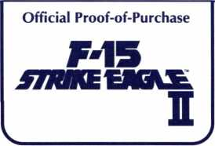

This Official Proof-of-Purchase
can earn you a free backup disk!
Details on Backup Order Form.
□ IBM 3.5 □ IBM 5.25
519M

