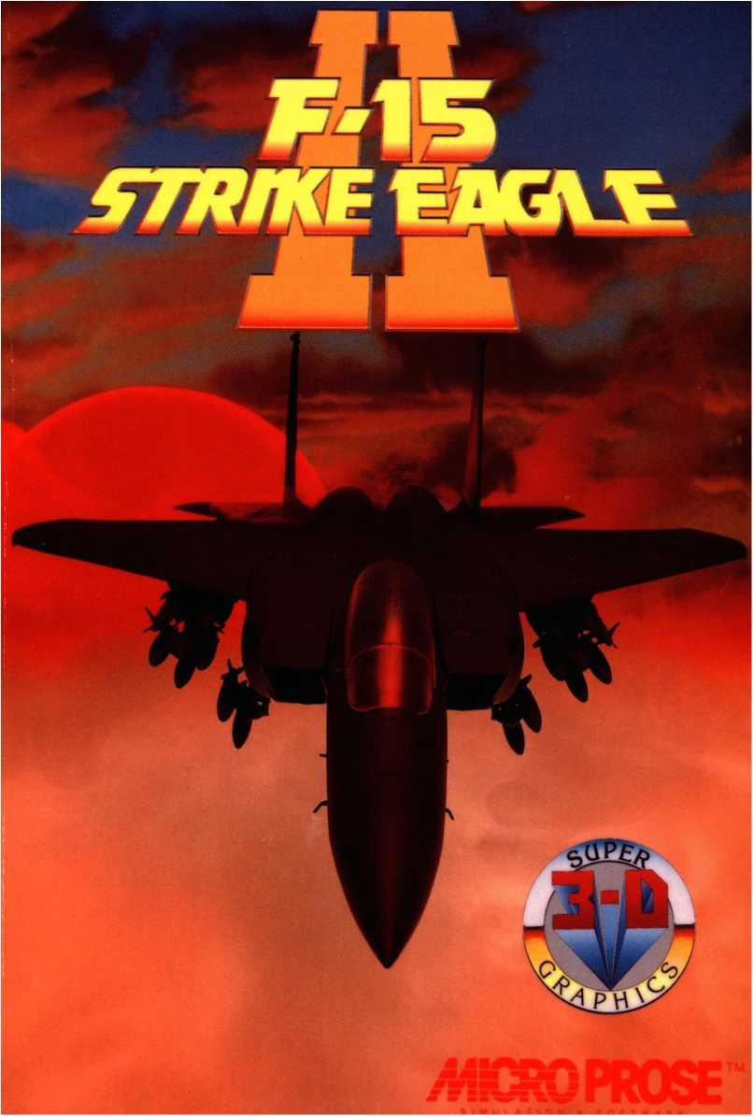

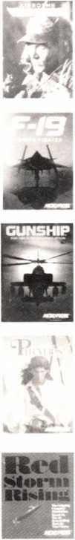
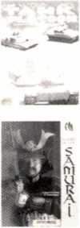
Enjoy these other great games from MPS Labs:
Airborne Ranger: the game of real-time man-to-man combat. You parachute deep into enemy territory on desperate solo missions against overwhelming odds.
"An arcade-style game from MicroProse? Yes, and a darned good one. “ Compute! 's Gazette
F-19 Stealth Fighter: the revolutionary combat flight simulator based on America's radar-elusive jet. Super 3-D Graphics display terrain and targets on thousands of missions with breathtaking clarity and detail. Sneaking past enemy radar adds unprecedented excitement.
☆ Winner, Best Simulation Award, Software Publishers Assn. ☆ "Calling F-19 Stealth Fighter a computer game is like calling the Pacific Ocean a puddle." PC Resource
Gunship: the best-selling simulation of the world's most formidable attack helicopter. The AH-64A "Apache" skims treetops at 110 knots to surprise targets with a 30mm gun and air-to-ground missiles. Solid-filled 3-D graphics draw you into the action for intense, heart-pounding combat.
"A remarkable piece of simulation software." PC Week
Pirates!: action-adventure role-playing simulation of fortunehunting on the Spanish Main. Intriguing scenarios develop around sailing, smuggling, sea battles, sword fights, land campaigns, artillery bombardments, rescues, treasurehunting, politics and love affairs. Over 50 historically authentic Caribbean towns to visit, trade with, and plunder. "Action Game of the Year, 1988." Computer Gaming World
Red Storm Rising: Immerse yourself in nuclear submarine technology. Pinpoint enemy ships and subs with sonar and radar — and keep them from zeroing in on you. Once you know who's out there — and where — you have the latest torpedoes and missiles designed just for them. Based on Tom Clancy's best-selling novel, developed with his advice. "Don’t miss this one... highest recommendation." Compute!
Look for this mid-1989 release from MPS Labs:
Ml Tank Platoon: You're in command of four tanks, each with four men. Give orders to just one Ml or all four at once. Take over as commander, gunner or driver in any tank. Call in air support, infantry, other tanks to help. Spectacular Super 3-D Graphics create real-life, real-war rolling terrain.
And Coming Soon:
Sword of the Samurai. Unparalleled action-adventure, roleplaying simulation in feudal Japan. A true advance in the art and science of game design.
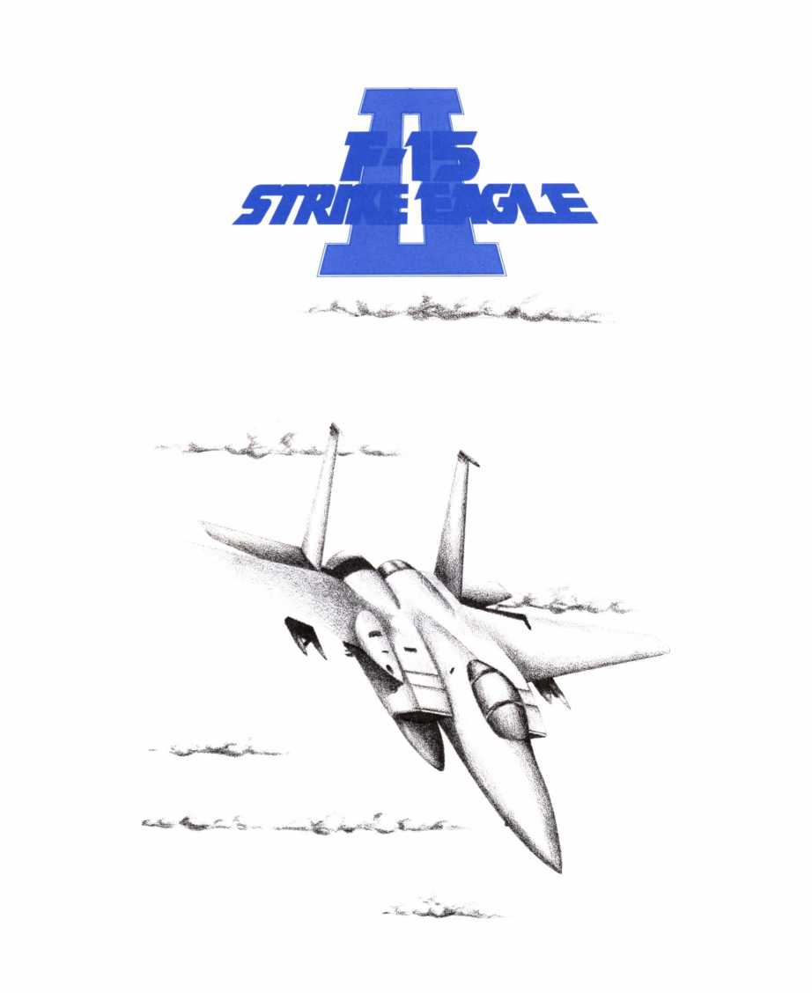
MICROPROSE SOFTWARE, INC.

F-15 Strike Eagle II™
Computer Simulation
MICROPROSE SOFTWARE, INC.
180 Lakefront Drive, Hunt Valley, MD. 21030
(301) 771-1151
All rights reserved.
Copyright © 1989 by MicroProse Software, Inc. This book may not be repro-
duced in whole or in part by any means without permission, except the
quotation of brief passages for reviews.
PRINTING HISTORY
Original F-15 Strike Eagle ©1985
F-15 Strike Eagle II ©1989
Printing: 987654321
IBM is a registered trademark of International Business Machines, Inc.
Apple and Macintosh are registered trademarks of Apple Computer, Inc.
Commodore 64 and Amiga are registered trademarks of Commodore Business
Machines, Inc.
Hercules is a registered trademark of Hercules Computer Technology, Inc.
Tandy is a registered trademark of Tandy Corporation.
Atari is a registered trademark of Atari Corp.
F-15 Strike Eagle and F-15 Strike Eagle II are registered trademarks of
MicroProse Software, Inc.

The F-15E Strike Eagle
Designer/Manufacturer: McDonnell Douglas, USA
Role: Strike Fighter
Crew: Two
Mission Weight at Takeoff: 35 tons
Engines: Two General Electric Fl 10 engines
Range: 1200 kms
Ceiling: 65000
Maximum Speed at O': 810 kts
Maximum Speed at 36000': 1260 kts or more
Maneuverability: Very Good
The F-15E Strike Eagle is the latest in a long line of F-15 Eagles, whose development began in the mid '60s. Originally conceived as an ultrapowerful, ultra-fast air-superiority fighter, the design has developed into an air-superiority fighter with ground-attack capabilities.
The F-15 Strike Eagle is one of the fastest, most maneuverable, and most powerful military aircraft in the world. It has the capacity to carry the latest air-to-air and air-to-ground armament in addition to its 20mm cannon. The latest version of the Strike Eagle is equipped with a sophisticated zoom FLIR/TV/laser target tracking system that allows the pilot to see close up views (either TV or thermal) of the target at all times.
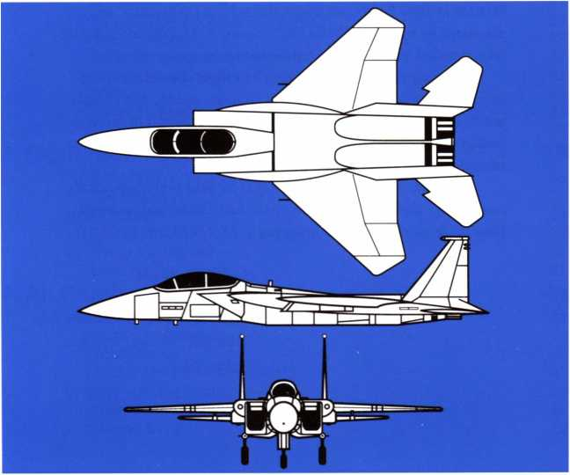
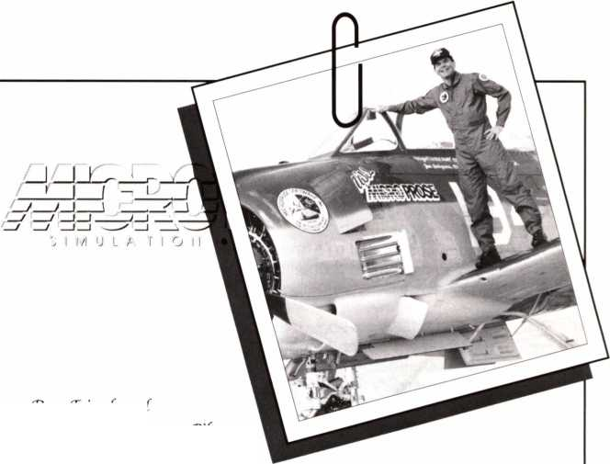
'Dear friends and fellow Computer Pilots:
It is with great pleasure that we at MicroProse bring you the sequel to our award-winning, all-time-best-selling product J-15 SDPJME 'EM] EE, which started the combat flight simulator market.
“Written in 1984 by Mr. Sid Meier, MicroProse Co-founder, and playtested by me, Major "‘Wild'Bill" Stealey, f-15 STKJXf. ‘EMJL'E set a standard that is hard to top — but we are going to try!
“We have taken all of our flying and flight simulation experience, combinedit with our Super 3 -99 graphics system, and brought you f-15SffJMf 'EDQL'E II. “We thinfwe've done it again: a combat flying simulation that is fun, exciting, challenging, and educational. “We hope you agree!
- with our best wishes and hopes for your continued success, and also our desire to continue to do the best combat flying simulations in the world, Sid and I bring you f-15 STRJXf 'EMjL'E II!
foodflying to you,
SYojsiJfMy f ““Wild‘Bill”Stealey, “President > fighter Pilot

CONTENTS
Introduction 7
Quickstart 9
- Tutorial 13
YOUR FIRST MISSION 14
Preflight Briefing Options 14
Helpful Hints 14
Check Out the Cockpit and the HUD 15
Flying to the Target 16
Attacking Enemy Aircraft 17
Attacking the Target 18
Returning Home 19
- Operating Instructions 21
AIRCRAFT CONTROLS 22
The Head-Up Display (HUD) 22
Cockpit Displays 25
Flight Controls 26
Weapons and Defenses 28
VIEWS AND SIMULATION CONTROLS 29
Views 29
Simulation Controls 21
YOUR CAREER AS A FIGHTER PILOT 32
The Pilot Roster 32
Difficulty Levels and Theaters 32
Ending Your Career 32
Missions 33
Ending a Mission 33
Multi-Player Option 34
- Flight Techniques 35
FUNDAMENTALS OF FLIGHT 36
The Forces 36
HOW TO FLY 38
Taking Off 38
Flying the Fighter 38
Landing The Fighter 41
- Air Combat 43
ATTACKING THE ENEMY 44
Missiles in General 44
Your Missiles 44
Your Ml6A1 20mm Vulcan 47
ENEMY ARMAMENTS 49
Enemy Missiles 49
Enemy Guns 50
DEALING WITH MISSILE ATTACKS 51
Missile Attack Warnings 51
Responses to Missile Attacks 51
DOGFIGHTING 56
The Missile Exchange 56
Dogfighting Maneuvers 58
- Theaters 63
Libya 64
Persian Gulf 67
Vietnam 72
Middle East 75
- Warplanes 79
US-Built Aircraft 80
Soviet-Built Aircraft 85
Designer’s Notes 91
Credits 94

INTRODUCTION
The pilot glances up at his HUD to verify his suspicions. It's true: the Iranian SAM battery at Bushehr is still active — the computer says it fired the SA-12 that almost took off the wing of the fighter.
The pilot rolls the jet over into a 90° bank and pulls back on his control stick, causing the screaming Strike Eagle to angle left in a deep turn that sends the G-counter to the max. The pilot taps a button on his console to arm his AGM-65D "Maverick" missile and a small square box appears on the HUD showing the ground location of the enemy radar—the Maverick already sees the target. The SAM radar at Bushehr, 30 klicks away, pops into view on the tracking camera CRT.
Just as the box on the HUD changes to a circle, indicating the Maverick can hit the target, a horn sounds in the pilot's ear, and a tiny red light on the console begins to flash. A burst message appears on the HUD: MiG-29 firing AA-10.
"So, the Russians are getting involved in this little party too!"
The pilot taps another button and the range of his scanning radar expands to show the enemy MiG behind him about 20 klicks. At that moment the close proximity klaxon begins its chirping — the missile is only seconds from impact. The pilot squeezes the trigger to release a chaff cartridge and swings into a tight right turn. The missile flies through the chaff and out the other side only to discover that the sleek Strike Eagle has disappeared.
The pilot rolls the fighter upside-down and pulls the stick all the way back, causing the fighter to power dive then level off 180° from its former heading. The MiG is there, right in front! The pilot quickly taps the button to arm an AIM-9M "Sidewinder." The tracking box appears around the enemy jet and immediately becomes a circle.
As the Russian pilot frantically jerks his stick back to climb away, the Sidewinder finds the underbelly and explodes, sending the MiG to a fiery explosion 15,000' below.
But before the enemy jet slams into the ground, another horn sounds. The message on the HUD now is: SAM radar at Bushehr firing SA- 12.
The pilot rearms his Maverick, circles around so that he's flying perpendicular to the approaching missile, and begins to turn toward it. The missile turns too, but the pilot gradually tightens his turn until the missile can't keep up. It rushes harmlessly past the Strike Eagle's tail. Now the fighter turns toward Bushehr with a vengeance.
One hundred-twenty miles away, high above the Middle Eastern plains, an American AWACS detects two MiG-2 Is taking off from the runway at Bandar Khomenyi and shoots a burst of encoded data to the Strike Eagle flying over the Persian Gulf. The message is unscrambled and appears on the HUD where the pilot makes a mental note to expect more company. He switches his tactical radar display to long range and begins tracking the progress of the MiGs.
The oil facilities at Kharg Island are slipping beneath the aircraft now as the pilot adjusts his heading to bore in on the enemy SAM site at Bushehr. As he crosses the Iranian coastline his tracking box changes to
a circle and he launches the missile, which has made an electronic snapshot of the target with its video-like camera and will fly directly into its center.
Before the Maverick hits the target the pilot heads back toward Al Hufuf. He pulls his Strike Eagle into an upward half loop to gain altitude so he'll have the energy advantage on the MIGs he's been watching. He arms an AIM-120A AMRAAM and gets ready to fire.
The MiGs are 40 klicks away now but coming on fast as the Strike Eagle continues climbing. At 25,000' the plane levels off, heading directly for the two MiGs. A horn sounds and another message appears; two more MiG-21 s are taking off, this time from Bushehr. Maybe it's best not to challenge all of them, but then...
The pilot launches a pair of AMRAAMs, then reaches over and hits the afterburner switch. There is a sudden explosion as fuel is dumped directly into the chamber and the Eagle leaps forward. The pilot pitches the nose down and begins to dive, gaining even more speed.
With a resounding crash, the Eagle breaks the sound barrier, as first one, then the other AMRAAM finds its mark. By the time the last MiGs reach the wreckage, the F-15 Strike Eagle will be home.

Special Welcome to Veterans of F-15 Strike Eagle
Welcome back,old friends!
Your F- IS Strike Eagle II has many new features that you’re going to enjoy, but underneath it’s still the same hard-hitting, fast-action bird you’ve come to know and love. For a fast checkout of your new Eagle, have a look at the Abbreviated Tutorial on the next page. Then get out there and let ’em have it!

QUICKSTART
There are several ways to get into playing F-15 Strike Eagle II. The most obvious and perhaps the most fun way is the try-and-see approach. But for those who prefer a little guidance we have provided a short tutorial to help you get started.
TRY-AND-SEE METHOD
We suggest that you try this method. Just dive in and try things out, referring to this manual and the Technical Supplement as necessary. We strongly suggest that you
- use the Keyboard Reference Card, and
- glance over Aircraft Controls in Chapter 2 (pgs 22-28) to familiarize yourself with the HUD and cockpit.
TUTORIAL METHOD
You can use the "Abbreviated Tutorial" method described below for your first flight, or you can work through the more detailed tutorial on pgs 13-19. If you like to be guided through a situation, we suggest the full tutorial. Note that the tutorial urges that you at least skim through Chapter 2 (pgs21-34).
STUDY METHOD
You can study the actual controls and operating instructions for the craft, then attempt to fly it. This is what real pilots do. In this case, read all of Chapter 2 (pgs 21-34) before flying and refer to the section as necessary. You can use the tutorial on your first flight or skip it, as you prefer. However, we suggest a practice mission as your first flight.

Abbreviated Tutorial
SET-UP AND OPTIONS
- Install the game as suggested onto floppy disks or hard disk (if you have one). See "Installation" in the Technical Supplement for details.
You can skip installation, but if you do none of your records can be saved.
- Load the Simulation: see "Loading Instructions" in the Technical Supplement for details and specific commands.
- Log onto the Pilot Roster: Following the on-screen instructions, erase one of the pilot names and type your name.
- Difficulty Level: As a new pilot, you should try the "Rookie" difficulty level first.
- Theater: Then accept the Libyan Theater.
- Today’s Mission: Your commanding officer informs you of your mission for today. He always gives you a two-part job to complete, a primary and a secondary target.
Stop! Now, before you push the selector to continue:
A QUICK CHECKOUT
Before starting the game, examine the Keyboard Reference Card. This is an invaluable aid in flying your fighter. You will notice that the command keys you'll need most often are mnemonic — that is, they will be easy to remember, once you are familiar with them. The card contains
a list of these keys and their functions, and shows you the other command keys in the game.
Find the Pause key. This is a very useful key while learning.
Skim through Aircraft Controls (pgs22-28) of this manual for an overview of the cockpit and HUD (head-up display). You'll need some familiarity with these before you fly.
You are also invited to look at Views and Simulation Controls (pgs 2931), especially the Out of Plane Views. Experiment with these on your first few flights. You'll find the views quite interesting and useful.
START THE GAME
Now, while the mission screen is still before you, tap the selector button and you'll find yourself already airborne. (If you didn't select "Rookie" from the Difficulty screen, see How To Fly, pg 38, for how to take off).
FLY TO YOUR TARGET
Turn on the autopilot (tap the Pilot. Automatic Key) to get on course to your target. Every time you touch the control stick, the autopilot automatically turns off. Therefore, you can experiment a bit with flight on the way to the target, then turn the autopilot on once more to get back on course.
Note that there is a triangular marker on the horizontal bar at the top of the HUD that indicates the bearing of your target; make sure this indicator remains centered on the horizontal line as you fly to your targets. Alternatively, the autopilot will always get you back on course.
During the flight to the target, you will undoubtedly encounter enemy aircraft that are trying to stop you from completing your task. You'll want to shoot them down or, at least, avoid being shot down. Read Weapons and Defenses (pg28) for more information.
ATTACK THE TARGET
Look at the map on the left side of your cockpit. You will see two cross-shaped markers; these indicate the locations of your two targets in Libya. When your fighter gets close to one of these, arm a Maverick missile (tap the Ground Attack Missile Key). If you are close enough to the target, it will appear in the right cockpit CRT, and a box will appear in your HUD. This box is a tracking box, and you can see what is being tracked in your right-hand cockpit CRT. You can cycle through all available ground targets by tapping the Target Search Key repeatedly. When you find the primary or secondary target stop searching and get ready to fire.
As you get closer, the tracking box in the HUD changes to an oval, and the CRT screen shows the words "Missile Lock." Your Maverick missile is now locked on and ready to fire.
To fire, tap the Fire Missile Key. The missile will find its own path to the target. If you want insurance, wait a second or two, then tap the Fire Missile Key again to fire a second missile at the same target.
FINISHING THE MISSION
You can either continue the mission according to the tutorial instructions, or you can return home immediately.
To return home immediately, tap the Waypoint Select Key to display the waypoints in the center of your HUD. Repeated tappings of the Waypoint Select Key will cycle through the waypoints for the primary,
secondary, and friendly airbase, When “Waypoint: Friendly Airbase" appears there, turn on your auto pilot (tap the Pilot, Automatic Key) to get on course for home.
LANDING
As you approach the friendly airbase, tap the Ground Attack Missile Key to switch the HUD to AIR-GROUND mode. When you are near the landing strip, it will appear in your right-side cockpit CRT. When you are very close to the airbase, your fighter will be set down safely onto the runway. This happens automatically. You have completed your first mission.
12

1. TUTORIAL
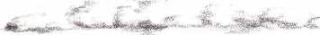
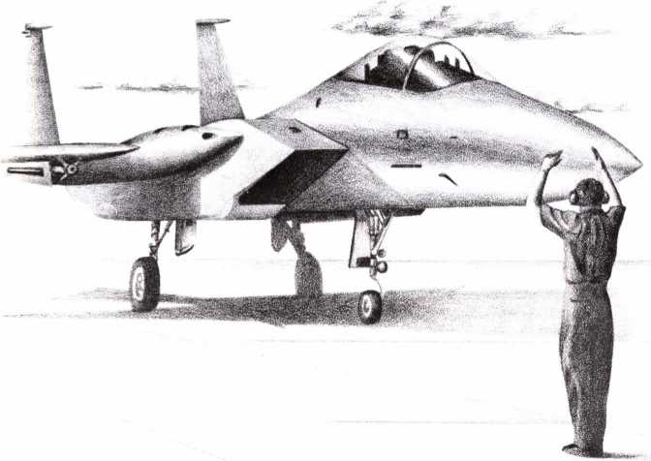

YOUR FIRST MISSION
This tutorial is designed to help you through your first mission. Though recommended, flying this tutorial is not required; it is provided purely as a convenience. For a faster entry into your first game, turn to Abbreviated Tutorial on pg 9. If you prefer to study the aircraft before you fly it, go directly to Chapter 2, starting on pg 21.
In either case, before you start the simulation you may wish to install it either on floppy disks or a hard disk (see “Installation" in the Technical Supplement for details). You can run the simulation without installation, but your score will not be saved at the end.
To begin play, load the installed game (or the original disks, if you didn't install it) into your computer. See “Loading" in the Technical Supplement for details.
Terminology
Keys: Each key control has a name in italics, which appears on the Keyboard Reference Card. A master list appears in the Technical Supplement.
Controller or Control Stick refers to the pointing device used by your computer. This may be a mouse, joystick, or cursor keys, depending on your hardware.
Selector refers to the mouse button, joystick trigger, Return key, or Enter key, depending on your hardware set-up. See the Technical Supplement for details.
The functions of joystick and mouse buttons during flight are defined in the Technical Supplement. For example, on a typical two-button joystick, the first button acts as the Fire Cannon Key, the second as the Fire Missile Key.
Preflight Briefing Options
Log onto the Pilot Roster: Follow the on-screen instructions to enter your name into the roster. Use the controller to select a name to erase, press the proper key to erase it, and type your name. Finish entering your name by pressing the Return or Enter key (For more information about the roster, see The Pilot Poster pg 32).
Choose your first mission: On your first mission, be sure to choose the following options:
- Rookie difficulty level, then press the selector;
- Libya Theater, then press the selector.
Next, your commanding officer appears and tells you what today's mission is. After reading this screen, press the selector.
Helpful Hints
TRAINING
You will find yourself already airborne when the mission starts (you do not have to take off in Rookie difficulty level). The first thing you should do is tap the Training Key. In training missions, enemy weapons do no damage. You can safely ignore enemy aircraft and missiles. Furthermore, you
have an automatic barometric altimeter that adjusts your altitude to keep you above 300'. However, it only makes mild corrections, and is useless if you make wild maneuvers.
PAUSE
To get the most from this tutorial, pause the simulation (tap the Pause Key) and read the next few paragraphs, then "un-pause" and resume action for a short period. Whenever you're confused, just pause. Note that tapping any key (except pause) will "un-pause" and resume the action.
RESUPPLY
In training missions (only) you can get an infinite supply of fuel and ammunition. Each time you tap the Resupply Key, your fuel tank is filled and your ammunition is increased to the maximum possible level. This option is especially useful in target practice.
A LIGHT TOUCH
Use a light touch on the Control Stick. The most common pilot error is a "ham-fist" on the stick, throwing the plane around the sky in uncontrolled abandon. Only emergencies should cause you to "peg" your stick (push it up against the stoppers, beyond which it cannot move). CHASING THE GAUGES
When you roll an aircraft left or right, pitch it up or down, change the throttle or the brakes, it takes time for the plane to "settle out." Good pilots fly by making a change, then waiting a couple of seconds to see the results. If you don't, you'll just “chase gauges" that are themselves still changing.
Airspeed settles out much more slowly than other settings. It takes time for your plane to build up velocity or lose momentum in level flight.

Check Out the Cockpit and the HUD
THE CONTROLS
Look at your Keyboard Reference Card, showing all the controls for your Fighter. The most often-used key commands are mnemonic, so they are easy to remember once you are familiar with them.
THE HUD
The upper half of your screen represents the transparent HUD (head- up display), through which you can see the world beyond. The vertical scale on the left side of the HUD indicates your airspeed and that on the right, your altitude. The horizontal scale across the top of the HUD indicates your heading. A full explanation of the symbols and numbers are described on pgs 22-25.
The HUD has two operating modes: AIR-AIR for aerial combat, and AIR-GROUND for ground attacks. Arming a missile (tapping the Shortrange, Medium-range. or Ground Attack Missile Keys)switches your HUD to the mode needed to operate the armed weapon automatically. For example, if you press the Short-range or Medium-range Missile Keys, your HUD is automatically set to AIR-AIR mode, because these missiles are air- to-air missiles; tapping the Ground Attack Missile Key places the HUD in AIR-GROUND mode, because your ground attack missiles are air-to- ground missiles.
THE COCKPIT
The lower half of your screen is the cockpit of your aircraft. The various elements are described on pgs 25-26. We suggest you look at the three CRT displays to get familiar with them.
- The left-side CRT shows a map of the world in which you will be flying. By tapping the Zoom Map Key you can zoom-in on the map; by tapping the Expand Map Key you zoom back out.
- The center CRT contains a radar tactical display showing the situation occurring in the immediate vicinity of your aircraft.
- The right CRT is your tracking camera display. When your onboard targeting system is tracking a target, you get a close-up view of the target in this display.
Beneath the CRTs is a series of warning lights. The two leftmost (marked "R" and "I" respectively) are missile warning lights. When a radar-guided missile is flying at you the "R" light flashes; when an infraredhoming missile Is coming at you the "I" light flashes (see Dealing with Missile Attacks, pg 51, for details).
The other two lights indicate when your landing gear is extended ("L") and when your brakes are on ("B").
On the far left hand side of the cockpit is your fuel gauge (labeled “F") and between the tactical display and tracking camera screen is your throttle gauge (labeled “T").

Flying to the Target
LEVEL FLIGHT
Once airborne your first step is to achieve level flight. Push the control stick forward or back until the horizon is level across the middle of the HUD. Then make fine adjustments until you're neither gaining nor losing altitude.
FLYING ON COURSE
Now it's time to get onto the right course. Look at the heading indicator across the top of your HUD and the INS Direction Indicator (the small, bright triangle somewhere on the top of the scale). Turn toward the indicator. As you turn, the triangle moves toward the center; when the triangle is in the center of the scale you're “on course" to the first waypoint, your primary target.
To turn, push the stick left or right — but do it gently — and the plane will bank. Release (center) the stick when the bank angle of the horizon is about 45°. To turn faster, pull back on the stick somewhat, but watch your speed (on the left of the HUD) and altitude (on the right). A turn with backpressure on the stick turns you much more quickly, but can slow your plane and rob you of lift, causing a drop in altitude.
Minimum safe speed varies with the current situation of your aircraft. A “stall indicator" bar rises from the bottom of the speed scale when you travel too slowly. If this bar reaches the tick-mark in the center of the scale, your plane stalls — it is no longer airworthy, and begins to fall out of control. If this happens, lower the nose to regain speed, then pull out into level flight.
Minimum safe altitude is about 300’. However, in this training mission stay at least 800' above the ground.
AUTOPILOT
If you're confused about which direction to fly, and how to do it, just tap the Pilot. Automatic Key. It will take over immediately, turning you onto the correct course. If you're below 4000' the autopilot will climb to that altitude. If you touch the control stick the autopilot automatically turns off.
ENJOYING THE FLIGHT
Once on course, enjoy yourself by trying out the nifty viewpoints available by toggling through the View Keys. You can return to the cockpit at any time: just tap the Cockpit Key.
You can see out the front, rear, and sides of the cockpit canopy using the Look Front. Look Rear. Look Left, and Look Right Keys. In mountain valleys and over urban areas the scenes can be thrilling.
You can also step “outside" your aircraft and watch it using the Chase Plane. Slot View, and Side View Keys. Bank the plane left and right to observe the difference between the chase plane (where you appear to be in a plane following in the "footsteps" of the fighter) and the slot (where you remain behind the fighter and always remain level).
The Tactical View, Reverse Tactical View, and Missile Views Keys are used in combat situations. These views show the target that is being tracked by your tracking camera and your aircraft (or missile), always keeping both on the screen. (See pgs 29-30 for a more detailed description of these options.)
ACCELERATED TIME
On long journeys, you can speed the passing of time by tapping the Accelerated Time Key. This doubles the rate at which time passes. To return to normal time, simply tap the key again. Combat activity or landing will automatically return you to normal time.

Attacking Enemy Aircraft
While flying, you will, no doubt, see enemy aircraft. These fighters will attempt to stop you from reaching your target. You may want to destroy them.
To do so, tap the Medium-range Missile Key. This arms one of your AMRAAM missiles and switches the HUD to AIR-AIR mode so that your targeting system will track enemy air targets. The tracked target will appear in the tracking camera CRT on the right side of the cockpit. Look at the display: it gives you the range to the aerial target (in kilometers) and the heading you must fly to get to it.
If a tracking box appears on your HUD, the target is in front of your aircraft; if not, look at the heading in the tracking camera CRT and turn toward that heading until you see the tracking box (or oval) appear in the HUD. When this occurs, wait for the tracking box to become an oval (if it's not already) then tap the Fire Missile Key. This launches a missile. For more information about attacking enemy aircraft and dealing with enemy air attacks, see Chapter 4 (pgs 44-62).
If the enemy fighter is within 15 kms you'll want to use your Sidewinders instead of your AMRAAMs. To use the Sidewinders, tap the Short-range Missile Key, then follow the procedure above.
You could, if you're feeling particularly heroic, attack the enemy
fighters with your cannon. This is more difficult, but it saves missiles and is very gratifying if you hit. Tap either the Medium- or Short-range Missile Key to get the HUD into AIR-AIR mode. This will cause a small circle to appear in the center of the HUD; this is the gunsight. The gunsight is historical, that is, it shows where the shells would be hitting now if you had fired them 2 seconds earlier; therefore you must lead your target. (For details about the cannon and missiles, see Attacking the Enemy, pg 44.)

Attacking the Target
As you approach the primary target and the coast of Libya is on the horizon, it's time to start thinking about taking that target out.
ARM YOUR MAVERICKS
Tap the Ground Attack Missile Key. This switches the HUD to AIRGROUND mode and arms one of your Maverick missiles. As you get near the target, it will suddenly appear in your tracking camera screen. Don't be concerned if other targets appear there first; the tracking system locks-on to the nearest target. A message will tell you when the primary or secondary target is being tracked.
You can search for your primary or secondary targets, or any other ground target, by tapping the Target Search Key. In AIR-GROUND mode this will cycle through all ground targets that your tracking system can find. You can stop anytime you find a target you want to attack.
WAIT FOR RANGE, ALTITUDE, AND MISSILE LOCK
You'll notice that a small box appears in the HUD. This is the "target box." The target seen on the tracking camera CRT is in the middle of this box. When you get within missile launch range, this box changes to an oval shape. In addition, "Missile Lock" flashes on the tracking camera CRT.
The oval shape means your missile can hit if you attack at maximum speed. If you wait longer, eventually the oval changes color. This means the missile can hit regardless of your speed. It's important that you not launch a weapon too low. You may be caught in the missile's explosion, or a missile may hit the ground before its motor can power it up and away. A simple rule to get you started is that safe launch of missiles requires at least 500' altitude.
LAUNCH
When you have "missile lock," launch the missile by tapping the Fire Missile Key. After launching, you may want to turn away slightly, since flying through an exploding target could damage your aircraft. Shortly after the launch the missile should hit the target. A successful hit causes a fire and sends a cloud of smoke into the sky.
THE SECONDARY TARGET
You can now fly to the secondary target and attack it as well, using the same procedure. Or, if you wish, you can call it quits and immediately start for home.

Returning Home
SETTING THE INS TO THE LANDING POINT
Tap the Waypoint Select Key until "Friendly Airbase" appears in the middle of your HUD. This moves the Waypoint marker along the heading track at the top of the HUD to a new position indicating the heading to your airbase.
FLYING HOME
You can either use the autopilot or manually fly the plane home. As before, guide yourself using the heading scale (horizontal scale at the top of the HUD). When the INS Direction Indicator triangle is lined up on the center of this scale, you're on course toward your home base.
Now simply fly toward the base, and when you get near it your plane will land automatically.
Congratulations! You've successfully completed your first mission as a fighter pilot.
20

2. OPERATING
INSTRUCTIONS
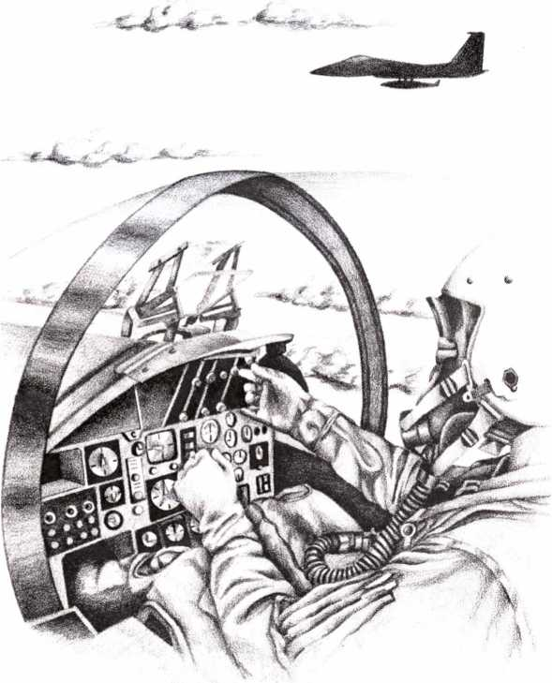

AIRCRAFT CONTROLS
What follows provides instructions for how to operate the game using the keyboard controls. It describes briefly what each control does and how it might be used. For information on the best way to use your fighter's capabilities, see chapters 3 and 4, Flight Techniques and Air Combat.

Terminology
Keys: Each control has a name in italics that is used to designate which key on your keyboard controls what function. A master list of all names and keys appears in the Technical Supplement.
Controller or Control Stick refers to the pointing device used by your computer. This may be a mouse, joystick, or cursor keys, depending on your hardware. See the Technical Supplement for details.
Selector refers to the mouse button, joystick trigger, Return key, or Enter key, depending on your hardware setup.
The functions of joystick and mouse buttons are defined in the Technical Supplement. For example, on a typical two-button joystick, the first button acts as the Fire Cannon Key, the second as the Fire Missile Key.

The Head-Up Display (HUD)
The HUD is designed to provide crucial flight and weapon information in a graphic format. HUD data is projected onto a wide-angle clear pane in the front of the cockpit. You look through the HUD to the outside world. As a result, valuable information is right in front of your eyes, where you can see it and the outside situation simultaneously.
HUD MODES
The HUD display has two modes: AIR-AIR and AIR-GROUND. When you tap either the Short-Range Missile or the Medium-Range Missile Keys the HUD switches to AIR-AIR mode automatically. When you tap the Ground Attack Missile Key, the HUD automatically switches to AIRGROUND mode.
AIR-AIR mode is for attacking enemy aircraft; your tracking system will track these targets only. AIR-GROUND mode is for attacking ground targets; your tracking system is restricted to these targets.
Some HUD information is universal across all modes. Other information is specific, available in just one of the modes.
AIR-AIR MODE INDICATORS
When your HUD is in AIR-AIR mode, you will know by the presence of the following:
Missile Targeting Envelope: This is a large, faint circle fixed on the HUD. It represents the area of sky in which an air-to-air missile can be aimed and "locked on" to a target.
Gunsight: In AIR-AIR mode the gunsight circle replaces the flight path indicator. The gunsight shows where your shells would be landing if you'd fired two seconds ago (the time it takes them to travel the 6 kilometer maximum range). If you're tracking a target that's closer than
6 km, it shows where the shells would land if you'd fired the proper time in the past for them to travel that range. See Your M61A120mm Cannon (pg 47) for details on using the gunsight.
AIR-GROUND MODE INDICATORS
AIR-GROUND mode is indicated by the absence of the missile targeting envelope and presence of the flight path indicator, which replaces the gunsight. This indicator shows the direction you are flying (which may be different from the nose indicator).
The plane is geometrically level when the nose indicator and flight path indicator overlap. However, this is rare in an aircraft. Furthermore, level flight (where you are neither climbing nor diving) often requires the nose to be pitched slightly above the flight path, to achieve a useful angle of attack. See Flight Techniques, pg 35, for more information.
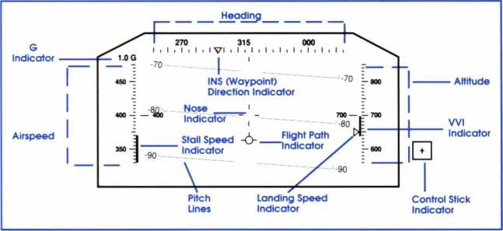

UNIVERSAL HUD INFORMATION
The great majority of information displayed on the HUD is available to you regardless of the mode your HUD is currently in. This information is described below.
Airspeed: Your airspeed appears on the left-side vertical scale, in knots. Beside the tick-mark showing your current speed is a digital readout of your speed.
Heading:Your heading (the absolute direction toward which you are flying, where 00°=North and 180°=South, 90°=East, and 270°=West) is indicated along the horizontal strip across the top of the HUD. By aligning the tick in the center of your HUD with one of the ticks on the scale you determine your absolute heading.
Altitude: Your altitude appears on the right-side vertical scale, in feet. A digital readout of your current altitude appears next to the scale's tick-mark until you exceed 20,000', at which point only the sliding scale remains.
Tracking Box: Your fighter is equipped with a computerized optical tracker. A small box — a tracking box — appears around the nearest target ahead, to help you locate it. The HUD mode determines whether ground or air targets are tracked. Of course, the tracking box is visible only when the target is in front of you.
On most systems the tracking box is color-coordinated with the
current armament. The color of the box indicates whether the current weapon is effective against the target being tracked. See the Technical Supplement for details on colors.
Missile Lock: The tracking box turns into an oval when the currently- armed missile is "locked on" to the target. This is a maximum range shot. A missile fired at this point may or may not hit. When the oval changes color, the shot is now a "sure thing," with hardly any chance of missing.
Stall Speed Indicator: At times a colored bar rises from the bottom of your airspeed scale; this represents the stall speed. If it rises above the center tick-mark, your plane stalls (see Stalls, on pg37 for more information).
Vertical Velocity Indicator (Wl): A colored bar extending upward or downward from the center tick-mark on the altitude scale indicates your fighter's vertical velocity.
If the VVI bar extends downward, your plane is losing altitude; if the Wl bar extends upward, your plane is gaining altitude. Each tick-mark represents 100 feet per minute. Therefore, the larger the bar, the faster you're gaining or losing altitude.
Landing Speed Indicator: This colored arrow appears on the altitude scale only when your landing gear is down. It indicates the safe maximum Wl for landing. If the Wl bar extends below this mark, landing is dangerous.
INS (Waypoint) Direction Indicator: The colored diamond marker on the top of the heading scale shows the heading you should fly to reach the currently selected Inertial Navigation System (INS) "waypoint." To get "on course," align the diamond marker with the center tick-mark.
For each mission, your Inertial Navigation System is pre-programmed with the primary and secondary targets and the airbase at which you will land after completing your mission. You can cycle through these waypoints by tapping the Waypoint Select Key.
Nose Indicator: This cross-hairs symbol is fixed in the middle of the HUD, and represents the direction your nose currently points.
G-Force Indicator: This readout in the upper left corner of the HUD indicates the current G-forces on your plane's airframe. In general, the plane can withstand more G stress than the pilot, whose limits are between -3 G and +9 G, depending on training and experience.
Pitch Lines: Pitch lines appear on the HUD when the horizon is invisible due to radical climbing or diving. Each pitch line represents 10° of pitch up or down. If your aircraft is geometrically level, pitch is 0°. If your aircraft is climbing straight up or diving straight down, the pitch is 90°.
Roll is indicated by the relative angle of the horizon or pitch line to the cockpit and nose indicator. If the horizon or a pitch line is perfectly horizontal, your craft is level. If the line slants to the left or right, your craft is rolled to the right or left.
Radio Messages: Coded burst transmissions arrive by radio periodically. These are decoded by your onboard computers and displayed as text across the top of the HUD.
WEAPONS AND DEFENSES UPDATES
Whenever you arm a new missile, by tapping the appropriate missile key, a message appears in the middle of the HUD indicating this. When
ever you fire a missile or your cannon, a message appears in the HUD indicating how many of the weapon you have remaining.
Whenever you release chaff or a flare (see Dealing With Missile Attacks, pg 51, for details) a message appears indicating you have released the defense and how many you have remaining.
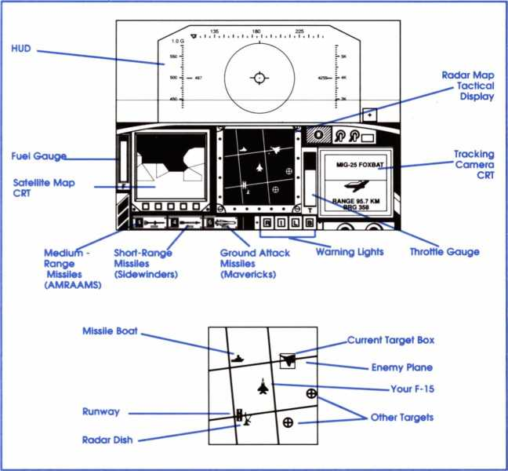

Cockpit Displays
Your fighter is equipped with three CRT displays inside the cockpit to help you identify threats and fly to your target area.
THE SATELLITE MAP
This CRT appears on the left side of the cockpit and portrays the geographical features of the region. It is oriented so North is always toward the top of the CRT. Your primary and secondary targets appear on this map as colored crosses.
Enemy radar signals are displayed graphically: dotted arcs are pulse radar, solid arcs are doppler radar. Ground search radar are entire 360° circles, while ground fire-control tracking radar are short arcs. Aircraft radar, search or fire-control, are short arcs except for AEW&C aircraft (the 11-76 "Mainstay" or E-3C "Sentry"), which have an entire 360° circle.
Missiles and aircraft also appear on this map as color-coded squares.
See the Technical Supplement for details.
Zooming and Expanding the Map: You can zoom in on or expand the map by tapping the Zoom or Expand Keys.
THE TACTICAL DISPLAY
This map is drawn by your computer from analysis of radar signals. It portrays the tactical situation surrounding your fighter and is oriented so the top corresponds to your flight path. Thus the map rotates as you turn.
The display graphically depicts aircraft, missiles, ground radar sources, airfields, and incidental ground targets. A 16km square grid is superimposed for range reference. See the Technical Supplement for details on the color coding of this map.
Warning: The airbase symbols on this map are icons only. They may not be correctly aligned. Do not use this map for landings!
Radar Ranges: You can adjust the range of the radar signals that draw this map. Tap the Radar Range Key to change to short, medium, or long range radar, thus changing the scale of the tactical display.
TRACKING CAMERA CRT
The camera CRT, located on the right side of the cockpit, shows a close-up view of the target being tracked. In addition, it displays the type of target tracked (the type of aircraft or ground installation), the range to the target, and the heading at which you must fly to reach it.
Primary and secondary objectives are listed as such. Civilian and friendly targets (which you shouldn't hit) are noted also.
FUEL AND THROTTLE GAUGES
Your F-15 cockpit has two gauges: a throttle gauge and a fuel gauge. The gauge in the center of the cockpit with the letter "T" beneath it is the throttle gauge and indicates the amount of thrust being generated. On the extreme leftside of the cockpit is an illuminated vertical bar with an "F" beneath it. This is your fuel guage. As you use fuel during a mission this bar shortens.
MISSILE WARNING LIGHTS
At the bottom of your cockpit are found warning lights. One marked "R" and the other morked "I." The "R" stdnds for rodor and this light begins flashing when a radar-guided missile is in the air and tracking you. The “I" stands for infrared and this light flashes when an infrared-homer is in the air and tracking your fighter.
LANDING GEAR AND BRAKE WARNING LIGHT
When your landing gear is extended, the "L" light is illuminated. If your fighter is going too fast for the gear to be safley extended, this light flashes. When your brakes (air or wheel) are on the "B" light is illuminated. WEAPONS READOUT
Along the lower left side of the cockpit is a panel that gives a constant digital readout of the number of each type of missile you have remaining. The leftmost shows AMRAAMs (medium-range AAM), the center shows Sidewinders (short-range AAM), and the right. Mavericks (AGM). For details about your missiles, see Attacking the Enemy, (pg 44).

Flight Controls
CONTROL STICK
Your fighter has a standard aircraft control stick. Pushing the stick
forward pitches the plane down, pulling it back pitches it up. Pushing the stick left rolls left, while pushing it right rolls right.
Note that the more you push the stick, the more the aircraft pitches or rolls in that direction. When you release the stick (i.e., center it) the aircraft remains in the new attitude until you move the stick again.
The control stick may be represented by a physical joystick, nu- meric/cursor keypad, or some other device (see your Technical Supplement for details). If you are not using a real joystick, a control stick locater box appears in the lower right corner of the HUD to show you the current position of your "stick."
CONTROLLING THE THROTTLE
The throttle controls the power output of your engines. Maximum throttle ("full military power") gives you maximum speed and performance, but also uses up fuel faster.
Throttle Controls: The Maximum Power Key immediately opens the throttle, giving you maximum thrust. The No Power Key closes the throttle, shutting down the engines. The Increase Throttle Key opens the throttle a small amount. The Decrease Throttle Key closes the throttle a small amount.
The Afterburner: Your fighter is equipped with an afterburner that allows you to gain a sudden burst of thrust power at the expense of a great deal of fuel. To use the afterburner, fly at top speed, then tap the Afterburner Key and watch as your airspeed shoots up dramatically. This can be very useful in tight situations where escape is the better part of valor.
EJECT (BAIL OUT)
There are situations when it is best to bail out of your aircraft. When you are so damaged by enemy fire that you can no longer keep the aircraft in the air, it's probably time to eject. Just tap the Eject Key and you're out. Do not, however, eject if your fighter is inverted, or if you are less than 100' from the ground; you'll end your career if you do.
LANDING GEAR
The Landing Gear Key toggles your landing gear up and down. The "L" light in the cockpit indicates the landing gear position (see the Technical Supplement for colors).
If the "L" light flashes, it means the gear is down at too high a speed — you should either slow down or raise the landing gear. Extended landing gear slows you down, and high speeds can rip it off entirely. BRAKES
If your aircraft is airborne, the Brake Key toggles the airbrake retracted (in) and extended (out). When the brake is extended the aircraft slows down because the airbrake causes extra drag.
If the aircraft is on the ground, the Brake Key toggles the landing gear brakes on and off. In either case, if the brakes are on, the "B" light is illuminated in the lower right corner of the cockpit.
AUTOMATIC PILOT
The Pilot, Automatic Key toggles the automatic pilot on and off. The autopilot, when active, flies you toward the current INS waypoint. If you're below 4000’ altitude, the autopilot climbs to that altitude. When the autopilot is turned on, a message appears in the center of the HUD.
If you touch the control stick in any way, the autopilot turns off.
Warning: The autopilot does not avoid hills and mountains!

Weapons and Defenses
These instructions give only the bare rudiments of how to operate each weapon. Many important secondary considerations (like not launching some too low) and tactical tricks are described in Air Combat (pg 43). WEAPONS
Missiles: To fire a missile you must first arm it. This is done by tapping the appropriate key for the missile you want to fire. Once a missile of a particular type has been armed all missiles of that type are armed until you arm a missile of another type.
To arm your:
- medium-range air-to-air missiles (AMRAAMs), tap the Mediumrange Missile Key.
- short-range air-to-air missiles (Sidewinders), tap the Short-range Missile Key.
- ground attack missiles (Mavericks), tap the Ground Attack Missile Key.
When a missile is armed, a brief message appears in the center of your HUD indicating the name of that missile. When a missile is fired a message indicates how many of that missile remain.
Once armed a missile may be fired by tapping the Fire Missile Key. Before firing a missile, make sure your targeting system is locked on to a target (the targeting box is an oval). If you want to be more certain of a hit, wait for the oval to change color. (For more information about your missiles and how and when to fire them see Firing Your Missiles, pg 46).
Missile Targeting: When you arm a missile, the targeting system in the missile begins tracking the closest possible target, and this target appears in your tracking camera CRT. This may or may not be the target you want to track.
If you've armed an air-to-air missile, the tracking system will focus only on the closest target. But if the missile you've armed is a groundattack missile, you can tap the Target Search Key to switch to a different target. You can cycle through all possible ground targets by repeatedly tapping the Target Search Key until you find the target you want to track.
Note that when an armed ground-attack missilo (a Maverick) finds the primary or secondary target, a message appears on the tracking camera CRT informing you of this.
Cannon: Your 20mm cannon is always available for use (unless out of ammo or damaged); it does not have to be armed. To fire the cannon, press the Fire Cannon Key to fire one burst.
DEFENSES
Your fighter is equipped with two types of missile evasion devices: chaff and flares. Chaff is used to confuse radar-guided missiles and flares are used to fool infrared-homing missiles (see Dealing With Missile Attacks. pg 51, for more information).
- To release a chaff cartridge, tap the Chaff Release Key.
- To release a flare, tap the Flare Release Key.

VIEWS AND SIMULATION CONTROLS
As an aid to learning flight maneuvers, a variety of out-of-plane viewpoints are available. In all these views your viewpoint is outside of your aircraft, looking at it and/or the enemy. These alternative views can be very helpful in learning maneuvers because you can clearly see the effect your actions have on the flight of the plane.
Other controls are also available that allow you to manipulate various aspects of the game itself, such as the level of detail that you want to see, how many sounds you want to hear, and so on.

Views
RETURN TO COCKPIT
Press the Cockpit Key to return to the normal, in-the-cockpit viewpoint.
This control is used to get you back into the cockpit — looking through the HUD — after you've switched to another view.
LOOK FRONT
Tap the Look Front Key to look out the front of your fighter.
LOOK LEFT
Tap the Look Lett Key to look out the left side of your fighter.
LOOK RIGHT
Tap the Look Right Key to look out the right side of your fighter.
LOOK REAR
Tap the Look Rear Key to look out the back of your fighter.
SLOT VIEW
Press the Slot View Key.
Here you are positioned directly behind your fighter. This view is named for the famous "in the slot" position used by aerial acrobatic teams. Unlike the chase plane view, slot view remains level with the ground, so you can clearly see the degree of pitch and roll your fighter is making.
The Zoom and Expand Keys function in this view, moving your viewpoint closer to (Zoom) or farther from (Expand) the fighter.
This view is an excellent one for learning the most efficient and effective flight maneuvers.
CHASE PLANE VIEW
Press the Chase Plane Key.
Here you are positioned in a hypothetical "chase aircraft" that follows a short distance behind your fighter. Although this view is very dramatic, its use as a teaching and learning aid is limited.
SIDE VIEW
Press the Side View Key.
Here your viewpoint is from the right side of the fighter. The Zoom and Expand Keys function in this view, moving your viewpoint closer to (Zoom) or farther from (Expand).
This view can provide a useful reference point. It's also an excellent way to check the state of your landing gear. Missile launches are most dramatic when seen from this viewpoint.
MISSILE VIEW
Press the Missile View Key.
In this view, you are positioned directly behind your own missile as it flies to its target. If more than one weapon is in flight, you are positioned behind the missile launched most recently. If no ordnance is in flight, you are positioned behind the plane, and will follow the first item launched.
The Zoom and Expand Keys move your viewpoint closer to (Zoom) or farther from (Expand) the missile.
This view is very entertaining, as it lets you follow the weapon directly to the target. If you're having trouble understanding why your weapons sometimes miss, switching to this view after launch can be helpful.
TACTICAL VIEW
Press the Tactical View Key.
Here you are positioned near your fighter, but looking past it at whatever target is being tracked on your tracking camera. This view automatically rotates to keep both your fighter and its target in view. The Zoom and Expand Keys function in this view, moving your viewpoint closer to (Zoom) or farther from (Expand) the fighter.
This view is invaluable when dogfighting. It helps you outmaneuver and line up on an opponent (although it's wise to return to the cockpit before shooting, to avoid wasting ammo). The view is also useful if you want to return for a second or third attack run on a ground target.
REVERSE TACTICAL VIEW
Press the Reverse Tactical View Key.
Here you are positioned near the fighter's target, looking past it to your own fighter. The target may be another plane, or a ground target — whatever your tracking camera is following. In either case, you see the target in the foreground, and your fighter far away. In fact, often your fighter is nothing but a dot in the sky. This view automatically rotates and pans to keep both the target and your plane in view.
The Zoom and Expand Keys function in this view, moving your viewpoint closer to (Zoom) or farther from (Expand) the target.
Experienced pilots find this a very dramatic view when making attack runs on ground targets. It's a great showoff view, swinging to follow your plane as you fly overhead.
DIRECTOR MODE
Press the Director Mode Key to turn director mode on or off.
Director mode is provided to allow you to watch all the neat views described above at the most appropriate times. Whenever you receive a radio transmission describing an event taking place in the theater (such as an enemy plane scrambling to intercept you, or a SAM site firing a missile at you), the Director will show this to you. It also shows when you fire a missile or someone fires at you.
Director mode can be very entertaining but is not recommended when you are in close proximity to enemy fighters, because it can be distracting when you are trying to dogfight. We recommend that you use Director mode only when not near the enemy, or when you are showing the game off to your friends.

Simulation Controls
PAUSE
The Pause Key immediately and instantly freezes the simulation. To resume action, press any key. Some computers have a special “pause" or “hold" key. Depending on the internal design of your machine, this key may also work.
ACCELERATED TIME
The Accelerated Time Key doubles the rate at which time passes. Accelerated time is useful when flying long distances without encountering any significant threats or opposition. “ACCEL" appears on the HUD when the accelerated time option is on. Tapping the Accelerated Time Key again returns the simulation to its normal time rate.
You should return to normal time before combat: it's very hard to control your fighter and respond to enemy actions in accelerated time. DETAIL ADJUST
The Detail Adjust Key allows you to change the amount and depth of ground detail visible through the cockpit. See the Technical Supplement for details. In general, the slower your computer, the lower the level of detail you should use.
VOLUME ADJUST
The Volume Adjust Key allows you to change the type and variety of sounds used in the simulation. See the Technical Supplement for details. When you press the key, the new sound setting appears briefly on the HUD.
RE-SUPPLY
The Re-supply Key is available only in training missions. Pressing this key fills the plane's fuel tanks and gives it extra weapons. Re-supply is designed for sight-seeing and target practice.
BOSS, HIDE GAME
The Boss, Hide Game Key immediately pauses the simulation and clears the screen, effectively concealing what software is really running on the computer. To resume, press any key.
This key is not only useful at the office, but also to forestall irate parents, children, spouses, and relatives who complain about your computer gaming!
QUIT
The Quit Key immediately ends the simulation. It does not save any information to disk, so your score will be lost.
For any additional simulation controls, see the Technical Supplement.
Your Career as a Fighter Pilot
As a fighter pilot in F-15 Strike Eagle II you will fly missions at four different levels of difficulty — Rookie, Pilot, Veteran, and Ace — and in four theaters — Libya, Persian Gulf, Vietnam, and Middle East. (For more information about the theaters, see chapter 5, Theaters, pgs 63.) PROMOTIONS AND MEDALS
For each mission you fly successfully, you receive points. When you've accumulated enough points you will be promoted, and if you receive a large number of points in a single mission, you may receive special commendation in the form of a medal.
The Pilot Roster
Each time you boot up the game and before each new mission you will be shown the Pilot Roster. This screen shows the ranks, scores, and medals of pilots that have flown before, and allows you to continue the career of a pilot who is still active or begin a new pilot's career. You may erase a pilot from the roster, but if you do it is permanent and cannot be undone.
Difficulty Levels and Theaters
After each mission you are given a choice of difficulty level and theater. You may choose any theater or difficulty level you like, but be warned that the higher difficulty levels are no "piece of cake" and you'll probably want some time in the easier ones to gain experience.
The four theaters are arranged in order of difficulty: Libya is the easiest and Middle East is the hardest; Vietnam is more difficult than the Persian Gulf. You can score more points in the higher risk areas, but you may last longer if you progress through the theaters and difficulty levels slowly. You are never forced to progress to a new theater or level of difficulty, but the game does suggest a slow, steady progression.
Ending Your Career
A pilot's career ends when he is killed, which can occur in one of two ways: 1) he crashes or unsuccessfully bails out of the fighter during a mission,or 2) he bails out of the fighter (even successfully) too many times during his career.
BECOMING A CASUALTY
There are two ways of being killed: crashing your fighter or bailing out under less than desirable circumstances.
Crashing: As you are hit by enemy fire during a mission and your plane becomes more damaged, it also becomes less and less effective — harder to fly, slower, and less maneuverable. Your airspeed will decrease to the extent where you may go into a stall from which you can't recover. Finally, your fighter will crash.
It's a good idea to bail out before you reach this point, because if your fighter crashes while you are aboard, you'll be killed.
Fatal Bail Out: If you eject (by tapping the Eject Key) at an altitude less than 2,000’ or greater than 14,000’ you stand a good chance of being killed. In addition, if you bail out while the plane is inverted you will almost certainly lose your life.
Too Many Bail Outs: The Air Force will retire you from active flight duty if you lose too many of its expensive jet fighters. If you bail out of the fighter too often during a career, you end your career.
Missions
Your career as a fighter pilot is a series of missions in each of which you are required to destroy two ground targets. You will constantly be the object of enemy SAM and AAM fire and may have to dogfight enemy fighters, but success is measured by whether you destroy your objectives. MISSION OBJECTIVES
Your objective in every mission is given to you by your commanding officer on the "Today's Mission" screen. There are always two objectives and they are always the destruction of enemy ground targets.
SCORING
To obtain a high score, you must destroy the primary and secondary targets and shoot down as many enemy aircraft as possible. You should always assume a full state of war exists with the enemy and should cripple him as much as possible. Therefore, destroying enemy ground installations such as SAM radars, oil storage facilities, runways, missile boats, and so on is also very good. Remember, though, that your primary and secondary targets must take priority.
Ending a Mission
A mission ends once both your main targets are destroyed and you have landed or bailed out safely.
SAFE LANDING
After you've destroyed the primary and secondary targets you can land at any friendly base to end the mission. When you land, stop and turn off your engines. Once you've destroyed your main targets, you cannot replenish fuel or ammunition (see Landing the Fighter, pg 41).
Landing During a Mission: Until you destroy your targets, you cannot end a mission by landing the fighter.
You may replenish your weapons during a mission by landing at any friendly airbase. But you cannot end the mission at this time unless the primary and secondary targets have been destroyed; you may only replenish your supply of weapons.
You should not land until both main targets are destroyed and you are ready to end the mission, because replenishing your weapons during a mission costs you a substantial portion of your final score.
SAFE BAIL OUT
When you bail out of your aircraft under safe conditions (not inverted, and not too low) you end the mission. If you have destroyed your primary and secondary targets, the mission is considered a success, even though you didn't bring the fighter home — these things happen!
Safe ejection can be accomplished between 2,000' and 14,000' altitude with the fighter in a gentle climb. Ejecting outside of these limits, especially at low altitude or in an inverted dive, can kill you, thus ending your career.
Warning: Strike Eagles are expensive pieces of equipment. The Air Force values its pilots but it also values its planes. If you bail out too many times during your career, the Air Force will take away your wings and give
you a desk job, ending your career.
Being Captured: Where you eject is important as well. Ejecting over friendly territory, or over water away from an enemy coastline is ideal — you can easily be rescued.
If you eject over enemy territory or near an enemy coastline, however, you may be captured. You, of course, are a top pilot, so the authorities will not let you languish in a POW camp; you are exchanged if you are captured. Your career doesn't end — but you will not receive a good score.
MISSION REVIEW
After completing a mission, you may watch a replay of what happened. Just select "Review Mission" from the "Mission Debriefing" screen. Multi-Player Option
If you want to play F-15 II competitively against another player, there is a "same mission" option. Anytime you choose the same difficulty level and same theater as the immediately preceding mission, the game will ask if you want to fly the same mission as the one just completed. If you say yes to this question, the next mission will have the same primary and secondary targets as the previous one and the fighter will begin the mission from the same base.
This is very convenient for playing against an opponent. Each player can fly his own pilot in identical missions and try to score the most points. You could, of course, use this option in solitaire play just for grins.
3. FLIGHT
TECHNIQUES
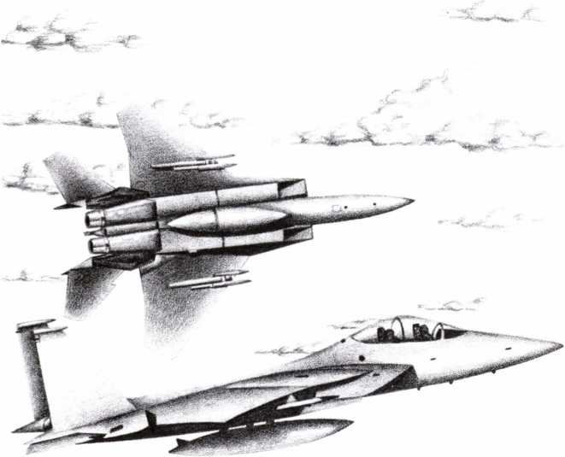

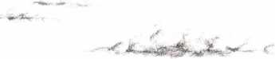

FUNDAMENTALS OF FLIGHT
This discussion of the principles of flight is not scientifically precise nor mathematically rigorous. It is provided here only to familiarize new fighter pilots with the fundamental principles at work while flying and landing a combat fighter.
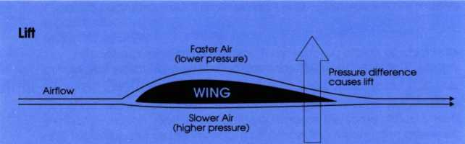

The Four Forces
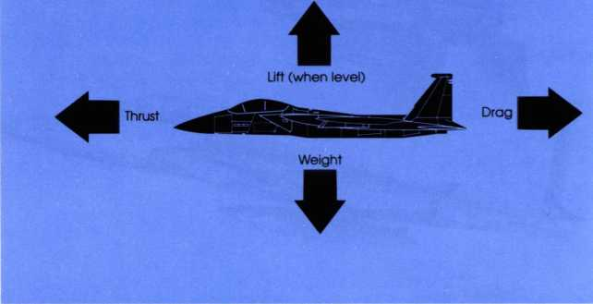

The Forces
Four basic forces act upon an aircraft in flight: thrust, drag, weight, and lift. Thrust pushes the plane forward; it varies with engine power. Drag (friction) reduces the effect of thrust and is relatively constant. Gravity pulls the plane toward the ground, regardless of the plane's attitude. Lift pushes upward from the wings, directly opposing gravity.
LIFT
Aircraft fly because of the difference in pressure created by air flowing over and under the wings. The wing design causes air to flow
faster over the top of the wing than under the bottom, creating high pressure beneath the wing and low pressure above it. This difference in pressure pushes the wing upward and is called lift. If the pressure difference is great enough, the upward lift is greater than the plane's weight (i.e.. the force of gravity) and the aircraft flies.
SPEED AND UR
The amount of lift generated by the wing varies with airspeed. The faster the plane flies, the faster the airflow, so the greater the pressure difference. If your plane is in level flight, reducing the speed reduces lift and causes a descent (even though you didn't point the nose down).
ANGLE OF ATTACK AND LIFT
The amount of lift generated also varies according to the angle between the wing and airflow. If you pull the nose up (thereby changing the angle of the wing relative to the airflow), you increase the pressure difference, increasing lift. If you dive, the reverse occurs. This difference between the airflow direction and a line through the wing (the wing "chord") is the "angle of attack."
Angle of attack is visible on your HUD in AIR-GROUND mode. In level flight, whenever your nose indicator is above your flight path, the difference between the two is the angle of attack.
THE EFFECT OF A ROLL
Lift is a force perpendicular to the wing. If the wings are tilted (you are rolling or banking the fighter) the lift force is no longer straight up. Instead it has two components: one moving the aircraft sideways, the other straight up. This causes the plane to turn. However, it also reduces the force opposing gravity.
During a turn a pilot can adjust the angle of attack by control stick "backpressure," that is, by pulling back slightly on the stick. The amount of adjustment needed is very small. Overcorrecting is a common error among beginner pilots.
ACHIEVING LEVEL FLIGHT
To achieve "level" flight at a given power setting, raise or lower the nose of your fighter until the Wl shows zero (i.e., no ascent or descent appears on the "V" strip gauge). Note that a pitch of 0° may show ascent or descent, depending on airspeed. Nosing up or down to a new "angle of attack" adds or subtracts lift as needed to achieve level flight. Never assume that a pitch of zero automatically means level flight.
STALLS
An aerodynamic stall occurs when the wing's angle of attack becomes too large. The air stops flowing smoothly over the wing, and instead part of the airflow breaks away onto an independent path. This erases the pressure difference, vastly reduces lift, and generally causes the nose to drop. Stall speed varies considerably depending on aircraft attitude, flap configuration, etc. Tight turns increase the stall speed. Simultaneously, the act of turning will tend to decrease your airspeed. As a result, stalls are quite common in tight turns.
Your fighter has an audible stall warning horn and a thin, colored bar showing stall speed on the HUD's airspeed indicator.

HOW TO FLY
If you are flying af Rookie level, you will not have to worry about takeoffs and landings — you begin the game already flying, and after you've destroyed your primary and secondary targets you can simply fly toward a friendly airbase and be landed automatically.
All other difficulty levels require you to take off. Following are some guidelines on how to take off, fly. and land in your fighter.
Taking Off
CHECKLIST
Look at the satellite map on the left side of the dashboard and note the locations of the primary and secondary targets for your mission. Now look at the heading scale along the top of your HUD and tap the Waypoint Select Key several times, noting the positions of the waypoint marker. Leave the marker pointing to the target you want to attack first.
Check your ordnance (tap the Short- and Medium-range Missile Keys and the Ground Attack Missile Key) to familiarize yourself with the weapons you are carrying.
ACCELERATE
Turn on your engines by tapping the Maximum Power Key. As you move down the runway or carrier deck, watch the speed scale (left side of the HUD) very carefully. A thin, colored bar on the side of that scale will gradually go down. This is the Stall Speed Indicator. When the bar drops below the center tick-mark your plane is past stall speed. This happens very quickly on a carrier deck, and somewhat slower on a runway.
CLIMB AND TURN ONTO COURSE
Once past stall speed, pull back gently on the stick. Watch the altitude scale on the right side of the HUD: you'll start climbing. Push the control stick left or right until the waypoint marker along the top of the HUD matches up with the center tick of the heading scale.
Alternatively, you can simply tap the Pilot, Automatic Key and let your autopilot turn you onto the correct course to the first waypoint.
Flying the Fighter
A LIGHT TOUCH
Use a light touch on your controller. The most common pilot error is a “ham-fist" on the stick, throwing the plane around the sky in uncontrolled abandon. That kind of heavy-handed flying may be fun in a dogfight, but it's totally useless for lining up a cannon shot, or making a landing. Unless it's an emergency use light, smooth stick movements. CHASING THE GAUGES
When you change an aircraft's operating regime, by moving the stick, changing the throttle, etc., the effects of the change don't happen instantly. It takes a second or two for your gauges and displays to “settle out" and show the new situation. For smooth flying a pilot always makes a change, then observes the effects. Constant adjustment and correction should be avoided, because all you'll do is “chase the gauges," overcorrecting every move.
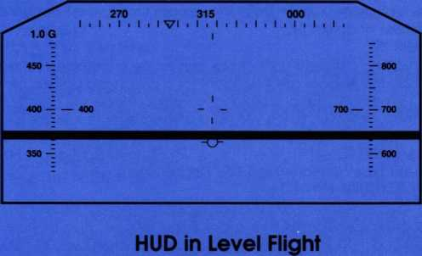
Your fighter is in level flight when the flight path indicator is on the horizon (the gray line above) and you are neither ascending nor descending (Wl is zero on the altitude scale at right). It's common for the nose of your fighter to be above your flight path.
STRAIGHT & LEVEL FLIGHT
To be a good combat pilot, you need to master level flight. Do this in a training scenario, rather than real life.
Climb to 2,000' (2K on the HUD altimeter) and level the aircraft so the nose of the plane points at the horizon. Now reduce the throttle to about 75% to achieve an economical cruising speed.
Although the nose indicator on the HUD may appear level with the horizon, a glance at the Wl probably shows that you are gradually climbing or descending. If climbing, push forward slightly on the stick and let go to see what happens; if you're descending pull back, Your goal is to keep the altimeter rock steady.
You'll notice that your flight path indicator aims at the horizon, but your nose indicator may be pointed above or below it, depending on your speed. Generally, the slower you're traveling, the higher you must pitch the nose to achieve level flight.
Experiment. Tap the Brakes Key. This slows your plane. Watch the HUD and notice how the flight path indicator drops as your speed and altitude drop. To achieve level flight at this new, lower speed, pitch up (pull back on the stick) until the flight path indicator is level with the horizon. You may need to adjust once or twice to find the setting.
TURNING
Beware of stalls when pulling tight turns. As your roll angle increases beyond 45° (when turning right or left), your stall speed rises from the normal 120 knot range to over 200 knots (in a 90° roll). Since tight turns can "bleed off" airspeed, a long, tight turn may reduce your airspeed below the stall speed. Keeping an eye on your speed is especially important when making tight turns at low altitude — a stall can mean a crash!
To make a very tight turn, roll to 80° or 90°. Then you can significantly
increase your turn rate by pulling back on the stick. However, this trick bleeds off airspeed even faster than a bank turn, and the danger of a stall increases accordingly.
CLIMBING
Ballistic ("straight up") climbs cannot be maintained for excessive periods: the engines are insufficient for a prolonged ballistic climb.
Remember that any prolonged vertical maneuver greatly reduces airspeed. However, going vertical is a very clever maneuver for changing direction, since you can roll while vertical, quickly pointing your nose in any desired direction, then push down into level flight again. For details of these types of maneuvers, see Dogfighting (pg 56).
LOW ALTITUDE FLYING
At altitudes under 500' you can expect increased buffets, downdrafts, and other irregularities that make flying difficult. Also beware of low ridgesand mountains. It's easy to fly into a mountain if you're not looking. Good pilots develop a "cross check" routine of scanning the entire HUD periodically, to make sure everything is okay.
In "Rookie" and "Pilot" flight options you have a barometric/laser altimeter. If you drop below 300' this device automatically but gently pushes your plane above 300 feet. Be warned, the device automatically turns off when the landing gear is down or when the gun is firing. The device is not proof against power dives, stalls, or other radical maneuvers, but works fine in normal flight regimes.
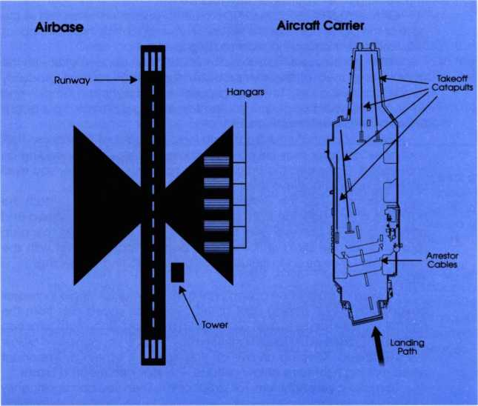
In fully realistic flight the automatic altimeter that keeps you above 300' is turned off. This allows a skillful pilot to cruise at extremely low altitudes.

Landing the Fighter
One of the more difficult maneuvers in flying the plane Is getting it safely back on the ground. If playing in Rookie difficulty level, all you have to do to land the plane is fly toward a friendly airbase; when you get near the base, the plane will be set down on the airstrip almost immediately. If playing in higher difficulty levels, you have the choice of landing the plane yourself or allowing the autopilot to land it for you.
ABOUT AIRBASES
All ground runways and aircraft carriers have a North-South orientation. On approach, a course of 000 (if coming from the south) or 180 (if coming from the north) will aim you directly at the runway. Airbase runways are more than twice as long as your safe landing distance at 200 kts, so you have a large safety margin.
Aircraft carriers have arrestor wires on the stern. You must touch down before or on these wires, which catch and stop your plane. If you miss you'll roll off the deck. Do not attempt to land on the bow of an aircraft carrier. There are no arrestor wires there, and other aircraft spotted for launching may be positioned there — you don't want to crash into them!
AUTOMATIC LANDING
Players who don't want to worry about learning to land the aircraft may use autopilot to land the plane for them. To do this, select friendly airbase with the Waypoint Select Key. Then turn the autopilot on (tap the Pilot, Automatic Key) and sit back and watch the plane land. You still may be shot at by enemy aircraft and ground-based weapons, but the autopilot will land your aircraft perfectly every time.
This approach can be quite useful in learning to land. Watch the fighter's HUD and panel to get an idea of timing, descent, braking, and so on in approaching the runway. After a few times you'll probably be ready to attempt a landing unassisted.
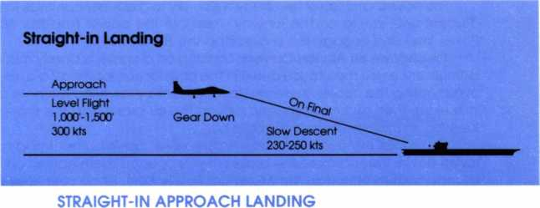

Probably the easiest way to land the fighter, short of autopilot, is to take the straight-in approach.
Simply put, you find the airfield, approach it from directly North or South, and slowly descend toward the runway. Just before touchdown, open
the brakes. That's it in a nutshell, but for more details read on.
Line-up the Approach: Set the waypoint marker on the airbase (by tapping the Waypoint Select Key). Set your course so that you approach with heading 000, or 180. Beginners should plan to find this approach about 40 km to 50 km from the runway. Attempting to find the approach and make a landing less than 20 km from base is not advised for beginners.
Approach at 300 kts: As you approach in level flight, reduce your throttle until the airspeed shows 300 knots (about 70% throttle). You'll need to raise the nose 5° to 7° to maintain level flight until you're about 20 km from the airbase or carrier.
Throttle 50%, Gear Down: Now reduce the throttle to about 50%. This slows the plane to about 230 kts. As you reach this speed, lower your landing gear. If you're moving too fast, extend the brakes (tap the Brake Key) for a brief period, then retract them again.
Descend: There are two methods for descending. One is to reduce the power slightly. If you were in level flight, you now have less thrust and will gradually descend. This method is generally preferred by pilots.
The other method is to reduce the pitch of the nose slightly. Typically you're landing with the nose pitched up about 5° to 7°, to maintain level flight at low power. Therefore, reduce this upward pitch a few degrees to cause a gradual descent — do not point the nose down and dive for the runway.
In either case, your nose should always have a positive pitch (the nose indicator should be above the flight path indicator).
Keep an eye on your airspeed and stall bar. If the stall bar indicator is too close to your current airspeed (within 25 kts), your throttle is too low or you're flying with brakes on. Increase the throttle or take off the brakes. Conversely, if you're moving too fast (over 250 kts), extend the brakes (tap the Brake Key) for a brief period, then retract them again.
Touchdown on Runways: Your altimeter will read O' on a runway and 125' on an aircraft carrier deck. These are your "touchdown" altitudes. The safe touchdown vertical velocity is shown by an arrow on the Wl portion of your HUD altimeter. A Wl of 400'/minute or less (4 ticks on the scale) is always safe.
The easiest and safest touchdown is simply to gradually continue the descent until you're on the runway. Then cut the power (tap the No Power key) and engage the brakes (tap the Brakes Key).
Touchdown on Aircraft Carriers: Landing on a carrier is slightly more difficult, since you must touch down in the arrestor cables area. To avoid overshooting the cables, increase your descent by lowering the nose a little extra, then at the last second extend the air brake (tap the Brakes Key) as you pull the nose back up a bit.
If you miss the carrier's arrestor cable area, don't bother trying to touch down. Instead close the brakes (if you opened them earlier) and hit maximum throttle (tap the Maximum Power Key). Since your nose is pointed up, you'll climb upward again.
4. AIR COMBAT
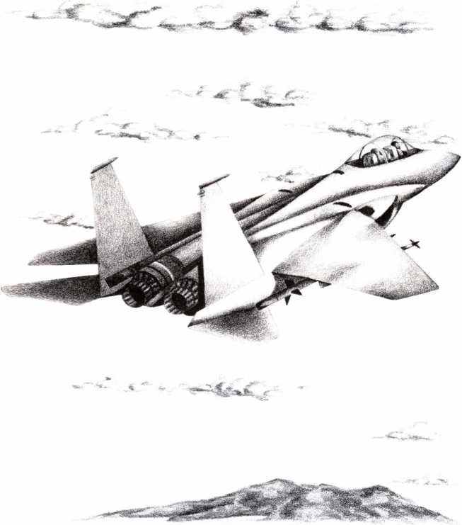

ATTACKING THE ENEMY
Your Strike Eagle is equipped with three types of missiles and one cannon. Two of the missile types, the AIM-9M Sidewinder and the AIM- 120A AMRAAM, are air-to-air missiles, or AAMs. They are used for destroying enemy aircraft. The other, the AGM-65D "Maverick," is an air-to- ground missile, or AGM. It is for firing at targets on the ground. The cannon (M61A1 20mm "Vulcan") may be used effectively against either air or ground, although it is far more difficult to hit targets with the cannon.
Missiles in General
RADAR-GUIDED MISSILES
There are essentially three types of radar-guided missiles: beam riders, semi-active homers, and active homers. The vast majority of radar- guided missiles fall into the first two categories, relying upon a radar beam emanating from the launcher to guide it to the target. This means that the launcher, whether an aircraft or ground-based radar station, must continue to track the target until the missile reaches it. The third type, called active homers, is the most technologically advanced, the most expensive, and the most deadly; they transmit and receive their own radar signals, so once fired, they guide themselves to the target. These are commonly called "fire-and-forget" weapons.
Most long- and medium-range missiles are radar-guided, because of the penetration power and range of radar beams.
INFRARED-HOMING MISSILES
All infrared (IR)-homing missiles are "fire-and-forget" weapons. These home-in on the heat coming out of your fighter's exhaust system or from the tips of the wings, where air friction makes them hot.
Early IR homers were somewhat unreliable because they were not very sensitive to differences in temperatures; they were easily confused by non-target heat sources, such as the sun or even hot rocks on the ground. Modern IR-homing systems are tuned to finer changes in temperature and ignore all but heat signatures characteristic of aircraft.
You r M issi les
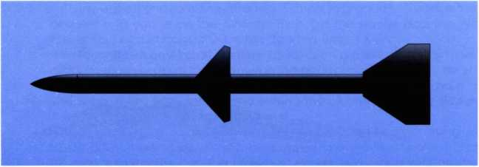

AMRAAMS
Your AIM-120A AMRAAM missile is one of the best medium-range weapons in the world. It is the only "fire-and-forget" radar-guided missile in American inventory. It has sufficient circuitry to penetrate most enemy
defenses, and sufficient maneuverability to chase down most fighters, not to mention nailing bombers and transports. Because the AMRAAM has greater range than the Sidewinder (32 km compared to 17 km), pilots typically open fire at long range with the AIM-120, then switch to Sidewinders if any enemy aircraft survive to that range.
Note: The AMRAAM has been in development for a number of years and is not yet generally available. They are available for your Strike Eagle, though.
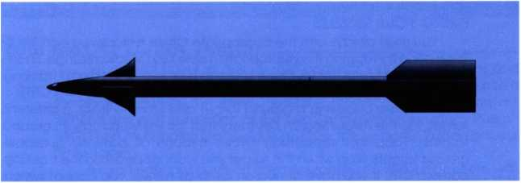

SIDEWINDERS
The short-range, IR-homing AIM-9M Sidewinder is probably the best dogfighting missile in the world. It is more maneuverable than the AMRAAM. giving it a better chance of "hanging on" to a twisting, turning target. The most advantageous firing position for the Sidewinder is up the enemy's tailpipes. The next best position is from above, diving down onto the top (hot side) of the enemy plane. The third best position is directly into the enemy's nose. Shots against the enemy as it crosses in front of you, or at its underside (the cold side) have very little chance of hitting.
The main weakness of the Sidewinder is its limited range.
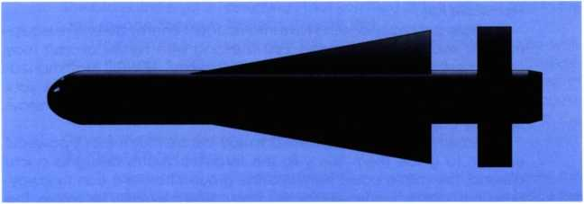

MAVERICKS
Your AGM-65D Maverick is an air-to-ground missile, used for destroying targets on the ground. It is a "fire-and-forget" weapon of almost unsurpassed quality. Once your tracking camera is on the right target, it's just a matter of waiting for the tracking box to change from a square to
an oval (indicating lock-on), and then for the oval to change color (indicating a high-accuracy firing solution). When firing at ground targets, it's usually wise to wait for the oval to change color before launching the missile. Once the missile is launched you can find other targets and maneuver as you please.
The Maverick uses a highly-advanced guidance system. When you lock-on to a target, the missile takes a “snapshot" of the target's infrared image which it then stores in memory. When fired, the missile simply flies toward its "memorized" target. The missile is smart enough to hit the target in the center.
FIRING YOUR MISSILES
You must always arm the appropriate missile before you can fire it. This is done by tapping the appropriate missile key (Medium-range, Shortrange, or Ground Attack). Once a missile is armed, it will begin tracking the nearest target (the target appears in your tracking camera CRT).
If you are attacking a ground target and want to track a different target, tap the Target Search Key (note that this key works only for ground targets). Tapping it repeatedly cycles through all currently available ground targets. Stop when the target you want appears on the tracking camera CRT. If you have armed an air-to-air missile, you cannot switch from target to target because the IR homer in the missile will track only the nearest target.
If the tracking box appears in your HUD, the target is in front of your fighter and you can fire the missile once it locks on. If the tracking box does not appear, check the heading of the target in the tracking camera CRT and turn towards that heading until the box is in your HUD.
Always remember to wait for lock-on before firing a missile. If you don't wait for the target box to become oval-shaped, you're firing without lock-on and will almost certainly miss. Once you have a lock, look at your airspeed. If you're moving fast (around 500 or more kts) or the target is closing, a maximum range lock-on shot will probably hit. However, if your speed is low or the target is flying away from you, wait until the range closes, ideally until the oval changes color. Then simply hit the Fire Missile Key.
Missile accuracy doesn't take into account enemy defensive equipment or evasive maneuvering. First line and elite fighter aircraft may prove more difficult to hit. Although the “Mainstay" AEW&C craft maneuvers poorly, it has superior defensive equipment that may make your missile go astray. You may find that guns are necessary against Mainstays flown by capable crews.
Remember that missiles fall 300' to 400' before their motor is powerful enough to guide them away to the target. If you're diving to a low altitude, the missile could slam into the ground before it can fly away. Firing in a tight turn, or while inverted, can cause the missile to tumble. The wisest method is to fire only when you're level and above 500'.
Sidewinders and AMRAAMs always home on the most prominent target, which is usually the nearest. They will do so even if you were tracking someone else. You may be tracking a target, fire a missile, and then discover it goes for one of the fighter escorts that happens to be closer!
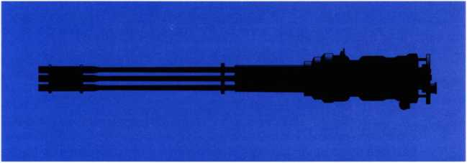

Your M61A1 20mm Vulcan
Jet aircraft travel so quickly that conventional machine guns and cannons cannot fire fast enough to guarantee a hit: a plane could literally fly between the shells. Therefore, modern aircraft cannon are either a group of guns (such as the twin 23mm cannons in many Russian MiGs) or a multi-barrel Gatling gun (such as the six-barrel Vulcan on your Strike Eagle).
Aircraft cannons have an effective range of 0.5 to 3 kilometers, with a maximum range of 6 kilometers. Inside 0.5 kilometer use of a cannon is unsafe, as there is a significant danger that a piece from a disintegrating target will hit you.
THE HISTORICAL GUNSIGHT
Your F-15 has the most modern, advanced gunsight available: a "historical" gunsight with automatic radar rangefinder. In normal operation this gunsight "assumes" you are firing at maximum range (6 kilometers). However, if your tracking box is on a closer target, that shorter range is used instead for gunsight calculations.
The gunsight computer constantly calculates range, flight path, and ballistics for you. It then displays where your shells would be if they were hitting the target now. The gunsight continually calculates firing, delays the appropriate time, and displays potential hits as they would occur. Therefore, the sight is "assuming" that you fired at the correct time in the past (hence the term "historical" gunsight).
The historical gunsight requires conscious "retraining" to use well, since it doesn't require you to "place the sight on the target." However, this weakness is more than compensated for by the advantages of anticipation firing. The sight allows you to fire sooner and more accurately than any other sight in existence. The historical gunsight is the device of choice among "in-the-know" fighter jocks.
ANTICIPATION FIRING
It takes about two seconds for the Vulcan's shells to travel the maximum 6 kilometer range. Therefore, to hit a target you must judge the speed at which the target and your sight converge. You should fire about two seconds before they meet. If the range is less than 6 km, wait a little less. For example, at 3 km wait until target and sight are one second apart; at 1.5 km wait until target and sight are a half second apart, etc.
You can use this sight like an old fashioned predicting sight. That is.
wait until the sight is on the target, then shoot. But at 6 km range you'll have to hope the target stays on the same course for two seconds to insure a hit.
In short, the key to using a historical gunsight is anticipation. Don't wait for the sight to reach the target. Instead, learn to anticipate the meeting of sight and target, then shoot ahead of time.
STRAFING GROUND TARGETS
Using your Vulcan cannon against ground targets requires some skill. In a strafing attack, dive low (under 500’) then straighten out and fly level. Because the cannon gunsight is optimized for air-to-air combat, "walking" your shells across the ground is the best way to hit a target, but this uses a lot of ammunition. Experienced pilots confine themselves to ranging bursts until they're close.
The most difficult problem in strafing is your limited range. Maximum cannon range is only 6 kilometers; effective range is just 3 kilometers. This means you have only a couple of seconds to hit the target before it passes beneath your gun.
A common error when strafing is "target fixation" where you ignore altitude. Remember that strafing means diving — and you've got to come up again sometime! After you pass your target, open the throttle and turn away. Keep an eye on your missile warnings and be ready to drop chaff or flares.

ENEMY ARMAMENT
The enemy will be firing sophisticated missiles at you in an attempt to destroy your aircraft. He will use basically two types of missiles: Surface-to- Air Missiles (SAMs), that are fired from ground installations, and Air-to-Air Missiles (AAMs), like your AMRAAMs, and Sidewinders, that are fired from his fighters.
His aircraft are also equipped with rapid-firing cannon, like your Vulcan. In general, the enemy's cannon are not as effective as your own, but be careful of the lucky shot.

Enemy Missiles
ENEMY SAMS
As you fly into enemy radar search zones, which include just about all of the areas into which you will fly, the enemy will attempt to destroy your fighter from ground-based missile launch sites. In order to avoid being shot down by SAMs it is important to understand how they work.
Radar-Guided SAMs: Medium- and long-ranged SAMs are radar- guided. All types use the same three-step process to engage their target:
- Radar search: Enemy search radar periodically scans a 360° area of the sky.
- Radar tracking: When a search radar finds a target (such as your plane) it "hands off" to a narrow-beam fire control radar which locks onto your craft. At this point a missile is launched.
- Radar control: Once the missile is launched, the narrow beam continues tracking your plane so the missile's course can be updated and corrected.
IR-Homing SAMs: Short-range SAMs are usually infrared-homing missiles. The only significant difference between the method used for killing you with IR SAMs and that for Radar SAMs is that once fired, an IR SAM doesn't rely upon the radar to update its course during flight; instead, it guides itself to the target.
- Radar search: A search radar finds your aircraft.
- Radar tracking: A tracking radar follows your aircraft.
- Missile launch: The IR homing missile is launched. At this point tracking radar is unnecessary, as the missile can guide itself to target. ENEMY AAMS
The enemy has a wide variety of threatening AAMs, but probably the most dangerous one is the Russian AA-10 "Alamo." Like your AMRAAM, it is a "fire-and-forget" medium range missile, and is difficult to shake. All other Russian medium- and long-range AAMs are radar-guided, semiactive homers — they rely upon a radar beam emanating from the firing aircraft to guide the missile to your fighter.
By definition, all IR-homing AAMs are “fire-and-forget" weapons. These are usually short-range (8-12 km), dogfighting missiles. The most dangerous is the Russian-built AA-8 “Aphid," whose maneuverability and modern IR seeker is almost a match for your Sidewinder. If enemy MiGs or Sukhois close to AA-8 range, you could be in trouble; only your dogfighting skill may save you.

Enemy Guns
The enemy has cannons equivalent to yours in range and power. However, the enemy still uses old predicting gunsights. This means they are virtually required to get behind you before they can make a decent shot. In addition, all but the most elite pilots will be slow to fire, since they must place the gunsight on the target and keep it there to score a hit.
If you sense the enemy is behind you and ready to fire cannons, “jinking" (small, violent moves in random directions) can throw off his aim.
Finally, Russian-built aircraft with the older GSh-23 cannon may not always hit, since the lower volume of firepower increases the chance of you “flying between the shells" and escaping serious injury. Don't rely on this: not every 23mm shell is an unlucky one!

DEALING WITH MISSILE ATTACKS
Inevitably, you will find yourself under attack from both groundbased and air-launched missiles. Your fighter is designed to give you ample warning before you are hit and destroyed, and there are several defense systems built into the plane to aid you in spoiling the enemy's attempts to shoot you down. In addition, with practice you can maneuver your way out of desperate situations without having to rely upon your fighter's defense systems.
Missile Attack Warnings
Your first warning that a missile has been fired at you comes in the form of a beep and a message displayed in your HUD. This will inform you of the type of missile fired and the place from which it was launched if it is a SAM or the type of enemy plane that fired it if it's an AAM.
At this point one of the warning lights on the dashboard begins flashing to remind you that a missile has you targeted. If the offending weapon is radar-guided, the "R" light flashes; if it is an IR-homer, the "I" light flashes.
Your next warning appears on your tactical screen, in the middle of the dashboard. You see the missile as it approaches your fighter. Finally, when the missile is within a few seconds of impact, you hear the missile proximity klaxon, a high-pitched beeping sound that continues until the danger is passed or until the weapon slams into your fighter.
Responses to Missile Attacks
REDUCE YOUR VISIBILITY
In some cases, especially when a missile is fired at you from great distances, you can avoid the danger by simply "hiding" from the radar that must track you to guide the missile to your fighter. Unfortunately, IR- homers that are already enroute cannot be evaded in this way, but you may avoid additional launches of IR missiles, since the first step in launching is to find you with radar.
First and foremost, the further you are from the enemy radar site, the weaker the signal, Therefore you may wish to simply turn and run away for a while, until the signal is too weak to "see" you. Also remember that reducing your altitude, lowering your engine power, and levelling out your flight will help.
Chaff & Missile Field of View
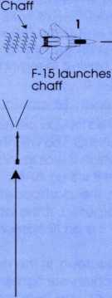
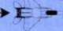
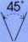
Missile
At point 1 the F-15 releases chaff. The missile homes on the chaff while the F-15 continues straight ahead. At 2, the F-15 is beyond the missile’s “view arc.” Once the missile passes the chaff, it will see no target and fly off blindly.
Missile Field of View
2
F-15 beyond missile's field of view

CHAFF (FOR RADAR-GUIDED MISSILES)
For defense against radar-guided missiles, your fighter is equipped with chaff cartridges. Each chaff cartridge deploys a cloud of tiny tin-foil strips that reflect enemy radar. For two or more seconds the strips form a huge radar reflector, blinding the missile, like a smoke screen.
The classic chaff technique is to wait until a radar-guided missile is just a couple seconds away (when the missile proximity klaxon sounds). At that instant fire a chaff cartridge (tap the Chaff Key) and turn away. The blinded missile will fly straight into the chaff, missing you.
Note that you do not have an endless supply of chaff cartridges; your current supply is constantly updated and indicated in the middle of your HUD whenever you use one.
Doppler Missiles: Enemy missiles with Doppler radar guidance systems are a special danger. These missiles will not home on the chaff unless your course is perpendicular (at right angles to) the missile. If the missile chases you from the rear or attacks from straight ahead, chaff has no effect.
Only three SAMs currently have Doppler guidance: the SA-10, SA-12, and SA-N-6. Only one AAM (air-to-air missile) has Doppler guidance: the AA-10.
FLARES (FOR IR-HOMING MISSILES)
For defense against IR-homing missiles, your fighter is equipped with heat-producing flares. Although called “flares," these are really small, finely tuned heat decoys. A flare lures an IR missile toward it (and away from you), but only during the 2 to 3 seconds it burns. After that the flare dies end the missile resumes seeking. Therefore, like chaff, the standard technique is to wait until the missile is a couple of seconds away (the klaxon sounds), then drop a flore while you turn away.
Like chaff cartridges, you don't have an infinite number of flares; your supply is indicated in the middle the HUD whenever you use one. MANEUVERS
It's important to remember that chaff and fldres aren 't perfect. Both radar-guided and IR-homing missiles continue seeking after your flare or chaff expires and Doppler radar missiles ignore chaff altogether if you're on the wrong course. Therefore, it's important to maneuver out of the missile's “field of view" when the defense expires. If you don't, the missile will re-acquire you and continue on a collision course!
If you're an especially skillful pilot, you can out-maneuver an enemy missile without mechanical aids.
Evading the Missile’s View: SAMs have a limited cone of vision; they con only “home" on targets within the acquisition arc of their seeker. This arc is a bare 45° ahead of the missile. If flares or chaff temporarily confuse a missile, you can evade attack by turning rapidly to move outside this 45° arc. Usually the quickest escape course is one perpendicular to the missile's flight path.

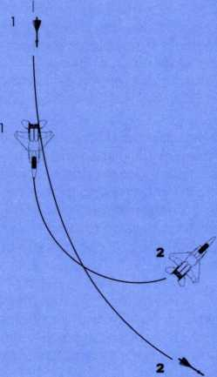
Turning Inside a Missile
The F-15 above turns so tightly the missile can’t stay with it and passes harmlessly to the right. This is a good maneuver for avoiding IR-homing missiles.
Turning inside a Missile: When a missile is close, you still have a chance to outmaneuver it, because its turning arc is larger than yours.
If the missile is trying to fly up your tail, roll over onto a wingtip for a tight turn, then pull back hard on the control stick to tighten the turn further. Keep an eye on your airspeed, since you can't stay long in this kind of a turn — soon the plane will stall. But meanwhile, the missile is making a wider, faster turn that causes it to zoom past harmlessly

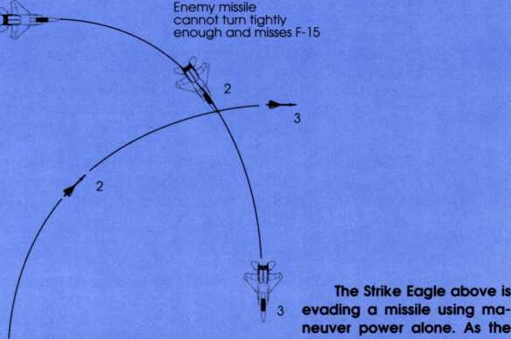
Enemy missile flying faster than F-15
Eagle turns, the missile tries to follow, but cannot turn fast enough. The missile “falls behind" and passes harmlessly to the rear.
Turning Toward a Missile i
Turning toward a Missile: If a SAM approaches you from the side, gradually turn toward it, increasing the tightness of your turn as it comes closer. The objective is to keep the missile's course at right angles (perpendicular) to your own.
This tactic works because the missile cannot turn with you. Instead, it gradually falls behind and zooms past your tail.
Evading Frontal Attacks: If a missile approaches you from the front, wait until it's about 8 to 12 kilometers away (about 2/3 of a grid square on the tactical display).
Then make a quick 90° turn, placing the missile facing your side. Now roll over 180° and turn toward the missile. Now you're set up for a turning battle (see “Turning toward a Missile," above).
Missile Minimum Range: Large less-maneuverable missiles fire straight up when first launched. This means that they can't begin homing until they're beyond a certain distance (in range and altitude) from their launchers. As a result, circling right over a battery of low-maneuverability SAMs can actually be very safe.

DOGFIGHTING
The best way to ambush an enemy plane is to slide up from behind it. Enemy aircraft have forward-facing radars only (except the IL-76 "Mainstay" AEW&C), so coming in from behind means you can catch him off guard.
Traditionally, fighter pilots prefer to attack from above. This gives them an energy advantage in a dogfight. However, missile tactics and the importance of secrecy make a height advantage less valuable. Gaining height makes you visible to enemy radar, which may warn your targets. Therefore, approaching low and from behind is often wiser. Only if your missile attacks fail and the enemy discovers you should you begin to seek an altitude advantage.
If you're surprised or "bounced" (attacked from above) by the enemy, immediately look for incoming missiles and take appropriate defensive action. Missiles arrive faster than aircraft, and must be avoided first. Only then can you begin dogfighting.

The Missile Exchange
Often an air-to-air battle starts because the enemy has discovered you and vectors fighters in your direction. The result, quite frequently, is a head-to-head face-off.
In this western-style showdown each side starts with an exchange of medium-ranged AAMs. Be prepared to chaff the "incoming" or maneuver it to a course perpendicular to your own. Once your medium-range radar missile is away, switch to a Sidewinder. You may get a second close-range missile shot if the AMRAAM fails. Scoring with a head-to-head cannon shot is much more difficult; it's not worth the ammo unless you're out of missiles or you're an incredibly good marksman.
In most cases, if you can get off a second missile shot so can an enemy carrying second-generation IR missiles (the AA-8 or AA-10 IR version). These nasties show up frequently on MiG-29s and Su-27s, but aren't unknown on other craft flown by veteran or elite pilots.
Early Turn
on a head-to-head pass
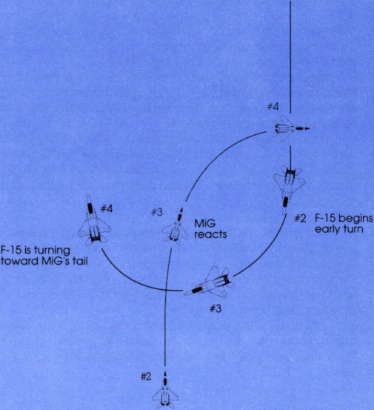
#1 j An F-15 executes an early
F-15
turn against a MiG. By position 4 the F-15 is already closing on the MiG's tail.
THE EARLY TURN
One of the most difficult but useful tactics in a head-to-head match is making an early turn. Against inexperienced pilots this trick is easy, since greenhorns usually keep boring in, hoping for a cannon shot, Against
vets, an early turn requires fine timing, If you turn more than a second or two ahead of the enemy, you're just telegraphing your intentions. If you wait too long, you get no advantage at all (see diagram).

Dogfighting Maneuvers
The essential rule in dogfighting is to get on the enemy's tail. On all fighters, gun and missile guidance systems face forward, so if you're on the enemy's tail he cannot shoot at you. If you can't get on his tail, try to place his aircraft as much ahead of you as possible, so you have the maximum number of firing opportunities.
Maintaining higher speed or altitude is valuable in a dogfight. A plane slower and lower can only dodge attacks. A plane faster or higher can attack or retreat as desired. Having a higher speed or altitude is termed the "energy advantage."
If the enemy is behind you, there are various classic escape maneuvers: Turning Inside, the Scissors Turn, the Immelmann Turn, the Split-STurn, and the Yo-Yo Turn. Not only should you learn to execute them, but also learn to recognize them so you can apply the appropriate countermaneuver.
TURNING INSIDE
You can see enemy planes approaching on your tactical display. The simplest solution to an enemy plane coming up behind you is to turn toward him. If you're turning faster and tighter than he is, you'll gradually circle around and get onto his tail. You make the tightest turn possible by rolling onto your side and pulling back hard on the control stick — but be careful of stalling!
Of course, if the enemy is turning faster than you, he will eventually come around behind you. If this happens try something else immediately. The longer you wait the worse it gets, until he lines up a shot and toasts you.
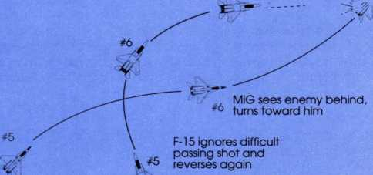
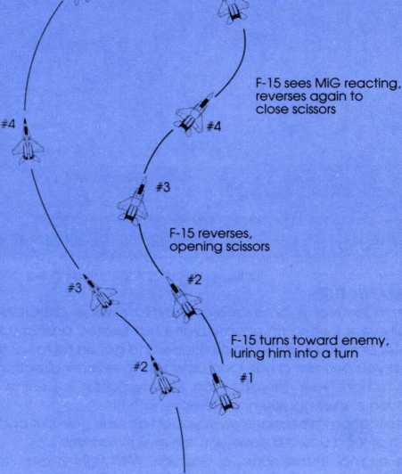
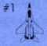
Scissors Turn
F-15 in firing position
*⁷
MiG behind F-15 but moving faster
SCISSORS TURN
A more complex way to out-smart an enemy aircraft is the scissors turn. Begin turning toward him as if you're planning to out-turn him, but once he begins to turn with you, quickly roll over to turn in the other direction. This opens the scissors. As the enemy realizes you've turned
away and tries to follow, reverse the procedure and roll back toward him again. If your turns were quicker and tighter than his, and/or you're a slower plane, he will eventually pass in front of you. This allows you to get onto his tail.
A novice enemy pilot trying to turn with you can easily be lured into a scissors trap. Even if his plane turns better, his slow reaction to each reversal will quickly give you the edge. A more experienced enemy pilot may avoid your trap by anticipating your next turn and blasting you (if his fighter is less maneuverable than yours), or by pulling up and over into a yo-yo turn (if he's faster).
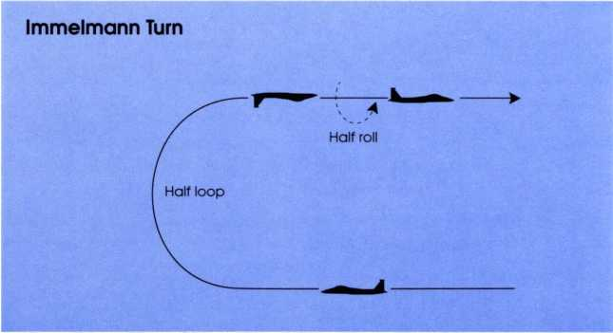

IMMELMANN TURN
This maneuver is an excellent way to reverse direction quickly, especially useful when an enemy plane has buzzed past in a head-on encounter and you want to gain altitude and get on his tail at the same time. First you perform a half loop upwards to reverse direction, then a half roll to right your aircraft. If an enemy fighter is behind you, an Immelmann can bring you nose-to-nose with him.
Note that an Immelmann gives you an altitude gain but costs speed, since a half-loop upward slows you down significantly.
The original Immelmann, a German WWI fighter ace, reputedly rolled while vertical, allowing him to finish the loop in whatever direction he desired. He still finished the half-loop inverted — it's aerodynamically more efficient that way.
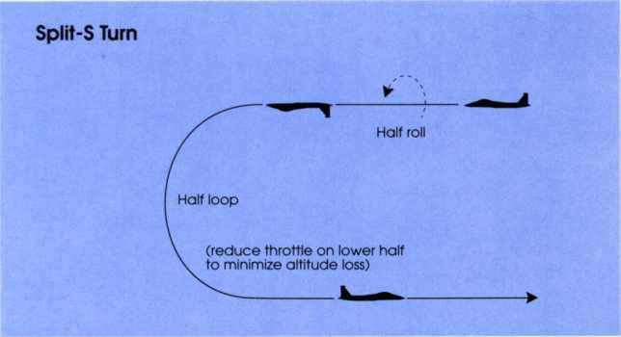

SPLIT-S TURN
This is another way of reversing direction quickly, but is more dangerous. Begin by rolling inverted, then pull the stick back to half-loop downward. Many pilots begin the loop before the roll is completed, rolling the plane while looping. The split-S causes you to lose considerable altitude, so it's often wise to reduce throttle and/or use speed brakes to minimize altitude loss.
The Split-S complements the Immelmann because you gain speed and lose altitude. Unwary fighter pilots have sometimes tried to Split-S into or away from the enemy without remembering their altitude. The result can be a Split-S right into the ground!
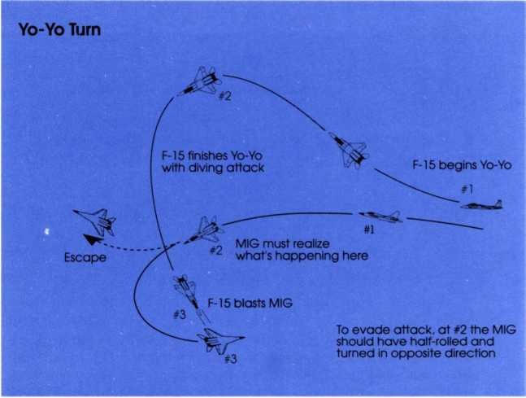

YO-YO TURN
This maneuver is used mainly by higher speed jets against slower opponents. Therefore, you should learn this maneuver well, because your fighter is one of the fastest, most powerful in the world. You may see SU- 27s and MIG-29S attempting it against you! This turn requires excellent cockpit visibility, something that earlier MiGs lack.
To execute a Yo-Yo turn, climb and roll toward the enemy, until he's visible out the top of your canopy. Then pull over into a dive while still turning. During the dive you roll the plane to help line up your shot. Very often you'll take that shot while inverted.
In effect you make a very big turn in three dimensions. Most of the turn radius is "consumed" with the climbing and diving, allowing a faster plane to travel farther and turn wider, yet still come out on the tail of the more maneuverable plane. As you gain altitude you gain the "energy advantage" and the flexibility to turn either way your opponent goes. American F-4 Phantom pilots used this maneuver with great success against slower but more maneuverable MiG-2 Is over North Vietnam during the Vietnam war.
Note that the best defense against a Yo-Yo is to reverse your turn, or to use the third dimension yourself (usually by going into a split-S).
Because a Yo-Yo requires good spatial perception, first practice it using the Slot View (if alone) or Tactical View (if you've got a target).

&

in

X-
J',


u
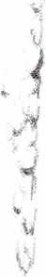
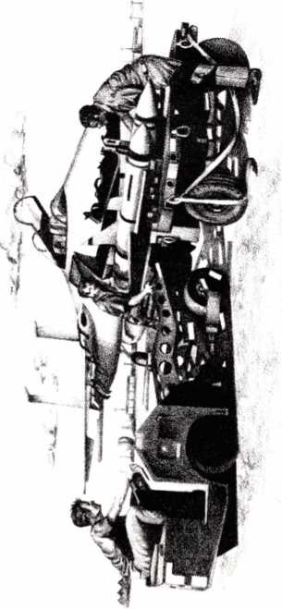

LIBYA
I ntrod action
Libya is ruled by Col. Muammar al-Qadhaffi, leader of the secret army organization that deposed the former king in 1969. The capital city is Tripoli and the nation's chief source of wealth is oil.
A desert nation, Libya has only one visually distinctive mountain region: the Jabal al Akbar to the east of Benghazi. Deep in the desert, east of Sabha, are the desolate, isolated mountains of the Al Haruj al Aswad, while to the west are the great sand seas (ergs).
Rich by third world standards, Libya buys most of its armament from the Soviet Union. Its military is trained by Soviet advisors, but national pride has prohibited (so far) any significant Soviet presence. Soviet advisors do not participate in combat operations.
Libya's army is approximately 60,000 men strong, its navy has 53 ships and 6,500 men, while its air force has roughly 530 planes, 30 combat helicopters, and 8,500 men. A 10,000-man paramilitary "Pan-African Legion” also exists as well as various terrorist training camps.
Sightseeing in Libya
Flying over Libya is a unique experience. It is a truly desert nation, a land of red and brown hardscrabble with patches of tan sand and gray boulder fields. Water is all underground, seeping to the surface in occasional patches of green oasis or mountain valley. Mountain ranges are low, undulating areas full of small hillocks and short peaks. From the air it's often hard to tell the difference between aging roadways and dark wadis (gullies) in the desert. But some works of man stand out, particularly the rust red of oil wells and pipelines or the distinctive star-pattern of SAM batteries.
Friendly Bases
Sigonella on Sicily (UD15): The USA maintains the Sigonella military field in southeastern Sicily. The Sigonella runway is the main staging point for air attacks against the North African coast, especially Libya. Unfortunately, the flight distances are quite long.
CV America at Sea (UD70): This 60,000-ton "Kitty Hawk" class conventional aircraft carrier, designated CV66, serves with the US 6th Fleet in the Mediterranean. It participated in the 1986 raids against Tripoli and Benghazi. The carrier is ideally positioned for launching and recovering strikes against Benghazi, the Gulf of Sirte, or targets deep inside Libya. Here it cruises on a southerly course with its traditional ring of close escorts. The carrier remains well north of the Gulf of Sirte to avoid SSM attacks from enemy ships and aircraft. It is surrounded by escorts and regularly replenishes the CAP (combat air patrol) with F-l 8 launches.
Neutral Bases
These airbases are in neutral territory. Don't use them unless specifically ordered to do so or if you must make an emergency landing.
Suda Bay on Crete (VD41): Near the city of Khania. this airfield is not an American base, although in years past it was a major NATO air and naval base. It has the advantage of being both closer and less public
than equivalent fields in Greece or Egypt.
Halfar on Malta (UDI 3): Once a critical strength position for the British Commonwealth in the Mediterranean, this is now a neutral port and sometime tourist haven.

Libyan Cities and Targets
Tripoli (TC87): The capital city of Libya has a large military-civilian airbase at Idris, well protected by SAM batteries. Until recently, long-range SA-5 Gammons watched the skies from these sites, but there are indications that Russian military advisors may replace these with more formidable SA-12 Gladiators.
Tripoli is also the site of a major army headquarters, various military depots, oil storage areas, and sometimes terrorist training camps. Missile boats can almost always be found prowling the coast nearby.
Sabha (UB17): This southern town is the main military base of operations for Libya's southerly expansion. It was the major depot for the war against Chad and is still extremely important to Libyan trans-Saharan ambitions. The most important military installations here are the large airbase and the SAM battery protecting it.
Misratah (UC26) & Sirt (UC43): These coastal towns house low-level military headquarters and oil storage tanks for refueling ships. Side is a secondary naval base, supporting missile boats that cruise the western side of the "Une of Death."
Ras Lanuf (UC82) & Port Brega (UC92): Ras Lanuf is Libya's largest and newest oil facility. A vast quantity of oil for export is stored here, and a large number of oil tankers ply the waters nearby. There is also a refinery, vast “farms" of oil tanks, and a major military headquarters. Port Brega oil facility is older but still in operation despite the completion of Ras Lanuf.
A number of SAM batteries are sited in this vital area. Port Brega airfield, west of town, serves both ports.
Benghazi (VC 16): This city is the site of Libya's second-largest military base, including the Benina airfield and powerful protective SAM batteries. The city itself is large, with a military headquarters and a few small oil storage facilities to serve the ancient port. Terrorist training camps are not uncommon in the hills to the east.
Al Bayda (VC37): This sleepy coastal town in the mountainous Jabal al Akbar has major military significance. It overlooks the narrow Ionian sea between Libya and Greece, making it an ideal site for anti-ship missiles. There is a small airstrip and SAM site as well.
Oil Fields: The great oil fields of Libya are in the southeast, where literally thousands of wells pump crude from the ground. This oil is piped to Ras Lanuf and Port Brega. The great producing fields can be found near Raguba (UC90), Waha (VB18), Amal (VC30), Jalo Oasis (VC40), and Gialo (VB49). Most fields have a few storage tanks on site to hold crude temporarily until it can be piped to the port. However, the majority of storage tanks are at the ports, not on the fields.
Secret Bases: Western intelligence operatives in Libya are preparing two secret, hard-pack surfaces suitable for aircraft landings. One is at Al Mukhayli (ONO VC43), the other is on the edge of the great ergs, at Yafran (ONC TC93).
Libyan Air Defenses
Libyan air defense forces use Russian-built equipment and are trained by Russian advisors. SA-2 Guideline and SA-5 Gammon SAMs have been the backbone of Libyan air defenses, but there are rumors of upgrades to new SA-10 Grumble and SA-12 Gladiator systems.
Local military forces make use of SA-7 and SA-14 shoulder-fired missiles. These are also popular terrorist weapons and can be expected in the vicinity of terrorist camps. Libyan army units use various mediumrange SAMs, including SA-8s, -9s, - Ils and -13s.
Libyan Air Force
Fighters: The Libyan Air Force is composed of over 140 MiG-23MF "Flogger" fighters, a number of MiG-25 "Foxbats" (for reconnaissance and long-range interception), and several antiquated MiG-2 Is. The Air Force also has various Mirage 5D fighter-bombers for ground attack missions.
Intelligence expects that MiG-23s and 25s will be your primary air-to- air opponents, although you may encounter the new MiG-29 "Fulcrum" flown by Soviet personnel.
Reconnaissance Bombers: Although Libya does not possess any Tu- 95 "Bear" reconnaissance bombers, Russian Bears frequently operate from Libyan bases.
Air Transports: It is suspected that Libya's antiquated fleet of C-130H and C-47 air transports (built in America) will be replaced with Russian equipment, perhaps including the new An-72 "Coaler" jet transport.
Libyan Navy
The Libyan Navy is composed primarily of missile corvettes and missile patrol boats. The largest of these is the 770-ton Russian-built Nanuchka II class armed with Styx surface-to-surface missiles, SA-N-4 SAMs, and a twin 57mm gun turret. Other boats include the Russian Osa- class, Italian-built Wadi M'ragh class, and the French-built La Combat- tante II types; these have poorer missiles and SA-N-5 SAMs, or no SAMs at all.
The Nanuchkas are the best boats in the Libyan Navy. They perform the most aggressive patrols, making them the primary threat. Patrols occur frequently in the Gulf of Sirte, south of the "Line of Death.' Sometimes the Libyan air force flies fighter missions in support of these naval patrols.

THE PERSIAN GULF

Introduction
Iran has been ruled by Shi'ite radicals since the overthrow of the proAmerican Shah in 1979. In September, 1980, Iraq attacked Iran, beginning a long, costly war between those nations that lasted for years. Both contestants are viewed with distrust by the Arab states south of the Persian Gulf and Iran's support of international terrorism has not improved the nation's image.
Iran also calls for a Shi'ite religious revolution throughout the Islamic world. This naturally bothers the leadership of the Arab states, since their governments are Sunni. However, Iran is populated by Persians, not Arabs. So far this cultural and linguistic barrier has hindered the spread of Iranian Shi'ite radicalism across the Persian Gulf to the Arab states.
Iran is a large nation with varied geography. The Elbruz and Zagros mountain ranges run from the northwest corner (where Iran touches Turkey and the Soviet trans-Caucasus) diagonally southeast, along the border with Iraq, and then parallel to the Persian Gulf. South of these mountains, at the head of the Gulf, are Iran's oilfields. North of the mountains the nation is divided into two regions. The western part, near Iraq, Turkey, and trans-Caucasus Russia, is fertile, heavily populated, and includes most of the major cities and industrial plants. The eastern part, bordering Pakistan, Afghanistan, and Soviet Central Asia, is largely barren desert and mountains with a small, impoverished, undereducated population.
Under the Shah, Iran's oil-rich finances permitted massive investment in military forces, mostly from the USA. Since the revolution, however, many complex weapons have failed for lack of spare parts and maintenance, while most of the rest were damaged or destroyed in the war with Iraq. Iran has some sophisticated aircraft and missiles remaining, but these are deployed to protect key cities in the interior, rather than as a border defense.

Sightseeing in The Persian Gulf
Like Libya, the Persian Gulf is a desert region, except for the large, high spine of mountains that runs diagonally through Iran from the northwest to the southeast. However, water is more plentiful, especially in Iran, resulting in increased agriculture and large local irrigation works to control the seasonal run-off from the mountain highlands.
The Gulf has many interesting and exceptional areas, such as the Tigris-Euphrates watershed that reaches the head of the gulf around Abadan. Once a great seaport and teeming metropolis, the destruction of the Iran-Iraq war has reduced the area to a ruin of small towns and villages.
Kharg Island, despite wartime attacks, is one of the great manmade wonders of the world. Surrounded by oil platforms and supertankers, guarded by missile boats and fighter patrols, it remains the site of numerous refineries and oil storage tanks.
There are also great oilfields south of Kuwait City, north of Bushehr in the Bandar-e-Rig, on Bahrain and Qatar, and along the UAE coastline
near Ruweiss and Tarif, as well as assorted individual platforms along the Arabian coast.
Another interesting region of Iran is the great valley of Bandar-e Lengeh and Bandar' Abbas. Seasonal rivers flowing from the mountains have formed a fertile valley floor that empties into the Straits of Hormuz, the strategic doorway to the Persian Gulf. On the opposite side (the southern side) of the straits, the mountainous peninsula of Musandam knifes into the straits, creating a narrow choke-point of naval traffic.
Friendly Bases
America's strongest allies in the Persian Gulf are Saudi Arabia and the tiny island kingdom of Bahrain.
CV Nimitz at Sea (KY83): This huge 80,000-ton nuclear carrier is the class ship of the latest and most powerful program of aircraft carriers. Normally assigned to the Pacific Fleet, it is prepared to visit the Indian Ocean at any time. Here it sails with a close escort of destroyers, and has its F-18s on regular rotation in CAP (combat air patrol).
American aircraft carriers do not sail into the restricted waters of the Persian Gulf, where they would be "sitting ducks" for land-based air and missile attacks. Carrier task forces remain in the Indian Ocean, although the Nimitz and her ring of close escorts have sailed deep into the Gulf of Oman to provide a base as close as possible to Persian Gulf targets. If threatened, the ship can always sail to the southeast and escape into the vast expanses of the Indian Ocean.
Ras as Saffaniyah (JY19): This is Saudi Arabia's northernmost oil terminal and port along the Gulf. Its airfield is in a useful strategic location.
Dhahram (JY54) & Al Hufuf (JY44): Dhahram is Saudi Arabia's largest port city on the Persian Gulf. However, the Al Hufuf airfield slightly inland is a strategically useful and less public position for basing missions and raids.
Bahrain (JY65): This small island nation is strongly pro-American, providing large naval and air base facilities for American military forces.
Neutral Bases
Kuwait is a friendly neutral nation, Oman is neutral but pro-Western, and the UAE (United Arab Emirates) are studiously neutral.
Kuwait City in Kuwait (JZ12): Originally neutral, Kuwait sought US aid and support after repeated Iranian threats and attacks. The Kuwait airport can be used occasionally to stage missions that demonstrate America's support of Kuwait, or for emergency landings. However, Kuwait is fearful of provoking more Iranian hostility and therefore will not grant America basing rights.
Qatar (JY75): This small independent nation works hard at the appearance of neutrality, probably because it has both strong proAmerican and strong pro-lranian factions. Although missions cannot be staged from here, it is possible to use the pro-American groups to aid in emergency landing situations.
Ruweiss (KY01) & Tarif (KYI 1): These small oil ports of the United Arab Emirates are not especially friendly to the American cause. Because the UAE is a decentralized government, pressure and money in the right places could permit an emergency landing.
Some of the largest oil fields of the UAE are in this area (ONC KY22- 23).
Abu Dhabi (KY31): Abu Dhabi is the major city of the United Arab Emirates (UAE), where the appearance of neutrality is most important. Emergency landings at this base are very difficult, but not impossible if Iranian diplomacy succeeds in making yet more enemies.
Al Khafi at Dubai (KY65): This large airfield outside the city of Dubai is the most strategically useful of all UAE airfields. It is the base closest to south-central Iran and is an important launching or retrieval point for deep missions. However, as at Abu Dhabi, political problems make the use of this base difficult to impossible.
Muscat in Oman (KY90): Oman is careful to remain neutral in all affairs, but is strongly pro-Western. For example, much of its army is trained and officered by "retired" British military personnel. The military portion of the Muscat airfield is available for missions and emergency landings, provided everything remains secret and politically "deniable."

Iranian Cities and Targets
Dezful (JZ38), Masjed Soleyman (JZ47), and Ahvaz (JZ37): These cities are the main "rear areas" behind the former Iran-Iraq battlefront. They have a variety of SAMs. Although ail originally had airbase facilities, it is believed that only Masjed Soleyman's remains intact.
Abadan (JZ24): This city is located at the final junction of the Tigris and Euphrates Rivers, near the Persian Gulf. Numerous battles in and around this area have destroyed a large part of the city and contaminated the once beautiful surrounding countryside with poisonous gas.
Bandar Khomenyi (JZ44): This is the main Iranian military base behind the southern part of the Iran-Iraq front and a major staging base for military supplies and munitions of all sorts. It has a large airbase, powerful SAM batteries, and a major military headquarters.
Bandar-e-Rig Oil Fields: These oil fields, clustered along the coast and inland hills (JZ61 and JZ71) are a key source of Iran's oil wealth.
Kharg Island (JZ60): This island is covered with refineries, oil storage tanks, and port facilities for oil tankers. Until the Iran-Iraq war it was the greatest oil terminal in the world. Repeated attacks have ruined many of the facilities, but never all of them. Now protected by SAM batteries, and missile boat patrols, it is still Iran's main port for oil export.
Much of Iran's oil wealth is offshore. One of the heaviest concentrations of oil platforms is in the vicinity of Kharg Island. Beware that some platforms are now used by Iranian Shi'ite "Guards" as military bases.
Bushehr (JZ80): This important coastal city was once a major oil port, but is now completely overshadowed by neighboring Kharg Island. The military forces on its SAM batteries and airbase are not always first rate. However, it is home port for many Iranian frigates and missile boats that patrol the gulf.
Shiraz (KZ03): This inland city, sited on a highland plateau, is one of the largest Iranian cities. It is also the nerve center and main headquarters for Iran's southern military command — the forces responsible for the Persian Gulf. There is an exceptionally large military airbase here that is usually protected by powerful SAM batteries.
Esfahan (JZ89): Nestled in a a large gap of the Zagros Mountains, this
inland city is the classic "gateway" to northwestern Iran. As a transportation and population center it naturally boasts an airfield and SAM sites.
Yazd (KZ38) and Kerman (KZ84): These two cities are distant population centers on the edge of the Iranian deserts. Both cities are dominated by strong traditionalist sentiment, which in recent years has translated into fervent Shi'ite extremism. However, the huge war has caused many families to reconsider their support for the Jihad.
Bandar-e Lengeh (KY57): This western city on the Straits of Hormuz has a minor military base, including an airfield and SAM battery. However, its primary function is civilian, serving the large oil fields in this area. Offshore oil platforms are especially common in KY35-45.
Seasonal rivers running from the mountains to the west down into Bandar-e Lengeh have a variety of interesting road and rail bridges over them.
Bandar ‘Abbas (KY68): This city is Iran's major military base on the Straits of Hormuz. Major Iranian Navy elements are based here, as well as the latest SAMs and a large, well-equipped military airbase
Secret Bases: Western intelligence operatives in Iran are preparing two secret, hard-pack surfaces suitable for aircraft landings. One is in the Shalamzar valley (JZ67) in the Zagros Mountains, the other in the mountains south of Kerman, at KZ82.
Iranian Air Defenses
Hawk batteries are Iran's longest-ranged surface-to-air missiles. Nearly exhausted in fighting with Iraq, these weapons are formidable defenders of Iran once more.
Sold by Britain to Iran, Rapier batteries are fast, but shorter-ranged, and hindered by a fire control system that is primarily visual, with the radar intended originally as backup. The Rapier radar system never approached the quality or sophistication of the Hawk. In fact, in the Falkland Islands fighting, the Rapier was surprisingly ineffective.
The Tigercat, an antiquated British design, appears in less-important areas. Many Tigercat sites have little or no radar, since the missile is designed for visual control. The Seacat is a naval version of the Tigercat, found on Iranian Vosper Mk 5 type frigates. It is somewhat more dangerous because the frigates have decent radar search systems.
Iranian Air Force
This service arm is composed primarily of American-built aircraft acquired during the Shah's rule. Before the outbreak of war the Air Force had a nominal strength of 75 F-14 Tomcats, about 200 F-4D and F-4E Phantom Ils, 140 F-5E Tiger Ils, plus various other planes and helicopters, including C-130 Hercules transports and P-3F Orion reconnaissance bombers.
Fighters: Iran lacks the sophisticated technicians and parts to keep its F-14s operational. Within a year after the revolution fewer than five were functional. No missiles or parts exist for the long-range Phoenix AAM system, but some F-l4s still have functional long-range radar. F-l4s can carry AIM-7F Sparrows or AIM-9H Sidewinders.
The older but less effective F-4s and F-5s are easierto maintain. These planes are the backbone of the Iranian fighting air force, intercepting
raids, guarding rear areas and ships from attack, and occasionally attempting a raid of their own.
Iranian fighters are equipped with AIM-9H Sidewinders, one of the last and best first-generation IR AAMs. The F-4 Phantoms (but not the F-5 Tigers) are designed to carry the AIM-7F Sparrow, a medium-range radar- guided missile.
Reconnaissance Bombers: Iran has few naval reconnaissance bombers, and most of those are P-3C Orions with inoperative electronic gear. Such planes are reduced to visual patrols only — a waste of aviation fuel in a modern warfare environment!
However, it's possible that long-range Russian Tu-95 "Bear" bombers may make an appearance, flying from Afghanistan or Yemen.
Airborne Early Warning & Control: Iran has no "AWACS" or other AEW&C aircraft. Instead, the few operational F-14s are used in this role, since the F-14 has an extremely powerful air search radar.
Air Transports: Iran has a variety of small, medium, and large air transports, including the American C-130 Hercules, German Fokker F27, French Dassault-Breguet Falcon 20, and Boeing 707 and 747 transport models. The exact types available vary greatly, depending on the supply of spare parts and the presence of knowledgeable mechanics. Given Iran's dislike of the West, some consider it likely that she will shop in Russia for the next transports bought, perhaps the new and very flexible An-72 Coaler.

Iranian Navy
The Iranian Navy suffered greatly in the Iran-Iraq war. Many ships were damaged in the fighting and remain unrepaired; others have deteriorated badly for lack of maintenance. The great naval base at Khorramshahr, near Abadan, was destroyed early in the war and remains a ruin.
It is believed that one or more of the four Vosper Mark 5 frigates are still functional. These 1,100-ton ships include Seacat SAMs, and a 4.5" gun turret. Occasional patrols by these or smaller ships can be expected in the region of Kharg Island or in the Straits of Hormuz. If functional, the Vosper frigates pose a significant military threat.
Iran's Shi'ite "Guards" also man a large number of fast motorboats. The crew carry rocket-propelled grenades to attack shipping, and shoulder-launched IR SAMs to protect themselves from air and helicopter attack. Virtually invisible, these "mosquitos" are a threat only to unarmed merchant shipping, or an aircraft unlucky enough to pass over the area. These boats are based all along the Iranian coast, especially at Bandar 'Abbas, and from a variety of offshore oil platforms.

VIETNAM
Introduction
Vietnam war missions take us back to when Southeast Asia consisted of five countries: North Vietnam, South Vietnam, Cambodia. Thailand, dnd Ldos. North Vietnam is attempting to conquer South Vietnam and reunite the two countries under Communist control. The North Vietnamese have established hegemony over Laos and Cambodia, and only South Vietnam and Thailand remain friendly to the US.
The principal geographic feature of the area is the Mekong River that flows from China to the sea. The area is heavily vegetated with lowland swamps, jungles, and wooded mountains. Outside the major cities, civilization is marked mainly by rice paddies and villages of grass huts.
North Vietnam is a poor nation, but is supplied with weapons by the Communist superpowers, mainly the Soviet Union. Their army is large relative to the national population and highly motivated. Despite heavy losses and generally inferior equipment, they have thrown the French out of the region and dre fighting the South Vietnamese and their US allies to a standstill. Their air force is equipped with older MiG 17s. some reportedly flown by pilots of sympathetic countries. Their northern cities and the supply routes south are heavily protected by anti-aircraft missile batteries. Their navy consists of only a few missile boats patrolling the coast.
The most important targets for US air attacks are the two major bridges on the supply routes heading south: the Paul Doumer Bridge near Hanoi, and the Thanh Hoa bridge. The majority of the supplies supporting the war in the south must pass over these two bottlenecks.
Sightseeing in Southeast Asia
This region is mostly green and overgrown, and often very little can be distinguished from the dir except rivers, rice paddies, and grass huts. Mountain ranges are low and wooded. The most impressive man-made features are the large bridges in North Vietnam. Also noticeable are smaller bridges dnd the distinctive pattern of SAM batteries.
The war is being fought in South Vietnam, and hotspots con be found in several areas of the country. Look for burning objects on the ground and flights of Huey helicopters.
Friendly Bases
Tan Sonh Nhut (XU53): Located outside of Saigon, this is the largest and busiest airport and base in Southeast Asia. Military aircraft based here are used primarily to support nearby ground troops.
Da Nang (YU37): The northernmost airbase in South Vietnam. Aircraft from here support local ground troops, interdict supplies on the Ho Chi Minh Trail, and strike targets over the border to the north.
Nha Trang (YU 12): Located to the east of the central highlands. Aircraft from this base support ground troops ond interdict supplies coming south on the Ho Chi Minh Trail.
Udorn (XV95): Just over the border in Thaildnd from the Laotian capital of Vientiane. Aircraft based here reach out to bomb targets in North Vietnam and Laos.
Don Muang (XV90): Located in the southeast corner of Thailand, this is an important base for making attacks on the Ho Chi Minh Trail and enemy troop concentrations in the central highlands of South Vietnam.
Korat (XV43): Located southeast of Bangkok in central Thailand. Aircraft from here conduct bombing attacks on targets in North Vietnam.
Takhli (XV45): This base northeast of Bangkok in Thailand is part of the air defense of the capital and was not an important base for war missions.
Bangkok (XV14): The capital of Thailand. The airbase here is too far from the war zones and North Vietnam to be particularly useful.
CVs Constellation (YU77) and Kitty Hawk (YV81) at Sea: These 80,000 ton carriers have a complement of approximately 85 aircraft, and are placed in the Gulf of Tonkin to strike targets deep in North Vietnam. Prohibited from striking civilian targets, the navy concentrates on the transportation routes bringing supplies south, especially the vital Paul Doumer and Thanh Hoa Bridges.
Each carrier group consists of one carrier and a ring of escort destroyers. A combat air patrol of fighter planes is continuously overhead to intercept any approaching North Vietnamese aircraft.

North Vietnamese Cities and Targets
Hanoi (YV68): Surrounded by numerous airbases and SAM batteries, the capital city of North Vietnam is one of the most heavily defended air targets in the world. The SAMs deployed in this area are either SA-2 Guideline or SA-5 Gammon missiles. Nearby airbases are located at Gia Lam, Phuc Yen, and Kep.
To the southwest of Hanoi is the Paul Doumer Bridge, one of the highest priority targets in North Vietnam. The bridge is also defended by SAM batteries.
Haiphong (YV86): This city is the most important North Vietnamese port, and it is guarded by SAM missiles and a fighter airbase nearby at Cat Bi. Located near Haiphong are numerous storage dumps and tankfarms.
Thanh Hoa Bridge (YV55): Southwest from Hanoi along the coast is this second important bridge, also heavily defended by SAM batteries.
Vinh (YV44): This coastal town supports an interceptor airbase that helps defend the major bridges to the northwest, the approaches to North Vietnam from Thailand, and the supply routes to the south.
Dong Hoi (YV30): This town supports the southernmost North Vietnamese airbase. Although often attacked by friendly forces, it remains operational and its fighters intercept attackers heading north or bombing the Ho Chi Minh Trail.

Cambodian and Laotian Cities and Targets
Phnom Penh (XU36): The capital city of Cambodia has fallen under the control of North Vietnamese-sponsored Communist forces. Enemy planes are operating from the airbase outside the city. SAM batteries have been placed in the area.
Vientiane (XV97): The country of Laos is controlled by the Pathet Lao, a Communist group supported by North Vietnam. Enemy aircraft are now based at Wattay, near the Laotian capital of Vientiane.
Ho Chi Minh Trail: This supply route from the north is a maze of roads and trails that winds through the mountains and jungles of both Vietnams,
Cambodia, and Laos. Targets along this trail are generally not fixed, but some bunker and depot locations are known.

North Vietnamese Air Defenses
The North Vietnamese use Russian-built equipment and are trained by Russian advisors. The majority of the SAMs deployed are SA-2 Guideline or SA-5 Gammon missiles.
NORTH VIETNAMESE AIR FORCE
The majority of the fighter aircraft in the North Vietnamese Air Force are MiG-17s, a highly maneuverable plane, but lacking in firepower and electronics. The air force also possesses a few more modern MiG-21 and MiG-23 aircraft, possibly flown by foreign nationals.
Intelligence predicts that MiG-17s will be your primary opponents, although you encounter MiG-2 Is and MiG-23s as well.
NORTH VIETNAMESE NAVY
The North Vietnamese Navy consists of only a few torpedo boats transferred to it from the navies of Communist China and the Soviet Union. From the Soviets came 190-ton S.O.-l class boats and from the Chinese came Shanghai-Il class boats. Both boat types are armed with light anti-aircraft cannon, but no SAMs, and thus offer only a small threat to aircraft.

THE MIDDLE EAST
Introduction
The Middle East has been the scene of constant tension and recurring warfare since the United Nations formed the country of Israel in 1948. In the crucible of this conflict, the Israelis have forged a superior army and air force that have consistently out-matched their opponents. The threat to Israel today comes from Syria and Iraq, although Iraq has been significantly worn down by eight years of warfare with Iran. The Jordanians have adopted a policy of near neutrality and are not expected to take an active part in any near future conflict. Lebanon has been torn apart by civil war and invasions by Israel, Syria, and Palestinian refugees.
The Syrians and Iraqis are supported financially by the Saudi Arabians, but receive most of their weapons and training from the Soviet Union. Jordan and Saudi Arabia act independently and have relatively strong ties to the West.
Sightseeing in the Middle East
The Middle East is primarily a desert world, with agriculture existing only along the coasts and rivers. A low chain of mountains extends northward along the coast through Israel and Lebanon, up into Turkey. Between the Mediterranean Coast and the mountains of Turkey and Iran, the desert is broken by the valleys of the Tigris and Euphrates Rivers. Visible from the air are many works of man, including the ruins of ancient buildings and nuclear power plants in Iraq rumored to be assembling nuclear weapons.
Friendly Bases
Akrotiri on Cyprus (ER 13): Aircraft from this British airbase are capable of reaching targets along the Mediterranean Coast. American or Israeli aircraft would not normally base here, but could use the facilities in an emergency.
CVN Eisenhower at sea (ER46): This 80,000-ton "Nimitz" class nuclear carrier often serves with the US 6th Fleet in the Mediterranean. Here it cruises off the coast of Lebanon, positioned to strike anywhere along the Mediterranean coast. Carrying a complement of approximately 85 aircraft, the Eisenhower is constantly guarded by a combat air patrol of fighter planes.
Ramat David (ER73), Tel Nof (ER82), Lod (ER81), and Hatzerim (ER91): These Israeli airbases are home for the fighters and fighter-bombers of the air force many consider to be the best in the world. Backed up against the sea by enemies or non-friendly neutrals, the Israelis must be prepared to launch air defense or attack missions in any of three directions.
Malatya in Turkey (ES25): Turkey is a NATO ally and no friend of Iraq or Syria. This airbase is home for aircraft assigned to defend Turkey's southeast border, and from here planes can reach the capitals and other targets in both Iraq and Syria.
Tabuk in Saudi Arabia (FS81): This airbase serves as a defensive post along the Saudi Arabian northern border. In any armed conflict in the region, US aircraft would be allowed to land here only in an emergency, unless circumstances called for Saudi Arabian support of US interests.
Jordanian Cities
Amman (ER94): Amman is the capital of Jordan and home for the major elements of the Royal Jordanian Air Force. The most numerous planes available are Mirage F-ls and Northrop F-5s. Ground air defense is provided by Hawk missiles.
Ma’An (FR21): Outside this city is the Prince Hassan airbase, where half of the Air Force's combat planes are deployed. Planes were placed here to reach the Sinai Peninsula, but now that the Israelis have made peace with Egypt, air elements here may be moved farther north to cover the West Bank areas.
Iraqi Cities and Targets
Baghdad (FS57): The capital city of Iraq is located between the Tigris and Euphrates Rivers. Although low in strength due to war losses, major elements of the Iraqi airforce are based here. Outside the city is a nuclear power plant that many believe is producing materials for nuclear weapons.
Mosul (ES88): The second largest city in Iraq also has heavy air defenses. Another nuclear facility is thought to be operating nearby.
Kirkuk (FS29), Habbabiyah (FS54), and H3 (FS20): At these locations the Iraqis have airbases ringing their country. Kirkuk faces Iran and H3 is an outpost at a pumping station in the desert along a major oil pipeline to Syria.
Syrian Cities and Targets
Damascus (ER85): This ancient city, the capital of Syria, is situated east of a gap in the coastal mountain ranges and was founded on the east-west trade route. Damascus is the major military base in Syria and home to a majority of the Syrian Arab Air Force.
Dayr As Zawr (ES92), Hirns (ER59), and Palmyre (ES70): These towns support airbases that guard Syria's northern and western borders. Dayr As Zawr is located at an ancient crossing point on the Euphrates River. Palmyre is a desert oasis town near the center of Syria. Hirns is northeast of Lebanon, helping to surround that country.
Halab (ES40): Previously known as Aleppo, this city is located in the northern hills of Syria near the Turkish border. Aircraft based here cover the Turkish border and can reach south to Israel or into the Mediterranean.
Al Ladhiqyah (ER48): This town north of Lebanon on the Mediterranean coast is near the Turkish border and supports the airbase closest to Cyprus. It is not a shipping port but is a vacation spot and fishing center.
Syrian Air Defenses
The Syrians use Russian-built equipment and are trained by Russian advisors. They possess over 75 batteries of surface-to-air missiles, mostly SA-2 Guideline and SA-3 Goa weapons. Local military forces are equipped with SA-7 and SA-14 shoulder-fired missiles, and these can also be expected in the vicinity of terrorist camps in Lebanon and Syria.
Syrian Air Forces
The Syrian Arab Air Force is composed of over 450 combat aircraft and 50,000 men. The majority of the interceptor aircraft available are MiG-2 Is and MiG-23s, with one squadron of MiG-25s. The MiG-25 squadron is reportedly serviced and manned by East Germans and Russians.
Intelligence expects that MiG-2 Is and MiG-23s will be your primary opponents, although you may encounter MIG-25s and possibly new MiG- 295 flown by Russian personnel.
Iraqi Air Defenses
Iraq has not invested large resources in air defense, and has only 10,000 men assigned to this branch. Largely separated from enemies to the west and north, it has concentrated most of its defense against Iran. SAM batteries deployed are either SA-2 Guidelines or SA-5 Gammons.
Iraqi Air Force
The Iraqi air force has substantially modern equipment, but did not demonstrate a high degree of training or skill during the war against Iran. The main air defense aircraft are MiG-21s and Mirage FIs.
78

6. WARPLANES
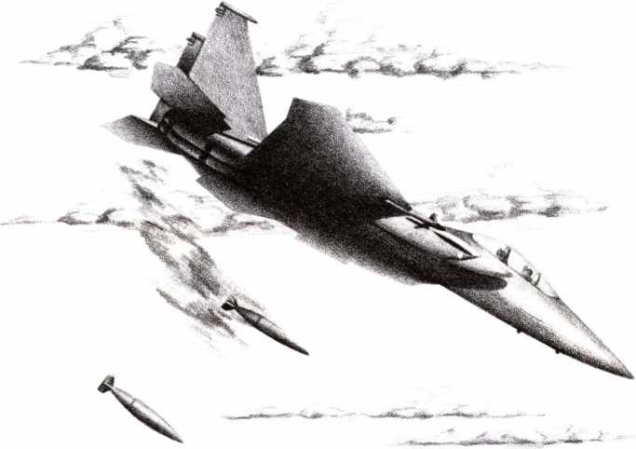

US-BUILT AIRCRAFT
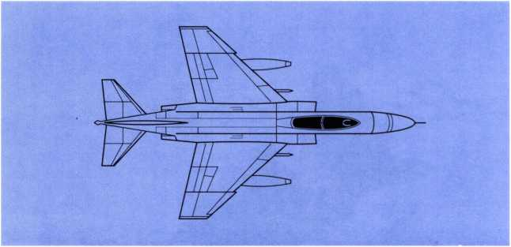

F-4E PHANTOM II
Serving the US Navy and Air Force as fighter and strike fighter throughout the 1960s and early 1970s, this old reliable is now obsolete and serves mainly for reconnaissance and electronic warfare (“Wild Weasel"). However, hundreds were sold to western nations worldwide, including Iran under the Shah. You can expect to encounter these flying patrols over the Persian Gulf.
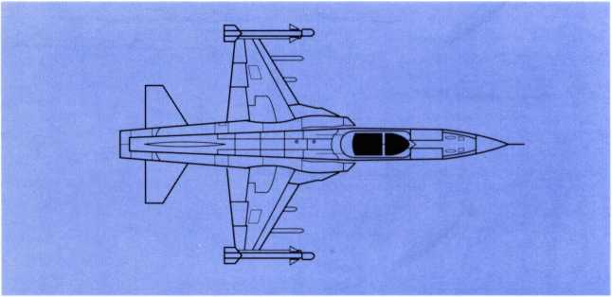

F-5E TIGER II
This inexpensive and unsophisticated fighter was never adopted by US combat arms, but has been widely sold abroad, including 138 to Iran. Underpowered, with poor avionics, it is useful only against obsolete opponents. It carries only short-range air-to-air weapons.
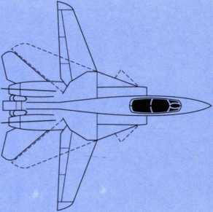

F-14D TOMCAT
This heavy, long-range interceptor has extremely powerful avionics for use with the AIM-54 Phoenix semi-active radar-homing missile, which has a 200 km effective range. The aircraft is the US Navy's long-range defender of carrier battle groups.
The swinging wings are computer-controlled for maximum performance but they signal the plane's energy state to the enemy. In 1987 the Navy began a program that upgraded the original TF30 engines with the newer, more powerful Fl 10s. About 80 TF30-engined F14s were supplied to Iran, but engine troubles, complexities in the avionics system, and the delicacy of the Phoenix missile have greatly reduced their military value. They are often used as radar-warning patrol aircraft.
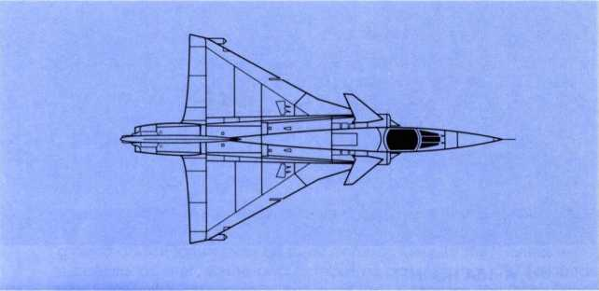

MIRAGE 3 NG
This large, powerful ground support/airsuperiority aircraft is based upon the famous French Mirage III series. This NG (new generation) version is the most advanced Mirage fighter to date. The prototype first flew in 1982 and was still in development in 1985.
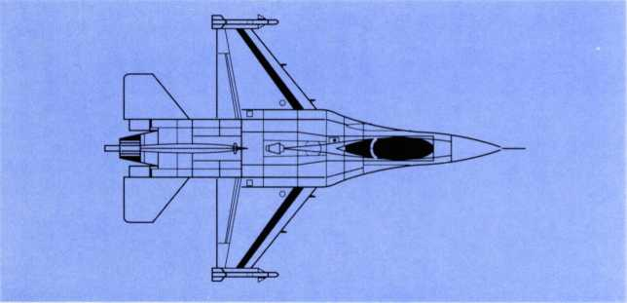

F-16C FALCON
The latest production fighter added to the US Air Force, the F-16 is the most maneuverable dogfighter in the world (with the possible exception of the MiG-29). The inherently unstable airframe that gives this agility would be unflyable except for the computerized electronic controls, hence its nickname "Electric Jet.”
Advanced air-ground avionics and anti-missile defenses are "extras," making the basic aircraft relatively cheap. Many western nations have purchased F-l6s. However, until the AIM-120 AMRAAM it had no long-range AAM.
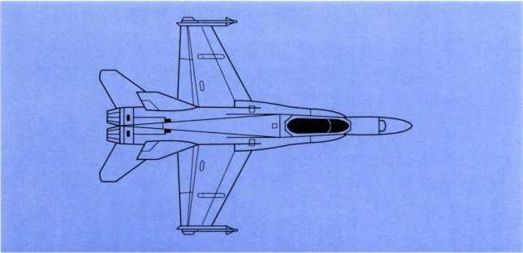

F/A-18A HORNET
Although not as maneuverable as the F-l6, this heavier multi-role fighter has numerous avionic and defensive aids built in. These were required by the US Navy, its main user, who needed an all-purpose fighter and attack bomber able to fire a variety of sophisticated weapons. Like the F-l6, it also is sold to various western nations.
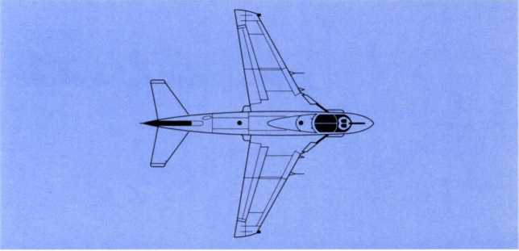

A-6E INTRUDER
Designed at the end of the 1950s as a low-level attack bomber for use in poor weather, this plane remains an unqualified success. Avionics and weapons have been rebuilt more than once to maintain the "state of the art," with upgrades under development.
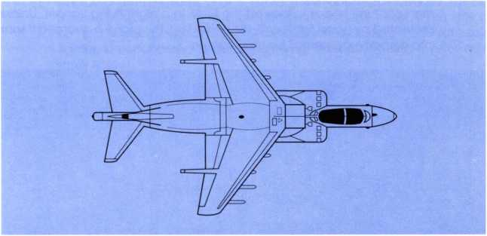

AV-8B HARRIER II
Originally designed as a strike fighter, the American-British co-redesign greatly enhanced maneuverability. Its avionics are designed for ground attack rather than air-to-air combat. Despite this. Harriers were successful as interceptors and combat air patrol in the 1982 Falklands war. The Harrier is the primary fighter of the US Marines, the British Royal Navy, and frontline squadrons of the British Royal Air Force (RAF) in Germany. Usually it uses short segments of roadway or a "ski-jump" deck for rolling takeoffs, and lands vertically, like a helicopter.
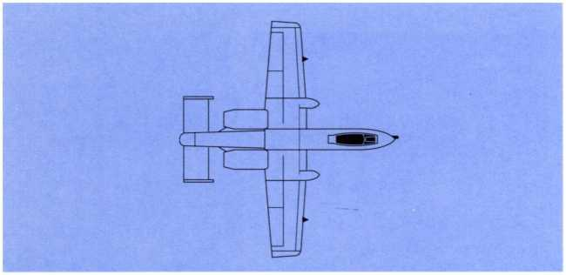

A-10A THUNDERBOLT II
This slow, heavily-armored plane was designed purely for frontline ground support with "tank busting" as its speciality. This role (unglamorous to the USAF), along with its peculiar appearance, earns it the unofficial nickname "Warthog."
Although intended for combat in Europe where low clouds and bad weather are frequent, the A-10 is a fair-weather day-only plane, but the manufacturer hopes to interest the USAF in a night-flying variant. Unless protected by good fighters (F-15s and F-16s), this plane is doomed if sent into airspace contested by USSR fighters.
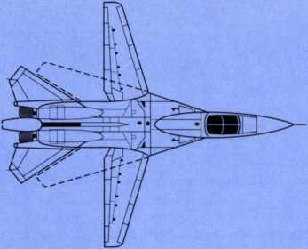

EF-111A RAVEN
This is a specially-built electronic warfare version of the F-l 11 strike and interdiction bomber. The original concept of the F-l 11 was a highspeed bomber for deep strikes at night or in bad weather. The EF-111 is popularly known as the "Electric Fox" or "Spark Vark" (the unofficial nickname of the F-l 11 is "Aardvark" or "Vark"). It is designed to accompany deep strike and interdiction missions, providing electronic screening and jamming. It is the fastest, most powerful such craft in the world.

SOVIET-BUILT AIRCRAFT
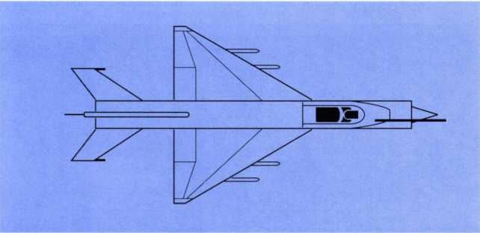

MIG-21 FISHBED
This agile, maneuverable, easy-flying fighter was the premier dogfighting plane of the 1960s and early 1970s. It has simple avionics and a standard armament of 2 or 4 AA-2s (now often replaced by AA-8s), making it inexpensive to buy, arm and maintain. However, it has little or no HUD, weak radars, and low-quality defenses, making it obsolete as a fighter. Unfortunately, its limited carrying capacity makes it poor as a strike fighter.
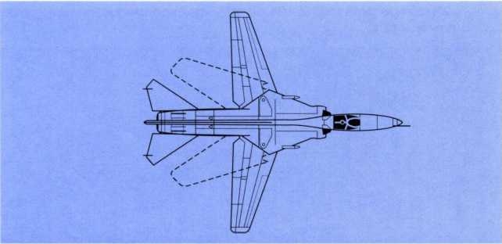

MIG-23 FLOGGER
This swing-wing fighter replacement for the MiG-21 originally had few avionics and a 22,485 lb. R-27 engine. This caused serious performance flaws, and the version sold abroad was unable to fire sophisticated weapons. The upgraded version, listed above, is still a mediocre performer. All versions commonly carry AA-2 and/or AA-8 missiles. Most USSR
and East European versions also use the AA-7 radar homing missile. With its MiG-27 brother, this plane has huge production runs, making it the cheapest fighter available today. This alone makes it one of the world's most popular aircraft.
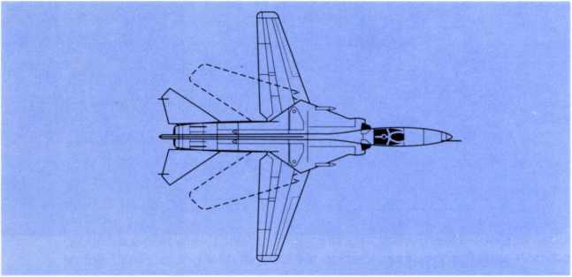

MIG-27 FLOGGER
This is the ground-attack variant of the MiG-23. In Russian frontline units it includes a laser designator for laser-guided munitions and simple terrain-avoidance radars for low-level attacks. Improved jammers and decoys are added as well. However, many sophisticated attack aids common on western strike fighters are not present. Presumably the MiG- 275 compensate for this with quantity, as huge production runs greatly lower its cost.
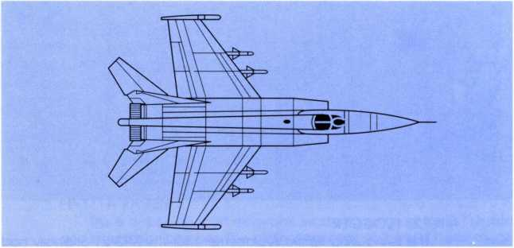

MIG-25 FOXBAT
This plane was originally designed to defend the distant borders of the USSR from air attack, working with special ground radars to attack enemy bombers with a special long-ranged AAM (the AA-6). It is ex
tremely fast, but quite unmaneuverable. A few are bought by client states for status reasons, but the reconnaissance version (MiG-25R) is more popular. It has an 88,000' ceiling, making it immune to normal SAM or fighter interception.
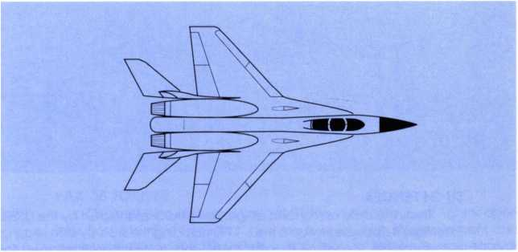

MIG-29 FULCRUM
Originally designed to outfight the F-15, this plane is a modern, lightweight dogfighter with superlative agility. It has engine power in excess of its weight. Common armament is AA-10 "fire and forget" radarhomers along with some AA-8 and/or AA-10 IR missiles. The degree of sophistication in the avionics is unknown, but unlikely to match western models. This MiG is considered the Russian equivalent of the F-l6,
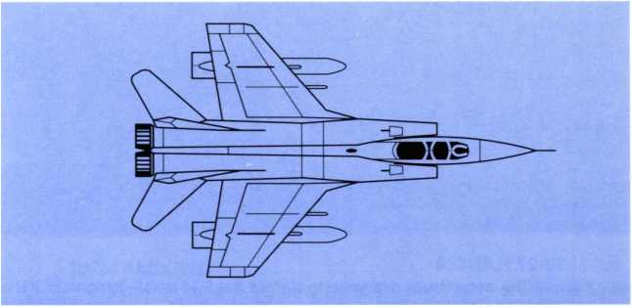

MIG-31 FOXHOUND
This aircraft is a redesigned MiG-25. Although slightly slower, it is improved in all other categories, especially low-altitude interceptions against planes and cruise missiles. The new AA-9 long-range missile is designed for look-down attacks on low-level cruise missiles. It also has AA- 8s and AA-lOs.
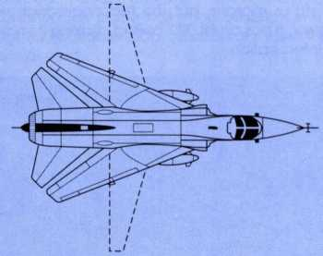

SU-24 FENCER
This is the most advanced air-ground attack plane built by the USSR. Externally it appears similar to the F-l 1T, including the side-by-side seating in the cockpit. However, its armament and avionics are designed for front-line and rear-area strikes into the teeth of enemy air defenses. Western air and ground commanders fear the Su-24 more than any other Soviet aircraft. The aircraft may carry a few AA-8s for self-defense, but it is not designed for air-to-air combat.
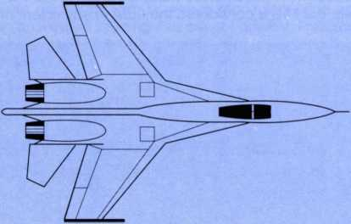

SU-27 FLANKER
This aircraft was designed to defeat the F-l4 and F-15 fighters. It is a large, powerful dogfighter whose usual armament is probably four AA-8 and four AA-10 missiles. In comparison to the MiG-29, the Su-27 is a larger, heavier plane. If its avionics and flight controls are truly modern, the Su- 27 may be the superior plane. However, in dogfighting maneuverability the MiG-29 and F-l 6 probably have the edge.
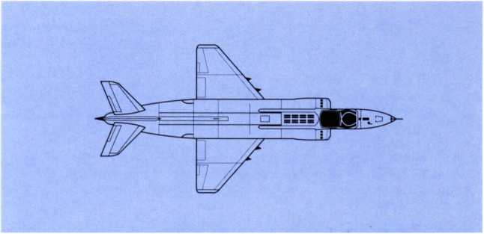

YAK-38 FORGER
Originally known as the Yak-36MP, this vertical take-off fighter operates from the Kiev-class aircraft carriers, which lack the equipment and deck space for conventional jets. Initially thought to be a Russian equivalent of the Harrier, the Yak-38 is considerably inferior. It has limited interception ability and very limited strike capacity. Until this plane, however, the Russian navy had nothing bigger than helicopters for its warships at sea.
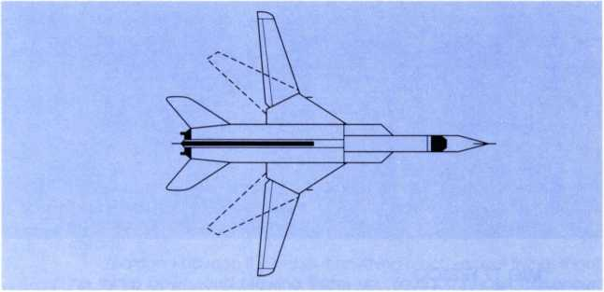

TU-26 BACKFIRE
Many of these swing-wing bombers are in service with the Soviet naval-air arm, carrying long-range missiles to attack hostile warships up to 3,000 kilometers out to sea. The Backfire's exceptionally long range and high speed, plus its powerful missiles make it a mortal threat to USN aircraft carriers. With aerial refueling it has sufficient range to get within cruise-missile-launch position of the USA. As a gesture to arms control, the USSR has removed air refueling equipment from its air force Backfires.
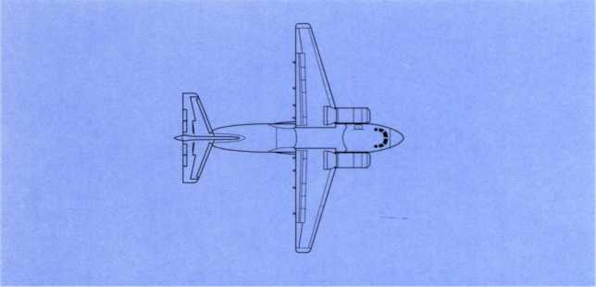

AN-72 COALER
This is the latest general-purpose medium air transport of the Soviet Union. Its jet engines and short-takeoff performance make it an outstanding utility craft for transporting all types of personnel and cargo between remote airfields.
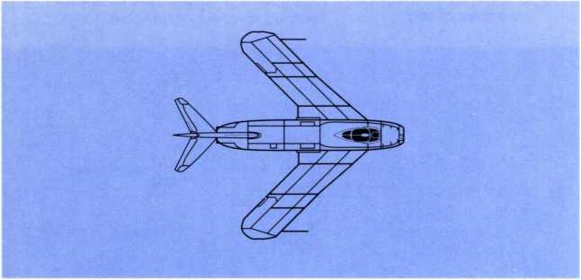

MIG 17 FRESCO
The MiG 17 represents the Soviet Union's first missile armed fighter/ interceptor. First seen in 1955 it was a major re-design of the MiG 15. While considered obsolete in 1965, it saw extensive action in the skies over Vietnam, where its performance against the more modern US fighters was admirable.

DESIGNER’S NOTES
Why We Did It
MicroProse Software became famous in 1984 for its classic combat flight simulator F-15 Strike Eagle. Since then we've done a host of fine games and simulations including Silent Service. Pirates!, Airborne Ranger. Gunship, Red Storm Rising, and most recently F-19 Stealth Fighter. Each of these games shows technological improvements over its predecessor. Since F-15 (our flagship product), we've come a tremendous long way.
The original F-15 was a phenomenal hit for us, and we think rightly so. It was the first combat flight simulator on the market to take itself seriously. It was not an arcade game, but a thoughtful attempt to give players the feeling they're flying real combat aircraft in a real combat environment. It was so successful that many other software houses quickly jumped on the bandwagon, hoping to create the same kind of sensation. We were — and continue to be — quite proud of F-15 Strike Eagle.
But we've come a long way since 1984. In fact if one were to compare the graphics of the original F-15 with those of F-19 it would be hard to tell they came from the same company. By today's standards, F-15 looks a bit ragged. The game is still a blast to play, but its appearance is five years behind.
So, near the end of 1988, Andy Hollis, one of our ace programmers, said that he'd like to see F-15 Strike Eagle updated to match the new graphic standards set by F-19. Why not, he reasoned, take the exciting game in F-15 and combine it with our new 3D graphics technology? It would give us a chance to make a complete circle and say, “Look — see what we've learned in five years."
A Fighter Pilot’s Dream
IF IT’S NOT FUN, IT WON’T BE DONE
F-15 Strike Eagle II is a player's game. We put everything in that is fun and left everything that's tedious or boring out. We tried to imagine what a fighter pilot would like most to have in his jet, and what parts of his job he'd most like to forget; we wanted realism only where realism is fun. So we gave you all the newest missiles, the newest targeting system, one of the fastest, most maneuverable fighters in the world, and placed it all in an action-packed arena where you can use this stuff— it's a fighter pilot's dream.
You don't have to think about anything much except flying, shooting things down, and blowing things up. You don't have to concern yourself with flight paths that won't disturb the enemy; they're already disturbed when you start playing. You just have to dogfight.
You don't have to think about guiding your missiles to the target — all your weapons are fire-and-forget. If a missile misses a target, well, there's nothing much you could have done anyway, except maybe waited longer to fire.
There's no hidden information — all you need to know is right in front of you on three CRTs on the console of the cockpit. If you're not feeling up to much competitive action, play at a lower difficulty level — the enemy pilots are still smart, just not as smart as you...perhaps. If you don't
want to bother landing the plane, the autopilot will land you perfectly every time. (In " Rookie mode" you don't even have to wait for this; when you get close to your friendly base a giant, invisible tractor beam reaches out and sets your plane lightly down on the runway.)
Don't think the game is unrealistic — it's not. All the weapons in the game exist (or are in production), and the fighter flies very much like a real F-15. The combat environment you choose when you pick a difficulty level is about as real as you'll find in any flight simulator anywhere. The only difference is that you don't have to deal with the dull parts. Only the fun parts of flying strike missions are in this game.
ACTION’S THE THING
In a word, the game is about ACTION. Where F-19\s “finesse in the air," F- 75 is "Rambo in the air." All the features of the game were designed with this single overriding concept in mind. The interface is simple to accommodate action. There's a limited number of keys, so when the action starts you don't have to think about which of 50 buttons to push, you just act. We made all the action-related keys mnemonic so an overlay would not be necessary.
In F-15, unlike most of our other games, there are exactly three preflight screens — then it's off to the MiG hunt. In "Rookie mode" you don't even have to take off to get into the action — when the game starts you are already flying toward your targets and are surrounded by enemy fighters. There are two ground targets that you must destroy to complete your mission, but the meat and potatoes of the game is air-to-air dueling. There is a constant cloud of enemy fighters flying around shooting missiles at you. And ground-based installations throw up a withering screen of missiles that you must dance to avoid.
The original F-15 Strike Eagle had seven scenarios that were setpiece situations. These were fun and exciting scenarios, but to fit in with the concept of the "fighter pilot's dream," we had to have more. In F-15 //you have a virtually unlimited number of scenarios — each mission you fly will be different from the last. Even if you happen to get the same primary and secondary targets, the enemy will come at you differently every time; the game therefore is endlessly replayable.
All in all, we are very proud of F-15 Strike Eagle II. It is a worthy successor to F-15 Strike Eagle.

Who Did It?
In projects as large as this, one numerous people are involved besides those in the screen credits. Many people give a passing opinion or two that the designer or programmer takes to heart and uses in the final game. In fact, it's reasonably accurate to say that everyone at MPS Labs had something to do with the way the game looks and acts. However, without the dedicated work of a few top-notch programmers and designers, projects like this would never get done.
In this case, the instigator was Andy Hollis. He was not the original designer of F-15 Strike Eagle but it was his favorite game for many years. After he wrapped up his work on F-19, in which he created the code for producing all that neat, highly-detailed 3D (incidentally, the new horizon, for those of you with 256-color graphics, was Andy's invention — looks real neat, huh?), he started clamoring to re-do F-15.
This caught the ears of company president Bill Stealey and original F-15 designer Sid Meier, who immediately saw the potential for such a project. Sid began to work on designing and programming the game almost at once, Soon there was enough excitement in the halls for the game to become a full-blown project, and in a few weeks we had something to work with.
Both Sid and Andy had worked on F-l9 Stealth Fighter and felt confident of producing a new, neat game, but to insure that, they solicited the help of some of the other F-19 crew. Game designer Bruce Shelley, who created the 3D databases for F-19, was called upon to make a couple of new 3D databases for the two new theaters: Vietnam and the Middle East. And Max (Maximum) Remington was again enlisted to make some new objects to place in the databases.
Veteran pixel ticklers (computer artists) Michael Haire and Murray Taylor were called in to furnish the start and end screen art and all the neat cockpit shots you see in the game. Barbara Bents got involved in the closing stages to round out the maps and some of the illustrations in this book.
Someone had to write the manual and I (Jeff Briggs) was asked to undertake that job. Along with Lawrence Shick, a most patient editor, and Iris Idokogi, a most talented artist, we were able to put the manual together in near record time.
Finally, the Quality Assurance people, led by Al Roireau, must be applauded for their dedicated service at tracking down and stomping out the inevitable bugs that software design seems to foster. The QA department here at MPS Labs deserves a lot of credit for the final product, 'cause they don't let it out before it's time.
We all hope you enjoy this game as much as we do. We hope you'll agree that it is a worthy successor to F-15 Strike Eagle.
The F-15 II Design Team
June 1989
Design and Programming
SID MEIER and ANDY HOLLIS
World Graphics and Databases
BRUCE SHELLEY with MAX REMINGTON
Computer Graphics
MICHAEL HAIRE, MURRAY TAYLOR, and MAX REMINGTON
Music and Sound
KEN LAGACE
Manual Text
JEFFERY L. BRIGGS
Print Media Director
IRIS IDOKOGI
Paper Graphics
BARBARA BENTS and IRIS IDOKOGI
Illustrations
MARCELL CIOLA
Layout
IRIS IDOKOGI and JACKIE ROSS
Quality Assurance
ALAN ROIREAU, CHRIS TAORMINO, and RUSS COONEY
Packaging Design
MARK CIOLA and JOHN EMORY
COPYRIGHT © 1989 BY MICROPROSE SOFTWARE, INC.,
ALL RIGHTS RESERVED
This Manual and the computer programs and audiovisuals on the accompanying floppy disks, which are described by this manual, are copyrighted and contain proprietary information belonging to MicroProse Software, Inc. No one may give or sell copies of this manual or the accompanying disks or of listings of the programs on the disks to any person or institution, except as provided for by the written agreement with MicroProse Software, Inc. No one may copy, photocopy, reproduce, translate this manual or reduce it to machine readable form, in whole or in part, without the prior written consent of MicroProse Software, Inc. Any person/persons reproducing any portion of this program, in any media, for any reason, shall be guilty of Copyright Violation, and shall be subject to civil liability at the discretion of the copyright holder.
LIMITED WARRANTY
Neither MicroProse Software, Inc., nor any dealer or distributor makes any warranty, express or implied, with respect to this manual, the disk or any related item, their quality, performance, merchantability, or fitness for any purpose. It is the responsibility solely of the purchaser to determine the suitability of the products for any purpose. Some states do not allow limitations on implied warranties or how long an implied warranty lasts, so the above limitation may not apply to you.
As a condition precedent to the warranty coverage provided below and to ensure identification, the original purchaser must complete and mail to MicroProse Software, Inc., 180 Lakefront Drive, Hunt Valley, Maryland 21030, within 30 days after purchase, the Registration/War- ranty card enclosed in this product. To the original purchaser only, MicroProse Software, Inc. warrants the media to be free from defects in material for 90 days. If during the first 90 days after purchase a defect in media should occur, the software may be returned to MicroProse Software, Inc., who will replace the media at no charge. If at any time after the initial 90 day period your media becomes defective, the media may be returned to MicroProse Software for replacement at a $10.00 service charge.
In no case will MicroProse Software, Inc. be held liable for direct, indirect or incidental damages resulting from any defect or omission in the manual, or other related items and processes, including, but not limited to, any interruption of service, loss of business, anticipated profit, or other consequential damages. Some states do not allow the exclusion or limitation of incidental or consequential damages, so the above limitation or exclusion may not apply to you.
This warranty gives you specific legal rights, and you may also have other rights which vary from state to state.
IMPORTANT: The preceding warranty does not apply if you make any unauthorized attempt to modify or duplicate the product, or if the product has been damaged by accident or abuse.

MicroProse Software, Inc.

180 Lakefront Drive, Hunt Valley,Maryland 21030
(301) 771-1151
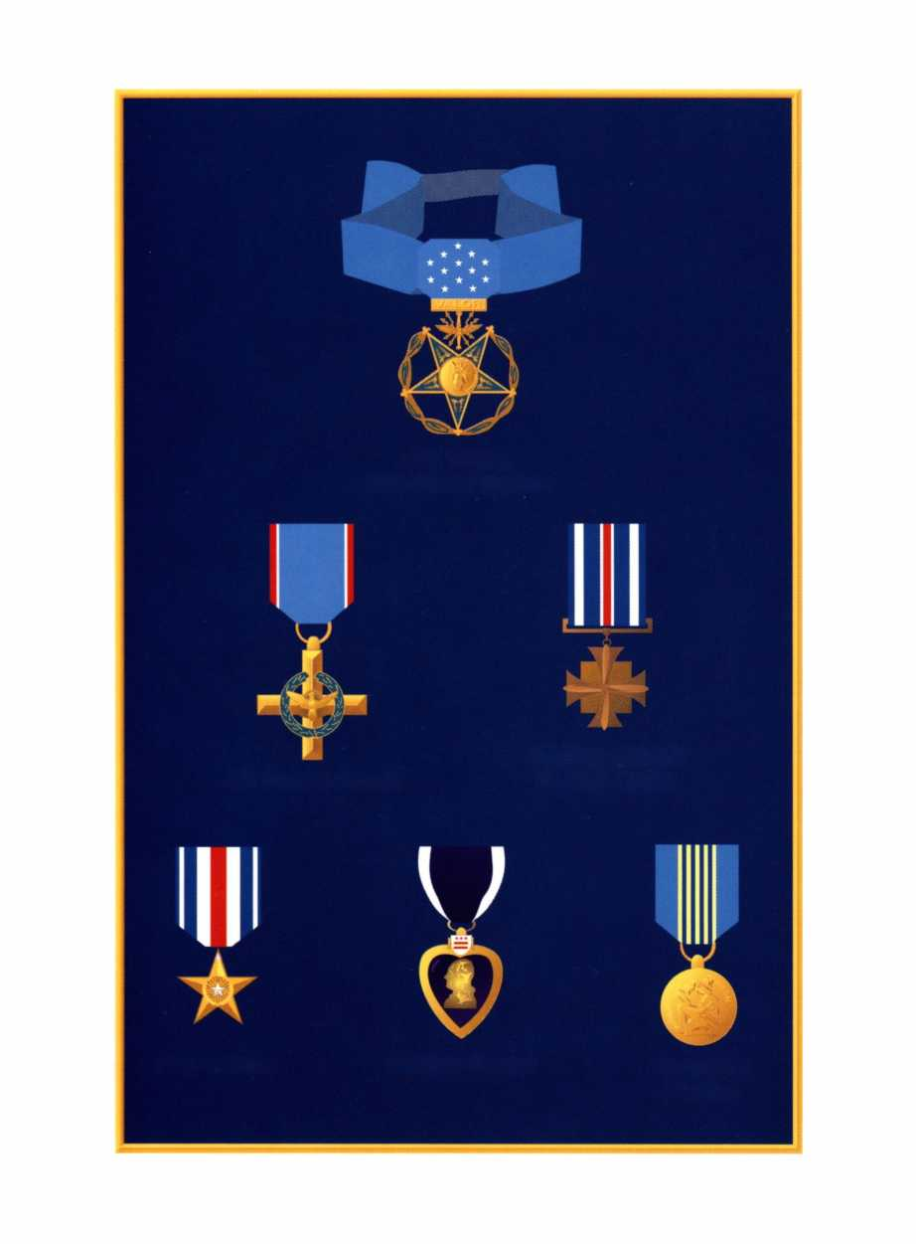
Air Force Cross
Silver Star
Purple Heart
Distinguished Flying Cross
Airman's Medal
Air Force Medal of Honor

180 Lakefront Drive, Hunt Valley, MD 21030 (301) 771-1151

