F-15 II HUD DISPLAY
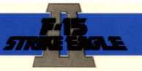
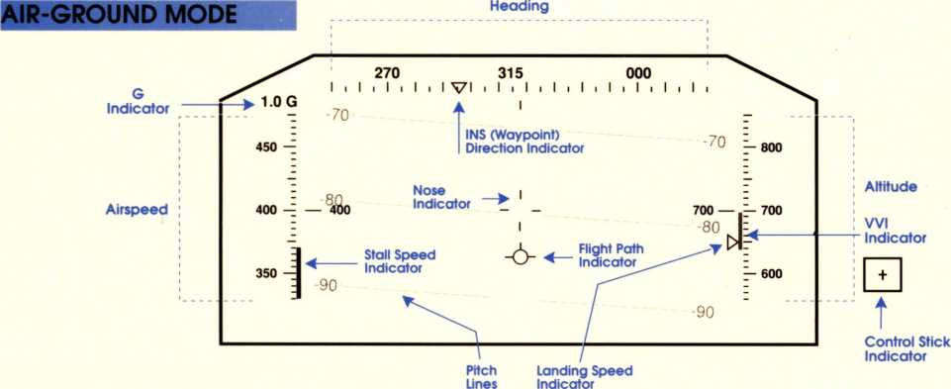
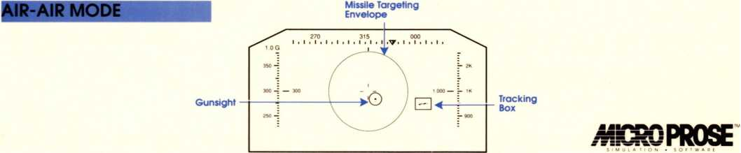

F-15 II KEYBOARD CONTROLS
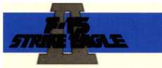
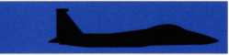

FLIGHT CONTROLS |  | VIEWS 'WHH
Increase Throttle | + | Return to Cockpit | Space
Decrease Throttle |  | Look Front | Fl
Maximum Power | Shift/ + Look Left |  | F2
No Power | Shift/- | Look Right | F3
Afterburner | A | Look Rear | F4
Eject | Esc | Slot View | F5
Landing Gear up/down | L | Chase Plane | F6
Brakes on/off | B | Side View | F7
Pilot, Automatic on/off | P | Missile View  Tactical View | F8  F9
WEAPONS and DEFENSES  Short-range Missile | S | Reverse Tactical View | F10
Medium-range Missile  Ground Attack Missile | M  G | Director mode on/off | D
Flare Release | F | ISIMULATION CONTROLS
Chaff Release | C | Accelerated Time fast/slow | Alt/A
Target Search | T | Boss, Hide Game | Alt/B
Fire Missile | Return | Detail Adjust | Alt/D
Fire Cannon | Backspace Keyboard sensitivity  Pause |  | Alt/K Alt/P
AVIONICS |  | Quit | Alt/Q
Waypoint Select | W | Re-supply | Alt/R
Radar Range | R | Joystick Re-center | Alt/J
Zoom Map | Z | Training | Alt/T
Expand Map | X | Volume Adjust | Alt/V

