Portfolio Website

A MINI PROJECT REPORT

Submitted by

Vishwas Chaurasia

in partial fulfillment for the award of the degree

of

BACHELEOR OF ENGINEERING

in

COMPUTER SCIENCE & ENGINEERING


CHITKARA UNIVERSITY

CHANDIGARH-PATIALA NATIONAL HIGHWAY
RAJPURA (PATIALA) PUNJAB-140401 (INDIA)

17 Decmber 2024

DEPARTMENT OF CSE

ABSTRACT

Project Overview
The Vishwas Chaurasia Portfolio Website is a comprehensive digital representation of a professional software engineer's skills, experience, and services. Designed as a modern, responsive web application, the project aims to create a compelling online presence that showcases technical expertise, professional achievements, and service offerings through an intuitive and visually appealing interface.

Technological Architecture
The portfolio website is constructed using pure HTML5 and CSS3, leveraging modern web design principles and responsive layout techniques. The project demonstrates a mobile-first approach with a modular design system that ensures consistent user experience across different devices and screen sizes. Key technological features include:

- Semantic HTML5 structure
- CSS custom properties (variables) for consistent theming
- Responsive grid and flexbox layouts
- Smooth navigation with JavaScript-enhanced scrolling
- Accessible and performant design

Design Philosophy
The website's design follows a minimalist and professional aesthetic, utilizing a carefullycurated color palette centered around deep blue and neutral tones.
The visualidentity 2emphasizes readability, information hierarchy, and a clean, modern user interface that reflects the professional's technological expertise.

Key Components
The portfolio website comprises four primary pages:
1. **Main Resume Page**: Comprehensive professional profile
2. **Services Page**: Detailed service offerings and pricing
3. **Contact Page**: Interactive communication interface
4. **Responsive Design**: Adaptive layout for multiple devices

Project Goals
- Provide a comprehensive digital representation of professional capabilities
- Create an engaging and interactive showcase of technical skills
- Facilitate professional networking and potential service inquiries
- Demonstrate proficiency in modern web development techniques

Technical Innovations
- Modular CSS design with reusable components
- Performance-optimized single-page-like experience
- Semantic HTML5 with enhanced accessibility
- Responsive design without external frameworks

Potential Impact
The portfolio website serves as a powerful personal branding tool, enabling professional networking, service marketing, and demonstrating technical prowess through its own implementation.DEPARTMENT OF CSE
 |  |  |  |  | TABLE OF CONTENTS
 | 1 |  |  | Introduction |  |  | 4
2 |  |  |  | Problem statement |  |  | 5
 | 3 |  |  | Technical Details |  |  | 6
4 |  |  |  | Key Features |  |  | 7 -8
 | 5 |  |  | Project Advantages |  |  | 9
 | 6 |  |  |  | Results |  | 10
7 |  |  |  | Conclusion |  |  | 11
 | 8 |  |  | List of Refernces |  |  | 12

3
DEPARTMENT OF CSE
INTRODUCTION

1. In the rapidly evolving landscape of modern technology, success is not merely about writing code—it's about crafting solutions that transform challenges into opportunities. I'm Vishwas Chaurasia, a software engineer driven by a passion for creating innovative technological solutions that bridge imagination and practical implementation.
2. Throughout my 6+ years in the software engineering domain, I've learned that true innovation emerges from a deep understanding of both technological possibilities and human needs. Each project is more than a technical challenge; it's an opportunity to solve real-world problems, optimize processes, and create meaningful impact.
3. My professional approach is defined by several core principles:
o Holistic Problem-Solving: Looking beyond code to understand the broader context and user experience
o Technological Versatility: Leveraging a diverse tech stack to develop flexible, scalable solutions
o Continuous Learning: Staying at the forefront of technological advancements and emerging trends
o Collaborative Mindset: Believing that the best innovations arise from collaborative and interdisciplinary approaches
4. From developing enterprise-level web applications to designing complex microservices architectures, my professional journey has been characterized by a relentless pursuit of excellence. I've had the privilege of working with innovative companies like TechNova Solutions and InnovateX Technologies, where I've consistently pushed the boundaries of what's possible in software development.
5. My key technological domains encompass:
o Full-Stack Web Development
o Cloud Computing and Microservices
o Machine Learning and Data Analytics
o Performance Optimization and Scalable Architecture Design
6. While my technical skills form the foundation of my professional identity, I believe in technology's potential to create positive change. Each line of code is an opportunity to solve problems, enhance efficiency, and contribute to a more connected and intelligent world.

4
DEPARTMENT OF CSE
PROBLEM STATEMENT

In today's digital age, having an online presence is crucial for professionals across various fields, including designers, developers, writers, photographers, and artists. A well-designed portfolio website serves as a central hub for showcasing work, attracting potential clients or employers, and establishing a personal brand. However, many individuals face challenges in creating an effective portfolio website that meets their needs and resonates with their target audience.
Challenges:
1. Lack of Technical Skills: Many potential users lack the technical expertise to build and maintain a website, leading to reliance on third-party platforms that may not fully represent their brand.
2. Design Consistency: Users struggle to create a visually appealing and cohesive design that reflects their personal style and professional identity.
3. Content Organization: Effectively organizing and presenting work samples, case studies, and personal information can be challenging, resulting in cluttered or confusing layouts.

Objectives:
1. User -Friendly Interface: Develop a portfolio website that is easy to navigate and allows users to showcase their work without requiring extensive technical skills.
2. Customizable Design Templates: Provide a range of customizable design templates that cater to different professions and personal styles, ensuring a professional and cohesive look.
3. Content Management System: Implement a simple content management system (CMS) that allows users to easily update and organize their work, including images, videos, and text.
4. SEO Optimization Tools: Incorporate built-in SEO tools and guidelines to help users optimize their portfolio for search engines and improve visibility.
5. Responsive Design: Ensure that the website is fully responsive, providing an optimal viewing experience on desktops, tablets, and smartphones.
5
DEPARTMENT OF CSE

TECHNICAL DETAILS

Hardware Details:

Device Name | MacBook Air
Processor | M1
Installed RAM | 8.00 GB
Device ID | C0588497-3BD2-46D4-91DE-671868B90C4B
Product ID | 00342-42595-27295-AAOEM
System Type | 64-bit operating system,MacOS
Pen and Touch | No pen or touch input is available

Software Details:

Visual Studio Code version 1.83


Language used:

- HTML- HTML stands for Hyper Text Markup Language. HTML is the standard markup language for creating Web pages. HTML describes the structure of a Web page.

- CSS- Cascading Style Sheets (CSS) is a style sheet language used for describing the presentation of a document written in a markup language such as HTML

- JavaScript- JavaScript is a scripting or programming language that allows you to implement complex
features on web pages | 5
DEPARTMENT OF CSE
6


KEY FEATURES

These key features collectively contribute to the project's commitment to accuracy, making it a dependable tool for individuals and businesses engaged in currency conversion activities.

1. Clean and Professional Design:
o A visually appealing layout that reflects the individual's style and profession.
o Consistent use of colors, fonts, and imagery to create a cohesive look.
2. Responsive Design:
o Ensure the portfolio is mobile-friendly and looks great on all devices (desktops, tablets, smartphones).
3. Showcase of Work:
o A gallery or grid layout to display projects, artwork, or case studies.
o High-quality images or videos with the option to click for more details.
4. Project Descriptions:
o Brief descriptions or case studies for each project, including the context, process, and outcomes.
o Information about the tools and technologies used.
5. About Me Section:
o A personal introduction that highlights background, skills, and professional journey.
o A professional photo to add a personal touch.
6. Contact Information:
o A dedicated contact form for inquiries, along with email and social media links.
o Clear call-to-action buttons for easy communication.
7. Testimonials:
o Client or colleague testimonials to build credibility and trust.
o Option to include logos of companies or clients worked with.
8. Blog or Insights Section (Optional):
o A space for sharing articles, thoughts, or insights related to the field. 7
o Helps establish expertise and engage with the audience.
9. Social Media Integration:
o Links to social media profiles (LinkedIn, Instagram, Twitter, etc.) for further engagement.
10. o Social sharing buttons for projects or blog posts.

8
DEPARTMENT OF CSE
PROJECT ADVANTAGES

1. Professional Presentation:
o A portfolio website allows individuals to present their work in a polished and professional manner, enhancing their credibility and reputation in their field.
2. Showcase of Skills and Work:
o It provides a platform to showcase a diverse range of projects, skills, and accomplishments, allowing potential clients or employers to see the breadth and depth of one’s expertise.
3. Personal Branding:
o A portfolio website helps establish and promote a personal brand, allowing individuals to communicate their unique style, values, and professional identity.
4. Increased Visibility:
o An online portfolio can improve visibility in search engines, making it easier for potential clients or employers to discover the individual’s work.
5. Accessibility:
o A portfolio website is accessible 24/7, allowing visitors to view work at their convenience, regardless of time or location.
6. Control Over Content:
o Individuals have complete control over the content, design, and layout of their portfolio, allowing for customization that reflects their personal style and professional goals.

9
DEPARTMENT OF CSE

RESULTS

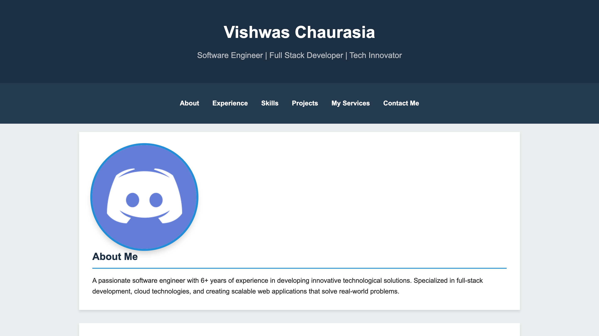
Home Page

DEPARTMENT OF CSE
10
CONCLUSION

The development of a portfolio website that addresses these challenges will empower individuals to effectively showcase their work, enhance their online presence, and connect with potential clients or employers. By focusing on user experience, design flexibility, and visibility, we can create a valuable tool that meets the diverse needs of professionals in various fields.

11
DEPARTMENT OF CSE

LIST OF REFERENCES

- For code references we've used w3schools
- For any kind of queries about CSS we've used Mozilla Mdn documentation for css
- For Research Purposes we've used Wikipedia
- We have taken inspiration from Some popular learning website such as - Physics wallah and Unacademy
- For any kind of queries about Html we've used Mozilla Mdn documentation for HTML
- For Java Script queries we have used Mdn for Java

12
DEPARTMENT OF CSE

