Maglev Stabilization Layer for Dual-PTEC Drive Systems
White Paper Proof of Concept for Centering, Damping, and Transition Control
Document Type | Concept white paper / stabilization proof of concept
Concept Thesis | Use dual rotating PTECs to generate momentum geometry and a separate maglev-derived layer to stabilize, center, and damp the drive stack.
Primary Use | Alignment control, oscillation suppression, transition smoothing, and vector-state discipline
Status | High-level control architecture draft
Abstract
This proof of concept frames maglev not as the main propulsion mechanism for a dual-PTEC system, but as the stabilization layer that makes paired rotating field cores usable. In this architecture, two rotating PTEC units establish the main momentum geometry, directional bias, or field state, while a lower maglev-derived trim layer provides centering, damping, stance correction, and transition smoothing. The result is a cleaner control stack: motion state is generated by the PTEC pair, and motion discipline is maintained by the stabilization layer beneath it.
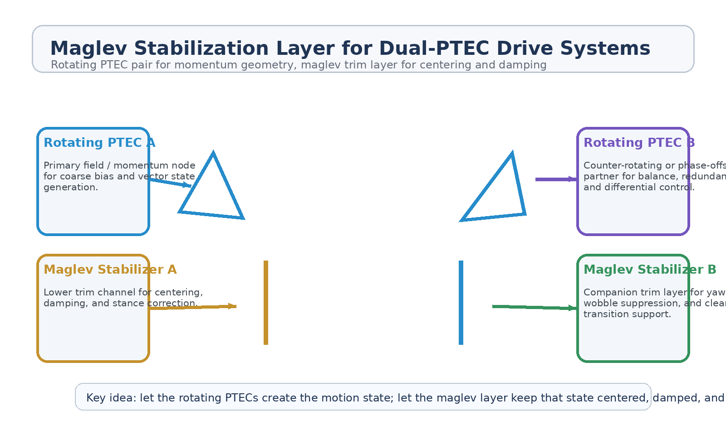
Figure 1. Dual-PTEC pair above maglev stabilization channels for centered, damped, transition-safe operation.
1. Concept Thesis
The central claim is modest and coherent: dual rotating PTEC elements can create useful momentum geometry, but that geometry becomes much more practical when a distinct stabilization layer keeps the stack centered, damped, and aligned. This mirrors the logic already present in guided maglev environments, where the most believable role of the field system is not miracle propulsion but disciplined capture, trim, and low-disturbance control.
Put simply, the upper pair creates motion state. The lower layer prevents that state from becoming noise.
2. Why the Maglev Layer Matters
• Suppresses wobble, drift, and yaw introduced by paired rotating field cores.
• Provides centering and stance correction during phase or vector transitions.
• Improves control authority during pulse-mode operation, heavy load states, or asymmetrical discharge.
• Reduces dependence on purely geometric balancing inside the dual-PTEC pair.
• Creates a cleaner handoff between field generation and external vector or exhaust stages.
3. System Architecture
Layer | Subsystem | Primary Function | Expected Effect
L1 | Dual Rotating PTECs | Generate field energy, momentum geometry, and coarse vector state. | Primary motion bias
L2 | Phase/Pair Control | Run matched, opposed, or offset states between the two cores. | Differential control
L3 | Maglev Stabilization Layer | Apply centering, damping, and trim beneath the active stack. | Motion discipline
L4 | Vector / Coupling Stage | Hand off stabilized state to exhaust, pulse release, or external field interaction. | Usable output
L5 | Protected Frame | Maintain structural alignment and reduce transition shock into the craft or carriage. | Lower disturbance

3.1 Upper Dual-PTEC Pair
The upper pair is strongest when treated as the source of momentum geometry and coarse vector authority. As earlier dual-chamber and pulse-drive concepts suggest, paired rotating cores provide more options than a single core: matched operation for throughput, opposed operation for stabilization, and phase-offset operation for differential bias. Those are useful, but they also create transition complexity that benefits from a separate stabilization layer.
3.2 Lower Maglev Trim Layer
The lower maglev-derived channels should be interpreted as trim and stabilization rails, not as the main free-space propulsion mechanism. Their conceptual role is to keep the drive stack centered, suppress oscillation, correct stance, and provide low-disturbance correction during vector changes or pulse release. This is the same reason maglev is convincing in guided transport: it excels at capture, centering, and smooth control inside an ordered geometry.
3.3 Hand-off to Output
Once the upper pair has established a usable motion state and the lower layer has stabilized it, the system can hand that condition to a true output stage such as a nozzle, pulse manifold, exhaust channel, or external coupling path. This separation keeps the architecture ambitious but honest: internal fields do not need to do every job at once.
4. Operational Modes
Mode | PTEC Behavior | Maglev Behavior | Result
Matched Rotation | Both cores run in aligned state. | Trim layer holds center and reduces build-up wobble. | Stable high-throughput state
Opposed Rotation | Cores counter-rotate for internal balance. | Maglev layer suppresses residual drift. | Lower net disturbance
Phase Offset | One core leads or lags for differential bias. | Maglev trim smooths transition and handoff jerk. | Cleaner steering / vector shift
Pulse Transition | Upper pair prepares a burst or rapid state change. | Lower layer damps shock and recenters after release. | Better control during impulse events

5. Why This Architecture Is Stronger
• Separates motion generation from motion discipline.
• Lets the dual-PTEC pair do the dramatic field work while the maglev layer keeps it usable.
• Reduces oscillation and transition penalties in compact drive stacks.
• Creates a clearer pathway from internal field logic to measurable external output stages.
• Fits earlier spine and guideway logic in which maglev-style systems are most believable as stabilizers and controllers.
6. Boundaries and Realism
This concept is strongest as a stabilization and control architecture. It should not be oversold as proof that maglev alone propels a craft in free space. Its more credible role is to center, damp, and discipline the state produced by the upper drive pair. That interpretation is also the most useful one because it gives each subsystem a clear job rather than asking one field stack to explain everything.
• Maglev here is a trim and damping layer, not the primary propulsion claim.
• The dual-PTEC pair remains responsible for coarse momentum geometry and vector state.
• Real translation still depends on an external reaction path or explicit coupling mechanism.
• The strongest contribution of the maglev layer is stability, not miracle thrust.
7. Proof-of-Concept Build Path
Phase | Goal | Bench / Program Activity | Success Signal
P1 | Upper-pair baseline | Characterize wobble, drift, and transition behavior from a dual rotating mockup without the trim layer. | Baseline disturbance profile
P2 | Maglev trim addition | Add lower centering and damping channels beneath the dual-core test rig. | Improved centering
P3 | Transition smoothing | Run matched, opposed, and phase-offset state changes with the trim layer active. | Reduced jerk and faster settling
P4 | Output handoff | Couple the stabilized stack to a simple vector/output surrogate. | Cleaner handoff to output stage
P5 | Comparative review | Compare with and without maglev stabilization under asymmetric load or pulse changes. | Clear control advantage

8. Conclusion
Maglev Stabilization Layer for Dual-PTEC Drive Systems is a cleaner and more believable architecture than asking one field stack to do everything. The upper pair creates the motion state. The lower layer keeps that state centered, damped, and stable enough to use. This makes the overall system easier to interpret as a control stack and gives a clearer boundary between internal field geometry and any later propulsion or vectoring claim.
As a white paper PoC, the concept is strongest when treated as the part of the machine that keeps the dramatic part from tearing itself loose.
Working one-line doctrine: Let the dual PTECs create the motion state; let the maglev layer keep that state centered, damped, and stable enough to use.

