Dual PTEC Precision Material Processing
Non-Operational White Paper PoC for Mining, Cutting, and Precision Material Ablation
Document Type | Non-operational industrial materials-processing proof-of-concept white paper
Concept Thesis | Use dual spinning PTECs as a resonance core and shared corridor-forming system for a precision material-processing beam, with CPSS acting as the conditioning backbone.
Primary Use | Mining, cutting, boring, precision ablation, and non-contact industrial material weakening
Status | Concept architecture draft; non-operational and non-buildable framing
Abstract
This proof of concept frames a dual-PTEC system as the resonance core of an industrial beam tool rather than as a conventional optical laser. Two spinning or counter-oscillating PTECs define a stabilized energy corridor, a CPSS layer conditions and smooths the power environment behind the system, and a shared beam path feeds an aperture or lens stage that turns the corridor into a controllable material-processing output. The strongest use cases are precision mining, cutting, boring, and non-contact ablation in difficult environments. This document is intentionally non-operational: it describes architectural roles, boundaries, and testable conceptual interfaces without providing construction instructions or actionable hazardous-device detail.
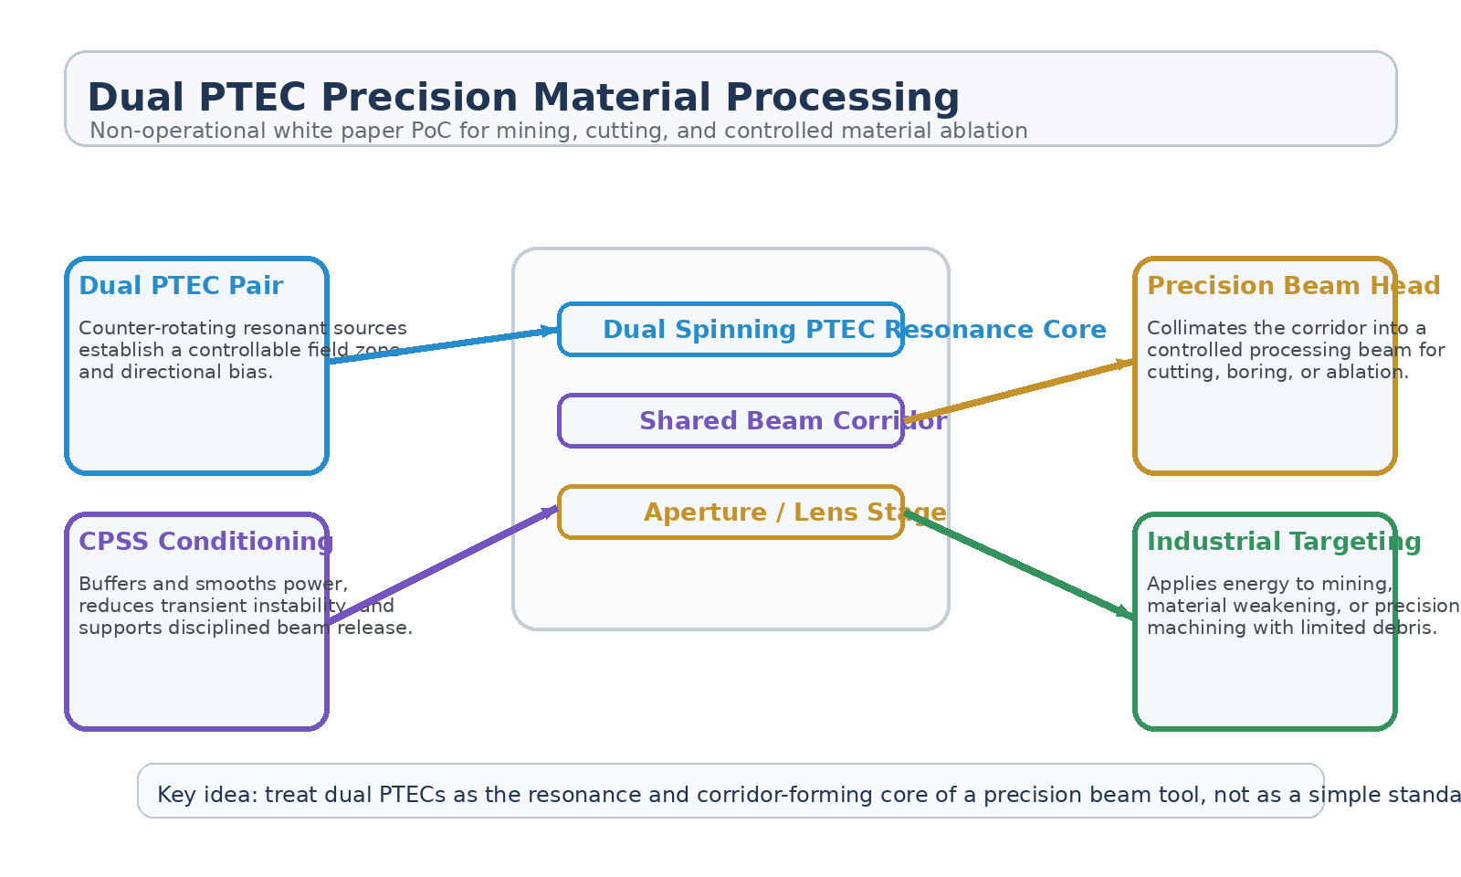
Figure 1. High-level dual-PTEC materials-processing architecture with resonance core, shared beam corridor, CPSS conditioning, and precision beam head.
1. Concept Thesis
The central idea is to reinterpret dual spinning PTECs as a controlled resonance and corridor-forming system for industrial energy delivery. A single energetic source tends to create a contained or recirculating field. A paired source architecture can instead bias a shared axis, creating a more useful corridor for shaping, collimating, and directing energy into a target-facing beam head.
That makes the concept more coherent as a precision beam tool than as a simple 'laser' claim. The system is better understood as a field-collimated materials-processing emitter.
2. Why the Source Concepts Fit Together
The LEVITATION-X mining concept already frames dual PTECs as the heart of a non-contact mining and material-disintegration platform, using a shared energy path, plasma support, and directional release idea.
The Dual Resonant Launch Chamber note supports the corridor logic behind that claim: two PTECs can form a shared guided axis whose job is to produce directional rather than purely contained behavior.
The CPSS brief adds the most credible support layer for power smoothing, transient handling, and adaptive delivery behind the resonant core.
3. System Architecture
Layer | Subsystem | Primary Function | Role
L1 | Dual PTEC Pair | Create the resonance core and directional bias around a shared axis. | Corridor-forming source
L2 | Shared Beam Corridor | Carry stabilized energy through a guided path between source and output stage. | Controlled channel
L3 | CPSS Conditioning Layer | Buffer, smooth, and discipline power delivery behind the beam system. | Stability backbone
L4 | Aperture / Lens Stage | Collimate and tune the output for target-facing processing. | Precision shaping
L5 | Industrial Target Interface | Apply energy to rock, ore, crust, or material stock in a controlled way. | Work surface

3.1 Dual Resonance Core
The paired PTECs are most useful when treated as a resonance core rather than as two independent emitters. Their job is to create a controllable shared zone that can be biased, stabilized, and routed into a useful axis for materials processing.
3.2 Shared Corridor
The corridor is the architectural upgrade. Instead of allowing the energetic state to remain diffuse or purely internal, the system feeds a common path that becomes the basis for shaping a processing beam. This is consistent with the earlier corridor logic used in the launch-chamber concept.
3.3 CPSS Backing Layer
CPSS is strongest here as a conditioning and reserve layer. Its conceptual value is in smoothing transient delivery, buffering irregular input, and helping the overall beam system behave like a disciplined industrial tool rather than an unstable burst source.
4. Most Credible Use Cases
• Orbital or remote mining in environments where physical contact is difficult.
• Precision boring, trenching, or localized crust weakening.
• Non-contact cutting or ablation of engineered materials.
• Material surface conditioning where minimal kinetic debris is preferred.
• Drone-mounted or fixed industrial processing heads for harsh environments.
5. Why This Is Better Than Calling It 'Just a Laser'
• The architecture depends on paired field sources and a corridor, not only an optical emitter.
• CPSS contributes as a systems-level stability layer rather than as the beam itself.
• The concept is strongest in industrial processing roles, not in simple handheld-laser metaphors.
• The beam head can be framed as a target-coupled machining interface instead of a generic light source.
6. Boundaries and Realism
This paper intentionally avoids operational or buildable device detail. The concept should not be oversold as a complete working laser design, a deployable weapon, or an immediately practical hazardous machine. Its strongest value is as a non-operational systems concept for how dual resonant sources, a conditioned corridor, and a precision output stage might be packaged into an industrial materials-processing framework.
• Best understood as a non-operational industrial PoC, not as a build guide.
• Most coherent for mining, cutting, and ablation framing rather than weapon framing.
• Real performance would still depend on corridor stability, thermal limits, and target coupling.
• The paired source architecture is the key conceptual contribution, not any one standalone emitter claim.
7. Proof-of-Concept Build Path
Phase | Goal | Bench / Program Activity | Success Signal
P1 | Resonance baseline | Demonstrate a stable paired-source zone and repeatable corridor behavior in a safe surrogate setup. | Repeatable corridor state
P2 | Conditioning integration | Add CPSS-like smoothing and compare stability against an unconditioned baseline. | Cleaner delivery behavior
P3 | Output shaping demo | Test a non-hazardous aperture or lens surrogate for spot control and corridor-fed alignment. | Improved shaping
P4 | Material-coupling study | Use inert or simulated targets to evaluate localized energy application at a concept level. | Controlled target response
P5 | Industrial packaging review | Evaluate corridor source, conditioning, and output head as one systems package. | Coherent tool architecture

8. Conclusion
Dual PTEC Precision Material Processing is most coherent when treated as a non-operational industrial systems concept. Dual spinning PTECs define the resonance core, the shared corridor turns that energy into a usable directed path, CPSS stabilizes the environment behind the system, and the output head applies the result to controlled material processing.
As a white paper PoC, the concept works best as a framework for precision mining, cutting, and ablation under harsh or remote conditions, while staying short of any operational build detail.
Working one-line doctrine: Treat dual PTECs as the resonance core of a precision beam tool, not as a simple standalone laser claim.

