Comms 3: Oscillation-Locked Plasma Relay Network
Global Secure Transport Concept with Encrypted Payload and Waveform-Locked Delivery
Document Type | Proof-of-concept white paper
Concept Thesis | Add a transport-layer security model in which oscillation-shaped plasma waveforms determine who can stay synchronized enough to recover the encrypted payload.
Primary Use | Secure long-range relay networking, trusted remote delivery, and layered channel discrimination
Status | Comms v3 architecture draft
Abstract
Comms 3 extends the earlier plasma-communications framework by treating oscillation not merely as a modulation trick, but as a transport-layer gatekeeper. The payload remains conventionally encrypted, but delivery also depends on the receiver’s ability to stay synchronized with a moving oscillation profile carried by the plasma or hybrid relay channel. This adds a second security layer: not only must the payload be decrypted, the carrier itself must be followed correctly. The result is a secure relay concept in which trusted remote delivery depends on message encryption, waveform behavior, live synchronization, and endpoint trust all at once.
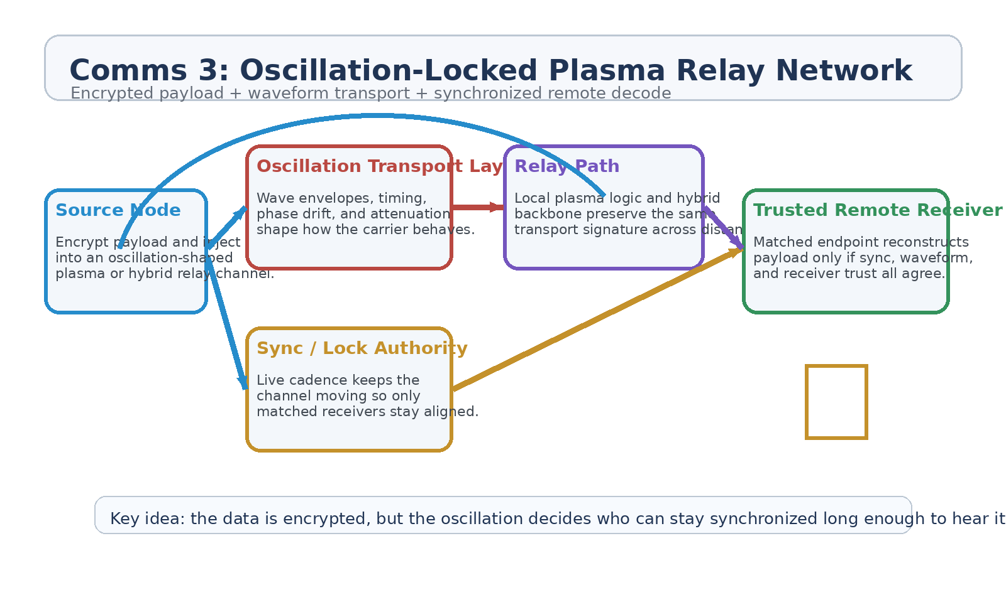
Figure 1. Comms 3 architecture with source encryption, oscillation transport, sync authority, relay path, and trusted remote receiver.
1. Concept Thesis
The essential upgrade in Comms 3 is the separation of message security from transport security. In ordinary secure systems, the payload is encrypted and the network merely carries it. In this architecture, the network contributes a second gate: the waveform transport itself moves in a way that must be tracked correctly for the signal to become usable.
In plain terms, the data is encrypted, but the oscillation decides who can stay synchronized long enough to hear it.
2. Core Security Layers
• Payload encryption protects the readable message contents.
• Oscillation-shaped transport hides the carrier inside moving timing, phase, and attenuation behavior.
• Live synchronization authority keeps the transport pattern changing over time.
• Trusted receiver logic or lattice-like endpoint trust decides whether the remote terminal can resolve the recovered signal into useful information.
3. Why Oscillation Transport Matters
Oscillation in this concept is broader than everyday sound. It refers to wave-envelope behavior: phase drift, timing cadence, amplitude motion, attenuation shaping, and transport signatures carried through a plasma-local node or preserved across a hybrid relay backbone. A receiver can know the key and still fail if it cannot stay aligned to the moving waveform state.
• The carrier becomes harder to interpret when captured out of phase or out of cadence.
• Transport-layer gating reduces the value of raw signal interception.
• Remote nodes can be selective: only receivers that stay in lock recover a coherent stream.
• The result is stronger channel discrimination than static encrypted traffic alone.
4. Layered Architecture
Layer | Subsystem | Primary Function | Security Role
L1 | Source Encryption | Encrypts the message payload before transport begins. | Protects readable contents
L2 | Oscillation Transport Layer | Shapes phase, timing, attenuation, and envelope behavior of the carrier. | Gates transport-level comprehension
L3 | Sync / Lock Authority | Maintains live cadence and changing transport state. | Breaks static interception assumptions
L4 | Hybrid Relay Path | Preserves transport signature across local plasma nodes and longer-range backbone segments. | Extends trusted delivery across distance
L5 | Trusted Remote Receiver | Reconstructs payload only if sync, waveform, and trust conditions all match. | Acts as the final access boundary

4.1 Source and Relay Logic
The source node does not merely send encrypted traffic. It injects the traffic into an oscillation-shaped channel whose transport behavior is itself meaningful. Relay nodes do not need to understand the payload, but they must preserve the transport profile closely enough that the trusted receiver can remain locked.
4.2 Trusted Remote Delivery
The remote endpoint only succeeds when multiple conditions agree: the payload key must be valid, the oscillation profile must still be trackable, the lock authority must remain in cadence, and the receiver must qualify as a trusted sink. This means interception alone is not equivalent to comprehension.
5. Defensive Value
• Harder passive interception because signal capture does not guarantee waveform recovery.
• Harder spoofing because false nodes must imitate both payload and live transport behavior.
• Improved receiver discrimination in crowded or contested network environments.
• Better segmentation for private internal meshes, enclave channels, and global relay paths.
6. Proof-of-Concept Build Path
Phase | Goal | Bench Activity | Success Signal
P1 | Encrypted baseline | Establish ordinary encrypted transport between two nodes. | Stable baseline secure channel
P2 | Oscillation transport | Add phase/timing/envelope shaping to the carrier and measure whether aligned receivers recover the stream more reliably than misaligned ones. | Transport-level discrimination
P3 | Sync authority | Introduce live cadence changes so the channel mutates over time. | Receivers retain lock while outsiders drift
P4 | Remote relay | Pass the signal through a relay segment that preserves oscillation signature across distance. | End-to-end lock continuity
P5 | Trusted receiver test | Require the endpoint to satisfy sync and trust conditions before payload reconstruction. | Capture no longer equals comprehension

7. Measurements
• Aligned versus misaligned receiver recovery rate.
• Signal usefulness after passive capture without transport lock.
• Lock retention under live cadence mutation.
• Relay fidelity across long-distance or multi-hop segments.
• False-accept and false-recover rates at the remote receiver.
• Spoof and replay resistance compared with payload-only encryption.
8. Boundaries and Realism
Comms 3 is strongest as a layered transport-security doctrine, not as a claim that plasma alone physically carries all global communications. The more realistic version is a hybrid network: plasma-local or field-aware nodes define the secure transport behavior, while longer-range relay backbones preserve that logic across distance. The innovation is in the transport signature and synchronization model, not in pretending one medium does everything.
• Oscillation transport adds a second security layer but does not replace payload encryption.
• Remote relay paths should preserve waveform logic even if the medium changes.
• Trusted receiver logic remains necessary if the goal is selective reconstruction rather than simple delivery.
• The architecture is most credible as a hybrid relay network with strong local control and disciplined long-range handoff.
9. Conclusion
Comms 3 turns the plasma-network idea into a stronger global or distributed relay concept by making the transport layer itself part of the trust model. A remote node does not merely decrypt a packet. It has to remain synchronized with a moving carrier profile long enough to reconstruct the traffic coherently.
That makes the network more selective, more resistant to blind capture, and better suited to GhostCore-style secure delivery where knowing the key is not enough if you cannot keep pace with the waveform.
Working one-line doctrine: The payload is encrypted, but the oscillation decides who can stay synchronized long enough to hear it.

