SEEKS
Seamless Electro Estatic Kinetic Seeker — Defensive Relay and Detection Drone PoC
Document Type | Defensive proof-of-concept white paper
Concept Thesis | Use a forward stabilized sensing head and relay stack to make the drone a real-time detection, tracking, and protected-communications node.
Primary Use | Perimeter reconnaissance, early warning, deconfliction, escort support, and mesh extension
Status | High-level defensive drone architecture draft
Abstract
SEEKS is a defensive relay-and-detection drone concept built around a forward stabilized sensing assembly, real-time mesh mapping, and protected communications. The drone acts as a mobile extension of a larger defensive network, pushing sensing farther forward while handing track seeds, anomaly data, and confidence-scored contact updates back to operators or relay meshes. Instead of a strike role, SEEKS is framed for reconnaissance, deconfliction, escort, hazard mapping, and early warning. The result is a small forward node that helps the larger system see sooner and coordinate better.
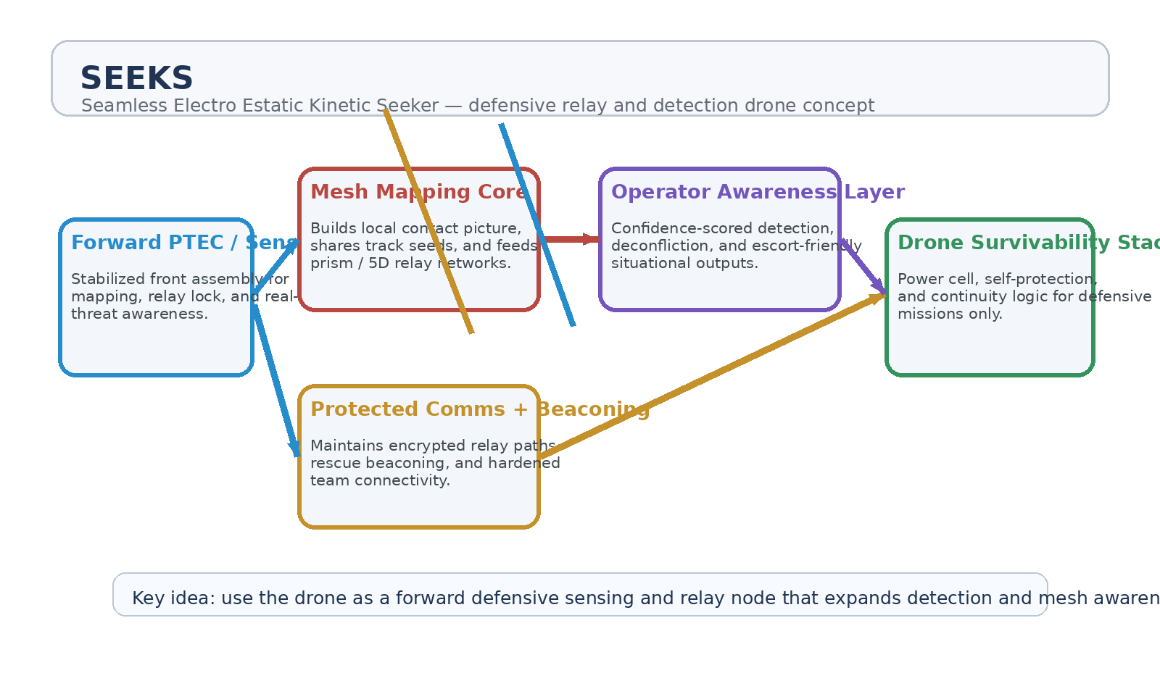
Figure 1. SEEKS architecture: forward sensor head, mesh mapping core, protected comms, operator awareness, and survivability stack.
1. Concept Thesis
The core value of SEEKS is reach. A drone can be placed farther forward than a fixed station or command ship, allowing the network to discover hazards, low-signature contacts, and route conflicts sooner. The forward assembly acts like a stabilized sensing and relay nose, while the rest of the drone exists to keep that forward awareness alive and connected.
In this framing, the platform is not a hunter-killer. It is a mobile defensive observer that extends a larger awareness mesh.
2. Core Functions
• Forward threat detection and anomaly sensing.
• Real-time relay of track seeds into a larger prism / 5D mapping mesh.
• Encrypted communications and protected team connectivity.
• Search, escort, and perimeter-watch roles in contested or cluttered environments.
• Local deconfliction support for nearby friendly traffic and assets.
3. System Architecture
Layer | Subsystem | Primary Function | Output
L1 | Forward PTEC / Sensor Head | Provides stabilized mapping, detection, and relay lock at the nose of the platform. | Forward awareness
L2 | Mesh Mapping Core | Converts local detections into track seeds and network-ready contact data. | Shared track formation
L3 | Protected Comms Layer | Maintains encrypted relay paths, beaconing, and continuity under stress. | Reliable connectivity
L4 | Operator Awareness Layer | Presents confidence-scored contacts and status to remote operators. | Actionable defensive picture
L5 | Drone Survivability Stack | Handles continuity, power management, and safe return or loiter behavior. | Persistent mission presence

3.1 Forward Sensor Head
The front assembly is the defining feature. It gives the drone a coherent forward-facing role as a mapping and sensing head. Whether the underlying mechanism is phase-stabilized, prism-assisted, or otherwise synchronized, the job is to improve local awareness and hand that awareness back to the wider network quickly.
3.2 Mesh Relay Role
SEEKS becomes much stronger when it is not treated as a solitary sensor. Its value rises when it acts as a mobile node inside a larger relay mesh. That lets one drone seed tracks, another confirm them, and fixed relays preserve continuity even when individual platforms rotate out of position.
3.3 Protected Communications
A forward drone is only useful if it stays connected. The comms layer therefore matters as much as the sensing stack. Encrypted channels, protected relay paths, and emergency beaconing allow the platform to remain useful in search, escort, and early-warning roles even when the environment is noisy or contested.
4. Defensive Mission Profiles
• Perimeter reconnaissance around stations, convoys, or high-value facilities.
• Early warning and low-signature contact seeding for a larger relay mesh.
• Search and rescue relay extension where line-of-sight or terrain breaks normal coverage.
• Escort support for protected convoys or sensitive transport corridors.
• Hazard and route mapping in environments with clutter, debris, or unstable traffic patterns.
5. Why This Drone Concept Is Useful
• Pushes situational awareness farther forward than fixed nodes alone.
• Reduces operator blind time by seeding tracks earlier.
• Improves deconfliction by sharing local contact changes quickly.
• Extends protected communications and beacon coverage.
• Can be fielded in numbers as a mobile layer around a larger defensive mesh.
6. Proof-of-Concept Build Path
Phase | Goal | Bench / Program Activity | Success Signal
P1 | Forward sensing demo | Validate stabilized front-end mapping and relay handoff from a moving drone platform. | Reliable forward contact seeding
P2 | Mesh relay integration | Connect one or more drones into a larger relay or 5D tracking mesh. | Shared track continuity
P3 | Protected comms test | Verify encrypted relay and beacon continuity under degraded conditions. | Robust connectivity
P4 | Operator display workflow | Render confidence-scored contacts and drone health to remote users. | Useful awareness output
P5 | Mission profile validation | Test reconnaissance, escort, or search-relay scenarios end to end. | Clear defensive mission value

7. Safeguards and Boundaries
• SEEKS is framed for detection, relay, and awareness, not for offensive action.
• Operator oversight remains central for escalation decisions.
• The system should preserve deconfliction and friendly-track integrity at all times.
• Autonomy should support safe return, loiter, or relay continuation rather than unsupervised engagement.
8. Conclusion
SEEKS is useful because it gives a larger defensive network eyes farther forward. By combining a stabilized front-end sensor head, real-time relay logic, and protected communications, the drone becomes a force multiplier for awareness rather than a standalone actor. It helps the bigger system detect sooner, track better, and coordinate more cleanly.
That makes SEEKS a credible proof-of-concept for a defensive relay-and-detection drone architecture in air or space-support roles.
Working one-line doctrine: Put the drone forward, let it see first, and use it to keep the wider defensive mesh awake.

