Comms 2: Oscillation-Locked Hybrid Communications
Secure Short- and Long-Range Plasma/Radio Relay Architecture
Document Type | Proof-of-concept white paper
Concept Thesis | Combine short-range plasma-local networks with long-range radio/photonic links using oscillation-based modulation, PTEC sync, and lattice-key receivers.
Primary Function | Hybrid secure communications for shipboard, relay, and deep-network environments
Status | Comms v2 architecture draft
Abstract
Comms 2 proposes a layered secure communications architecture in which local plasma-assisted links and long-range radio or photonic links share a common oscillation-based modulation and synchronization model. In this system, oscillation is not treated as decorative signal motion. It becomes a functional part of both transmission and concealment. Controlled oscillatory envelopes shape phase, amplitude, timing, and attenuation behavior so that the signal carries data while also becoming harder to interpret off-axis or out of sync. PTEC provides the live phase-lock and channel mutation authority, while lattice-key receivers act as trusted physical decode gates.
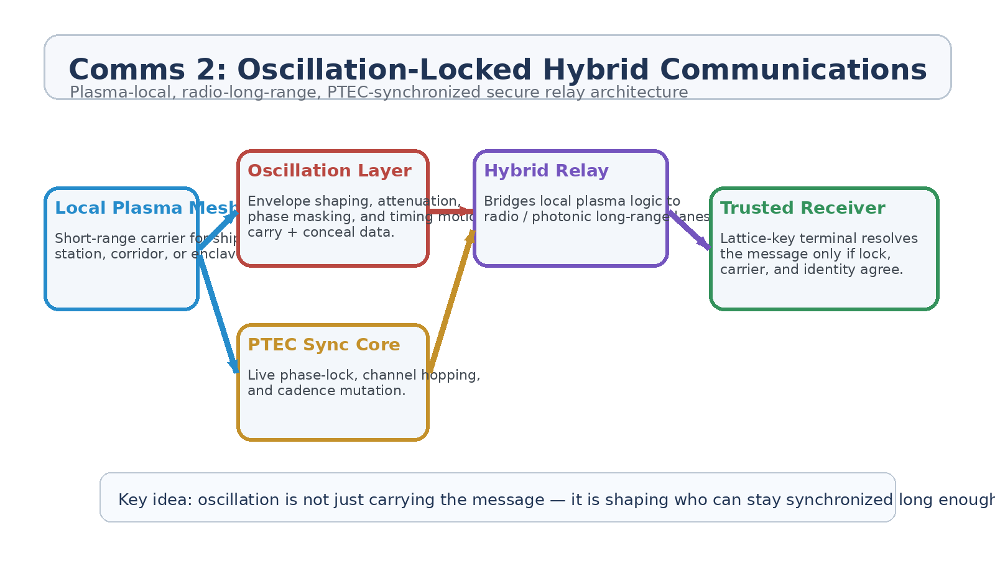
Figure 1. Comms 2 architecture: local plasma mesh, oscillation layer, PTEC synchronization, hybrid relay, and trusted receiver.
1. Concept Thesis
The key upgrade in Comms 2 is that the network stops pretending that one medium should do everything. Short-range communications benefit from highly controlled local environments, where plasma-assisted or field-aware links can be tightly shaped. Long-range communications benefit from the practical reach of radio or photonic relays. Comms 2 connects these worlds through a shared oscillation logic so that local and distant links behave like parts of one security ecosystem.
In ordinary language: the local network breathes through plasma logic, the distant network travels through radio or photonics, and the oscillation model gives both of them the same voiceprint.
2. Why Oscillation Matters
• Oscillation can carry information through phase, amplitude, timing, and envelope shape.
• Oscillation can also hide information by making the signal harder to interpret unless the receiver tracks the same moving pattern.
• Attenuation can be managed as a security feature, not just a loss mechanism, reducing useful recovery outside the intended lock corridor.
• A live oscillation model gives PTEC a practical role as a synchronization and channel-keying engine.
3. Layered Architecture
Layer | Subsystem | Primary Function | Security Role
L1 | Local Plasma Mesh | Handles short-range shipboard, corridor, station, or enclave traffic in a controlled medium. | Provides high-control local carrier.
L2 | Oscillation Layer | Encodes data and shapes attenuation through moving envelopes, cadence, and waveform behavior. | Carries plus conceals traffic.
L3 | PTEC Sync Core | Maintains live phase-lock, timing discipline, and channel mutation across active links. | Makes static interception and spoofing harder.
L4 | Hybrid Relay | Bridges local plasma logic to radio or photonic long-range transport. | Extends the system beyond local spaces.
L5 | Lattice-Key Receiver | Authenticates and resolves traffic only for properly matched terminals. | Acts as physical trust boundary.

3.1 Local Plasma Mesh
The local plasma mesh is the controlled short-range environment. It works best inside ships, stations, hardened facilities, or sealed industrial corridors where the medium can be monitored and shaped. This is where plasma-assisted 'Wi-Fi' makes the most sense: not as universal magic networking, but as a tuned local carrier with strong field control and environmental discipline.
3.2 Oscillation Layer
The oscillation layer is the real conceptual upgrade. Instead of transmitting on a static, easily characterized pattern, the network uses oscillatory envelopes to shape how the signal behaves in time and space. Data lives in the motion itself: phase drift, timing cadence, amplitude swing, pulse repetition, and attenuation behavior. An unauthorized listener may detect energy and still fail to retain a useful lock.
• Transmission role: encode and transport data.
• Masking role: obscure the readable structure of the channel.
• Attenuation role: reduce useful signal recovery outside the intended sync path.
• Continuity role: provide a shared dynamic signature across short- and long-range layers.
3.3 PTEC and Hybrid Relay
PTEC remains the live synchronization authority. It does not replace encryption or become the message itself. It controls cadence, lock-state evolution, and channel movement. The hybrid relay then carries that logic outward into radio or photonic lanes so long-range traffic inherits the same sync behavior and security doctrine, even when the medium is no longer literally plasma.
4. Security Model
Threat | Problem | Comms 2 Response
Passive interception | Traffic can be recorded and analyzed later. | Oscillation shaping plus normal encryption makes capture less useful and less stable.
Spoofing | False traffic may impersonate a friendly signal. | Live PTEC-driven timing and lattice-key resolution make convincing impersonation harder.
Replay | Recorded bursts may be rebroadcast. | Oscillation cadence changes and live sync drift break static replay assumptions.
Off-axis leakage | Receivers outside the intended corridor may still hear part of the signal. | Attenuation shaping reduces recoverable structure outside the lock zone.
Jamming | Attackers may try to swamp the channel. | Hybrid relay plus channel mutation supports re-lock and lane migration.

5. Operational Modes
• Shipboard secure mode for command, engineering, and medical traffic in controlled compartments.
• Relay mode where local plasma nodes bridge outward to radio or photonic long-range channels.
• Enclave mode with separate oscillation profiles and lattice-key classes for sensitive departments.
• Low-observable mode where attenuation shaping reduces useful off-axis leakage and narrows the effective lock corridor.
• Emergency mode where the network collapses to a smaller set of hardened oscillation patterns and trusted receivers.
6. Proof-of-Concept Build Path
Phase | Goal | Bench Activity | Success Signal
P1 | Local carrier demo | Show a short-range plasma-analog or field-aware link carrying structured data between nearby nodes. | Stable local channel.
P2 | Oscillation encoding | Add oscillation-based modulation and show data recovery only when envelope tracking is correct. | Data rides the oscillation.
P3 | Attenuation shaping | Demonstrate that off-axis or out-of-sync receivers recover less useful structure. | Leakage becomes less valuable.
P4 | Hybrid relay | Bridge the local oscillation logic to a radio or photonic long-range link. | Same security doctrine across media.
P5 | PTEC lock test | Use a live sync authority to mutate cadence and verify that trusted receivers retain lock better than untrusted ones. | Improved anti-spoof / anti-replay behavior.

7. Measurements
• Lock stability for synchronized versus unsynchronized receivers.
• Bit error rate under oscillation-based modulation across local and long-range segments.
• Off-axis recoverability before and after attenuation shaping.
• Replay and spoof success rates against static and oscillation-locked channels.
• Time required to reacquire a valid channel after controlled interference.
• End-to-end integrity across plasma-local to radio-relay handoff.
8. Boundaries and Realism
Comms 2 is strongest as a hybrid architecture, not a replacement for every normal communications system. Plasma-like logic works best in controlled local environments. Radio and photonics remain the realistic long-range carriers. The innovation lies in making both layers obey the same oscillation, synchronization, and trust doctrine so the entire network behaves like one secure organism rather than several disconnected tools.
• Oscillation improves concealment and sync behavior, but it should complement ordinary cryptography rather than replace it.
• Attenuation shaping is a security enhancement, not a guarantee of invisibility.
• The PTEC sync layer must fail gracefully without collapsing the whole network.
• Lattice-key receivers remain important if the system wants physical trust instead of software-only trust.
9. Conclusion
Comms 2 upgrades the earlier plasma-communications concept by giving the network a more coherent division of labor. Local plasma-assisted links provide high-control environments. Radio or photonic relays handle distance. Oscillation carries and conceals the message. PTEC keeps the channel alive through phase-lock and cadence mutation. Lattice-key receivers decide who can actually resolve the traffic into meaning.
That makes the system suitable for GhostCore environments where trust is not merely a password problem, but a live agreement between medium, motion, and matter.
Working one-line doctrine: The oscillation is not just carrying the message — it is deciding who can stay synchronized long enough to hear it.

