Phase-Locked Plasma Communications
PTEC-Assisted Secure Communications Array
Document Type | Clean proof-of-concept white paper
Concept Thesis | Combine conventional cryptography, waveform modulation, lattice-key decoding, and a PTEC phase-lock core for secure communications.
Primary Use | Shipboard, enclave, and long-range GhostCore communications architecture
Status | Speculative secure-comms subsystem draft
Abstract
Phase-Locked Plasma Communications is a GhostCore secure-communications concept that merges plasma or plasma-assisted radio carriers with conventional encryption, waveform-level obfuscation, lattice-key substrate authentication, and a PTEC-driven phase synchronization core. In this architecture, PTEC does not replace message encryption. Instead, it supplies the live rotational timing, phase discipline, and channel-mutation behavior that make it substantially harder to intercept, spoof, or remain locked onto an active communications stream. The result is a layered model for shipboard, enclave, and long-range secure channels where the signal, the decoder, and the synchronization authority all have to agree in real time.
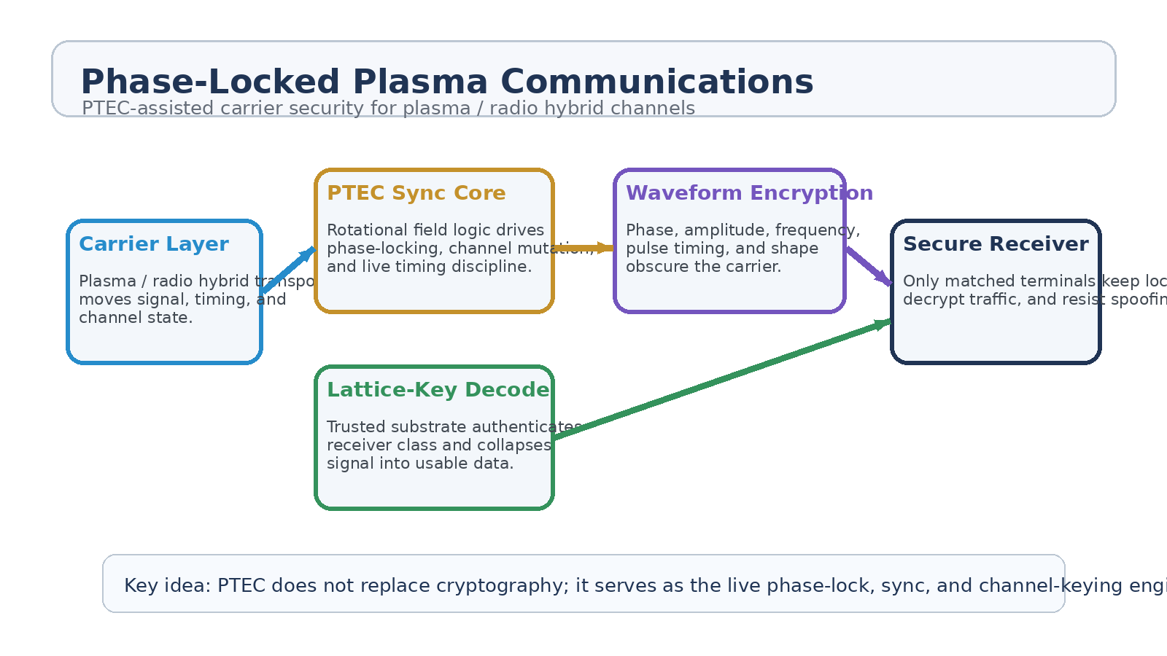
Figure 1. Layered communications architecture with PTEC as the live phase-lock and channel-keying core.
1. Concept Thesis
The cleanest way to describe this system is simple: the carrier moves the signal, the lattice key authenticates and decodes it, and the PTEC keeps the channel alive in a way that unauthorized listeners cannot easily follow. This makes the communications stack materially richer than a normal radio link and more dynamic than static keying alone.
PTEC therefore serves as a synchronization and channel-keying authority. It drives phase behavior, rotating field cadence, timing jitter control, and channel mutation patterns. In ordinary language, it acts like a live heartbeat for the communications lane.
2. Why Add PTEC to the Communications Stack
• To provide a live phase-lock engine that changes the channel behavior over time instead of leaving it statically predictable.
• To support channel hopping, timing discipline, and anti-spoof synchronization across multiple receivers.
• To make interception harder even before an attacker reaches the cryptographic layer.
• To align communications security with the same wider GhostCore field logic used in power, transit, and lattice-key identity systems.
3. Layered System Architecture
Layer | Subsystem | Primary Function | Security Role
L1 | Carrier Layer | Plasma, radio, or plasma-assisted radio transport moves signal, timing, and session state. | Provides the medium.
L2 | Conventional Encryption | Protects message contents with normal cryptographic methods. | Protects readable payload.
L3 | Waveform Encryption | Hides signal structure in phase, amplitude, frequency, pulse timing, and modulation shape. | Obscures the carrier form.
L4 | PTEC Sync Core | Drives live phase-lock, dynamic keying cadence, and channel mutation. | Makes lock retention and spoofing harder.
L5 | Lattice-Key Receiver | Authenticates receiver class and collapses signal into trusted usable information. | Acts as physical decode gate.

3.1 Carrier Layer
The transport medium can be a controlled plasma corridor, a radio-frequency lane informed by the plasma carrier concept, or a hybrid architecture where radio is the distance workhorse and plasma logic shapes local channel behavior. The exact medium matters less than the design principle: the carrier is only one layer of security, not the whole story.
3.2 PTEC as Live Synchronization Core
PTEC belongs in this design because it can be treated as a rotating field and timing authority. Rather than storing the message or replacing cryptography, it continuously influences the phase relationship, channel cadence, and lock-state evolution of the active link. A valid receiver must therefore remain synchronized to a changing field pattern, not merely know a fixed password or modulation profile.
• Dynamic keying engine: channel behavior changes while traffic is live.
• Phase-randomization core: the lock pattern is not static across time.
• Channel-hopping synchronizer: receivers follow a coordinated motion through the available spectrum or waveform space.
• Resonance authority: only trusted devices stay aligned long enough to make sense of the traffic.
3.3 Lattice-Key Decoding
The receiver side remains just as important. Even if an adversary records the carrier, follows part of the channel pattern, or captures a terminal, the lattice-key substrate still acts as a decode and trust boundary. Signal capture is not the same thing as signal comprehension. In the best version of the architecture, the right receiver must be physically capable of responding correctly, not just logically authorized.
4. Security Model
Threat | Why It Matters | How This Architecture Responds
Interception | Captured traffic can be analyzed later. | Payload encryption plus waveform obfuscation reduces useful capture value.
Spoofing | False signals can mislead or hijack receivers. | PTEC phase-locking makes fake synchronization harder to sustain.
Replay attacks | Recorded bursts may be rebroadcast later. | Live timing mutation and sync drift break static replay assumptions.
Terminal theft | A stolen device may still reveal sessions. | Lattice-key gating and live lock requirements keep endpoints incomplete.
Jamming / lock disruption | Adversaries may try to break the lane itself. | PTEC-driven channel mutation helps the network re-phase and relocate.

5. Operational Modes
• Shipboard secure mode: interior corridors and critical departments use phase-locked channels for command, sensor, and engineering traffic.
• Enclave mode: medical, command, or weapons networks use separate lattice-key classes and different sync profiles.
• Relay mode: longer-distance radio links inherit PTEC-driven timing logic for channel authentication and anti-spoof control.
• Emergency harden mode: the network narrows to only the most trusted channels and most resilient synchronization patterns.
6. Proof-of-Concept Build Path
Phase | Goal | Bench Activity | Success Signal
P1 | Carrier validation | Demonstrate a stable radio or plasma-analog carrier moving encrypted data between two nodes. | Usable baseline link.
P2 | Waveform layer | Add phase, timing, and shape variation beyond ordinary packet encoding. | Improved concealment without loss of decode integrity.
P3 | PTEC sync loop | Introduce a rotating timing authority that changes lock behavior while traffic stays live. | Receivers stay locked; unauthenticated listeners fall out of sync.
P4 | Lattice-key gate | Require a trusted substrate at the receiver before the channel resolves into usable data. | Signal capture no longer equals meaningful access.
P5 | Anti-spoof exercise | Test replay, spoofing, and jamming against the full stack. | Demonstrated resistance improvement over static radio link.

7. Measurements
• Receiver lock stability under live PTEC-driven channel mutation.
• Bit error rate and message recovery quality across different carrier conditions.
• Spoof success rate with and without the PTEC sync layer.
• Replay success rate against static versus phase-locked channels.
• Time to reacquire a valid channel after controlled interference.
• False-accept and false-reject rates for lattice-key authenticated receivers.
8. Boundaries and Realism
This architecture does not claim that plasma somehow replaces all normal communications engineering. It is strongest as a layered secure-comms concept in which conventional cryptography still protects the message, while waveform logic, lattice-key decoding, and PTEC-driven phase synchronization add harder-to-copy physical and temporal constraints. Radio remains the practical long-range workhorse. Plasma logic and PTEC synchronization make that workhorse stranger, more selective, and more difficult to impersonate.
• PTEC enhances channel security; it does not replace cryptographic payload protection.
• Lattice-key substrates should be treated as trust anchors, not as magic all-purpose decoders.
• Long-range deployment will likely use hybrid radio / photonic / field-aware architectures rather than one medium alone.
• Graceful fallback modes are required if the phase-lock layer is disrupted.
9. Conclusion
Phase-Locked Plasma Communications is a cleaner successor to a simple 'plasma Wi-Fi' idea because it separates roles clearly. The carrier moves the signal. Cryptography protects the message. Waveform logic obscures the channel. Lattice keys decide who is physically able to decode it. PTEC keeps the entire communications lane alive through live synchronization and channel mutation.
That makes the architecture useful for exactly the kinds of systems GhostCore keeps circling back to: private internal meshes, secured shipboard command traffic, resilient relay channels, and communications environments where knowing the password is not enough if you cannot keep pace with the field.
Working one-line doctrine: PTEC does not replace encryption; it gives the encrypted channel a live heartbeat that unauthorized listeners struggle to follow.

