Autonomous Micro-Hab Reactor Module
White Paper Proof of Concept for a Compact Spacecraft Life-Support Cabin Node Scaled from the Reactor/Biosuit Stack
Document Type | Non-operational habitat and life-support proof-of-concept white paper
Concept Thesis | Scale the biosuit reactor architecture into a compact spacecraft habitation module that combines photonic power support, oxygen regeneration, water processing, hygiene utility, and shell buffering for a sealed crew volume.
Primary Use | Crew survival, emergency habitation, atmospheric recycling, water-loop support, sanitation, and resilient sealed-cabin operation
Status | High-level concept architecture draft
Abstract
Autonomous Micro-Hab Reactor Module scales the earlier biosuit reactor concepts into a cabin-sized survival node for spacecraft use. The module combines a photon-reactor or reserve-cell layer, a prism-centered oxygen-regeneration core, a reclaimed-water electrolysis loop, a compact hygiene and contamination-control utility, and a field-regulated shell buffer surrounding a true inner pressure volume. In this framing, the earlier suit logic becomes architectural rather than wearable: instead of sustaining a single body, the system sustains a small habitable compartment. The result is best understood as a self-supporting emergency or distributed habitation module for deep-space craft, support tenders, shelters, or compartment-level survival cells.
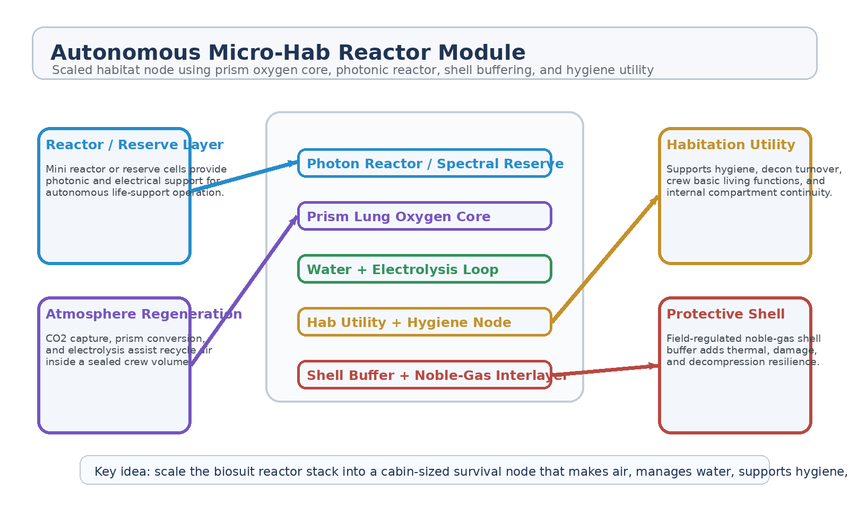
Figure 1. Autonomous Micro-Hab Reactor Module with reactor/reserve layer, prism oxygen core, electrolysis loop, hygiene utility, and buffered shell.
1. Concept Thesis
The core idea is to enlarge the biosuit survival stack into a miniature spacecraft habitation node. A suit is a moving life-support shell around one person; a micro-hab module is that same logic wrapped around a small room. The reactor and reserve layers provide power, the prism-lung core recycles atmosphere, the water loop restores oxygen and utility balance, the hygiene node supports repeated occupancy, and the shell buffer adds resilience against thermal shock, puncture progression, and environmental stress.
This makes the concept strongest as a modular cabin organ for a larger ship: something that can keep a crew alive locally even if the wider vessel is degraded.
2. How the Source Concepts Scale Up
From the PORS and enhanced biosuit concepts, the module inherits the photon-reactor logic, the oxygen-regeneration loop, electrolysis assist, and the idea that reserve cells can hold photonic or electrical support when ordinary generation is limited.
From Prism Lung, it inherits the prism-centered conversion heart, lattice-regulated oxygen recovery, electrolysis blending, and the discipline that oxygen regeneration is a controlled systems problem rather than a one-device miracle.
From Field-Pressurized Reactive Shell, it inherits the buffered shell concept: a true inner pressure hull surrounded by a useful interstitial layer regulated for thermal, load, and damage-response behavior.
From Halo Photon Hygiene Chamber, it inherits the practical lesson that daily life needs a real hygiene workflow, not only a dramatic emergency decon story.
3. System Architecture
Layer | Subsystem | Primary Function | Hab Role
L1 | Photon Reactor / Reserve Layer | Provide photonic and electrical support through mini reactor logic or reserve cells. | Power backbone
L2 | Prism Lung Oxygen Core | Recycle CO2 and support closed-loop oxygen regeneration. | Atmosphere organ
L3 | Water + Electrolysis Loop | Recover water and supply supplemental oxygen when demand rises. | Reliability backstop
L4 | Hab Utility + Hygiene Node | Support crew cleaning, contamination control, and daily-use living turnover. | Human operations
L5 | Buffered Shell Assembly | Protect the pressure hull with an interstitial shell-management layer. | Resilience envelope

3.1 Reactor and Reserve Layer
At cabin scale, the reactor layer is best treated as a compact power and reserve backbone rather than as a giant central plant. It feeds the prism conversion core, water processing, hygiene utility, sensors, and environmental controls. Spectral reserve or overdrive-style cells can sit beside it as a continuity layer so the cabin keeps working through transient failures.
3.2 Prism Lung at Cabin Scale
Prism Lung becomes the atmosphere organ of the room. Exhaled carbon dioxide, humidity, reclaimed moisture, and available power are routed through a compact prism-centered regeneration core. The module's job is not to create a magical atmosphere from nothing, but to reduce resupply burden and keep the small habitat breathable longer under closed-loop conditions.
3.3 Hygiene and Human Utility
A small habitation cell still needs human operations support. That means particulate removal, daily hygiene, chamber reset, and contamination management must exist as routine utility functions. Scaled from the earlier hygiene-chamber logic, the hab module therefore includes a compact utility niche or integrated sanitation workflow rather than assuming survival alone is enough.
3.4 Buffered Shell
The outer shell concept is still valuable at this scale. A true inner pressure wall protects the crew volume, while an interstitial noble-gas or regulated shell layer helps with thermal buffering, damage localization, and decompression grace. This makes the module more survivable as an emergency room or detachable survival cell.
4. Best Use Cases
• Emergency survival cabin inside a larger ship.
• Detachable lifeboat or refuge pod for a small crew.
• Distributed hab node on a modular spacecraft or station.
• Medical isolation compartment with independent atmosphere support.
• Exploration shelter cell for surface-to-orbit transfer or contingency use.
5. Why This Is Stronger Than a Simple Hab Pod
• It recycles atmosphere instead of relying only on stored gas.
• It adds water-loop and electrolysis resilience instead of a single oxygen path.
• It includes actual human-operations support such as hygiene and contamination control.
• It protects the pressure hull with a buffered shell concept rather than a single wall.
• It can function as a modular survival organ inside a larger damaged spacecraft.
6. Boundaries and Realism
Autonomous Micro-Hab Reactor Module should be framed honestly as a layered survival-support architecture, not as a promise of indefinite self-sufficiency without consumables, maintenance, or external power. Its strongest value is in extending habitable time, reducing resupply pressure, and preserving a small crew volume under degraded conditions.
• Most credible as a compact survival or distributed-habitation node.
• Not a replacement for the entire life-support infrastructure of a major ship.
• Still dependent on real power, water recovery, thermal control, and maintenance discipline.
• Best used to keep a small crew alive longer and safer under closed-loop conditions.
7. Proof-of-Concept Build Path
Phase | Goal | Bench / Program Activity | Success Signal
P1 | Closed-cabin baseline | Model a sealed small-room atmosphere and utility demand profile. | Credible hab load baseline
P2 | Prism oxygen integration | Add a compact oxygen-regeneration loop with electrolysis assist. | Improved closed-loop endurance
P3 | Utility + hygiene integration | Demonstrate daily-use sanitation and contamination-control workflow in a small compartment. | Usable human operations layer
P4 | Shell buffering | Test an interstitial shell layer for thermal and damage-response behavior. | More graceful failure behavior
P5 | Full module review | Assess whether the combined stack functions as one coherent survival cabin. | Integrated hab-node doctrine

8. Conclusion
Autonomous Micro-Hab Reactor Module takes the suit-scale survival stack and gives it walls. The reactor and reserve layer provide the energy backbone. Prism Lung becomes the room's atmosphere organ. Electrolysis and water recovery extend reliability. Hygiene support makes the room livable. The buffered shell makes it harder to kill.
As a white paper PoC, the concept is strongest as a miniature habitable reactor cell: not the whole ship, but the small self-supporting chamber that keeps life going when the rest of the ship is hurting.
Working one-line doctrine: Scale the biosuit reactor stack into a cabin-sized survival node that makes air, manages water, supports hygiene, and protects a small crew volume.

