VeilPiercer Relay Mesh
Defensive White Paper Proof of Concept
Document Type | Defensive monitoring proof-of-concept white paper
Concept Thesis | Fuse prism relay nodes, passive anomaly sensing, triangulation, and 5D state mapping into a confidence-scored contact-tracking mesh.
Primary Use | Defensive situational awareness, relay-based triangulation, and persistent low-signature contact tracking
Status | High-level relay mesh architecture draft
Abstract
VeilPiercer Relay Mesh is a defensive triangulation and tracking concept built around distributed prism relay nodes, passive anomaly detection, and 5D state estimation. Rather than depending on one perfect active sensor, the mesh compares multiple anchored viewpoints, looking for field disturbance, waveform deficit, plasma wake behavior, or other low-signature anomalies across time. When a candidate contact persists, the network forms a 5D state estimate that includes position, time, and orientation-aware observation viability. The output is a confidence-scored awareness layer for operators, not an autonomous engagement system.
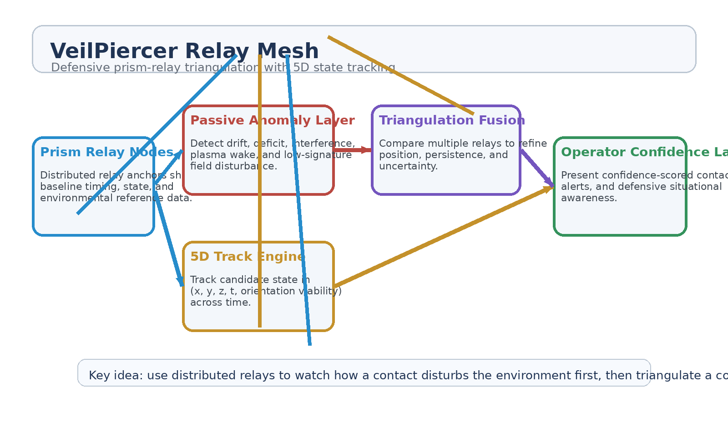
Figure 1. VeilPiercer Relay Mesh architecture: relay anchors, passive anomaly sensing, 5D track formation, triangulation fusion, and operator confidence output.
1. Concept Thesis
The core idea is simple: if one sensor view is uncertain, many synchronized relay views can still form a useful track. Prism relays act as anchored reference nodes. They share time, baseline state, and environmental observations across a distributed mesh. When a low-signature object disturbs the environment—through phase lag, attenuation gaps, wake effects, or waveform deficit—the network treats those disturbances as track seeds instead of waiting for an obvious reflection.
That makes the system particularly useful for defensive monitoring of intermittent, stealthy, or aspect-sensitive contacts whose signatures may only appear indirectly.
2. Why 5D State Matters
In this architecture, 5D does not imply mysticism. It means the network tracks a contact using more than flat position alone. The state includes three-dimensional location, time continuity, and orientation-relative observation viability. That lets the mesh reason about where a contact is, how it is moving, how aspect changes affect observation quality, and how confidence should evolve over time.
• Three spatial dimensions capture location and motion geometry.
• Time captures persistence, prediction, and continuity quality.
• Orientation viability captures how useful a view is from a given relay angle or track state.
• The result is richer than a simple dot on a map.
3. Relay Mesh Architecture
Layer | Subsystem | Primary Function | Output
L1 | Prism Relay Nodes | Provide distributed anchor points, timing alignment, and shared baseline awareness. | Mesh reference state
L2 | Passive Anomaly Layer | Detect disturbance, wake, attenuation deficit, and interference anomalies. | Candidate contact seeds
L3 | 5D Track Engine | Estimate contact state across position, time, and observation viability. | Persistent track ribbon
L4 | Triangulation Fusion | Fuse multiple relay viewpoints to refine location and uncertainty. | Confidence improvement
L5 | Operator Layer | Present contacts, alerts, and uncertainty to humans. | Defensive situational awareness

3.1 Prism Relay Nodes
Prism relays serve as more than repeaters. In this concept they function as synchronized anchors for timing, environment comparison, and viewpoint geometry. That makes them useful for a triangulation problem because each node contributes not only a reading, but a reference frame.
3.2 Passive Anomaly Detection
The network remains passive-first. Instead of flooding the environment with constant active emission, it begins by looking for how a target disturbs the baseline: waveform deficit, phase lag, attenuation anomalies, plasma wake effects, or other mismatches between expected and observed environmental behavior. These weak clues become the beginning of a track rather than being discarded as noise.
3.3 Triangulation and Fusion
Once multiple relay nodes register coherent anomaly behavior, the system triangulates the contact candidate and compares state estimates over time. The most useful result is not a single fixed coordinate, but a confidence-scored ribbon of plausible motion and aspect-dependent viability. That is where 5D state estimation and prism relays naturally meet.
4. Defensive Use Cases
• Orbital perimeter and air/space corridor monitoring.
• Persistent tracking of low-signature or intermittent contacts.
• Distributed early warning in contested sensing environments.
• Multi-node confirmation when one relay loses line-of-sight or signal quality.
• Situational awareness for operators who need track confidence rather than false certainty.
5. Confidence Model
A defensive system should expose uncertainty clearly rather than pretending all contacts are equal. VeilPiercer Relay Mesh therefore produces confidence tiers based on relay agreement, persistence, track coherence, and anomaly strength.
Confidence Tier | Meaning | Operator Action
Low | Single-node anomaly or weak short-lived multi-node disturbance. | Monitor and hold.
Medium | Multi-node coherence with a forming 5D track and repeatable geometry. | Continue tracking and compare.
High | Persistent relay agreement with strong triangulation and stable state evolution. | Raise defensive alert and maintain awareness.

6. Proof-of-Concept Build Path
Phase | Goal | Bench / Program Activity | Success Signal
P1 | Relay baseline | Stand up multiple prism-like relay nodes and record a synchronized environmental baseline. | Stable shared reference state.
P2 | Anomaly seeding | Introduce weak disturbances and verify that multi-node comparison outperforms single-node detection. | Reliable contact seeds.
P3 | 5D track formation | Track seeded contacts through position, time, and observation viability over repeated intervals. | Persistent ribbon-like state estimate.
P4 | Triangulation fusion | Fuse multiple relay viewpoints into a narrower uncertainty volume. | Improved location confidence.
P5 | Operator awareness layer | Render confidence tiers, contact persistence, and uncertainty for human review. | Usable defensive monitoring output.

7. Measurements
• Detection improvement from multi-node fusion versus single-node observation.
• Triangulation uncertainty before and after relay comparison.
• Track persistence across intermittent or low-signature contacts.
• False-alarm reduction from shared baseline logic.
• Operator interpretation quality when contacts are presented with confidence tiers and uncertainty volumes.
• System continuity when one or more relays lose quality or line-of-sight.
8. Boundaries and Realism
VeilPiercer Relay Mesh is explicitly framed as a defensive monitoring and tracking system. It is not an autonomous engagement architecture. Its purpose is to improve awareness, persistence, and confidence for human operators by comparing multiple distributed relay views and forming a richer state estimate than a single sensor can provide.
• Human operators remain responsible for escalation decisions.
• The mesh is passive-first and only seeks to maintain awareness and triangulation confidence.
• The value of the system is in persistent defensive situational awareness, not aggressive automation.
• A relay mesh improves correlation; it does not make uncertainty disappear.
9. Conclusion
VeilPiercer Relay Mesh turns prism relays and 5D mapping into a coherent defensive contact-tracking architecture. Distributed relay anchors provide reference geometry. Passive anomaly sensing turns weak disturbances into track seeds. 5D state estimation carries those seeds forward as a persistent motion ribbon. Triangulation fusion then narrows uncertainty and raises confidence where multiple nodes agree.
The result is not a perfect sensor. It is a smarter mesh: one that watches for disturbance first, keeps uncertainty honest, and gives human operators a better chance of maintaining contact with low-signature air or space objects across time.
Working one-line doctrine: Use distributed relays to watch how a contact disturbs the environment first, then triangulate a confidence-scored 5D track.

